**TY B.Tech. (CSE) – II [ 2022-23 ]**

**5CS372 : Advanced Database System Lab.**

**Assignment No. 9**

Install & deploy the following cloud databases on windows platform :

1. MongoDB

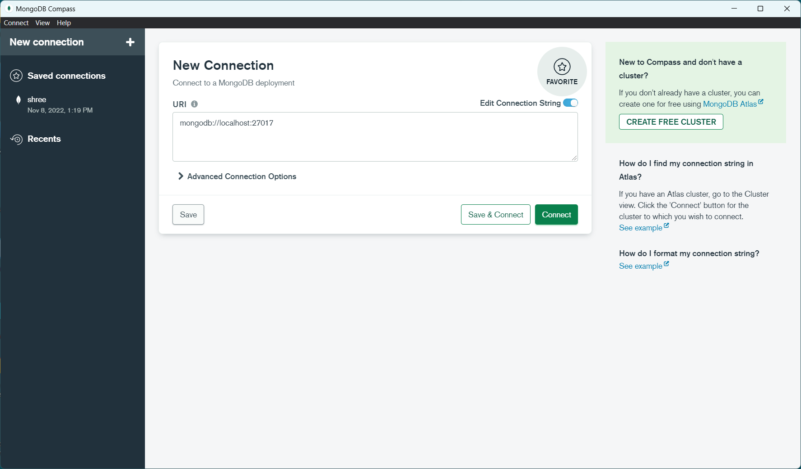

1. CassandraDB

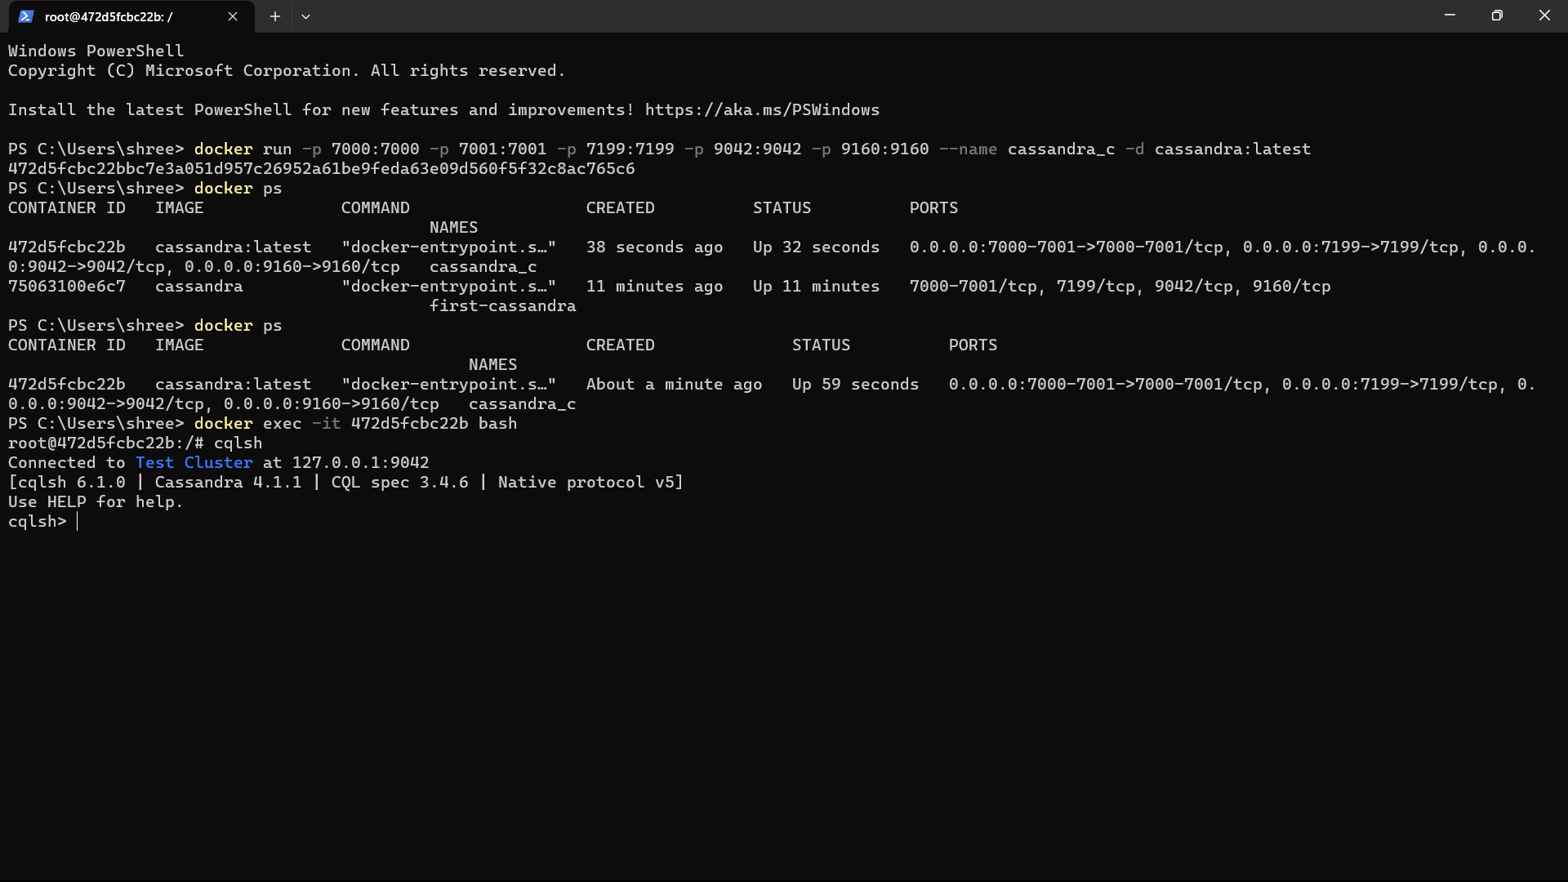

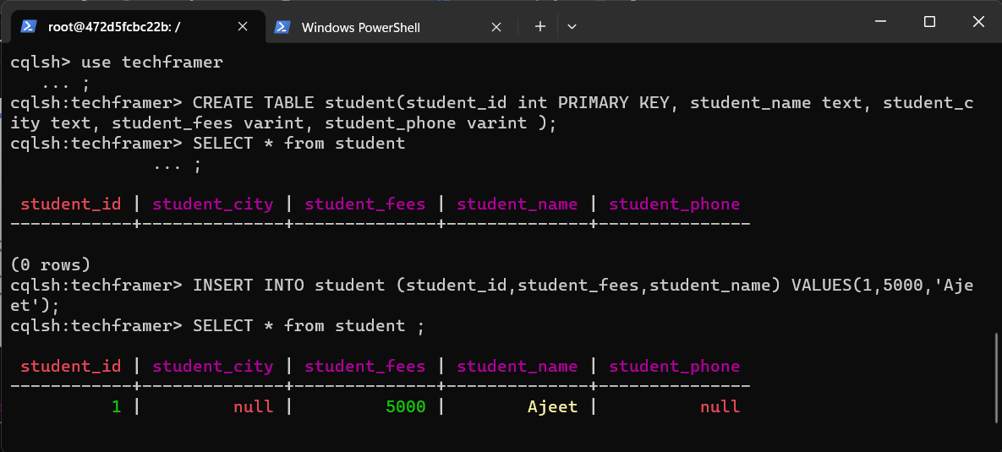

**Q. Write Python desktop Application to demonstrate the CRUD operation with above backend cloud databases**. ***Assume any database***.

**Code:**

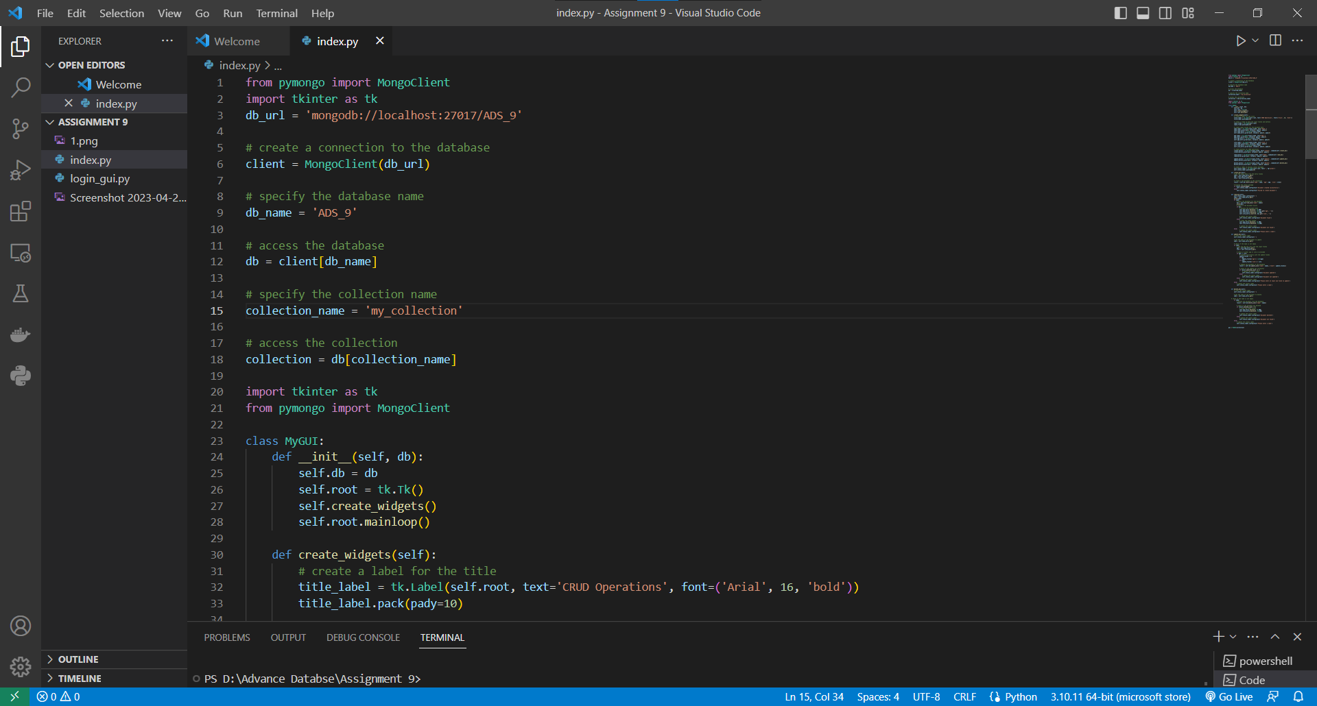

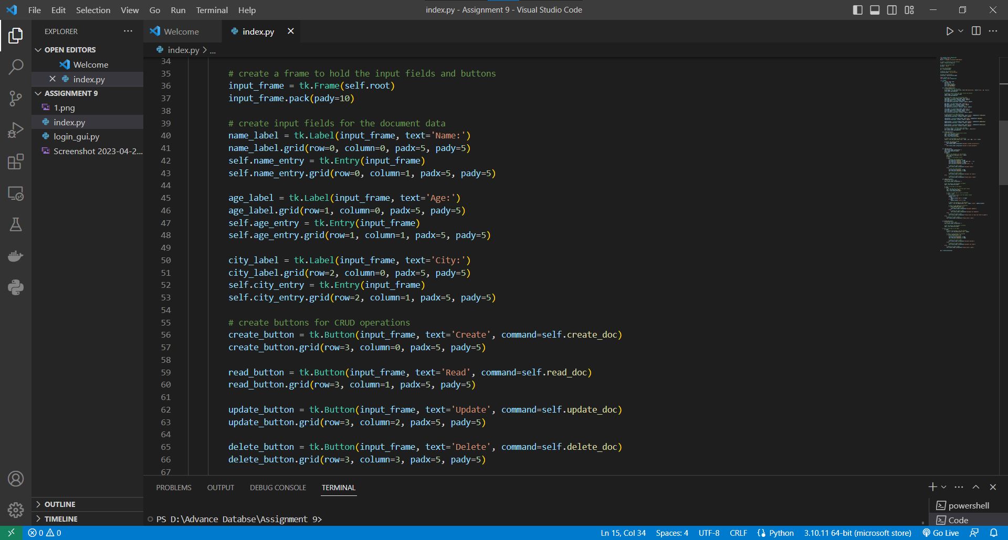

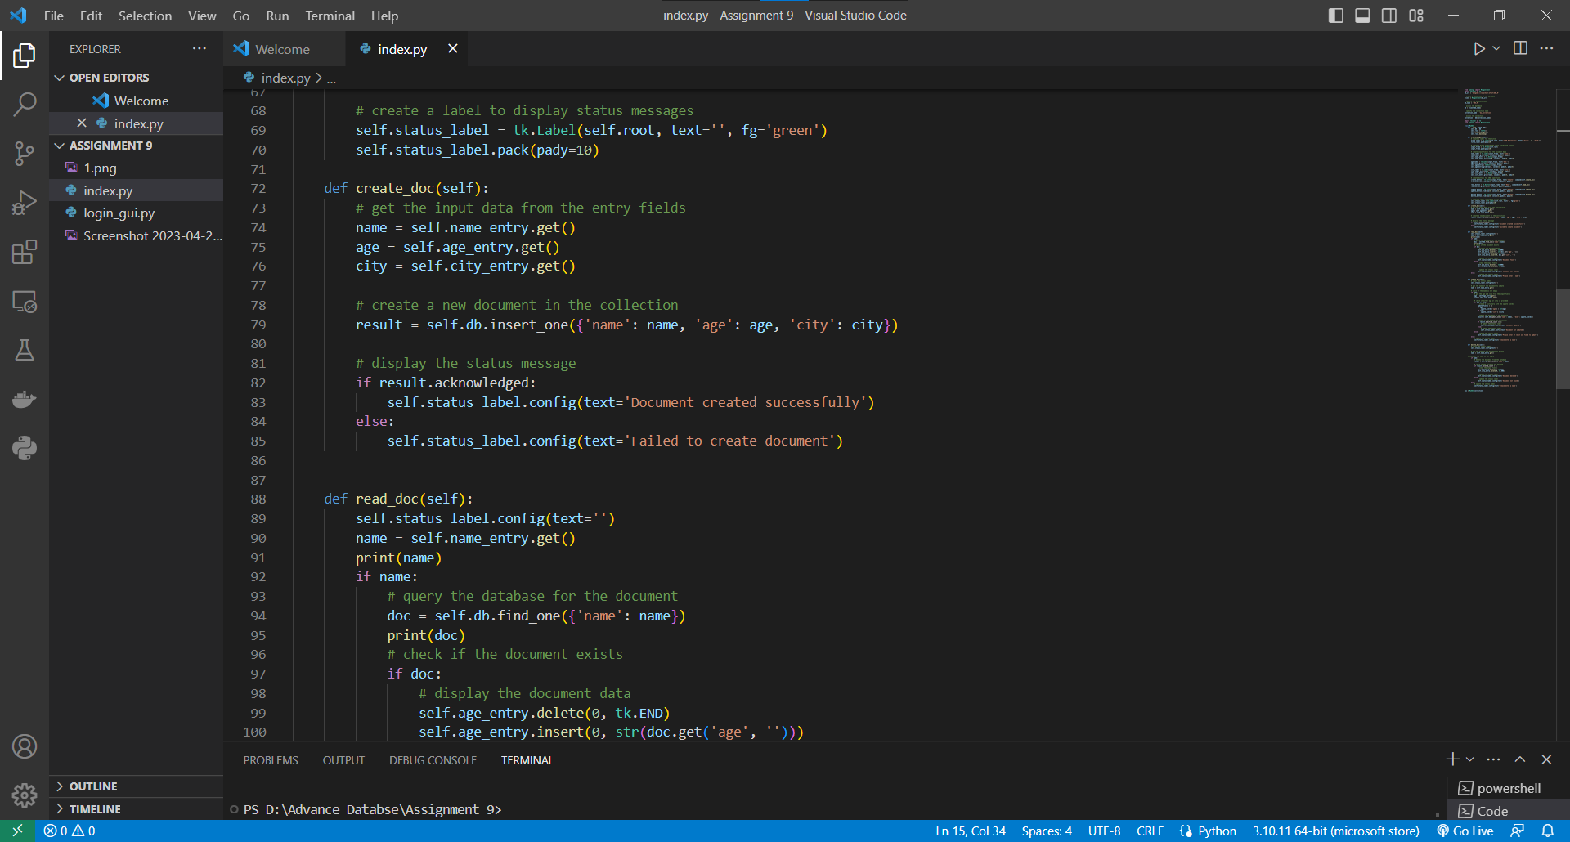

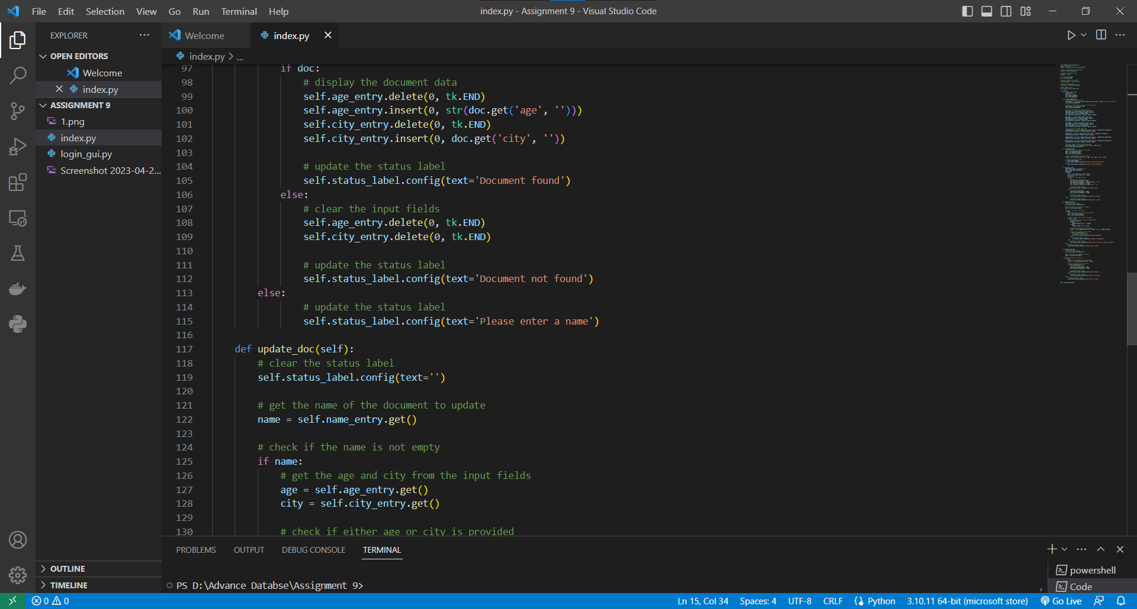

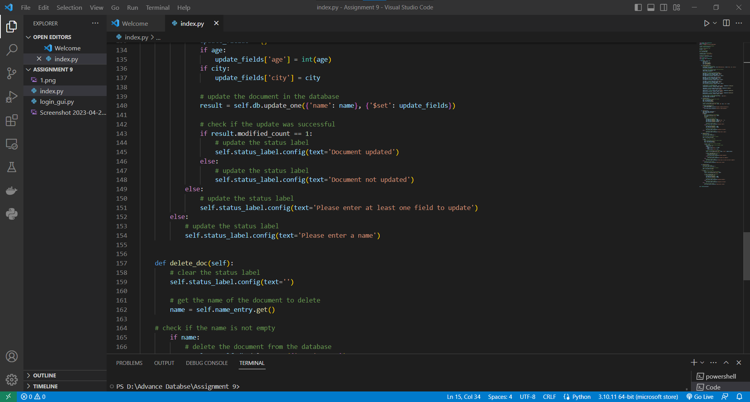

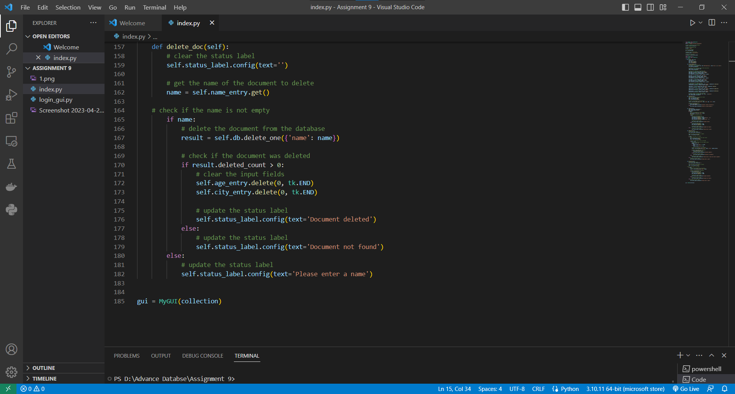

**Result:**

**1.CREATE**

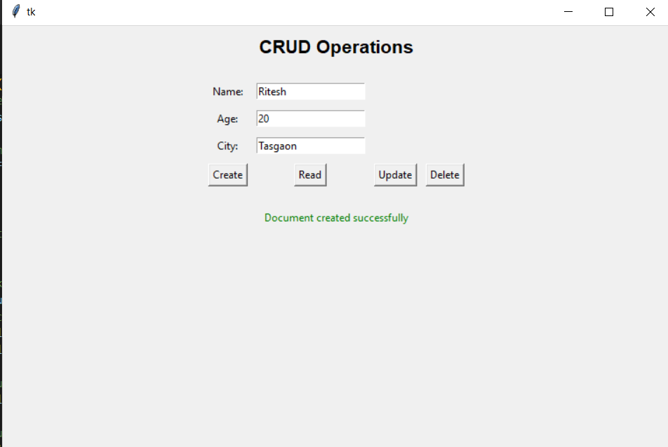

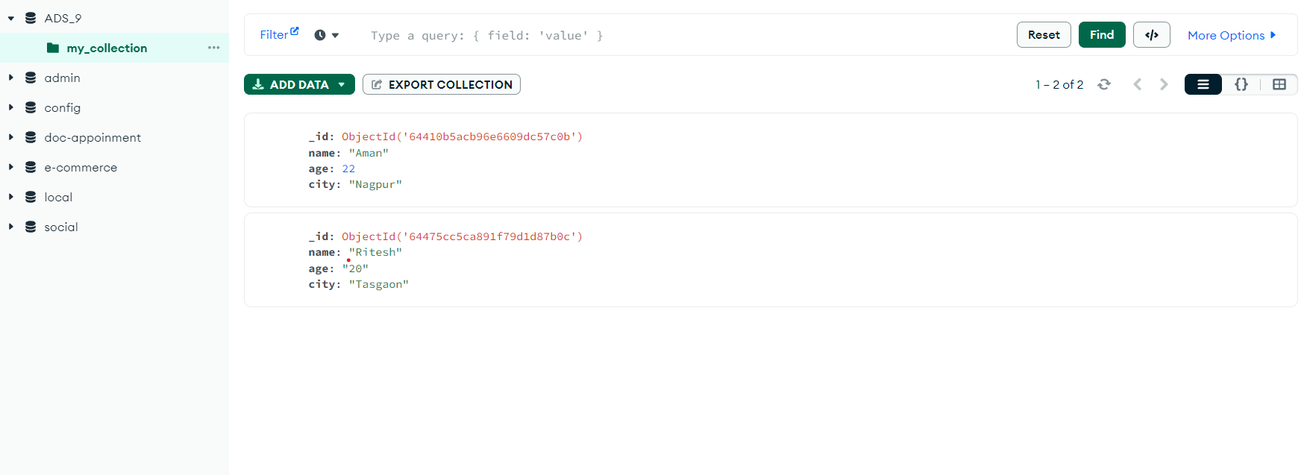

**2.Read:**

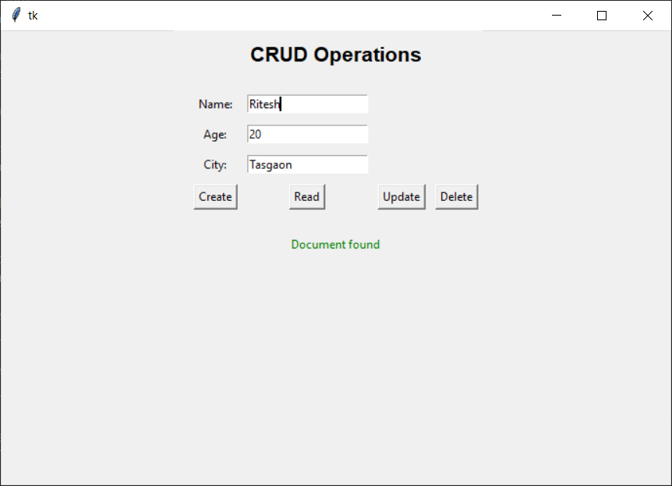

**3.Update:**

Before Update**:**

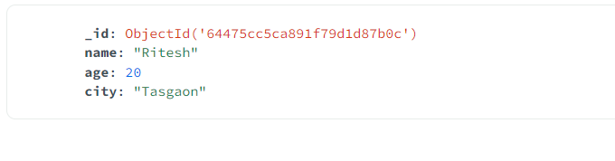

After Update**:**

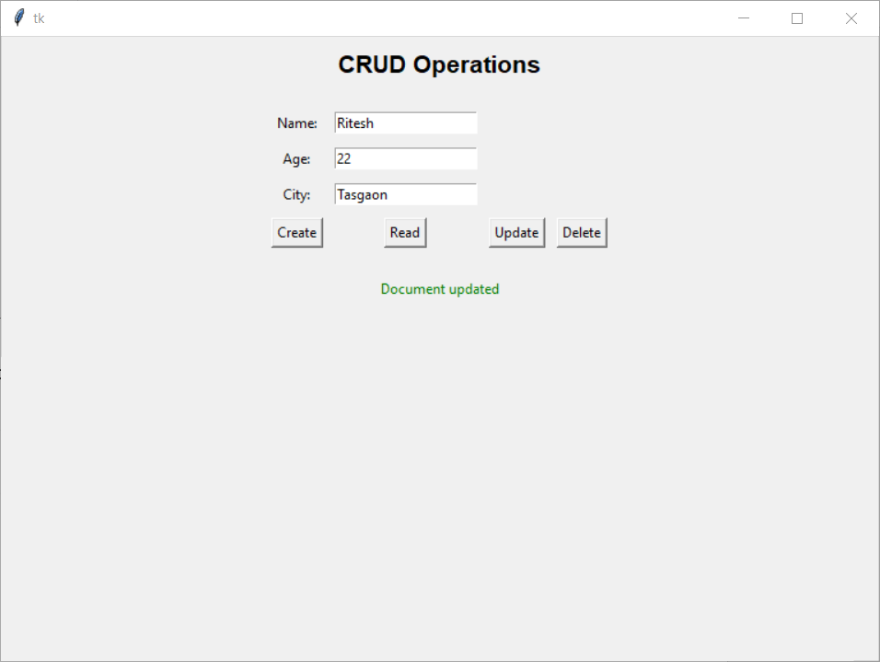

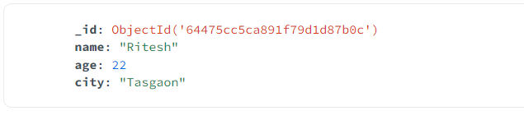

**4.Delete:**

Before Delete**:**

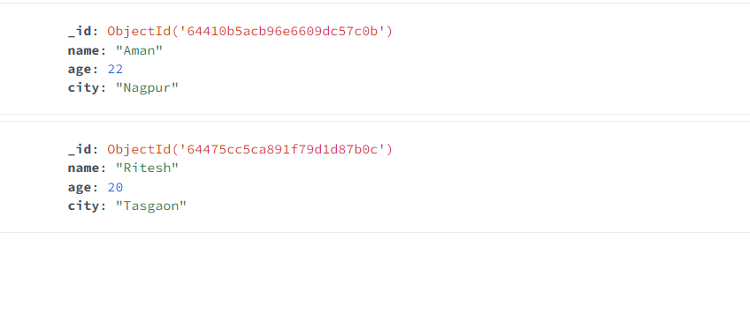

After Delete**:**

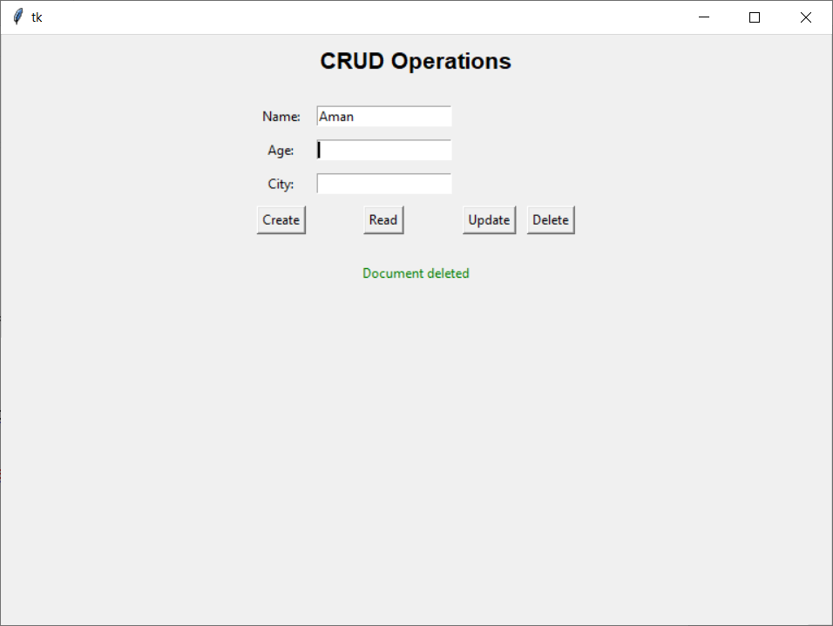

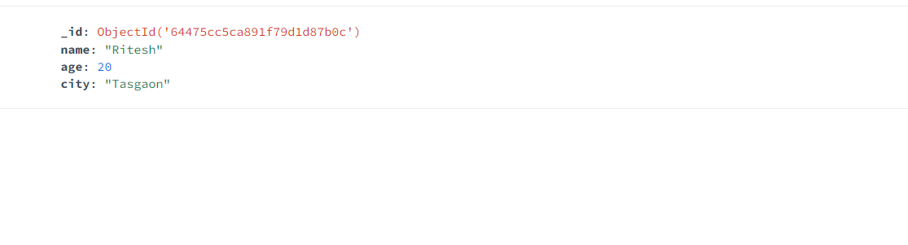

**Dr. B. F. Momin**

**Course Coordinator**