**Roll No: 2003028**

**Lab Evaluation 1**

**Lab Task Q1**

**Question: Create a Latex program which will format following text:**

**Solution (Latex Code):**

|  |
| --- |
| \documentclass{book}  \usepackage{ulem}  \usepackage{fancyhdr}  \usepackage{amsmath}  \title{2003028}  \author{Md. Abdullah AL Mamun}  \begin{document}  \setlength{\topmargin}{5cm}  \setlength{\rightmargin}{5cm}  \setlength{\leftmargin}{5cm}  \maketitle  If $f(x,y)$ is a function, where $f$ partially depends on $x$ and $y$ and if we differentiate $f$ with respect to $x$ and $y$, then the derivatives are called the partial derivatives of $f$. The formula for the partial derivative of $f$ with respect to $x$, taking $y$ as a constant, is given by:  \begin{center}  $f_x = \frac{\partial f}{\partial x} = \lim_{h \to 0} \frac{f(x+h,y)-f(x,y)}{h}$  \end{center}  And the partial derivative of $f$ with respect $y$ keeping $x$ as constant, we get;  \begin{center}  $f_y = \frac{\partial f}{\partial y} = \lim_{h \to 0} \frac{f(x,y+h)-f(x,y)}{h}$  \end{center}  The $Gradient$ of f at point (x0 , y0 ) is deﬁned as follows:  \begin{center}  $\nabla f(x_0,y_0) =$  $\begin{bmatrix}  \frac{\partial f}{\partial x}(x_0,y_0) \\  \frac{\partial f}{\partial y}(x_0,y_0)  \end{bmatrix}$  \end{center}  \begin{center}  $=  \begin{matrix}  f_x \\  f_y  \end{matrix}$  \end{center}  \end{document} |

**Output (Screen/SnapShot of Generated PDF):**

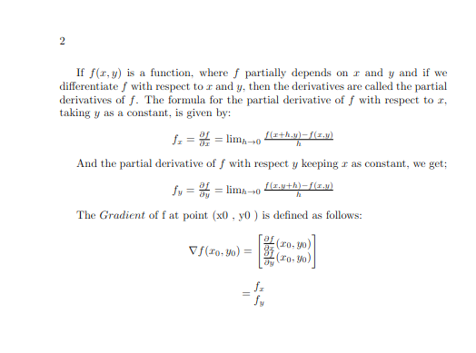

**Lab Task Q2**

**Question: Create two chapters using same paragraph with formatting as in previous question in a two mini page whose margin will be narrow and there will be two footers with random texts.**

**Solution (Latex Code):**

|  |
| --- |
| \documentclass{article}  \usepackage{ulem}  \title{2003028}  \author{Md. Abdullah AL Mamun}  \begin{document}  \maketitle  This research work is focused on detecting low-grade glioma tumorous cells in MRI images. Glioma is a common brain tumor, that exhibits properties of benign tumors. We used the TCGA-LGG Segmentation dataset for our research. It consists of 3929 brain tumor images and corresponding FLAIR abnormality segmentation masks obtained from 110 patients. \citation{wadhwa2019review}.  Table \ref{tab:encoder-models} lists the models used as encoder for U-Net architecture.  \begin{table}[htbp]  \centering  \caption{Models used for U-Net encoder and trainable blocks/stages for finetuning.}  \label{tab:encoder-models}  \begin{tabular}{c c c}  \hline  Family & Models & Trainable Blocks \\  \hline  EfficientNet & EfficientNetB0 to B7 & Block 30 to 32 \\  DenseNet & DenseNet169, DenseNet201 & Block 7 \\  VGG & VGG16, VGG19 & Block 5 \\  \hline  \end{tabular}  \end{table}  \bibliographystyle{plain}  \bibliography{references}  \end{document} |

**Output (Screen/SnapShot of Generated PDF):**

