Experiment No: 05
Name of The Experiment: Write a 8086 Assembly program to take input a decimal number and check if it’s prime or not.
Theory: Prime numbers are fundamental in mathematics and cryptography. Detecting primes is a common computational task. The algorithm explained bellow employed by the prime number detection program is based on the fact that a prime number is only divisible by 1 and itself. The program iterates through potential divisors starting from 2 up to less than the input number. If at any point the number is found to be divisible without a remainder, it is not a prime number. Otherwise, it is considered prime.
Program:
.MODEL SMALL
.STACK 100H
.DATA
MSG1 DB 'ENTER THE NUMBER: $'
PRIME DB 'THE NUMBER IS PRIME.$'
N_PRIME DB 'THE NUMBER IS NOT PRIME.$'
NUM DW ?
.CODE
INCLUDE PROCS/INDEC.ASM
INCLUDE PROCS/OUTDEC.ASM

MAIN PROC
MOV AX, @DATA
MOV DS, AX

CALL INDEC
MOV CX, AX
MOV NUM, 2
PRIME_LOOP:
MOV DX, 0
MOV AX, CX
MOV BX, NUM
DIV BX

CMP DX, 0
JE N_PRIME_OUTPUT
INC NUM

MOV BX, NUM
CMP BX, CX
JE PRIME_OUTPUT
JMP PRIME_LOOP

N_PRIME_OUTPUT:
LEA DX, N_PRIME
MOV AH, 9
INT 21H
JMP EXITPROGRAM

PRIME_OUTPUT:
LEA DX, PRIME
MOV AH, 9
INT 21H
JMP EXITPROGRAM
EXITPROGRAM:
MOV AH, 4CH
INT 21H
MAIN ENDP
END MAIN

Input and Output:
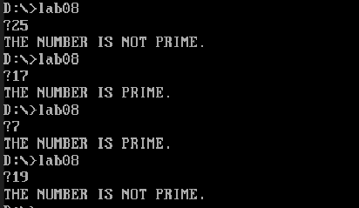

Comments: This programs works fine for a lot of prime numbers, but maybe due to the register garbage values, sometimes it may occur in wrong result.

