Title: Force Sensor-Based Weight Measurement System

Md Abdullah Al Mamun
Computer Science and Engineering, RUET
2003028

Introduction:
This project aims to develop a force sensor-based weight measurement system using an Arduino microcontroller. The system utilizes a force sensor that outputs an analog value proportional to the pressure or weight applied. The Arduino reads this analog signal, applies a calibration algorithm, and converts it into an accurate weight measurement. The measured weight is then displayed on an LCD screen for easy monitoring.
By calibrating the force sensor with known weights, the system establishes a linear relationship between the sensor output and the actual weight. The Arduino processes this data in real-time, allowing for precise and reliable weight measurement. This project has potential applications in various fields, such as digital weighing scales and automated load detection systems.

Objectives:
- To design a system that accurately measures weight using a force sensor interfaced with an Arduino microcontroller.
- To calibrate the force sensor by establishing a linear relationship between sensor output and actual weight values.
- To develop an algorithm that converts the sensor's analog output into weight units, such as kilograms.
- To display the measured weight on an LCD screen for easy real-time monitoring.
- To implement a user-friendly system for practical applications in weight measurement, such as digital weighing scales and load detection systems.
- To ensure precision and reliability in weight measurement by fine-tuning the sensor and Arduino system for consistent performance across different weight ranges.
Configuration of the system:
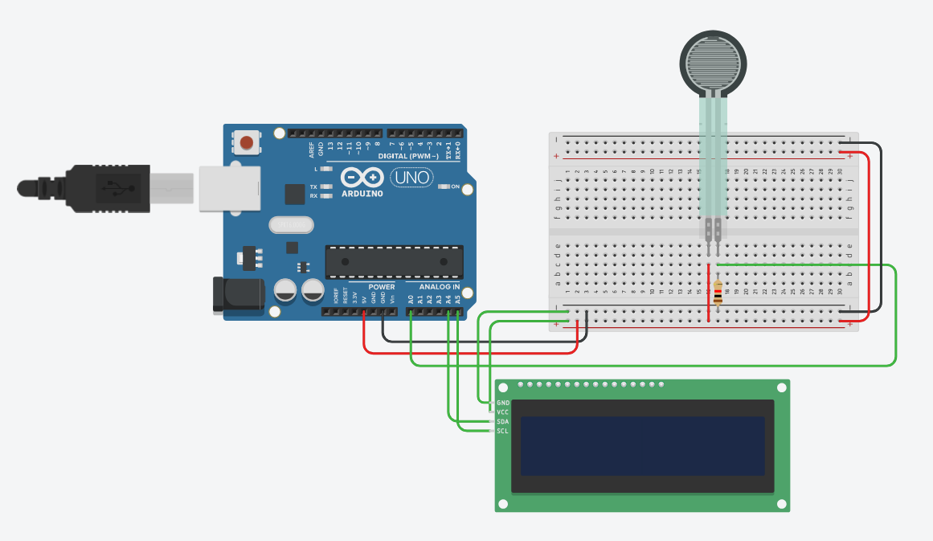Figure 1: Circuit Diagram
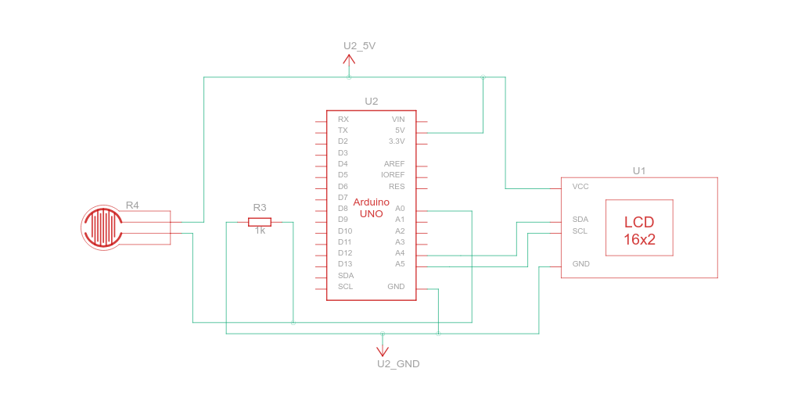Figure 2: Schematic Diagram
C++ Code :
#include <Adafruit_LiquidCrystal.h>

Adafruit_LiquidCrystal lcd(0);

float slope = 0.01;
float offset = 0.0;

void setup()
{
lcd.begin(16, 2);
lcd.setBacklight(1);
lcd.print("Welcome!!!");

pinMode(A0, INPUT);
}

void loop()
{
int forceSensorValue = analogRead(A0);
float voltage = forceSensorValue * (10.0 / 1023.0);
float weight = voltage * 10.0;

float force = forceSensorValue * slope + offset;

lcd.setCursor(0, 1);
lcd.print("Weight: ");
lcd.print(weight);
lcd.print(" g");
}

Output:
Conclusion:
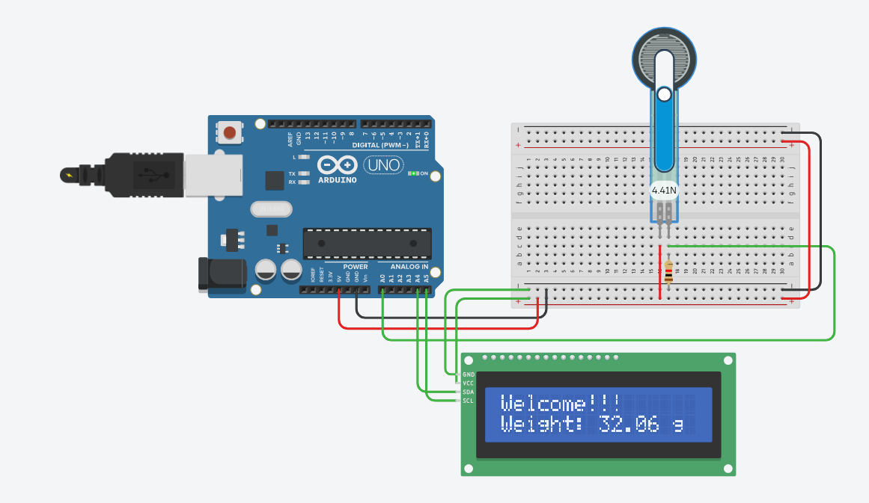Figure 3: Simulation of the setup
This project successfully demonstrated a force sensor-based weight measurement system using Arduino. The system converts the sensor's analog output into weight and displays it on an LCD. However, accurate calibration of the force sensor is essential for reliable measurements. In this case, the sensor did not show accurate results, likely due to improper calibration. Future improvements should focus on refining the calibration process to ensure precise and consistent weight readings.

