Name: Md. Abdullah Al Mamun
Roll: 2003028

Question 1:
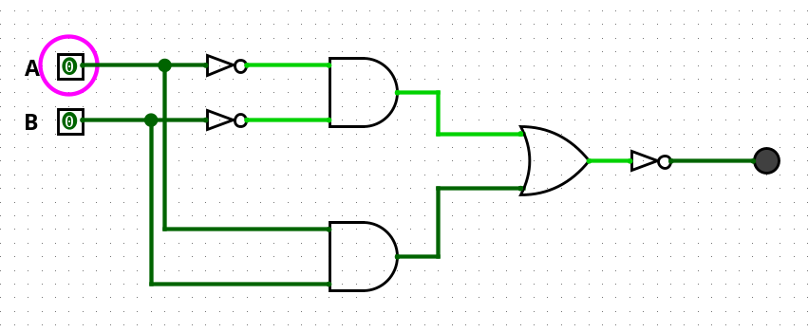

Question 2:

Module:
module DownCounter ( input wire clk, input wire reset, output wire [4:0] output_count); reg [4:0] count;
always @(posedge clk or posedge reset) begin if (reset) count <= 5'b11111; else count <= count - 1; end
assign output_count = count;
endmodule

Test Bench:
`timescale 1ns/1ps
module DownCounter_tb; reg clk; reg reset; wire [4:0] count;
DownCounter dut(clk, reset, count);
initial begin $dumpfile("5bitDownCounter.vcd"); $dumpvars(0, DownCounter_tb);
clk = 0; reset = 1; #10 reset = 0; end
initial begin $monitor("count = %b", count); end
always #5 clk = ~clk;
initial begin #100 $finish; end
endmodule
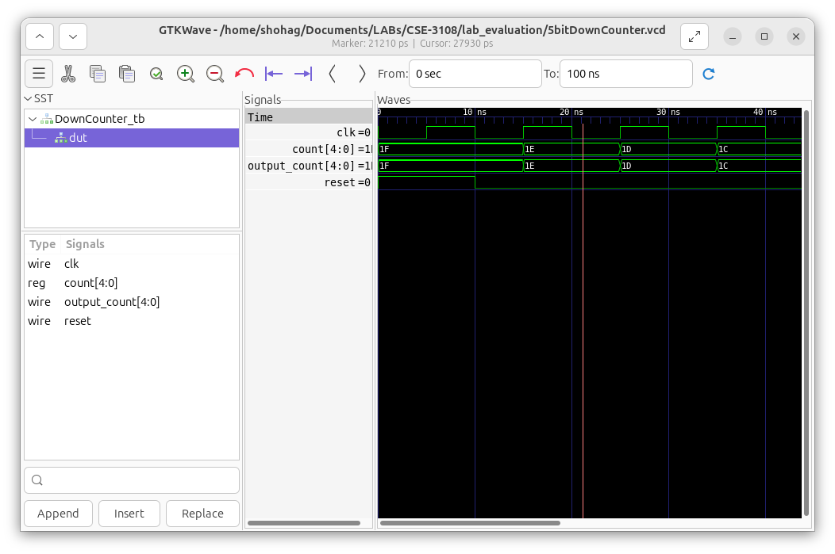

Question 3:

mov R1, #0 ;mov R2, #10 ;
while CMP R1, R2 ;
BEQ done ;
ADD R1, R1, #5 ;
B while ;
done STOP ;end

