C++ Project
Topic: E-Store

Made By: S. Sitaraman
Class: XII – A

ACKNOWLEDGMENT

This is to certify that S. Sitaraman of Apeeejay School, Noida (Class: XII-A) has created a project on the topic “Electronic Items Store”. He generated this report after a lot of hard work. The report has been created under the guidance of the teacher Mrs. Sujata Bhardwaj and qualifies the benchmarks for the C++ Project.

About The Project:
This Project contains a Portal for both customers and suppliers where customers can buy products supplied by the suppliers.

The project includes:
- Supplier Portal
  - Login and Signup
  - Product details
- Customer Portal
  - Login and Signup
  - Buy Product
  - Cart
  - Checkout

Header Files:
- <fstream.h> - cin,cout,ofstream,ifstream,fstream
- <stdio.h> - gets(),puts(),open(),close(),seekg()
- <string.h> -strcmp(),strcpy()
- <conio.h> - getch(),clrscr()

Classes and Functions :

CLASS | Members | Functions
Cart | int qty  char product_no[20]  char product_name[100]  long int product_cost  char product_color[100] | int view_cart()
Supplier | char supplier_name[100]  char supplier_password[20]  char supplier_sname[100]  char supplier_username[100]  char product_no[20]  char product_name[100]  float product_cost  char product_color[100] | void supplier_product_input() // Product input  void view_product() //Shows Products  void view_supplier() //Shows Supplier Details  void supplier_signup() //Supplier Registration  void supplier_login() //Supplier Login  void supplier_menu() //Supplier Menu
Customer | char customer_name[100];  char customer_password[20];  char customer_sname[100];  char customer_username[100];  char customer_address[100];  long int customer_mobile;  long int product_no;  char product_name;  float product_cost;  char product_color[100]; | void view_product() //Shows Products  void marketplace_menu() //ShowsMarketplace  void buy() //Buying Products  void customer_cart() //Cart  void checkout() //Checkout  void view_customer() //Customer Details  void customer_signup() //Customer Signup  void customer_login() //Customer Login  void customer_menu() //Customer Menu

Hardware Used:
SSD, RAM, CPU

Software Used:
Windows 10, MacOS, LibreOffice Writer, Visual Studio Code, Github.

CODE

#include <fstream.h>
#include <stdio.h>
#include <string.h>
#include <conio.h>

void hr(int x){
cout << "+";

for (int i = 0; i < x; i++)
cout << "-";

cout << "+ \n";
}

//Cart Class
class cart{
public:
int qty;
char product_no[20];
char product_name[100];
long int product_cost;
char product_color[100];

int view_cart(){
int empty = 0;
int length;
ifstream cart_file;
cart s;
//Open File
cart_file.open("cart.txt", ios::in | ios::binary);
//Check If file is Empty
cart_file.seekg(0, ios::end); // put the "cursor" at the end of the file
length = cart_file.tellg(); // find the position of the cursor
cart_file.close();
if(length == 0){
empty = 1;
cout << "Empty Cart";
}
else{
ifstream cart_file;
cart s;
//Open File
cart_file.open("cart.txt", ios::in | ios::binary);
int i = 1;
cout << "| Sno | Serial No.| Product | Cost | Qty | Color |" << endl;
do
{
cart_file.read((char *)&s, sizeof(s));
cout << " " << i << " " << s.product_no << " " << s.product_name << " $" << s.product_cost << " " << s.qty<< " "<< s.product_color << "\n";
hr(60);
i++;
} while (cart_file.read((char*)&s, sizeof(s)));
cart_file.close();
}
return empty;
}

};

//Supplier Class Starts
class supplier
{
//Supplier
char supplier_name[100];
char supplier_password[20];
char supplier_sname[100];
char supplier_username[100];
//Product

public:
char product_no[20];
char product_name[100];
float product_cost;
char product_color[100];

void supplier_product_input(); // Product input
void view_product(); //Shows Products supplier by supplier
void view_supplier(); //Shows Supplier details
void supplier_signup(); //Supplier Registration
void supplier_login(); //Supplier Login
void supplier_menu(); //Supplier Menu
};

void supplier::supplier_product_input()
{
fstream product_file;
supplier s;

//User Input
clrscr();
cout << "|| Welcome To Product Selling ||\n";
cout << "Enter product name\n";
cin >> s.product_name;
cout << "Enter Serial No\n";
cin >> s.product_no;
cout << "Enter Product Cost\n";
cin >> s.product_cost;
cout << "Enter Product Color\n";
cin >> s.product_color;

//File Input
product_file.open("products.txt", ios::out | ios::app | ios::binary);
product_file.write((char *)&s, sizeof(s));
product_file.close();

getch();

}
void supplier::view_product()
{
int length;
ifstream product_file;
supplier s;
//Open File
product_file.open("products.txt", ios::in | ios::binary);
//Check If file is Empty
product_file.seekg(0, ios::end); // put the "cursor" at the end of the file
length = product_file.tellg(); // find the position of the cursor
product_file.close();
if(length == 0){
cout << "empty";

}

else{
ifstream product_file;
supplier s;
//Open File
product_file.open("products.txt", ios::in | ios::binary);
int i = 1;
cout << "| Sno | Serial No.| Product | Cost | Color |" << endl;
do
{
product_file.read((char *)&s, sizeof(s));
cout << " " << i << " " << s.product_no << " " << s.product_name << " " << s.product_cost << "$ " << s.product_color << "\n";
hr(54);
i++;
} while (product_file.read((char*)&s, sizeof(s)));
product_file.close();
}

getch();

}

void supplier::view_supplier()
{
int length;
ifstream supply_file;
supplier s;
//Open File
supply_file.open("supplier.txt", ios::in | ios::binary);
//Check If file is Empty

supply_file.seekg(0, ios::end); // put the "cursor" at the end of the file
length = supply_file.tellg(); // find the position of the cursor
supply_file.close();
if(length == 0){
cout << "empty";
}
else{
ifstream supply_file;
supplier s;
//Open File
supply_file.open("supplier.txt", ios::in | ios::binary);
int i = 1;
do
{
supply_file.read((char *)&s, sizeof(s));
cout << " " << i << " " << s.supplier_username << " " << s.supplier_password << " "
<< "\n";
hr(43);
i++;
} while (supply_file.read((char *)&s, sizeof(s)));
supply_file.close();
}

getch();
}

void supplier::supplier_signup()
{

clrscr();
fstream supply_file;
supplier s;

//User Input
cout << "Enter your Details\n";
cout << "Enter your first name: ";
cin >> s.supplier_name;
cout << endl;
cout << "\nEnter your last name: ";
cin >> s.supplier_sname;
cout << endl;
cout << "\nEnter your Username: ";
cin >> s.supplier_username;
cout << endl;
cout << "\nEnter your password: ";
cin >> s.supplier_password;
cout << endl;

//File Input
supply_file.open("supplier.txt", ios::out | ios::app | ios::binary);
supply_file.write((char *)&s, sizeof(s));
supply_file.close();

}
void supplier::supplier_login()
{
int present;
supplier x;
cout << "Enter your Username: ";
cin >> x.supplier_username;
cout << "\nEnter your password: ";
cin >> x.supplier_password;
cout << endl;
present = 0;
ifstream supply_file;
supplier s;
supply_file.open("supplier.txt", ios::in | ios::binary);
//Looping and reading all file contents
while (supply_file.read((char *)&s, sizeof(s)))
{

if ((strcmp(s.supplier_username, x.supplier_username) == 0) && (strcmp(s.supplier_password, x.supplier_password) == 0))
present = 1;
}
supply_file.close();
if (present == 1)
{
supplier_product_input();
}
else
{
cout << "Record Not Found! Try signing up";
getch();

}
}

void supplier::supplier_menu()
{
char x;
do
{
clrscr();
cout << "|| Welcome To Supplier Area ||\n"
<< "\n[1]Login\n\n[2]Signup\n\n([0] to exit)\n > ";
cin >> x;
if (x == '1')
{
clrscr();
supplier_login();
}
else if (x == '2')
{
clrscr();
supplier_signup();
}
else if (x == 'x')
{
clrscr();
view_supplier();
}

else if (x == 'y')
{
clrscr();
view_product();
}

else
{
cout << "Enter valid input";
}

} while (x != '0');
}

//Supplier Functions End

//Customer Class starts
class customer
{
//About customer
char customer_name[100];
char customer_password[20];
char customer_sname[100];
char customer_username[100];
char customer_address[100];
long int customer_mobile;

//Product
long int product_no;
char product_name;
float product_cost;
char product_color[100];

public:
void view_product(); //Shows Products
void marketplace_menu(); //Shows Marketplace
void buy(); //Buying Products
void customer_cart(); //Cart
void checkout(); //Checkout
void view_customer(); //Shows customer details
void customer_signup(); //customer Registration
void customer_login(); //customer Login
void customer_menu(); //customer Menu

};

void customer::view_product()
{
supplier s;
s.view_product();
}

void customer::marketplace_menu()
{
clrscr();

char choice;
do
{
clrscr();
cout << "|| Welcome To Marketplace ||\n\n[1] Buy\n\n[2] Cart\n\n[3] Checkout\n\n([0] Exit)";
cin >> choice;
if (choice == '1')
{
buy();
}
else if (choice == '2')
{
customer_cart();
}

else if (choice == '3')
{
checkout();
}
else
{
cout << "Enter valid input";
}
} while (choice != '0');
}

void customer::buy()
{
clrscr();
char serial_no[10];
cout << "\n\t\t\t || Buy || \t \t \n\n";
view_product();
cout << "\nTo choose product, type its Serial No. Below:\n";
cin >> serial_no;

ifstream product_file;
supplier s;
//Open File
product_file.open("products.txt", ios::in | ios::binary);
do
{
product_file.read((char*)&s, sizeof(s));
if ((strcmp(s.product_no, serial_no) == 0)){ //If present add into cart
cart c;
cout << "\n Enter Quantity :\n";
int qnt;
cin>>qnt;

//Putting Values Into Cart
strcpy(c.product_name,s.product_name);
c.qty = qnt;
strcpy(c.product_no,serial_no);
c.product_cost = s.product_cost;
strcpy(c.product_color,s.product_color);

fstream cart_file;
cart_file.open("cart.txt",ios::out|ios::app|ios::binary);
cart_file.write((char*)&c, sizeof(c));
cart_file.close();
}
} while (product_file.read((char*)&s, sizeof(s)));
product_file.close();
// char yn;
// do{
// cout << "\nProceed to Checkout?(y/n)\n";

// cin>>yn;
// if(yn == 'Y' || yn == 'y')
// checkout();
// }while(yn != 'n');
// getch();
//
}

void customer::customer_cart(){
cart cc;
clrscr();
cout << " \t \t || Your Cart || \t \t \n\n";
cc.view_cart();
// char yn;
// do{
// cout << "\nProceed to Checkout?(y/n)\n";

// cin>>yn;
// if(yn == 'Y' || yn == 'y')
// checkout();
// }while(yn != 'n');
getch();

}

void customer::checkout()
{
clrscr();
ifstream cart_file;
cart s;
int sum = 0;
//Open File
cart_file.open("cart.txt", ios::in | ios::binary);
do
{
cart_file.read((char *)&s, sizeof(s));
sum = sum + (s.product_cost*s.qty);
} while (cart_file.read((char*)&s, sizeof(s)));
cart_file.close();
cart x;
char pchoice[20];
do{
clrscr();
cout << "\n|| Checkout ||\n" << endl << "Items in cart: \n\n";
int empty = x.view_cart();
if(empty== 1){
cout << "\n Sorry Your cart is empty, please buy something..\n";
getch();

break;
}
else{
cout << " Choose your payment method: " << endl
<< "\nMENU\n" << "\n 1]Credit/Debit card \n 2]Paytm \n 3]Back \nEnter Response: \n";
cin>> pchoice;

switch (pchoice[0]) {
case '1':
int one,two,three,four,cvv;
char pur;
cout << "Outstanding Amt. to be payed = $" << sum << "\n Enter Card Number: \n";
cin >> one >> two >> three >> four;
cout << "Enter CVV\n";
cin >> cvv;
cout << "Are you sure to purchase(Y/N): \n";
cin >> pur;
if(pur == 'Y' || pur == 'y')
{
cout << "Transaction completed\n";
fstream d;
fstream f;
d.open("cart.txt",ios::out|ios::in|ios::binary);
f.open("temp.txt",ios::out|ios::binary);
remove("cart.txt");
rename("temp.txt","cart.txt");
d.close();
f.close();
getch();

marketplace_menu();
}
break;

case '2':
int phone,otp;
char purch;
cout << "Outstanding Amt. to be payed = $" << sum << "\n Enter Phone Number: \n";
cin >> phone;
cout << "Enter OTP (Use anything as default)\n";
cin >> otp;
cout << "Are you sure to purchase(Y/N): ";
cin >> purch;
if(purch == 'Y' || purch == 'y')
{
cout << "Transaction completed\n";
fstream d,f;
d.open("cart.txt",ios::out|ios::in|ios::binary);
f.open("temp.txt",ios::out|ios::binary);
remove("cart.txt");
rename("temp.txt","cart.txt");
d.close();
f.close();
marketplace_menu();
}
break;
case 3:
break;
default:
cout << "Invalid input try again" << '\n';

getch();
break;

//If no of items in cart >= 1, then checkout
}
}
}while(pchoice[0]!='3');
}

void customer::view_customer()
{
ifstream customer_file;
customer s;
customer_file.open("customer.txt", ios::in | ios::binary);
int i = 1;
do
{
customer_file.read((char *)&s, sizeof(s));
cout << " " << i << " " << s.customer_username << " " << s.customer_password << " "
<< "\n";
hr(43);
i++;
} while (customer_file.read((char *)&s, sizeof(s)));
customer_file.close();

getch();
}

void customer::customer_signup()
{
clrscr();
fstream customer_file;
customer s;
cout << "Enter your Details\n";
cout << "Enter your first name: ";
cin >> s.customer_name;
cout << endl;
cout << "\nEnter your last name: ";
cin >> s.customer_sname;
cout << endl;
cout << "\nEnter your Username: ";
cin >> s.customer_username;
cout << endl;
cout << "\nEnter your password: ";
cin >> s.customer_password;
cout << endl;
cout << "\nEnter Shipping Address: ";
cin >> s.customer_address;
cout << endl;
cout << "\nEnter Mobile Number: ";
cin >> s.customer_mobile;
cout << endl;
customer_file.open("customer.txt", ios::out | ios::app | ios::binary);
customer_file.write((char *)&s, sizeof(s));
customer_file.close();

}
void customer::customer_login()
{
int present;
customer x;
cout << "Enter your Username: ";
cin >> x.customer_username;
cout << "\nEnter your password: ";
cin >> x.customer_password;
cout << endl;
present = 0;
ifstream customer_file;
customer s;
customer_file.open("customer.txt", ios::in | ios::binary);
//Looping and reading all file contents
while (customer_file.read((char *)&s, sizeof(s)))
{

if ((strcmp(s.customer_username, x.customer_username) == 0) && (strcmp(s.customer_password, x.customer_password) == 0))
present = 1;
}
customer_file.close();
if (present == 1)
{
marketplace_menu();
// cout << "Successfully Logged in!\n";
}
else
{
cout << "Record Not Found! Try signing up";
getch();

}
}
void customer::customer_menu()
{
char x;
do
{
clrscr();
cout << "|| Welcome To Customer Menu||\n"
<< "\n[1]Login\n\n[2]Signup \n\n([0] to exit)\n > ";
cin >> x;
if (x == '1')
{
clrscr();
customer_login();
}
else if (x == '2')
{
clrscr();
customer_signup();
}
else if (x == 'x')
{
clrscr();
view_customer();
}
else if (x == 'y')
{
clrscr();
view_product();
}

else if (x == '0')
{
break;
}

else
{
cout << "Enter valid input";
}

} while (x != '0');
}

//Customer Funtions End

//Home Menu Starts
void menu()
{
char a;
//Do menu starts
do
{
clrscr();
cout << "|| Welcome to Estore where you can buy or supply Electronic Products! ||\n"
<< "\n[1] Supplier \n\n[2] Customer \n\n([0] to Exit)\n> ";
cin >> a;
if (a == '1')
{
clrscr();
supplier supply_session;
supply_session.supplier_menu();
}
else if (a == '2')
{
clrscr();
customer customer_session;
customer_session.customer_menu();
}
else if (a == '0')
{
break;
}

else
{
cout << "Enter Valid Character";
}

} while (a != '0');
}

void main()
{
clrscr();
menu();
getch();
}

OUTPUT
Home Page
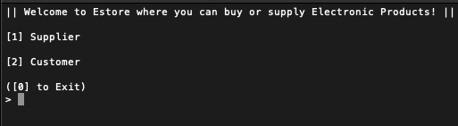
Supplier Menu
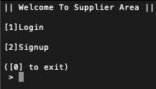

Supplier Signup
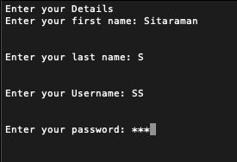

Supplier Login
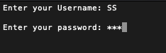

Product Details
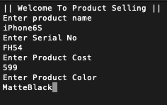

Customer Details
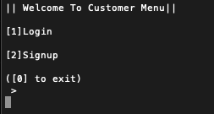

Customer Signup
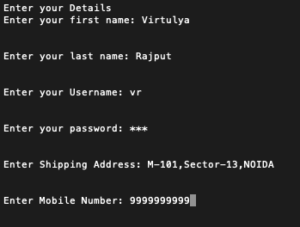

Customer Login
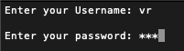

Marketplace
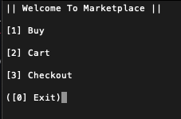

Buy
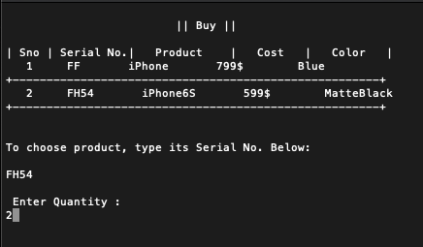

Cart
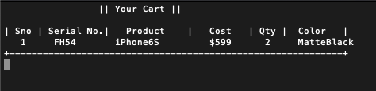
Checkout
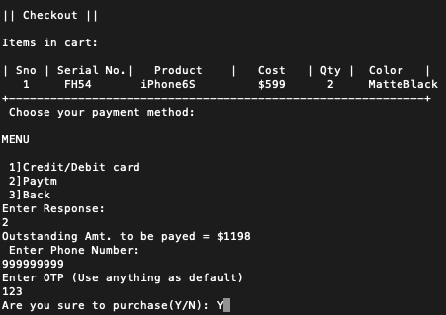
BIBLOGRAPHY
C++ Book - Sumita Arora

