C++ Project Report
Topic: E-Store
Made By: Virtulya Rajput
Class: XI – A

ACKNOWLEDGMENT
This is to certify that Virtulya Rajput of Apeeejay School, Noida (Class: 11-A) has created a project on the topic “Electronic Items Store”. He generated this report after a lot of hard work. The report has been created under the guidance of the teacher Mrs. Sujata Bhardwaj and qualifies the benchmarks for the C++ Project.

About The Project:
The Project asks a user to login or sign up to the e-commerce portal. Once the user has logged in, they are asked to select the product they want to purchase. After selecting the product(s), they enter the variants of their product they want to purchase. They can review and make changes to their cart. The user is also asked to confirm their purchase of payment. Finally they are taken to the checkout screen.

The project includes:
- Client Login/Signup Portal
- Purchasing Page
- Cart
- Checkout

Header Files:
- iostream.h – I/O Functions
- stdio.h – String I/O Functions
- string.h – String handling Functions

Functions:
- main() - Main body
- login() - User login function
- signup() -User signup function
- client() - Client area function
- hline() - Horizontal line function
- buy() - Buying function
- cart() - Cart Function
- chk() - Checkout Function

Hardware Used:
SSD, RAM, CPU

Software Used:
Windows 10, MacOS, LibreOffice Writer, Atom Text Editor, Github.

Code:

#include <iostream>
#include<stdio.h>
#include<string.h>

using namespace std;

struct suppliers
{
string name[20];
string sname[20];
char pass[20];
char id[20];
char add[1000];
};
suppliers supplier[20];
void signup()
{
cout<<"Enter your name and surname:"<<endl;
cin>>supplier[1].name[0];
cin>>supplier[1].sname[0];

cout<<"\nEnter your ID:";
cin>>supplier[1].id;

cout<<"\nEnter your password:";
cin>>supplier[1].pass;

cout<<"Enter your shipping address:"<<endl;
cin>>supplier[1].add;
cout<<endl;
}

struct cart{
int id;
char nme[20];
char color[20];
int qnt;
int cst;
};
//product structure
struct product{
int sno;
char name[20];
int price;
};

//line function
void hline(int len){
for(int i=0; i < len; i++){
cout << "-";
}
}

int g;
cart cons[20];
void buy(){

product prod[6];
//1
prod[0].sno = 1;
strcpy(prod[0].name,"iPhone Xs Maxx ");
prod[0].price = 999;
//2
prod[1].sno = 2;
strcpy(prod[1].name,"iPhone Xs ");
prod[1].price = 799;
//3
prod[2].sno = 3;
strcpy(prod[2].name,"One Plus 6t ");
prod[2].price = 539;
//4
prod[3].sno = 4;
strcpy(prod[3].name,"Samsung S9 Plus");
prod[3].price = 479;
//5
// prod[4].sno = 5;
// strcpy(prod[4].name,"iPad Pro 2018 ");
// prod[4].price = 799;
// //6
// prod[5].sno = 6;
// strcpy(prod[5].name,"Surface Pro 5 ");
// prod[5].price = 899;

int quant;
system("clear");
char ichoice[1];
do{
cout << "\n Welcome to Marketplace" << endl
<< " Chose the number of the corresponding product you want to choose: " << endl
<< "\n MENU \n" ;
cout << "+"; hline(27); cout << "+";
for(int b=0;b<4;b++){
cout << "\n|" << prod[b].sno <<" | " << prod[b].name<< " | $" << prod[b].price << " | ";
}
cout << "\n|5 | Back | |\n";
cout << "+"; hline(27); cout << "+";
cout << "\nWhat would you like to purchase: ";
cin >> ichoice;

switch(ichoice[0]) {
case '1':
if(cons[0].qnt == 0){ //Checks if item pre-exists
g=1;
cout << "Enter color(JetBlack[JB]/Gold[RG]/Silver[S]): ";
cin >> cons[0].color;
if(strcmp(cons[0].color,"JB")!=0 || strcmp(cons[0].color,"RG")!=0 || strcmp(cons[0].color,"W")!=0){
cout << "Enter Valid color ";
cin >> cons[0].color;
}

cons[0].id = prod[0].sno;
cons[0].cst = prod[0].price;
strcpy(cons[0].nme,prod[0].name);
}

system("clear");
cout << "Want to purchase anything else?";
break;

case '2':
if(cons[1].qnt == 0){ //Checks if item pre-exists
g=2;
cout << "Enter color(MatteBlack[MB]/RoseGold[RG]/Silver[S]): ";
cin >> cons[1].color;
if(strcmp(cons[1].color,"MB")!=0 || strcmp(cons[1].color,"RG")!=0 || strcmp(cons[1].color,"W")!=0
||strcmp(cons[1].color,"w")!=0 ||strcmp(cons[1].color,"mb")!=0||strcmp(cons[1].color,"rg")!=0){
cout << "Enter Valid color ";
cin >> cons[1].color;
}
cons[1].id = prod[1].sno;
cons[1].cst = prod[1].price;
strcpy(cons[1].nme,prod[1].name);
}

system("clear");
cout << "Want to purchase anything else?";
break;

case '3':
g=3;
if(cons[2].qnt == 0){ //Checks if item pre-exists
cout << "Enter color(Black[B]/Purple[P]/White[W]): ";
cin >> cons[2].color;
if(strcmp(cons[2].color,"B")!=0 || strcmp(cons[2].color,"P")!=0 || strcmp(cons[2].color,"W")!=0
||strcmp(cons[2].color,"w")!=0 ||strcmp(cons[2].color,"b")!=0||strcmp(cons[2].color,"p")!=0){
cout << "Enter Valid color ";
cin >> cons[2].color;
}
cons[2].id = prod[2].sno;
cons[2].cst = prod[2].price;
strcpy(cons[2].nme,prod[2].name);
}

system("clear");
cout << "Want to purchase anything else?";
break;

case '4':
if(cons[3].qnt == 0){ //Checks if item pre-exists
g=4;
cout << "Enter color(Black[B]/Gold[G]/White[W]): ";
cin >> cons[3].color;
if(strcmp(cons[3].color,"B")!=0 || strcmp(cons[3].color,"G")!=0 || strcmp(cons[3].color,"W")!=0
||strcmp(cons[3].color,"w")!=0 ||strcmp(cons[3].color,"b")!=0||strcmp(cons[3].color,"g")!=0){
cout << "Enter Valid color ";
cin >> cons[3].color;
}
cons[3].id = prod[3].sno;
cons[3].cst = prod[3].price;
strcpy(cons[3].nme,prod[3].name);
}
system("clear");
cout << "Want to purchase anything else?";
break;
case '5':
break;
default:
cout << "Invalid input try again" << '\n';
cin.ignore();
cin.get();
system("clear");
break;
}
}
while(ichoice[0] != '5');
}

void chk(){
cout << endl;
int e = 0;
for(int v=0;v<10;v++){
e += cons[v].cst;
}
for(int j=0; j< g ;j++){
if(j == 0 && cons[j].cst != 0){
cout << "+ ";
hline(35);
cout << " +\n| Name | Colour | Cost($) |\n";
cout << " "<< cons[j].nme << " "<< cons[j].color << " " << cons[j].cst << " " << "\n" ;
}
else if(cons[j].cst != 0){
cout << "+ ";
hline(35);
cout << " +\n| Name | Colour | Cost($) |\n";
cout << " "<< cons[j].nme << " "<< cons[j].color << " " << cons[j].cst << " " << "\n" ;
}
else if(e==0){\
cout << "No items selected, Press any key to go to the previous menu";
}
}
cout << "+ "; hline(35); cout << " + \n Outstanding amount : $" << e;
cin.ignore();
cin.get();
}
void checkout(){
int e = 0;
for(int v=0;v<10;v++){
e += cons[v].cst;
}
char pchoice[20];
do{
system("clear");
cout << "\nCheckout \n" << endl << "Items in cart \n";
chk();
cout << " Chose your payment method: " << endl
<< "\n MENU" << "\n 1]Credit/Debit card \n 2]Paytm \n 3]Paypal \n 4]Back \nEnter Response: ";

cin>> pchoice;

switch (pchoice[0]) {
case '1':
int one,two,three,four,cvv;
char pur[1];
cout << "Outstanding Amt. to be payed = $" << e << "\n Enter Card Number: \n";
cin >> one >> two >> three >> four;
cout << "Enter CVV\n";
cin >> cvv;
cout << "Are you sure to purchase(Y/N): ";
for(int l=0; l < 4; l++){
if(cons[l].cst != 0){
cout << cons[l].nme << " \n";
}
}
cin >> pur;
if(strcmp(pur,"Y")==0){
system("clear");
cout << "You purchased ";
for(int n=0; n < 4; n++){
if(cons[n].cst != 0){
cout << cons[n].nme << " \n";
}
}
}
cout << " These items will be delivered to the address : \n" << supplier[1].add << " \n Be Sure to come back! (Press ENTER to go back) \n";
cin.ignore();
cin.get();

break;

case '2':
long double phone,otp;
char pone[1];
cout << "Outstanding Amt. to be payed = $" << e << "\n Enter Phone Number: \n";
cin >> phone;
cout << "Enter OTP (Use anything as default)\n";
cin >> otp;
cout << "Are you sure to purchase(Y/N): ";
for(int l=0; l < 4; l++){
if(cons[l].cst != 0){
cout << "\n" << cons[l].nme << " \n";
}
}
cin >> pone;
if(strcmp(pone,"Y")==0){
cout << "You purchased ";
for(int n=0; n < 4; n++){
if(cons[n].cst != 0){
cout << " \n" << cons[n].nme << " \n";
}

}
}
cout << " These items will be delivered to the address : \n" << supplier[1].add << " \n Be Sure to come back! (Press ENTER to go back) \n";
cin.ignore();
cin.get();

break;

case '3':
int acc;
char ppp[20];
cout << "Outstanding Amt. to be payed = $" << e << "\n Enter Account Id: \n";
cin >> acc;
if(acc > 11){
cout << "Enter valid 10 Digit Account number";
cin >> acc;
}
cout << "Enter password\n";
cin >> ppp;
cout << "Are you sure to purchase(Y/N): ";
for(int l=0; l < 4; l++){
if(cons[l].cst != 0){
cout << "\n" << cons[l].nme << " \n";
}
}
cin >> ppp;

if(strcmp(ppp,"Y")==0){

cout << "You purchased ";

for(int n=0; n < 4; n++){

if(cons[n].cst != 0){
cout << " \n" << cons[n].nme << " \n";
}

}
}
cout << " These items will be delivered to the address : \n" << supplier[1].add << " \n Be Sure to come back! (Press ENTER to go back) \n";
cin.ignore();
cin.get();

break;

case '4':
break;

default:
cout << "Invalid input try again" << '\n';
cin.ignore();
cin.get();
break;
}

}
while(pchoice[0] != '4');

}

//MENU
int client(){
int no;
char cchoice[10];
do{
system("clear");
cout << "\n Welcome to Client Area" << endl
<< " Chose the number corresponding to your purpose: " << endl
<< "\n MENU" << "\n 1]Buy \n 2]Cart \n 3]Checkout \n 4]Back \nEnter Response: ";

cin>> cchoice;

switch (cchoice[0]) {
case '1':
buy();
break;

case '2':
chk();
break;

case '3':
checkout();
break;

case '4':
break;

default:
cout << "Invalid input try again" << '\n';
cin.ignore();
cin.get();
break;
}
}
while(cchoice[0] != '4');
return 0;
}

void login()
{

char iid[20];
char ipass[20];
cout<<"Enter your ID:";
cin>> iid;
cout<<endl<<"Enter your password:";
cin>> ipass;
cout<<endl;

if( strcmp(iid,supplier[1].id) == 0 && strcmp(ipass,supplier[1].pass) == 0){
system("clear");
client();
}
else{
cout << "Invalid Login , Please signup (press enter to continue)\n";
cin.ignore();
cin.get();
}

}
//MENU
int main() {
system("clear");
char mchoice[10];
int no;

do{
system("clear");
cout << "\n Welcome to E-Store" << endl
<< " Chose the number corresponding to your role: " << endl
<< "\n MENU" << "\n | 1] | Signup \n | 2] | Login \n | 3] | Exit \nEnter Response: ";
cin>> mchoice;

switch (mchoice[0]) {
case '1':
signup();
break;
case '2':
login();
break;
case '3':
system("clear");
cout << "Thanks for visiting, hope to see you again!\n";
break;

default:
cout << "Invalid input try again" << '\n';
cin.ignore();
cin.get();
break;
}

}
while(mchoice[0] != '3');

return 0;
}
OUTPUT
Home screen
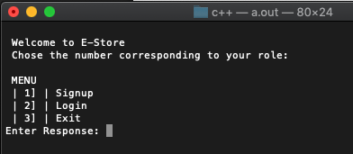

Signup Screen
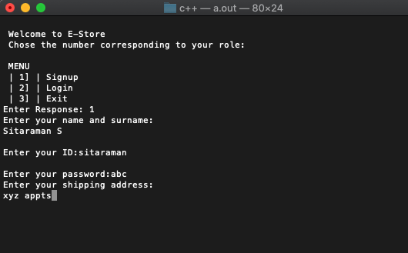
Login Screen
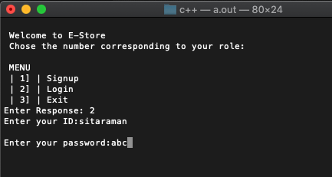

Client menu
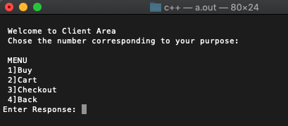

Marketplace
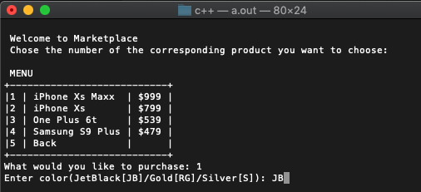
Cart
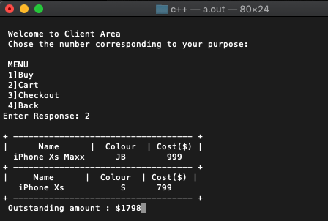

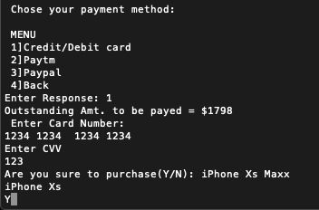
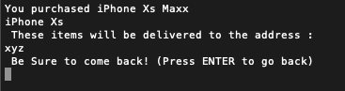
Checkout

BIBLOGRAPHY
Works cited from:

www.google.com
www.stackoverflow.com
C++ Book - Sumita Arora

