8. Connect up an inverter (NOT gate), a pin and an LED to the output. Check its correct-  
ness by filling out a truth table like the following. Add the circuit screen shot and  
the table to your submission document:

|  |  |
| --- | --- |
| Pin | Output |
| 0 | 1 |
| 1 | 0 |

10. Connect up a 2-input XOR gate, connect a pin to each input and an LED to the output.  
Check its correctness by filling out a truth table like the following. Add the circuit  
screen shot and the table to your submission document:

|  |  |  |
| --- | --- | --- |
| Pin 1 | Pin 2 | Output |
| 0 | 0 | 0 |
| 0 | 1 | 1 |
| 1 | 0 | 1 |
| 1 | 1 | 0 |

12. Using Boolean Algebra, derive a logical expression that compares two two binary inputs A and B. That is, it should evaluate to True if and only if both A and B are the same (i.e, out-  
put = 1 if inputs are both 0, or both 1).

|  |  |  |
| --- | --- | --- |
| Pin A | Pin B | Output |
| 1 | 1 | 1 |
| 0 | 0 | 1 |
| 1 | 0 | 0 |
| 0 | 1 | 0 |

13. Now implement your circuit from Step 12 in Logisim, and test it to ensure it works as de-  
scribed above.

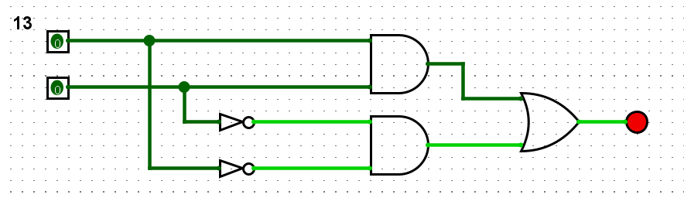

15. Extend your circuit from Step 13 to do the same thing for three inputs. It should output 1 if all three input bits are either all 0, or all 1.

|  |  |  |  |
| --- | --- | --- | --- |
| Pin A | Pin B | Pin C | Output |
| 1 | 1 | 1 | 1 |
| 0 | 0 | 0 | 1 |
| 1 | 0 | 0 | 0 |
| 0 | 1 | 0 | 0 |
| 0 | 0 | 1 | 0 |
| 1 | 1 | 0 | 0 |
| 1 | 0 | 1 | 0 |
| 0 | 1 | 1 | 0 |

