**1. Review the lecture slides on types of memory and provide a short answer to the following questions (using your own words):**

**1.1. What is ROM and what is its primary purpose?**

* **ROM (Read only memory):** a type of memory that store data permanently and cannot be changed. Data storing in ROM cannot be changed and will be retained even when the computer is powered off.
* **Purpose:**
* Optimize reading-only actions.
* Storing BIOS – instruction for computer right after turning on.
* A close-up of a computer error

  Description automatically generatedStoring data that needs to be permanently retained and accessible, even when power is turned off or the device is restarted.

**1.2. What is RAM and how is it different from ROM ?**

* **RAM (Random Access memory):** a type of memory that store data that the computer's processor (CPU) needs to access quickly while it's actively running programs and performing tasks.
* **Differences with ROM:**
* Data storing in RAM can be modify and can be easily read and write frequently.
* Data storing in ROM are not intended to change frequently and are only intended to Read.
* Data storing in RAM cannot be retained after the computer turned off.
* Data storing in ROM can be retained after the computer turned off.

**1.3 What is the difference between static RAM and dynamics RAM ?**

* **Static RAM:** retain information until power removed. Fast, larger area of silicon per byte, requiring constant power.
* **Dynamic RAM:** retain information as long as the contents are refreshed frequently enough. Smaller area of silicon per byte, low power requirement .

**1.4 What type of memory is typically used in USB thumb drives? Why shouldn’t we rely on this for critical data storage?**

* **Flash memory (EEPROM)** are typically used in USB thumb drives.
* Because charge stored between insulator, in order to writes, the electrons must pierce through barrier layer and physically damaging it. Therefore, it has a finite life and could be unusable after a certain number of writes.

**2. Consider a computer with 1GB RAM (1024 MB). Given memory addressing is for each byte, how many bits are needed to address all bytes in the system’s RAM?**

* 1gb = 1024 MB = 1024*1024 kb = 1024^3 byte = 1024^3 * 8 bits

**3. Give a brief description of the Von Neumann and Harvard computing architectures. What are the fundamental differences between the two and for what is each designed to achieve?**

* **The Von Neumann architecture:** is fundamental computing architectures which *control bits and data bits (data and instruction) are stored a* ***common memory space/hardware***.
* **Harvard Computing architecture:** is fundamental computing architectures which *control bits and data bits (data and instruction) are stored a* ***separate memory space/hardware***.
* The Von Neumann architecture prioritizes flexibility in programming, support a wide range of tasks, handling multiple tasks, handling interruptions (one programs need immediate attention while another process is undergoing). **Aiming for multiple tasking CPU.**
* The Harvard Computing architecture prioritizes flexibility of hardware and spaces, performance optimization, parallelism, immune to buffer overflow attack. **Aiming for single tasking CPU where memory is scarce, and speed is important.**

**4. What is cache memory and what is its primary role?**

* **Cache memory** is a type and of high-speed volatile computer memory providing a temporary storage area for data instructions.
* **The primary role** of cache memory is to provide a temporary storage area for data and instructions that the CPU uses frequently or is likely to use soon.

**5. Explain the concept of an interrupt, and list four common types.**

* Interrupts is a response to a signal that needs attention from the software.
* Instead of going and asking each device if they need attention, the devices will trigger an interrupt if they need attention.

Four Common types of interrupts:

* Hardware Interrupts (keyboards, mouse…).
* Software interrupts
* Clock interrupts.
* I/O interrupts.

**5.1. Polling is an alternative to interrupts. Briefly explain polling and why it is not commonly used.**

* Polling is an alternative to interrupts. The concept of polling is that the CPU is going to ask if each device is needing attention, checking states of each device, …
* Because:
  + It can’t utilize CPU resources and wasting time checking hardware which doing nothing.
  + Wasting time and freezing computer while polling.

**6. Explain the general concept of a stack - how do they work, and what is their primary purpose.**

* Stacks if a way of organizing, storing, and addressing data, operate in the First in – Last Out principle.

**6.1. How are stacks useful for handling interrupts?**

* + A stack allows us to mothball/backup/hibernate a process task while dealing with another tasks.
    - Push the instructions/data into the stacks.
    - Dealing with the interruption.
    - Pop the stored data/instructions back off the stack.

**6.2. How are stacks useful in programming?**

* + Stack allows storing procedure/function while programming.

**Practical - Stacks of Stacks!**

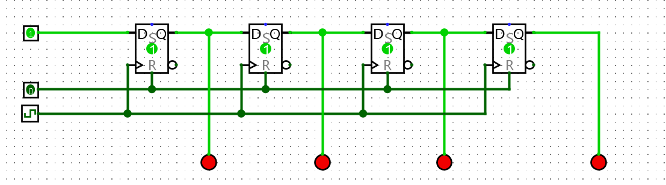**9. Start by building a simple shift register that moves bits from one flip flop to the next each clock pulse. For this you will need a “Data In” pin which sets the next bit to be pushed to the stack, and a clock to invoke the shifting.**

**10. For your shift register to work as a stack, it needs to be bi-directional. This means the input to any Flip Flop could come from two places - the left or the right. In lectures we discussed a simple “encoder” circuit that selects which of two data inputs is allowed through, based on a third selection bit. Design the logic for this 2-bit encoder and demonstrate it to your lab demonstrator.**

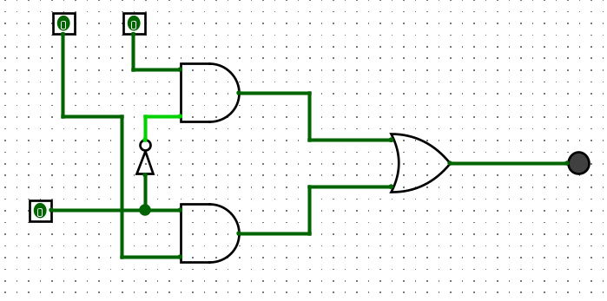

**11. Now incorporate your encoder above to allow bi-directional shifting of your stack. Your stack should:**

**11.1. push and pop bits onto and off the stack, using clock pulses and a direction toggle switch.**

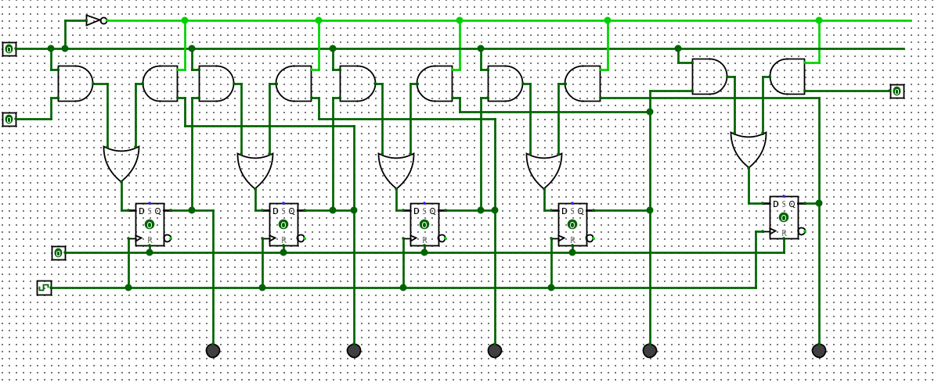**11.2. show the state of each Flip Flop using LEDs.**

**12. Modify your stack so that it has the option to read out its contents in parallel to a separate register of D Flip Flops. This should only occur when a “stack dump” toggle switch (i.e., pin) is enabled. When the toggle is disabled, the register of D Flip Flops should retain the last state read in (and should have LEDs connected to each Flip Flop out showing its state).**

