**Individual Report**

**COS10026 – Computing Inquiry Project**

**Minh Hoang Duong**

**104487115**

**Assignment Part 1**

**Introduction**………………………………………………………………………………………………………………….2

**Website Introduction** …………………………………………………………………………………………………2

**The objective of the report** ………………………………………………………………………………………2

**Website contents**…………………………………………………………………………………………………..2

**Homepage (index.html)** …………………………………………………………………………………………….2

**Job Description Pages (jobs.html)** …………………………………………………………………………2

**Group detail pages (about.html)** ……………………………………………………………………………2

**Applying pages (apply.html)** ……………………………………………………………………………………2

**Group’s enhancement (enhancement.html)** …………………………………………………….3

**Sitemaps**…………………………………………………………………………………………………………………………..3

**Website Development**…………………………………………………………………………….3

**HTML Utilization**……………………………………………………………………………………………………………3

**CSS Utilization**………………………………………………………………………………………………………………..4

**Web design**………………………………………………………………………………………………………………………4

**Key features**…………………………………………………………………………………………………………………….4

**Contribution – self-reflection**…………………………………………………………………………………..4

**Screenshot**………………………………………………………………………………………………………………..5

**Conclusion**…………………………………………………………………………………………………………………7

1. **Introduction:**
   1. **Website Introduction:**
   2. **The objective of the report:**
2. **Website contents:**
   1. **Homepage (index.html)**

This home page site is where viewers will land after accessing the website. It contains the overall information of the company and what the viewers expect on the website. (Images 2.1)

Programming and designing responsibilities of Thai Son Nguyen.

* 1. **Job Description Pages (jobs.html)**

This site provides viewers with a brief description of the company's open positions, such as the reference number, requirements, expected salary, and roles. (Images 2.2)

Programming and designing responsibilities of Duy Tan Pham.

* 1. **Group detail pages (about.html)**

This site provides viewers with information about the creators and their roles in the websites. Each person has played a crucial role during the development of the website, and each site and part is responsible for each member. (Images 2.3)

Programming and designing responsibilities by Minh Hoang Duong (the individual author of this report).

* 1. **Applying pages (apply.html)**

This site contains a form where viewers can fill in their personal information to apply for the open positions. (Images 2.5)

Programming and designing responsibilities of Duy Tan Pham

* 1. **Group’s enhancement (enhancement.html)**

This page is added to show viewers our efforts of implementing creativity outside of the course to make the websites more accessible and user-friendly. (Images 2.4)

* 1. **A diagram of a website

     Description automatically generatedSitemaps**

1. **Website Development**
   1. **HTML Utilization**

* Even though each member is responsible for programming each HTML file for each site, we make sure that our HTML files are validated and everyone follows the same structure as below:
* **Header**: including navigation bar and the logo images (also serves as a button taking the viewers back to the index.html)
* **Body:** contain the context of the sites
* **Footer:** contains external links to relatable sites.
* Every image, form, table, and element, including headers, paragraphs, anchors, and div, are utilized and used with suitable purposes.
* The sites I am responsible for designing are also divided into sections using comments
  1. **CSS Utilization**
* Like HTML, we also make sure that the CSS files are validated. Due to the requirement of only allowing one CSS file submission, we ensure that every class is utilized and reused while dividing it into suitable parts, allowing debugging and maintaining convenience.
  1. **Web design**
* **Layout**: We decided to go with a horizontal strip layout as it allows smooth scrolling experiences and makes it easier to arrange tables, images, contexts
* **Graphic:** We decided to use a minimalist theme with the primary colors black and white. They do not require complicated techniques like color blending and mixing while providing an appealing appearance.
* **Animation:** Every animation is utilized to help viewers navigate, creating a user-friendly interface or highlighting main pieces of information.
  1. **Key features**
* In addition to following all the basic requirements in the assignment, we also put much effort and creativity with no other reason than creating a user-friendly, interactive website:
  + Every site contains a header with a navigation bar and the company's logo, which also serves as the button taking viewers back to the index.html.
  + The navigation bar is filled with buttons and hover-animation, creating an interactive interface.
  + Both sides of the websites are filled with decorative gifs (or videos), which make the website less empty and create an appealing appearance.
  + All content is utilized into buttons, including members' face images (button taking viewers to that member's GitHub page) student email (button linking to student email).
  1. **Contribution – self-reflection**
     + I am responsible for the group detail pages (about.html) including collecting information, designing layout, styles, and tables, and programming HTML and CSS.
     + I also help other team members with HTML and CSS validation, debugging and fixing errors during validation, and designing logos.

1. **A screenshot of a website

   Description automatically generatedScreenshot**

Image 2.1: Home page (index.html)

Image 2.2: Job Description page (jobs.html)

Image 2.3: Group Detail Page (about.html)

Image 2.4: Group’s Enhancements page (enhancement.html)

Image 2.5: Applying pages (apply.html)

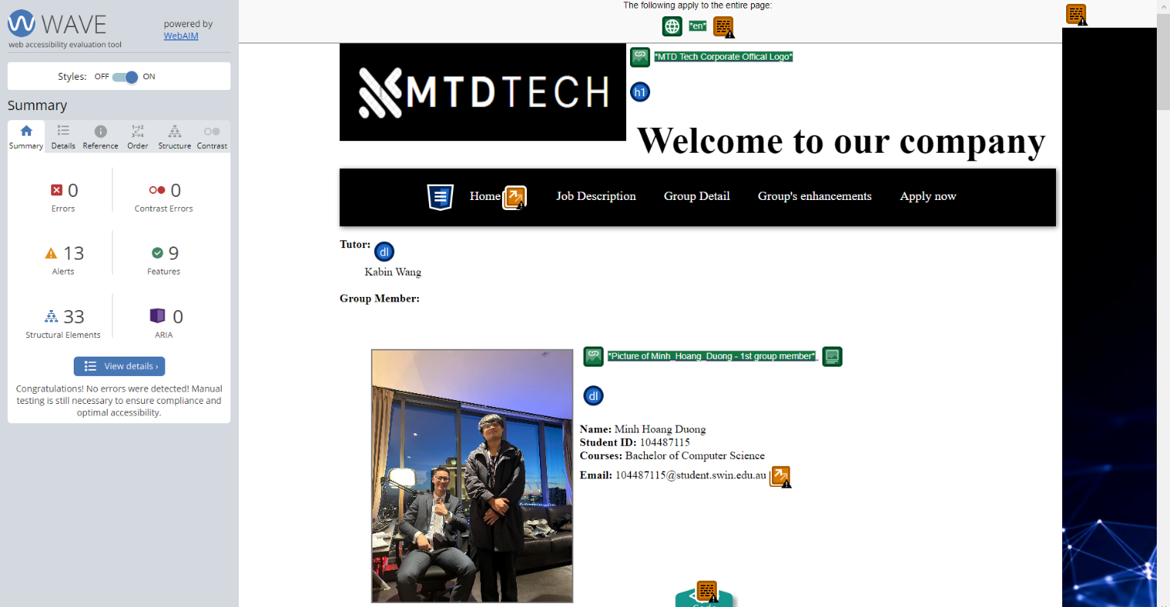

Image 3.1: Validated group detail pages

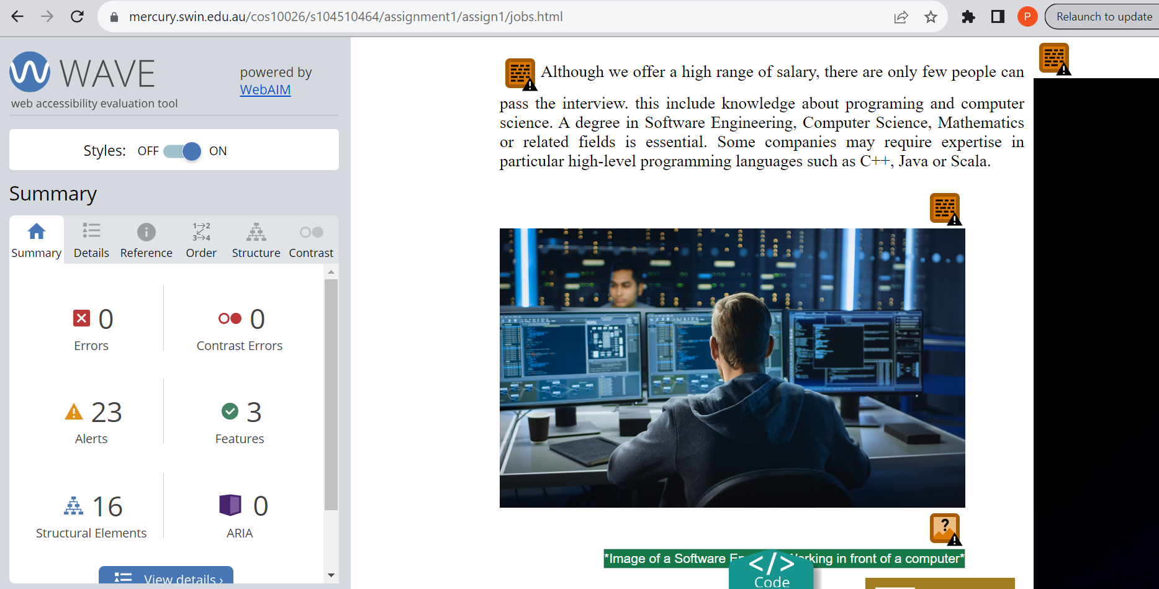Image 3.2: Validated job description pages

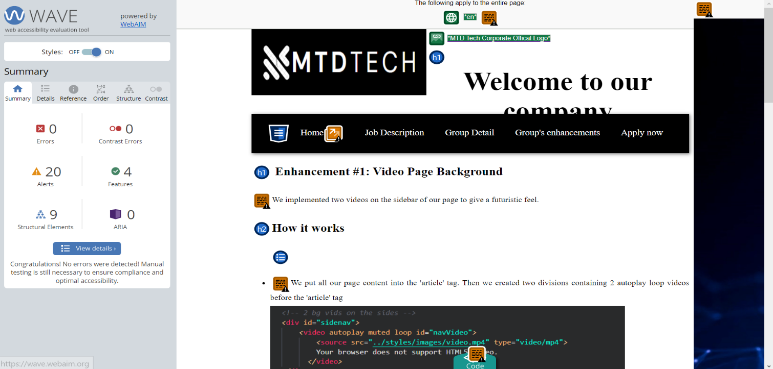

Image 3.3: Validated group’s enhancements page

Image 3.4: Validated Applying pages

1. **Conclusion:**
   * + In conclusion, the creation of this website is to recruit new employees for vacant positions in the company known as MTD. This report informs readers about the website's navigation, structure, and broken-down parts, including index.html, jobs.html, apply.html, and enhancement.html.
     + Referring to my contribution, I have completed my responsibilities and helped others with common assignments.