MINISTRY OF CONSUMER AFFAIRS, FOOD & PUBLIC DISTRIBUTION
DIRECTORATE OF LEGAL METROLOGY — STATUTORY INSPECTION NOTICE
Generated under Legal Metrology (Packaged Commodities) Rules, 2011 & LM Act 2009
———————————————————————————————————————————————————————
Inspection Number: | INS-20260913-1C491
Inspection Date: | 2026-09-13 14:53:20
Commodity / Product: | Glucose-based beverage mix (Orange Flavor)
Manufacturer / Packer: | ZYDUS WELLNESS PRODUCTS LIMITED, Zydus Corporate Park, Scheme No. 63, Survey No. 536, Khoraj (Gandhinagar), Nr. Vaishnodevi Circle, Ahmedabad - 382481

COMPLIANCE VERDICT: POTENTIAL NON COMPLIANCE (Score: 87.5%)

1. Mandatory Legal Metrology Declarations (Packaged Commodities Rules, 2011)
Declaration Field | Extracted Value | Confidence | Status
Manufacturer Details | ZYDUS WELLNESS PRODUCTS LIMITED, Zydus Corporate Park, Scheme No. 63, Survey No. 536, Khoraj (Gandhinagar), Nr. Vaishnodevi Circle, Ahmedabad - 382481, Gujarat, India | 96% | Verified
Product Name | Glucose-based beverage mix (Orange Flavor) | 96% | Verified
Net Quantity | 125 g (75 g + 50 g FREE) | 96% | Verified
Maximum Retail Price (MRP) | Rs. 55.00 | 96% | Verified
Manufacturing / Packing Date | 23/04/24 | 96% | Verified
Consumer Grievance Care Details | Phone: 1800 120 6868 | Email: customercare@zyduswellness.com | 96% | Verified
Country of Origin | India | 96% | Verified
Unit Sale Price (USP) | Rs. 0.73 Per g | 96% | Verified

2. Packaged Food Safety & Standards Assessment (FSSAI Regulations)
Declaration Field | Extracted Value | Confidence | Status
FSSAI License / Registration | 10020021005270 | 96% | Verified
Veg / Non-Veg Indicator | [NOT DETECTED] | 0% | Missing
Ingredients List | Sucrose, Glucose, Acidity Regulator (INS 330), Minerals (Calcium Phosphate, Zinc Sulphate, Calcium Phosphate, Zinc Gluconate), Nature Identical Flavouring Substances (Orange), Edible Common Salt, Vitamin C, Colour (INS 110) | 96% | Verified
Nutritional Facts Panel | Per 100 g: Energy: 366 kcal, Protein: 0 g, Carbohydrate: 91.4 g, Total Sugars: 91.4 g, Added Sugars: 91.4 g, Total Fat: 0 g, Sodium: 71 mg, Vitamin C: 40 mg, Calcium: 150 mg, Phosphorus: 75 mg, Magnesium: 132 mg, Zinc: 6.5 mg | 96% | Verified
Expiry / Best Before Date | 18/10/25 | 96% | Verified
Batch / Lot Identification | A02868N | 96% | Verified
Allergen Advisory | Not stated / No allergen advisory detected | 0% | Review Required
Storage Condition Instructions | See top panel for instructions for use and storage instructions | 96% | Verified

2. Photographic Evidence & Machine Bounding Box Inspection Map
Statutory package image captured during inspection alongside OpenCV bounding box detection evidence map:
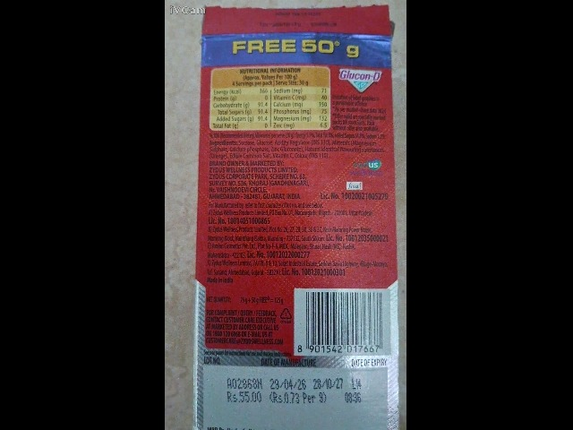 | 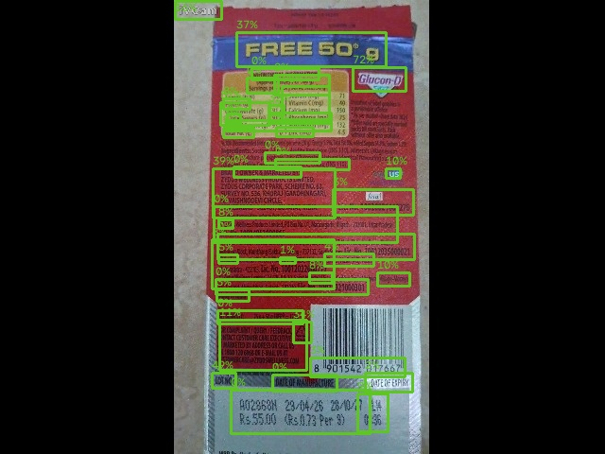
Figure 1: Captured Package Photograph | Figure 2: AI Readability & Bounding Box Map

3. Statutory Rule Infringements & Violations Detected
Rule Citation | Declaration Field | Severity | Statutory Penalty
FSSAI Labelling Reg 2.2.2.4 - Mandatory Vegetarian (Green Dot) or Non-Veg (Brown Triangle) Symbol | Veg / Non-Veg Indicator | Critical | Rs. 25,000.00

4. Enforcement Officer Review & Decision
Decision: FURTHER_REVIEW
Official Remarks / Directions:
Check whether the following ingredients are vegetarian
________________________________________
Inspector Signature & Official Stamp
Directorate of Legal Metrology

