MINISTRY OF CONSUMER AFFAIRS, FOOD & PUBLIC DISTRIBUTION
DIRECTORATE OF LEGAL METROLOGY — STATUTORY INSPECTION NOTICE
Generated under Legal Metrology (Packaged Commodities) Rules, 2011 & LM Act 2009
———————————————————————————————————————————————————————
Inspection Number: | INS-20260913-2DA4F
Inspection Date: | 2026-09-13 07:44:03
Commodity / Product: | Instant Energy Drink
Manufacturer / Packer: | Zydus Wellness Products Limited, Zydus Corporate Park, Scheme No. 63, Survey No. 535, Khoraj (Sarkhej-Gandhinagar Highway), Near Vaishnodevi Circle, A

COMPLIANCE VERDICT: COMPLIANT (Score: 93.8%)

1. Mandatory Legal Metrology Declarations (Packaged Commodities Rules, 2011)
Declaration Field | Extracted Value | Confidence | Status
Manufacturer Details | Zydus Wellness Products Limited, Zydus Corporate Park, Scheme No. 63, Survey No. 535, Khoraj (Sarkhej-Gandhinagar Highway), Near Vaishnodevi Circle, Ahmedabad - 382481, Gujarat, India | 96% | Verified
Product Name | Instant Energy Drink | 96% | Verified
Net Quantity | 125 g (75 g + 50 g FREE) | 96% | Verified
Maximum Retail Price (MRP) | Rs. 55.00 | 96% | Verified
Manufacturing / Packing Date | 29/04/24 | 96% | Verified
Consumer Grievance Care Details | Phone: 1800 123 9433 | Email: customercare@zyduswellness.com | 96% | Verified
Country of Origin | India | 96% | Verified
Unit Sale Price (USP) | Rs. 0.44 Per g | 96% | Verified

2. Packaged Food Safety & Standards Assessment (FSSAI Regulations)
Declaration Field | Extracted Value | Confidence | Status
FSSAI License / Registration | 10020021005270 | 96% | Verified
Veg / Non-Veg Indicator | Vegetarian | 96% | Verified
Ingredients List | Sucrose, Glucose, Acidity Regulator (INS 330), Minerals (Calcium Phosphate, Magnesium Phosphate, Zinc Sulphate), Vitamin C (L-Ascorbic Acid), Natural Identical Flavouring Substances (Orange), Edible Common Salt, Colour (INS 110) | 96% | Verified
Nutritional Facts Panel | Per 100 g: Energy: 366 kcal, Protein: 0 g, Carbohydrate: 91.4 g, Total Sugars: 91.4 g, Added Sugars: 91.4 g, Total Fat: 0 g, Sodium: 71 mg, Vitamin C: 40 mg, Calcium: 170 mg, Phosphorus: 119 mg, Magnesium: 17.8 mg, Zinc: 6.5 mg | 96% | Verified
Expiry / Best Before Date | 28/10/25 | 96% | Verified
Batch / Lot Identification | R02868M | 96% | Verified
Allergen Advisory | Not stated / No allergen advisory detected | 0% | Review Required
Storage Condition Instructions | Store in a cool, dry place away from strong odors | 96% | Verified

2. Photographic Evidence & Machine Bounding Box Inspection Map
Statutory package image captured during inspection alongside OpenCV bounding box detection evidence map:
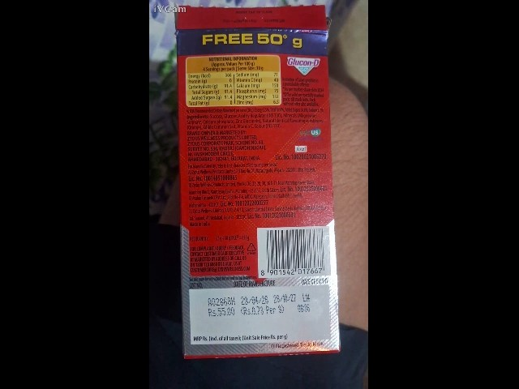 | 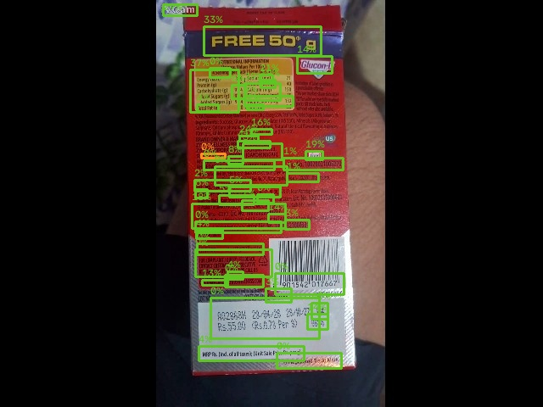
Figure 1: Captured Package Photograph | Figure 2: AI Readability & Bounding Box Map

4. Enforcement Officer Review & Decision
Decision: CONFIRMED
Official Remarks / Directions:
Passsed All test
________________________________________
Inspector Signature & Official Stamp
Directorate of Legal Metrology

