MINISTRY OF CONSUMER AFFAIRS, FOOD & PUBLIC DISTRIBUTION
DIRECTORATE OF LEGAL METROLOGY — STATUTORY INSPECTION NOTICE
Generated under Legal Metrology (Packaged Commodities) Rules, 2011 & LM Act 2009
———————————————————————————————————————————————————————
Inspection Number: | INS-20260913-7FC1A
Inspection Date: | 2026-09-13 07:39:01
Commodity / Product: | Potato Chips
Manufacturer / Packer: | ABC Foods Pvt. Ltd., 123, Industrial Area, New Delhi - 110020, India

COMPLIANCE VERDICT: POTENTIAL NON COMPLIANCE (Score: 68.8%)

1. Mandatory Legal Metrology Declarations (Packaged Commodities Rules, 2011)
Declaration Field | Extracted Value | Confidence | Status
Manufacturer Details | ABC Foods Pvt. Ltd., 123, Industrial Area, New Delhi - 110020, India | 96% | Verified
Product Name | Potato Chips | 96% | Verified
Net Quantity | 50 g | 96% | Verified
Maximum Retail Price (MRP) | ₹ 20.00 | 96% | Verified
Manufacturing / Packing Date | JAN 2025 | 96% | Verified
Consumer Grievance Care Details | Phone: 1800 123 4567 | Email: care@abcfoods.in | 96% | Verified
Country of Origin | India | 96% | Verified
Unit Sale Price (USP) | Not declared separately | 0% | Review Required

2. Packaged Food Safety & Standards Assessment (FSSAI Regulations)
Declaration Field | Extracted Value | Confidence | Status
FSSAI License / Registration | [NOT DETECTED] | 0% | Missing
Veg / Non-Veg Indicator | [NOT DETECTED] | 0% | Missing
Ingredients List | Potatoes, Edible Vegetable Oil (Palmolein Oil), Iodised Salt, Spices & Condiments. | 96% | Verified
Nutritional Facts Panel | Serving size: 30 g; Energy: 160 kcal; Protein: 2 g; Carbohydrate: 20 g; Total Fat: 8 g; Sodium: 180 mg | 96% | Verified
Expiry / Best Before Date | JUN 2025 | 96% | Verified
Batch / Lot Identification | A1258 | 96% | Verified
Allergen Advisory | Not stated / No allergen advisory detected | 0% | Review Required
Storage Condition Instructions | Not stated | 0% | Review Required

2. Photographic Evidence & Machine Bounding Box Inspection Map
Statutory package image captured during inspection alongside OpenCV bounding box detection evidence map:
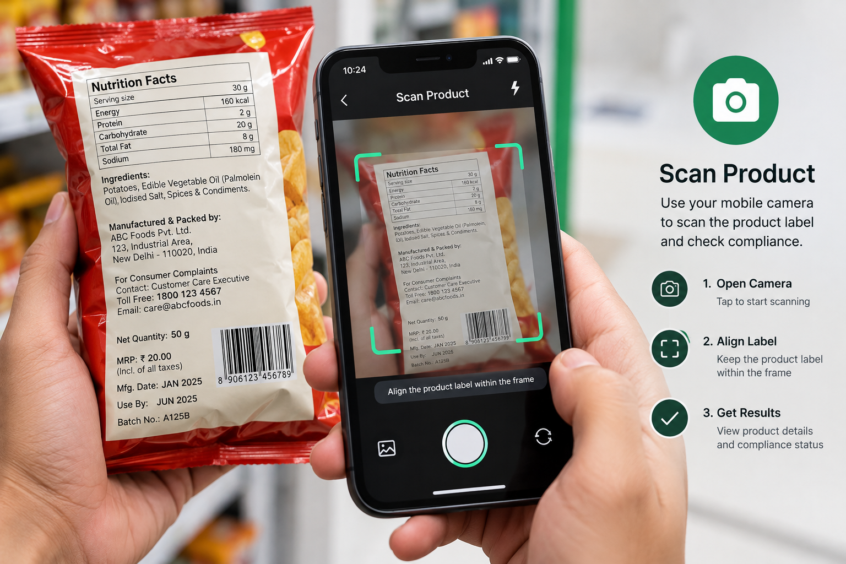 | 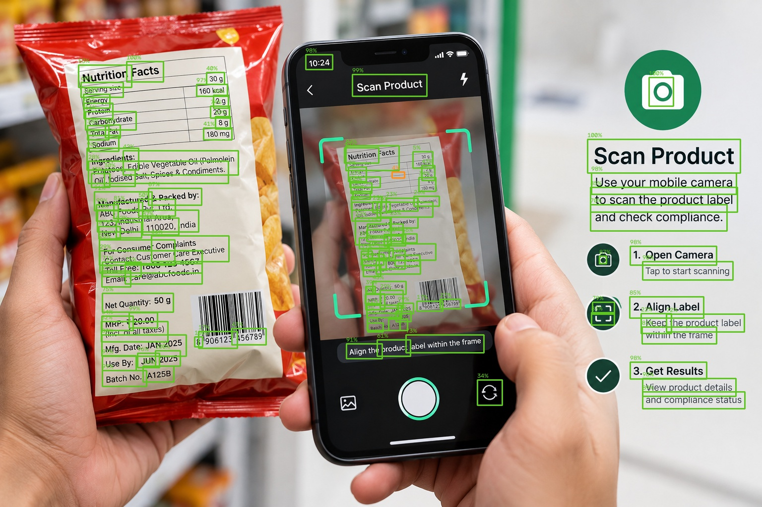
Figure 1: Captured Package Photograph | Figure 2: AI Readability & Bounding Box Map

3. Statutory Rule Infringements & Violations Detected
Rule Citation | Declaration Field | Severity | Statutory Penalty
FSS Act Sec 31 - Mandatory 14-Digit FSSAI License / Registration Number with Logo | FSSAI License / Registration | Critical | Rs. 50,000.00
FSSAI Labelling Reg 2.2.2.4 - Mandatory Vegetarian (Green Dot) or Non-Veg (Brown Triangle) Symbol | Veg / Non-Veg Indicator | Critical | Rs. 25,000.00

4. Enforcement Officer Review & Decision
Decision: NONE
Official Remarks / Directions:
None
________________________________________
Inspector Signature & Official Stamp
Directorate of Legal Metrology

