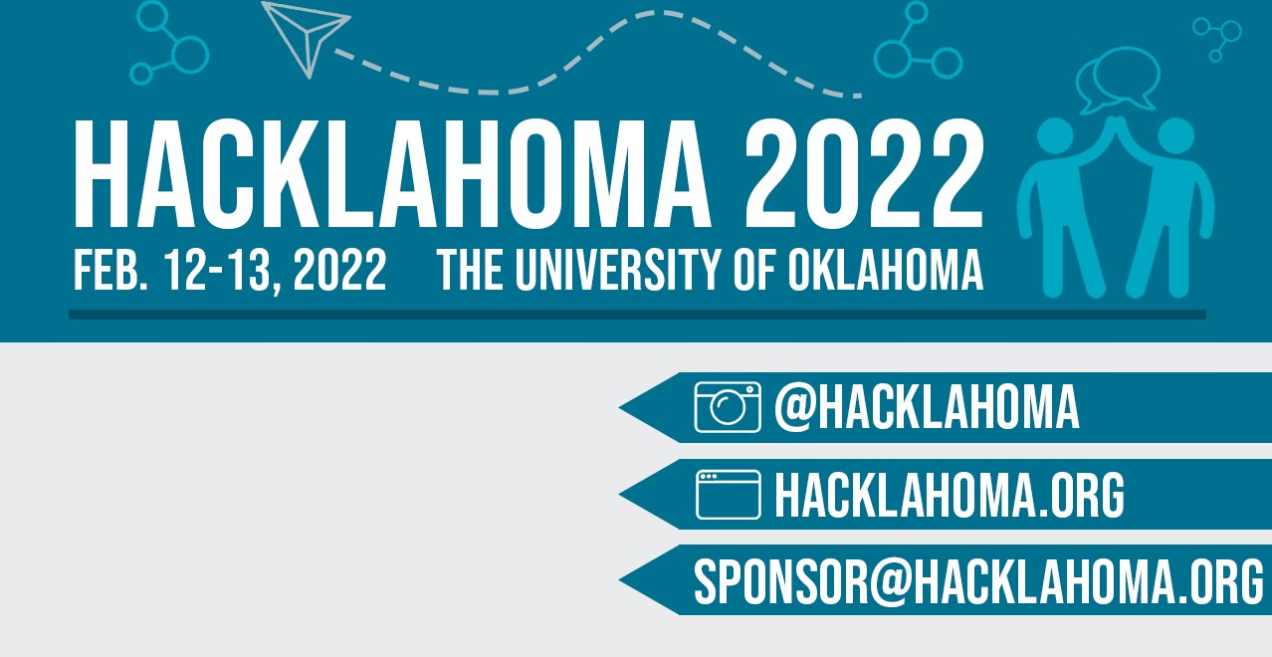



Hacklahoma is the largest hackathon in the state of Oklahoma. Our goal is to create a collaborative space for students of all backgrounds to express their creative and innovative visions. Talented students come together at Hacklahoma to strengthen their leadership and teamwork skills and solve real-world problems. In 24 fast-paced hours, students brainstorm, develop, and demonstrate their hard work. This annual event offers an empowering and interactive setting. It is with great honor that Hacklahoma 2022 will be the University of Oklahoma’s fifth annual student-run hackathon!

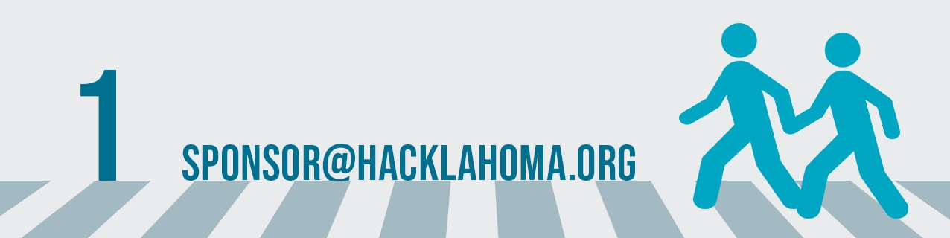From the 12th and 13th of February 2022, you can expect more than 350 passionate students to come together at Hacklahoma. With your support, sponsorship, and mentorship, Hacklahoma can continue connecting students with exciting technology!



Did you know that hackathons have become the new career fairs? Not only are they quickly replacing traditional recruitment, but they are also fostering innovation within the community. Sponsoring Hacklahoma will give you direct access to the top, most passionate and talented students in the region. With the fast growth of technology, you can count on our members to someday serve your technical needs.

*Advertise your brand.* Inspire the tech and software development community in Oklahoma with your

company’s technical expertise.

*Recruit the brightest student developers.* Gain access to their resumes and portfolios while building relationships with these talented students through networking and mentoring.

*Test and showcase your products and APIs.* Get real-time feedback on your tech and have students use your product in ways you never thought of.

*Run workshops, tutorials, and talks.* Teach students how to use your technology and speak about important skills to have in the professional world.

*Develop a larger tech community in Oklahoma.* Encourage the enthusiasm for innovation and help Oklahoma become a strong leader in technology.



Ideal sponsors establish a strong presence with the Hacklahoma community by sending representatives, developers, and mentors to the event. This allows Hacklahoma attendees to learn more about your company goals and culture in addition to professional opportunities in the tech industry.

Sponsors can work with us to coordinate workshops, showcase their unique company culture, and find ways to challenge our hackers. In fact, our team can help you host an interactive experience, tech-talk, or mini-challenge, which are great ways to advertise your company.

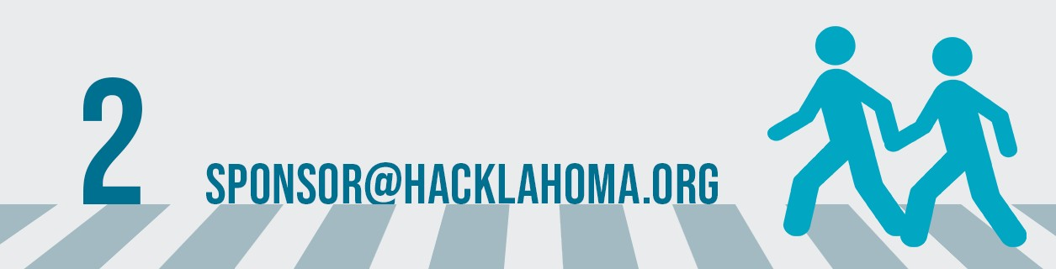Promote your business with your branding! Our hackers love swag! Sponsors who give out company- branded shirts, pens, stickers, water bottles and more, leave a lasting impression on Hacklahoma attendees.

# BY THE NUMBERS: HACKLAH0MA 2020

#### IN-PERSON EVENT

**282**



**-**

**HACKERS**

## GENDER

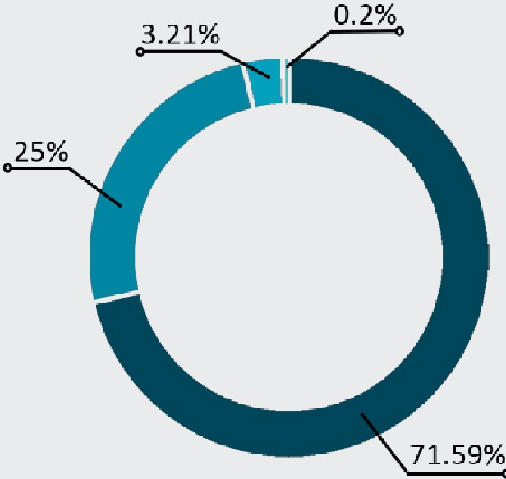

**59**

**PROJECTS**

-Male

* Female
* Prefer not to say
* Non-binary/other

**19**

I I **SPONSORS**

## CLASS STANDING

* + Senior
  + Junior

- Sophomore

* + Freshman

55.38%

|  |  |  |
| --- | --- | --- |
|  | | **MAJOR** |
| Computer Science |  |  |
| Computer Engineering | 7.87% |  |
| Electrical Engineering | 3.85% |  |
| Data Science & Analytics | 3.85% |  |
| Mechanical Engineering |  |  |
| Software Engineering  Industrial & Systems Engineering |  |  |
| Mathematics |  |  |
| Chemical Engineering |  |  |
| Biomedical Engineering |  |  |

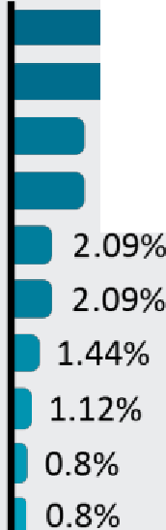Other------ 20.71%

0 10 20 30 40 so 60

Percentage(%) of Attendees

•



[**SPONSOR@HACKLAHOMA.ORG**](mailto:SPONSOR@HACKLAHOMA.ORG)

# BY THE NUMBERS: HACKLAHOMA 2021

#### ONLINE EVENT HOSTED ON DISCORD

**183**

**HACKERS**

**29**

**PROJECTS**

## GENDER CLASS STANDING

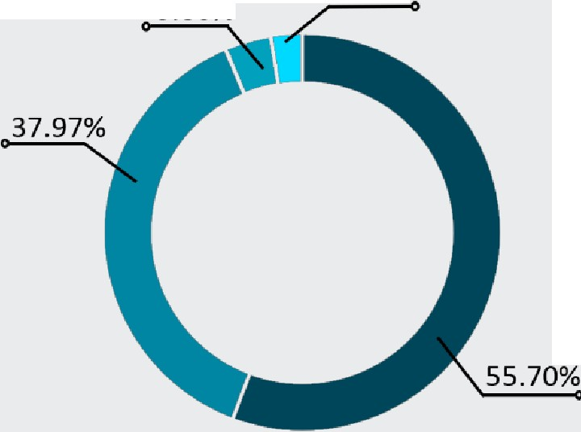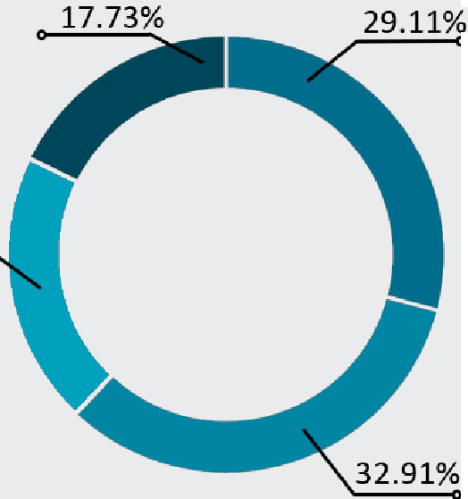3.80% 2.53%

-Male

- Female

- Prefer not to say

- Non-binary/other

## MAJOR

20.25%

* Senior
* Junior

- Sophomore

* Freshman

Computer Science

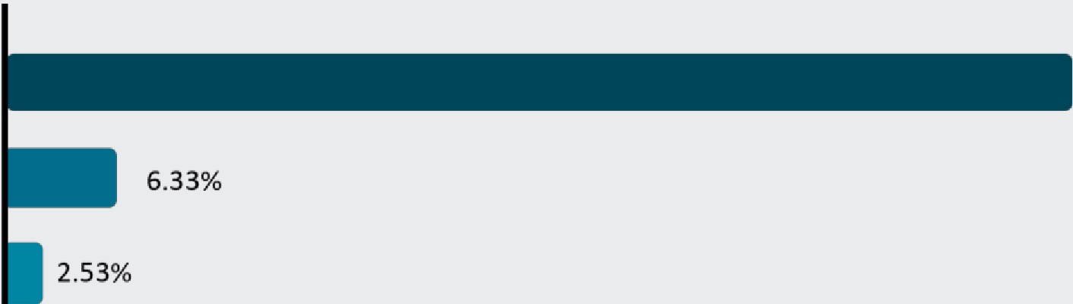

69.62%

21.52%

Computer Engineering

Electrical Engineering

Other

0 10 20

30 40 so 60 70

Percentage(%) of Attendees

•



[**SPONSOR@HACKLAHOMA.ORG**](mailto:SPONSOR@HACKLAHOMA.ORG)



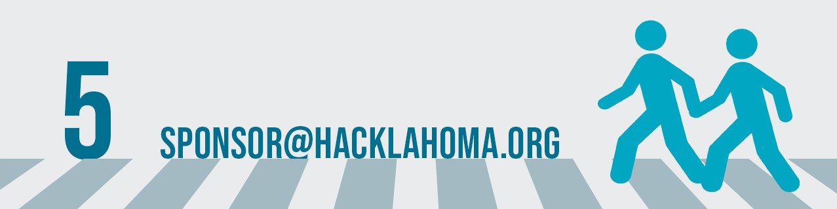

### These are the general sponsoring options.



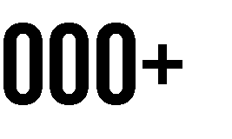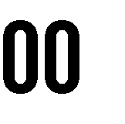

Logo on Website Sponsor Kick-Off Events

Representative(s) 3+ Reps 3+ Reps 3 Reps 2 Reps 2 Reps 1 Rep



Mentors (min. 2) Booth at Event Screen Advertisement

Workshop or Tech Talk Logo on Shirt

Social Media Shoutout Resume Access Opening Remarks Closing Remarks

Private Interview Room

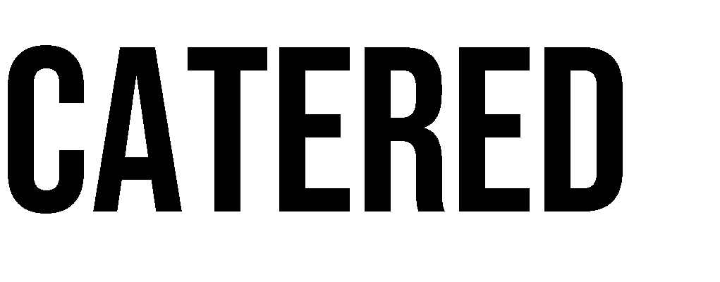

These are alternative sponsor options and their respective tier benefits in exchange for helping us run Hacklahoma directly.



$1000 or prizes for teams of 4 worth $1000

Creating a challenge with prizes

Tech talk, workshop, interactive activity worth

$500

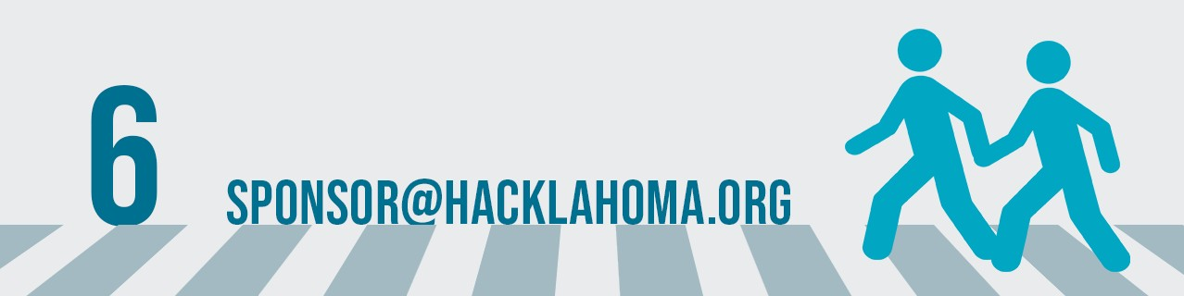



Logo on Website Sponsor Kick-Off Events Social Media Shoutout Booth at Event Mentors (min. 2)

Booth at Event



These are alternative sponsor options and their respective tier benefits in exchange for directly supporting our food/catering requirements.



Benefits In Exchange For Directly Supporting Our Food/Catering Requirements



Logo on Website Screen Advertisement Booth at Event

Social Media Shoutout Logo on Tablecloth Sponsor Kick-Off Events Opening Remarks

Closing Remarks

### If our tiers and sponsorship options aren't what you're looking for, please email us at sponsor@hacklahoma.org! We will work with your

company to provide the best contribution possible.

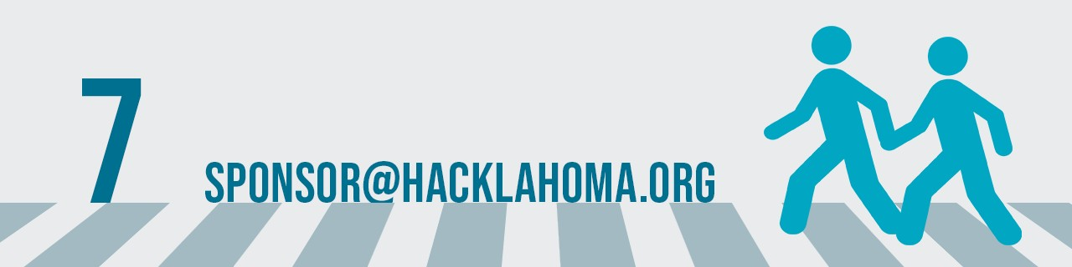

**CONTACT US!**



FOLLOW US [@HACKLAHOMA](https://www.instagram.com/hacklahoma/) VISIT [HACKLAHOMA.ORG](https://hacklahoma.org/)

EMAIL [SPONSOR@HACKLAHOMA.ORG](mailto:SPONSOR@HACKLAHOMA.ORG)

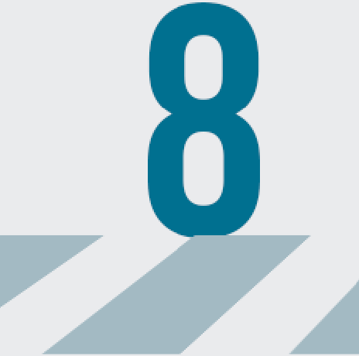•



[SPONSOR@HACKLAHOMA.ORG](mailto:SPONSOR@HACKLAHOMA.ORG)

