1. The HR department needs a query that prompts the user for an employee last name. The query then displays the last name and hire date of any employee in the same department as the employee whose name they supply (excluding that employee). For example, if the user enters Zlotkey, find all employees who work with Zlotkey (excluding Zlotkey).

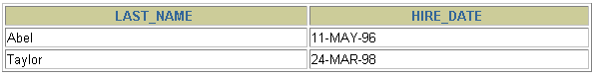

2. Create a report that displays the employee number, last name, and salary of all employees who earn more than the average salary. Sort the results in order of ascending salary.

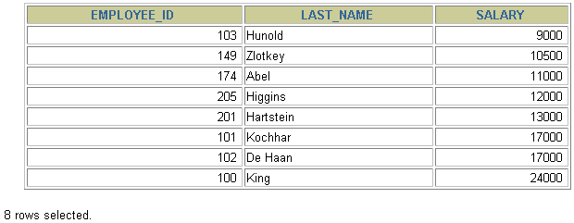

3. Write a query that displays the employee number and last name of all employees who work in a department with any employee whose last name contains a *u*. Place your SQL statement in a text file named lab_06_03.sql. Run your query.

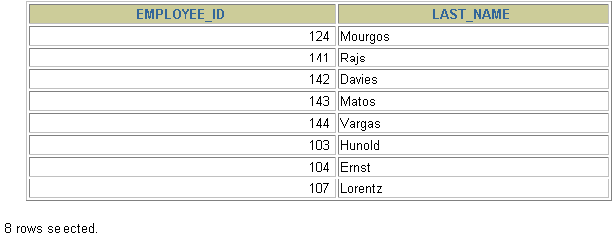

4. The HR department needs a report that displays the last name, department number, and job ID of all employees whose department location ID is 1700.

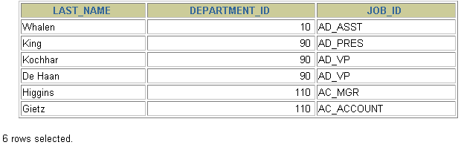

5. Create a report for HR that displays the last name and salary of every employee who reports to King.

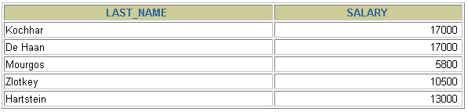

**6.** Create a report for HR that displays the department number, last name, and job ID for every employee in the Executive department.

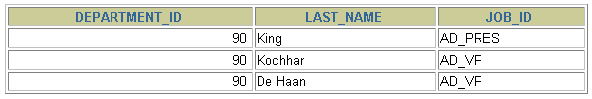

1. Write a query for the HR department to produce the addresses of all the departments. Use the LOCATIONS and COUNTRIES tables. Show the location ID, street address, city, state or province, and country in the output. Use a NATURAL JOIN to produce the results.

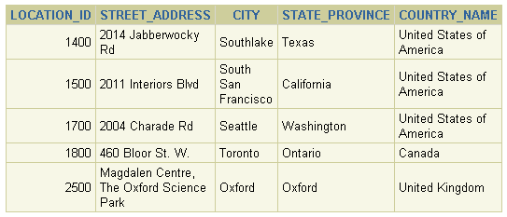

1. The HR department needs a report of all employees. Write a query to display the last name, department number, and department name for all employees.

**…**

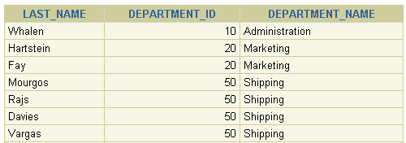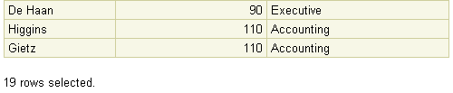

1. The HR department needs a report of employees in Toronto. Display the last name, job, department number, and department name for all employees who work in Toronto.

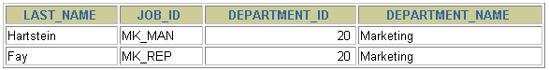

1. Create a report to display employees’ last name and employee number along with their manager’s last name and manager number. Label the columns Employee, Emp#, Manager, and Mgr#, respectively.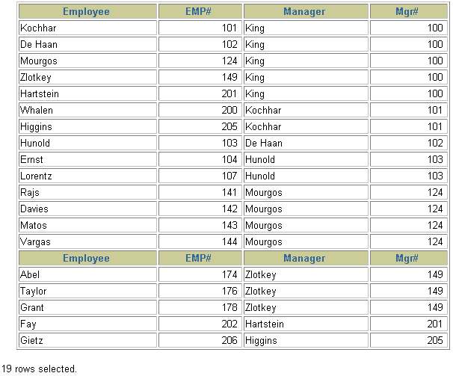
2. Display all employees including King, who has no manager. Order the results by the employee number.

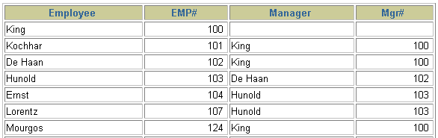

1. Create a report for the HR department that displays employee last names, department numbers, and all the employees who work in the same department as a given employee. Give each column an appropriate label.

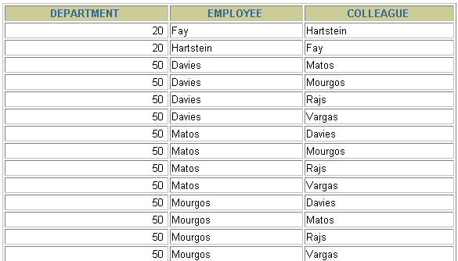

**…**



1. **The HR department needs a list of department IDs for departments that do not contain the job ID ST_CLERK. Use set operators to create this report.**

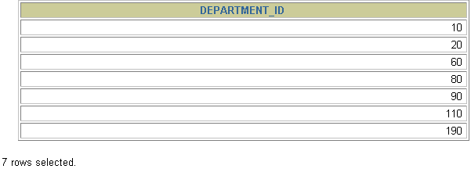

1. **The HR department needs a list of countries that have no departments located in them. Display the country ID and the name of the countries. Use set operators to create this report.**



1. **Produce a list of jobs for departments 10, 50, and 20, in that order. Display job ID and department ID using set operators.**

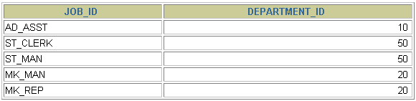

1. **Create a report that lists the employee IDs and job IDs of those employees who currently have a job title that is the same as their job title when they were initially hired by the company (that is, they changed jobs but have now gone back to doing their original job).**



17. Find the highest, lowest, sum, and average salary of all employees. Label the columns  
 Maximum, Minimum, Sum, and Average, respectively. Round your results to the nearest whole number.



1. **Display the minimum, maximum, sum, and average salary for each job type.**

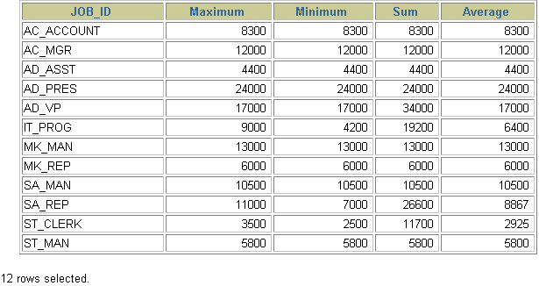

1. Write a query to display the number of people with the same job.

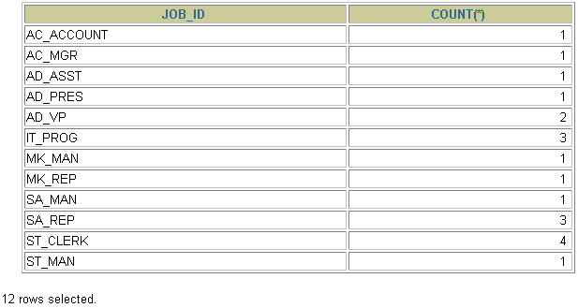

7. Determine the number of managers without listing them. Label the column Number of Managers. *Hint: Use the MANAGER_ID column to determine the number of managers.*



**8.Find the difference between the highest and lowest salaries. Label the column DIFFERENCE.**

