Week 7: Prompt Framework (Before and After)
Name: Adam Hamzat
Task I redid: Week 3 concept exploration: generate different design directions for the ShopHive Home screen
Tool used: Claude AI connected to Figma for both runs

1. Before: the rough prompt
“Using Google Stitch, Uizard, or any text-to-UI/sketch-to-UI tool of your choice, generate 3+ different concept directions for one core screen in your project. Pick your favorite and explain what made it stronger than the other two.”
This was the assignment text, sent with the message “The next task”. It gave no brand, audience, list of content, quality bar or constraints, so the AI had to guess all of them.

2. After: the structured prompt (task, context, elements, behavior, constraints)
Element | What I wrote
Task | Generate 4 clearly different concept directions for the ShopHive Home screen. Score all four against these criteria: time to first product, trust, brand fit, accessibility and discoverability. Then recommend one and explain why.
Context | ShopHive is a multi-vendor marketplace app for Nigerian buyers and sellers. Buyers are first-time and returning online shoppers on mid-range Android phones who worry about fraud, delivery and returns. Brand: primary green #0B6E4F, Inter font, hexagon-cart logo, friendly and trustworthy tone. Prices are in Naira.
Elements | Every concept must include: delivery location, search, category access, a deal or promo area, a product list showing price, rating, seller name and add-to-cart, at least one trust cue (verified seller, secure payment or easy returns), and a bottom navigation bar.
Behavior | Act as a senior mobile product designer. Give each concept a different layout strategy, not just different colours. For each, state the strategy, who it suits and its main trade-off. Do not ask questions; state any assumptions instead.
Constraints | Mobile 390×844. Keep every concept on-brand (green primary, Inter). Realistic Nigerian sample products with ₦ prices. Text contrast WCAG AA and tap targets of at least 44px. At most 4 products visible per screen. No stock photos. Deliver one Figma board with the four screens side by side.

3. Both outputs side by side
 | BEFORE: rough prompt | AFTER: structured prompt
Directions | 3: A Clean Utility, B Immersive Dark, C Community Local | 4: A Search-first, B Deals-led, C Trust-led, D Category-first
How they differ | Mostly in colour theme and mood | In layout strategy (what leads the screen)
Brand | A used the brand green. B (navy and emerald) and C (cream and orange) did not. | All four use the ShopHive green and Inter
Trust cues | Only Concept C had one (a verified-seller badge) | Every concept has one (verified badges, secure-payment line, trust banner)
Extras | A pick with general reasons | Per-concept strategy, who it suits and trade-off; a scorecard; a recommendation
Pick | Concept A (clean, search-first) | Concept C (trust-led), score 26 vs 24 for Concept A

Screenshots:
BEFORE output | AFTER output
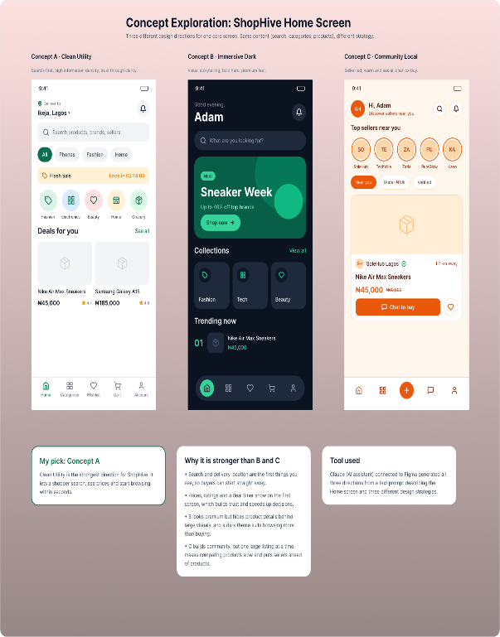 | 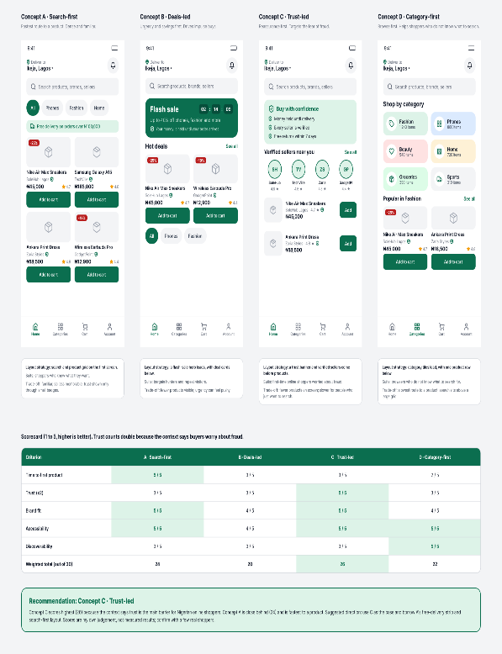

4. Scorecard from the structured run
Criterion | A Search-first | B Deals-led | C Trust-led | D Category-first
Time to first product | 5 | 3 | 3 | 2
Trust (counts double) | 3 | 3 | 5 | 3
Brand fit | 5 | 4 | 5 | 4
Accessibility | 5 | 4 | 5 | 5
Discoverability | 3 | 3 | 3 | 5
Weighted total (out of 30) | 24 | 20 | 26 | 22

The structured run recommended Concept C, because the context said trust is the main barrier for Nigerian online shoppers. Concept A scored close behind and is the fastest route to a product. The scores are my own judgement, not measured results.

5. What improved
Area | BEFORE | AFTER
Brand fit | Two of three concepts used colours outside the ShopHive palette because the brand was never stated. | All four concepts use the ShopHive green and the Inter font.
Audience and context | Generic marketplace. Nothing showed the worries of Nigerian first-time shoppers. | Naira prices, Lagos delivery and trust cues: verified sellers, money held until delivery, free returns.
Required content | Left to the AI, so delivery, trust and seller details varied or were missing. | Every concept shows location, search, categories, deals, price, rating, seller, a trust cue and navigation.
Quality bar | None stated. Chips and buttons were about 36px high and contrast was not checked. | 44px tap targets and AA contrast were requested and applied.
Distinct directions | 3 directions that differed mostly in colour and mood. | 4 directions with different layout strategies.
Decision support | A pick with general reasons. | A scorecard on 5 criteria, with trust weighted by the stated context, plus trade-offs.
Fixes after the first run | Needed fixes (clipped filter chips, tool-used note, pick to confirm). | None needed during this run.

