What Is Tokenization? | IBM
What is tokenization? - GeeksforGeeks
Tokenization and Digital Vault Security - Grok
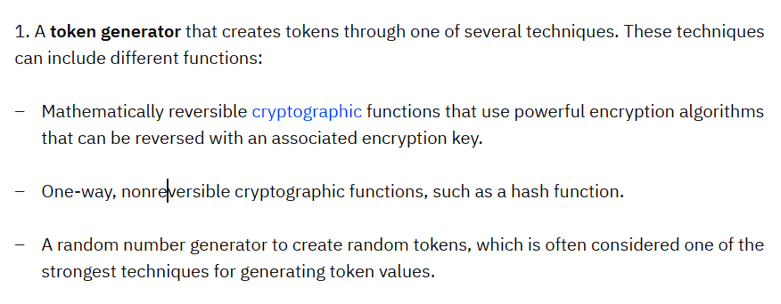

Non-fungible token - Wikipedia
ERC-721 - Wikipedia
Metadata - Wikipedia

