Submeters:
Hadar Gal Zigdon 318659935
Sapir Levi 318776010

Spark Training questions
Please answer the questions below

Exercise 1
Q1. Please put your code here:
import sys
from pyspark import SparkContext, SparkConf

if __name__ == "__main__":
if len(sys.argv) != 2:
print("Usage: wordcount <input_folder>", file=sys.stderr)
sys.exit(-1)

conf = SparkConf().setAppName("python-word-count")
sc = SparkContext(conf=conf)

text_file = sc.textFile("hdfs://" + sys.argv[1])
counts = text_file.flatMap(lambda line: line.split(" ")) \
.map(lambda word: (word, 1)) \
.reduceByKey(lambda a, b: a + b) \
.repartition(5) \
.filter(lambda x: len(x[0])>5)
# "takeOrdered" is an action.
list = counts.takeOrdered(40, key = lambda x: -x[1])
print("--------------------------------------------")
# print (repr(list)[1:-1])
print(*list, sep="\n")
print("--------------------------------------------")

Q2. Add print-screen of the stage proving you have 5 tasks

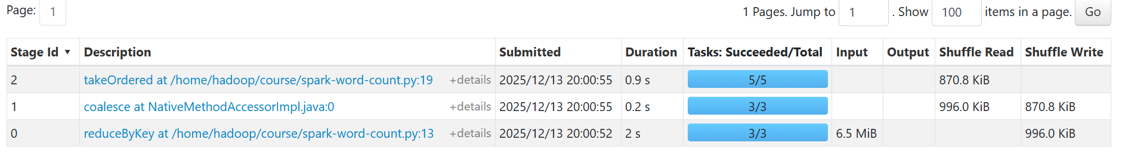

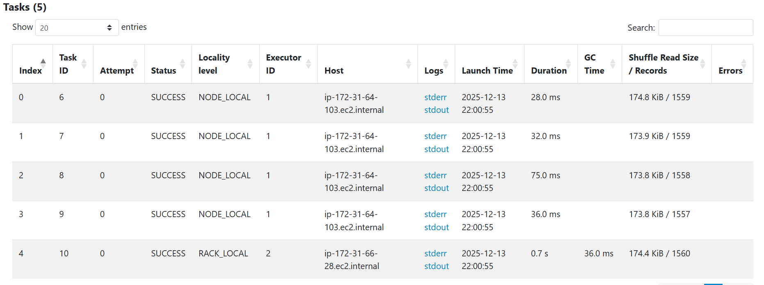

Exercise 2
Q1. Please put your code here:
import sys
from pyspark import SparkContext, SparkConf

if __name__ == "__main__":
if len(sys.argv) != 2:
print("Usage: wordcount <input_folder>", file=sys.stderr)
sys.exit(-1)

conf = SparkConf().setAppName("python-word-count")
sc = SparkContext(conf=conf)

text_file = sc.textFile("hdfs://" + sys.argv[1])

all_words = text_file.flatMap(lambda line: line.split(" ")).cache()

distinct_total = all_words.distinct().count()

counts = (all_words
.map(lambda w: (w, 1))
.reduceByKey(lambda a, b: a + b)
.filter(lambda x: len(x[0]) > 5))

top40 = counts.takeOrdered(40, key=lambda x: -x[1])

print("--------------------------------------------")
print(*top40, sep="\n")
print("--------------------------------------------")
print(f"TOTAL DISTINCT WORDS (ALL): {distinct_total}")

Q2. Write the number of words found
77928

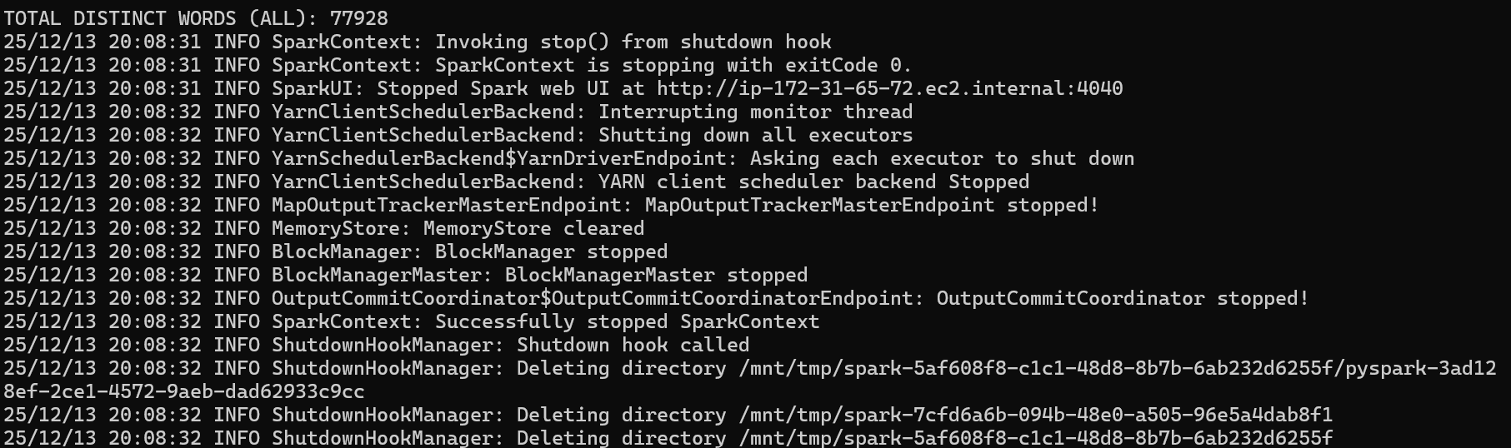

Exercise 3
Put a print-scrin with the DAG of the first stage, which shows it reads the files from s3a://<your_bucket_name>

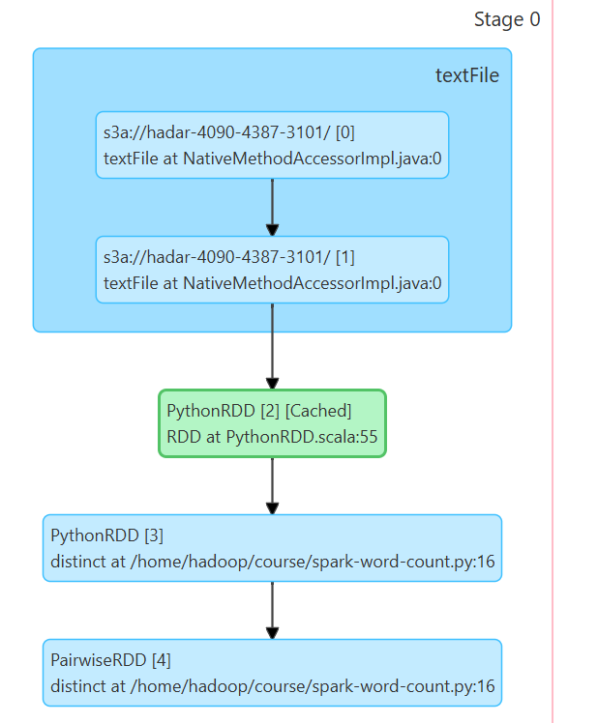

Exercise 4
Q1. Please put your code here:
import sys
from pyspark import SparkContext, SparkConf

def clean_word(word):
while word.endswith(".") or word.endswith(","):
word = word[:-1]
return word

if __name__ == "__main__":
if len(sys.argv) != 2:
print("Usage: longestword <input_folder>", file=sys.stderr)
sys.exit(-1)

conf = SparkConf().setAppName("python-longest-word")
sc = SparkContext(conf=conf)

text_file = sc.textFile("s3a://" + sys.argv[1])

words = (text_file
.flatMap(lambda line: line.split(" "))
.map(clean_word)
.filter(lambda w: len(w) > 0 and w.isalpha()))

longest = words.reduce(lambda a, b: a if len(a) >= len(b) else b)

print("--------------------------------------------")
print(longest)
print(len(longest))
print("--------------------------------------------")

Q2. Put here the printout of the longest word:
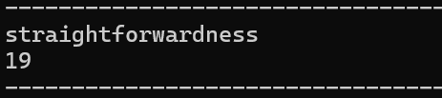

Exercise 5
Q1. Please put your code here:
import sys
from pyspark import SparkContext, SparkConf

if __name__ == "__main__":
if len(sys.argv) != 2:
print("Usage: count_words_in_line <input_folder>", file=sys.stderr)
sys.exit(-1)

conf = SparkConf().setAppName("count-words-in-line")
sc = SparkContext(conf=conf)

text_file = sc.textFile("s3a://" + sys.argv[1])

best = (text_file
.map(lambda line: (len([w for w in line.split() if w]), line))
.reduce(lambda a, b: a if a[0] >= b[0] else b))

print("--------------------------------------------")
print("Max number of words in a line:")
print(best[0])
print("Line content:")
print(best[1])
print("--------------------------------------------")

Q2. Put here the printout of the line with the most words:
