Table of Contents

Task general description 2

Data set 2

Basic pipe 2

First improvement- data augmentation: 4

Second improvement- training two last layers with data augmentation: 7

## Task general description

In this task we:

* Built a flower classifier with task transfer from a VGG-16 pre-trained network.
* Improved the classifier using data augmentation in training data and training several layers of the network.
* Trained and tested our classifiers performances on flowers dataset that was collected in Volkani institute.
* Analyzed and reported our results.

## Data set

* In this task we worked with a flowers dataset that was collected in Volkani institute.
* The data includes 473 cropped images of flowers and non-flowers, with corresponding labels.
* We loaded the images, got them to RGB scale, and resized them according to 224*224*3 scale.
* Data split
* We used the first 300 cropped images for training.
* We used 25% of the training set for validation (randomly).
* The remaining 172 images were used as test set on which the results were obtained.

**We tried to improve the network using:**

* Data augmentation.
* Training the two last layers.
* Modifying the net by replacing the global layers to layers with 128 neurons.
* We tried different optimizers.
* Drop-out for FC-1 and FC-2 layers.
* Combinations of the above.

## Basic pipe

We performed task-transfer based on VGG-16 architecture. The classification is flower or not flower. Thus, the output layer has a two neuron estimating p ̂(y=1|x) and p ̂(y=0|x) (i.e. the probability that an image is a flower or not). We used the pre-trained weights of the VGG-16 network, dropped the last layer, and add a new one.

**Error rate**

The error rate obtained over the test set is 22.1% .

**5 worst errors of type 1 on the test set:**

|  |  |  |
| --- | --- | --- |
| C:\Users\Administrator\Downloads\WhatsApp Image 2019-02-03 at 17.10.57.jpeg | C:\Users\Administrator\Downloads\WhatsApp Image 2019-02-03 at 17.11.20.jpeg | C:\Users\Administrator\Downloads\WhatsApp Image 2019-02-03 at 17.11.46.jpeg |
| C:\Users\Administrator\Downloads\WhatsApp Image 2019-02-03 at 17.12.01.jpeg | C:\Users\Administrator\Downloads\WhatsApp Image 2019-02-03 at 17.12.18.jpeg |  |

**5 worst errors of type 2 on the test set:**

|  |  |  |
| --- | --- | --- |
| C:\Users\Administrator\Downloads\WhatsApp Image 2019-02-03 at 17.12.39.jpeg | C:\Users\Administrator\Downloads\WhatsApp Image 2019-02-03 at 17.12.53.jpeg | C:\Users\Administrator\Downloads\WhatsApp Image 2019-02-03 at 17.13.10.jpeg |
| C:\Users\Administrator\Downloads\WhatsApp Image 2019-02-03 at 17.13.27.jpeg | C:\Users\Administrator\Downloads\WhatsApp Image 2019-02-03 at 17.13.49.jpeg |  |

**A recall-precision curve**

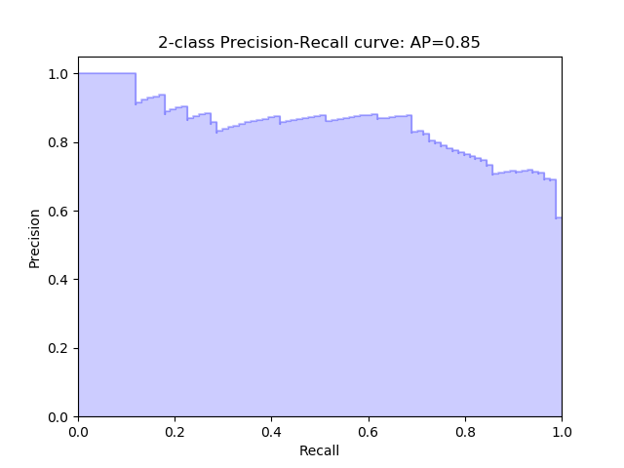

## First improvement- data augmentation:

We applied horizontal and vertical flips, rotation, zooming and picture shift for the training data set. We examine the data and noticed that the majority of the images are taken from above; therefore we decided to use vertical flip in addition to the horizontal flip. We performed 4 augmentations randomly for each image.

Augmentation example:

|  |  |
| --- | --- |
| C:\Users\Administrator\Downloads\פרח4.jpg | C:\Users\Administrator\Downloads\פרח3.jpg |
| C:\Users\Administrator\Downloads\פרח2.jpg | C:\Users\Administrator\Downloads\פרח1.jpg |

**Error rate**

The error rate obtained over the test set is 31.4% .

**5 worst errors of type 1 on the test set:**

|  |  |  |
| --- | --- | --- |
| C:\Users\Administrator\Downloads\WhatsApp Image 2019-02-03 at 17.39.38.jpeg | C:\Users\Administrator\Downloads\WhatsApp Image 2019-02-03 at 17.39.54.jpeg | C:\Users\Administrator\Downloads\WhatsApp Image 2019-02-03 at 17.40.12.jpeg |
| C:\Users\Administrator\Downloads\WhatsApp Image 2019-02-03 at 17.40.33.jpeg | C:\Users\Administrator\Downloads\WhatsApp Image 2019-02-03 at 17.40.46.jpeg |  |

**5 worst errors of type 2 on the test set:**

|  |  |  |
| --- | --- | --- |
| C:\Users\Administrator\Downloads\WhatsApp Image 2019-02-03 at 17.41.01.jpeg | C:\Users\Administrator\Downloads\WhatsApp Image 2019-02-03 at 17.41.23.jpeg | C:\Users\Administrator\Downloads\WhatsApp Image 2019-02-03 at 17.41.41.jpeg |
| C:\Users\Administrator\Downloads\WhatsApp Image 2019-02-03 at 17.41.57.jpeg | C:\Users\Administrator\Downloads\WhatsApp Image 2019-02-03 at 17.42.12.jpeg |  |

**A recall-precision curve**

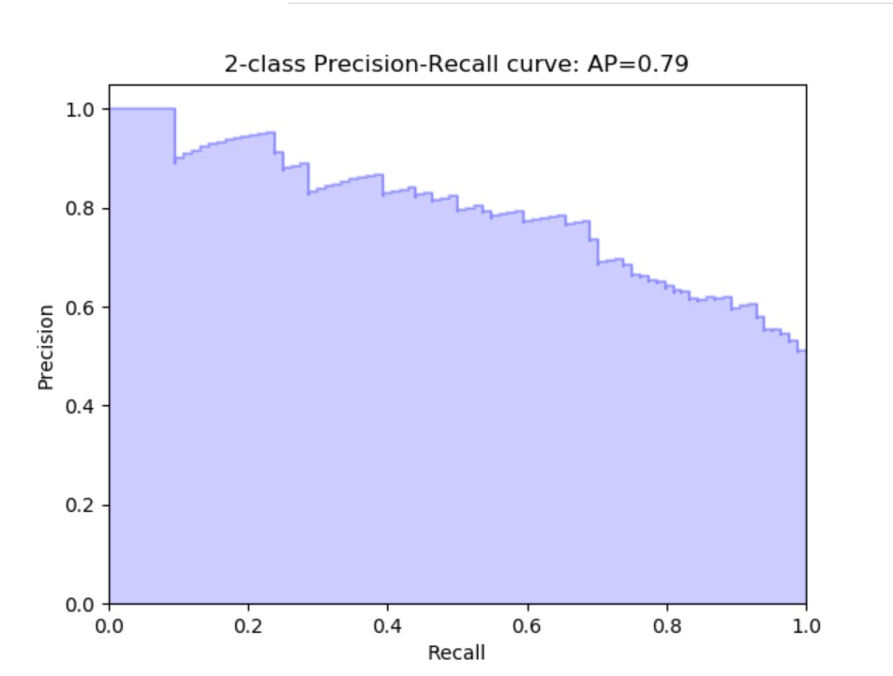

## Second improvement- training two last layers with weight decay:

**Error rate**

The error rate obtained over the test set is 20.93%

**5 worst errors of type 1 on the test set:**

|  |  |  |
| --- | --- | --- |
|  |  |  |
|  |  |  |

**5 worst errors of type 2 on the test set:**

|  |  |  |
| --- | --- | --- |
|  |  |  |
|  |  |  |

**A recall-precision curve**

