sp-flowchart-js

>git clone <https://github.com/Haddley/sp-flowchart-js.git>

>yo @microsoft/sharepoint

>cd sp-flowchart-js

>gulp serve

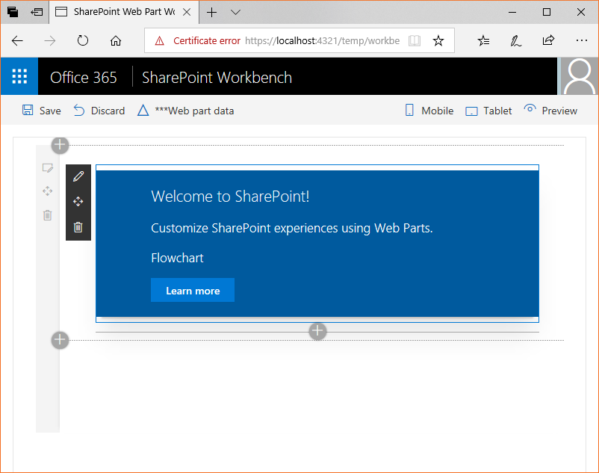

>npm shrinkwrap

>npm install flowchart.js

>npm install @pnp/spfx-controls-react

>npm install office-ui-fabric-react

>npm install @microsoft/sp-core-library

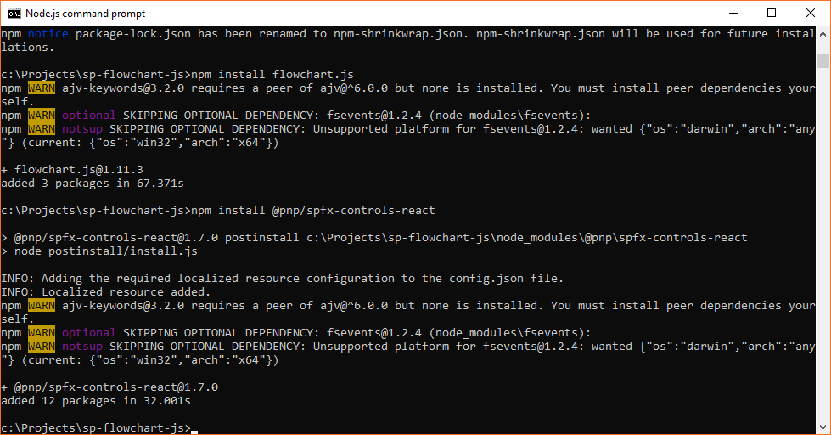

import \* as React from 'react';

import styles from './Flowchart.module.scss';

import { IFlowchartProps } from './IFlowchartProps';

import { escape } from '@microsoft/sp-lodash-subset';

import { WebPartTitle } from "@pnp/spfx-controls-react/lib/WebPartTitle";

export default class Flowchart extends React.Component<IFlowchartProps, {}> {

public render(): React.ReactElement<IFlowchartProps> {

return (

<div>

<WebPartTitle displayMode={this.props.displayMode}

title={this.props.title}

updateProperty={this.props.updateProperty} />

<h1>{this.props.description}</h1>

</div>

);

}

}

import { WebPartContext } from "@microsoft/sp-webpart-base";

import { DisplayMode } from "@microsoft/sp-core-library";

import { IFlowchartWebPartProps } from "../FlowchartWebPart";

export interface IFlowchartProps extends IFlowchartWebPartProps {

displayMode: DisplayMode;

updateProperty: (value: string) => void;

context: WebPartContext;

}

{

"$schema": "https://developer.microsoft.com/json-schemas/spfx/client-side-web-part-manifest.schema.json",

"id": "210a6bf7-ab94-4810-9904-6f8cbfc6c6e1",

"alias": "FlowchartWebPart",

"componentType": "WebPart",

// The "\*" signifies that the version should be taken from the package.json

"version": "\*",

"manifestVersion": 2,

// If true, the component can only be installed on sites where Custom Script is allowed.

// Components that allow authors to embed arbitrary script code should set this to true.

// https://support.office.com/en-us/article/Turn-scripting-capabilities-on-or-off-1f2c515f-5d7e-448a-9fd7-835da935584f

"requiresCustomScript": false,

"preconfiguredEntries": [{

"groupId": "5c03119e-3074-46fd-976b-c60198311f70", // Other

"group": { "default": "Other" },

"title": { "default": "Flowchart" },

"description": { "default": "Flowchart (flowchart.js)" },

"officeFabricIconFontName": "Page",

"properties": {

"description": "Flowchart Description",

"title":"Flowchart Title"

}

}]

}

import \* as React from 'react';

import \* as ReactDom from 'react-dom';

import { Version } from '@microsoft/sp-core-library';

import {

BaseClientSideWebPart,

IPropertyPaneConfiguration,

PropertyPaneTextField

} from '@microsoft/sp-webpart-base';

import \* as strings from 'FlowchartWebPartStrings';

import Flowchart from './components/Flowchart';

import { IFlowchartProps } from './components/IFlowchartProps';

export interface IFlowchartWebPartProps {

description: string;

title: string;

}

export default class FlowchartWebPart extends BaseClientSideWebPart<IFlowchartWebPartProps> {

public render(): void {

const element: React.ReactElement<IFlowchartProps > = React.createElement(

Flowchart,

{

description: this.properties.description,

title: this.properties.title,

context: this.context,

displayMode: this.displayMode,

updateProperty: (value: string) => {

this.properties.title = value;

}

}

);

ReactDom.render(element, this.domElement);

}

protected onDispose(): void {

ReactDom.unmountComponentAtNode(this.domElement);

}

protected get dataVersion(): Version {

return Version.parse('1.0');

}

protected getPropertyPaneConfiguration(): IPropertyPaneConfiguration {

return {

pages: [

{

header: {

description: strings.PropertyPaneDescription

},

groups: [

{

groupName: strings.BasicGroupName,

groupFields: [

PropertyPaneTextField('description', {

label: strings.DescriptionFieldLabel

})

]

}

]

}

]

};

}

}