sp-react-chartjs-2

# Create a new repository

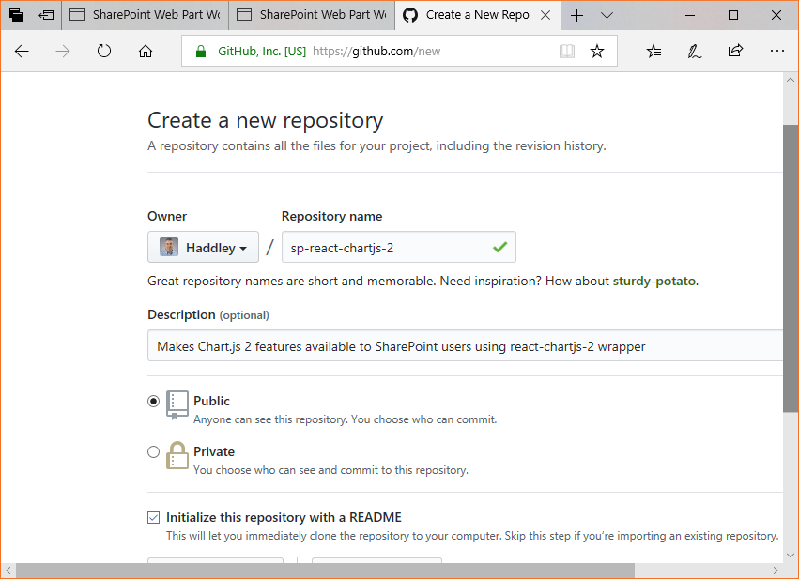

>git clone <https://github.com/Haddley/sp-react-chartjs-2.git>

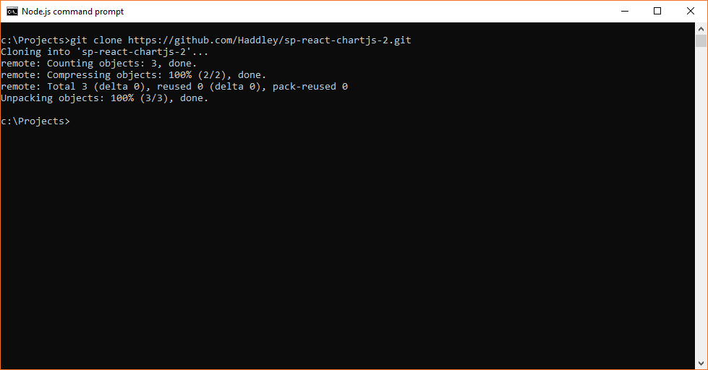

>yo @microsoft/sharepoint

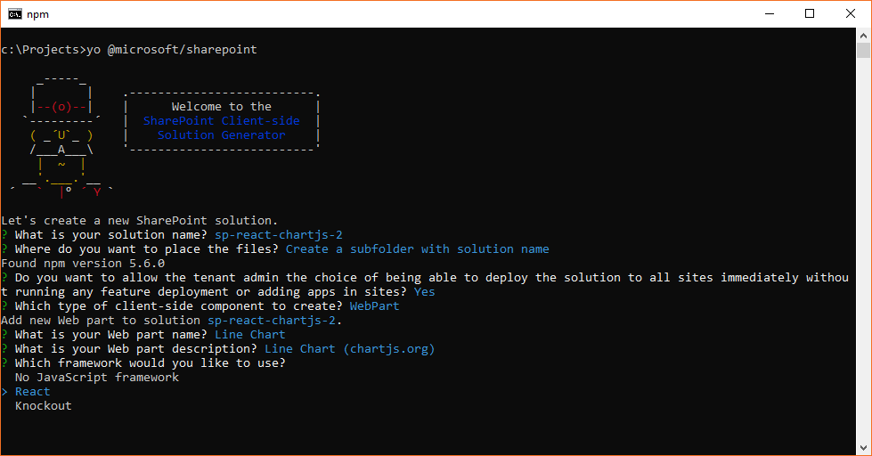

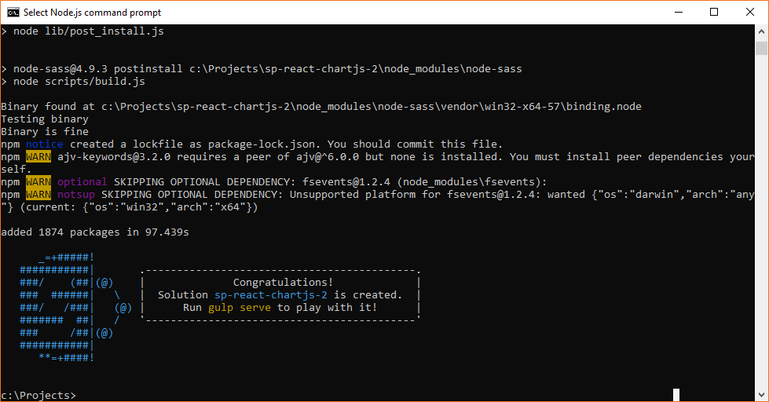

>git status

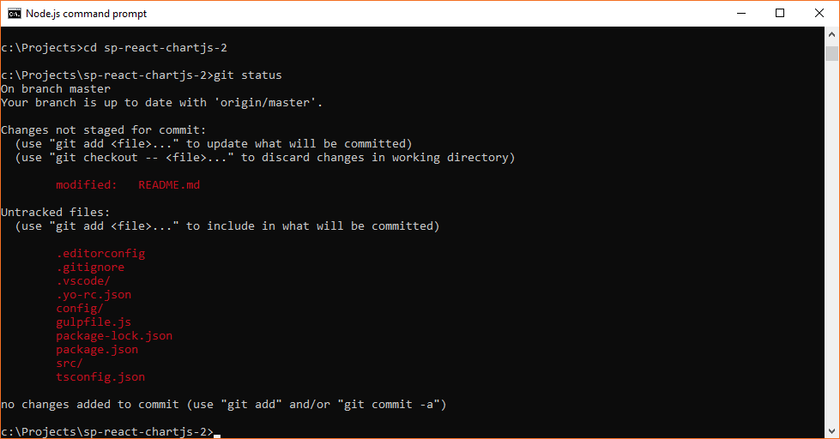

>git add .

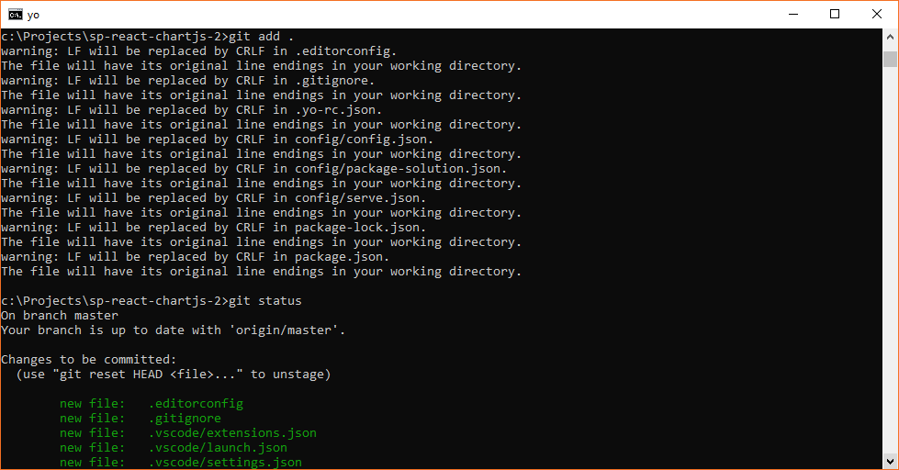

>yo @microsoft/sharepoint

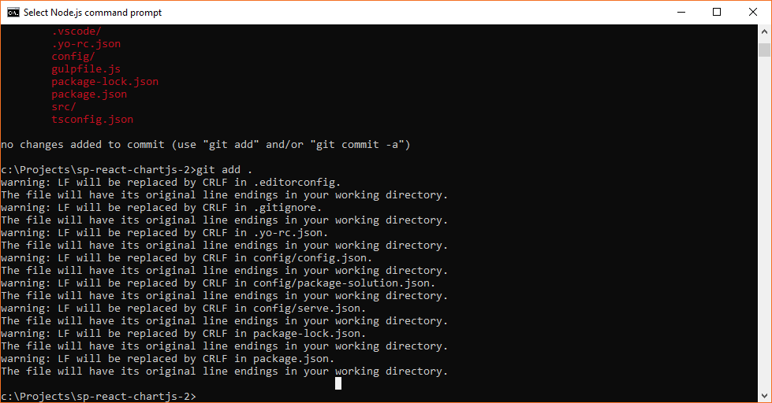

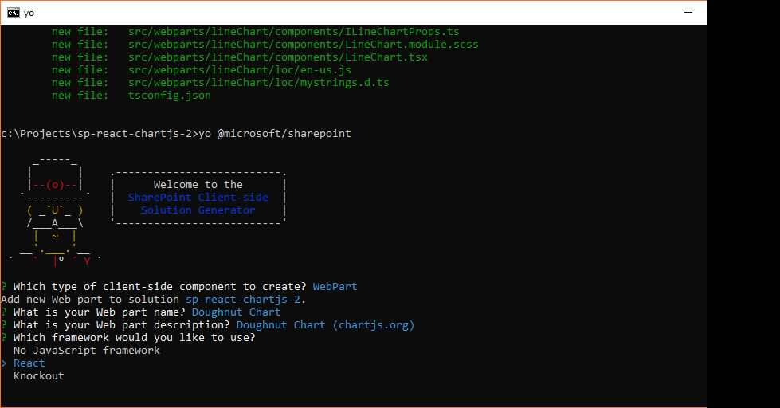

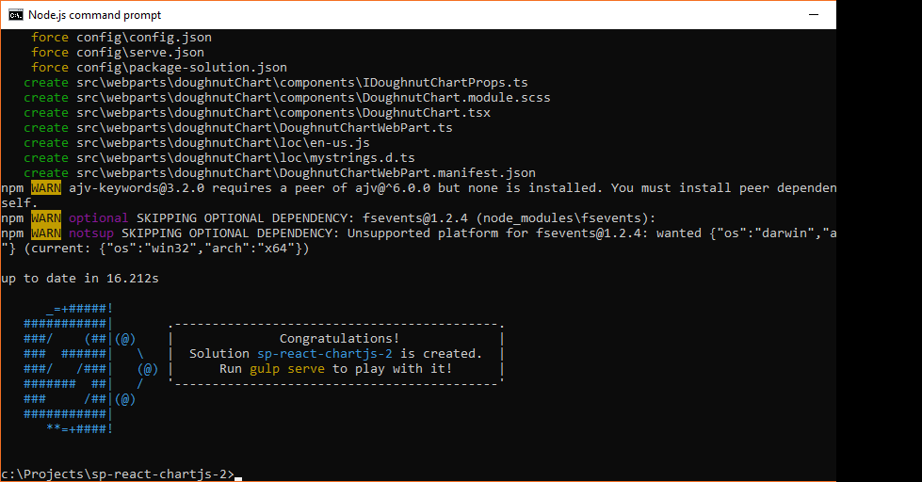

>gulp serve

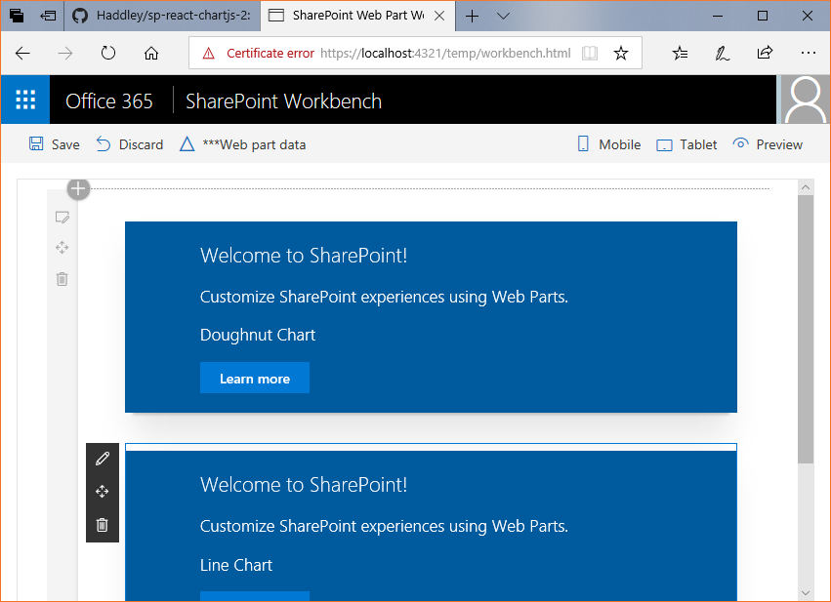

>npm i react-chartjs-2

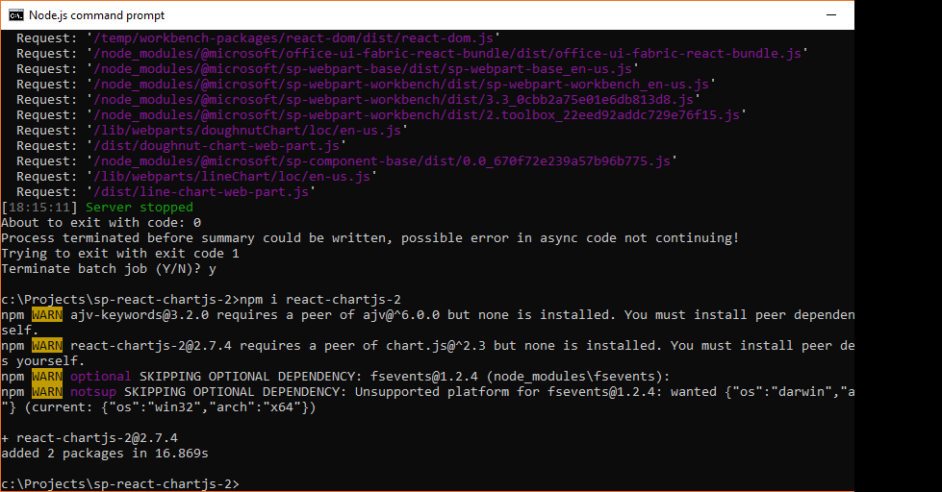

<https://github.com/jerairrest/react-chartjs-2/blob/master/example/src/components/line.js>

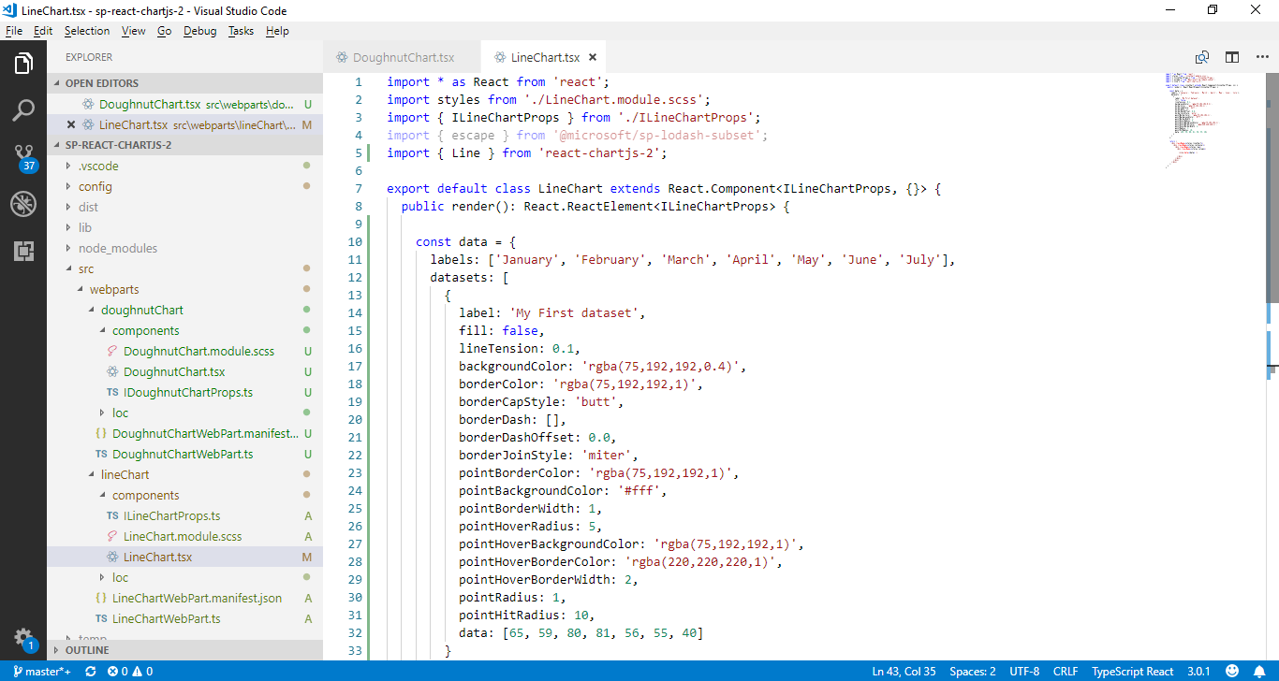

<https://github.com/jerairrest/react-chartjs-2/blob/master/example/src/components/doughnut.js>

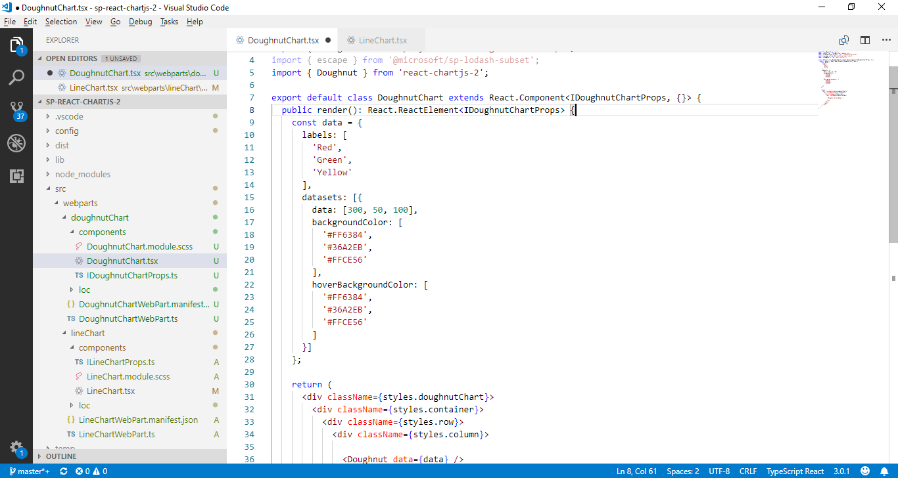

>npm install react-chartjs-2 chart.js --save

>gulp serve

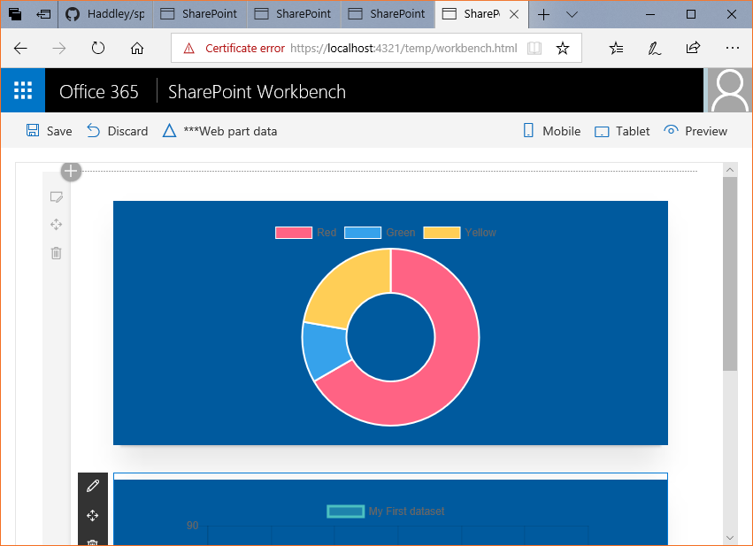

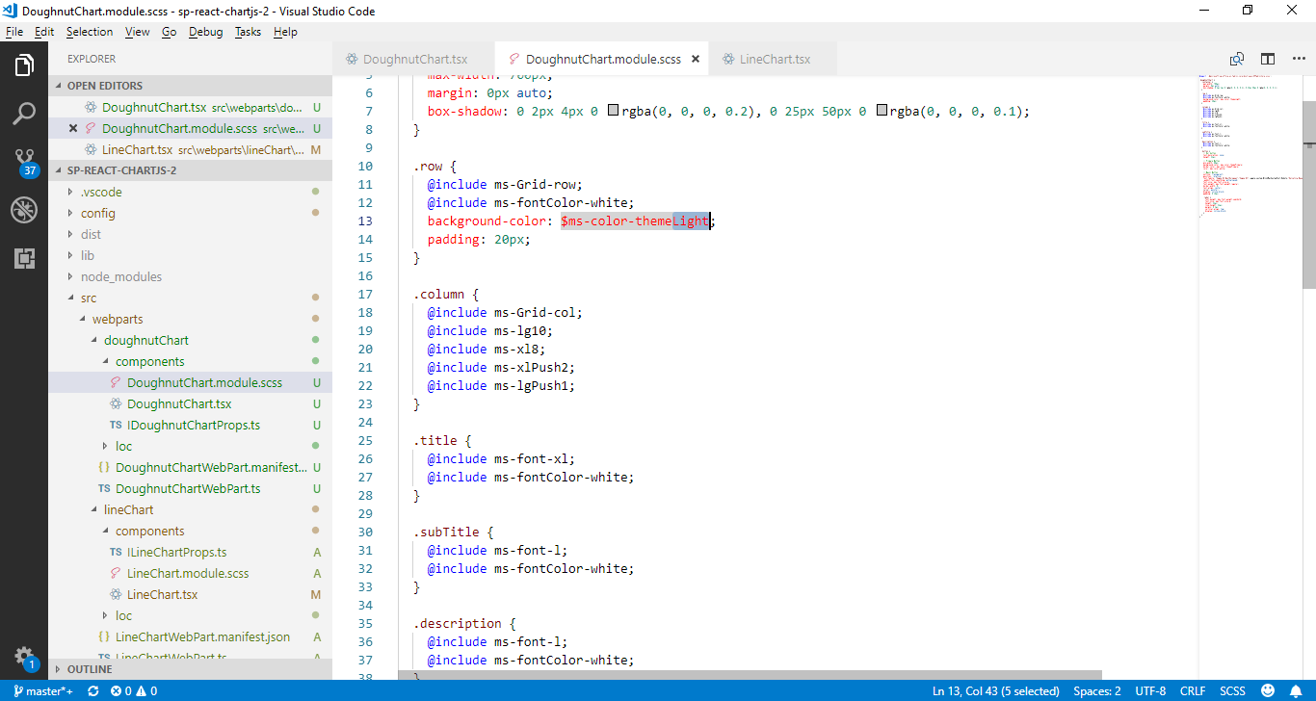

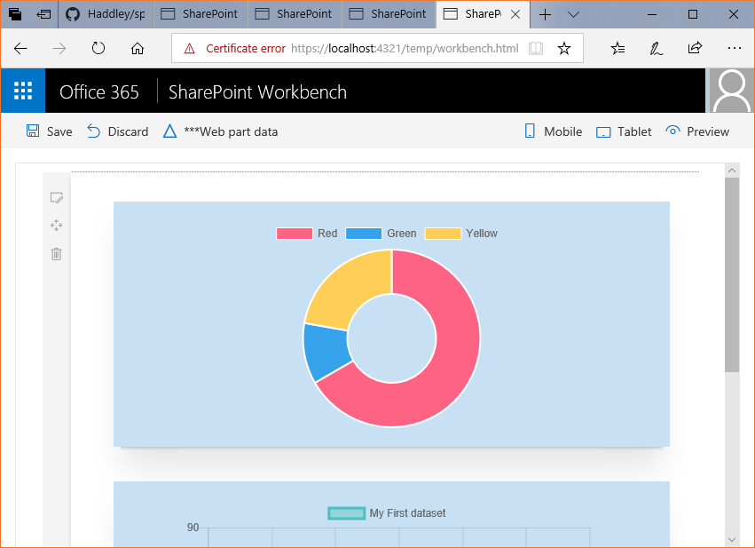

<https://github.com/jerairrest/react-chartjs-2/blob/master/example/src/components/bar.js>

<https://github.com/jerairrest/react-chartjs-2/blob/master/example/src/components/bubble.js>

<https://github.com/jerairrest/react-chartjs-2/blob/master/example/src/components/horizontalBar.js>

<https://github.com/jerairrest/react-chartjs-2/blob/master/example/src/components/pie.js>

<https://github.com/jerairrest/react-chartjs-2/blob/master/example/src/components/polar.js>

<https://github.com/jerairrest/react-chartjs-2/blob/master/example/src/components/radar.js>

<https://github.com/jerairrest/react-chartjs-2/blob/master/example/src/components/scatter.js>

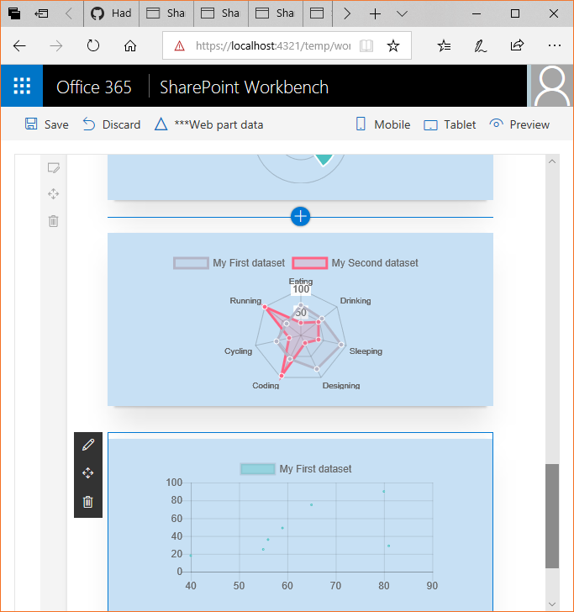

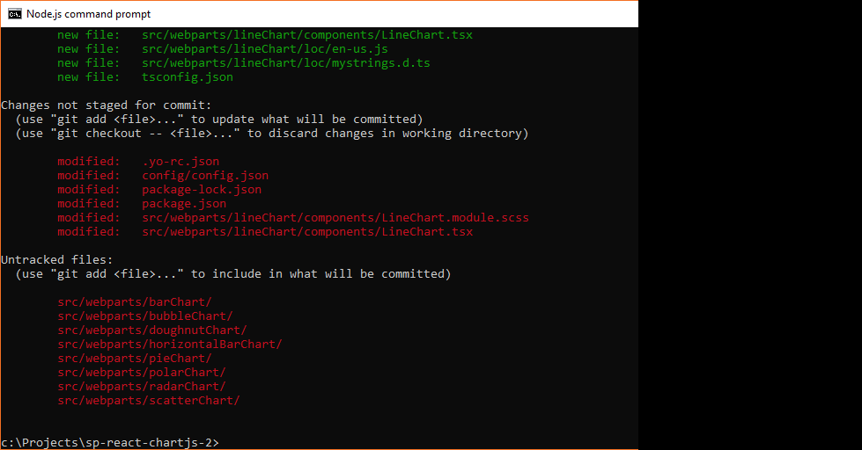

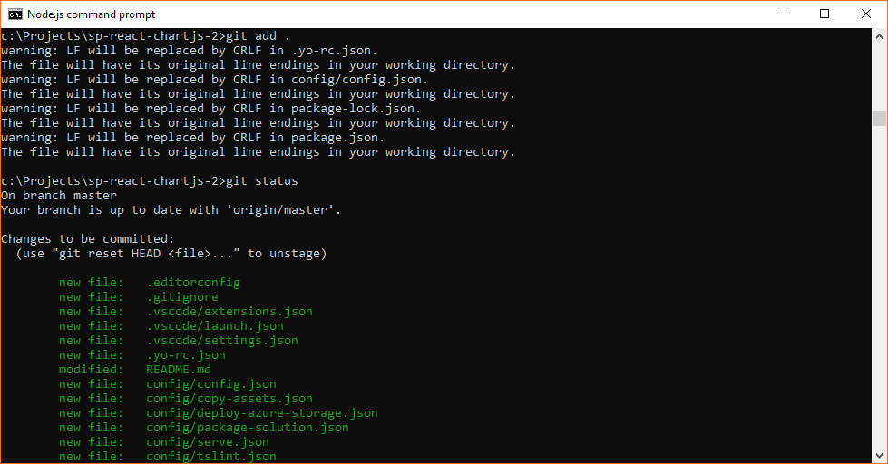

>git commit -m “initial commit”

>git push origin master