AI-Powered Exoplanet Habitability Explorer

Research Report I



Supervisor

Mam Nabeela Ashraf

Submitted by

Hadeed Ahmad
2022-ag-7746

Tahzeeb Arif
2022-ag-8065

BS Computer Science & Software Engineering
Department of Computer Science
University of Agriculture, Faisalabad.
Table of Contents

1. INTRODUCTION 1
1.1 Background 1
1.2 Description 1
1.3 Scope 1
1.4 Objectives 2
2. REQUIREMENTS 2
2.1 Functional Requirements 2
2.2 Non- Functional Requirements 3
2.3 Hardware Requirements 4
2.4 Software Requirements 4
3. METHODOLOGY 4
3.1 Process Model 4
3.2 Tools & Technologies 5
4. TIMELINE 6
5. CONCLUSION 7

List of Figures

Figure 1:Hybrid Agile Incremental Model 5
Figure 1: Timeline 6

INTRODUCTION

1.1 Background
One of the most important scientific discoveries of the twenty-first century has been the identification of exoplanets. Thousands of exoplanets have been discovered by NASA's Kepler, K2, and TESS missions; each has distinct features like size, orbital distance, temperature, mass, density, and host star characteristics. However, manual analysis is not feasible due to the enormous amount of data gathered by NASA's instruments. Determining whether a planet can support liquid water or potentially sustain life requires advanced computational analysis, multi-parameter evaluation, and modern Artificial Intelligence (AI) techniques.
Combining data science and astronomy is made possible by the development of astrophysical simulations and machine learning (ML). By creating an intelligent, interactive system that forecasts habitability, visualizes planetary systems, and facilitates simulation-based exploration, the AI Exoplanet Habitability Explorer aims to close this scientific gap.

Description
A web-based platform called the AI Exoplanet Habitability Explorer combines astrophysical modeling, data visualization, deep learning, and machine learning. The system uses current web technologies to process NASA's Kepler, K2, and TESS datasets, classify exoplanets using machine learning models, generate a habitability score (0–1), and display visual simulations.

The project contains multiple modules including:
- Data acquisition & preprocessing
- AI-driven habitability classification
- 3D orbit visualization
- Interactive dashboards
- Custom planet simulation module
- Explainable AI module (SHAP/LIME)
- Authentication and cloud deployment

The system is designed to be user-friendly, futuristic, and scientifically accurate for researchers, students, and the general public.

1.3 Scope
The scope of this project includes:
Included in Scope
- Collection and cleaning of exoplanet datasets
- Storage of structured data in PostgreSQL
- Development of ML/DL models
- Backend REST API in Django
- Interactive frontend in React & Tailwind CSS
- 3D orbit visualization (Three.js / D3.js)
- Real-time prediction for hypothetical planets
- Deployment to cloud platforms
- Complete documentation and testing
Not Included
- Real-time astronomical data synchronization
- Predictive modeling using spectroscopy or advanced astrophysics
- Large-scale GPU training infrastructure

1.4 Objectives
Main Objective
To develop an intelligent, AI-powered exoplanet habitability prediction and visualization system.
Sub-Objectives
- Predict exoplanet habitability using ML and DL models.
- Create a backend API for predictions and data management.
- Design a modern UI with interactive graphs and 3D simulations.
- Enable users to input custom parameters and run simulations.
- Provide explainability to understand AI predictions.
- Deliver a fully deployed and documented system.

REQUIREMENTS

2.1 Functional Requirements

FR01: User Authentication
FR01-01 | System shall allow user registration and login.
FR01-02 | The system shall authenticate credentials.
FR01-03 | Invalid login attempts shall generate an error message.

FR02: Exoplanet Data Exploration
FR02-01 | System shall display a list of exoplanets.
FR02-02 | System shall provide detailed profiles of each planet.
FR02-03 | System shall allow users to filter by parameters such as temperature, mass, or distance.

FR03: Habitability Prediction
FR03-01 | System shall use an AI model to generate a habitability score.
FR03-02 | Score shall range from 0–1.
FR03-03 | The system shall classify planets as:  - Habitable  - Potentially Habitable  - Non-Habitable

FR04: Interactive Visualizations
FR04-01 | System shall display 3D orbit simulations.
FR04-02 | Visualization shall allow zoom, rotate, and time controls.
FR04-03 | Graphical charts shall show relationships (temperature vs radius, etc.).

FR05: Planet Simulation
FR05-01 | Users shall input hypothetical planet parameters.
FR05-02 | The system shall run the AI model in real-time.
FR05-03 | The system shall show comparison graphs versus real exoplanets.

FR06: AI Explainability Assistant (AI Bot)
FR06-01 | The system shall include an AI Explainability Assistant (AI Bot).
FR06-02 | The bot shall explain the habitability prediction in simple terms.
FR06-03 | The bot shall display feature importance (e.g., “Distance from star had the biggest effect”).
FR06-04 | The bot shall answer user queries about predictions.
FR06-05 | The system shall use SHAP/LIME visualization to show how each parameter influenced the score.

FR07: User Dashboard
FR07-01 | System shall display saved simulations.
FR07-02 | System shall allow exporting results.

2.2 Non- Functional Requirements
NFR01: System should remain available 24/7.
NFR02: Prediction response time ≤ 3 seconds.
NFR03: UI must be fully responsive (mobile, tablet, desktop).
NFR04: Database must be secure and encrypted.
NFR05: Visualization should render smoothly at 60 FPS.
NFR06: System should support at least 5000 users.
NFR07: API must conform to RESTful standards.
NFR08: Code should be maintainable and well-documented.

2.3 Hardware Requirements
Processor: Intel Core i3 or above
RAM: 4GB (8GB recommended)
Storage: 40–50 GB
Internet connection

2.4 Software Requirements
Windows: 8/10/11 or Linux
Browser: Chrome / Firefox / Edge

METHODOLOGY

3.1 Process Model
For this project, the Hybrid Agile Model is selected because it provides the flexibility, adaptability, and iterative refinement required for a research-oriented AI software system. The project contains multiple dynamic components such as AI model development, data processing pipelines, backend APIs, user interface design, and 3D visualizations. These modules cannot be completed linearly; they require continuous updates based on new findings and feedback.
3.1.1 Why Hybrid Agile Works Best
- Agile
- Short development sprints
- Frequent supervisor feedback
- Continuous UI and feature improvement
- Iterative
- AI models require repeated training and tuning
- Results improve through multiple iterations
- Incremental
- Features added module by module
- Backend, frontend, AI, and visual components built separately
- Final system assembled through stable increments

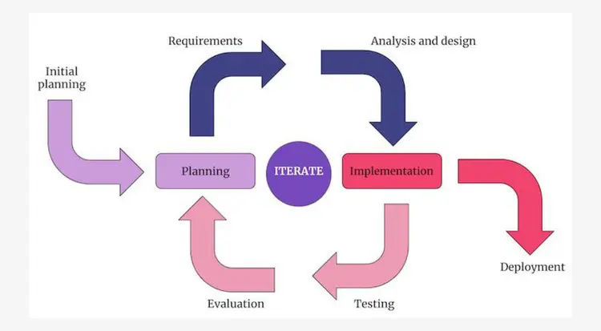
Figure 1: Hybrid Agile Incremental Model

Tools & Technologies
Python: Used for training the machine learning model and performing data preprocessing.
Scikit-Learn / XGBoost: Libraries used to build, train, and optimize the habitability prediction model.
Django REST Framework: Provides backend APIs for communication between the AI model and frontend interface.
PostgreSQL: Stores user data, prediction results, and planetary records in a structured database.
React.js: Used to develop the frontend interface with fast, interactive, component-based UI.
Tailwind CSS: Utility-first CSS framework used to design a modern and responsive user interface.
Three.js: Enables 3D visualizations of planets and interactive space-based graphics in the browser.
Chart.js / D3.js: Used to generate charts and visual analytics for planetary comparison and predictions.
Figma: Used to design the UI layout, wireframes, and screens before development.
Render / Vercel / AWS: Cloud platforms used to deploy the backend, frontend, and AI services online.

Timeline
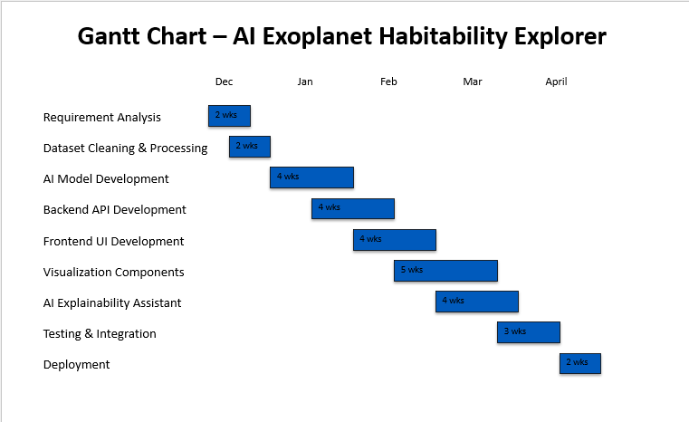
Figure 2: Timeline

CONCLUSION
The AI Exoplanet Habitability Explorer is a modern, intelligent software solution designed to make exoplanet exploration accessible, interactive, and scientifically meaningful. With advanced AI-based habitability prediction, a user-friendly interface, a simulation tool, and an AI Explainability Assistant, the platform offers a complete environment for learning and analysis.
By adopting the Hybrid Agile methodology, the development process ensures flexibility, continuous improvement, and delivery of high-quality features. The final product stands as a powerful educational and research tool, enabling users to explore distant worlds and understand the scientific reasoning behind habitability predictions.

