***Coding Academy by Orange***



MASTERPIECE PROJECT

**Title**: Anamel

**developed by**: Hadeel Al-Zoubi

## Orange Coding Academy - Irbid

4th Cohort 2024

**Acknowledgments**

I would like to express my deepest gratitude to God Almighty for giving me the ability to complete my project, and I would also like to express my great appreciation to the programming academy from Orange for giving me the opportunity to be here. I am especially grateful for the help provided by our dearest trainers at the Academy, and I would like to commend the supervision provided by our valuable trainers starting from the Director of Irbid Academy Mr. Muhammad Freihat, job coach Amer Abu Al Hayja, technical trainer coach Batool Walid and coach Ayman Aljaradat.

Abstract

Anamal is a platform to support small projects that specialize in handicrafts, merchants are registered on the platform by the super admin, and accordingly, this merchant displays his handicrafts, and the buying and selling process is done through the website itself.

# Chapter 1: Introduction

## Problem Statement

**Small businesses and local artisans, particularly in rural and underserved areas, struggle to market and sell their products due to limited access to digital platforms. They often lack the technical resources or reach to compete with larger businesses, leading to missed opportunities for growth and sales. Moreover, consumers interested in handmade and local products often face difficulty in finding a reliable source to purchase such items.**

## Solution

**The Anamel platform is designed to bridge this gap by offering a digital marketplace specifically tailored to support small businesses, particularly those selling handmade products. The site provides vendors with an easy-to-use interface to showcase their products, manage inventory, and handle orders. Customers can browse through a diverse range of handmade items, easily purchase what they need, and choose their preferred delivery method. The platform also supports secure payment options, fostering trust between buyers and sellers. This initiative opens up new marketing and sales channels for small businesses, helping them expand their reach and grow sustainably. Additionally, the platform includes features for promoting artisanal craftsmanship, encouraging fair trade, and empowering local entrepreneurs.**

# Chapter 2: Methodology

## 2.1 System Requirements

**A.**

|  |  |  |
| --- | --- | --- |
| **No** |  | Requirement Description |
| **1** | | The website allows users to sign in |
| **2** | | The website allows admins to sign in |
| **3** | | The website allows admin to access users’ requests. |
| **4** | | The website allows admin to show all user and our orders. |
| **5** | | The website allows admin to add new categories and new products. |

**B.**

|  |  |
| --- | --- |
| **No.** | Requirement Description |
|  | Ease of use: The website is user-friendly, simple, and responsive |
|  | Safety and confidentiality: No one allowed to access user requests information other  than the authorized person, who are admins. |

# Chapter 3: Technologies

## Programming Languages

|  |  |  |
| --- | --- | --- |
| **No** |  | Website |
| **1** | | HTML5 |
| **2** | | CSS3 – Bootstrap |
| **3** | | JavaScript |
| **4** | | Core Api |
| **5** | | SQL SERVER |

## Database

Using SQL SERVER to manage operations database.

There are 9 tables as shown in Shema below with necessary relation between them.

Tables: Users, CartItem , order Details, carts, ContactForm, products, managers, categories,VendorForm and orders.

## Database schema:

## C:\Users\Orange\Pictures\Screenshots\Screenshot 2024-10-17 163920.png

**Chapter 4: Design Models**

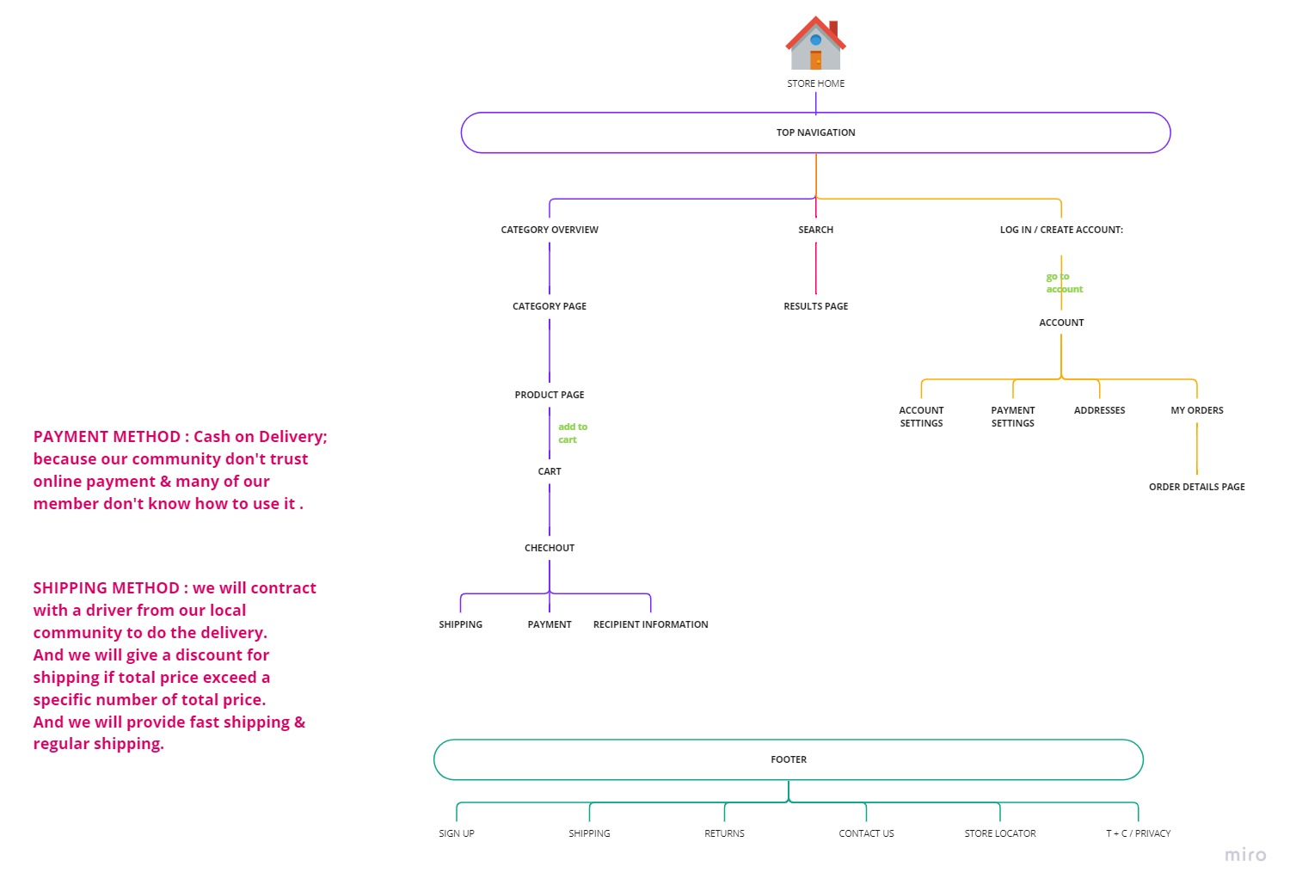

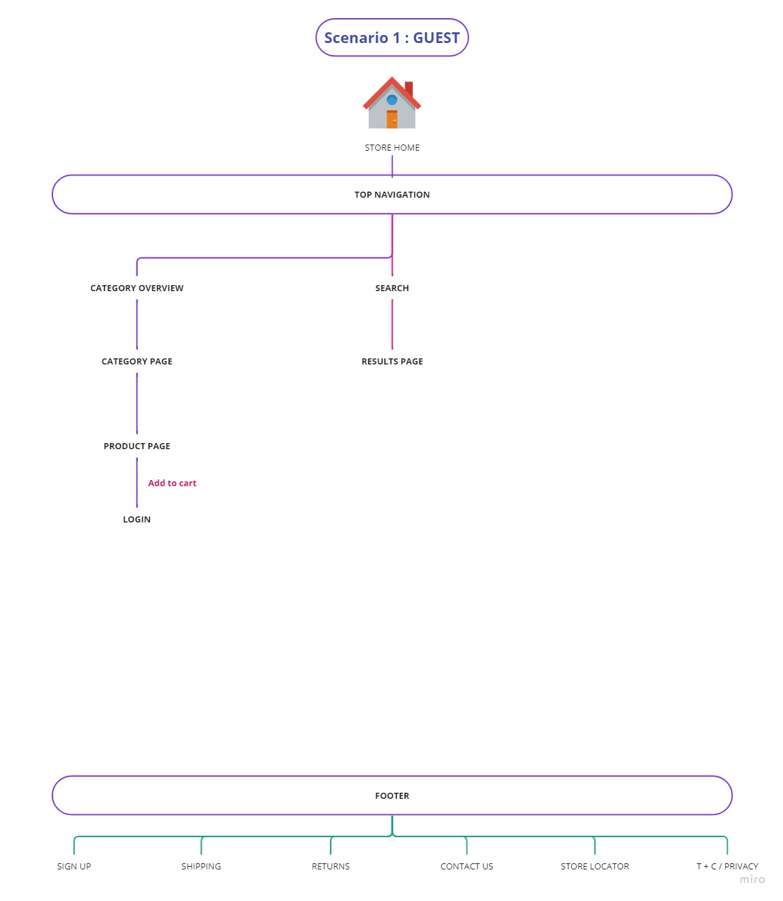

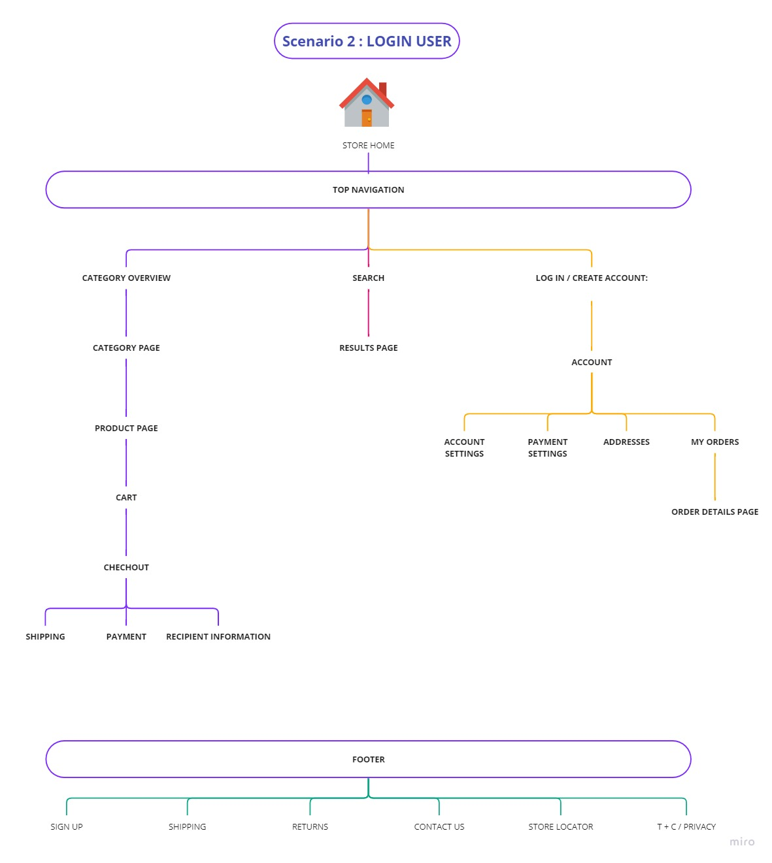

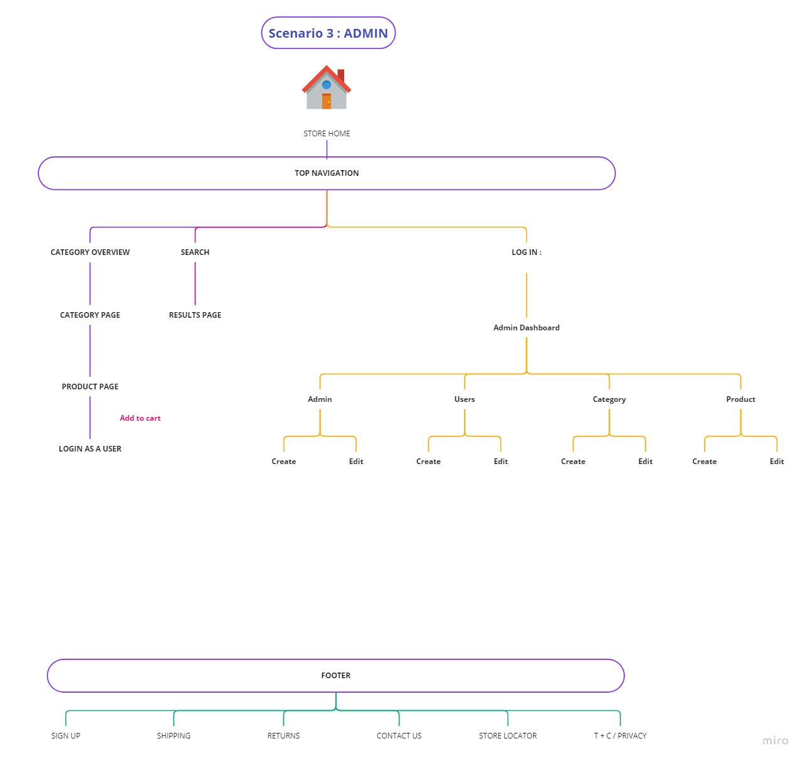

**Chapter 5: Experiments and results**

**Projects Features:**

* + 1. The website implements SEO.
    2. The website considers UX/UI design principles.
    3. The website is fully responsive.
    4. The website contains quiet animations.
    5. The website considers security by hashing strong passwords and activating the authorization demanding the user’s role.