adv.stats.mod12.R

hadeelmusallam

2022-11-16

#A)  
require(timeSeries)

## Loading required package: timeSeries

## Loading required package: timeDate

studentCredit<- c(31.9,27,31.3,31,39.4,40.7,42.3,49.5,  
 45,50,50.9,58.5,39.4,36.2,40.5,  
 44.6,46.8,44.7,52.2,54,48.8,55.8,58.7,63.4)  
credTS<- ts(studentCredit, frequency = 12, start = c(2012,1))  
credTS

## Jan Feb Mar Apr May Jun Jul Aug Sep Oct Nov Dec  
## 2012 31.9 27.0 31.3 31.0 39.4 40.7 42.3 49.5 45.0 50.0 50.9 58.5  
## 2013 39.4 36.2 40.5 44.6 46.8 44.7 52.2 54.0 48.8 55.8 58.7 63.4

plot(credTS)

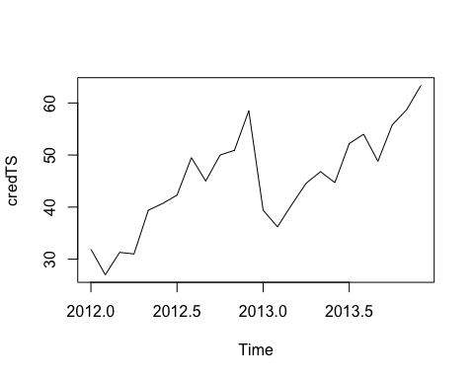

#B)   
smoothCredit<- HoltWinters(credTS,beta=FALSE, gamma=FALSE)  
smoothCredit

## Holt-Winters exponential smoothing without trend and without seasonal component.  
##   
## Call:  
## HoltWinters(x = credTS, beta = FALSE, gamma = FALSE)  
##   
## Smoothing parameters:  
## alpha: 0.8232442  
## beta : FALSE  
## gamma: FALSE  
##   
## Coefficients:  
## [,1]  
## a 62.44453

plot(smoothCredit)

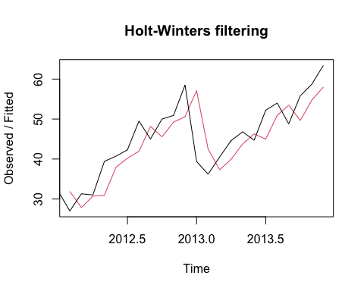

#C)  
#using the Holt-Winters Filtering function produces a simple exponential smoothing model.   
#The smooth plot in red shows over the original time series plot in black.   
#The plot is similar to the observed values but it seems to stagger behind.