adv.stats.mod7.R

hadeelmusallam

2022-10-09

#1.1  
x <- c(16, 17, 13, 18, 12, 14, 19, 11, 11, 10)  
y <- c(63, 81, 56, 91, 47, 57, 76, 72, 62, 48)  
#The relationship between the predictor and response variable is   
#described by the correlation and the scatterplot of the data.   
cor(x,y)

## [1] 0.7282365

#You must plot the points to see the linear relationship.   
plot(x,y)

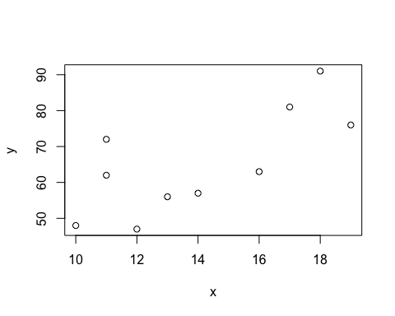

#This plot shows there is a positve linear relationship   
#between the predictor and the response variable.   
  
#1.2   
regression.Model=lm(y~x)  
regression.Model$coefficients

## (Intercept) x   
## 19.205597 3.269107

#2  
x<-c(3.6,1.8,3.333,2.283,4.533,2.883)  
y<-c(79,54,74,62,85,55)  
  
df<- data.frame(x,y)  
model_2<- lm(x~y)  
summary(model_2)

##   
## Call:  
## lm(formula = x ~ y)  
##   
## Residuals:  
## 1 2 3 4 5 6   
## -0.2039 -0.3149 -0.1331 -0.3724 0.3238 0.7005   
##   
## Coefficients:  
## Estimate Std. Error t value Pr(>|t|)   
## (Intercept) -1.53317 1.12328 -1.365 0.2440   
## y 0.06756 0.01623 4.162 0.0141 *  
## ---  
## Signif. codes: 0 '***' 0.001 '**' 0.01 '*' 0.05 '.' 0.1 ' ' 1  
##   
## Residual standard error: 0.4724 on 4 degrees of freedom  
## Multiple R-squared: 0.8124, Adjusted R-squared: 0.7655   
## F-statistic: 17.32 on 1 and 4 DF, p-value: 0.01413

p=plot(x~y,type="b")  
coef(model_2)

## (Intercept) y   
## -1.53317418 0.06755757

abline(model_2,col="blue",lwd=4)

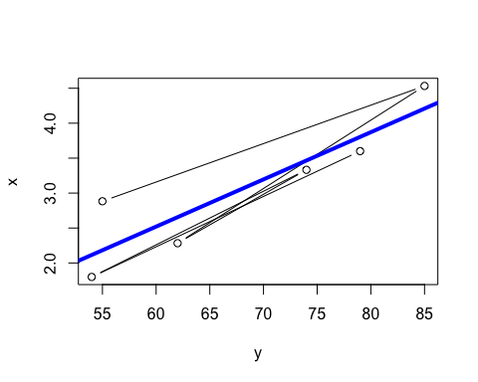

confint(model_2)

## 2.5 % 97.5 %  
## (Intercept) -4.65190869 1.5855603  
## y 0.02248535 0.1126298

#2.1 . The relationship model between the predictor and the response   
#variable is x = -1.53317+0.06756y  
  
#2.2. The regression equation has the parameters of  
#the coefficient function are 0.06756   
#for the predictor variable. -1.53317 for the intercept.   
  
#2.3. It is seen that The fitted model is not linear.  
#The relationship between the waiting and discharge is   
#nonlinear or polynomial.  
#The confint function shows that the 95% confidence level is there for   
#the intercept and the predictor.   
  
#3  
mcars.df= mtcars[c("mpg","disp", "hp", "wt")]  
print(head(mcars.df))

## mpg disp hp wt  
## Mazda RX4 21.0 160 110 2.620  
## Mazda RX4 Wag 21.0 160 110 2.875  
## Datsun 710 22.8 108 93 2.320  
## Hornet 4 Drive 21.4 258 110 3.215  
## Hornet Sportabout 18.7 360 175 3.440  
## Valiant 18.1 225 105 3.460

cars_model= lm(formula = mcars.df$mpg~mcars.df$disp+mcars.df$hp+mcars.df$wt, data= mcars.df)  
cars_model

##   
## Call:  
## lm(formula = mcars.df$mpg ~ mcars.df$disp + mcars.df$hp + mcars.df$wt,   
## data = mcars.df)  
##   
## Coefficients:  
## (Intercept) mcars.df$disp mcars.df$hp mcars.df$wt   
## 37.105505 -0.000937 -0.031157 -3.800891

summary(cars_model)

##   
## Call:  
## lm(formula = mcars.df$mpg ~ mcars.df$disp + mcars.df$hp + mcars.df$wt,   
## data = mcars.df)  
##   
## Residuals:  
## Min 1Q Median 3Q Max   
## -3.891 -1.640 -0.172 1.061 5.861   
##   
## Coefficients:  
## Estimate Std. Error t value Pr(>|t|)   
## (Intercept) 37.105505 2.110815 17.579 < 2e-16 ***  
## mcars.df$disp -0.000937 0.010350 -0.091 0.92851   
## mcars.df$hp -0.031157 0.011436 -2.724 0.01097 *   
## mcars.df$wt -3.800891 1.066191 -3.565 0.00133 **   
## ---  
## Signif. codes: 0 '***' 0.001 '**' 0.01 '*' 0.05 '.' 0.1 ' ' 1  
##   
## Residual standard error: 2.639 on 28 degrees of freedom  
## Multiple R-squared: 0.8268, Adjusted R-squared: 0.8083   
## F-statistic: 44.57 on 3 and 28 DF, p-value: 8.65e-11

#the intercept value is 37.105505, b1 is -0.000937, b2 is -0.031157, and b3 is -3.800891.   
#hp and wt has a significant relationship, but since the p-value is greater than   
#the significance level, then mpg and disp has no significant relationship.   
  
#4  
library(ISwR)  
plot(metabolic.rate~body.weight,data=rmr)

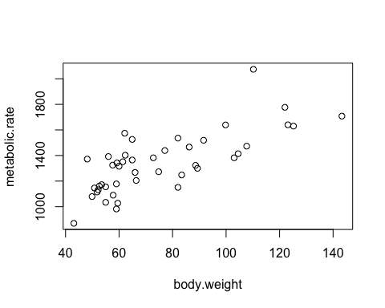

attach(rmr)  
md = lm(metabolic.rate ~ body.weight)  
summary(md)

##   
## Call:  
## lm(formula = metabolic.rate ~ body.weight)  
##   
## Residuals:  
## Min 1Q Median 3Q Max   
## -245.74 -113.99 -32.05 104.96 484.81   
##   
## Coefficients:  
## Estimate Std. Error t value Pr(>|t|)   
## (Intercept) 811.2267 76.9755 10.539 2.29e-13 ***  
## body.weight 7.0595 0.9776 7.221 7.03e-09 ***  
## ---  
## Signif. codes: 0 '***' 0.001 '**' 0.01 '*' 0.05 '.' 0.1 ' ' 1  
##   
## Residual standard error: 157.9 on 42 degrees of freedom  
## Multiple R-squared: 0.5539, Adjusted R-squared: 0.5433   
## F-statistic: 52.15 on 1 and 42 DF, p-value: 7.025e-09

#4.1  
#with x= 80, then y is 1375.987 kcal/24hr.