Architecture: Arabic HR PDF RAG System with Vision-Aware Table Understanding
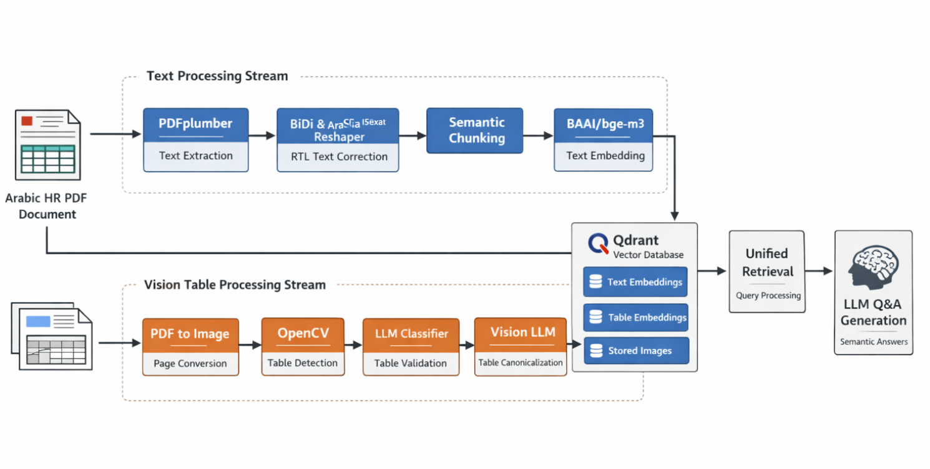
1. Problem Statement
This system builds a Retrieval-Augmented Generation (RAG) pipeline over Arabic HR law PDF documents that contain a mixture of:
- Standard Arabic paragraphs
- Highly complex tables with:
  - Merged cells
  - Empty cells
  - Ragged layouts
  - RTL Arabic content inside tables
Traditional PDF parsing and RAG approaches fail in this domain because:
- Arabic text is extracted in incorrect reading order.
- Table parsers flatten tables into meaningless text, losing structure.
- Visual table layouts are misinterpreted as graphics or frames.
- OCR-based approaches lose semantic relationships between cells.
To solve this, the system separates document processing into two specialized streams:
- Text Processing Stream
- Vision Table Processing Stream
Both streams are optimized independently and unified at the embedding and retrieval layer.

2. High-Level Architecture
Each PDF is processed through two parallel pipelines:
Stream | Purpose | Technique
Text Stream | Extract and prepare Arabic paragraphs | PDFplumber + RTL correction
Vision Table Stream | Understand complex tables visually | OpenCV + Vision LLM
Both streams converge into:
- Embedding phase using BAAI/bge-m3
- Storage in Qdrant
- Unified semantic retrieval

3. Text Processing Stream (Paragraph Content)
Step 1 — Text Extraction using PDFplumber
PDFplumber extracts raw Arabic characters along with positional metadata from each page.
This positional data is essential for later correcting reading order.
Step 2 — Arabic RTL Correction
Arabic text from PDFs often appears reversed or broken.
- python-bidi — restores correct right-to-left reading order
This produces semantically correct Arabic text.

Step 3 — Semantic Chunking
Text is split based on semantic boundaries (not fixed size) to improve retrieval quality.
Step 4 — Embedding with BAAI/bge-m3
Each chunk is embedded using the multilingual embedding model:
model_name = "BAAI/bge-m3"
This model is chosen for strong multilingual and semantic retrieval performance, including Arabic.
Step 5 — Storage in Qdrant
Each embedding is stored with metadata:
- Document name
- Page number
- Content type: text
- Reference to the page image for grounding

4. Vision Table Processing Stream (Tables)
Because Arabic HR tables break traditional parsers, a vision-first pipeline is used.
Step 1 — Convert PDF Page to Image “manually”
Each page is converted into an image to enable visual processing.
Step 2 — Table Detection using OpenCV “manually”
OpenCV analyzes the page image to detect grid-like structures, lines, and rectangular contours that represent candidate tables.
Since OpenCV may detect decorative frames, validation is required.
Step 3 — Crop Detected Table Region “manually”
Each candidate table region is cropped from the page image.
Step 4 — Table Classification using LLM “manually”
The cropped region is sent to the LLM to classify whether it is:
- A true table
- A graphical/decorative rectangle
False positives are filtered out here.
Step 5 — Vision-Based Table Understanding (Vision LLM Path)
The confirmed table image is sent directly to a Vision-capable LLM through the API.
The LLM performs:
- Visual reading of Arabic text from the image
- Understanding of rows, columns, merged cells, and empty cells
- Interpretation of implicit relationships between cells
- Full semantic understanding of the table
Step 6 — Semantic Interpretation & Canonicalization
The Vision LLM produces a canonical textual representation of the table that preserves:
- Headers and subheaders
- Cell values
- Row/column relationships
- Meaning of empty or repeated cells
- Full contextual meaning of the table
This output is not a grid, but a semantic explanation of the table.
Step 7 — Embedding Canonical Table Content
The entire canonical table representation is embedded as one semantic unit using BAAI/bge-m3.
Step 8 — Storage in Qdrant with Traceability
Each table embedding is stored with metadata:
- Document name
- Page number
- Content type: table
- Table caption (if present)
- Stored cropped table image
- Reference to the original page image
This allows full traceability and answer grounding.

5. Unified Retrieval Layer
At query time:
- Qdrant retrieves relevant embeddings from:
  - Text chunks
  - Canonical table representations
- The LLM receives both types of context.
- The LLM generates answers using paragraph knowledge and table knowledge seamlessly.

