Scaffold-Aware Machine Learning QSAR Modeling of Human Acetylcholinesterase Inhibitors
  - Molecular Representation, Stereochemistry, and Prediction Error Analysis
SCIENTIFIC WORKING REPORT | REVISED PORTFOLIO DRAFT
This research portfolio report documents the completed retrospective modeling analyses. The streamlined notebook was successfully executed against the local provisionally curated dataset, with matching rounded scaffold-CV and revised internal-holdout metrics. Source-publication and assay-level provenance verification, bibliography verification, and independent external validation remain outstanding. This is a working scientific report, not a peer-reviewed publication.

Abstract
Background: Human acetylcholinesterase (AChE) is a pharmacologically relevant target in the symptomatic treatment of Alzheimer’s disease. Quantitative structure–activity relationship (QSAR) modeling offers a computational approach to investigating relationships between molecular structure and inhibitory potency.
Methods: Experimental AChE IC50 records were retrieved from ChEMBL and subjected to provisional assay filtering, molecular standardization, conflict screening, and aggregation. The resulting dataset comprised 3,644 unique standardized compounds. Molecular representations included Morgan fingerprints, chirality-aware Morgan fingerprints, and eight physicochemical descriptors calculated using RDKit. Several regression algorithms were investigated, with particular attention to scaffold-aware cross-validation. A revised train–holdout partition was generated using achiral Bemis–Murcko scaffolds to prevent identical achiral scaffold groups from appearing in both partitions.
Results: The selected Extra Trees regression model, using chirality-aware Morgan fingerprints and physicochemical descriptors, achieved a mean five-fold scaffold cross-validation R² of 0.575, RMSE of 0.803, and MAE of 0.596. On the revised internal holdout set of 814 compounds, the model achieved an R² of 0.481, RMSE of 1.011, and MAE of 0.670. Classical descriptor-based regression models, including multiple linear regression and partial least squares regression, exhibited substantially lower cross-validation performance. Prediction error analysis showed that the 15 compounds with the largest absolute errors contributed 40.28% of the total holdout squared error, with pronounced underprediction observed for a structurally related group of highly potent compounds.
Conclusions: The findings demonstrate moderate predictive performance under scaffold-aware evaluation and identify important limitations in extrapolation to certain chemical series. The study highlights the importance of molecular representation, stereochemical considerations, scaffold-based validation, and compound-level error analysis in QSAR model assessment. Remaining uncertainties in experimental assay provenance and the exploratory nature of model development limit the interpretation of the reported performance as independent prospective validation.
Keywords: Acetylcholinesterase; QSAR; ChEMBL; RDKit; Extra Trees; Morgan fingerprints; scaffold-based validation; stereochemistry; machine learning.

1. Introduction
Alzheimer’s disease is associated with progressive cognitive impairment and remains a major challenge for therapeutic development. Acetylcholinesterase (AChE) catalyzes the hydrolysis of acetylcholine and is an established pharmacological target for symptomatic management. Small-molecule AChE inhibitors therefore provide a relevant chemical space for investigating structure–activity relationships.
Quantitative structure–activity relationship (QSAR) modeling relates molecular representations to experimentally measured biological activity. Physicochemical descriptors summarize global molecular properties, whereas circular fingerprints encode local structural environments. Machine-learning regression can model nonlinear associations between these representations and inhibitory potency, although predictive performance depends strongly on the underlying assay data and evaluation design.
A central challenge in ligand-based modeling is chemical-series dependence. Randomly splitting closely related compounds between training and evaluation sets can yield optimistic estimates of generalization. Scaffold-based grouping offers a more demanding assessment by separating molecular core structures. Stereochemical differences also merit attention because stereoisomers may share conventional connectivity fingerprints while displaying distinct activities.
This study developed a provisionally curated human AChE IC50 dataset from ChEMBL, compared descriptor-based classical QSAR with fingerprint-based machine-learning approaches, and evaluated a selected Extra Trees model under achiral-scaffold-aware validation. The analysis further examined the contribution of stereochemical representation and identified chemical series associated with disproportionately large prediction errors. The emphasis is on reproducible assessment and transparent limitations rather than claiming prospective drug-discovery readiness.

2. Materials and Methods

2.1. Data Collection
Experimental inhibitory activity data for human acetylcholinesterase (AChE) were retrieved from the ChEMBL database using the target identifier CHEMBL220, corresponding to human AChE (UniProt accession P22303).
The initial collection contained 10,079 IC50 activity records. Records were filtered to retain numerical IC50 measurements reported in nanomolar units with an exact equality relationship. Following this initial filtering, 7,275 records were retained.
IC50 values were transformed to the logarithmic potency scale according to: pIC50 = 9 − log10(IC50 [nM]). Higher pIC50 values therefore correspond to greater experimentally reported inhibitory potency.

2.2. Data Curation and Molecular Standardization
A multistage data-processing workflow was applied to improve the consistency of the activity dataset.
Assay metadata were retrieved and used for preliminary classification and exclusion of records considered insufficiently supported for the intended direct AChE inhibition modeling task. Molecular structures were processed using RDKit, including molecular cleanup and fragment-parent standardization to remove disconnected counterions and retain the principal molecular structure.
Compounds associated with conflicting activity measurements were screened using the range of reported pIC50 values. Molecular entries exhibiting substantial activity disagreement were excluded under the predefined conflict-screening procedure.
For compounds with multiple eligible measurements, activity values were aggregated using the median pIC50. The resulting provisional modeling dataset contained 3,644 unique standardized compounds.
Because the underlying measurements originated from heterogeneous experimental sources, and source-publication verification was not completed for every assay, the dataset was treated as provisionally curated rather than fully harmonized.

2.3. Molecular Descriptor Calculation
Eight physicochemical descriptors were calculated using RDKit: molecular weight (MW), octanol–water partition coefficient (LogP), topological polar surface area (TPSA), hydrogen bond donors (HBD), hydrogen bond acceptors (HBA), number of rotatable bonds, ring count, and fraction of sp³-hybridized carbon atoms (FractionCSP3).
These descriptors were used as inputs for classical regression baselines and in combination with molecular fingerprints for selected machine-learning models.

2.4. Molecular Fingerprint Generation
Morgan fingerprints were generated using RDKit with a radius of 2 and a fixed length of 2,048 bits.
Both conventional Morgan fingerprints and chirality-aware Morgan fingerprints were investigated. The latter incorporated stereochemical information into the molecular representation.
The selected model used a combined feature representation comprising 2,048 chirality-aware Morgan fingerprint bits and eight physicochemical descriptors, giving a total of 2,056 input features.

2.5. Scaffold-Based Dataset Partitioning
Molecular scaffolds were generated using the Bemis–Murcko framework implemented in RDKit.
Initial exploratory experiments used chirality-aware scaffold grouping. Subsequent structural-overlap analysis identified shared achiral scaffolds and molecular connectivity patterns across the original training and test partitions.
To address this issue, a revised split was generated using achiral Bemis–Murcko scaffolds as grouping identifiers. The revised partition contained 2,830 training compounds and 814 internal holdout compounds.
No achiral Bemis–Murcko scaffolds or identical non-isomeric molecular connectivity representations were shared between the revised partitions. Five-fold GroupKFold cross-validation was performed within the revised training set using achiral scaffold groups.
The revised holdout was used for final internal performance characterization. However, because the broader dataset had already been examined during earlier exploratory modeling, this partition was not considered a fully independent external validation set.

2.6. Machine-Learning Model Development
Several regression algorithms were investigated during exploratory model development, including Random Forest, Extra Trees, support vector regression, k-nearest neighbors, Ridge regression, XGBoost, LightGBM, and CatBoost.
Extra Trees regression was selected for the final modeling workflow based on exploratory comparisons and subsequent scaffold-based cross-validation.
The final Extra Trees configuration used 300 trees, square-root feature sampling at each split, a minimum of one sample per leaf, two samples per split, unrestricted maximum depth, and random_state = 42.
The selected configuration was fitted to the full revised training set before generating predictions for the revised internal holdout.

2.7. Classical QSAR Baselines
Multiple linear regression (MLR) and partial least squares (PLS) regression were evaluated as classical QSAR baselines.
Both methods used the eight RDKit physicochemical descriptors. Descriptor standardization was performed within the cross-validation pipeline to avoid using validation-fold information during preprocessing.
PLS models with 2, 4, and 6 latent components were evaluated. Model performance was assessed using five-fold achiral scaffold GroupKFold cross-validation on the revised training partition.

2.8. Model Performance Evaluation
Predictive performance was quantified using the coefficient of determination (R²), root mean squared error (RMSE), and mean absolute error (MAE).
The selected Extra Trees model was assessed using five-fold scaffold cross-validation and the revised internal holdout set.
Compound-level residuals were calculated as: Residual = Experimental pIC50 − Predicted pIC50.
Prediction errors were investigated using experimental-versus-predicted activity plots, residual distributions, and analysis of compounds with the largest absolute errors. The contribution of the 15 largest absolute errors to the total squared prediction error was also calculated to characterize error concentration within the holdout set.

Model Performance Snapshot
Model | Evaluation | R² | RMSE | MAE
Extra Trees + chiral Morgan + descriptors | 5-fold scaffold CV | 0.575 | 0.803 | 0.596
Extra Trees + chiral Morgan + descriptors | Revised internal holdout | 0.481 | 1.011 | 0.670
MLR + 8 descriptors | 5-fold scaffold CV | 0.164 | 1.126 | 0.908
PLS (6) + 8 descriptors | 5-fold scaffold CV | 0.162 | 1.127 | 0.908
Reporting note: All results derive from the provisional curated dataset; the revised holdout is internal and not a fully independent external validation set.

3. Results

3.1. Curated Dataset and Revised Scaffold Partition
After provisional assay-level filtering, molecular standardization, conflict screening, and median aggregation of eligible measurements, 3,644 unique standardized compounds were retained. The revised achiral Bemis–Murcko scaffold split allocated 2,830 compounds to training and 814 to the internal holdout. The two partitions had no shared achiral Murcko scaffold identifiers or identical non-isomeric molecular connectivity representations. The training and holdout sets nevertheless differed in activity distribution, with holdout pIC50 exhibiting greater dispersion (standard deviation approximately 1.404 versus 1.240 in training).

3.2. Model Comparison under Scaffold Cross-Validation
The selected Extra Trees model combining 2,048-bit chirality-aware Morgan fingerprints and eight RDKit descriptors yielded mean five-fold achiral scaffold GroupKFold R² = 0.575, RMSE = 0.803, and MAE = 0.596. For comparison, descriptor-only multiple linear regression achieved R² = 0.164, RMSE = 1.126, and MAE = 0.908; descriptor-only PLS regression with six components achieved R² = 0.162, RMSE = 1.127, and MAE = 0.908. Because the feature representations differed, this comparison evaluates modeling pipelines rather than isolating the effects of regression algorithms.

3.3. Revised Internal Holdout Performance
After fitting the frozen Extra Trees configuration to all 2,830 training compounds, evaluation on 814 revised holdout compounds produced R² = 0.481, RMSE = 1.011 pIC50 units, and MAE = 0.670 pIC50 units. Performance was lower than the average scaffold cross-validation result, indicating weaker predictive accuracy on this particular holdout partition. This internal holdout was not a fully untouched validation set because the broader dataset had been examined during earlier model-development experiments.

3.4. Prediction Error Characteristics
The experimental-versus-predicted plot showed a tendency to underpredict some highly potent inhibitors and overpredict some low-potency compounds. Residual analysis revealed a pronounced positive tail. The 15 compounds with the largest absolute residuals accounted for 40.28% of the holdout sum of squared errors; 30 of 814 compounds had absolute errors exceeding 2 pIC50 units. Fourteen of the 15 largest errors occurred among compounds with experimental pIC50 approximately 9.29–10.96 and predicted values approximately 5.73–5.94. Their displayed structures shared apparent isoquinolinone-related motifs. Chemical-series membership, source assays, and the reliability of these extreme potency measurements require source-level verification; these compounds were not removed from reported metrics.

4. Discussion
The results suggest that a structure-enriched, nonlinear QSAR pipeline captures more activity variation than the tested descriptor-only linear baselines under scaffold-aware cross-validation. This observation is consistent with the possibility that substructural patterns and nonlinear relationships contribute information not represented by eight global physicochemical descriptors. However, the experiment does not establish that the Extra Trees algorithm itself is superior to linear regression when both use identical molecular features.
The modest improvement of chirality-aware over conventional Morgan fingerprints during exploratory scaffold cross-validation was small (mean R² approximately 0.575 versus 0.568 on the revised training set). Earlier error inspection also identified stereoisomeric structures with markedly different reported activities. Those cases motivate explicit stereochemical representation, but their experimental provenance and stereochemical assignments require verification before treating them as independently confirmed activity cliffs.
The concentration of squared error in a small set of extremely potent compounds suggests that the model has difficulty generalizing to at least one chemically related high-potency region. Possible explanations include limited local training coverage, experimental heterogeneity, and inadequate structural representation; the present results do not distinguish these explanations. The extreme compounds should be investigated against primary literature and assay metadata, not excluded merely because their predictions are inaccurate.
A pIC50 prediction error of one unit corresponds to a tenfold difference in IC50 on the original concentration scale. Consequently, even apparently moderate aggregate errors may limit practical potency ranking or quantitative lead optimization. The model should be considered exploratory and not used as a standalone decision-making tool for experimental prioritization without further validation and uncertainty assessment.

5. Study Limitations
- Assay provenance and comparability: Assay classification and source-publication verification remain incomplete; pooled IC50 values may reflect heterogeneous experimental protocols.
- Internal validation: The revised scaffold holdout eliminated the audited achiral scaffold overlap, but prior exposure of the broader dataset during exploratory analyses prevents it from functioning as a fully independent external test.
- Scaffold partitioning: An achiral Murcko scaffold split tests a particular notion of structural separation, not every possible definition of chemical novelty or prospective applicability.
- Model-selection uncertainty: Hyperparameters and representation choices were explored using related data; the reported scaffold CV scores are not nested-CV estimates of the entire model-selection procedure.
- Error concentration: A small, highly potent structural series contributes disproportionately to squared error; its primary experimental evidence requires manual verification.
- Feature comparison: Descriptor-only MLR/PLS and fingerprint-plus-descriptor Extra Trees do not isolate algorithmic differences.

6. Conclusion
A scaffold-aware QSAR workflow was developed for a provisionally curated set of 3,644 human AChE inhibitors. The selected chirality-aware Morgan fingerprint and descriptor-based Extra Trees model achieved mean scaffold cross-validation R² = 0.575 and revised internal holdout R² = 0.481. Classical descriptor-only MLR and PLS baselines performed substantially less well under the same training-partition scaffold folds. Compound-level analysis identified pronounced underprediction of a small group of highly potent compounds and demonstrated that aggregate metrics alone obscure important reliability limitations. The principal contribution of this study is a transparent, reproducible exploratory workflow and a critical assessment of generalization, rather than a claim of deployment-ready potency prediction.

7. Final Figures
Reproducible public-notebook outputs (subject to data-release review): results/Publish_v2_ExtraTrees_scaffold_cv.csv; results/Publish_v2_MLR_PLS_scaffold_cv.csv; results/Publish_v2_holdout_metrics.csv; results/Publish_v2_holdout_predictions.csv. The full exploratory records and trained estimator models/ExtraTrees_ChiralMorgan_Final_v2.joblib are retained locally. The streamlined notebook requires data/processed/AChE_QSAR_provisional.csv and does not reproduce assay-level curation from original ChEMBL records.
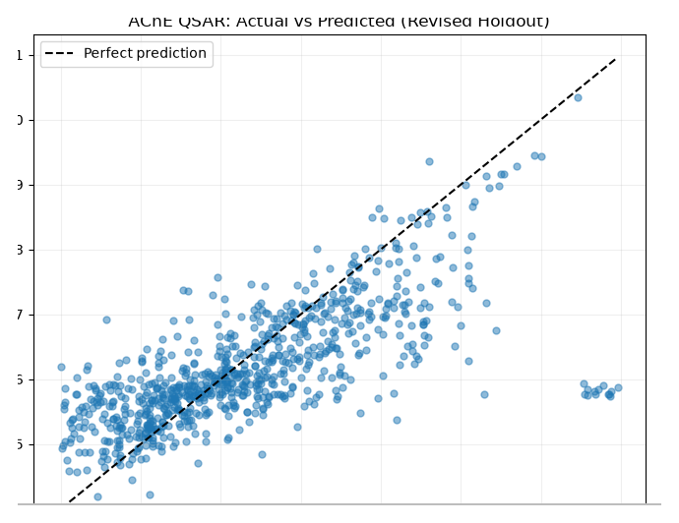
Figure 1. Experimental versus predicted pIC50 for 814 compounds in the revised internal scaffold holdout. The dashed diagonal indicates perfect agreement.
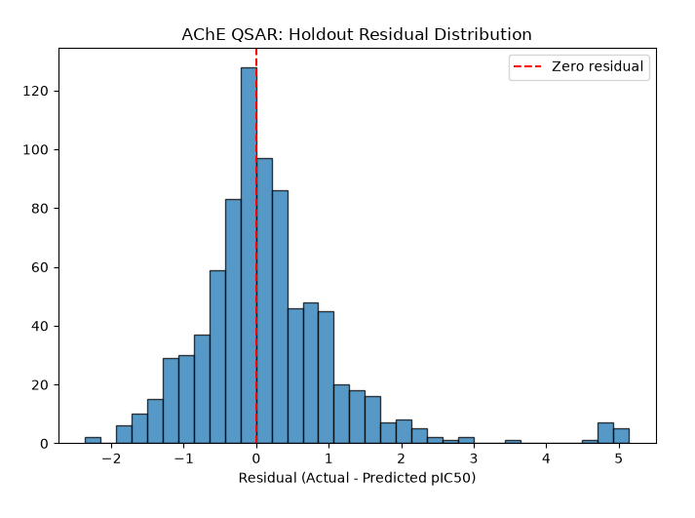
Figure 2. Distribution of residuals (experimental minus predicted pIC50) for the revised internal holdout. The dashed vertical line marks zero residual.

8. References
1. ChEMBL Database. EMBL-EBI. https://www.ebi.ac.uk/chembl/ (accessed October 2026).
2. RDKit: Open-Source Cheminformatics Software. https://www.rdkit.org/ (accessed October 2026).
3. Bemis GW, Murcko MA. The properties of known drugs. 1. Molecular frameworks. Journal of Medicinal Chemistry. 1996;39(15):2887–2893. doi:10.1021/jm9602928.
4. Rogers D, Hahn M. Extended-connectivity fingerprints. Journal of Chemical Information and Modeling. 2010;50(5):742–754. doi:10.1021/ci100050t.
5. Geurts P, Ernst D, Wehenkel L. Extremely randomized trees. Machine Learning. 2006;63:3–42. doi:10.1007/s10994-006-6226-1.
6. Morgan HL. The generation of a unique machine description for chemical structures—A technique developed at Chemical Abstracts Service. Journal of Chemical Documentation. 1965;5(2):107–113. doi:10.1021/c160017a018.

