**VIDYAVARDHAKA COLLEGE OF ENGINEERING**

**P.B. No.206, Gokulam, III - Stage, Mysore - 570 002, Karnataka, INDIA.  
Phone: +91 821 4276201 / 202 / 225.**



**DEVOPS LABORATORY 20CS77**

**(ACADEMIC YEAR 2023-24)**

Activity Based Assessment

**Submitted By**

**Student1[USN1]**

**Student2[USN2]**

**Student3[USN3]**

**Student4[USN4]**

### 

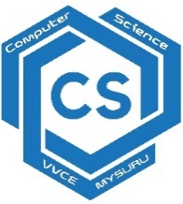

**Department of Computer Science and Engineering**

Devops Laboratory – Activity Based Assessment

**Tools Used**

1. Git and Git Hub
2. Jenkins
3. Docker and Docker Hub
4. Slack Channel
5. Selenium
6. Maven

**Introduction to tools**

 git and GitHub are not the same thing. Git is an open-source, version control tool created in 2005 by developers working on the Linux operating system; GitHub is a company founded in 2008 that makes tools which integrate with git. You do not need GitHub to use git, but you cannot use GitHub without using git. There are many other alternatives to GitHub, such as GitLab, BitBucket, and “host-your-own” solutions such as gogs and gittea. All of these are referred to in git-speak as “remotes”, and all are completely optional. You do not need to use a remote to use git, but it will make sharing your code with others easier.

Jenkins

Jenkins Tutorial is designed for both beginners and professionals. Our Tutorial provides all the basic and advanced concepts of Jenkins, such as Jenkins installation, Jenkins Configuration, Jenkins Pipeline, etc.

Jenkins is an open source automation tool written in Java programming language that allows continuous integration.

Jenkins builds and tests our software projects, which continuously making it easier for developers to integrate changes to the project, and making it easier for users to obtain a fresh build.

**Docker Hub**

**Docker Hub** is a repository service and it is a cloud-based service where people push their Docker Container Images and also pull the Docker Container Images from the **Docker Hub** anytime or anywhere via the internet. It provides features such as you can push your images as private or public. Mainly DevOps team uses the Docker Hub. It is an open-source tool and freely available for all operating systems. It is like storage where we store the images and pull the images when it is required. When a person wants to push/pull images from the Docker Hub they must have a basic knowledge of Docker. Let us discuss the requirements of the Docker tool.

**Architecture of Pipeline**

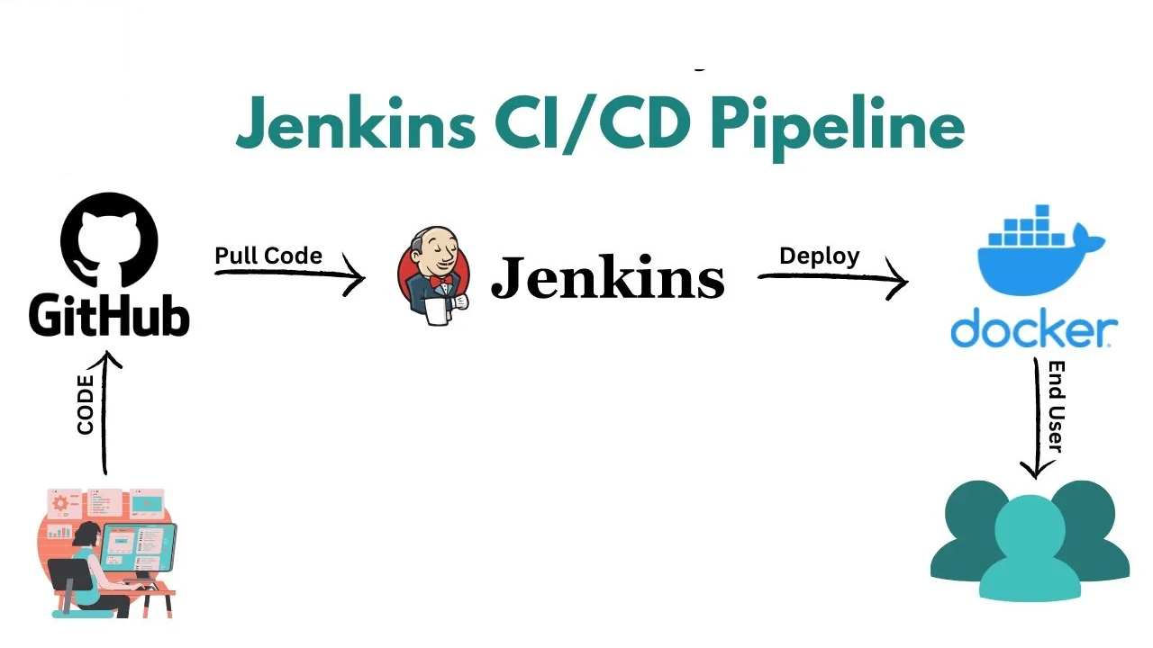

**Implementation of Pipeline**

**Github**

**Pushing the code into git hub**

**Jenkins**

**Configuration**

**Docker configuration in Jenkins**

**Pipeline script**

**Pushing the image into docker hub**

