

**Management and Entrepreneurship**

**(BCSMA503)**

**Activity Based Assessment**

**On**

**“Naresh Goyal and Jet Airways: A Story of Rise and Fall”**

**Submitted By:**

|  |  |
| --- | --- |
| **Yashwanth S** | **4VV22CS189** |
| **Venkatesha Y K** | **4VV22CS181** |
| **Yesh Gowda** | **4VV22CS190** |

**Submitted To:**

**Prof. Kavitha D N**

**Department of**

**Computer Science and Engineering**

**VVCE**

**Introduction**

Naresh Goyal’s journey and Jet Airways’ evolution epitomize ambition and innovation in Indian aviation. Founded in 1993 with a vision of providing affordable and quality air travel, Jet Airways became one of India’s most iconic airlines. This report examines the rise, growth, challenges, controversies, and lessons learned from its downfall.

Goyal’s entry into the travel and tourism industry laid the foundation for his rise as an aviation mogul. With strategic vision and a passion for service, Jet Airways redefined air travel in India. However, its rise was met with challenges that eventually led to its collapse, offering valuable lessons for future enterprises.



Logo of JET AIRWAYS

Naresh Goyal

**Building Jet Airways**

Jet Airways began operations with a small fleet of Boeing 737 aircraft, prioritizing customer satisfaction and operational efficiency. Key milestones in its journey included:

* **Domestic Expansion**: Jet Airways established a strong presence in India, connecting multiple cities.
* **Brand Development**: The airline fostered customer loyalty through innovative services and a strong corporate identity.
* **Service Excellence**: By maintaining high standards of hospitality, Jet Airways set itself apart from competitors.

Naresh Goyal’s leadership and his deep understanding of the aviation industry propelled the airline to the forefront of Indian air travel. The airline became synonymous with luxury and reliability, garnering a loyal customer base.

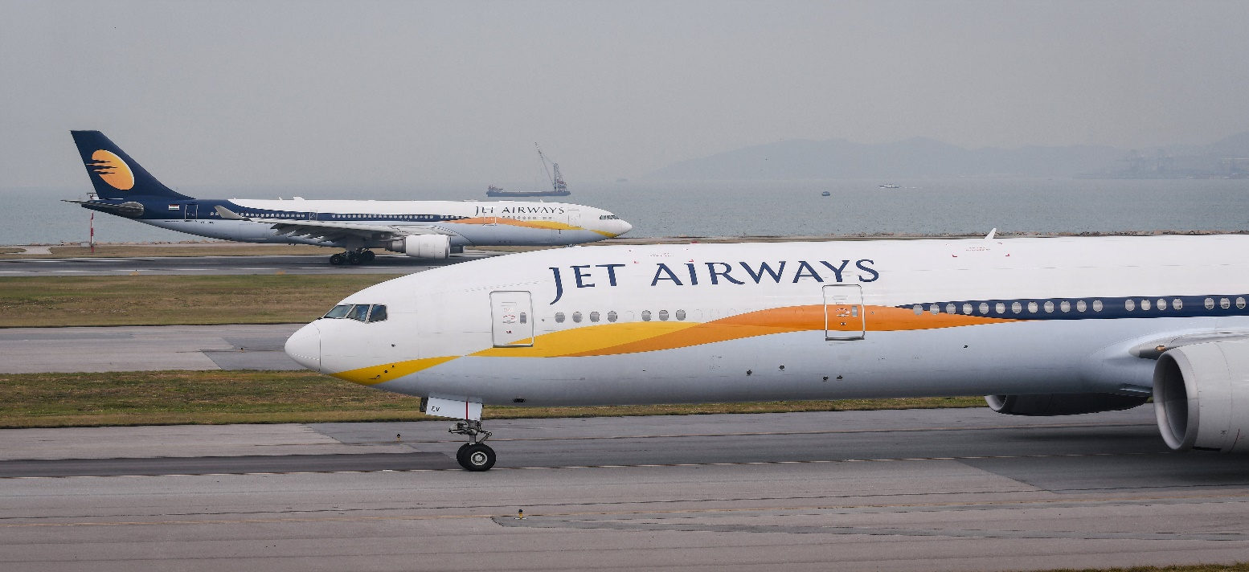

**Expansion and Challenges**

**Expansion**

Jet Airways ventured into international markets, connecting India to major global hubs. Key developments during this period included:

* **Modernization**: Fleet upgrades to include newer and more efficient aircraft.
* **Strategic Partnerships**: Collaborations with international airlines to strengthen its global presence.
* **JetLite**: Launch of a low-cost subsidiary to cater to budget-conscious travelers.

**Challenges**

Despite its achievements, Jet Airways encountered numerous challenges, such as:

* **Volatile Fuel Prices**: Rising operational costs impacted profitability.
* **Intense Competition**: The entry of low-cost carriers eroded its market share.
* **Economic Conditions**: Slowing economic growth affected consumer spending on air travel.

While Jet Airways managed to navigate these challenges for a time, they sowed the seeds of future difficulties.

**The Downfall**

In 2013, Etihad Airways acquired a 24% stake in Jet Airways, providing much-needed financial support through a $2.5 billion investment. Despite this, Jet Airways was unable to overcome its structural challenges.

**Factors Leading to the Collapse**

* **Debt Accumulation**: The airline amassed significant debt, straining its financial resources.
* **Mismanagement Allegations**: Accusations of financial irregularities tarnished its reputation.
* **Operational Hurdles**: Rising operational costs and inefficient resource utilization exacerbated its problems.
* **Investor Confidence**: A lack of investor trust made it difficult to secure additional funding.

In April 2019, Jet Airways ceased operations, marking the end of an era in Indian aviation. The collapse disrupted the aviation sector, leaving thousands of employees jobless and impacting related industries.

**Lessons and Conclusion**

**Lessons**

* **Sustainable Growth**: Rapid expansion must be matched with financial stability.
* **Transparent Leadership**: Ethical and transparent management is crucial to maintaining stakeholder trust.
* **Adaptability**: In an industry subject to volatile factors, resilience and adaptability are essential.

**Conclusion**

Naresh Goyal’s legacy is a tale of immense success tempered by critical failures. Jet Airways demonstrated the potential for innovation and excellence in Indian aviation, while its downfall underscores the importance of responsible leadership and financial discipline.

Despite Jet Airways’ collapse, the Indian aviation industry remains vibrant, with new players and low-cost carriers reshaping the market. Goyal’s story serves as a cautionary tale and a source of inspiration for aspiring entrepreneurs in the aviation sector.