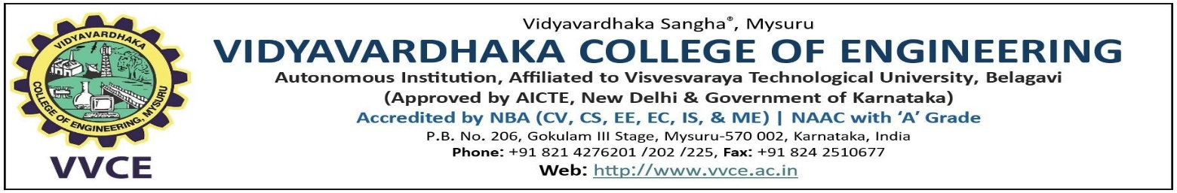

BLOCKCHAIN TECHNOLOGY (BCSBT603)

A Report On

“SUI – Layer 1 Blockchain”
Powering the Next Generation of Fast, Secure, and Scalable Web3 Apps

Submitted By
Yesh Gowda 4VV22CS190
Yashwanth S 4VV22CS189
Venkatesha Y K 4VV22CS181
Manoj Kumar M 4VV23CS409

Under the guidance of
Prof Abdul L S
Department of Computer Science and Engineering VVCE, Mysuru
INTRODUCTION
In the rapidly evolving world of blockchain technology, scalability, speed, and user experience are critical for the mass adoption of decentralized applications. Sui is a next-generation Layer 1 blockchain built from the ground up to address these needs. Developed by Mysten Labs, a team of former Meta engineers, Sui introduces a unique object-centric data model, parallel transaction execution, and ultra-low latency to deliver blazing-fast performance and flexibility for developers. By using the Move programming language, Sui ensures both security and programmability, making it a powerful platform for building high-performance decentralized applications in gaming, DeFi, NFTs, and beyond.

BACKGROUND AND DEVELOPMENT
Mysten Labs was founded in 2021 by ex-Meta engineers who previously worked on the Diem blockchain and the Move programming language. Their goal was to develop a blockchain that could truly scale with user demand, without compromising security or decentralization.
Sui was officially launched in May 2023 after several testnet phases that proved its performance capabilities. The project quickly gained traction thanks to its technical innovations, developer-friendly tools, and strong backing from venture capital firms such as a16z (Andreessen Horowitz), Coinbase Ventures, and Binance Labs.

ARCHITECTURE AND TECHNOLOGY
🧱 Object-Centric Model
Unlike traditional account-based models, Sui uses an object-based architecture. Every asset, whether a token, an NFT, or a custom structure, is treated as an object with ownership and attributes. This allows greater flexibility and programmability.
⚙️ Parallel Execution
Sui can execute independent transactions in parallel rather than sequentially, which drastically increases throughput. This is especially useful for applications with high user interactions, such as gaming or trading platforms.

🧠 Move Programming Language
Sui uses a version of Move, a smart contract language created by Meta. Move is memory-safe and supports fine-grained access control, which makes it both powerful and secure for smart contract development.
🌐 Horizontal Scaling
Sui is designed to scale horizontally, meaning that the system can increase performance by simply adding more validators, without needing to redesign its core infrastructure.

CONSENSUS AND SECURITY
Sui employs a hybrid consensus mechanism:
For simple transactions (e.g., object transfers), Sui avoids consensus entirely using Byzantine Consistent Broadcast, which enables fast finality.
For complex transactions involving shared state, Sui uses Narwhal and Bullshark, advanced consensus protocols that ensure both safety and liveness.
Security is ensured through a combination of:
- Cryptographic proofs
- Validator stake delegation (Delegated Proof-of-Stake)
- Strict validation of Move bytecode
- These features allow Sui to maintain security while delivering high-speed processing.
Tokenomics:
The native utility token of the Sui blockchain is $SUI. It plays several crucial roles:
Gas Fees: Paid by users for transaction execution and smart contract interactions.
Staking: Users can stake $SUI tokens to validators to help secure the network and earn rewards.
Governance: Token holders will eventually be able to vote on protocol upgrades and changes.
Incentives: Used for rewarding developers and participants in the ecosystem.

Token Supply:
Max supply: 10 billion $SUI
Initial distribution included community reserves, early contributors, and validators.

ECOSYSTEM AND USE CASES
Sui is rapidly expanding its ecosystem across multiple sectors:
🔸 Gaming
Sui’s low latency and high throughput make it ideal for real-time Web3 games that require fast interactions and complex logic.
🔸 NFTs
Supports dynamic and composable NFTs with rich metadata. Developers can build NFTs that evolve over time, interact with users, or serve as components in larger dApps. 🔸 DeFi
Sui enables secure, fast, and scalable DeFi protocols, including lending platforms, DEXs, and synthetic assets.
🔸 Real-World Use
Identity verification systems, supply chain solutions, and tokenized assets can benefit from Sui’s flexible object model and fast finality.
Some notable projects and tools in the Sui ecosystem include:
Suiet Wallet, Ethos Wallet
SuiNS (Name Service)
BlueMove (NFT Marketplace)
Cetus (DeFi Protocol)

ADVANTAGES OF SUI
High Scalability: Parallel execution ensures the network doesn’t slow down under load
Fast Finality: Transactions are confirmed in under 2 seconds.
Object-Centric Data Model: More intuitive and powerful for developers building complex dApps.
Secure and Reliable: Advanced consensus mechanisms and Move’s safety features reduce the risk of bugs and exploits.
Developer Friendly: Strong documentation, SDKs, and APIs support rapid development.

LIMITATIONS AND CHALLENGES
New Language (Move): Developers must learn a new programming language, which may slow adoption initially.
Young Ecosystem: Although growing quickly, the Sui ecosystem is not yet as mature as Ethereum or Solana.
Adoption Curve: Applications need to drive user engagement to leverage Sui’s technical strengths.

FUTURE ROADMAP
Sui’s roadmap includes:
Expanding validator infrastructure for better decentralization
Enabling full on-chain governance using $SUI
Launching major dApps and NFT projects
Improving developer tools and Move documentation
Partnerships with game studios and DeFi platforms

Mysten Labs continues to invest in R&D and community growth to ensure Sui becomes a foundational layer for the next generation of decentralized internet applications.

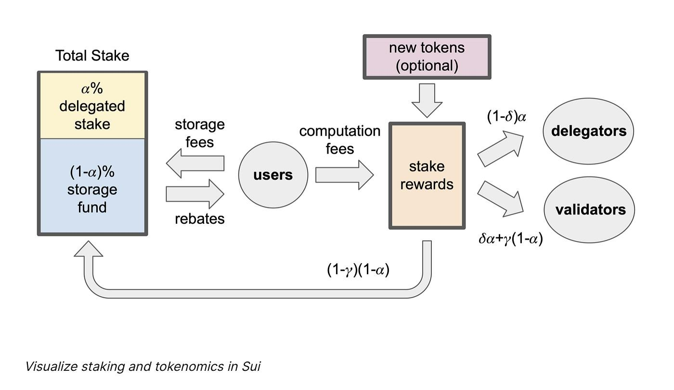

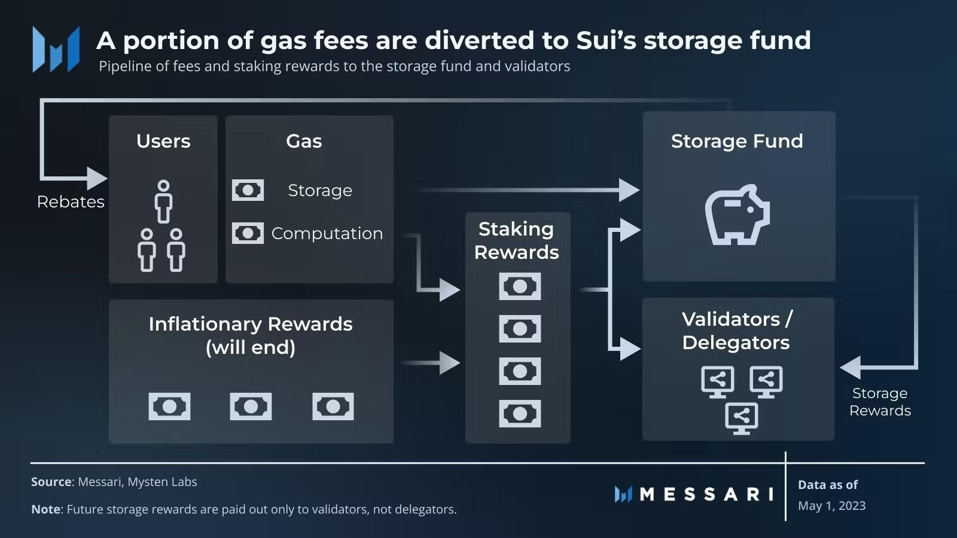

REAL-WORLD ADOPTION AND INDUSTRY USE CASES
Sui is gaining traction in real-world industries where speed, transparency, and low fees are essential.
🔸 Supply Chain and Logistics
Track movement of goods using object-based tokens with real-time updates.
Allows programmable, traceable product histories (e.g., from farm to table).
🔸 Digital Identity and Credentials
Securely store digital IDs, certificates, and licenses.
Enables decentralized KYC processes and access control using NFTs.
🔸 Tokenization of Real Assets
Real estate, art, and commodities can be represented as unique objects.
Sui’s object model supports fractional ownership and lifecycle tracking.
🔸 CBDCs and Payment Systems
Central banks and financial institutions are exploring Sui for fast, programmable payments and stablecoin platforms.

SUI WALLET ECOSYSTEM
Wallets are a key part of the user experience. Some notable ones in 2025 include:
Suiet – A feature-rich wallet with staking, NFTs, and dApp browser.
Ethos Wallet – User-friendly for new users; supports social login and multi-chain.
Wave Wallet – Focuses on DeFi and cross-chain swaps.
These wallets provide seamless onboarding, enabling mass adoption by simplifying key management and gas fee estimation.

Developer Ecosystem & Tools:
Sui offers an extensive suite of tools that have expanded in 2025:
Sui CLI and SDKs (JavaScript, Python, Rust)
Sui DevNet – Test environments for experimentation.
Explorer & Faucet – Tools for on-chain data and test tokens.
Sui Move IDEs – Plugins for VS Code and other editors.
Hackathons, grants, and bounties by Mysten Labs and community DAOs support continued innovation.
SUI IN GAMING AND METAVERSE
Sui is rapidly becoming the preferred chain for Web3 gaming and metaverse platforms.
Dynamic NFTs: Characters that level up, items that evolve, and experiences that change over time.
In-game Economies: Fast, low-cost, and secure in-game transactions.
Cross-game Asset Use: Object-centric model enables assets that move between games.
Games like Abyss World, Final Form, and Rune Realms are building rich gameplay on Sui.
15. Cross-Chain Interoperability:
In 2025, Sui supports multiple bridge protocols for cross-chain transfers:
Wormhole
LayerZero
Celer cBridge
These bridges allow Sui to connect with Ethereum, Solana, BNB Chain, and others, enabling broader DeFi participation and liquidity flow.
Sustainability and Energy Efficiency
Unlike Proof-of-Work blockchains, Sui is energy-efficient:
Validators use minimal energy.
Delegated Proof-of-Stake (DPoS) minimizes computational waste.
Supports environmentally sustainable dApps and green finance solutions.
This makes Sui attractive for eco-conscious governments and companies.
REGULATORY CONSIDERATIONS AND COMPLIANCE
Sui is designed with compliance in mind:
Supports programmable compliance: developers can build features like KYC/AML into smart contracts.
Partnering with legal tech firms to build dApps that align with global data privacy and financial regulations (e.g., GDPR, FATF).
In 2025, regulators globally are recognizing Sui’s object model as a framework for compliant asset tokenization.

COMMUNITY AND GOVERNANCE
Sui's community has grown to include:
Global DAOs working on ecosystem growth.
Sui Builder Houses in India, Vietnam, Europe, and the US.
Open-source contributors from over 60 countries.
Governance features are being rolled out, allowing $SUI holders to vote on:
Protocol upgrades
Funding allocations
Ecosystem priorities
This democratic structure promotes transparency and user trust.

CONCLUSION
The evolution of blockchain technology has entered a new chapter with the emergence of high-performance Layer 1 networks like Sui. As the limitations of traditional blockchains become increasingly evident in highdemand scenarios such as DeFi, gaming, and real-world asset tokenization, Sui provides a timely and powerful alternative.
Sui’s core innovation lies in its object-centric architecture, which fundamentally rethinks how data and digital assets are structured and managed on-chain. Combined with parallel transaction execution, a robust Move programming model, and an efficient Delegated Proof-of-Stake consensus, Sui is engineered for speed, scalability, and security without compromising decentralization.
In 2025, Sui is not just a promising protocol—it is a growing ecosystem with active adoption in sectors such as gaming, NFTs, DeFi, digital identity, and global payments. Its compatibility with cross-chain bridges, ecofriendly infrastructure, and developer-first approach makes it attractive for both startups and institutional partners.

