Lebanese American University



COE 322: Logic Design Lab – Lab2

Jean Paul Zammar – 202401434
Hadi Jouni – 202400434
2/02/2
Table of Contents
Table of figures 3
Table of tables 4
Introduction 5
Equipment needed 6
Content 7

Table of figures

Table of tables

Introduction

This lab let us understand arithmetic operations by designing logic circuits. In this experiment, a half adder and a 2 bit-multiplier were studied to understand how binary addition and multiplication are performed. A half adder was implemented using two IC gates. In addition, a 2-bit multiplier was designed using AND gates and half adders to show the principles of binary multiplication. The designs were analyzed theoretically, simulated using Quartus, and then implemented on a breadboard to compare results with the theoretical one.

Equipment needed

Content

To start off this project, we need to design a 5-bit synchronous up/down counter to keep track of the class capacity and make sure that valid input sequences are being respected. For instance, when the class is full (29 students) the counter should not be counting even though the enter switch is high, similarly for the case where the class is empty, the counter should not update the capacity even though the exit switch is high. The state machine is divided into 2 states where one handles the up count, and one handles the down count. The tables below reflect the type of counter that we want. At the state 00000, the counter stays at 00000 when down counting and at states 11101(29) 11110 (30) and 11111(31) the counter stays at 11101 when up counting.
Down count state table:
Table 1: Down count state table
Q |  |  |  |  | Q’ |  |  |  |  | T4 | T3 | T2 | T1 | T0 | O
0 | 0 | 0 | 0 | 0 | 0 | 0 | 0 | 0 | 0 | 0 | 0 | 0 | 0 | 0 | 0
0 | 0 | 0 | 0 | 1 | 0 | 0 | 0 | 0 | 0 | 0 | 0 | 0 | 0 | 1 | 0
0 | 0 | 0 | 1 | 0 | 0 | 0 | 0 | 0 | 1 | 0 | 0 | 0 | 1 | 1 | 0
0 | 0 | 0 | 1 | 1 | 0 | 0 | 0 | 1 | 0 | 0 | 0 | 0 | 0 | 1 | 0
0 | 0 | 1 | 0 | 0 | 0 | 0 | 0 | 1 | 1 | 0 | 0 | 1 | 1 | 1 | 0
0 | 0 | 1 | 0 | 1 | 0 | 0 | 1 | 0 | 0 | 0 | 0 | 0 | 0 | 1 | 0
0 | 0 | 1 | 1 | 0 | 0 | 0 | 1 | 0 | 1 | 0 | 0 | 0 | 1 | 1 | 0
0 | 0 | 1 | 1 | 1 | 0 | 0 | 1 | 1 | 0 | 0 | 0 | 0 | 0 | 1 | 0
0 | 1 | 0 | 0 | 0 | 0 | 0 | 1 | 1 | 1 | 0 | 1 | 1 | 1 | 1 | 0
0 | 1 | 0 | 0 | 1 | 0 | 1 | 0 | 0 | 0 | 0 | 0 | 0 | 0 | 1 | 0
0 | 1 | 0 | 1 | 0 | 0 | 1 | 0 | 0 | 1 | 0 | 0 | 0 | 1 | 1 | 0
0 | 1 | 0 | 1 | 1 | 0 | 1 | 0 | 1 | 0 | 0 | 0 | 0 | 0 | 1 | 0
0 | 1 | 1 | 0 | 0 | 0 | 1 | 0 | 1 | 1 | 0 | 0 | 1 | 1 | 1 | 0
0 | 1 | 1 | 0 | 1 | 0 | 1 | 1 | 0 | 0 | 0 | 0 | 0 | 0 | 1 | 0
0 | 1 | 1 | 1 | 0 | 0 | 1 | 1 | 0 | 1 | 0 | 0 | 0 | 1 | 1 | 0
0 | 1 | 1 | 1 | 1 | 0 | 1 | 1 | 1 | 0 | 0 | 0 | 0 | 0 | 1 | 1
1 | 0 | 0 | 0 | 0 | 0 | 1 | 1 | 1 | 1 | 1 | 1 | 1 | 1 | 1 | 1
1 | 0 | 0 | 0 | 1 | 1 | 0 | 0 | 0 | 0 | 0 | 0 | 0 | 0 | 1 | 1
1 | 0 | 0 | 1 | 0 | 1 | 0 | 0 | 0 | 1 | 0 | 0 | 0 | 1 | 1 | 1
1 | 0 | 0 | 1 | 1 | 1 | 0 | 0 | 1 | 0 | 0 | 0 | 0 | 0 | 1 | 1
1 | 0 | 1 | 0 | 0 | 1 | 0 | 0 | 1 | 1 | 0 | 0 | 1 | 1 | 1 | 1
1 | 0 | 1 | 0 | 1 | 1 | 0 | 1 | 0 | 0 | 0 | 0 | 0 | 0 | 1 | 1
1 | 0 | 1 | 1 | 0 | 1 | 0 | 1 | 0 | 1 | 0 | 0 | 0 | 1 | 1 | 1
1 | 0 | 1 | 1 | 1 | 1 | 0 | 1 | 1 | 0 | 0 | 0 | 0 | 0 | 1 | 1
1 | 1 | 0 | 0 | 0 | 1 | 0 | 1 | 1 | 1 | 0 | 1 | 1 | 1 | 1 | 1
1 | 1 | 0 | 0 | 1 | 1 | 1 | 0 | 0 | 0 | 0 | 0 | 0 | 0 | 1 | 1
1 | 1 | 0 | 1 | 0 | 1 | 1 | 0 | 0 | 1 | 0 | 0 | 0 | 1 | 1 | 1
1 | 1 | 0 | 1 | 1 | 1 | 1 | 0 | 1 | 0 | 0 | 0 | 0 | 0 | 1 | 1
1 | 1 | 1 | 0 | 0 | 1 | 1 | 0 | 1 | 1 | 0 | 0 | 1 | 1 | 1 | 1
1 | 1 | 1 | 0 | 1 | 1 | 1 | 1 | 0 | 0 | 0 | 0 | 0 | 0 | 1 | 1
1 | 1 | 1 | 1 | 0 | 1 | 1 | 1 | 0 | 1 | 0 | 0 | 0 | 1 | 1 | 1
1 | 1 | 1 | 1 | 1 | 1 | 1 | 1 | 1 | 0 | 0 | 0 | 0 | 0 | 1 | 1

Up count state table:
Table 2: Up count state table
Q |  |  |  |  | Q’ |  |  |  |  | T4 | T3 | T2 | T1 | T0 | O
0 | 0 | 0 | 0 | 0 | 0 | 0 | 0 | 0 | 1 | 0 | 0 | 0 | 0 | 1 | 0
0 | 0 | 0 | 0 | 1 | 0 | 0 | 0 | 1 | 0 | 0 | 0 | 0 | 1 | 1 | 0
0 | 0 | 0 | 1 | 0 | 0 | 0 | 0 | 1 | 1 | 0 | 0 | 0 | 0 | 1 | 0
0 | 0 | 0 | 1 | 1 | 0 | 0 | 1 | 0 | 0 | 0 | 0 | 1 | 1 | 1 | 0
0 | 0 | 1 | 0 | 0 | 0 | 0 | 1 | 0 | 1 | 0 | 0 | 0 | 0 | 1 | 0
0 | 0 | 1 | 0 | 1 | 0 | 0 | 1 | 1 | 0 | 0 | 0 | 0 | 1 | 1 | 0
0 | 0 | 1 | 1 | 0 | 0 | 0 | 1 | 1 | 1 | 0 | 0 | 0 | 0 | 1 | 0
0 | 0 | 1 | 1 | 1 | 0 | 1 | 0 | 0 | 0 | 0 | 1 | 1 | 1 | 1 | 0
0 | 1 | 0 | 0 | 0 | 0 | 1 | 0 | 0 | 1 | 0 | 0 | 0 | 0 | 1 | 0
0 | 1 | 0 | 0 | 1 | 0 | 1 | 0 | 1 | 0 | 0 | 0 | 0 | 1 | 1 | 0
0 | 1 | 0 | 1 | 0 | 0 | 1 | 0 | 1 | 1 | 0 | 0 | 0 | 0 | 1 | 0
0 | 1 | 0 | 1 | 1 | 0 | 1 | 1 | 0 | 0 | 0 | 0 | 1 | 1 | 1 | 0
0 | 1 | 1 | 0 | 0 | 0 | 1 | 1 | 0 | 1 | 0 | 0 | 0 | 0 | 1 | 0
0 | 1 | 1 | 0 | 1 | 0 | 1 | 1 | 1 | 0 | 0 | 0 | 0 | 1 | 1 | 0
0 | 1 | 1 | 1 | 0 | 0 | 1 | 1 | 1 | 1 | 0 | 0 | 0 | 0 | 1 | 0
0 | 1 | 1 | 1 | 1 | 1 | 0 | 0 | 0 | 0 | 1 | 1 | 1 | 1 | 1 | 1
1 | 0 | 0 | 0 | 0 | 1 | 0 | 0 | 0 | 1 | 0 | 0 | 0 | 0 | 1 | 1
1 | 0 | 0 | 0 | 1 | 1 | 0 | 0 | 1 | 0 | 0 | 0 | 0 | 1 | 1 | 1
1 | 0 | 0 | 1 | 0 | 1 | 0 | 0 | 1 | 1 | 0 | 0 | 0 | 0 | 1 | 1
1 | 0 | 0 | 1 | 1 | 1 | 0 | 1 | 0 | 0 | 0 | 0 | 1 | 1 | 1 | 1
1 | 0 | 1 | 0 | 0 | 1 | 0 | 1 | 0 | 1 | 0 | 0 | 0 | 0 | 1 | 1
1 | 0 | 1 | 0 | 1 | 1 | 0 | 1 | 1 | 0 | 0 | 0 | 0 | 1 | 1 | 1
1 | 0 | 1 | 1 | 0 | 1 | 0 | 1 | 1 | 1 | 0 | 0 | 0 | 0 | 1 | 1
1 | 0 | 1 | 1 | 1 | 1 | 1 | 0 | 0 | 0 | 0 | 1 | 1 | 1 | 1 | 1
1 | 1 | 0 | 0 | 0 | 1 | 1 | 0 | 0 | 1 | 0 | 0 | 0 | 0 | 1 | 1
1 | 1 | 0 | 0 | 1 | 1 | 1 | 0 | 1 | 0 | 0 | 0 | 0 | 1 | 1 | 1
1 | 1 | 0 | 1 | 0 | 1 | 1 | 0 | 1 | 1 | 0 | 0 | 0 | 0 | 1 | 1
1 | 1 | 0 | 1 | 1 | 1 | 1 | 1 | 0 | 0 | 0 | 0 | 1 | 1 | 1 | 1
1 | 1 | 1 | 0 | 0 | 1 | 1 | 1 | 0 | 1 | 0 | 0 | 0 | 0 | 1 | 1
1 | 1 | 1 | 0 | 1 | 1 | 1 | 1 | 0 | 1 | 0 | 0 | 0 | 0 | 0 | 1
1 | 1 | 1 | 1 | 0 | 1 | 1 | 1 | 0 | 1 | 0 | 0 | 0 | 1 | 1 | 1
1 | 1 | 1 | 1 | 1 | 1 | 1 | 1 | 0 | 1 | 0 | 0 | 0 | 1 | 0 | 1

The states tables were designed with T flipflops to facilitate our flipflops equations. Now let’s derive them:
Down count flipflops equations (A => Q4, B => Q3, C => Q2, D => Q1, E=> Q0):
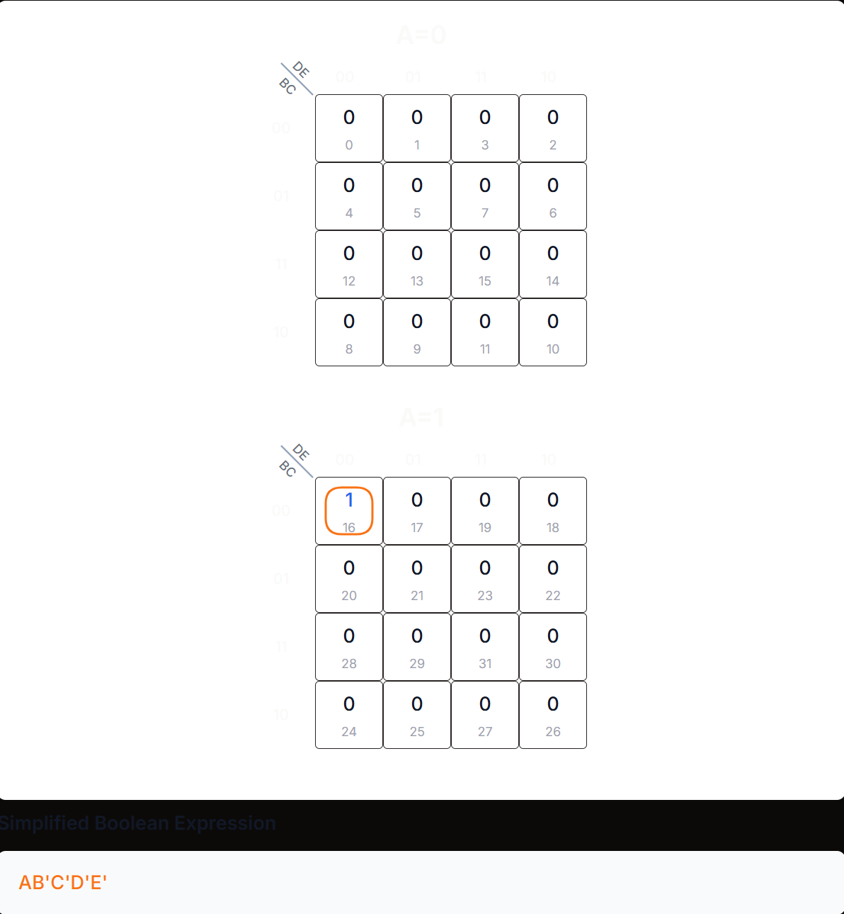
Figure 1:KMAP-T4 (DOWN)
T4 = Q4Q3’Q2’Q1’Q0’
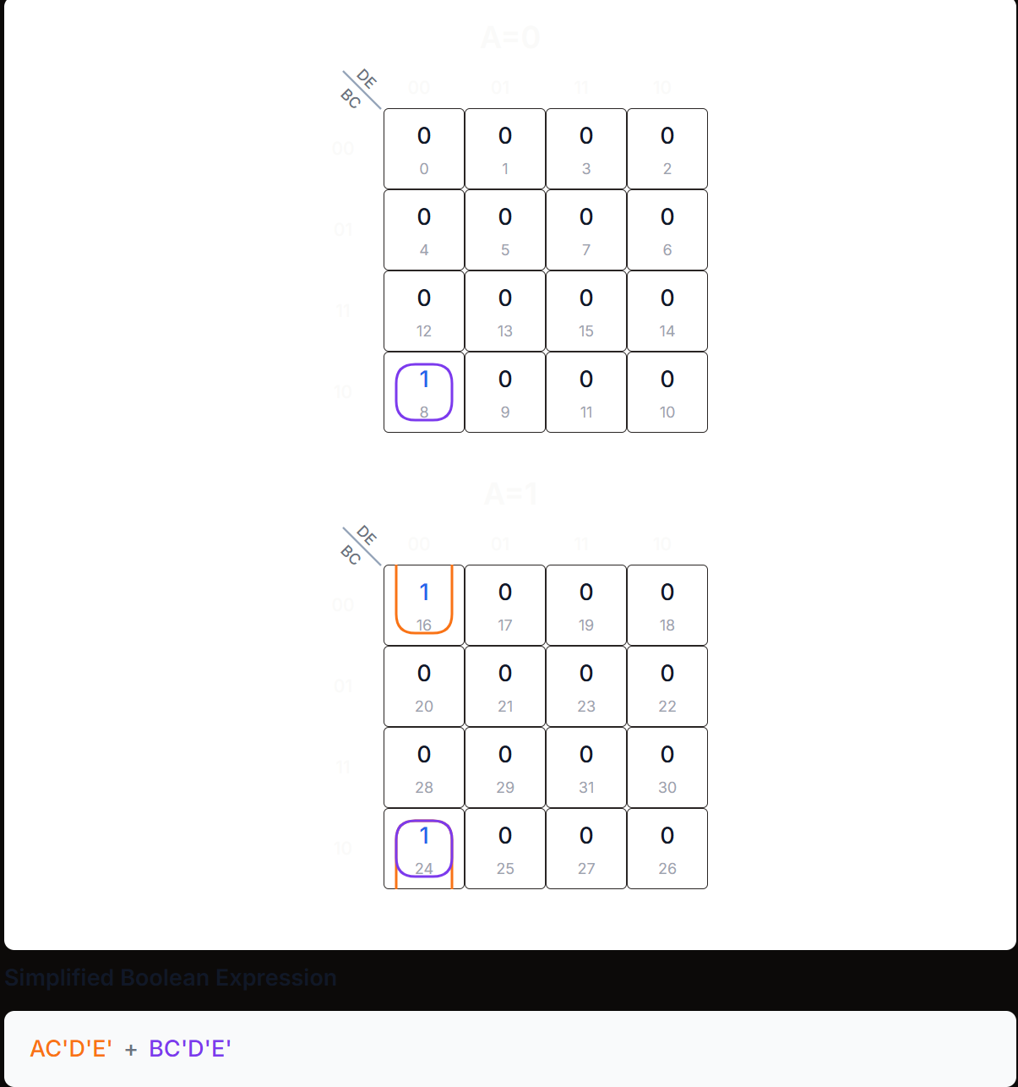
Figure 2:KMAP-T3 (DOWN)
T3 = Q2’Q1’Q0’ (Q4 + Q3)
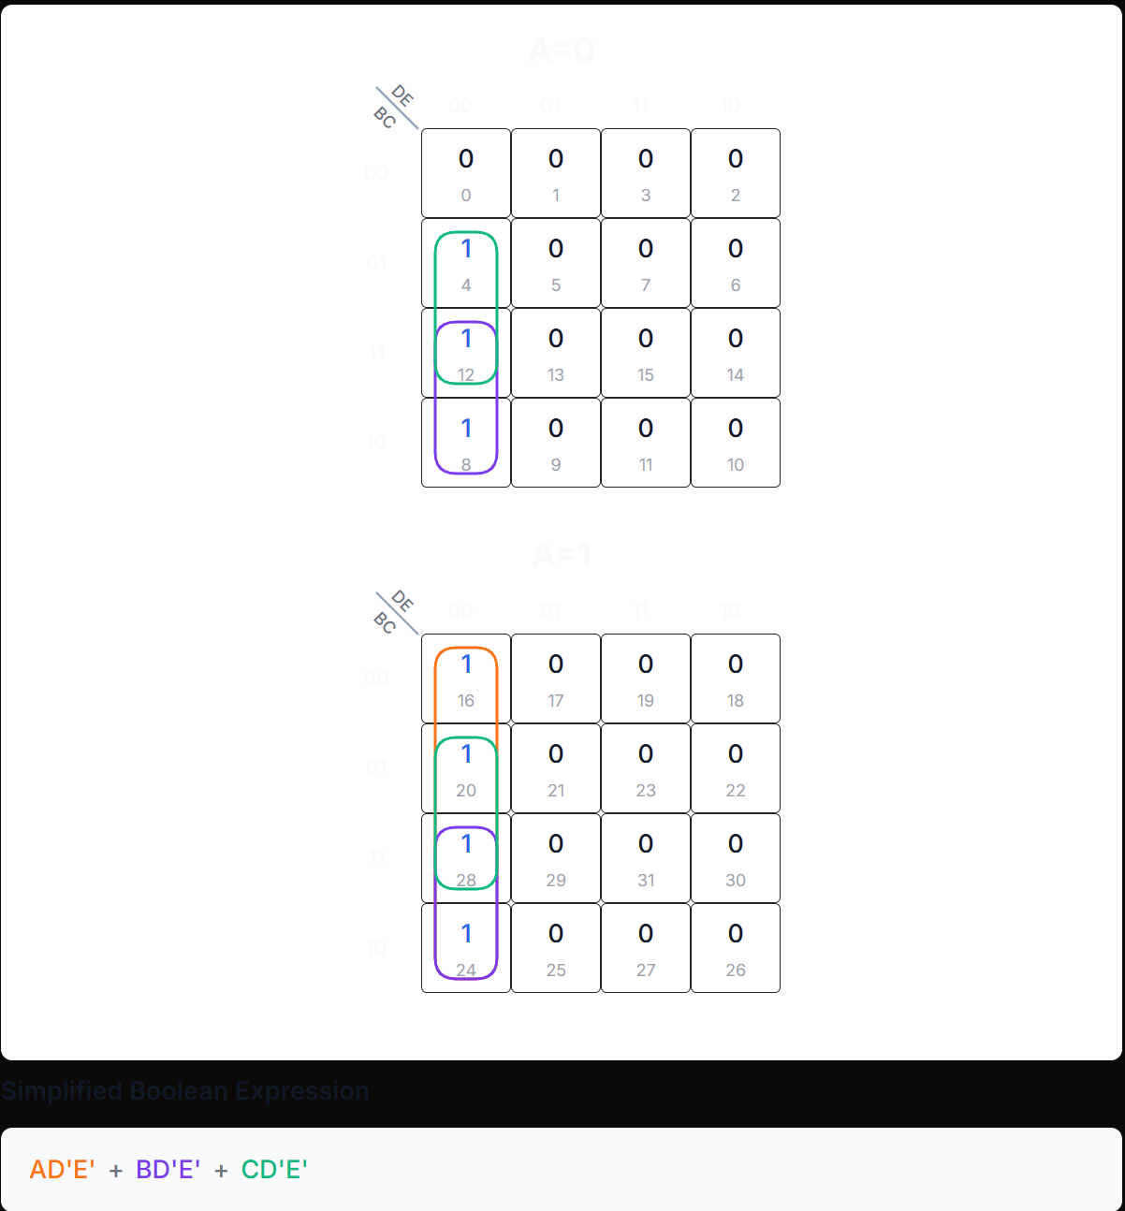
Figure 3:KMAP-T2 (DOWN)
T2 = Q1’Q0’ (Q4 + Q3 + Q2)
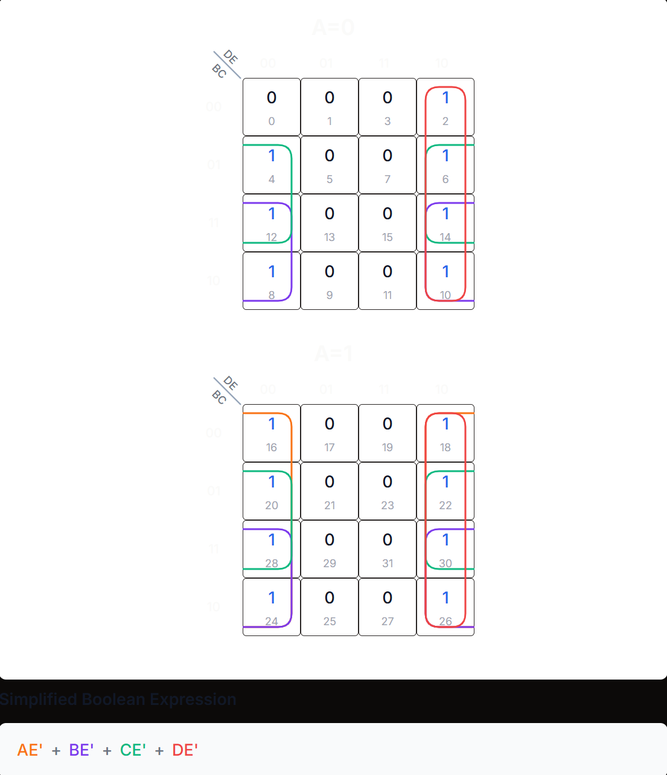
Figure 4:KMAP-T1 (DOWN)
T1 = Q0’ (Q4 + Q3 + Q2 + Q1)
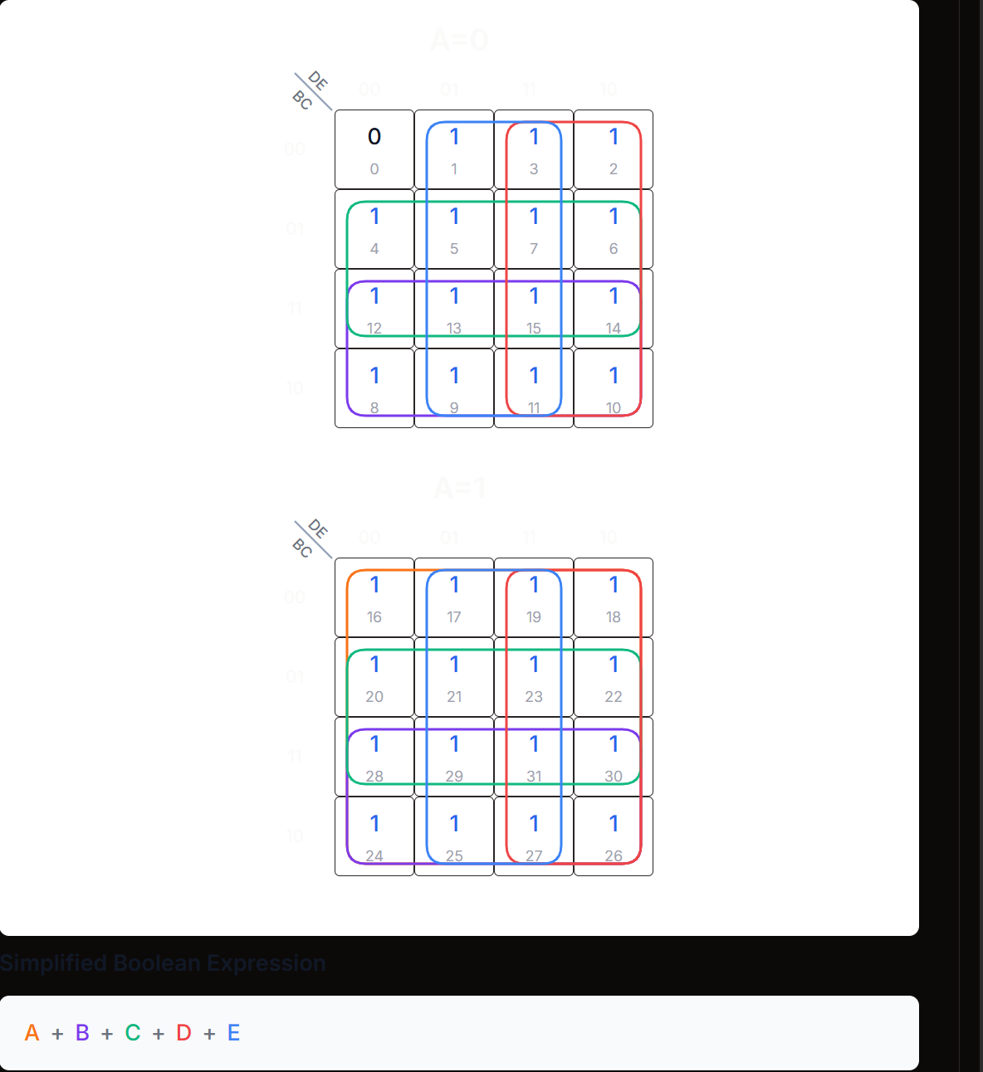
Figure 5:KMAP-T0 (DOWN)

T0 = Q4 + Q3 + Q2 + Q1 + Q0
UP count flipflops equations (A => Q4, B => Q3, C => Q2, D => Q1, E=> Q0):
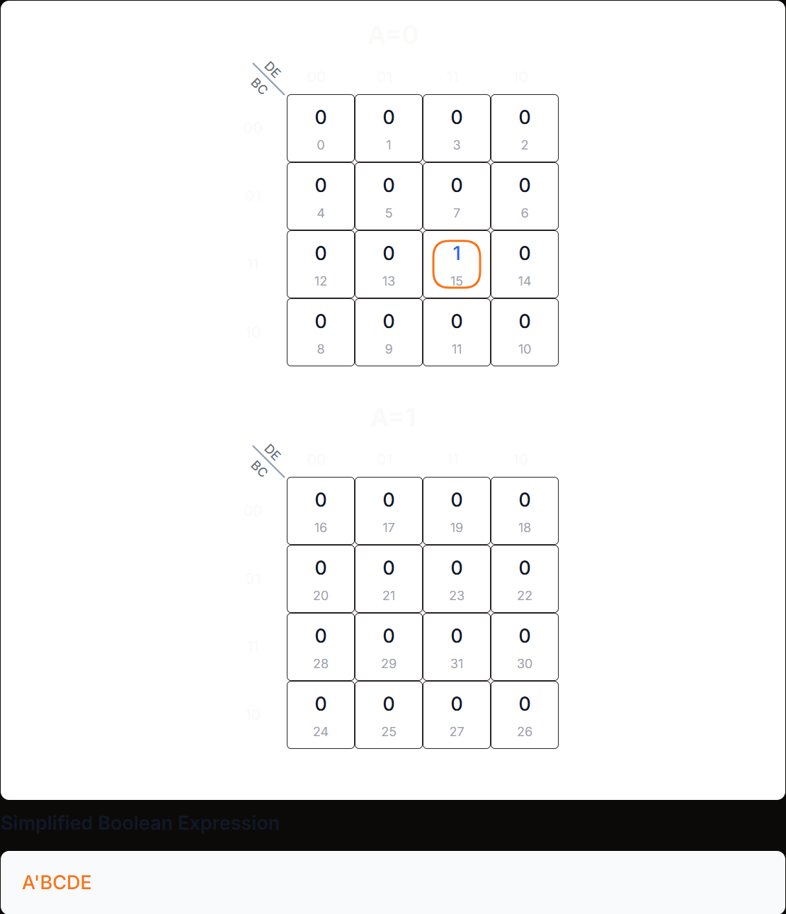
Figure 6:KMAP-T4 (UP)
T4 = Q4’Q3Q2Q1Q0
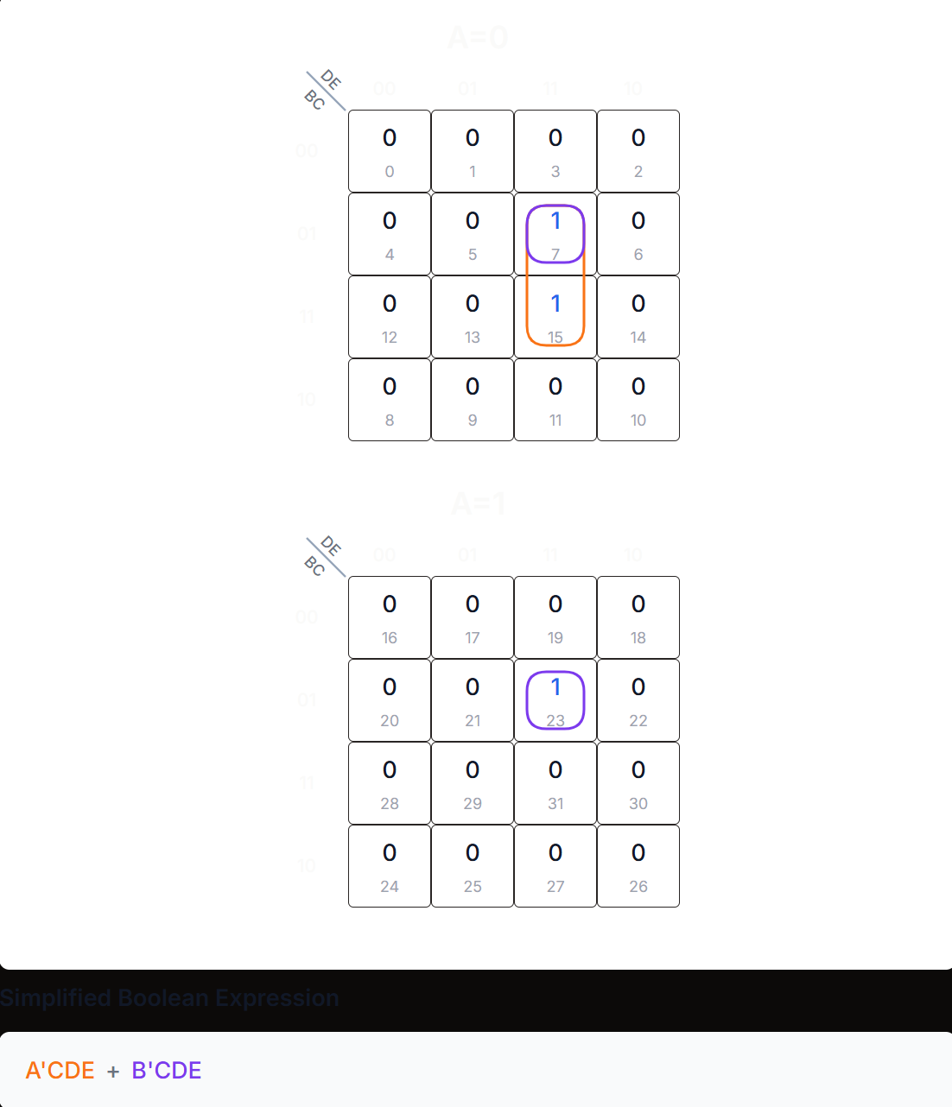
Figure 7:KMAP-T3 (UP)
T3 = Q2Q1Q0 (Q4’ + Q3’)
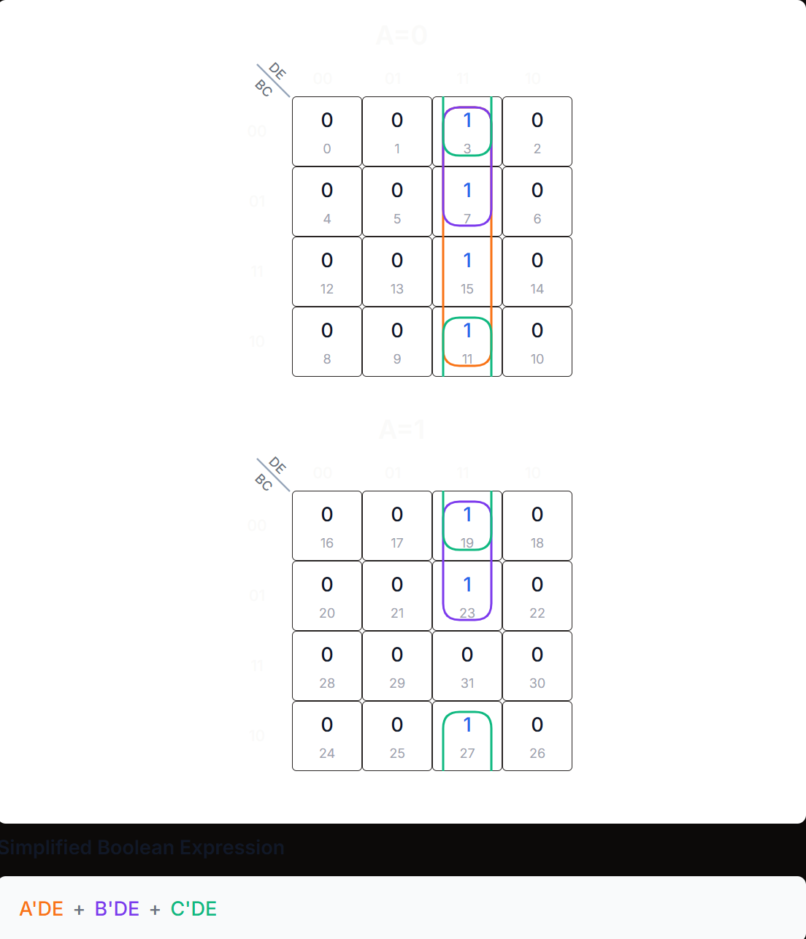
Figure 8:KMAP-T2 (UP)
T2 = Q1Q0 (Q4’ + Q3’ + Q2’)
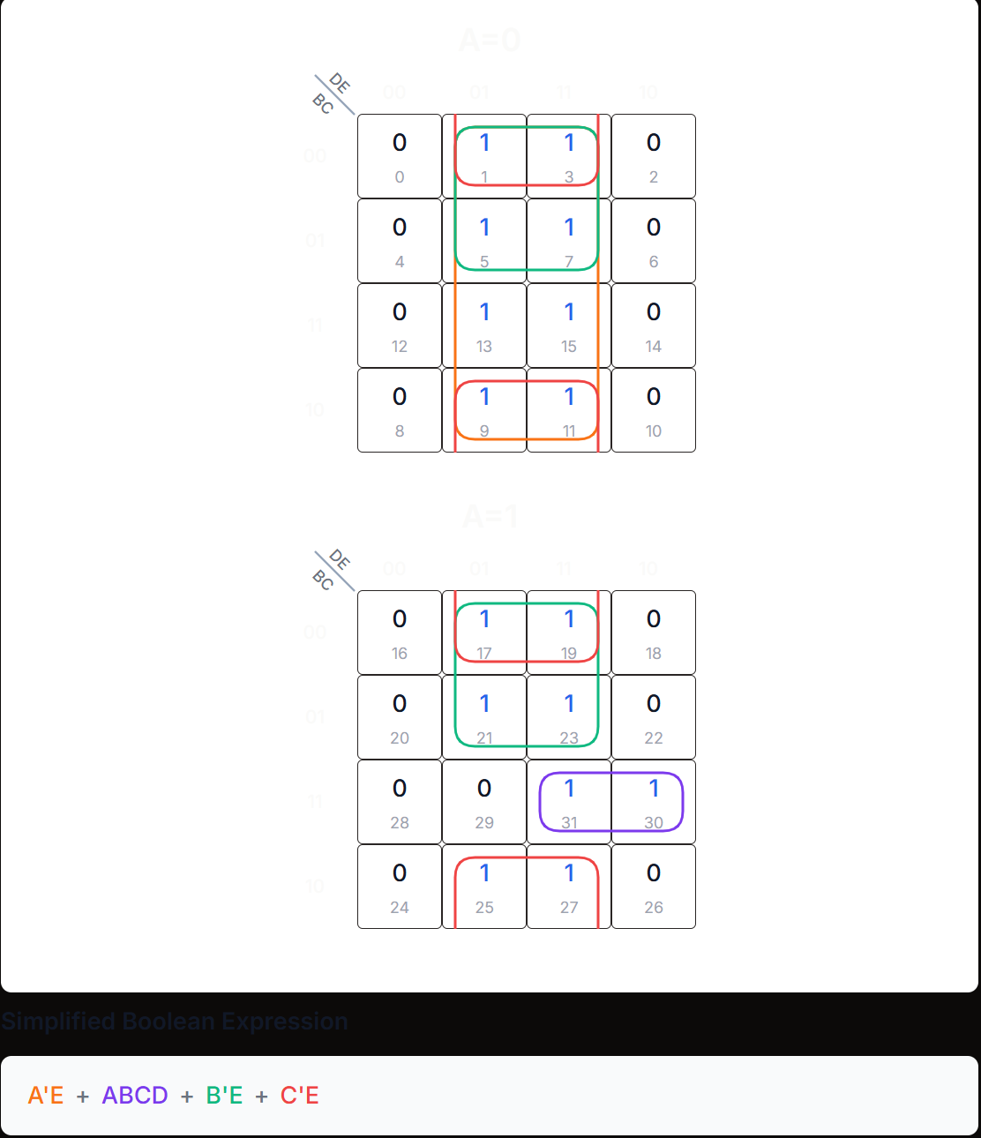
Figure 9:KMAP-T1 (UP)
T1 = Q0 (Q4’ + Q3’ + Q2’) + Q4Q3Q2Q1
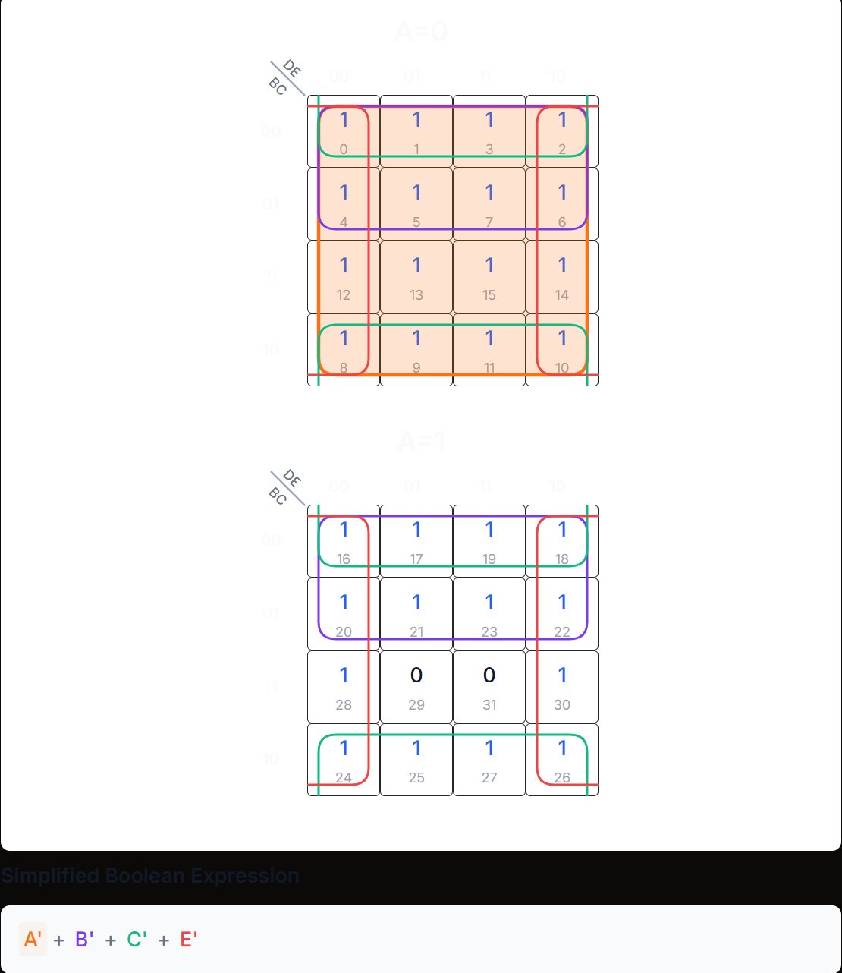
Figure 10:KMAP-T0 (UP)
T0 = Q4’ + Q3’ + Q2’ + Q0’
After obtaining the flipflops equations, we need to include our input bits. For the enter bit, we are adding an and for all the flipflops equations for counting up with the enter switch and we are adding an and for all the flipflops equations for counting down with the exit switch. To prevent any invalid combinations between the enter and exit inputs we added an and on each one with the complement of the other (like a XOR Gate).The reset switch is connected to all the clears of the flipflops and for the lock bit (that we will implement after), we are adding an and with it and the clock.
This gives us a priority order as follows:
- Reset
- Lock
- Enter or Exit
After implementing the equations above, we obtain the circuit below by using JK flipflops whit J and K connected (Equivalent to T flipflops):
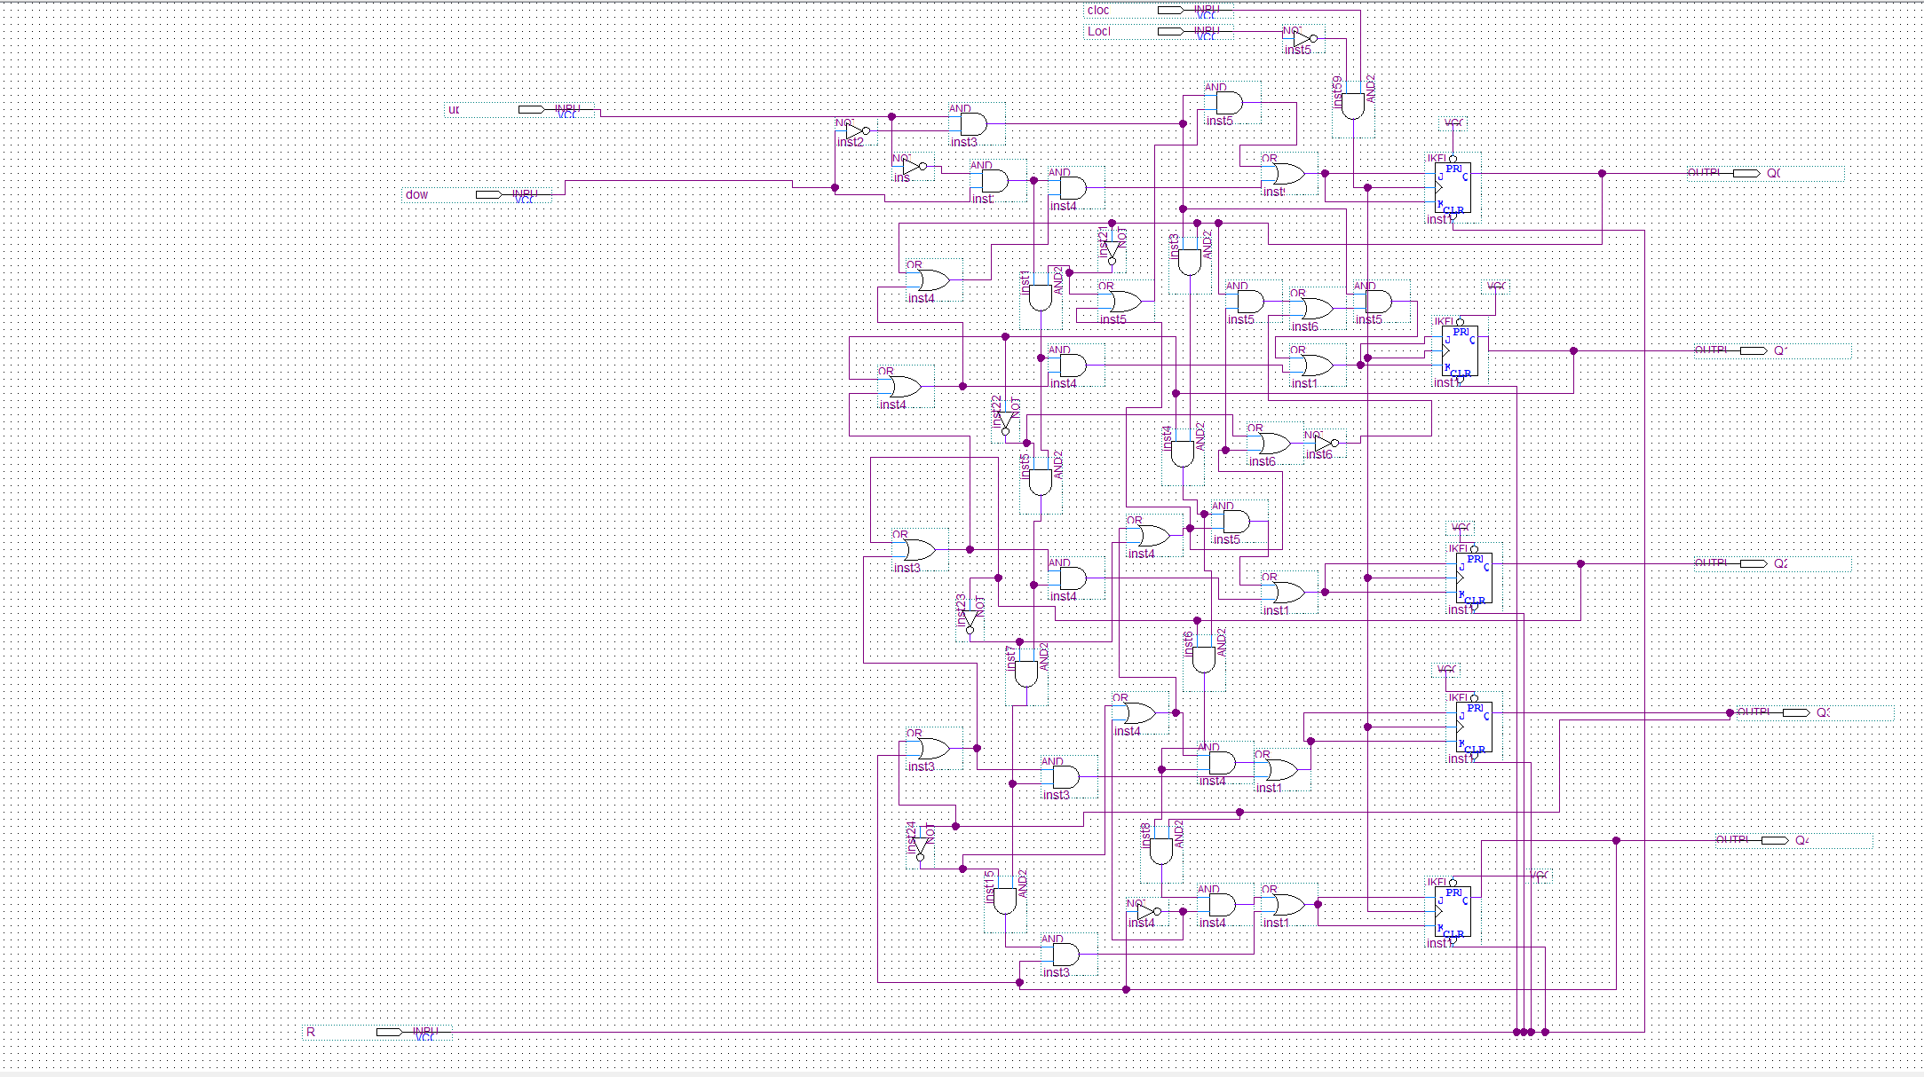
Figure 11: Modified 5 bit synchronous UP/DOWN counter

To test everything, we simulated the results with different values:

Here, we are testing the Lock and Reset bits were when the lock is HIGH, we are maintaining the value that we were at and when the Reset is low, we are back to state 00000.

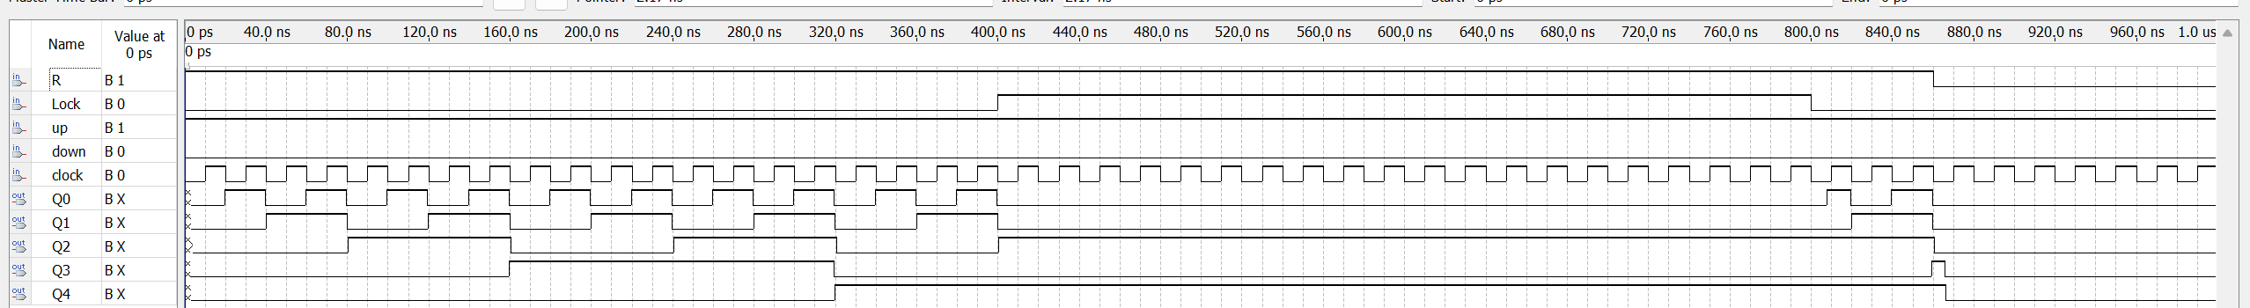
Figure 12:Testing counter1

Here we are testing the up and down counter with the limiting states. When down counting, state 00000 was maintained, and when up counting state 11101 was maintained.
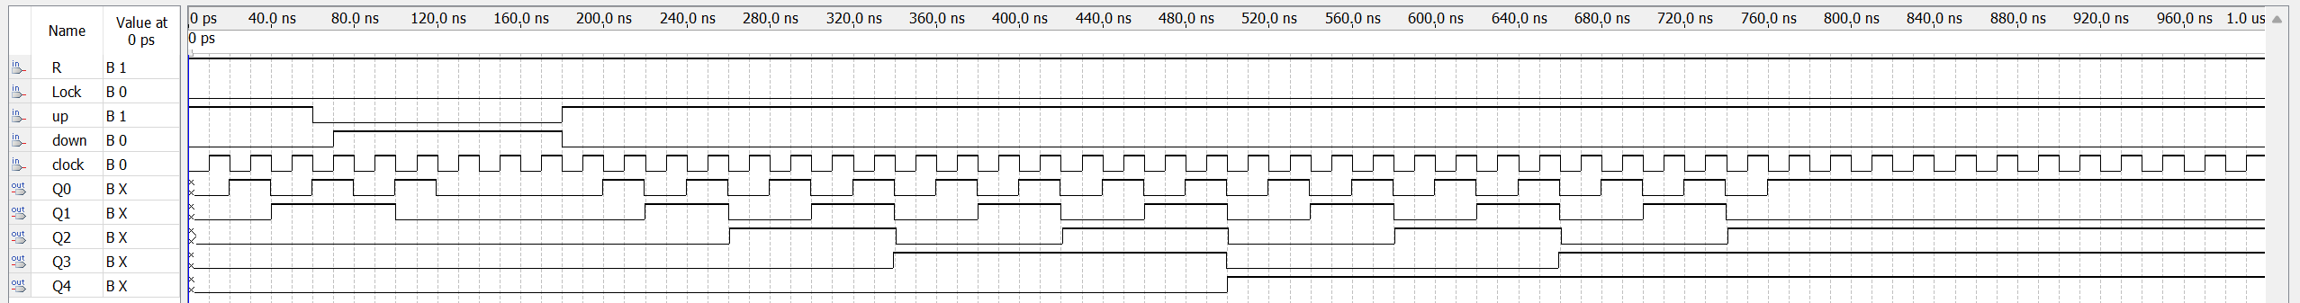
Figure 13:Testing counter2
Here we are testing the behavior of the counter when the switches enter/exit are 0/0 or 1/1. And as we can see the previous states are maintained when both bits are the same.
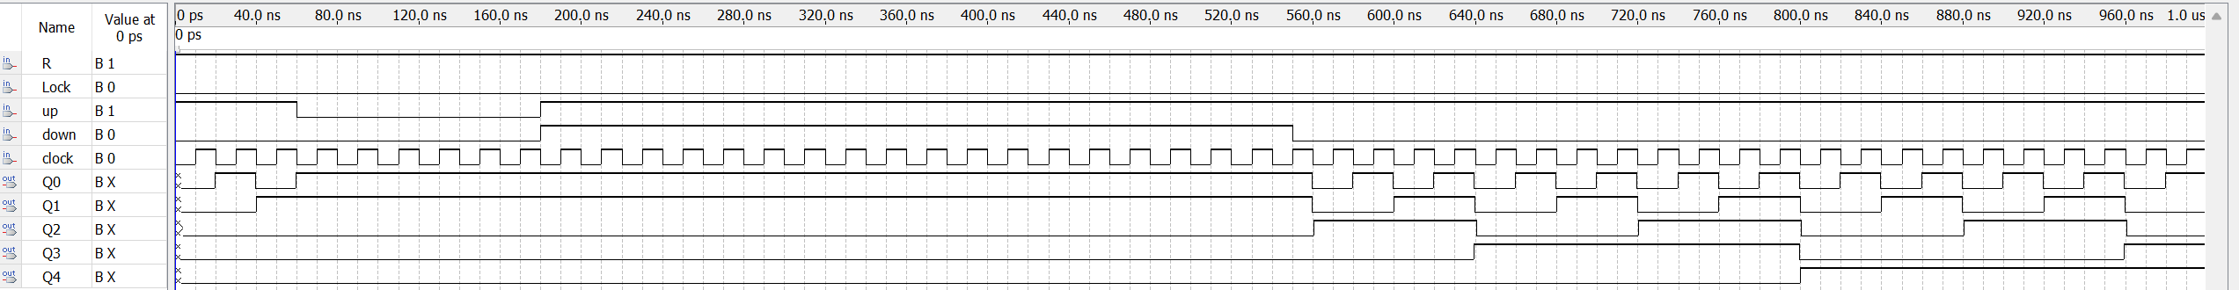
Figure 14: Testing counter3
Now, we have a 5 bit up/down synchronous counter that is limited to between 0 and 29. Therefore, let’s implement the count of the students on the 2 seven segment display.
To start off, we need to differentiate between 3 intervals of numbers: 0 to 9, 10 to 19 and 20 to 29 students because each one of those values has different output on the 2 seven segment displays.
For the unit display and for the values between 0 and 9, we can directly plug the state from the counter to the BCD to a 7-segment decoder. For the values between 10 and 19, the unit equivalent can be obtained by adding, with a 74LS83 4-bit adder, the binary representation of the number to 110(6). Same thing for the values between 20 and 29, but by adding 1100(12). And for the second display, the intervals take respectively 0,1,2. Let’s reassemble everything on a table.
Table 3: 7-segment table summary
State | Tenth (7 seg) | Unit (7 seg) | Output Tenth  (ANODE) | Output of Unit  (ANODE)
00000 | 00000 | 00000 | 0000001 | 0000001
00001 | 00000 | 00001 | 0000001 | 1001111
00010 | 00000 | 00010 | 0000001 | 0010010
00011 | 00000 | 00011 | 0000001 | 0000110
00100 | 00000 | 00100 | 0000001 | 1001100
00101 | 00000 | 00101 | 0000001 | 0100100
00110 | 00000 | 00110 | 0000001 | 0100000
00111 | 00000 | 00111 | 0000001 | 0001111
01000 | 00000 | 01000 | 0000001 | 0000000
01001 | 00000 | 01001 | 0000001 | 0001100
01010 | 00001 | 00000 | 1001111 | 0000001
01011 | 00001 | 00001 | 1001111 | 1001111
01100 | 00001 | 00010 | 1001111 | 0010010
01101 | 00001 | 00011 | 1001111 | 0000110
01110 | 00001 | 00100 | 1001111 | 1001100
01111 | 00001 | 00101 | 1001111 | 0100100
10000 | 00001 | 00110 | 1001111 | 0100000
10001 | 00001 | 00111 | 1001111 | 0001111
10010 | 00001 | 01000 | 1001111 | 0000000
10011 | 00001 | 01001 | 1001111 | 0001100
10100 | 00010 | 00000 | 0010010 | 0000001
10101 | 00010 | 00001 | 0010010 | 1001111
10110 | 00010 | 00010 | 0010010 | 0010010
10111 | 00010 | 00011 | 0010010 | 0000110
11000 | 00010 | 00100 | 0010010 | 1001100
11001 | 00010 | 00101 | 0010010 | 0100100
11010 | 00010 | 00110 | 0010010 | 0100000
11011 | 00010 | 00111 | 0010010 | 0001111
11100 | 00010 | 01000 | 0010010 | 0000000
11101 | 00010 | 01001 | 0010010 | 0001100
11110 | 00010 | 01001 | 0010010 | 0001100
11111 | 00010 | 01001 | 0010010 | 0001100

We can find that for the interval 20 to 29 in binary can be noticed by having Q4 (Q3+Q2) HIGH (Two Tenth), otherwise it is not in the range. Same for the values between 10 and 19, the corresponding equation is Q4’Q3(Q2+Q1) + Q4 Q3’Q2’ (One tenth).
This can be designed by connecting A4 A3 A2 A1 (first number to be added) to Q3 Q2 Q1 Q0. Now, the second number to be added must be 0000 (0), 0110(6) or 1100(12) depending on how many students are in the class.
We connected B4 B3 B2 B1 by following the table below:
Table 4: Output table for addends
Q4 (Q3+Q2) | Q4’Q3(Q2+Q1) + Q4 Q3’Q2’ | B4B3B2B1
0 | 0 | 0000
0 | 1 | 0110
1 | 0 | 1100

B4 = Q4 (Q3+Q2)
B3 = Q4 (Q3+Q2) + Q4’Q3(Q2+Q1) + Q4 Q3’Q2’
B2 = Q4’Q3(Q2+Q1) + Q4 Q3’Q2’
B1 = 0.
Let’s implement everything:
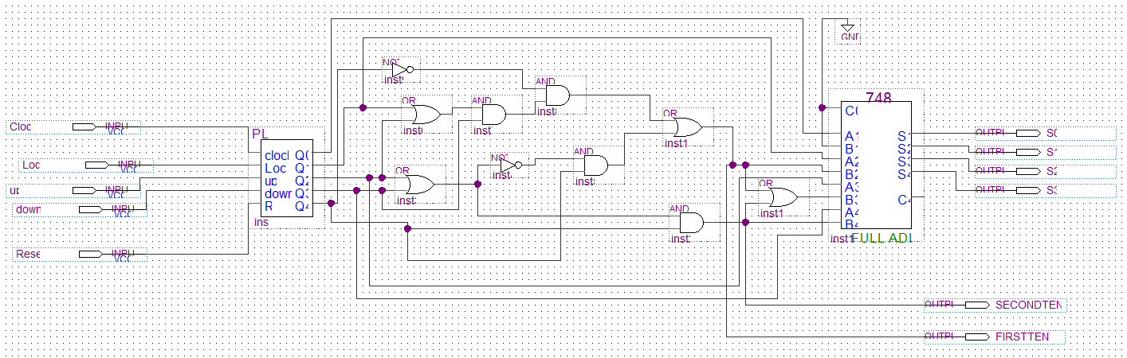
This is our counter

Figure 15: Adder for 7 segments
This circuit transforms the input in bits to the equivalent BCD unit value as in the table above.
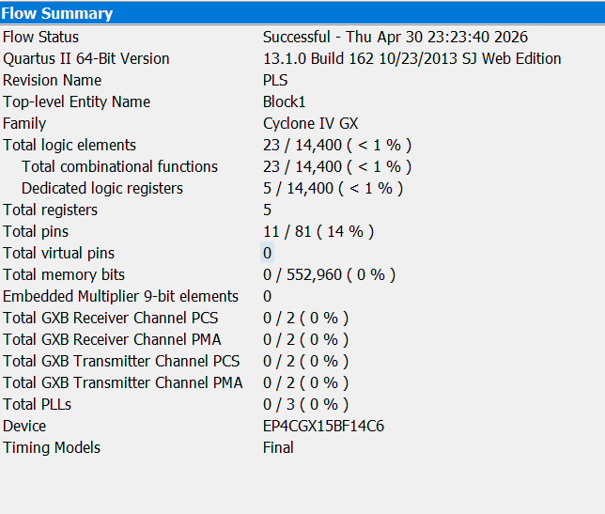
Figure 16:Compilation of adder

Now, let’s test our circuit.
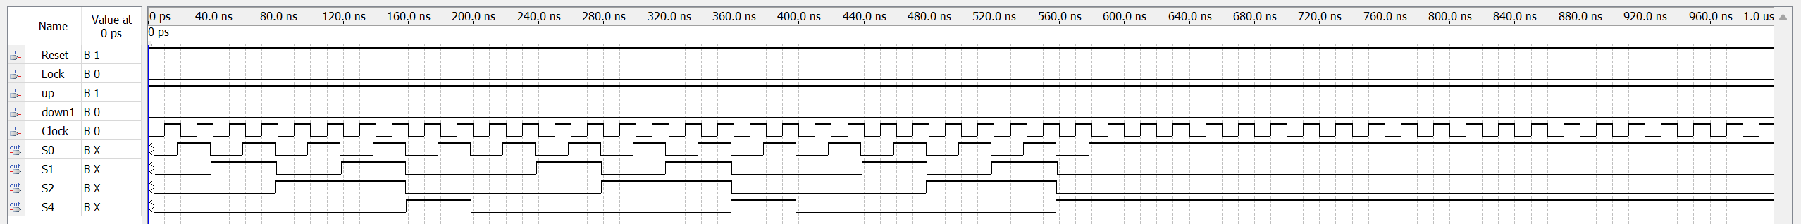
Figure 17: Output Sums
We got as except the results of the third column of the table.
On the circuit, we added the two signals that indicate in which interval of values we are and used it to implement the second 7 segments display.

Table 5: Second 7-segment output table
Second Tenth | First Tenth | a | b | c | d | e | f | g | Num
0 | 0 | 0 | 0 | 0 | 0 | 0 | 0 | 1 | 0
0 | 1 | 1 | 0 | 0 | 1 | 1 | 1 | 1 | 1
1 | 0 | 0 | 0 | 1 | 0 | 0 | 1 | 0 | 2

a = First Tenth
b = 0
c = Second tenth
d = First Tenth
e = First Tenth
f = First Tenth + Second Tenth
g = Second Tenth’

The circuit below represents everything described:
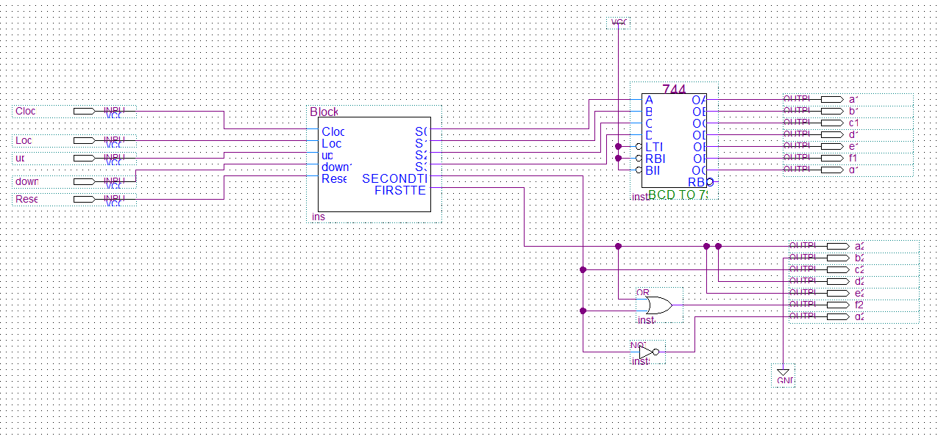
This is the adder implemented above
Figure 18: Two 7-segment display circuits for counter

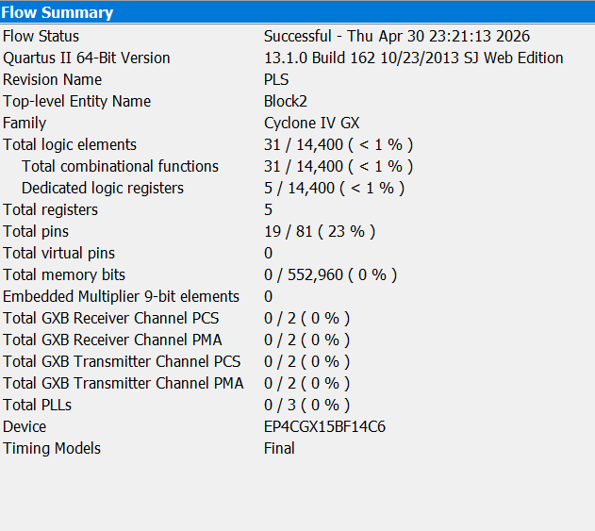
Figure 19:Compilation of the 7 Segment circuit counter

Let’s test our circuit:
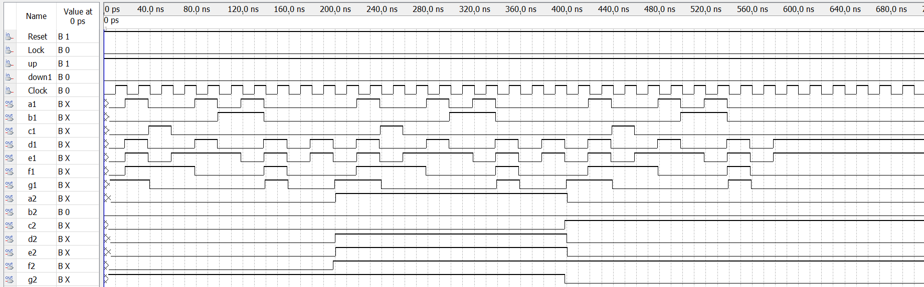
Figure 20:Output 7 Segment counter
As we can see the outputs are correct. For a1 to g1, we have the same values as the last column of the summary table and for a2 to g2, we have the same values as the fourth column.
Now, we need to implement the timer. The timer needs to start at 10 and start down counting to 0 and stop until the class is locked then unlocked or if we reset everything.
To implement this, we used the 74LS193, a 4 bit up/down synchronous counter, by always disabling the up bit and by presetting 1010. All we must do here is to connect the outputs of the counter to a 7-segment display decoder. But we only have one exception for 1010.
We need it to display 0 on the unit display and 1 on the tenth display.
For the unit display, we need to check if both first and third bit (1010) are high and displaying 0. (Suppose the counter output are Q3Q2Q1Q0 (MSB to LSB) and DCBA the input of the 7-segment decoder).
This is summarized in the table below:
Table 6: Input of the unit decoder timer
Q3 | Q2 | Q1 | Q0 | D | C | B | A
1 | 0 | 1 | 0 | 0 | 0 | 0 | 0
Otherwise |  |  |  | Q3 | Q2 | Q1 | Q0

For C and A, Q2 and Q0 are already 0, so A = Q0 and B = Q2.
As for D, only when Q3Q1 High -> 0 otherwise Q3. This gives (Q3Q1)’. Q3.
As for B, only when Q3Q1 High -> 0 otherwise Q1. This gives (Q3Q1)’. Q1.
As for the second display, to not use another decoder, we can directly connect it to the display’s inputs.
We want at 1010 to display 1 otherwise 0.
The outputs are summarized in the table below:
Table 7:Output of the second display for timer
Q3 | Q2 | Q1 | Q0 | a | b | c | d | e | f | g | Num
1 | 0 | 1 | 0 | 1 | 0 | 0 | 1 | 1 | 1 | 1 | 1
Otherwise |  |  |  | 0 | 0 | 0 | 0 | 0 | 0 | 1 | 0

This part is implemented like how it is shown below:
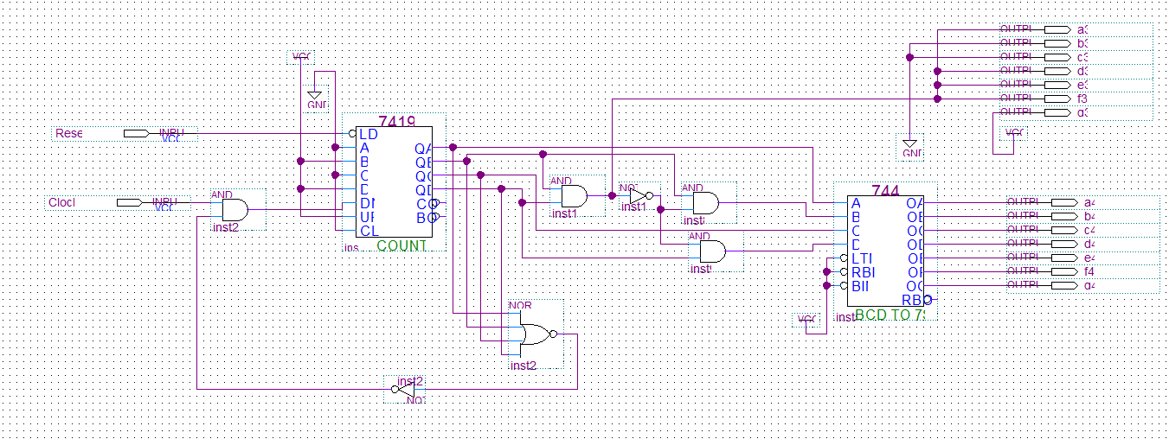
Figure 21: Timer circuit
Let’s simulate the circuit:

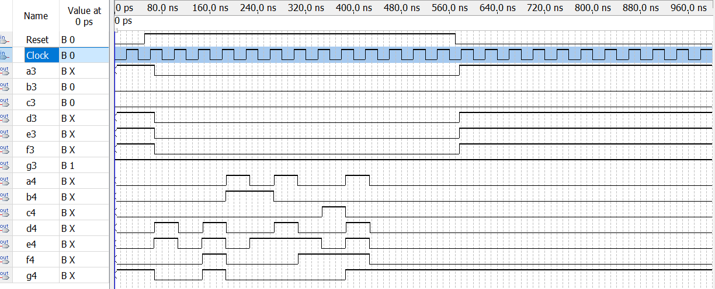
Figure 22:Simulation of circuit timer
Those results match our expectations. When we reset it, we got displayed 10 again.

In this part, we are going to implement the last 7 Segment display that outputs O if the class is Open or L if the class is Locked.
This table will help us proceed:
Table 8: Truth table for the last display
L (Lock) | a | b | c | d | e | f | g | Display
0 | 0 | 0 | 0 | 0 | 0 | 0 | 1 | O
1 | 1 | 1 | 1 | 0 | 0 | 0 | 1 | L

This gives us the following:
a,b,c = L;
d,e,f = 0;
g = 1;
Let’s implement it:
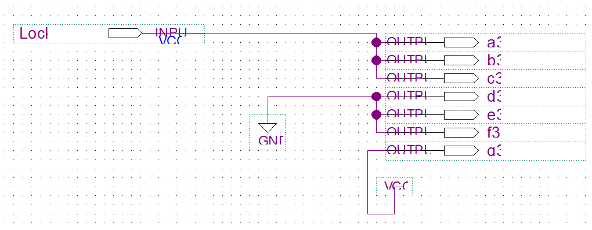
Figure 23:Third 7 Segment Display circuit
Let’s test our design:
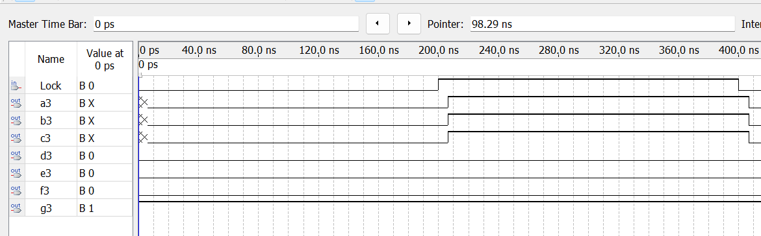
Figure 24:Simulation of the last display
The results match the table above.
Up to this point, the ‘Lock’ input has been included in every implementation but not designed. We will now proceed to implement it.
The lock bit is high when:
- Class capacity is full.
- Timer has reached 0.
- Instructors lift the lock switch.
We need to extract those from the previous implementations.
From the counter, the lock bit should be high when 11101 is reached.
This can be done by checking if (Q4’ +Q3’+ Q2’+Q1’)’ is high. (We used the complements and a 4 input NOR gate because we already have the complements of the outputs on the fliflop IC and we already used one 4 input nor gate).
For the timer that reaches 0, we already have a 4 input nor gate that checks if all the output of the down counter is 0 to stop counting.
And lastly, we add a lock switch for the teacher to close the classroom.
All this is implemented as shown below:

