

[Lebanese International University](https://en.wikipedia.org/wiki/Lebanese_International_University)

Submitted to The School of Arts & Science of The Lebanese International University Bekaa, Lebanon



***CSCI441 COMPUTER SCIENCE MACHINE LEANRING REPORT FALL SEMESTER (2024-2025)***

***Your Actions, Your Wellness***

**Presented by:**

**Names: Hadi Kabbani & Maher Alhamwi**

**Supervised by:**

**Name: Aya Mhalla**

**Contents**

1 Introduction: 5

1.1 Overview: 5

1.2 Problem: 5

1.3 Approach: 5

1.3.1 Linear Regression: 5

1.3.2 Random Forest Regression: 5

2 Data Collection and Description: 6

2.1 Dataset: 6

2.2 Data Size: 6

2.2.1 Number of Data Points and Features: 7

2.2.2 Important Observations: 7

2.3 Data Exploration: 8

2.3.1 Summary Statistics: 8

2.3.2 Data Types: 9

2.3.3 Key Distributions: 10

3 Algorithm Explanation 12

3.1 Random Forest: 12

3.1.1 Why This Model: 12

3.2 Linear Regression: 12

3.2.1 Why This Model: 13

3.3 Justification for Model Choice: 13

3.3.1 Why Random Forest Regressor? 13

3.3.2 Why Linear Regression? 14

4 Model Training and Evaluation 15

4.1 Train-Test Split: 15

4.2 Training the Model: 15

4.2.1 Initialize the Model: 15

4.2.2 Train the Model: 15

4.2.3 Fit the Model: 15

4.2.4 Predict The Model: 15

4.2.5 Code: 15

4.3 Evaluation Metrics: 16

4.3.1 Mean Squared Error (MSE): 16

4.3.2 R-Squared (R²): 16

4.3.3 Mean Absolute Error (MAE): 16

4.3.4 Model Performance: 16

4.3.5 General Evaluation Code: 17

5 Results: 18

5.1 Model Accuracy: 18

5.1.1 Linear Regression Results: 18

5.1.2 Random Forest Regressor Results: 18

5.2 Interpretation: 18

5.2.1 Linear Regression Results: 18

5.2.2 Random Forest Regressor Results: 19

5.3 Insights: 19

6 Discussion: 20

6.1 Model Performance: 20

6.1.1 Linear Regression: 20

6.1.2 Random Forest: 21

6.2 Feature Importance (Random Forest): 21

6.3 Challenges: 21

6.4 Model Limitations: 22

7 Conclusion: 23

7.1 Summary: 23

7.2 Recommendations: 23

7.3 Future Work: 24

8 Real-World Applications: 25

8.1 Use Cases: 25

8.2 Impact: 25

9 References 27

**Figures:**

Figure ‎2‑1Data Columns 6

Figure ‎2‑2Number of Row and Columns 7

Figure ‎2‑3Correlation Between Data 7

Figure ‎2‑4Duplicated and Missing Data 8

Figure ‎2‑5 Summary Statistics 9

Figure ‎2‑6Columns Data Types 9

Figure ‎2‑7Dataset Overall info 10

Figure ‎3‑1Linear Regression Equation 13

Figure ‎4‑1Mean Squared Error Equation 16

Figure ‎4‑2 R-Squared Equation 16

Figure ‎4‑3 Mean Absolute Error Equation 16

Figure ‎5‑1Linear Regression Performance 18

Figure ‎5‑2 Random Forest Regressor Performace 18

Figure ‎6‑1 Linear Regression on Test Data 20

Figure ‎6‑2 Random Forest on Test Data 21

# Introduction:

## Overview:

This project focuses on building a machine learning model to understand how daily activity affects health. The dataset includes information like the number of steps taken, distance traveled, and the amount of time spent in different activity levels (very active, moderately active, lightly active, and sedentary). It also includes the calories burned during the day.

The goal of the model is to predict how different activity patterns impact health, such as estimating calorie burn or understanding the relationship between activity and overall fitness. This can help people make better choices for their health and lifestyle.

## ****Problem:****

The problem being addressed is understanding how daily physical activity impacts health outcomes such as calorie burn and overall fitness. People often struggle to track and interpret their activity data in a meaningful way. By using machine learning, we can uncover patterns in the data that predict health metrics more accurately and provide personalized recommendations. This is important because it can guide individuals in making healthier lifestyle choices based on their activity levels.

## ****Approach:****

For this task, I will be using **Linear Regression** and **Random Forest Regression** to predict continuous health outcomes like calories burned based on the activity data. The models will be trained using features such as steps taken, distance traveled, and time spent in various activity levels.

### ***Linear Regression:***

**Linear Regression** is a simple model that can capture the relationship between the input features and a continuous target variable (calories burned).

### ***Random Forest Regression***:

**Random Forest Regression** is an ensemble learning method that combines multiple decision trees to make more accurate predictions, especially when the relationship between the features and target is more complex.

After training both models, we will evaluate their performance using metrics like **Mean Absolute Error (MAE)**, **Mean Squared Error (MSE)**, and **R² score**. The comparison of these models will help us determine which one provides better predictions for the given dataset.

# Data Collection and Description:

## Dataset:

The dataset used for this project was obtained from **Kaggle**, a popular platform for data science projects. It includes detailed records of daily activity such as:

* **Total Steps:** The number of steps taken in a day.
* **Total Distance:** The total distance covered, measured in miles.
* **Activity Levels:** Time spent in various activity categories:
  + **Very Active Minutes**
  + **Fairly Active Minutes**
  + **Lightly Active Minutes**
  + **Sedentary Minutes**
* **Calories Burned:** Total calories burned in a day.

This dataset is well-suited for the project because it captures multiple aspects of daily physical activity, making it ideal for understanding how different activity patterns influence health outcomes such as calorie expenditure.

import pandas as pd

data = pd.read_csv(“fit-data.csv”)

print("\nFirst Few Rows:")

print(data.head())

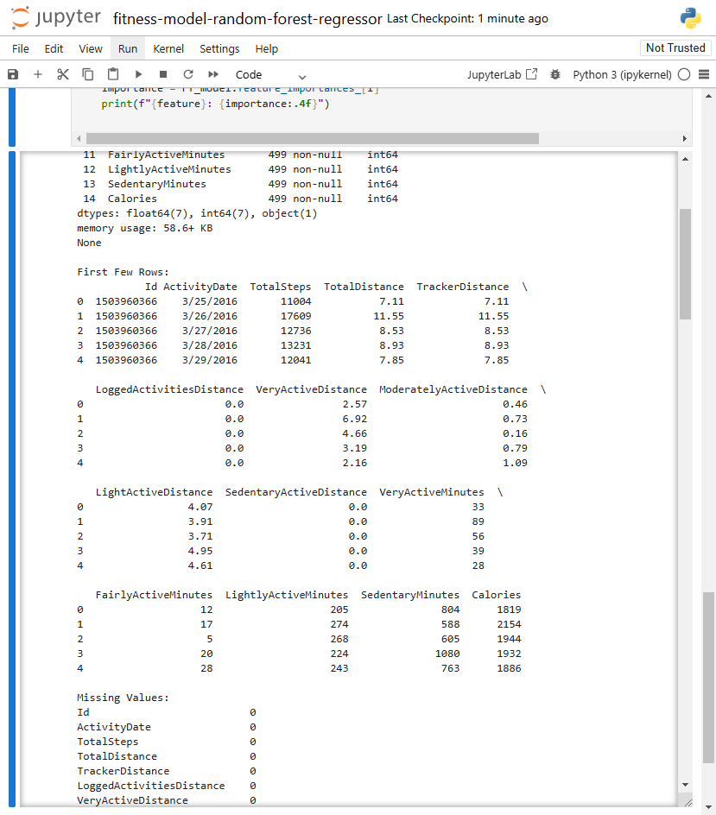

Figure ‎2‑1Data Columns

## ****Data Size:****

The dataset consists of:

### **Number of Data Points and Features**:

num_data_points = data.shape[0]

num_features = data.shape[1]

print(f"Number of Data Points: {num_data_points}")

print(f"Number of Features: {num_features}")

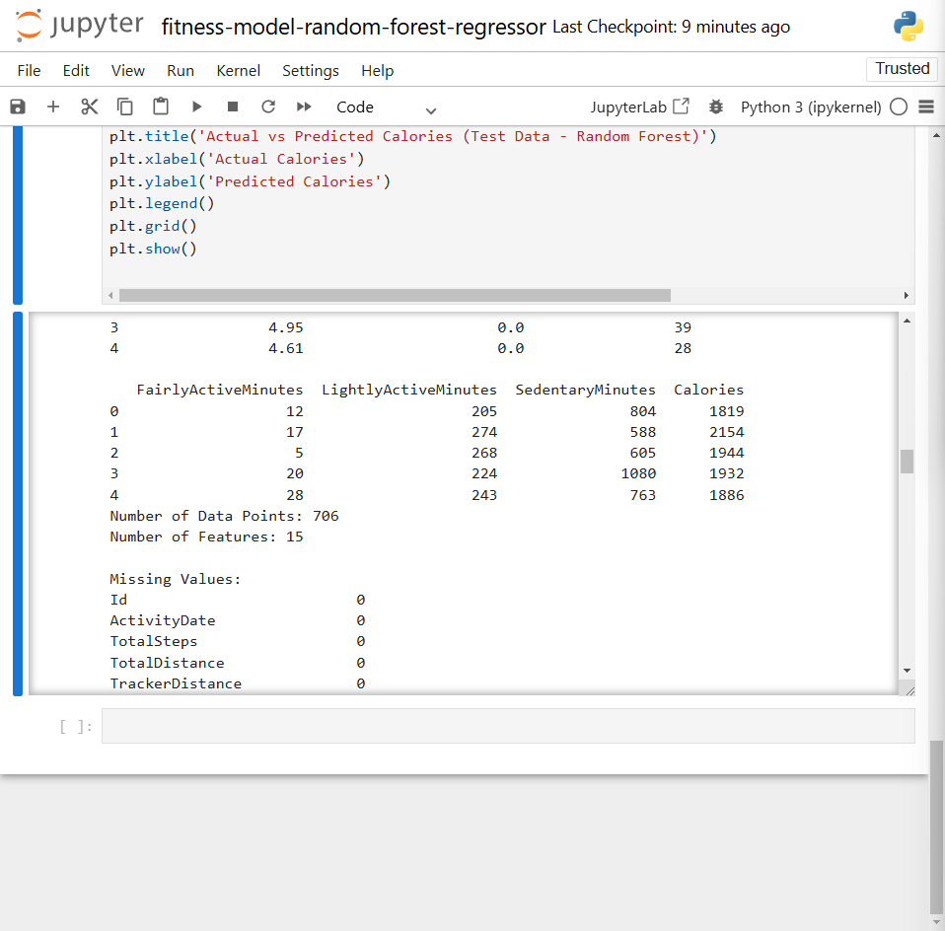

Figure ‎2‑2Number of Row and Columns

### **Important Observations**:

* Some features have strong correlations with the target variable (calories burned).

plt.figure(figsize=(10, 8))

corr_data = pd.concat([X, y], axis=1)

sns.heatmap(corr_data.corr(), annot=True, fmt=".2f", cmap="coolwarm")

plt.title('Feature and Target Correlation Heatmap')

plt.show()

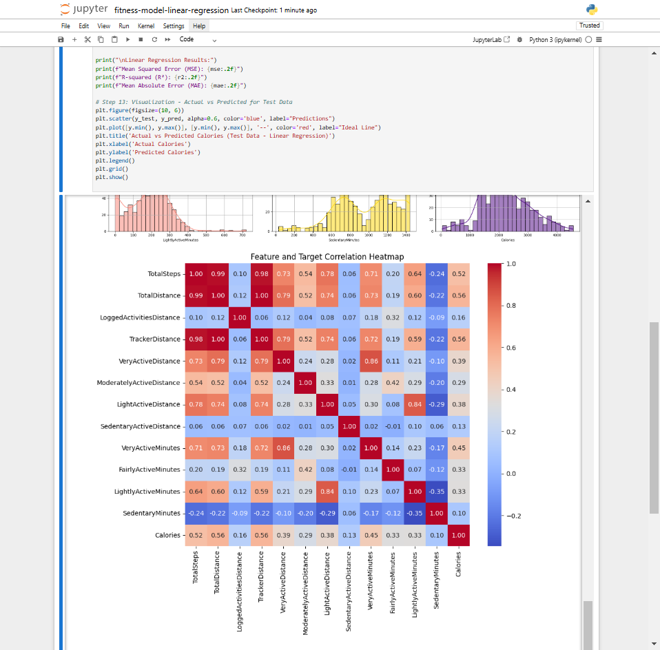

Figure ‎2‑3Correlation Between Data

* There may be missing or duplicate data points, which were cleaned before analysis.

missing_values = data.isnull().sum()

print("\nMissing Values:")

print(missing_values)

duplicates = data.duplicated().sum()

print(f"\nTotal Duplicates: {duplicates}")

data = data.apply(lambda col: col.fillna(col.mean()) if col.dtype in ['int64', 'float64'] else col.fillna(col.mode()[0]), axis=0)

data.drop_duplicates(inplace=True)

data = data[data['Calories'] > 0]

print(f"\nData shape after removing duplicates and missing values: {data.shape}")

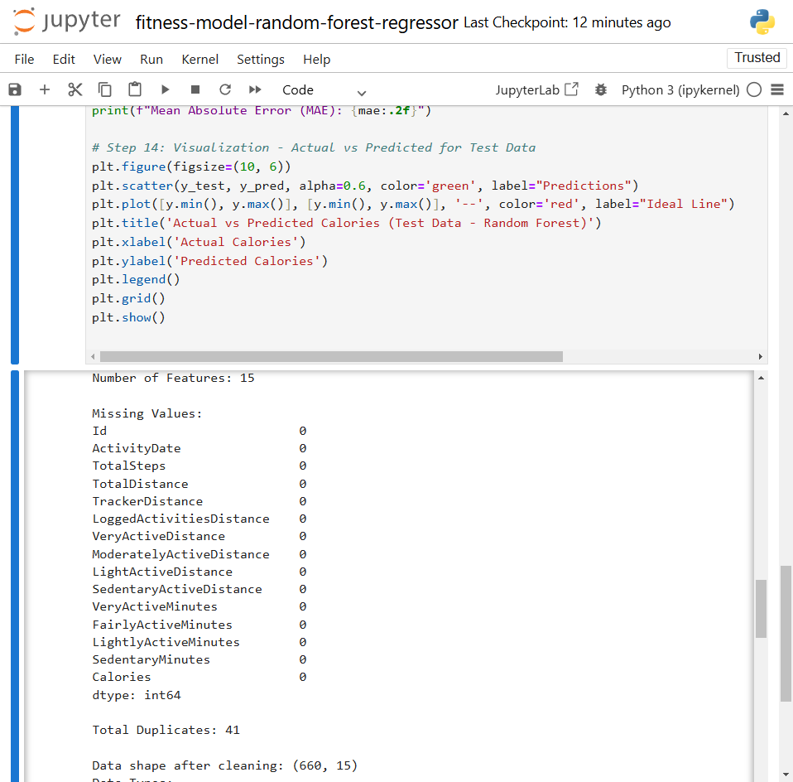

Figure ‎2‑4Duplicated and Missing Data

## ****Data Exploration:****

Initial exploration of the dataset revealed the following:

### **Summary Statistics**:

This part of the code generates the summary statistics for key features: TotalSteps, TotalDistance, Calories, and activity-related minutes (VeryActiveMinutes, FairlyActiveMinutes, LightlyActiveMinutes, and SedentaryMinutes).

print("\nDataset Description:")

print(data.describe())

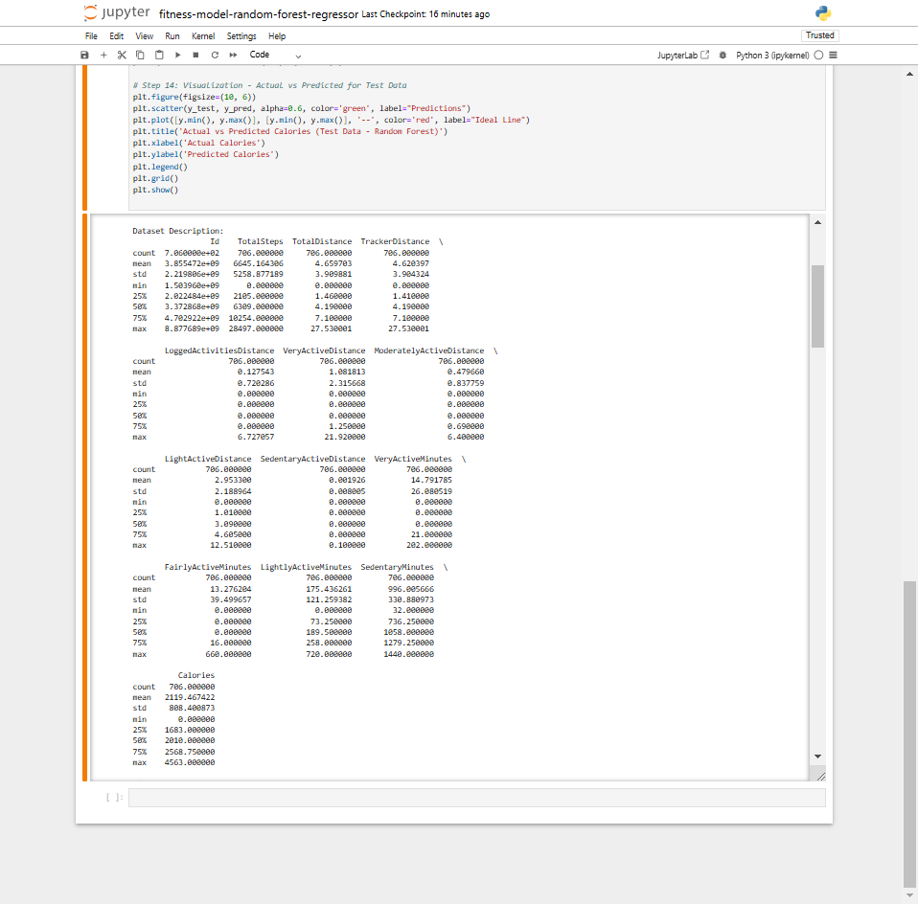

Figure ‎2‑5 Summary Statistics

### *Data Types:*

This step checks the data types for each feature (whether they are numeric or categorical).

data_types = data.dtypes

print("Data Types:\n", data_types)

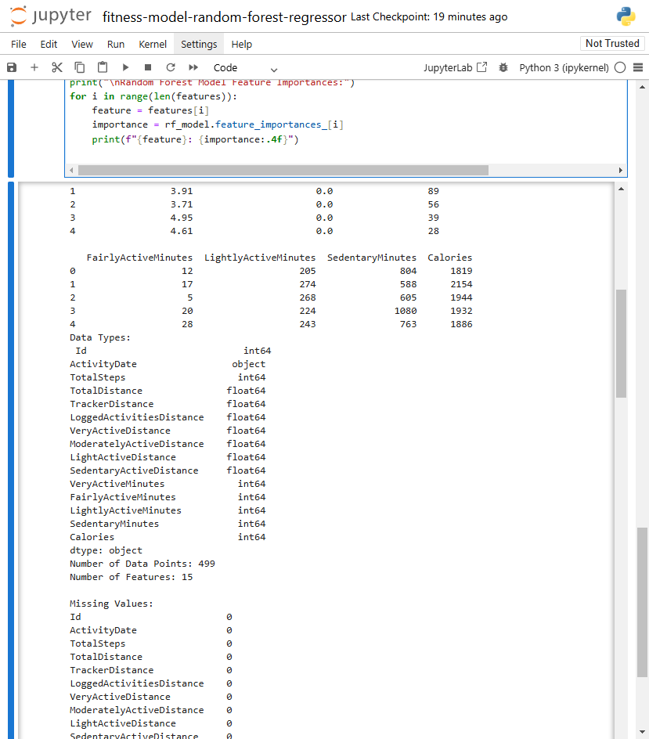

Figure ‎2‑6Columns Data Types

The following code show the overall view about the data:

print("Dataset Info:")

data.info()

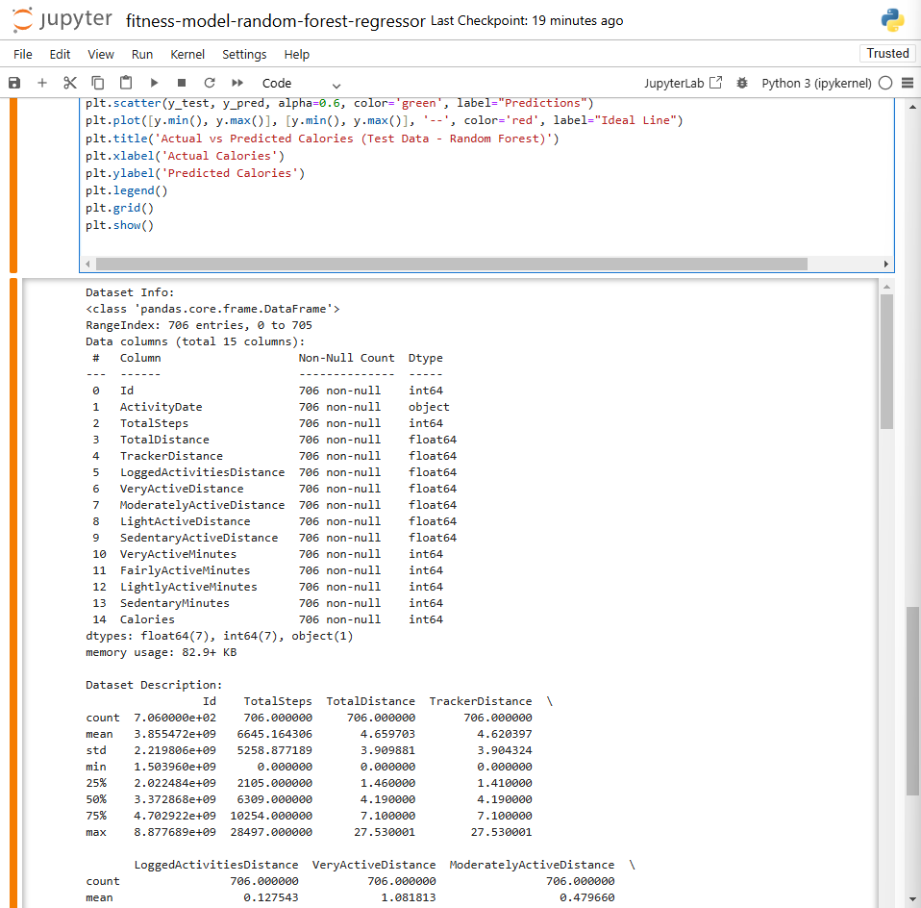

Figure ‎2‑7Dataset Overall info

### **Key Distributions**:

**Histogram:** These histograms will show how the distribution of dataset key looks. You’ll likely see a normal distribution with some outliers.

colors = ['blue', 'green', 'orange', 'purple', 'red', 'pink', 'brown', 'gray', 'teal', 'cyan',

'magenta', 'lime', 'yellow', 'salmon', 'gold', 'indigo', 'lightblue', 'lightgreen',

'lightcoral', 'skyblue', 'violet']

num_columns = len(data.columns)

rows = (num_columns // 3) + (1 if num_columns % 3 != 0 else 0)

plt.figure(figsize=(20, rows * 5))

for i, column in enumerate(data.columns, 1):

plt.subplot(rows, 3, i)

sns.histplot(data[column], bins=30, kde=True, color=colors[i % len(colors)], edgecolor='black')

plt.title(f'Distribution of {column}', fontsize=12)

plt.xlabel(column)

plt.ylabel('Frequency')

plt.grid(True)

plt.tight_layout()

plt.show()

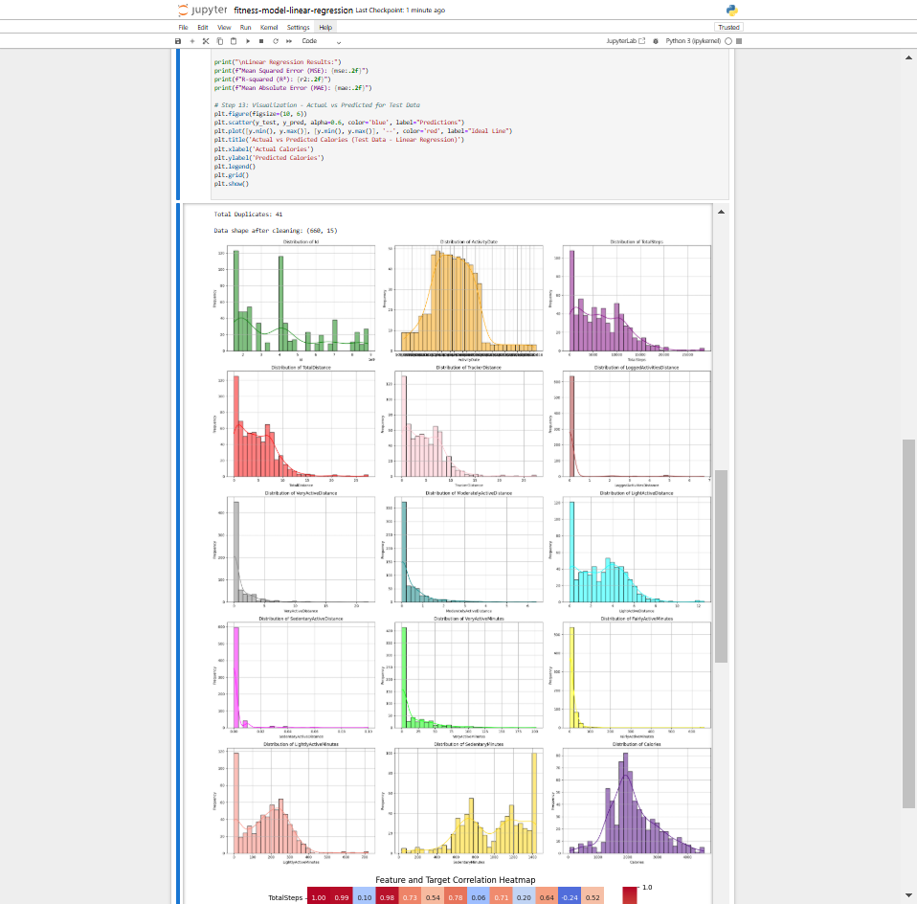

# Algorithm Explanation

## Random Forest:

The **Random Forest Regressor** is an ensemble learning method that builds multiple decision trees during training and outputs the average prediction of the individual trees. It works by creating a forest of decision trees, where each tree is trained on a random subset of the data and a random subset of features. During the prediction phase, the output from each individual tree is averaged to produce a final prediction.

* **Decision Trees**: A decision tree splits data based on feature values, which minimizes variance in the target variable. Each tree is built using a subset of the data, which reduces the risk of overfitting.
* **Ensemble Approach**: Random forests combine many decision trees to improve the stability and accuracy of predictions. By averaging the results of many decision trees, random forests avoid overfitting and generalize better to new data.

### Why This Model:

#### **Complexity of Data**:

The data for predicting calories burned consists of both continuous variables (like TotalSteps, TotalDistance) and categorical variables (such as activity levels). Random forests can handle both types of variables effectively and can capture complex relationships between them.

#### **Feature Interactions**:

Random forests are excellent for handling interactions between features, which is important because the features (e.g., activity minutes, steps, distance) are likely interdependent and influence the target variable (calories burned) in a non-linear manner.

#### **Robustness to Overfitting**:

Random forests are less prone to overfitting than single decision trees, making them ideal for tasks where there is a large number of features or data with noise (as in the case of fitness data). The method’s inherent ability to generalize well is important when predicting continuous outcomes like calories burned.

#### **High Accuracy**:

Random forests typically provide high accuracy compared to other algorithms due to their ensemble nature and ability to aggregate information from multiple decision trees, which reduces model variance and bias.

## ****Linear Regression:****

**Linear Regression** is a simple and interpretable model that assumes a linear relationship between the input features and the target variable. It predicts the target variable by calculating a weighted sum of the input features, where the weights are learned during training to minimize the difference between predicted and actual values (i.e., minimizing the residual sum of squares).

The equation for a linear regression model is: 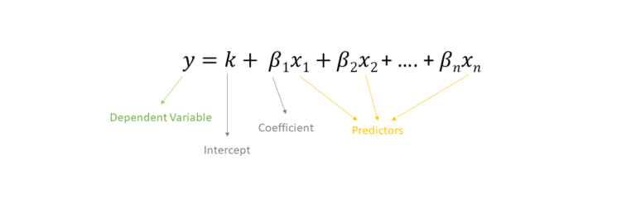

Figure ‎3‑1Linear Regression Equation

### Why This Model:

#### **Simplicity and Interpretability**:

Linear regression is a straightforward and interpretable model, making it suitable when understanding the relationship between variables is important. For example, the effect of each feature (like TotalSteps or VeryActiveMinutes) on calories burned can be easily explained by the coefficients.

#### **Linear Relationships**:

If the relationship between the input features and the target is approximately linear, linear regression is a strong choice. Although this assumption might not always hold in complex real-world data, it can provide a baseline for comparison against more complex models.

#### **Faster Training and Less Computation**:

Linear regression is computationally efficient compared to more complex models like random forests, which may require more resources and longer training times. This is especially beneficial when computational efficiency is a concern.

#### **Baseline Model**:

Linear regression often serves as a strong baseline model, which can then be compared with more complex models. In cases where the linear assumptions hold true, it can perform surprisingly well with minimal tuning.

## Justification for Model Choice:

### Why ****Random Forest Regressor****?

The **Random Forest Regressor** is chosen for this task because of the complex relationships in the dataset (e.g., interactions between steps, distance, activity minutes, and calories). Random forests excel at handling nonlinearities and interactions between features, which is crucial for accurately predicting calories burned. Additionally, their robustness to overfitting and ability to handle both continuous and categorical data makes them a powerful tool for this prediction task.

### Why ****Linear Regression****?

**Linear Regression** is chosen as a simpler, interpretable model to provide a baseline for understanding the relationship between the input features and calories burned. It is useful for quick insights into how the variables are related and serves as a point of comparison for more complex models like Random Forests. While it may not capture non-linear relationships as well, its simplicity makes it a good starting point for the analysis.

# Model Training and Evaluation

## Train-Test Split:

The dataset is divided into two subsets: a **training set** and a **test set**. The training set is used to train the model, while the test set is used to evaluate its performance. This helps assess how well the model generalizes to unseen data. In this project, we use an 80-20 split, where 80% of the data is used for training and the remaining 20% is used for testing.

from sklearn.model_selection import train_test_split

X_train, X_test, y_train, y_test = train_test_split(X, y, test_size=0.2, random_state=42)

* **X:** Features (input variables)
* **y:** Target variable (calories burned)
* **test_size=**0.2: 20% of the data is used for testing
* **random_state=**42: Ensures reproducibility of the results.

## Training the Model:

Once the data is split into training and testing sets, we train the chosen machine learning models (e.g., **Random Forest Regressor** or **Linear Regression**) using the training data. The training process involves fitting the model to the data by adjusting its parameters to minimize prediction errors.

### Initialize the Model:

We initialize the model (Random Forest and Linear Regression).

### Train the Model:

The model is trained using the training set (X_train, y_train). This means the model learns patterns from the features (steps, distance, activity minutes, etc.) to predict the target (calories burned).

### Fit the Model:

The model uses the training data to find the best-fit line (in case of linear regression) or decision boundaries (in case of random forests).

### Predict The Model:

After the model has been trained using the training dataset, we use it to predict the **Calories burned** for the test dataset. The predictions are based on the feature values (e.g., Total Steps, Total Distance, Active Minutes) that were not used during training. The prediction step helps us understand how well the model generalizes to unseen data.

### Code:

#### Linear Regression Code:

from sklearn.linear_model import LinearRegression

linear_model = LinearRegression()

linear_model.fit(X_train, y_train)

y_pred = linear_model.predict(X_test)

#### Random Forest Code:

from sklearn.ensemble import RandomForestRegressor

rf_model = RandomForestRegressor(

n_estimators=300, # Number of trees in the forest

max_depth=None, # Maximum depth of the tree

min_samples_split=10, # Minimum samples to split a node

min_samples_leaf=5, # Minimum samples at a leaf node

random_state=42 # Random seed for reproducibility

)

rf_model.fit(X_train, y_train)

y_pred = rf_model.predict(X_test)

## Evaluation Metrics:

To evaluate the model's performance, we use various metrics that measure the quality of predictions. These include:

### Mean Squared Error (MSE):

Measures the average of the squared differences between actual and predicted values. A lower MSE indicates better model performance.

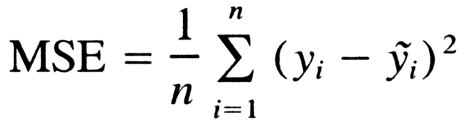

Figure ‎4‑1Mean Squared Error Equation

### R-Squared (R²):

Represents the proportion of variance in the target variable that is explained by the model. R² ranges from 0 to 1, with 1 indicating a perfect model.

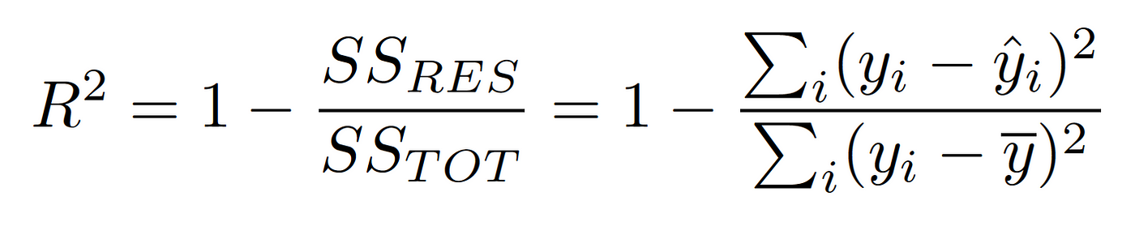

Figure ‎4‑2 R-Squared Equation

### Mean Absolute Error (MAE):

Measures the average of the absolute differences between the actual and predicted values. A lower MAE indicates better performance.

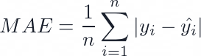

Figure ‎4‑3 Mean Absolute Error Equation

### Model Performance:

The model's performance is assessed based on the evaluation metrics:

* **MSE**: A lower MSE means the model's predictions are closer to the actual values.
* **R²**: A higher R² value indicates that the model explains a large portion of the variance in the target variable.
* **MAE**: A lower MAE means the model's average error in predictions is smaller.

### General Evaluation Code:

from sklearn.metrics import mean_squared_error, r2_score, mean_absolute_error

# Calculate performance metrics

mse = mean_squared_error(y_test, y_pred)

r2 = r2_score(y_test, y_pred)

mae = mean_absolute_error(y_test, y_pred)

print(f"Mean Squared Error (MSE): {mse:.2f}")

print(f"R-squared (R²): {r2:.2f}")

print(f"Mean Absolute Error (MAE): {mae:.2f}")

# Results:

## ****Model Accuracy****:

### **Linear Regression Results**:

#### Standard Model Evaluation****:****

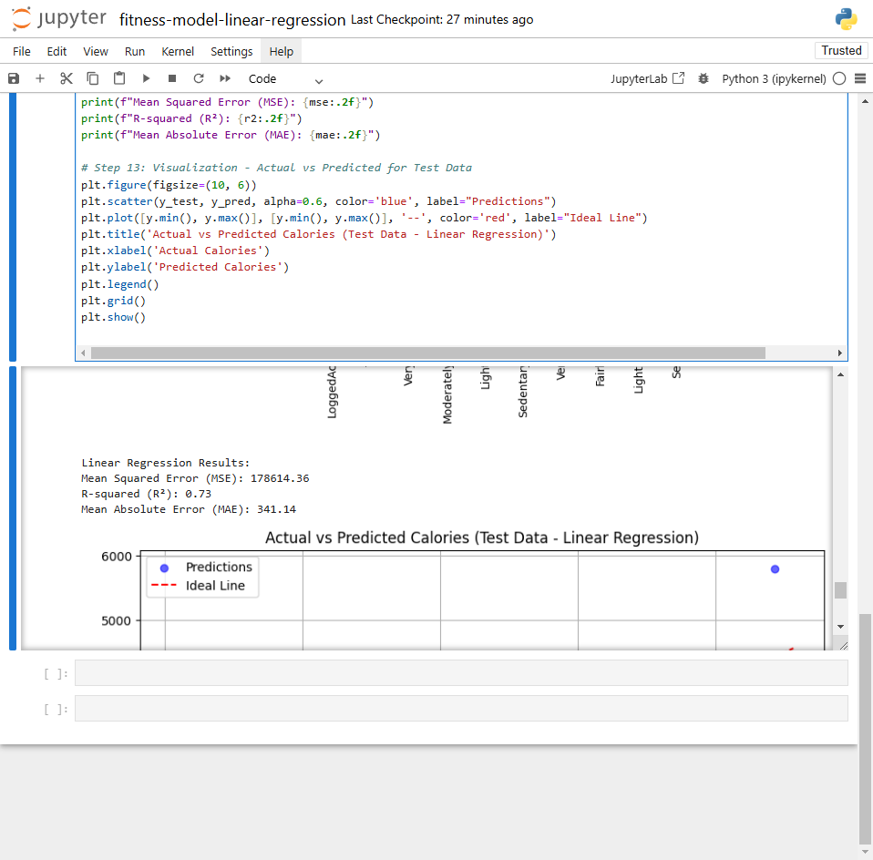

Figure ‎5‑1Linear Regression Performance

### **Random Forest Regressor Results**:

#### Standard Model Evaluation****:****

Figure ‎5‑2 Random Forest Regressor Performace

## Interpretation:

### Linear Regression Results:

#### ***Mean Squared Error (MSE): 178,614.36:***

MSE is a measure of how well the model's predictions match the actual values. It calculates the average squared difference between predicted and actual values. A higher MSE indicates that the predictions are farther from the true values. In this case, the relatively high MSE suggests that the Linear Regression model has some level of error in its predictions, possibly due to overfitting, especially with the inclusion of duplicated data.

#### ***R-squared (R²): 0.73:***

R-squared represents the proportion of the variance in the dependent variable (output) that is explained by the model. A value of 0.73 means that the model explains 73% of the variability in the target variable. While this is a fairly good result, it indicates that 27% of the variance is unexplained, which could suggest room for improvement, particularly if the model is overfitting to the duplicated data.

#### ***Mean Absolute Error (MAE): 341.14:***

MAE measures the average absolute difference between the predicted and actual values. It gives a sense of how far off, on average, the predictions are. In this case, an MAE of 341.14 indicates that, on average, the model's predictions are off by 341.14 units. A lower MAE would indicate better accuracy, but the relatively high MAE suggests that the model's predictions are not very precise, potentially due to overfitting to the duplicated data.

### Random Forest Regressor Results:

#### Mean Squared Error (MSE): 127,603.98:

The MSE for the Random Forest model is lower than that of Linear Regression, suggesting that the Random Forest model is doing a better job of minimizing prediction errors. This could be because Random Forest is less sensitive to overfitting compared to Linear Regression, particularly when handling duplicated data, and is better at capturing complex patterns in the data.

#### R-squared (R²): 0.72:

The R-squared value for Random Forest is very close to that of Linear Regression (0.72 vs. 0.73), indicating that both models explain a similar amount of the variance in the data. However, Random Forest generally performs better with more complex relationships between features, and this metric suggests it is on par with Linear Regression in terms of explaining variance.

#### Mean Absolute Error (MAE): 258.31:

The MAE for Random Forest is lower than that of Linear Regression (258.31 vs. 341.14), suggesting that Random Forest's predictions are more accurate on average. This is a strong indicator that the Random Forest model is better at making precise predictions, likely because it can handle nonlinearities and interactions between features more effectively than Linear Regression.

## ****Insights****:

**Prediction Accuracy:** The **Random Forest** model outperforms **Linear Regression** with lower MSE (127,603.98 vs. 178,614.36) and MAE (258.31 vs. 341.14), indicating more accurate predictions.

**Explained Variance:** Both models have similar R-squared values (0.73 for Linear Regression, 0.72 for Random Forest), suggesting they explain a similar amount of variance in the target variable.

**Overfitting:** Despite improvements, **Random Forest** may still overfit to the duplicated data, but it handles it better than **Linear Regression**, which shows higher error metrics.

**Model Suitability:** **Random Forest** is better for capturing complex relationships, while **Linear Regression** may struggle with overfitting, especially with duplicated data.

# Discussion:

## Model Performance:

### Linear Regression:

The Linear Regression model achieved an R2 value of 0.73 on the test data, demonstrating its ability to capture a substantial portion of the variance in the target variable. However, the model struggled with non-linear patterns, which could potentially be addressed through techniques such as:

* **Polynomial features** to model non-linear relationships.
* **Interaction terms** to capture dependencies between predictors.
* Advanced methods like **Ridge** or **Lasso regression** to manage multicollinearity and improve generalization.

Outlier detection and robust regression methods could also enhance model performance by mitigating the influence of extreme values.

**Prediction Accuracy:** Despite its simplicity, Linear Regression exhibited higher error metrics compared to the Random Forest model, with an MSE of 178,614.36 and an MAE of 341.14. These results indicate less precise predictions compared to Random Forest.

**Explained Variance:** Linear Regression and Random Forest showed similar R2 values (0.73 and 0.72, respectively), suggesting comparable abilities to explain variability in the target variable.

**Model Suitability:** Linear Regression is suitable for simpler, linear relationships but may underperform when the data contains complex or non-linear patterns.

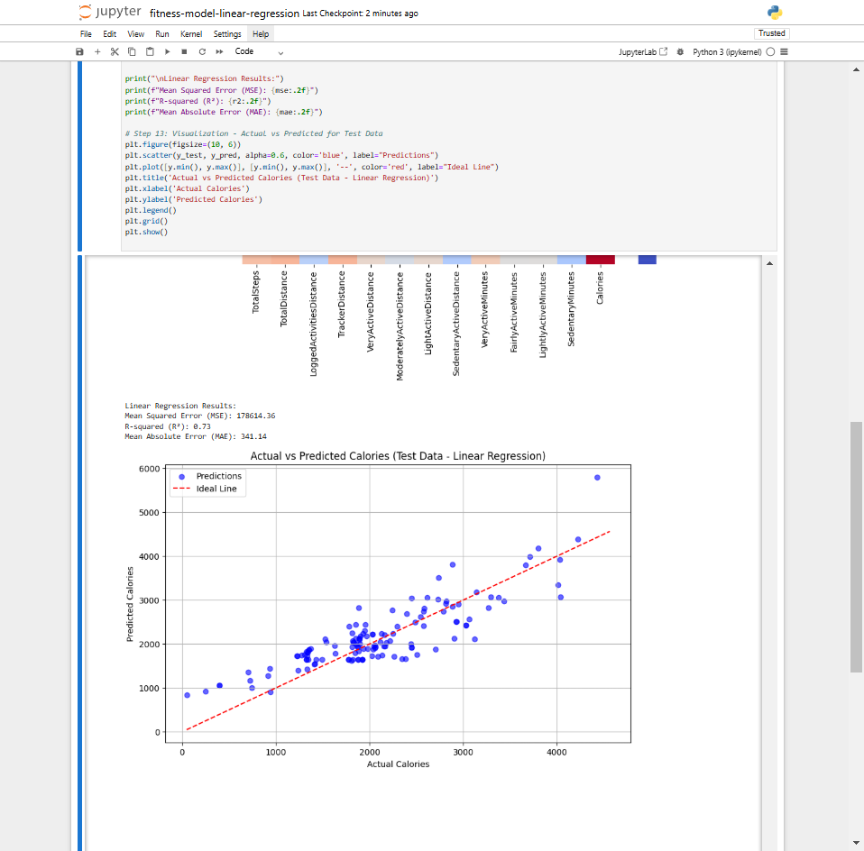

Figure ‎6‑1 Linear Regression on Test Data

### Random Forest:

The Random Forest Regressor achieved an R2 value of 0.72 on the test data, indicating a strong performance comparable to Linear Regression in terms of explained variance. However, Random Forest excelled in prediction accuracy with a lower MSE (127,603.98) and MAE (258.31).

**Addressing Overfitting:** While Random Forest performed better than Linear Regression. To enhance generalization, the following strategies could be implemented:

* **Hyperparameter tuning** to optimize the number of estimators, maximum tree depth, and other parameters.
* **Limiting tree depth** or applying **pruning techniques** to reduce model complexity.
* **Regularization** and **cross-validation** to fine-tune the model and ensure it is not overly specialized to the training data.

**Model Suitability:** Random Forest is particularly effective at capturing complex, non-linear relationships and can better handle variations in the data compared to Linear Regression.

Figure ‎6‑2 Random Forest on Test Data

## Feature Importance (Random Forest):

Random Forest provides valuable insights into feature importance. By analyzing the most significant features for predicting calorie burn, the model’s output becomes more interpretable. This aligns well with physical activity data, where understanding which factors contribute the most to energy expenditure can help refine health monitoring tools.

## Challenges:

**Data Collection:** Variability in activity patterns and sensor errors are common issues in real-world datasets. These challenges can reduce model accuracy and highlight the need for reliable data sources.

**Data Preprocessing:** Missing values and duplicates are critical issues that can significantly affect model performance. Proper preprocessing steps, like handling missing data and removing duplicates, are essential for building an effective model.

**Modeling Challenges:** Linear Regression struggles with non-linear relationships, while Random Forest is prone to overfitting, especially on repetitive data. These challenges should be addressed in future iterations.

## Model Limitations:

**Linear Regression:** The model assumes linearity between the features and the target variable, which limits its effectiveness on non-linear data. The sensitivity to outliers also reduces the robustness of the model. Methods for detecting and handling outliers, such as using robust regression techniques, could help address this.

**Random Forest:** Overfitting and lack of interpretability are two major limitations. Implementing techniques like cross-validation, pruning, or using simpler models could improve generalization and enhance interpretability.

# Conclusion:

## ****Summary****:

In this project, we explored the use of **Linear Regression** and **Random Forest Regressor** to predict calories burned based on various activity-related features. Our analysis revealed several important insights:

**Linear Regression** performed reasonably well, explaining 73% of the variance in the target variable. However, the model may not effectively capture complex, non-linear relationships in the data.

**Random Forest Regressor** performed reasonably well on the test data with an R² of 72%, suggesting it captured some of the patterns in the data. which indicates that the model may have overfitted to repetitive patterns. This suggests that Random Forest may struggle to generalize to new, diverse data and could benefit from further tuning.

**Feature importance analysis** for the Random Forest model provided highlighted significant predictors like **TotalSteps**, **VeryActiveMinutes**, and **Calories**, emphasizing that physical activity levels are critical for predicting energy expenditure.

In conclusion, while both models showed potential, **Random Forest** emerged as the better choice overall, with a performance of (R² = 72% & MSE = 127603.98 & MAE = 258.31) compared to Linear Regression's (R2 = 73% & MSE = 178614.36 & MAE = 341.14). Despite the close R² values, **Random Forest** provided better insight into feature importance and demonstrated a slightly more robust handling of complex patterns. However, improvements in generalization through model tuning and testing on diverse datasets are essential for both models.

## ****Recommendations****:

To improve the model, several strategies can be considered:

**Hyperparameter Tuning**: Fine-tuning the hyperparameters of the Random Forest model, such as the number of trees, tree depth, and minimum samples per leaf, could lead to better generalization and reduced overfitting. Techniques like grid search or random search for hyperparameter optimization could be employed.

**Feature Engineering**: Additional features can be created to capture non-linear relationships. For instance, adding interaction terms between features, polynomial features, or log-transformed variables could help the Linear Regression model capture more complexity. Also, incorporating features like age, gender, or exercise intensity (if available) could enhance the models' predictive power.

**Model Exploration**: While **Random Forest** and **Linear Regression** are solid models, exploring other algorithms such as **Gradient Boosting Machines (GBM)**, **XGBoost**, or **Support Vector Machines (SVM)** could yield better results, especially for capturing complex relationships and improving generalization.

## ****Future Work****:

The project can be extended and improved in several ways:

**Incorporating Time-Series Data**: If timestamps or activity sequences are available, incorporating time-series analysis (e.g., using recurrent neural networks (RNNs) or long short-term memory networks (LSTMs) could help predict calories burned based on activity patterns over time. This approach could capture temporal trends and more accurately model sequential dependencies.

**Exploring Deep Learning Models**: If the dataset is sufficiently large, exploring deep learning models such as neural networks could provide a more powerful approach for predicting calories burned, especially if there are complex, non-linear interactions between features.

**Expanding the Dataset**: Adding more diverse data (e.g., from different devices, users, or activity types) could help improve model generalization and robustness. A more diverse dataset can also help the model adapt to varying conditions and capture broader trends.

**Integration with Wearable Devices**: Integrating this model with real-time data from wearable devices could lead to the development of a dynamic, personalized fitness tracker. This would allow for real-time calorie predictions based on a user's current activity, making the model more practical and valuable for users.

# Real-World Applications:

## ****Use Cases****:

This calorie prediction model has significant real-world applications across several domains, particularly in health, fitness, and wellness industries. Here are some potential use cases:

**Personalized Fitness Trackers**: The model can be integrated into fitness tracking apps or wearable devices (e.g., Fitbit, Apple Watch) to provide users with real-time predictions of calories burned based on their activity levels. This would help users better understand how their physical activities translate to energy expenditure, enabling more accurate and tailored fitness plans.

**Health and Wellness Programs**: For organizations offering wellness programs or for nutritionists and dietitians, this model can be used to monitor the energy expenditure of individuals. By predicting calories burned from daily activities, professionals can create personalized meal plans and fitness routines, improving the overall health and fitness of their clients.

**Public Health Research**: In the field of public health, this model can be used to analyze large-scale population data to study the relationship between physical activity and health outcomes (such as obesity or cardiovascular disease). It could provide insights into how different levels of activity contribute to energy balance and help in designing more effective public health interventions.

**Smart Clothing**: The model can be embedded in smart clothing with embedded sensors to provide accurate calorie-burning estimates as people engage in daily activities or exercises. This technology could revolutionize wearable fitness gear and provide real-time health insights.

**Sports Science and Performance**: Coaches and sports scientists could use the model to estimate the energy expenditure of athletes during training sessions. This could help optimize training regimens and recovery strategies by balancing the energy spent and required.

**Employee Wellness Programs**: Companies can use this model to offer personalized fitness insights to their employees as part of corporate wellness programs. By tracking daily activities, companies can encourage healthier lifestyles, which may lead to higher employee engagement, lower healthcare costs, and improved productivity.

## ****Impact****:

The model has the potential to make a significant impact on decision-making and problem-solving in real-world contexts by offering more personalized, data-driven insights:

**Empowering Users**: By providing accurate calorie burn predictions based on daily activities, users gain more control over their health and fitness goals. It helps individuals make informed decisions about their daily routines, such as whether to increase their activity levels to meet fitness goals or reduce sedentary behavior to improve overall health.

**Improved Health Outcomes**: With better predictions of calorie expenditure, users can optimize their diet and exercise routines to achieve specific health goals, such as weight loss, weight maintenance, or muscle gain. This personalized approach enhances motivation and adherence to fitness programs, leading to more successful health outcomes.

**Enhanced Healthcare Decisions**: Health professionals could use the model to provide more personalized advice to patients, particularly those managing chronic conditions like diabetes, obesity, or cardiovascular diseases. The model could inform decisions related to physical activity recommendations and nutrition plans.

**Cost Reduction for Healthcare**: As the model helps in preventing lifestyle-related diseases by encouraging healthier habits, it can contribute to long-term cost savings in healthcare. By promoting exercise and proper energy management, it can reduce the incidence of obesity, diabetes, and cardiovascular problems.

**Supporting Public Health Policy**: In large-scale public health studies, this model could be used to analyze population-level trends in physical activity and calorie expenditure. The findings could inform government policies aimed at reducing sedentary lifestyles, promoting physical activity, and tackling obesity.

# References

Möbius. (2023). *FitBit Fitness Tracker Data*. Retrieved from Kaggle: https://www.kaggle.com/datasets/arashnic/fitbit