**Viruses**

*Developer Guide*

|  |  |  |
| --- | --- | --- |
| **Supervisor.** | **Sir Ebad Uddin Ahmed** | |
| **Batch.** | **2210C2** | |
| **Group.** | A | |
| **Serial No.** | **Enrollment Number** | **Student Name** |
| 1. | 1424748 | Syed Zamin Abbas Zaidi |
| 2. | 1423493 | M. Aqib Zubairi |
| 3. | 1424826 | Syed Abdul Hadi Ali |
| 4. | 1424859 | Sheikh M.Affan |

1. **Home** (*index (1).html*)

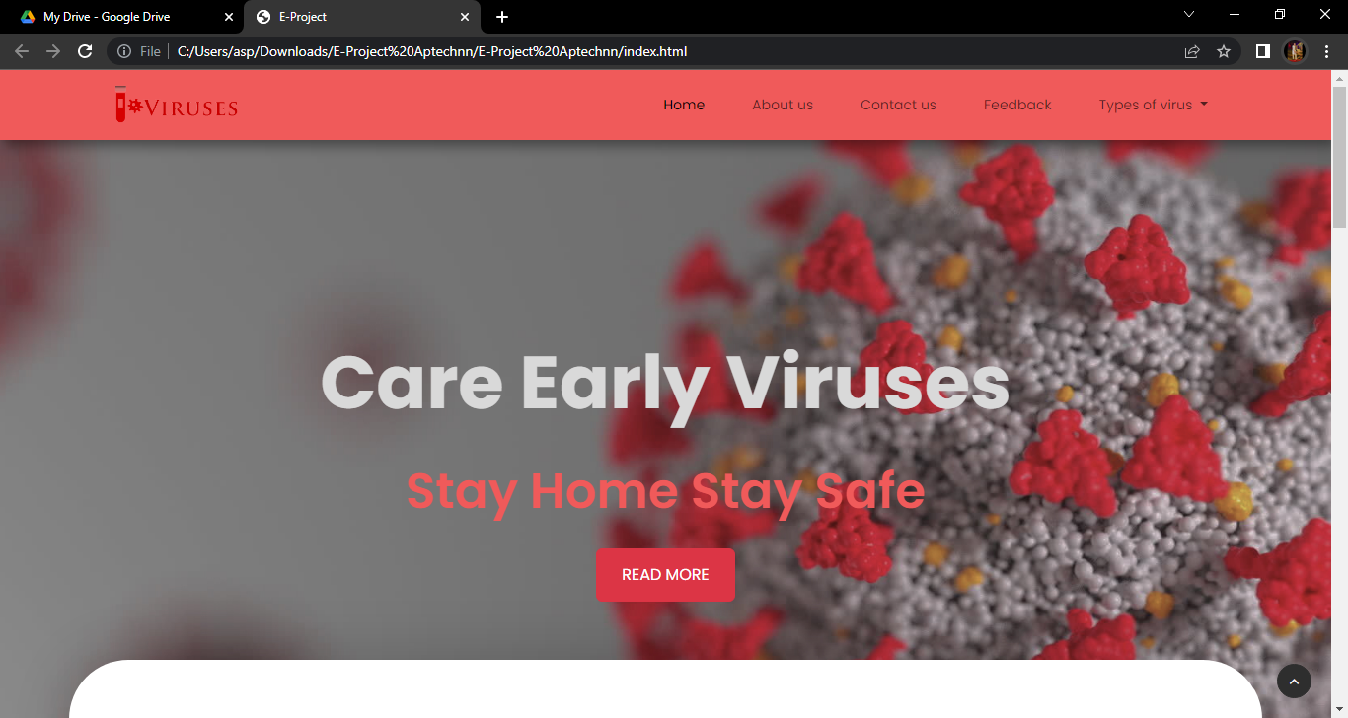

***Figure 1: Home page to viruses?***

 Our Slogan has given the awareness of viruses toward our website.

* OUR HOME PAGE WELCOME OUR CUSTUMERS WITH ATTRACTIVE QOUTE.

**Code of Home page**

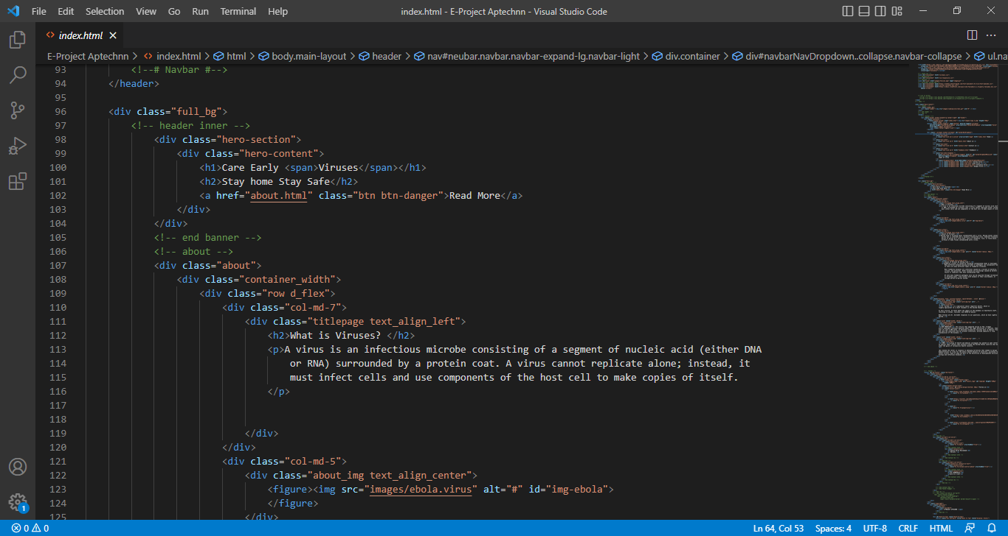

1. **Navbar (index.html)**

**

***Figure 2: Navbar***

We have given FIVE essentials. By clicking any of the essential’s and redirect to the linked page. (Index.html)

**Code of Navbar**

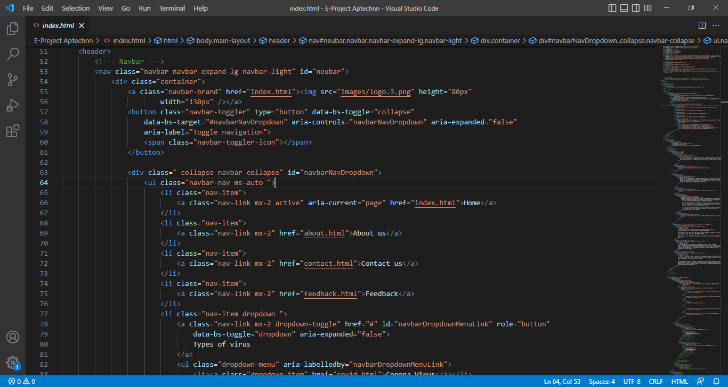

1. **Menu (index .html)**

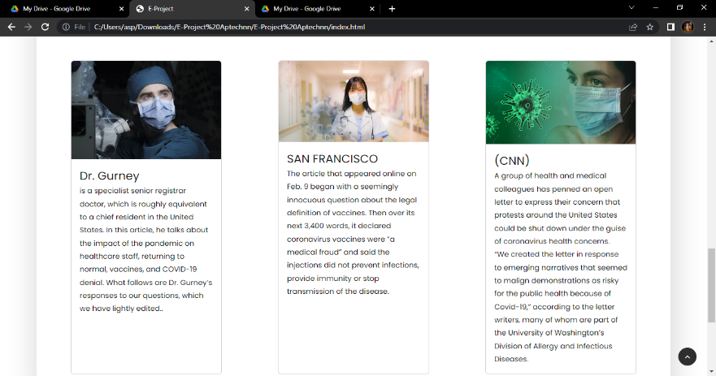

***Figure 3: Menu***

* We given a knowledge about viruses.
* They description about doctors statement.

***Code of MENU OFFERS***

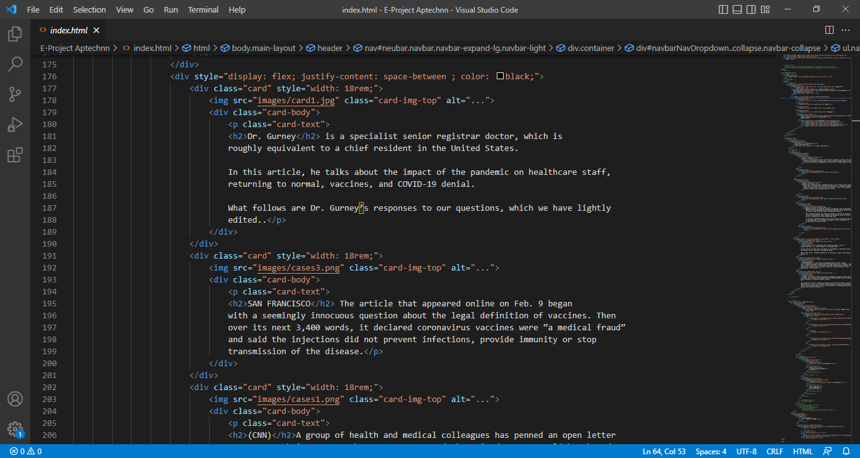

***Figure 4: About us***

*We have Knowledge about viruses.*

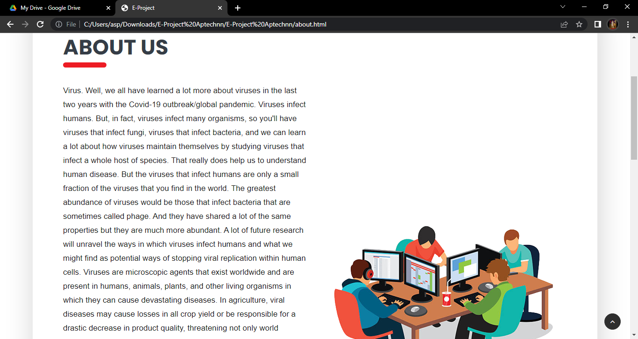

***Code of about us***

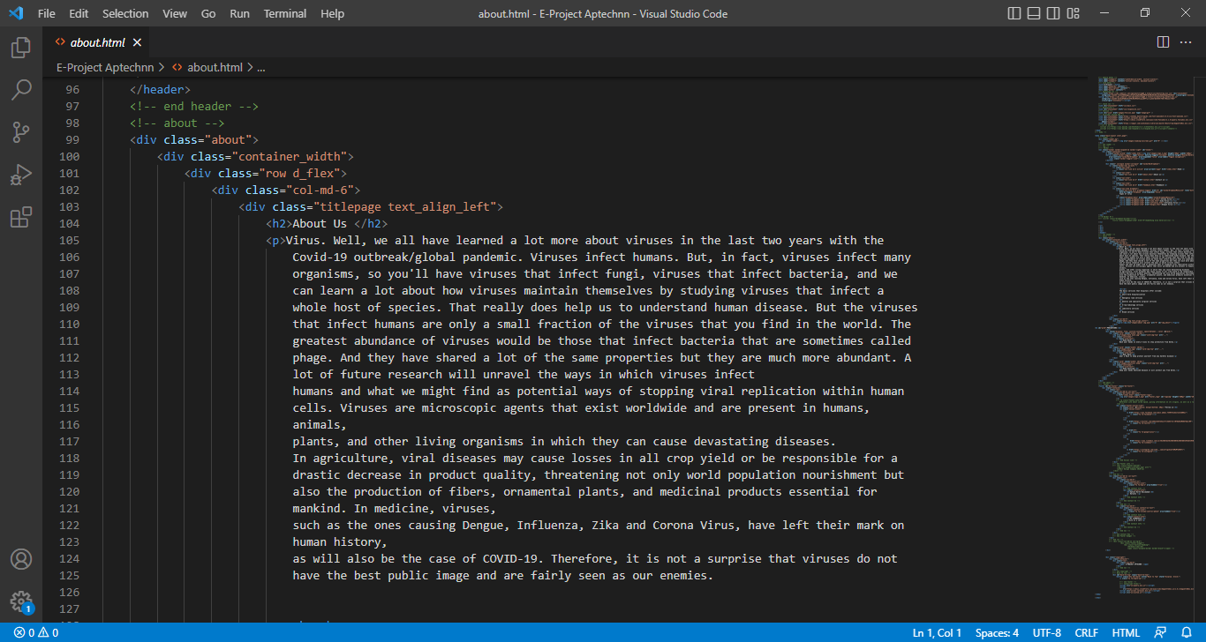

***5.Types of viruses (index .html)***

**CORONA VIRUS**

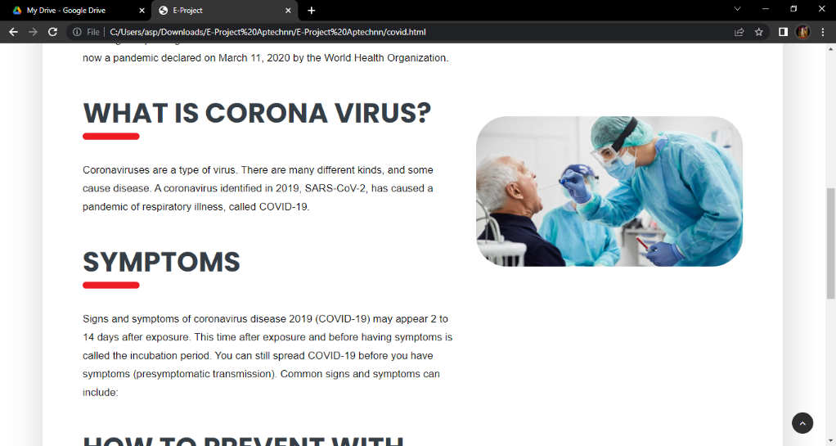



***Code of arivval***

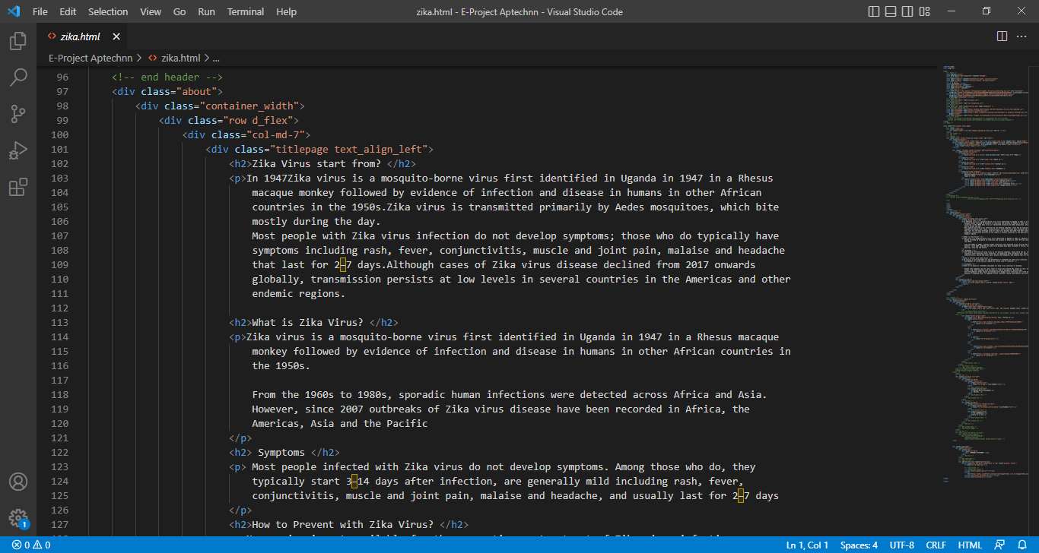

**ZIKA VIRUS**

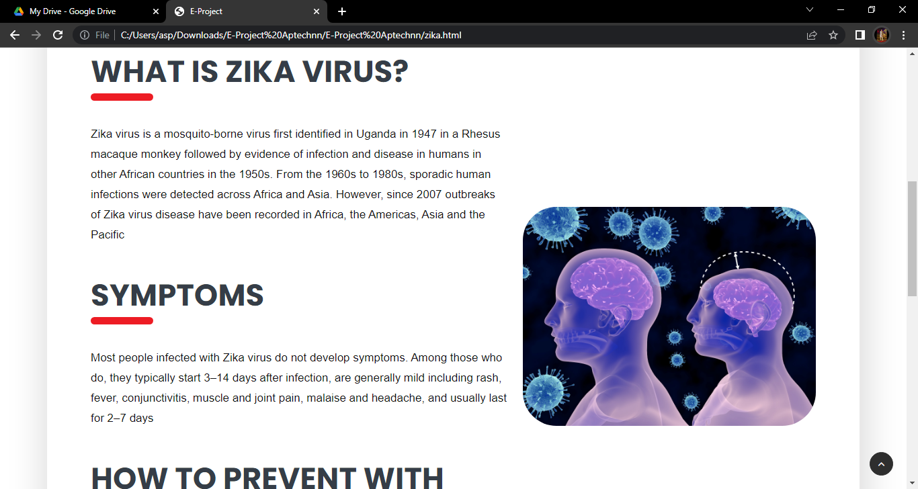

***CODE OF ARRIVAL***

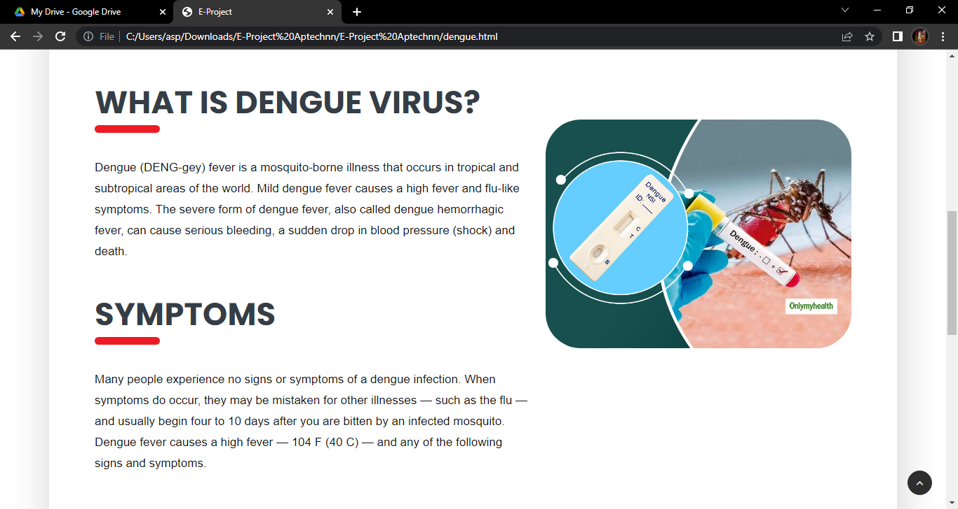 ***DENGUE VIRUS***

***CODE OF ARRIVAL***

***8. feedback(feedback. Html):***

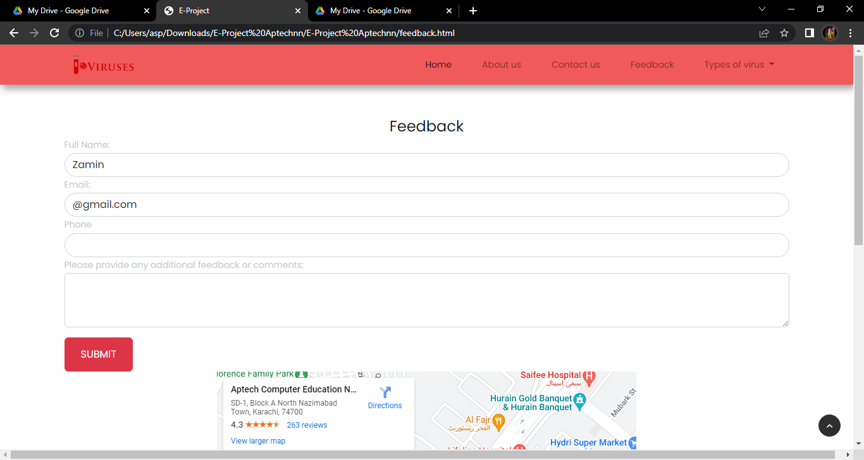

*On clicking feedback. feedback form page open on blank page there customer show two buttons create account button and sing up button with these two options they can create their account or sing in if they have already an account****.***

***9.footer (index .html):***

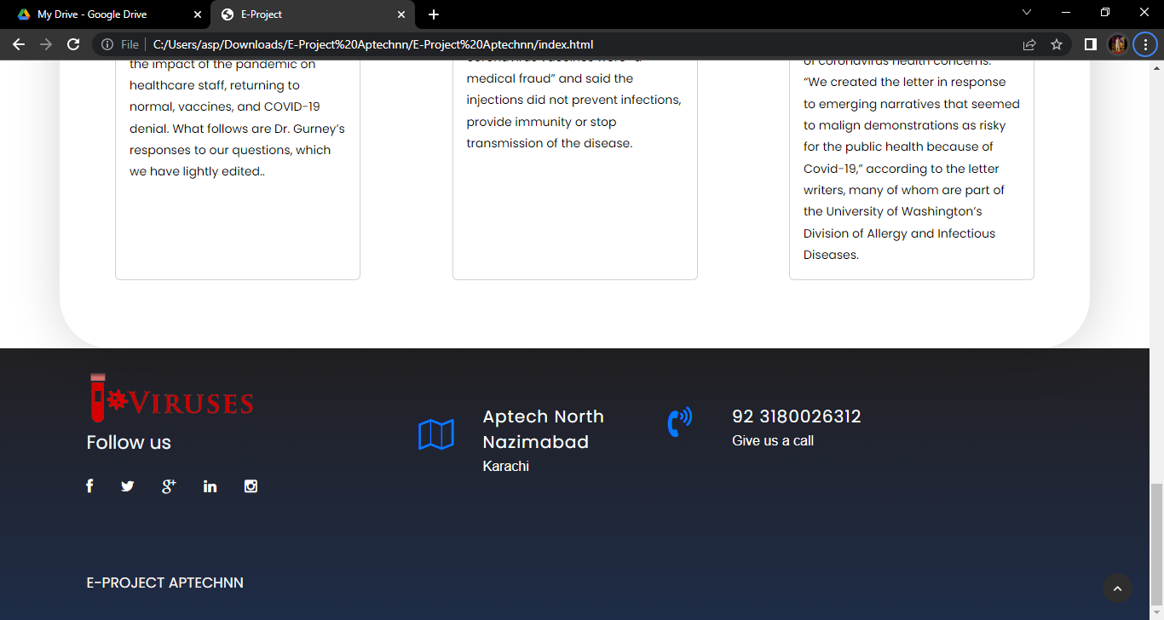

***Figure 14: Footer***

**effects in footer to make our website more relaxing.­**

***CODE FOR FOOTER:***



