**Normalization of Genes: Real counts**

**Correlation method: Pearson**

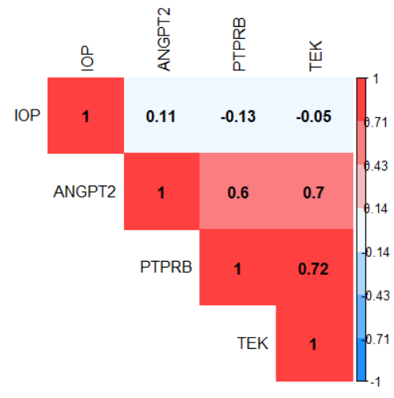

**Correlation method: Spearman**

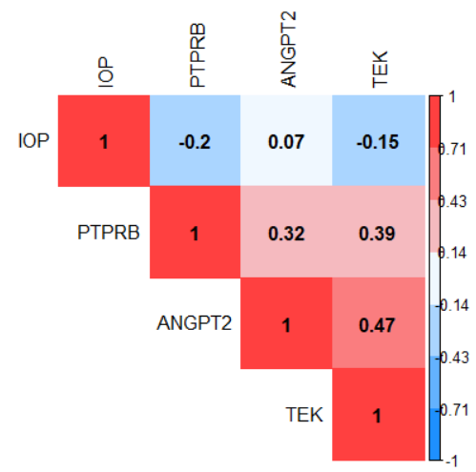

**Distribution**

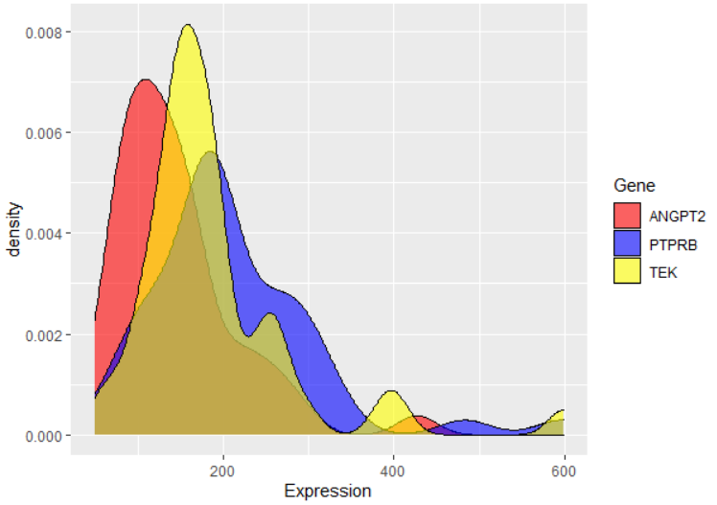

**Normalization of Genes: Log2**

**Correlation method: Pearson**

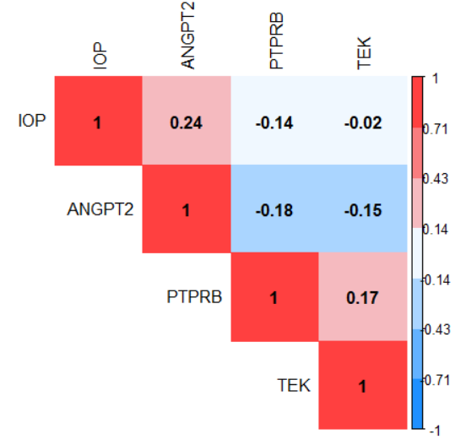

**Correlation method: Spearman**

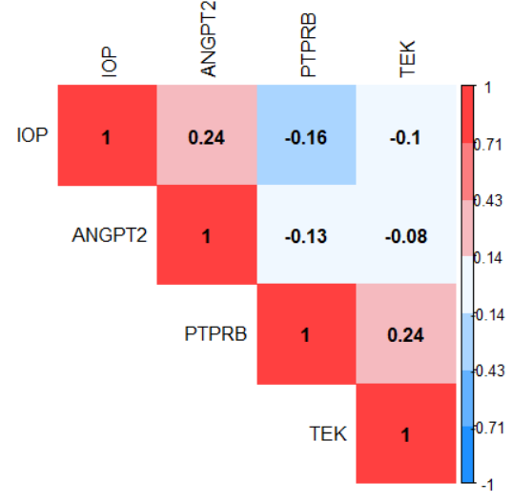

**Distribution**

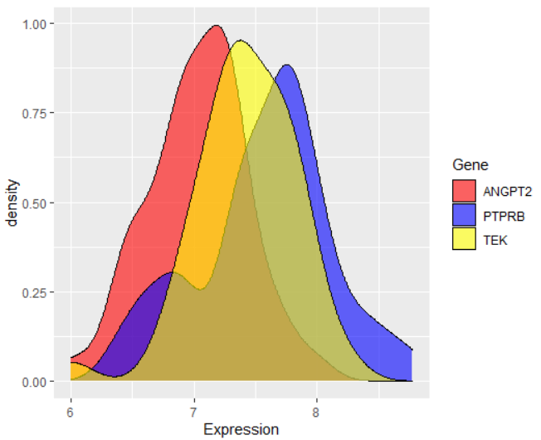

**Normalization of Genes: vst**

**Correlation method: Pearson**

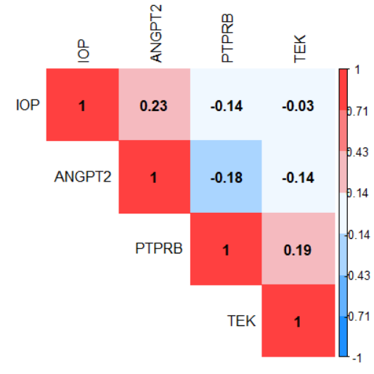

**Correlation method: Spearman**

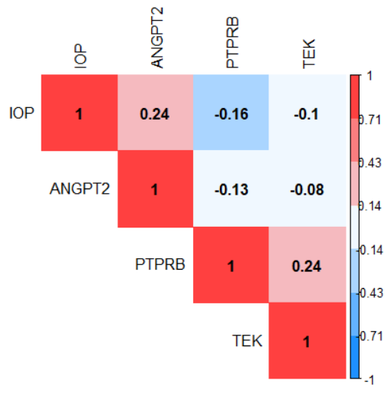

**Distribution**

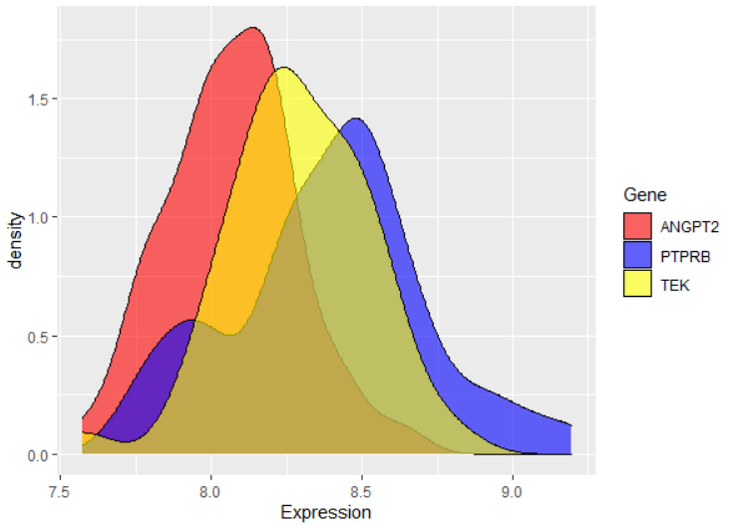

**Normalization of Genes: rlog**

**Correlation method: Pearson**

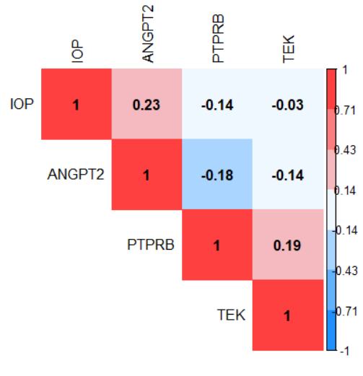

**Correlation method: Spearman**

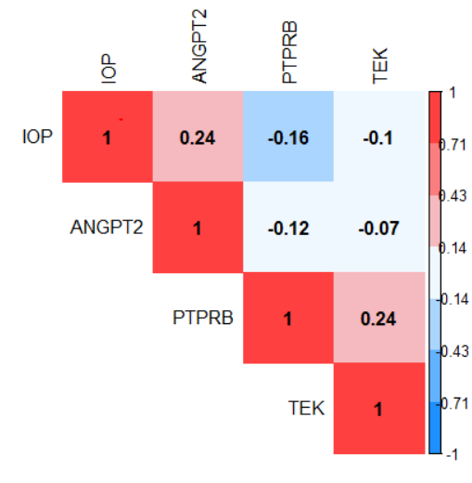

**Distribution**

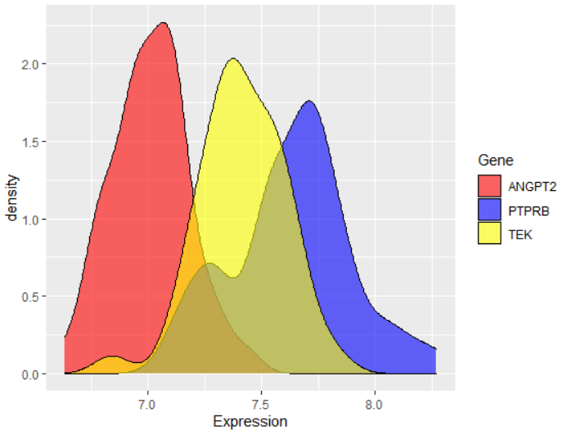

**Heatmap figures results**

* Based on the heatmap figures above, I found the two genes **PTPRB** and **TEK** act similarly. They have a negative correlation with **IOP** and **ANGPT2**. Also, **IOP** has a weak positive linear relationship with **ANGPT2**.
* Compare three normalization methods: **Log2** (Log2 Normalized Counts Transformation), **rlog** (Regularized Log Transformation), and **vst** (Variance Stabilizing Transformation), and based on the distribution plots of three genes, it shows that **rlog** normalization gives good performance for our analysis in this step. Therefore, I consider the **rlog** function as a normalization method.

dds <- DESeqDataSetFromTximport(txi.rsem, samples, design=~Sex+Batch+Age.scaled)

rld <- rlog(dds, blind=FALSE)

* Also, between Pearson (linear correlation) method and Spearman (linear-skewed correlation) method, I found that the probability density function of TEK is between ANGPT2 and PTPRB. Also, there is a high overlap between TEK and PTPRB. It means that there is a strong relation between PTPRB and TEK. I think the correlation of Spearman is better than Pearson. I believe that ANGPT2 and PTPRB have a negative relationship, and PTPRB and TEK have a positive correlation. So, I choose the **Spearman** method for the subsequent analysis.
* Based on the density function of IOP, in the figure below, I found that maybe its distribution is not normal, and I need to normalize it first, then compare it with the other three genes. There are several ways to check the normality of distribution, like plotting the probability density function (like the figure below), plotting the quartile-quartile plot (Q-Q plot), and do Shapiro-Wilk normality test. Among them, I preferred the reliable Shapiro-Wilk normality test. In the output of this test, the p-value > 0.05, implying that the distribution of the data is not significantly different from the normal distribution. In other words, I can assume the normality for p-value > 0.05 in this test. After running this test for three normalized genes and IOP data, I found that for sure, the IOP data is not a normal distribution; it is right-skewed data. There are some common transformations for normalization of this type of data like **square** **root**, **cube** **root**, and **log** functions.

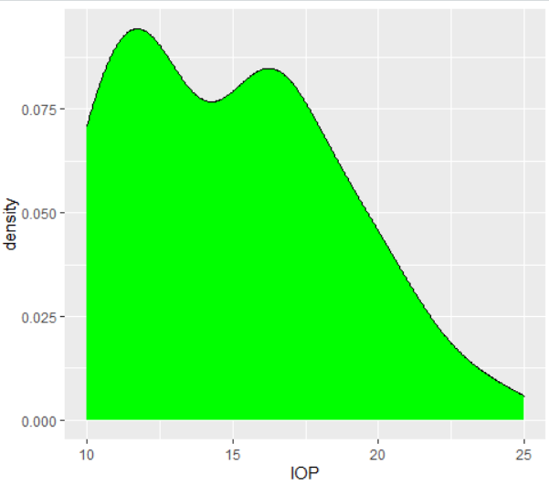

**ANGPT2**

W = 0.9904, p-value = 0.9686

p-value > 0.05 then ANGPT2 is normal

**PTPRB**

W = 0.97918, p-value = 0.587

p-value > 0.05 then PTPRB is normal

**TEK**

W = 0.98158, p-value = 0.6841

p-value > 0.05 then TEK is normal

**IOP**

W = 0.93549, p-value = 0.01474

p-value < 0.05 then IOP is not normal

**Normalization of IOP**

In this section, I am going to normalize the IOP with different methods:

1. **rlog**

First, I tried to normalize the IOP with other 32883 genes and used the logarithmic geometry mean method. But, after checking the Shapiro-Wilk normality test, I found that the output data is not normal distribution again. It has some skewness in the right side. So, as I thought, this is not a suitable method for normalization, because of mixing IOP data with gene expression data. If you look at the correlation table, the correlation between IOP and IOP_normal is 0.62. It means that the nature of original IOP data is changed during the normalization.

W = 0.88815, p-value = 0.0004137

p-value < 0.05 then IOP_norm is not normal

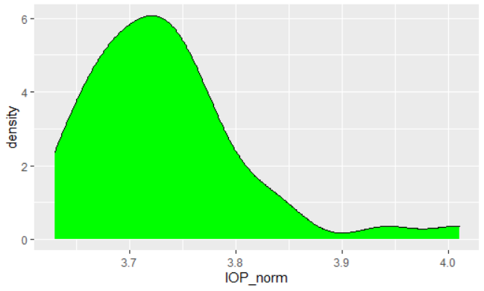 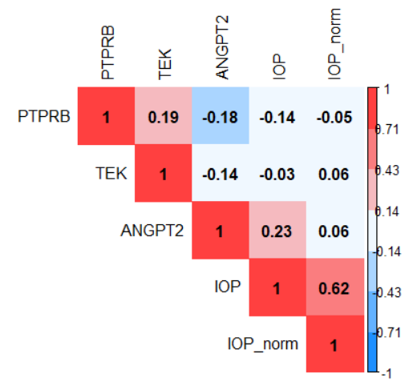

1. **Standard method (x - mean(x)) / std(x)**

Then uses the standard method for normalization of IOP data to convert its distribution into the normal distribution.

W = 0.93549, p-value = 0.01474

p-value < 0.05 then IOP is not normal

skewness(corrTable$IOP) = 0.4156063

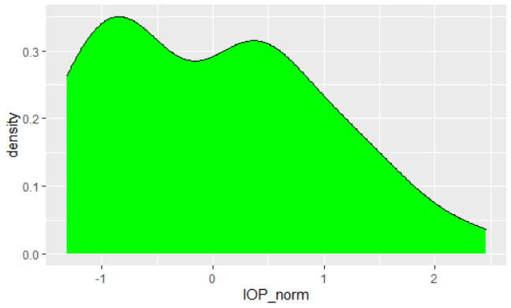 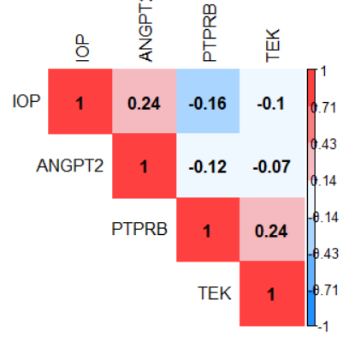

1. **Box-Cox power transformation Lambda = -0.1**

W = 0.93785, p-value = 0.01795

p-value < 0.05 then IOP is not normal

skewness(corrTable$IOP) = 0.01833074

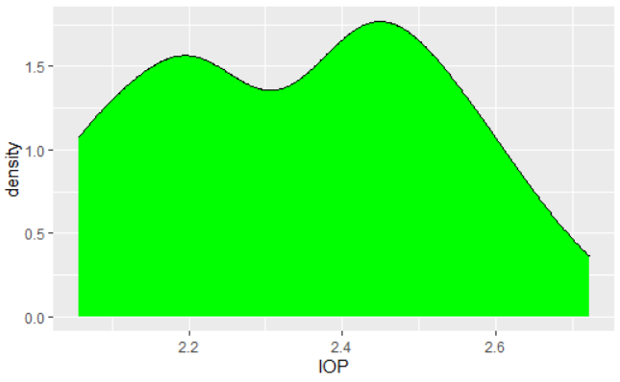 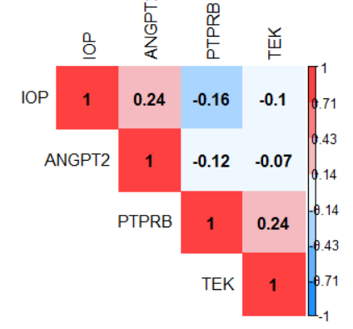

1. **Log transformation Log(x), Log2(x), Log10(x)**

W = 0.93874, p-value = 0.01934

p-value < 0.05 then IOP is not normal

skewness(corrTable$IOP) = 0.05192562

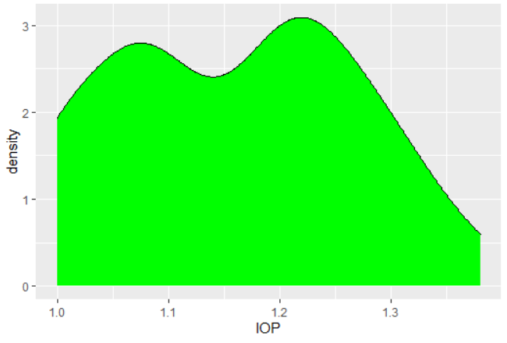 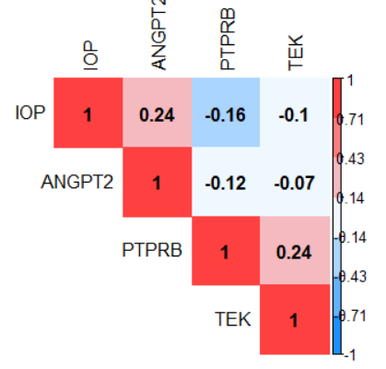

1. **Square root transformation sqrt(x)**

W = 0.93998, p-value = 0.02147

p-value < 0.05 then IOP is not normal

skewness(corrTable$IOP) = 0.2272393

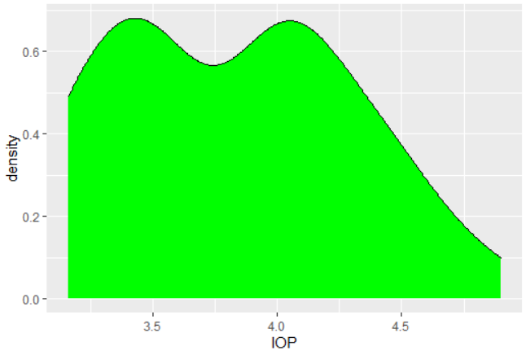 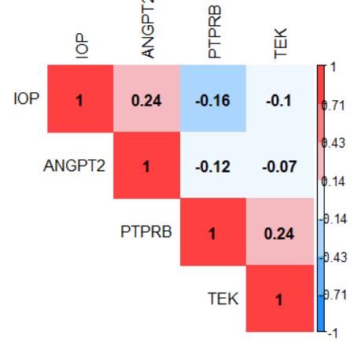

1. **Cube root transformation cuberoot(x)**

W = 0.94018, p-value = 0.02184

p-value < 0.05 then IOP is not normal

skewness(corrTable$IOP) = 0.1674028

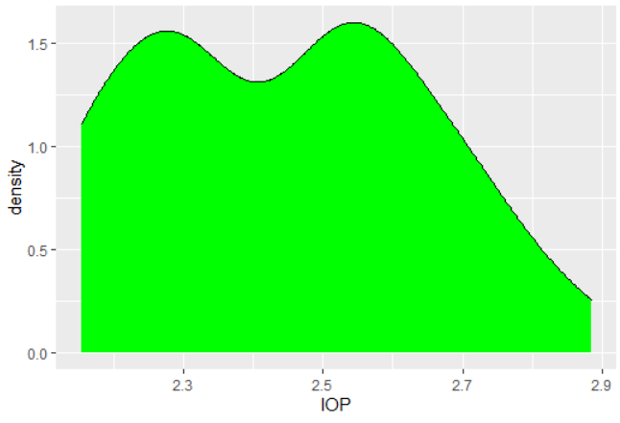 

1. **Adjusting based on Age (Dr. Chen) IOP(x) / Age(x)**

Dr. Chen suggested this method, but in my opinion, this is not a fair method. All of the previous 6 normalization methods are in the transformation class. They are completely reasonable except the first one (using rlog for IOP) that I rejected it by myself. In this method, IOP data are divided into Age of samples. If we look at the IOP density distribution, before and after adjusting, we found that the IOP for samples with around IOP=17 is suppressed. IOP=17 is in the middle of the range (10-24), and I think we are not allowed to do that. If you look at the correlation table below, although the correlation of ANGPT2 with new IOP_Age is increased a bit (from 0.24 to 0.29), however, the correlation between IOP and IOP_Age is 0.72. It means that the nature of original IOP data is changed during the adjustment. Also, in general, correlations between 0.2 and 0.4 are moderate, and those below 0.2 are considered weak. Therefore, 0.24 and 0.29 is not significantly different. However, the correlation 0.29 is almost (semi-) significant, too, with p-value 0.058 compare to the original IOP with a correlation of 0.24 with p-value 0.11. In my opinion, this is not a wise method, and I do not prefer to use this adjustment.

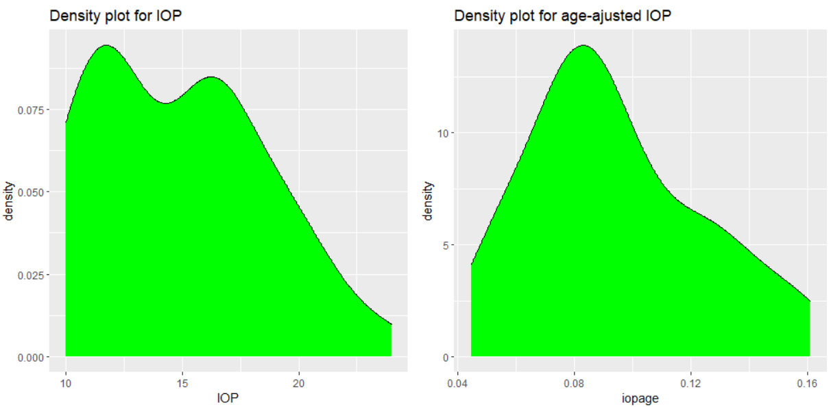

W = 0.93549, p-value = 0.01474 W = 0.95304, p-value = 0.06623

p-value < 0.05 then IOP is not normal p-value > 0.05 then iopavg is normal

skewness(df1$IOP) = 0.4156063 skewness(df1$iopage) = 0.5328915

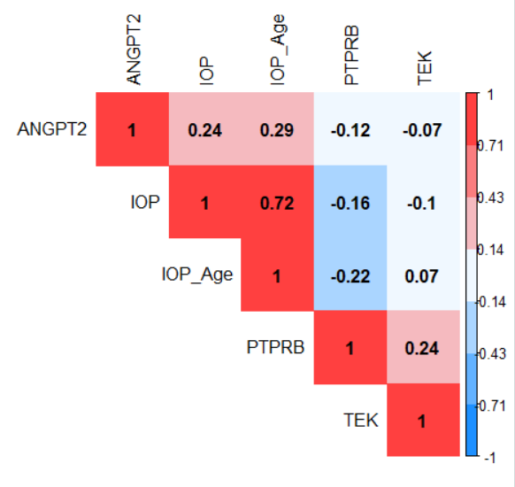

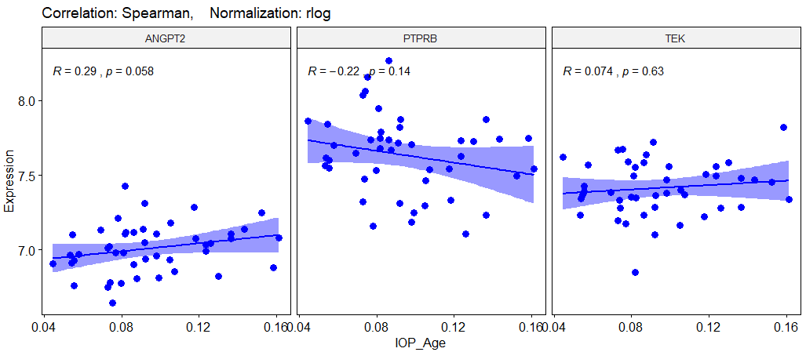

**Compare IOP normalization methods**

Among these seven normalization methods, just the last one can convert the distribution of IOP to a normal distribution; however, I have doubt it is a reasonable method. Except for rlog method (first method) and adjusted IOP (last one), the correlation matrix is not changed during normalization. Therefore, I cannot accept these first and last ones as a good normalization method. Almost all of them skewed right. I have chosen the **Log10 transformation normalization** as the best normalization method. Its density is semi-normal compare to others and has relatively low skewness. However, the goal is a correlation calculation between ANGPT2 and IOP. None of the transformation normalization methods does affect the correlation analysis significantly. Therefore, I have considered **rlog** as a normalization method for genes and **No**-**normalization** for IOP. Also, I considered **Spearman** as a correlation method for further analysis.

**Correlation between IOP and ANGPT2**

In this section, I want to calculate the **Spearman** correlation of real IOP (without normalization) with ANGPT2 gene expression (normalized using the **rlog** method). Based on the correlation coefficient R and P-values in the figure below, I found that IOP has a positive relationship with ANGPT2 and a negative relationship with PTPRB and almost not correlated with TEK. However, none of them are significantly correlated. Based on the best R and P-values, I focused on the week relationship of IOP and ANGPT2.

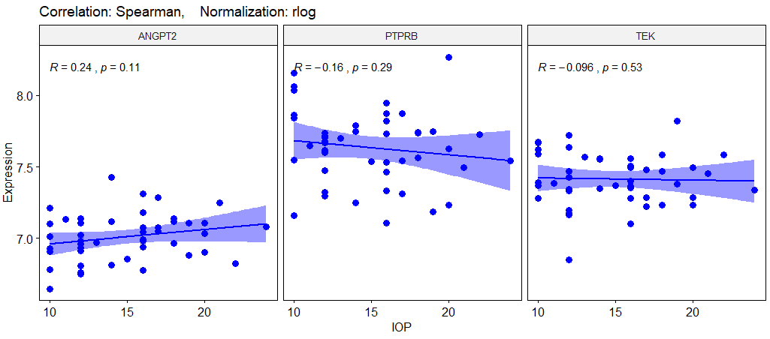

**Partial-Correlation between IOP and ANGPT2 based on IOP subgroups**

In the two figures below, I plot the correlation of three genes with three subgroups of IOP (Normal, Elevated, and High). As I can see, ANGPT2 has the highest positive correlation with Normal_IOP (R = 0.23) subgroup. Also, PTPRB has the highest negative correlation with Normal_IOP (R = -0.32) subgroup. It means that the Normal_IOP subgroup has a major role in a part of the IOP dataset in the association with ANGPT2 and PTPRB. I mean, lower IOP related to the low expression of ANGPT2 and relatively high expression of PTPRB.

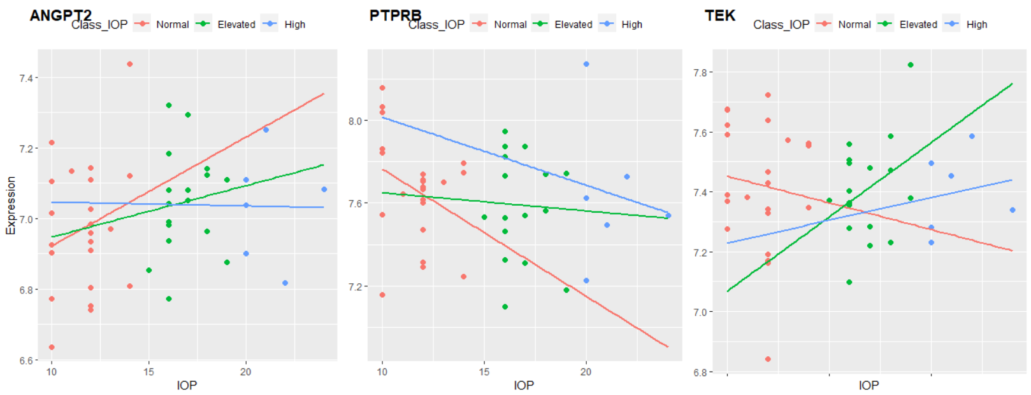

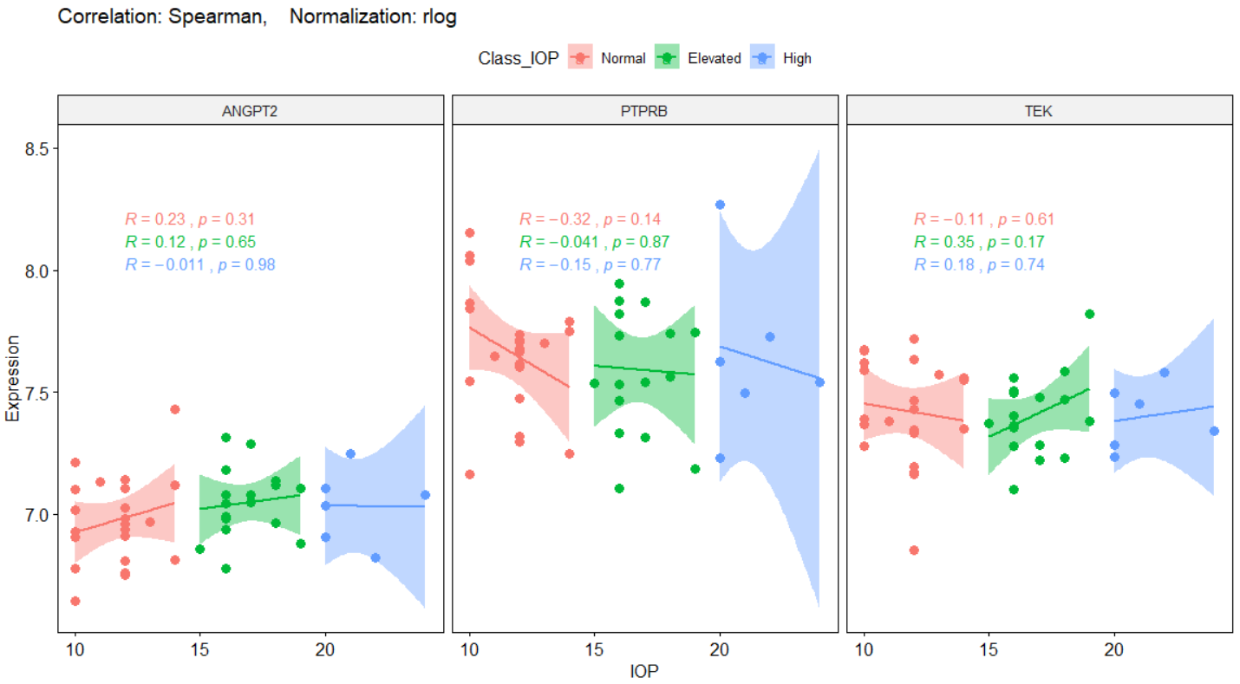

Although I am looking for a high correlation between the High_IOP subgroup and ANGPT2, however, as there are low samples in the high_IOP subgroup, it is not a significant relationship. Therefore, I decided to classify the IOP feature into two subgroups: Normal and High. In the figure below, I look for the correlation of IOP subgroups with three genes. In this scenario, half of the samples are High_IOP, around 50% of the samples (23 samples). However, the High_IOP subgroup is not correlated with ANGPT2 and PTPRB again. I mean, Normal_IOP has a vital role in the correlation of IOP with ANGPT2 or PTPRB still.

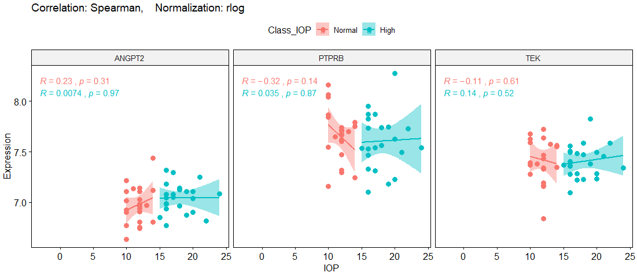

As a conclusion and based on figures above, ANGPT2 has a week-correlation, but not significant, with whole IOP data (R=0.24, P-value=0.11), which related to the Normal_IOP (R=0.23, P-value=0.31). However, the ANGPT2 gene has the maximum week-correlation with IOP, among other genes. Therefore, we need to look at this gene deeply. Maybe other features like Age, Sex, or Batch give some clues.

**Partial-Correlation between IOP_Age and ANGPT2 based on IOP subgroups**

As I am curious about the adjusted IOP based on Age, Dr. Chen’s method, I have repeated the partial-correlation analysis for IOP_Age data, too.

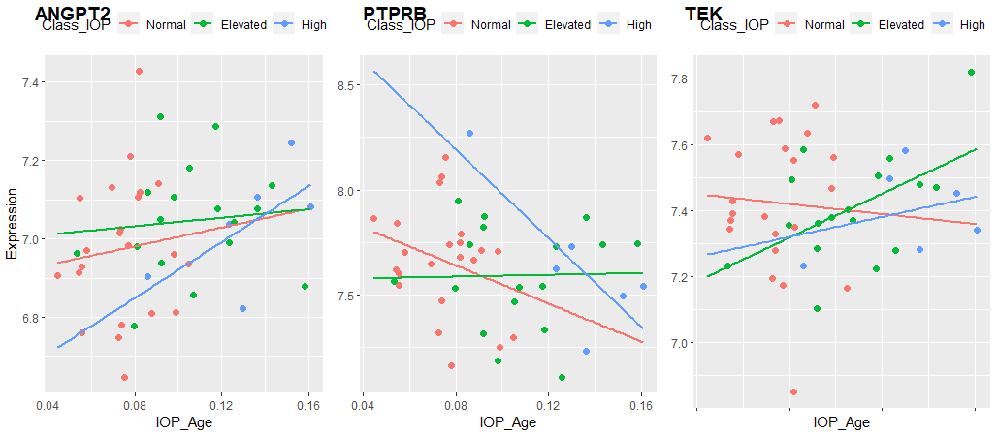

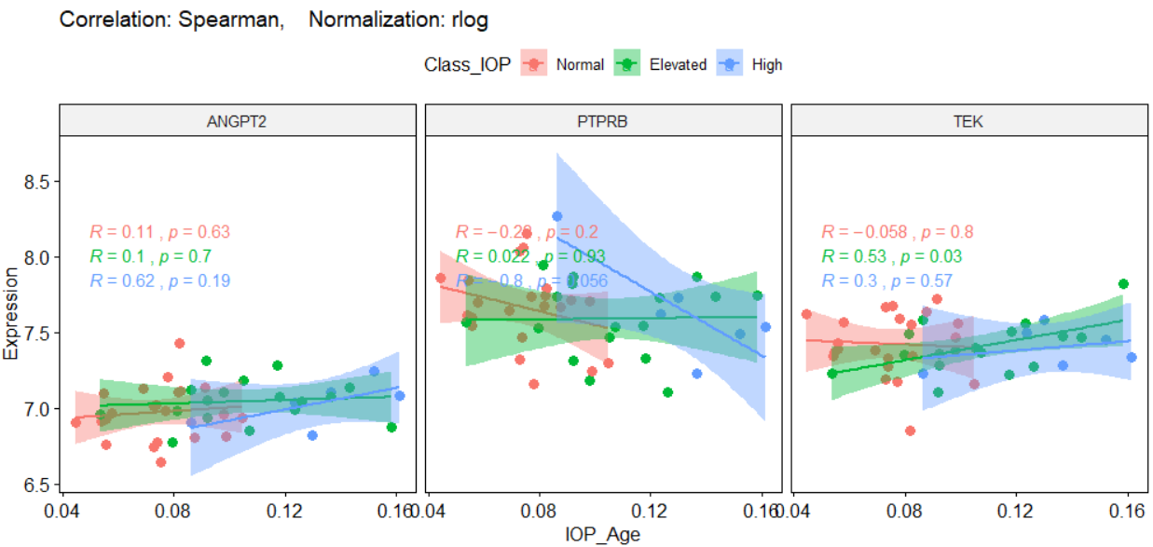

There is high positive correlation between **High_IOP_Age** and **ANGPT2** (R=+0.62, P-value=0.19) and high negative correlation between **High_IOP_Age** and **PTPRB** (R=-0.8, P-value=0.056). However, if you look at this figure, all three colores Blue, Green, and Red have overlaps, which is the results of adjustment. Adjusting with Age, caused Normal_IOP (Red) considers as High_IOP (Blue), and it is not correct.

Then, I classified the IOP-Age feature into two subgroups: Normal and High. In this scenario, half of the samples are High_IOP_Age; around 50% of samples (23 samples). In this condition, there is no significant feature to talk about.

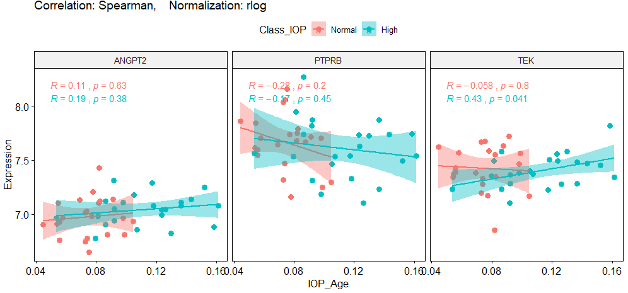

**Analysis of t-test for IOP subgroups**

To discuss the correlation between ANGPT2 and IOP subgroups statistically, I did a t-test and ANOVA analysis too. In the t-test analysis, I want to test that the mean expression level of ANGPT2 is equal in two separate groups of Normal_IOP and High_IOP (with almost the same sample sizes). If not, then the expression level of ANGPT2 in each subgroup of IOP are not similar together, and the expression levels are varied in different subgroups of IOP.

**H0:** The mean of ANGPT2 expression level in the Normal_IOP group is equal to the mean of ANGPT2 expression level in the High_IOP group.

**Ha:** Both means are not equal.

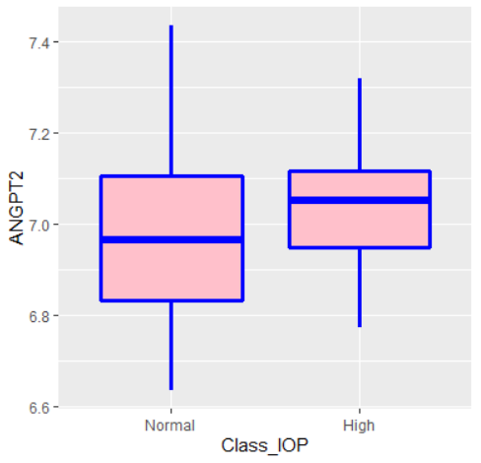

The results of two sided t-test with 95% confidential is:

t.test(ANGPT2 ~ Class_IOP, data=corrTable_IOP2, mu=0, alt="two.sided", conf=0.95, var.eq=F, paired=F)

t = -1.4124, df = 39.885, p-value = 0.1656

alternative hypothesis: true difference in means is not equal to 0

95 percent confidence interval:

-0.1705142 0.0302361

sample estimates:

mean in group Normal mean in group High

6.973136 7.043275

The P-value of the test is 0.1656, which is higher than the significant level, 0.05. Therefore, I cannot reject the Null-Hypothesis to accept the alternative hypothesis. I conclude that the average expression level of the ANGPT2 gene in samples with Normal_IOP is not significantly different from the samples with High_IOP; the expression level of the ANGPT2 gene is almost the same in two groups (6.97 ≈ 7.04).

It means that different IOP subgroups have not an essential role in the expression level of ANGPT2.

**Analysis of ANOVA for IOP subgroups**

As in the real state, we have three subgroups of IOP, so we need to run the ANOVA analysis instead of a t-test for them.

**H0:** The mean of ANGPT2 expression level in all three groups of IOP (Normal, Elevated, and High) is equal together.

**Ha:** They are not equal.

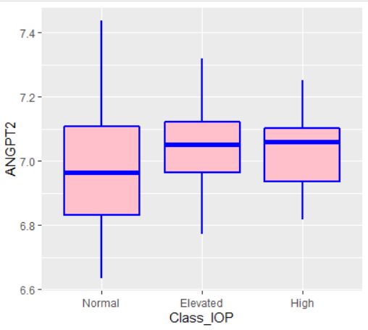

Anova_results <- aov(ANGPT2 ~ Class_IOP, data=corrTable)

summary(Anova_results)

Df Sum Sq Mean Sq F value Pr(>F)

Class_IOP 2 0.0561 0.02806 1 0.377

Residuals 42 1.1789 0.02807

F(2,42) = 1, P-value > 0.05

The P-value is higher than 0.05, so the null hypothesis is not rejected again. Therefore, I cannot claim that the expression level of ANGPT2 is significantly varied in three different IOP groups.

**Partial-Correlation between IOP and ANGPT2 based on Age feature**

In this section, I am going to calculate the correlation between IOP and ANGPT2 based on different Age subgroups. I classified samples into four subgroups: **Adolescent** (113<=Age<135), **Adult** (135<=Age<154), **Middle_Aged**(154<=Age<183), and **Aged** (183<=Age<=346). Then, plot the correlation based on each subgroup.

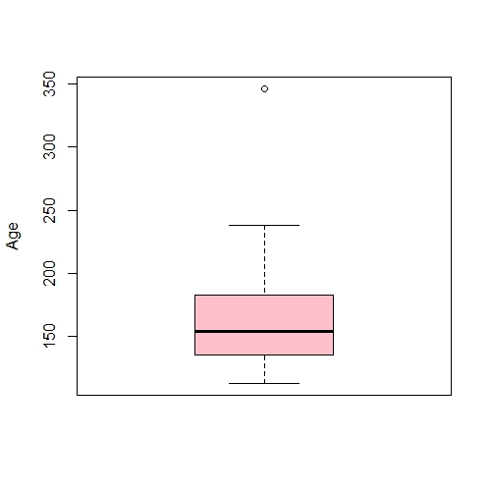

346

238

183

154

135

113

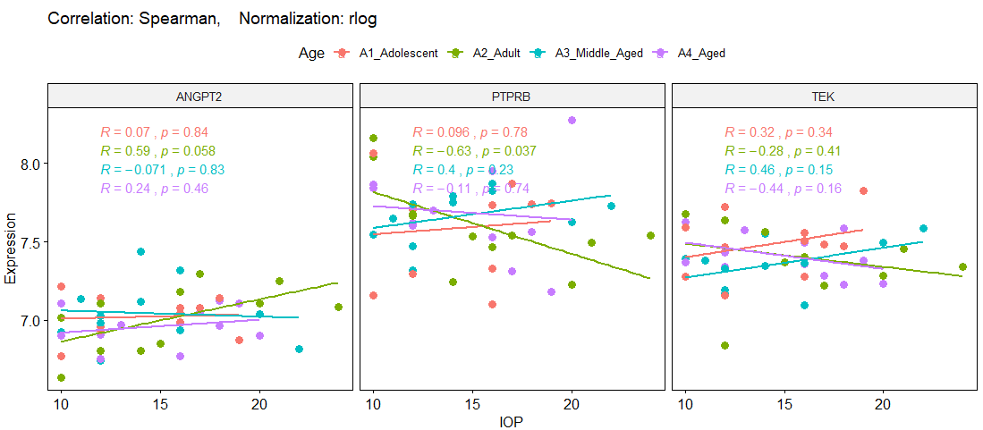

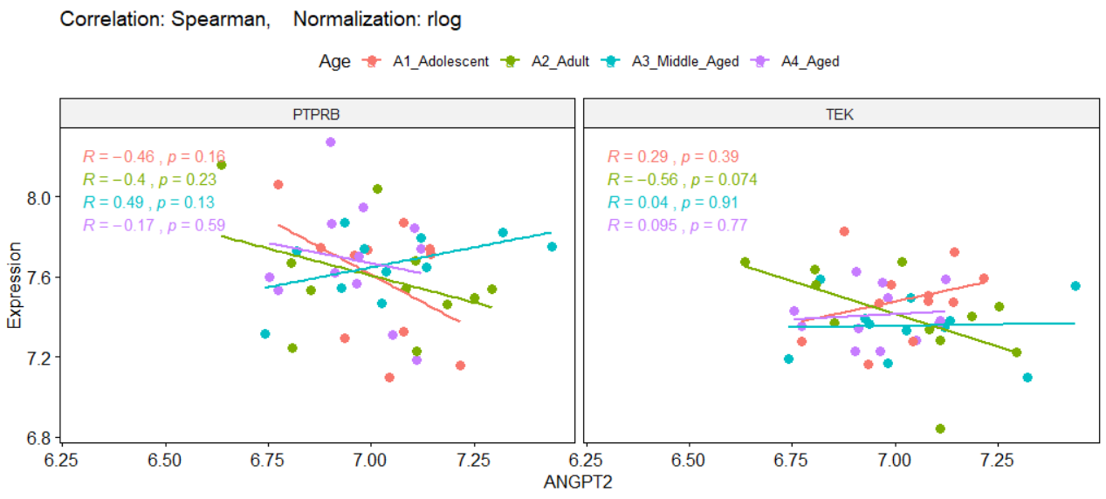

**Good news:** Based on the results, I can see there is a **semi-significant relationship** in the **Adult** subgroup between IOP and ANGPT2 (R=+0.59, P-value=0.058), and PTPRB (R=-0.63, P-value=0.037). Also, there is a semi-significant relationship between ANGPT2 and TEK genes in this subgroup (Adult); figure below. Therefore, I am curious about **Adult** subgroup. To test these observations, I am going to do a t-test and ANOVA analysis.

**Analysis of ANOVA and lm considering Age**

There are four subgroups of Age, and I run ANOVA analysis in for ANGPT2 expression along with these subgroups.

**H0:** The mean of ANGPT2 expression level in all four subgroups of Age is equal together.

**Ha:** They are not equal.

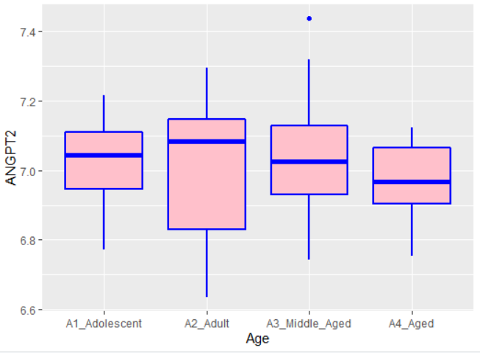

Anova_results <- aov(ANGPT2 ~ Age, corrTable); summary(Anova_results)

Df Sum Sq Mean Sq F value Pr(>F)

Age 3 0.0415 0.01384 0.476 0.701

Residuals 41 1.1935 0.02911

Anova_results <- aov(ANGPT2 ~ IOP + Age, corrTable); summary(Anova_results)

Df Sum Sq Mean Sq F value Pr(>F)

IOP 1 0.0642 0.06420 2.290 0.138

Age 3 0.0494 0.01647 0.587 0.627

Residuals 40 1.1214 0.02804

Linear_model <- lm(ANGPT2 ~ IOP + Age, corrTable); summary(Linear_model)

Call:

lm(formula = ANGPT2 ~ IOP + Age, data = corrTable)

Residuals:

Min 1Q Median 3Q Max

-0.33588 -0.07945 0.00237 0.10007 0.44388

Coefficients:

Estimate Std. Error t value Pr(>|t|)

(Intercept) 6.9309303 0.1335659 51.891 <2e-16 ***

IOP 0.0109180 0.0067533 1.617 0.113

Age -0.0005102 0.0005813 -0.878 0.385

Residual standard error: 0.1655 on 42 degrees of freedom

Multiple R-squared: 0.06906, Adjusted R-squared: 0.02473

F-statistic: 1.558 on 2 and 42 DF, p-value: 0.2225

The P-value is higher than 0.05, so the null hypothesis is not rejected again. Therefore, I cannot claim that the expression level of ANGPT2 is significantly varied in four different Age groups.

Then, I decided to divide the Age into just two subgroups as below and run the t-test. In each division, I followed a logical rule: 1) split ages half by half (Adolescent and Adults in the first group and Middle-Aged and Aged in the second group). 2) separate Adults from others. 3) separate Aged (as the oldest samples) from others. 4) separate Adolocent (as the youngest samples) from others.

**Division 1): Divided ages half by half (Adolescent and Adults in the first group and Middle-Aged and Aged in the second group)**

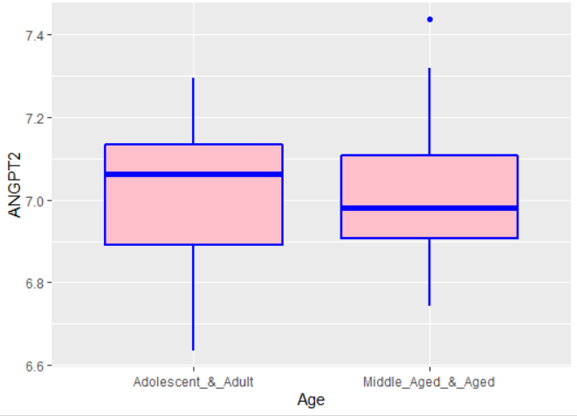

Anova_results <- aov(ANGPT2 ~ Age, corrTable_Age2); summary(Anova_results)

Df Sum Sq Mean Sq F value Pr(>F)

Age 1 0.003 0.002999 0.105 0.748

Residuals 43 1.232 0.028651

Anova_results <- aov(ANGPT2 ~ IOP + Age, corrTable_Age2); summary(Anova_results)

Df Sum Sq Mean Sq F value Pr(>F)

IOP 1 0.0642 0.06420 2.308 0.136

Age 1 0.0024 0.00239 0.086 0.771

Residuals 42 1.1684 0.02782

t.test(ANGPT2 ~ Age, corrTable_Age2, mu=0, alt="two.sided", conf=0.95, var.eq=F, paired=F)

Welch Two Sample t-test

data: ANGPT2 by Age

t = 0.32342, df = 42.84, p-value = 0.748

alternative hypothesis: true difference in means is not equal to 0

95 percent confidence interval:

-0.08551491 0.11817765

sample estimates:

mean in group Adolescent_&_Adult: 7.017332

mean in group Middle_Aged_&_Aged: 7.001000

In all tests and analyses, P-values are higher than 0.05, and I cannot reject the null hypothesis.

**Division 2): separate Adults from others**

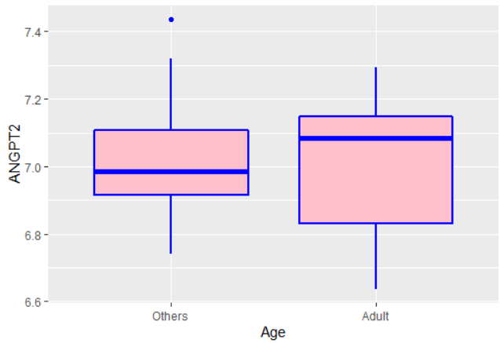

Anova_results <- aov(ANGPT2 ~ Age, corrTable_Age2); summary(Anova_results)

Df Sum Sq Mean Sq F value Pr(>F)

Age 1 0.0003 0.00027 0.009 0.923

Residuals 43 1.2347 0.02872

Anova_results <- aov(ANGPT2 ~ IOP + Age, corrTable_Age2); summary(Anova_results)

Df Sum Sq Mean Sq F value Pr(>F)

IOP 1 0.0642 0.06420 2.303 0.137

Age 1 0.0001 0.00011 0.004 0.951

Residuals 42 1.1707 0.02787

t.test(ANGPT2 ~ Age, corrTable_Age2, mu=0, alt="two.sided", conf=0.95, var.eq=F, paired=F)

Welch Two Sample t-test

data: ANGPT2 by Age

t = -0.082964, df = 13.696, p-value = 0.9351

alternative hypothesis: true difference in means is not equal to 0

95 percent confidence interval:

-0.1534463 0.1420401

sample estimates:

mean in group Others mean in group Adult

7.007590 7.013293

In all tests and analyses, P-values are higher than 0.05, and I cannot reject the null hypothesis.

**Division 3): separate Aged (as the oldest samples) from others**

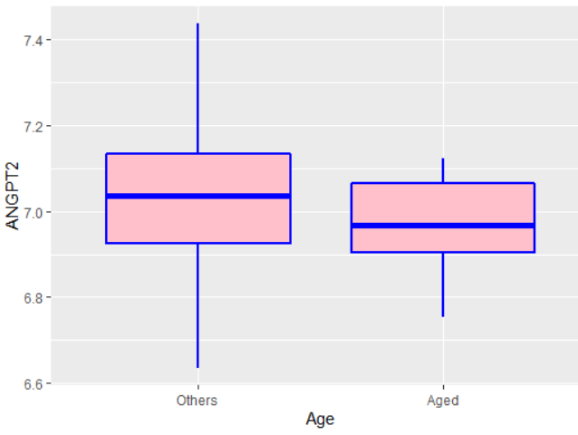

Anova_results <- aov(ANGPT2 ~ Age, corrTable_Age2); summary(Anova_results)

Df Sum Sq Mean Sq F value Pr(>F)

Age 1 0.0361 0.03613 1.296 0.261

Residuals 43 1.1989 0.02788

Anova_results <- aov(ANGPT2 ~ IOP + Age, corrTable_Age2); summary(Anova_results)

Df Sum Sq Mean Sq F value Pr(>F)

IOP 1 0.0642 0.06420 2.384 0.130

Age 1 0.0397 0.03969 1.474 0.232

Residuals 42 1.1311 0.02693

t.test(ANGPT2 ~ Age, corrTable_Age2, mu=0, alt="two.sided", conf=0.95, var.eq=F, paired=F)

Welch Two Sample t-test

data: ANGPT2 by Age

t = 1.3563, df = 28.837, p-value = 0.1855

alternative hypothesis: true difference in means is not equal to 0

95 percent confidence interval:

-0.03257421 0.16072912

sample estimates:

mean in group Others mean in group Aged

7.026072 6.961994

In all tests and analyses, P-values are higher than 0.05, and I cannot reject the null hypothesis.

**Division 4): separate Adolocent (as the youngest samples) from others**

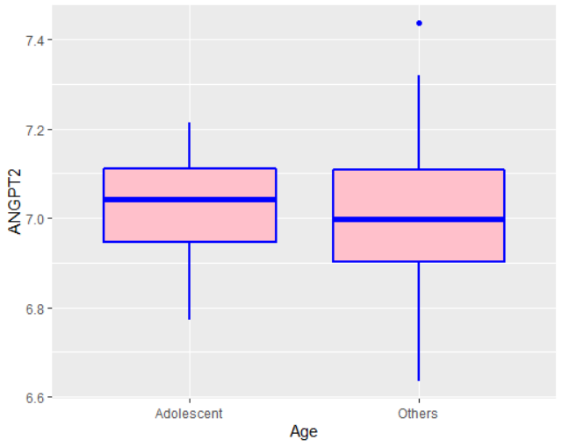

Anova_results <- aov(ANGPT2 ~ Age, data=corrTable_Age2)

summary(Anova_results)

Df Sum Sq Mean Sq F value Pr(>F)

Age 1 0.0022 0.002233 0.078 0.782

Residuals 43 1.2328 0.028669

Anova_results <- aov(ANGPT2 ~ IOP + Age, data=corrTable_Age2)

summary(Anova_results)

Df Sum Sq Mean Sq F value Pr(>F)

IOP 1 0.0642 0.06420 2.312 0.136

Age 1 0.0045 0.00452 0.163 0.689

Residuals 42 1.1663 0.02777

t.test(ANGPT2 ~ Age, data=corrTable_Age2, mu=0, alt="two.sided", conf=0.95, var.eq=F, paired=F)

Welch Two Sample t-test

data: ANGPT2 by Age

t = 0.32893, df = 23.455, p-value = 0.7451

alternative hypothesis: true difference in means is not equal to 0

95 percent confidence interval:

-0.08658991 0.11937447

sample estimates:

mean in group Adolescent mean in group Others

7.021370 7.004977

In all tests and analyses, P-values are higher than 0.05, and I cannot reject the null hypothesis.

All analysis above indicates that there is no significant relation between IOP and ANGPT2 based on different subgroups of Age feature.

**Partial-Correlation between IOP and ANGPT2 based on three subgroups of Age feature**

Based on the previous analysis, I cannot find any significant t-test or ANOVA for previous subgroups. However, I found that there is a good relation between IOP and ANGPT2 and PTPRB just in the **Adult** subgroups. Now, I am going to divide samples to three equal subgroups: **Adolescent** (113<=Age<138), **Adult** (138<=Age<178), and **Aged** (178<=Age<=346). Then, plot the correlation based on each subgroup.

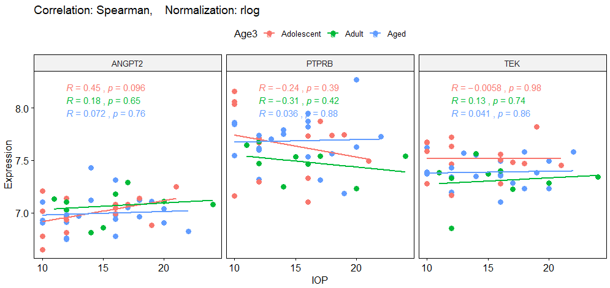

**Good news:** Based on this division, again, there is a **semi-significant relationship** in the youngest subgroup, **Adolescent**, between IOP and ANGPT2 (R=+0.45, P-value=0.096). It means that the relationship of IOP with ANGPT2 is related to the particular subset of Age.

**Partial-Correlation between IOP and ANGPT2 based on the best subgroup of Age feature**

After previous analysis, I found that there is a best subgroups of Age, which IOP measure of these samples are significantly correlated to the ANGPT2 and PTPRB genes. After several trying, finally I found this subset. Now, I am going to divide samples to three varient subgroups: **Adolescent** (113<=Age<127) with 4 samples, **Adult** (127<=Age<167) with 23 samples, and **Aged** (167<=Age<=346) with 18 samples. I considered the **Adult** subgropup with almost suffisient samplesize (23) as the best subgroup, which I looked for. Then, I plot the correlation based on each subgroup.

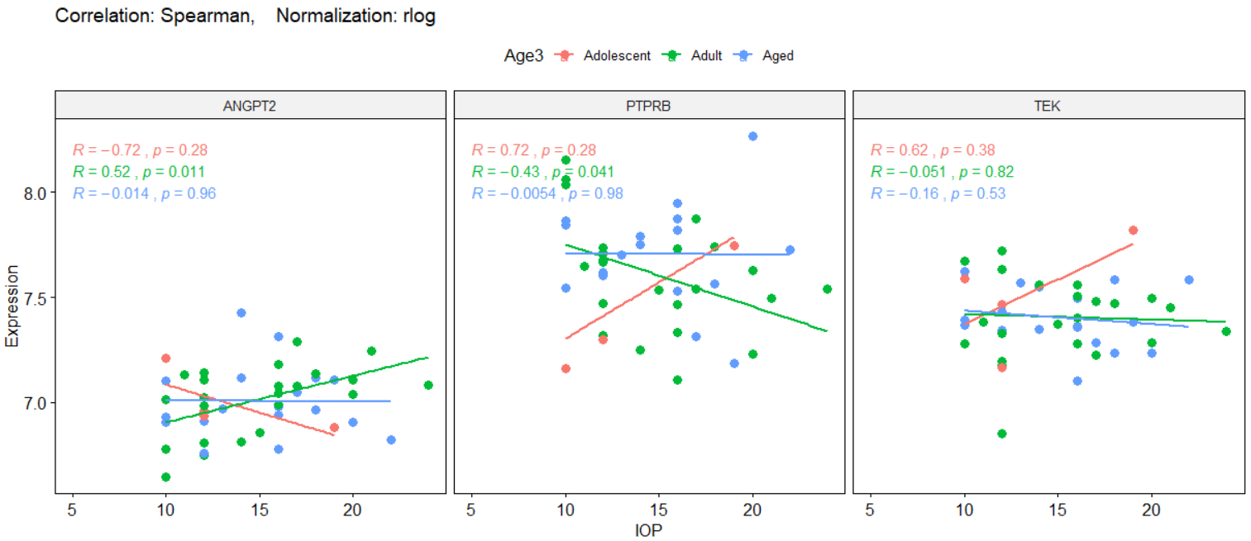

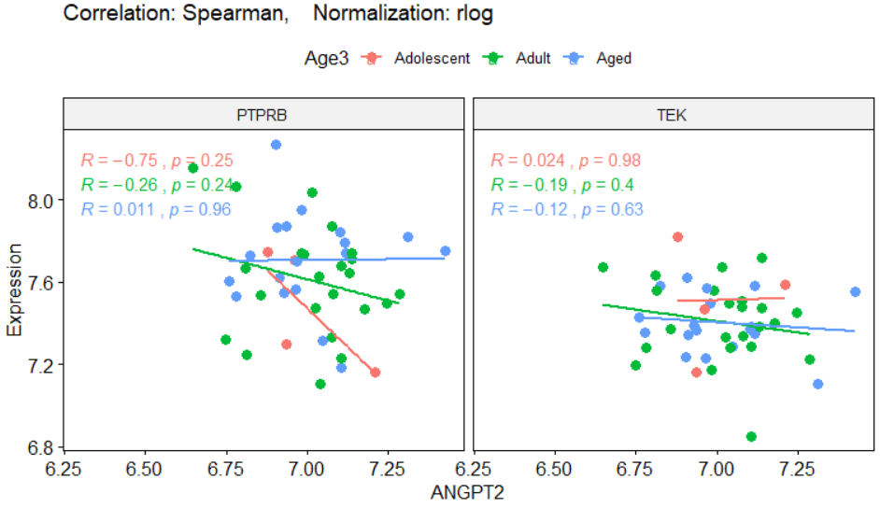

As you can see, there are **significant and strong relationship** in the **Adult** subgroup, between IOP and ANGPT2 (R=+0.52, P-value=0.011), and PTPRB (R=-0.43, P-value=0.041).

**Analysis of ANOVA and lm considering Age3**

There are three subgroups of Age3, and I run ANOVA analysis in for ANGPT2 expression along with these subgroups.

**H0:** The mean of ANGPT2 expression level in all three subgroups of Age is equal together.

**Ha:** They are not equal.

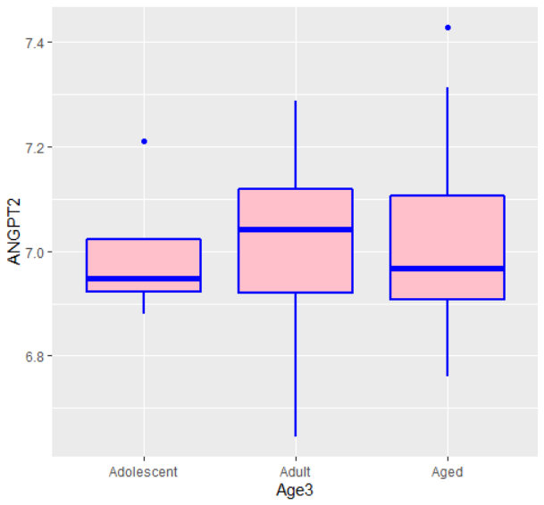

Anova_results <- aov(ANGPT2 ~ Age3, data=corrTable); summary(Anova_results)

Df Sum Sq Mean Sq F value Pr(>F)

Age3 2 0.0013 0.000644 0.023 0.977

Residuals 42 1.1738 0.027948

Anova_results <- aov(ANGPT2 ~ IOP + Age3, data=corrTable); summary(Anova_results)

Df Sum Sq Mean Sq F value Pr(>F)

IOP 1 0.0609 0.06092 2.244 0.142

Age3 2 0.0012 0.00059 0.022 0.979

Residuals 41 1.1130 0.02715

Linear_model <- lm(ANGPT2 ~ IOP + Age3, corrTable); summary(Linear_model)

Call:

lm(formula = ANGPT2 ~ IOP + Age3, data = corrTable)

Residuals:

Min 1Q Median 3Q Max

-0.31830 -0.07672 -0.01378 0.09230 0.43428

Coefficients:

Estimate Std. Error t value Pr(>|t|)

(Intercept) 6.8629166 0.1216377 56.421 <2e-16 ***

IOP 0.0101084 0.0067542 1.497 0.142

Age3Adult 0.0001003 0.0899622 0.001 0.999

Age3Aged -0.0103533 0.0919917 -0.113 0.911

---

Residual standard error: 0.1648 on 41 degrees of freedom

Multiple R-squared: 0.05284, Adjusted R-squared: -0.01646

F-statistic: 0.7624 on 3 and 41 DF, p-value: 0.5217

The P-value is higher than 0.05, so the null hypothesis is not rejected again. Therefore, I cannot claim that the expression level of ANGPT2 is significantly varied in three different Age3 groups. Then, I decided to divide the Age3 into just two subgroups and run the t-test. I kept the **Adult** subgroups and mixed the **Adolocent** and **Aged** group as another subgroup. Therefore, the samples size of each new subgroups are almost equal.

summary(corrTable_Age2$Age3)

Others Adult

22 23

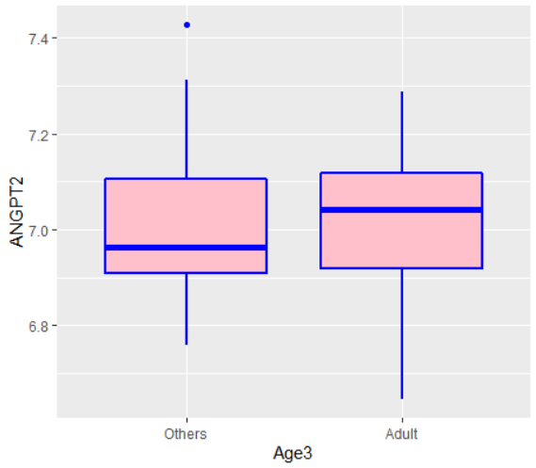

Anova_results <- aov(ANGPT2 ~ Age3, corrTable_Age2); summary(Anova_results)

Df Sum Sq Mean Sq F value Pr(>F)

Age3 1 0.001 0.001021 0.037 0.848

Residuals 43 1.174 0.027304

Anova_results <- aov(ANGPT2 ~ IOP + Age3, corrTable_Age2); summary(Anova_results)

Df Sum Sq Mean Sq F value Pr(>F)

IOP 1 0.0609 0.06092 2.298 0.137

Age3 1 0.0008 0.00083 0.031 0.861

Residuals 42 1.1134 0.02651

t.test(ANGPT2 ~ Age3, corrTable_Age2, mu=0, alt="two.sided", conf=0.95, var.eq=F, paired=F)

Welch Two Sample t-test

data: ANGPT2 by Age3

t = -0.1934, df = 42.914, p-value = 0.8476

alternative hypothesis: true difference in means is not equal to 0

95 percent confidence interval:

-0.1089114 0.0898513

sample estimates:

mean in group Others mean in group Adult

7.004234 7.013764

In all tests and analyses, P-values are higher than 0.05, and I cannot reject the null hypothesis.

**Partial-Correlation between IOP and ANGPT2 based on Sex feature**

In this section, I am going to calculate the correlation between IOP and ANGPT2 based on different Sex subgroups. Among 45 samples, 12 (26%) of them are male, and 33 (73%) are Female. Also, there are 13 (29%)Pregnant samples.

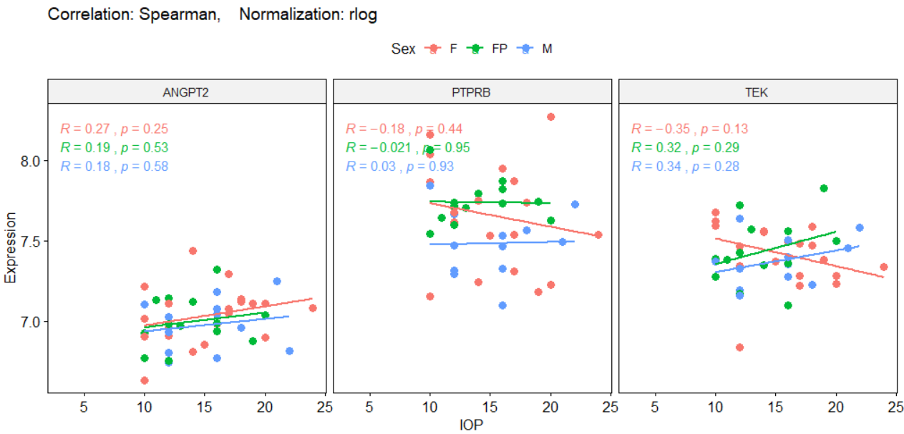

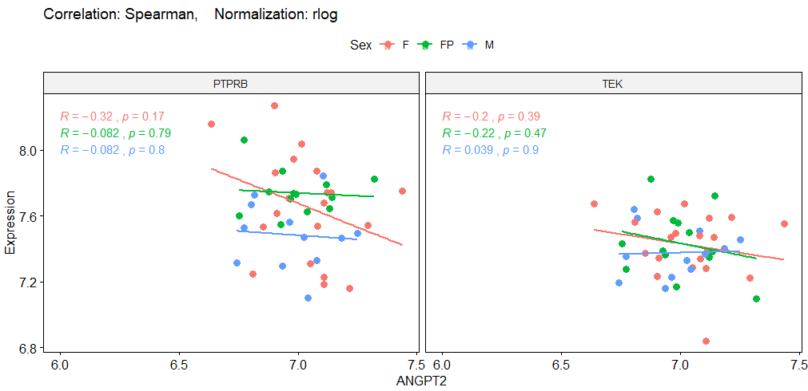

There is no significant correlation between Sex subgroups and genes. Almost all three Sex subgroups have a similar role in the relationship between IOP and ANGPT2.

Now, I am going to do a t-test and ANOVA analysis.

**Analysis of ANOVA and lm considering Sex**

There are three subgroups of Sex, and I run ANOVA analysis in for ANGPT2 expression along with these subgroups.

**H0:** The mean of ANGPT2 expression level in all three subgroups of Sex is equal together.

**Ha:** They are not equal.

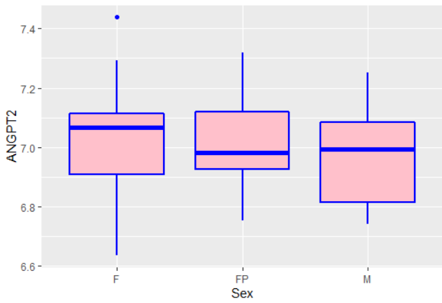

Anova_results <- aov(ANGPT2 ~ Sex, corrTable); summary(Anova_results)

Df Sum Sq Mean Sq F value Pr(>F)

Sex 2 0.0286 0.01430 0.498 0.611

Residuals 42 1.2064 0.02872

Anova_results <- aov(ANGPT2 ~ IOP + Sex, corrTable); summary(Anova_results)

Df Sum Sq Mean Sq F value Pr(>F)

IOP 1 0.0642 0.06420 2.300 0.137

Sex 2 0.0261 0.01306 0.468 0.630

Residuals 41 1.1447 0.02792

Linear_model <- lm(ANGPT2 ~ IOP + Sex, corrTable); summary(Linear_model)

Call:

lm(formula = ANGPT2 ~ IOP + Sex, data = corrTable)

Residuals:

Min 1Q Median 3Q Max

-0.34689 -0.09229 -0.00910 0.09460 0.41424

Coefficients:

Estimate Std. Error t value Pr(>|t|)

(Intercept) 6.880054 0.111283 61.825 <2e-16 ***

IOP 0.010219 0.006874 1.487 0.145

SexFP -0.025231 0.060223 -0.419 0.677

SexM -0.058909 0.061013 -0.966 0.340

---

Residual standard error: 0.1671 on 41 degrees of freedom

Multiple R-squared: 0.07313, Adjusted R-squared: 0.005313

F-statistic: 1.078 on 3 and 41 DF, p-value: 0.3689

The P-value is higher than 0.05, so the null hypothesis is not rejected again. Therefore, I cannot claim that the expression level of ANGPT2 is significantly varied in three different Sex subgroups.

Then, I decided to divide the Sex group into just two subgroups as below and run the t-test. Division 1) convert FP to F. Division 2) convert F and M to NonP.

**Division 1): Convert FP to F. So, we have just F and M**

summary(corrTable_Sex2$Sex)

F M

33 12

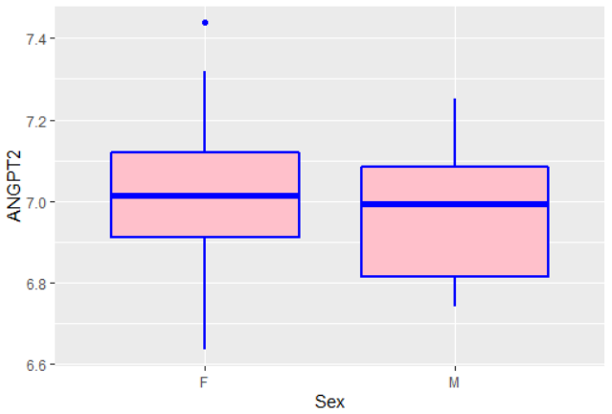

Anova_results <- aov(ANGPT2 ~ Sex, corrTable_Sex2); summary(Anova_results)

Df Sum Sq Mean Sq F value Pr(>F)

Sex 1 0.0167 0.01675 0.591 0.446

Residuals 43 1.2183 0.02833

Anova_results <- aov(ANGPT2 ~ IOP + Sex, corrTable_Sex2); summary(Anova_results)

Df Sum Sq Mean Sq F value Pr(>F)

IOP 1 0.0642 0.06420 2.346 0.133

Sex 1 0.0212 0.02122 0.775 0.384

Residuals 42 1.1496 0.02737

Anova_results <- aov(ANGPT2 ~ IOP + Sex + Age, corrTable_Sex2); summary(Anova_results)

Df Sum Sq Mean Sq F value Pr(>F)

IOP 1 0.0642 0.06420 2.279 0.139

Sex 1 0.0212 0.02122 0.753 0.391

Age 3 0.0511 0.01703 0.605 0.616

Residuals 39 1.0985 0.02817

t.test(ANGPT2 ~ Sex, corrTable_Sex2, mu=0, alt="two.sided", conf=0.95, var.eq=F, paired=F)

Welch Two Sample t-test

data: ANGPT2 by Sex

t = 0.77303, df = 19.763, p-value = 0.4487

alternative hypothesis: true difference in means is not equal to 0

95 percent confidence interval:

-0.07418849 0.16144413

sample estimates:

mean in group F mean in group M

7.020618 6.976991

In all tests and analyses, P-values are higher than 0.05, and I cannot reject the null hypothesis.

**Division 2): Convert F and M to NonP. So, we have just Pregnant (P) and Non-Pregnant (NonP)**

summary(corrTable_Sex2$Sex)

NonP P

32 13

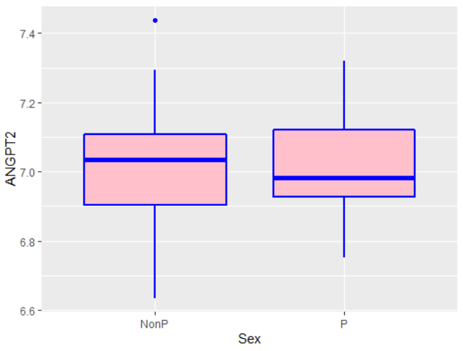

Anova_results <- aov(ANGPT2 ~ Sex, corrTable_Sex2); summary(Anova_results)

Df Sum Sq Mean Sq F value Pr(>F)

Sex 1 0.0026 0.002578 0.09 0.766

Residuals 43 1.2324 0.028661

Anova_results <- aov(ANGPT2 ~ IOP + Sex, corrTable_Sex2); summary(Anova_results)

Df Sum Sq Mean Sq F value Pr(>F)

IOP 1 0.0642 0.06420 2.303 0.137

Sex 1 0.0001 0.00009 0.003 0.955

Residuals 42 1.1707 0.02787

Anova_results <- aov(ANGPT2 ~ IOP + Sex + Age, corrTable_Sex2); summary(Anova_results)

Df Sum Sq Mean Sq F value Pr(>F)

IOP 1 0.0642 0.06420 2.254 0.141

Sex 1 0.0001 0.00009 0.003 0.956

Age 3 0.0600 0.01999 0.702 0.557

Residuals 39 1.1108 0.02848

t.test(ANGPT2 ~ Sex, corrTable_Sex2, mu=0, alt="two.sided", conf=0.95, var.eq=F, paired=F)

Welch Two Sample t-test

data: ANGPT2 by Sex

t = 0.31355, df = 24.603, p-value = 0.7565

alternative hypothesis: true difference in means is not equal to 0

95 percent confidence interval:

-0.09308437 0.12648488

sample estimates:

mean in group NonP mean in group P

7.013809 6.997109

In all tests and analyses, P-values are higher than 0.05, and I cannot reject the null hypothesis.

All analysis above indicates that there is no significant relation between IOP and ANGPT2 based on different subgroups of Sex feature.

**Partial-Correlation between IOP and ANGPT2 based on Batch feature**

In this section, I am going to calculate the correlation between IOP and ANGPT2 based on different Batch subgroups. Our 45 samples have four batch numbers: B12 (12 samples), B13 (6 samples), B14 (21 samples), and B15 (6 samples).

> summary(corrTable$Batch)

B12 B13 B14 B15

12 6 21 6

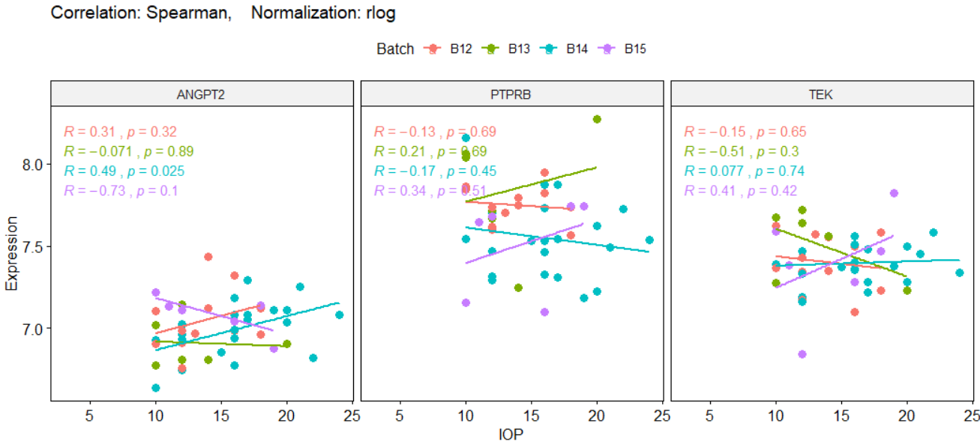

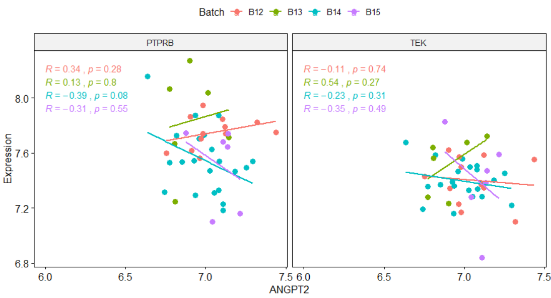

**Good news:** Based on the results, I can see there is a **significant relationship** in the **B14** subgroup between ANGPT2 and IOP (R=+0.49, P-value=0.025), and PTPRB (R=-0.39, P-value=0.08). Now, I am going to do a t-test and ANOVA analysis.

**Analysis of ANOVA and lm considering Batch**

There are four subgroups of Batch, and I run ANOVA analysis in for ANGPT2 expression along with these subgroups.

**H0:** The mean of ANGPT2 expression level in all three subgroups of Batch is equal together.

**Ha:** They are not equal.

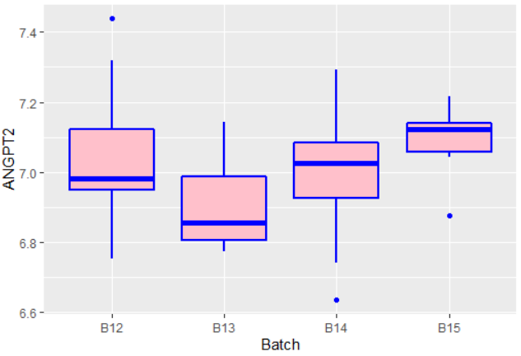

Anova_results <- aov(ANGPT2 ~ Batch, corrTable); summary(Anova_results)

Df Sum Sq Mean Sq F value Pr(>F)

Batch 3 0.120 0.0400 1.471 0.237

Residuals 41 1.115 0.0272

Anova_results <- aov(ANGPT2 ~ IOP + Batch, corrTable); summary(Anova_results)

Df Sum Sq Mean Sq F value Pr(>F)

IOP 1 0.0642 0.06420 2.468 0.124

Batch 3 0.1301 0.04336 1.666 0.190

Residuals 40 1.0407 0.02602

Anova_results <- aov(ANGPT2 ~ IOP + Batch + Sex + Age, corrTable); summary(Anova_results)

Df Sum Sq Mean Sq F value Pr(>F)

IOP 1 0.0642 0.06420 2.587 0.117

Batch 3 0.1301 0.04336 1.747 0.175

Sex 2 0.0200 0.00999 0.403 0.672

Age 3 0.1522 0.05073 2.044 0.125

Residuals 35 0.8685 0.02482

Linear_model <- lm(ANGPT2 ~ IOP + Batch, corrTable); summary(Linear_model)

lm(formula = ANGPT2 ~ IOP + Batch, data = corrTable)

Residuals:

Min 1Q Median 3Q Max

-0.28542 -0.09903 -0.00121 0.08289 0.38699

Coefficients:

Estimate Std. Error t value Pr(>|t|)

(Intercept) 6.885063 0.106772 64.484 <2e-16 ***

IOP 0.011808 0.006988 1.690 0.0989 .

BatchB13 -0.130901 0.080821 -1.620 0.1132

BatchB14 -0.082366 0.060811 -1.354 0.1832

BatchB15 0.031996 0.080754 0.396 0.6940

Residual standard error: 0.1613 on 40 degrees of freedom

Multiple R-squared: 0.1573, Adjusted R-squared: 0.07304

F-statistic: 1.867 on 4 and 40 DF, p-value: 0.1352

The P-value is greater than 0.05, so the null hypothesis is not rejected again. Therefore, I cannot claim that the expression level of ANGPT2 is significantly varied in four different Batch subgroups.

Then, I decided to divide the Batch group into just two subgroups as below and run the t-test. Division 1) divided Batch half by half (B12 and B13 in the first group and B14 and B15 in the second group). 2) separate B14 from others.

**Division 1): Devided Batch half by half (B12 and B13 in first group and B14 and B15 in the second group)**

summary(corrTable_Batch2$Batch)

B_1 B_2

18 27

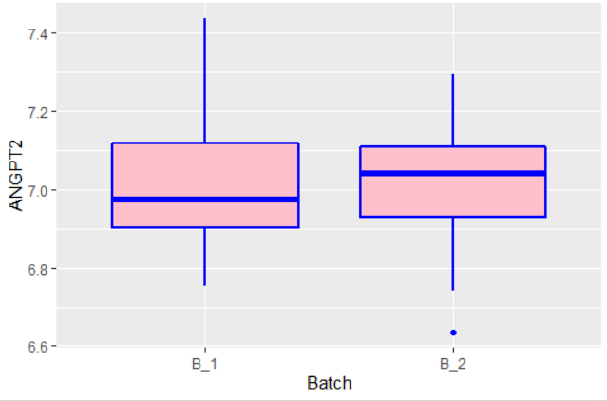

Anova_results <- aov(ANGPT2 ~ Batch, corrTable_Batch2); summary(Anova_results)

Df Sum Sq Mean Sq F value Pr(>F)

Batch 1 0.002 0.001991 0.069 0.793

Residuals 43 1.233 0.028675

Anova_results <- aov(ANGPT2 ~ IOP + Batch, corrTable_Batch2); summary(Anova_results)

Df Sum Sq Mean Sq F value Pr(>F)

IOP 1 0.0642 0.06420 2.305 0.136

Batch 1 0.0012 0.00115 0.041 0.840

Residuals 42 1.1697 0.02785

Anova_results <- aov(ANGPT2 ~ IOP + Batch + Age, corrTable_Batch2); summary(Anova_results)

Df Sum Sq Mean Sq F value Pr(>F)

IOP 1 0.0642 0.06420 2.273 0.140

Batch 1 0.0012 0.00115 0.041 0.841

Age 3 0.0681 0.02269 0.803 0.500

Residuals 39 1.1016 0.02825

t.test(ANGPT2 ~ Batch, corrTable_Batch2, mu=0, alt="two.sided", conf=0.95, var.eq=F, paired=F)

Welch Two Sample t-test

data: ANGPT2 by Batch

t = -0.25607, df = 32.962, p-value = 0.7995

alternative hypothesis: true difference in means is not equal to 0

95 percent confidence interval:

-0.12145519 0.09430056

sample estimates:

mean in group B_1 mean in group B_2

7.000838 7.014415

In all tests and analyses, P-values are higher than 0.05, and I cannot reject the null hypothesis.

**Division 2): Separate B14 from others**

summary(corrTable_Batch2$Batch)

B14 Others

21 24

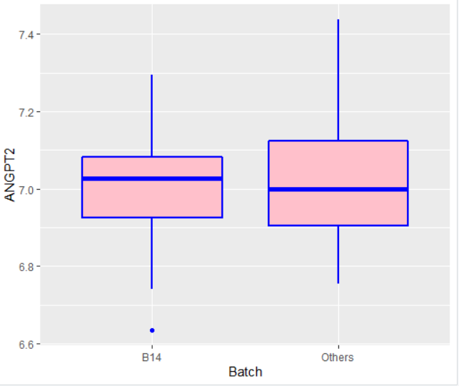

Anova_results <- aov(ANGPT2 ~ Batch, corrTable_Batch2); summary(Anova_results)

Df Sum Sq Mean Sq F value Pr(>F)

Batch 1 0.009 0.00899 0.315 0.577

Residuals 43 1.226 0.02851

Anova_results <- aov(ANGPT2 ~ IOP + Batch, corrTable_Batch2); summary(Anova_results)

Df Sum Sq Mean Sq F value Pr(>F)

IOP 1 0.0642 0.06420 2.378 0.131

Batch 1 0.0366 0.03665 1.357 0.251

Residuals 42 1.1342 0.02700

Anova_results <- aov(ANGPT2 ~ IOP + Batch + Age + Sex, corrTable_Batch2); summary(Anova_results)

Df Sum Sq Mean Sq F value Pr(>F)

IOP 1 0.0642 0.06420 2.388 0.131

Batch 1 0.0366 0.03665 1.363 0.250

Age 3 0.0798 0.02661 0.990 0.408

Sex 2 0.0597 0.02986 1.111 0.340

Residuals 37 0.9946 0.02688

t.test(ANGPT2 ~ Batch, corrTable_Batch2, mu=0, alt="two.sided", conf=0.95, var.eq=F, paired=F)

Welch Two Sample t-test

data: ANGPT2 by Batch

t = -0.56261, df = 42.503, p-value = 0.5767

alternative hypothesis: true difference in means is not equal to 0

95 percent confidence interval:

-0.1299189 0.0732570

sample estimates:

mean in group B14 mean in group Others

6.993875 7.022205

In all tests and analyses, P-values are higher than 0.05, and I cannot reject the null hypothesis.

All analysis above indicates that there is no significant relation between IOP and ANGPT2 based on different subgroups of the Batch feature.

**Nonlinear Correlation Analysis**

In this section, I foucsed on nonlinear correlation analysis, which I did on the data. I used two NonLinear Correlatoin (**nlcor**) and Nonlinear Nonparametric Statistics (**NNS**) tests. The only thing I found from nlcor analysis is: “When PTPRB highly expressed, ANGPT2 expressed low”.

nlcor(corrTable$PTPRB, corrTable$ANGPT2, plt=T)

x = corrTable$PTPRB y= corrTable$ANGPT2

