**Final report of RNAseq correlation anlysis**

This is the final report of analysing the RNAseq data and looking for the correlation of IOP data with three genes of 45 samples. First of all, I normalized the expresseion levels of 32883 genes. I had some options and finally choose **rlog** (regularized log transformation) method among others (Log2, Log10, Ln, vst). Then I considered three genes among them.

**Real counts Normalized with rlog**

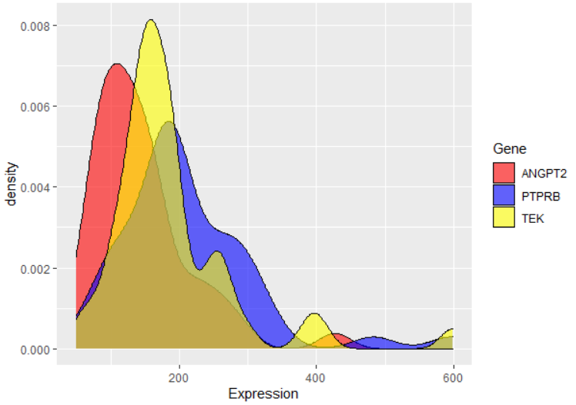 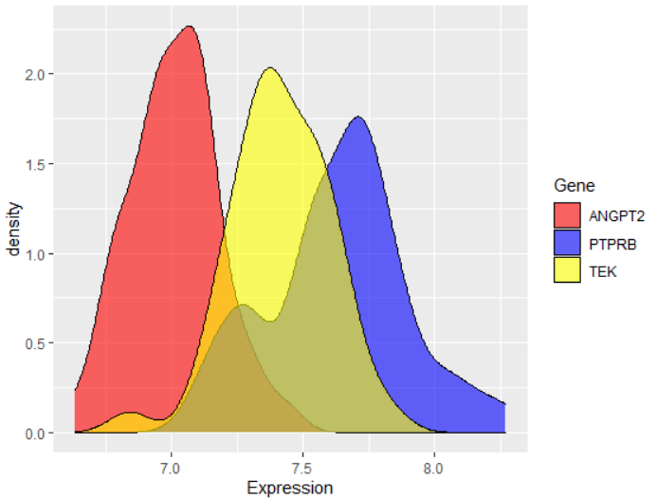

Also, I found that IOP dataset for 45 samples is not normally distributed. I have tried using 7 different methods to normalize it, but unfortunatelly I could not; almost all of them are skewed right. Although, the **Log10 transformation normalization** was the best normalization method for IOP, however, none of them does affect the correlation analysis significantly. Therfore, I prefered to use real IOP data without any normalization.

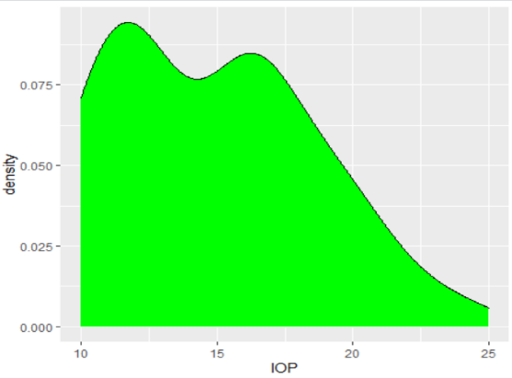

Then, I tried to find the significant correlation between IOP and three genes. There is two major correlation calculation methods: Pearson (looking for linear correlation) and Spearman (looking for linear and end-skewed correlation). Betweem them, I choose the **Spearman** method for the subsequent analysis based on analysis of three genes density distribution.

I tried to find a strong correlation, but I could not find any significant relationship, just a non-significant and weak correlation of IOP with ANGPT2 gene.

**Real counts**

**Correlation method: Pearson**

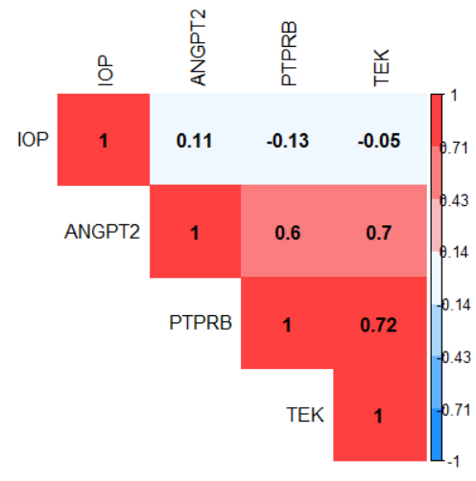

**Correlation method: Spearman**

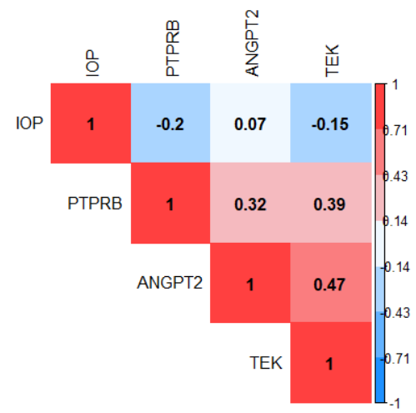

**rlog Normalization**

**Correlation method: Pearson**

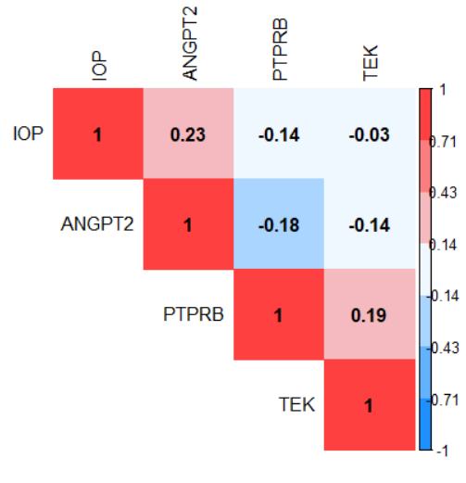

Selected method

**Correlation method: Spearman**

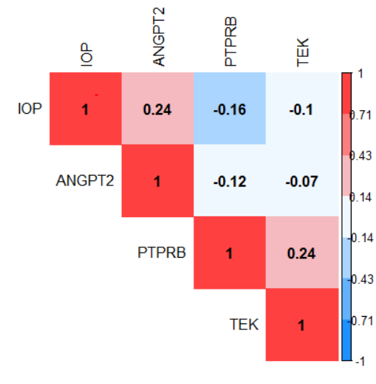

Based on the heatmap figures above, I found the two genes **PTPRB** and **TEK** act similarly. They have a negative correlation with **IOP** and **ANGPT2**. Also, **IOP** has a weak positive linear relationship with **ANGPT2**, and a weak negative linear relationship with **PTPRB**.

**Correlation between IOP and Genes**

Considering **Spearman** correlation method and real IOP (without normalization) and three genes’ expression level (normalized using the **rlog** method) calculated the correlation. Based on the correlation coefficient R and P-values in the figure below, I found that IOP has a positive relationship with ANGPT2 and a negative relationship with PTPRB and almost not correlated with TEK. However, none of them are significantly correlated.

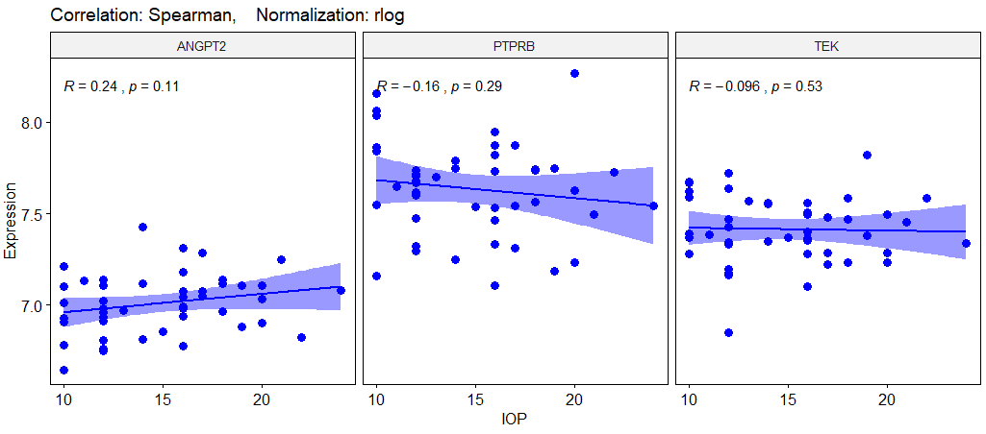

Then, focused on the three subgroups of IOP (Normal, Elevated, and High) and calculate the correlation based on those data. As I can see, ANGPT2 has the highest positive correlation with Normal_IOP (R = 0.23) subgroup. Also, PTPRB has the highest negative correlation with Normal_IOP (R = -0.32) subgroup. It means that the Normal_IOP subgroup has a major role in a part of the IOP dataset in the association with ANGPT2 and PTPRB. I mean, lower IOP related to the low expression of ANGPT2 and relatively high expression of PTPRB. But, none of the are significant correlation.

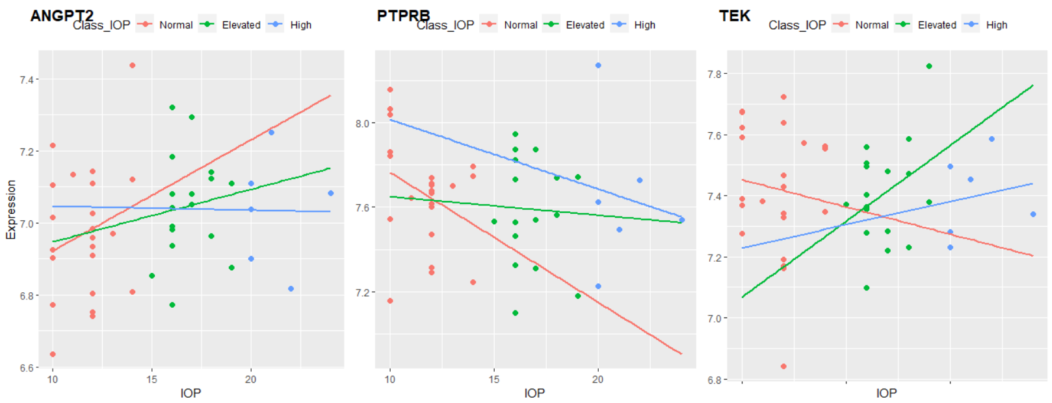

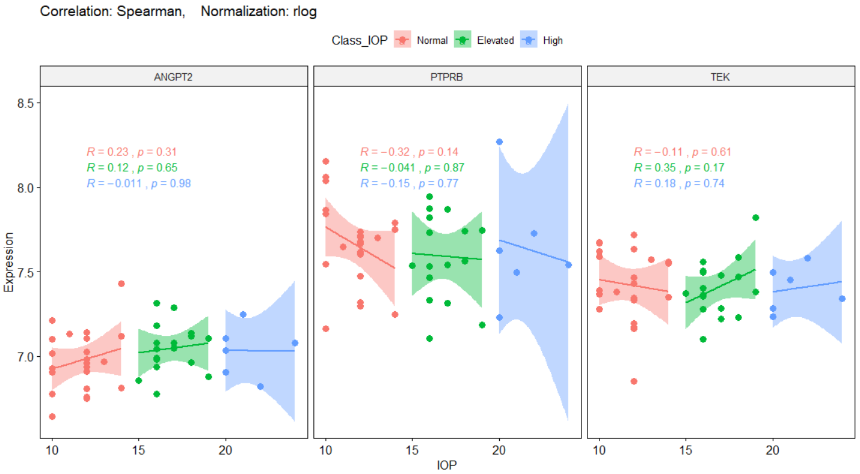

There are low samples in the high_IOP subgroup. Therefore, I decided to classify the IOP feature into two subgroups: Normal and High. In this scenario, half of the samples are High_IOP, around 50% of the samples (23 samples). However, the High_IOP subgroup is not correlated with ANGPT2 and PTPRB again. I mean, Normal_IOP has a vital role in the correlation of IOP with ANGPT2 or PTPRB still. But, none of the are significant correlation again.

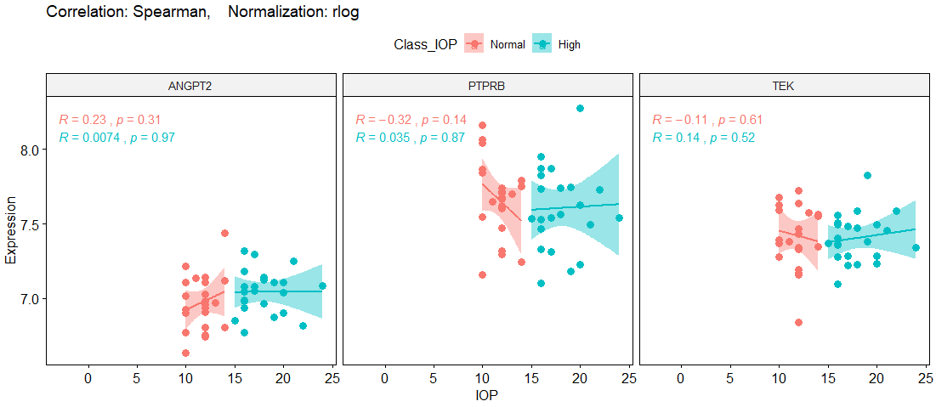

**Correlation between IOP and Genes based on Age**

In this section, I am going to calculate the correlation between IOP and Genes based on different Age subgroups. I classified samples into four subgroups (quartiles): 1) **Adolescent** (113<=Age<135), 2) **Adult** (135<=Age<154), 3) **Middle_Aged**(154<=Age<183), and 4) **Aged** (183<=Age<=346). Then, plot the correlation based on each subgroup.

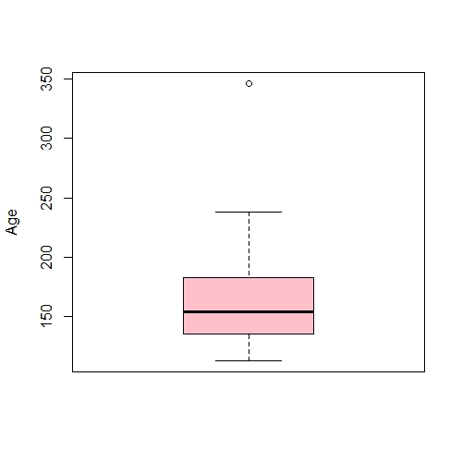

346

238

183

154

135

113

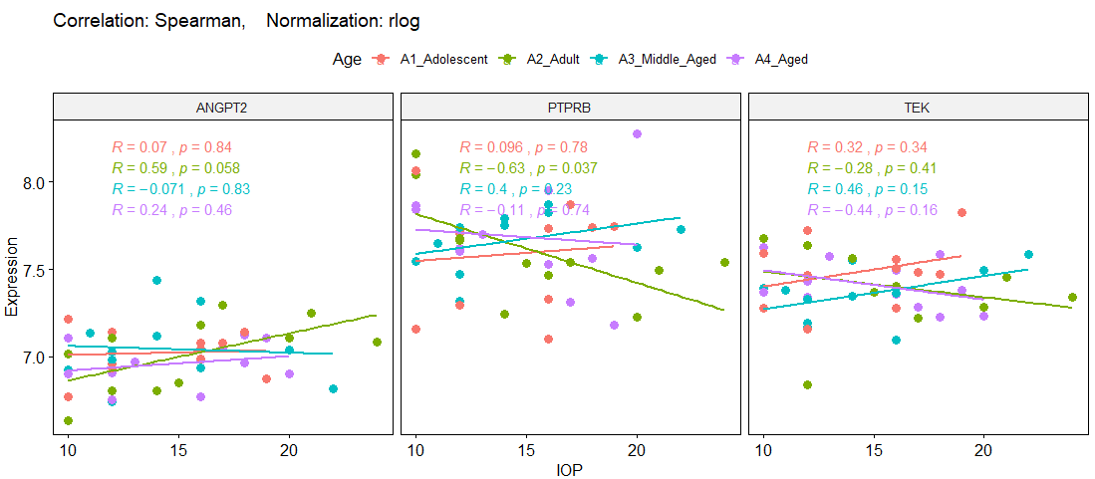

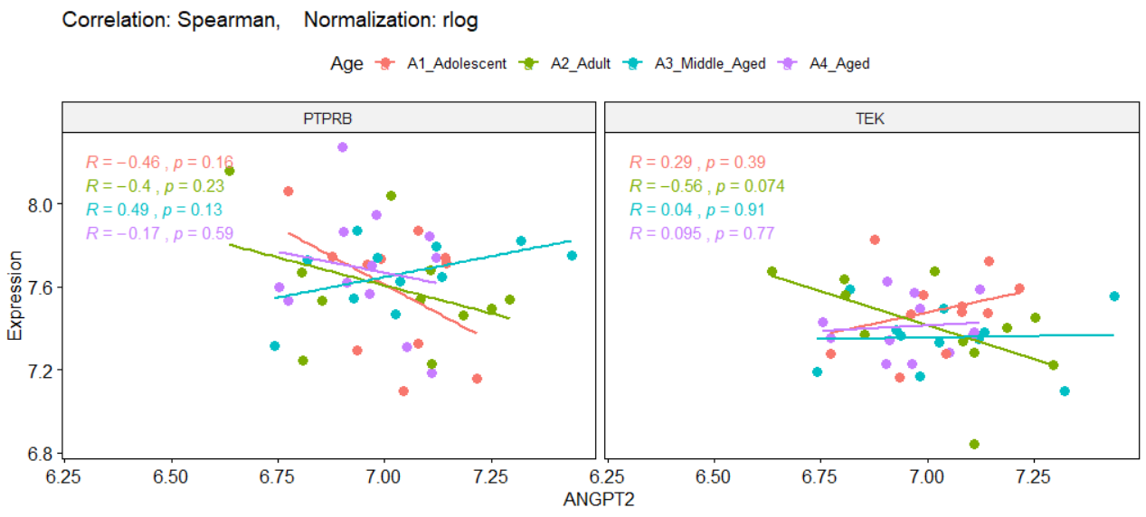

**Good news:** Based on the results, I can see there is a **semi-significant relationship** in the **Adult** subgroup between IOP and ANGPT2 (R=+0.59, P-value=0.058), and **significant relationship** PTPRB (R=-0.63, P-value=0.037). Also, there is a semi-significant relationship between ANGPT2 and TEK genes in this subgroup (Adult).

I am curious about **Adult** subgroup. Then, I divide samples to three equal subgroups: **Adolescent** (113<=Age<138), **Adult** (138<=Age<178), and **Aged** (178<=Age<=346). Then, plot the correlation based on each subgroup.

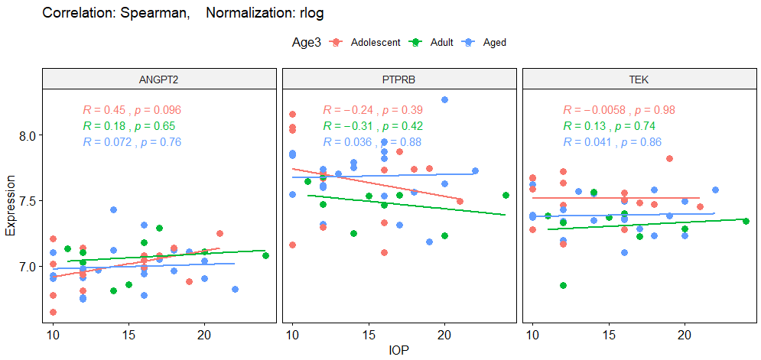

As I did not get a reasonable results, I found that there is a best subgroups of Age, which IOP measure of these samples are significantly correlated to the ANGPT2 and PTPRB genes. After several trying, finally I found this subset. Now, I am going to divide samples to three varient subgroups: **Adolescent** (113<=Age<127) with 4 samples, **Adult** (127<=Age<167) with 23 samples, and **Aged** (167<=Age<=346) with 18 samples. I considered the **Adult** subgropup with almost suffisient sample-size (23) as the best subgroup, which I looked for. Then, I plot the correlation based on each subgroup.

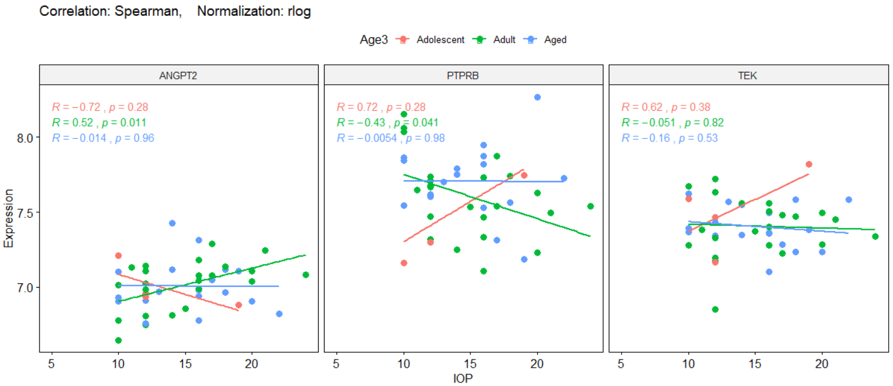

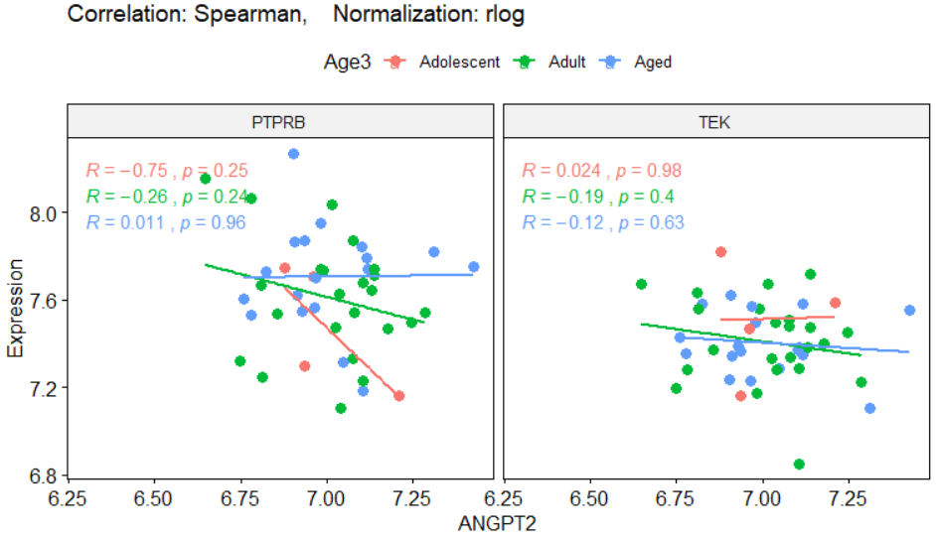

As you can see, there are **significant and reasonable relationship** in the **Adult** subgroup, between IOP and ANGPT2 (R=+0.52, P-value=0.011), and PTPRB (R=-0.43, P-value=0.041). In the next step, I tried to do same analysis based on other features:Sex and Batch, as below.

**Correlation between IOP and Genes based on Sex**

In this section, I am going to calculate the correlation between IOP and genes based on different Sex subgroups. Among 45 samples, 12 (26%) of them are male, and 33 (73%) are Female. Also, there are 13 (29%)Pregnant samples.

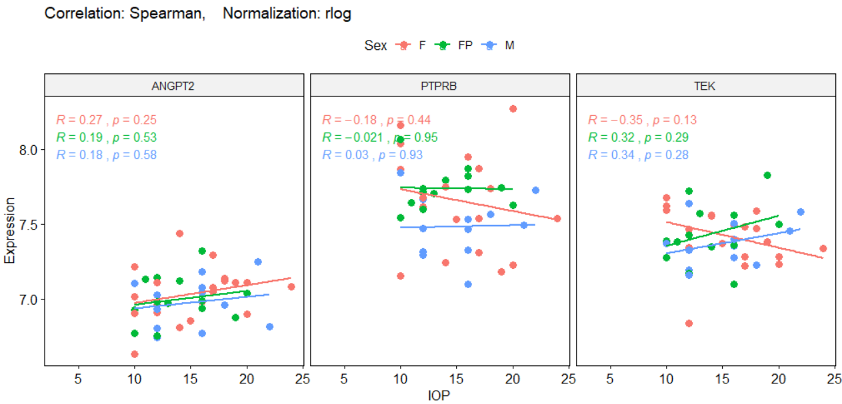

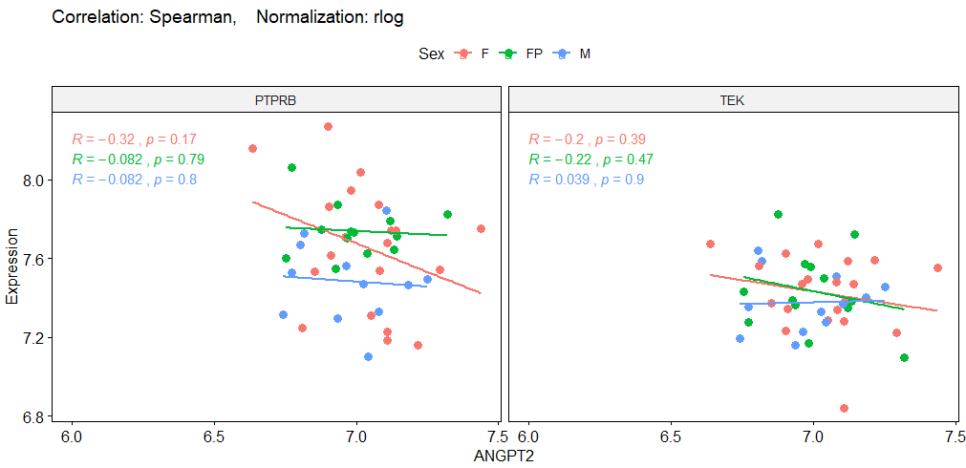

There is no significant correlation between Sex subgroups and genes. Almost all three Sex subgroups have a similar role in the relationship between IOP and genes. Then, I divide samples to two subgroups: **Male** with 12 samples, and **Female** with 33 samples. Then, plot the correlation based on each subgroup. Again, there is no significant correlation between these Sex subgroups and genes.

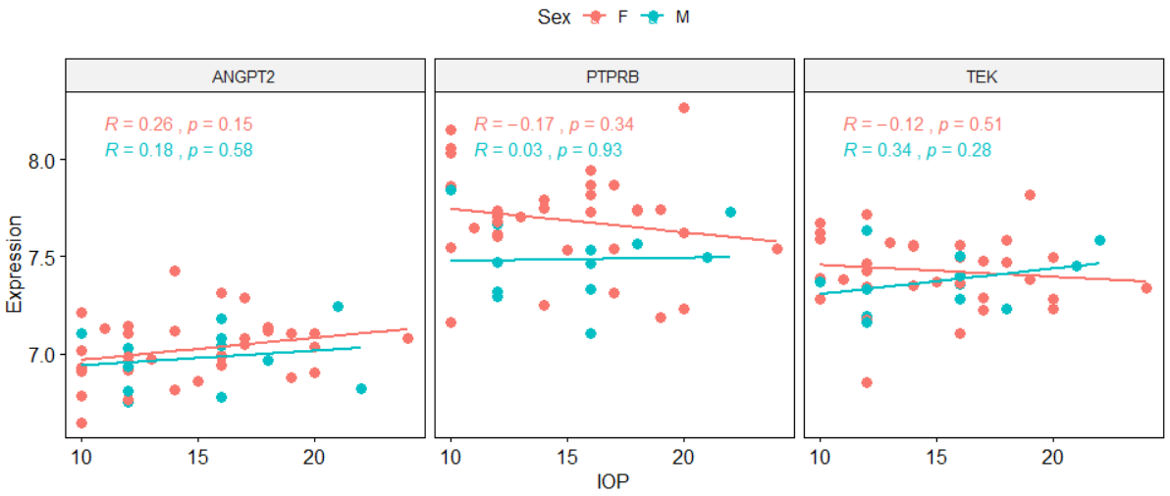

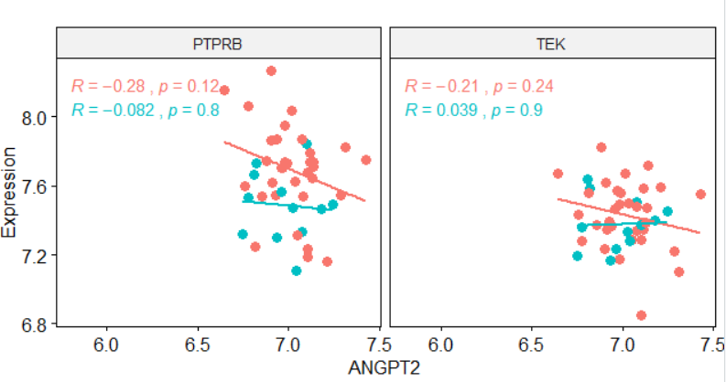

**Partial-Correlation between IOP and ANGPT2 based on Batch feature**

In this section, I am going to calculate the correlation between IOP and genes based on different Batch subgroups. Our 45 samples have four batch numbers: **B12** (12 samples), **B13** (6 samples), **B14** (21 samples), and **B15** (6 samples).

**Good news:** Based on the results, I can see there is a **significant relationship** in the **B14** subgroup between ANGPT2 and IOP (R=+0.49, P-value=0.025), and also ANGPT2 and PTPRB genes (R=-0.39, P-value=0.08). As these subgroups are classified experimentally, so I did not consider to manour on reclassification of them and look for the best subgroups.

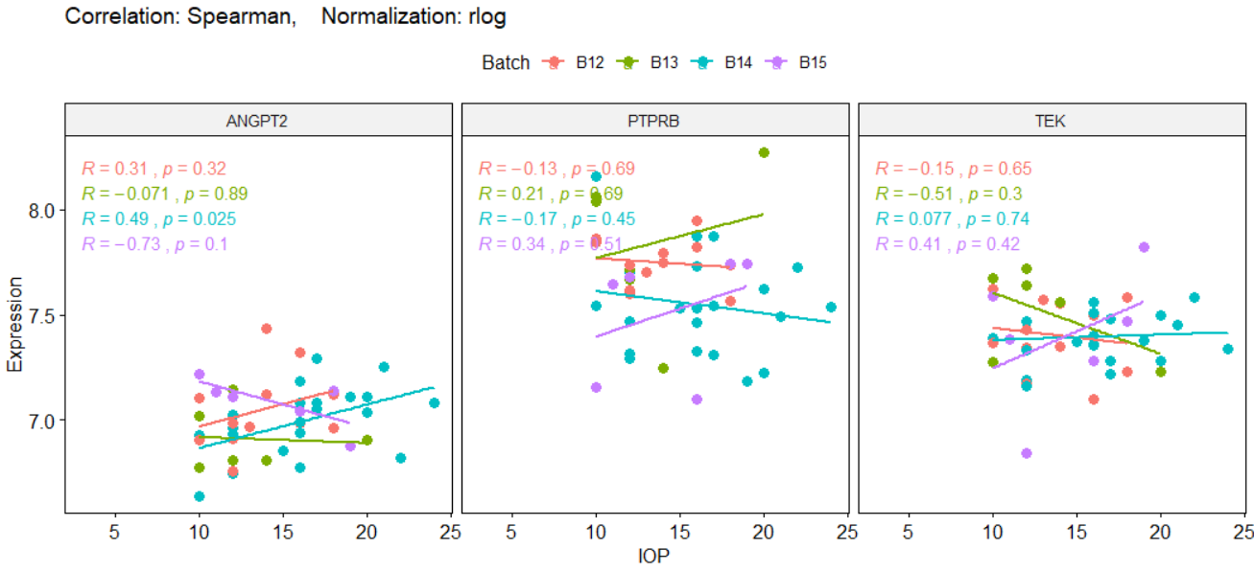

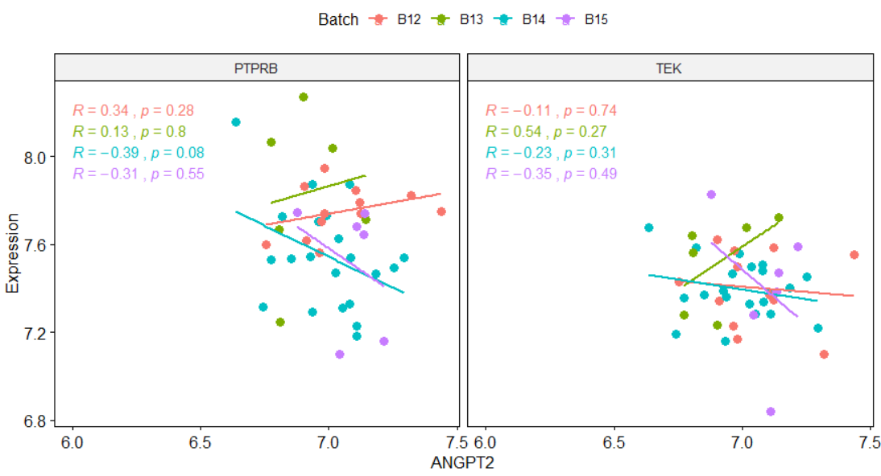

**Nonlinear Correlation Analysis**

Also, I tried to do nonlinear correlation analysis too. I used two NonLinear Correlatoin (**nlcor**) and Nonlinear Nonparametric Statistics (**NNS**) tests. The only thing I found from nlcor analysis is: “When PTPRB highly expressed, ANGPT2 expressed low”. In figure below, you can see the results: x=PTPRB and y=ANGPT2.

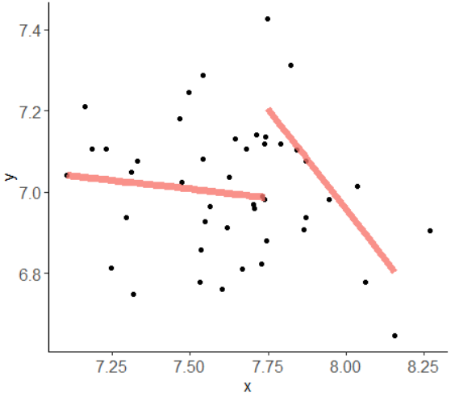

**ANOVA Analysis**

In this section, I tried to do ANOVA analysis for three subgroups of Age (best fitted one).

**H0:** The mean of ANGPT2 expression level in all three subgroups of Age is equal together.

**Ha:** They are not equal.

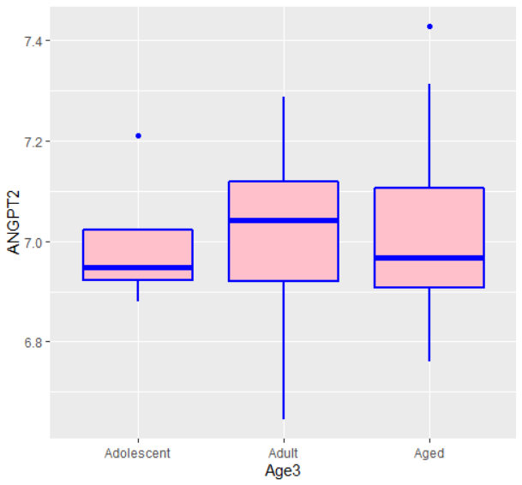

Anova_results <- aov(ANGPT2 ~ Age3, data=corrTable); summary(Anova_results)

Df Sum Sq Mean Sq F value Pr(>F)

Age3 2 0.0013 0.000644 0.023 0.977

Residuals 42 1.1738 0.027948

Anova_results <- aov(ANGPT2 ~ IOP + Age3, data=corrTable); summary(Anova_results)

Df Sum Sq Mean Sq F value Pr(>F)

IOP 1 0.0609 0.06092 2.244 0.142

Age3 2 0.0012 0.00059 0.022 0.979

Residuals 41 1.1130 0.02715

Linear_model <- lm(ANGPT2 ~ IOP + Age3, corrTable); summary(Linear_model)

Call:

lm(formula = ANGPT2 ~ IOP + Age3, data = corrTable)

Residuals:

Min 1Q Median 3Q Max

-0.31830 -0.07672 -0.01378 0.09230 0.43428

Coefficients:

Estimate Std. Error t value Pr(>|t|)

(Intercept) 6.8629166 0.1216377 56.421 <2e-16 ***

IOP 0.0101084 0.0067542 1.497 0.142

Age3Adult 0.0001003 0.0899622 0.001 0.999

Age3Aged -0.0103533 0.0919917 -0.113 0.911

---

Residual standard error: 0.1648 on 41 degrees of freedom

Multiple R-squared: 0.05284, Adjusted R-squared: -0.01646

F-statistic: 0.7624 on 3 and 41 DF, p-value: 0.5217

The P-value is higher than 0.05, so the null hypothesis is not rejected. Therefore, I cannot claim that the expression level of ANGPT2 is significantly varied in three different Age3 groups. It means that these three subgroups have similarity and hidden relationship and we cannot differentiate them in ANGPT2 expression level.

Then, I decided to divide the Age3 into just two subgroups and run the t-test for similar hypothesis. I kept the **Adult** subgroup and mixed the **Adolocent** and **Aged** subgroups as the same subgroup. Therefore, the samples size of each new subgroups are almost equal; **Adult** with 23 samples and new **Others** subgroup with 22 samples.

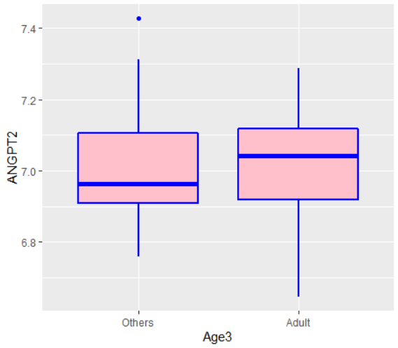

Anova_results <- aov(ANGPT2 ~ Age3, corrTable_Age2); summary(Anova_results)

Df Sum Sq Mean Sq F value Pr(>F)

Age3 1 0.001 0.001021 0.037 0.848

Residuals 43 1.174 0.027304

Anova_results <- aov(ANGPT2 ~ IOP + Age3, corrTable_Age2); summary(Anova_results)

Df Sum Sq Mean Sq F value Pr(>F)

IOP 1 0.0609 0.06092 2.298 0.137

Age3 1 0.0008 0.00083 0.031 0.861

Residuals 42 1.1134 0.02651

t.test(ANGPT2 ~ Age3, corrTable_Age2, mu=0, alt="two.sided", conf=0.95, var.eq=F, paired=F)

Welch Two Sample t-test

data: ANGPT2 by Age3

t = -0.1934, df = 42.914, p-value = 0.8476

alternative hypothesis: true difference in means is not equal to 0

95 percent confidence interval:

-0.1089114 0.0898513

sample estimates:

mean in group Others mean in group Adult

7.004234 7.013764

Again, P-values are higher than 0.05, and I cannot reject the null hypothesis; same conclusion.