# **CHAPTER 1**

# **INTRODUCTION**

## **1.1 Research Background**

In early 1770, there is a English Scientiest called Joseph Priestly that has invented the erosive effect of Electrical Discharge Machining (EDM). // Electrical Discharge machining ( EDM ) is an electro-thermal non-traditional machining process, the synonym name for this EDM are spark eroding, spark machining, die sinking, burning, wire burning or wire erosion. The synonym name stated above is a manufacturing process where we can determine what type of shape that we want and the edges of the material. In order to make sure this process works as our desired shape, the material has to be electrically conductive [1]. Electrical discharge machining provides the best solutions to machine in terms of high-strength, corrosion and wear-resistant materials. The 3 parameters are important in manufacturing in order to protect the quality of metal and its surface roughness. Thus, EDM equipment is very useful for modern manufacturing systems [2].

Eventually, the world technology and manufacturing keep growing up. Thus, high technology machine is needed to make sure the industry maintain in a good position. Cutting or shaping metal is not an easy task, it need to be done with perfectly. When it comes to perfect, it means the accuracy and surface roughness has to be exactly meet the requirement to avoid several problems in future. Cutting tools function as removing a few parts of metal until it fulfilled the size, shape and surface quality for the workpiece according to the design parameter [3].

If a metal workpiece that has been produced by any cutting machine contain defect and been used in industrial machine. The probability for the machine to have problem is very high and will affect the production. However, we can avoid such thing to occururing by focusing on surface quality of the workpiece. Surface finish is the main element for cutting process, also known as surface texture. From the surface texture, // we are many forms of renewable energy in this planet. Most of these energies are produced due to sunrise and sunset where wind and hydroelectric power are the direct result of differential temperature or humidity of the Earth’s surface, which leads to air moving (wind) and precipitation forming as the air is lifted. Energy that is produced directly from the conversion of sunlight is the solar energy by using panels or collectors. There are also other renewable energies that do not depend on sunlight such as, geothermal energy and tidal energy. Geothermal energy is a result of radioactive decay in the crust combined with the heat of accreting Earth, whereas tidal energy is a conversion of gravitational energy [2].

However, producing electrical energy does not mean it has to come from these sources only. The generation of electricity can also come from a simple energy conversion such as energy produced by humans, vehicles, or other objects. Heat energy from vehicles or human body and also the energy produced by the movements (kinetic energy) of humans are classified as waste energy that has the potential to produce electricity by using suitable sensors. In this research, sensors that will be studied are piezoelectric sensor and also thermoelectric sensor. Piezoelectric sensor is a device that uses the piezoelectric effect, to measure changes in pressure, acceleration, temperature, strain, or force by converting them to an electrical charge. On the other hand, thermoelectric sensor is a device that produces electricity by a difference of temperature. These sensors will be discussed in details in the following chapter.

The battery lifespan or its energy density has become a lagging trend throughout the years. Most of the batteries that are used for small devices such as mobile phones have a very limited capacity of finite power sources [3]. Therefore, due to the need of continuously powered devices, a self-powered device is required. Other drawbacks of a battery are also factorized by its small battery storage. Thus, user would have to continuously charging their devices in order to keep it functioning. These lead to an increasing of expenditure on electrical bills.

## **1.2 Problem Statement**

The problem statement for this project is that the existing servomechanism model only functioned as basic which is the dc geared motor only rotate forward and backward and no further studies have been conducted. This means that people are hard to understand the Electric Discharge Machining(EDM) functionality or how it works. Therefore, no exposure to surrounding about this EDM system and for those who are new to EDM system, likely hard to understand the fundamental of EDM.

Besides that, there is no voltage gap difference shown in any servomechanism model. This voltage gap is a gap between the connected electrode with dc geared motor and the workpiece. Hence, an electrode has been applied to this project together with the workpiece so that the gap can be shown. The gap is determined by Arduino coding in terms of voltage difference where voltage difference control the gap between electrode and workpiece. On the other hand, the movement of electrode controlled by dc geared motor and a motor driver needed to supply the dc geared motor.

Last but not least,// the physical and characteristic of the product itself is also considered as one of the problem statement for this project. The existing energy harvesting charger is less user-friendly which it is uncomfortable to be used. Thus, choosing suitable sensors size and designing the product to be small, light and user-friendly is important. In order to make this renewable energy charger to be portable, the flow of system must be understood thoroughly before implementing it for further research.

## **Research Aim (KIV)**

Voltage gap is important……maintain surface quality. Spark produces has to be constant when applied to the material / . thus , gapping is important. To measure the voltage gap -> using potentiometer. //The waste heat/energy can be useful if people do concern on generating electricity to power up their devices by only doing routine activities. By doing so, it will not only help us to reduce the usage of electricity, but also help us to be healthier and practice a better lifestyle. Converting these energies with the help of pressure/kinetic sensor (piezoelectric) and heat sensor (thermoelectric), we can use the energy converted to charge any small devices that we owned. If this product is accepted by the community due to its user-friendly and fast charging, more people will be attracted and interested to practice a better lifestyle using this renewable energy charger.

But the question is, why do I strongly suggest that people should use alternative way to produce electricity? This is because the electricity bills from TNB are increasing and had never dropped from time to time. The main reason is that TNB are producing electricity by non-renewable energy. Any sources that are non-renewable are expensive and soon will be dried. Therefore, it leads to an increasing on rates of TNB electricity. In order to keep the source lifespan longer, we should learn how to conserve energy and also practice with other alternatives way in producing our own electricity.

Although the idea of this project will only produce small amount of power, however it can still help us to practice and reduce the usage of electricity straight from TNB. Besides, in this modern world, most people are using more than a gadget in their daily life. The energy consumption would be high if they do not expose themselves with alternative way to generate electricity thus, pays more on electrical expenditure.//

## **1.4 Objectives**

1. Improvise servomechanism model with addition of electrode move up and down
2. To develop a model that shows the gap between electrode and the workpiece

## **1.5 Scope of Work**

In this project, servomechanism model of EDM system will have several things that need to be considered under the project scope.. The scope of this project consists of hardware elements which are:

1. Choosing type of DC geared motor in terms of rpm/min and torque to control the movement of electrode.

2. Using suitable potentiometer to give accurate value that affect the voltage difference.

3. This project focusing on small model only.

## **1.6 Gantt Chart**

**Table 1.1:** FYP 1 Weekly Activity(Renewable Energy Charger)

|  |  |  |  |  |  |  |  |  |  |  |  |  |  |  |
| --- | --- | --- | --- | --- | --- | --- | --- | --- | --- | --- | --- | --- | --- | --- |
| **KEY ACTIVITIES** |  |  |  |  |  |  |  |  |  |  |  |  |  |  |
| **Weeks** | **1** | **2** | **3** | **4** | **5** | **6** | **7** | **8** | **9** | **10** | **11** | **12** | **13** | **14** |
| Meeting with Supervisor  -get advices/ feedbacks on topic |  |  |  |  |  |  |  |  |  |  |  |  |  |  |
| Find topic/title |  |  |  |  |  |  |  |  |  |  |  |  |  |  |
| Theory: |  |  |  |  |  |  |  |  |  |  |  |  |  |  |
| Information finding  -understand on servomechanism  -find/study suitable components |  |  |  |  |  |  |  |  |  |  |  |  |  |  |
| Set objectives and scopes |  |  |  |  |  |  |  |  |  |  |  |  |  |  |
| Writing literature review |  |  |  |  |  |  |  |  |  |  |  |  |  |  |
| Planning on methodology |  |  |  |  |  |  |  |  |  |  |  |  |  |  |
| Design circuit |  |  |  |  |  |  |  |  |  |  |  |  |  |  |
| Listing & Costing Equipment Needed |  |  |  |  |  |  |  |  |  |  |  |  |  |  |
| Report writing on FYP 1 |  |  |  |  |  |  |  |  |  |  |  |  |  |  |
| Preparing for presentation (Viva 1) |  |  |  |  |  |  |  |  |  |  |  |  |  |  |

**Table 2.2:** FYP 2 Weekly Activity(Renewable Energy Charger)

|  |  |  |  |  |  |  |  |  |  |  |  |  |  |  |
| --- | --- | --- | --- | --- | --- | --- | --- | --- | --- | --- | --- | --- | --- | --- |
| **KEY ACTIVITIES** |  |  |  |  |  |  |  |  |  |  |  |  |  |  |
| **Weeks** | **1** | **2** | **3** | **4** | **5** | **6** | **7** | **8** | **9** | **10** | **11** | **12** | **13** | **14** |
| Meeting with Supervisor  -get advices/ feedbacks on topic |  |  |  |  |  |  |  |  |  |  |  |  |  |  |
| Design circuit connection |  |  |  |  |  |  |  |  |  |  |  |  |  |  |
| Find components/devices needed |  |  |  |  |  |  |  |  |  |  |  |  |  |  |
| Listing and Costing |  |  |  |  |  |  |  |  |  |  |  |  |  |  |
| Assemble and run circuit |  |  |  |  |  |  |  |  |  |  |  |  |  |  |
| Collect data |  |  |  |  |  |  |  |  |  |  |  |  |  |  |
| Analysis data |  |  |  |  |  |  |  |  |  |  |  |  |  |  |
| Report writing on FYP 2 |  |  |  |  |  |  |  |  |  |  |  |  |  |  |
| Prepare for presentation (Viva 2) |  |  |  |  |  |  |  |  |  |  |  |  |  |  |
| Submit Report |  |  |  |  |  |  |  |  |  |  |  |  |  |  |

**1.7 Report Outline**

This report consists of 5 chapters. *Chapter 1* covers research background as the overview of this project. Some issues that are related to this thesis were discussed in the problem statement and the objectives were stated clearly as well as the scope of this project. *Chapter 2* contains literatures reviews related to energy scavenging, piezoelectric and thermoelectric sensors. *Chapter 3* explains how this project planned to be carried out step by step. The hardware and components implementation are also described in this chapter. *Chapter 4* shows the preliminary results. Finally, conclusion will be stated in *Chapter 5.*

# **CHAPTER 2**

# **LITERATURE REVIEW**

## **2.1 Introduction**

In this world, we can see metal are widely used in construction, industry or any high technology machine. For construction, metal used as a framework before finishing it with the cement. While industry used metal for their machine depends on every specification that machine needed. We can see with the current issues of cutting metal, which is need to be very accurate at the edges or any shapes. Surface roughness is one of the important parameters that need to be count. A lot of cutting metal machine has been develop such as Plasma cutters, Laser cutters, CO2 laser cutters, Fibre laser cutters and many more. For this paper, I will explain using Electrical Discharge Machining and its parameters.

## **2.2 Metal Cutting**

Cutting seems to be mushrooming in manufacturing. Various of methods been used to cut metals and can be divided according to their physical phenomenon. These methods have their own limitations in term of accuracy, cost and effect on the material. As an example the quality of alloys may be damaged by excessive heat and for laser cutting is not recommended to cut aluminium due to its highly reflective material [4].

**Table 2.2:** Physical Phenomenon in cutting element and its type of cutting used [5].

|  |  |
| --- | --- |
| Physical Phenomenon | Type of Cutting |
| Chip forming | Sawing, drilling, milling and turning |
| Shearing | Punching, stamping and scissoring |
| Abrading | Grinding, lapping and polishing |
| Heat | Flame cutting, Plasma cutting, Laser cutting |
| Electrochemical | Electrical Discharge Machining (EDM) |

## **2.3 Principle of Electrical Discharge Machining (EDM)**

This process undergoes by removing material from the workpiece with a series of current due to recurring current discharge between the two electrodes [6]. In this case, electrically conductive material will be immersed in a dielectric fluid with transient discrete electric spark discharges produced by electric voltage. This dielectric fluid is much needed in this process to ensure the accuracy of the metal while undergo cutting process [2,6]. The electrode from the machine is called tool-electrode, while the other electrode is workpiece-electrode which is from the material itself. The cutting process occur when electric spark react due to gap between this two electrodes. Hence, it is important to make sure the tool-electrode and workpiece-electrode do not have any actual contact at all [6]. Figure 2.1 below show the setup for the mechanical part and electrical set up. In the figure 2.1, a thin gap around 0.25mm is used between the two electrodes that has been immersed in dielectric liquid. For the dielectric fluid, various of type that can be used as long as it is suitable [1].

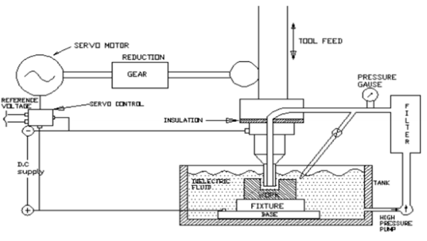

Figure 2.1: Set up for Electrical Discharge Machining (EDM) [1]

The figure shown above is the electric setup for EDM. Inside the tank, the tool-electrode act as cathode and the workpiece-electrode as anode. When power is supplied, the voltage across the gap will wait until it becomes sufficiently high and it will discharge between the gap in form of spark and that is why we called this EDM as spark machining. During spark, the electrons and positive ions are accelerated and produced discharge channel that becomes conductive. At this point, when sparks jump from tool-electrode to workpiece-electrode it will cause collisions between the electrons and ions and creating channel of plasma [1]. Plasma cause a sudden drop of electric resistance and once formed, it will permit continuous current flow to be higher. These will create a powerful magnetic field and increasing amount of ions. The moment where spark occur between electrodes, pressure is developed at a very high temperature, the high pressure and high temperature will cause the metal to be melted and easy to be shaped.

The changes of temperature leads to material removal. Material removal occurs because of instant vaporization of the metal due to melting process. However, only few parts of metal is removed. From figure 2.2, due to plasma channel is no longer constant. The plasma channel will collapse and generate shock waves or pressure, while removing the material it will form a hole of the removed material around the site of spark [1].

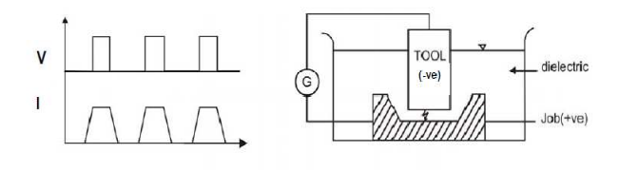

Figure 2.2: Working Principle of EDM process [1]

## **2.5 Types of EDM**

There is two different types of EDM , which is :

### **2.5.1) Die-sinking**

### **2.5.2) Wire Cut**

* + 1. Die-Sinking EDM

B.R. Butinzky and N. I. Lazarenko is a well known Russian scientist. They found out that erosion can be controlled when both of the electrodes immerse in a dielectric fluid. ////The development of thermoelectric technology has growing since decades ago, using various heat sources such as geothermal energy, power plants, automobiles and other industrial heat generating process. However with the growth of technology, we are now able to extract and convert heat energy into a useful energy [8, 9].

*Energy Harvesting From Waste Heat*

The development of thermoelectric technology has growing since decades ago, using various heat sources such as geothermal energy, power plants, automobiles and other industrial heat generating process. However with the growth of technology, we are now able to extract and convert heat energy into a useful energy [8, 9].

The heat that is releases by objects such as pot, kettle, heater and others can be harvested and converted into an energy that may serve useful purpose. Waste heats are considered as low-cost or even no-cost resources. Implementing Olsen cycle on pyroelectric material can directly convert the waste heat into electrical energy. The principle of the Olsen cycle is to charge a capacitor via cooling under low electric field and to discharge it under heating at higher electric field [10].

This waste heat energy can be converted into electrical energy by using thermoelectric generator. The output from the thermoelectric sensor will varies according to the temperature difference experienced by the sensor. The large the temperature difference, the more electrical energy is produced and vice versa. Thus, it is important to know the temperature of the surface that will be measured by the sensor in order to get better output [10, 11].

*Energy Harvested By Human*

Human body can be considered as a storehouse of energy. There exist two possibilities to scavenge energy from human power which is by active or passive [13]. Active energy means that the powering electronic devices happen when the user has to undertake additional actions to generate power. On contrarily, passive energy means that the person is not forced to do extra actions in order to generate power. Therefore he or she can stay on his or her daily activities [11].

Starnes presents human power as possible source for wearable computers. An analysis of power generation was done from breathing, body heat, blood transport, arm motion, typing and also walking [12, 13].

**Table 2.2:** Human energy expenditures for selected activities [13]

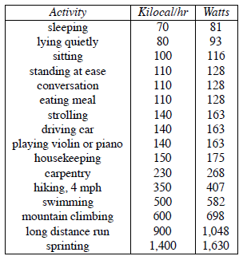

Table 2.2 shows the power dissipated by the human body for selected activities. The option to parasitically harvest energy from the everyday human activity implies that an unobtrusive technique has to be adopted [12, 14]. This energy can be scavenged and converted into electrical energy by using sensors. One of the sensors that can be used to convert energy from mechanical pressure is piezoelectric sensor where it can be inserted in shoes. Every step that is taken by a person would generate small electrical energy. However, the energy produced is very low thus improvements on the output are essential [3].

**2.4 Source of Energy Harvesting**

There are various sources for energy harvesting such as wind turbines, photovoltaic cells, thermoelectric generators and mechanical vibrations devices. Some of the applications under mechanical vibrations devices are piezoelectric devices and electromagnetic devices [15]. Since this project is focusing on energy harvesting from heat and pressure, therefore the source of energy harvesting will be focusing on thermoelectric generator and also piezoelectric sensor.

An inertial mass can be used to create movement when a device is exposed to vibration. Such movement can be converted to electrical energy by using three mechanisms such as piezoelectric, electrostatic and electromagnetic. The form of energy utilized here is the mechanical (pressure) energy [5].

*Piezoelectric Sensor*

Piezoelectric sensor has the ability to convert mechanical energy from pressure, vibrations or force into electricity. Piezoelectric material creates electrical charge when it is mechanically stressed. Table 3 shoes the properties of common industrial piezoelectric materials which are polyvinylidene fluoride (PVDF) and lead zirconate titanate (PZT) [16, 17]. The efficiency of the material converting mechanical energy into electrical energy is shown in Table 2.3 which is the coupling constant.

**Table 2.3:** Piezoelectric characteristic of PVDF and PZT [16, 20]

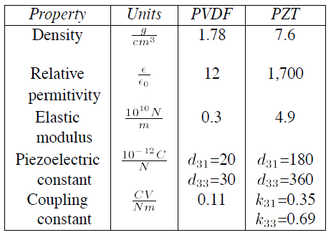

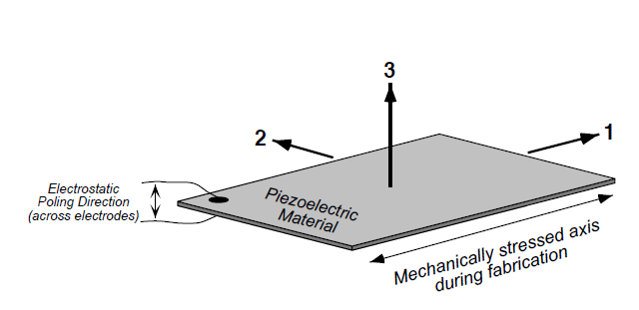

**Figure 2.1:** Definition of axis for piezoelectric materials

All of the axis surfaces shown in Figure 2.1 are typically metallized with crystalline materials to facilitate electrical connection. When strain is caused to axis 1 by electrical charge applied to axis 3, axis 1 will produce an electrical charge along axis 3, thus pulling the piezo material along the axis to develop a voltage across 3-axis [14]. The voltage produced while there is a change in the polarization caused by the reconfiguration of the ions within the crystalline structure or by a re-orientation of molecular groups. Thus the higher the mechanical stress, the bigger the change in polarization and the more electricity will be produced [18].

There are two main type of piezoelectric sensor which is the piezo ceramics and piezo film. In this project, the piezoelectric sensor that will be used is piezo film. It is chosen because it has low density and better sensitivity than the ceramic element. Besides that, since pressure energy can be obtained by walking, inserting film type of sensor into the shoe is suitable to make user walk comfortably [3].

*Thermoelectric Sensor*

Thermoelectric generators (TEG) are devices that use Seebeck effect which is converting heat directly into electrical energy [11]. Seebeck effect involves the generation of an electromagnetic force (emf) when two junctions of two dissimilar metal bars connected to each other are retained at different temperatures. The structure of having two different metals is often called as thermoelectric generator (TEG) [19]. Thermoelectric generator (TEG) will generate DC electricity continuously as long as there is temperature difference experienced by the sensor. The bigger the temperature difference, the more electrical energy is produced thus causing an increasing of efficiency in energy conversion [12].

Other than Seeback effect, Peltier effect is also used to be utilized in thermoelectric devices. Although industry has abundant options for utilizing waste heat energy, but some of the large applications are still not practically seize the waste energy using traditional energy conversion. With the existence of thermoelectric generator (TEG), it offers ability means to add value to the industrial process to produce electricity from the waste heat energy produced.

Thermoelectric generator (TEG) consists of a thermocouple that has the N-type (material with excess electrons) and P-type (material with excess holes) element connected electrically in series and thermally in parallel. TEG devices has the ability to generate micro-volts per degree temperature difference and able to supply enough power to small devices. With the development of studies on thermoelectric generator, the current TEGs are now convenient and reliable to be used. Besides that, TEG module that are now easy to get from the market has many advantages such as no moving parts, quiet, and also being environmentally friendly [8, 20].

Figure 2.2 shows an array of N-type and P-type semiconductor legs that create a typical thermoelectric effect (TE) module. The legs are pellets of either antimony telluride or bismuth telluride. Aluminum oxide ceramic is used as the top and bottom of the module as to provide electrical insulation and good thermal conductivity [21].

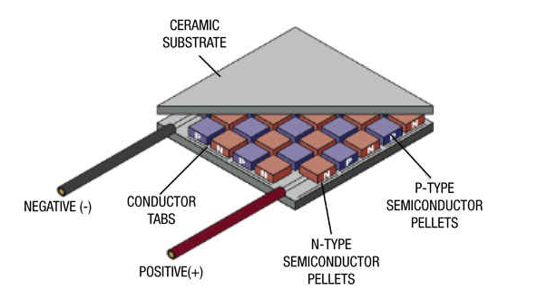

**Figure 2.2:** Thermoelectric generator module construction.

A thermoelectric generator (TEG) energy system takes advantage of any temperature difference between both of its surfaces (the cold and hot surfaces). It does not matter whether a thermoelectric generator is used to harvest heat from temperature gradient of a few degrees or hundred; the same set of principle is applied. The charge (electrons) moved in the TEG by the flow of the heat. Therefore, without temperature difference, there will be no flow of heat thus causing no electrical output from the generator. A thermal energy harvesting is both powerful and intriguing. Wasted energy is easily scavenged by thermoelectric generator and thermoelectric have the ability to cover a big range of power from small devices up to large applications as alternative energy sources or backup power [21].

**Table 2.4:** Findings from journals related to project

|  |  |
| --- | --- |
| **“Energy Harvesting from Human Body Using Thermoelectric Generator”**  P. Mahalakshmi, S. Kalaiselvi  May 2014 [11] | * Thermoelectric generators consist of a thermocouple module that employs the temperature gradient between hot and cold to generate electricity. * Output is low, thus DC-DC converter is essential. |
| **“A Review of Piezoelectric Energy Harvesting Based on Vibration”**  Heung Soo Kim, Joo-Hyong Kim, Jaehwan Kim  October 2011 [3] | * Real applications of the vibration-based energy harvesters are still limited. * Development of piezoelectric materials is essential to improve the performance of energy harvester. * Energy harvester should be able to sustain under harsh vibration and shocks. * Since output is small, rectification and storing circuit is needed. |
| **“Energy Harvesting from Passive Human Power”**  M. Loreto Mateu Saez  January 2004 [12] | * Investigate energy sources to power wearable devices from passive human activity (motion & heat). * The output voltage and current of the generator is transient and discontinuous. |

Table 2.4 below shows previous studies on thermoelectric and piezoelectric sensors that have been conducted. In conclusion, a significant similarity among the journals are the output from the sensors are very small thus in order to get sufficient power to charge devices such as phones, an amplifier is essential to be included in the circuit.

**CHAPTER 3**

**RESEARCH METHODOLOGY**

1. **Introduction**

In this chapter, a setup of hardware design will be explained as to achieve the objectives of this project. There are few things that need to be considered such as the type of sensors use, the performance with modification or external circuit to boost the output, and how comfort this project would be. The steps and important readings will be used to study the performance of the project. Furthermore, the implementation of hardware of the energy harvesting system will be described throughout this chapter.

1. **Project Workflow**

The Figure 3.1 shows the project workflow of this Energy Harvesting Charger project. This project is started with an idea of what is going to be studied about and a title is set as “Energy Harvesting Charger”. In order to have better understanding, sources from journal, thesis, books, articles and others were needed. The objectives were determined at early stage as to guide in conducting this project. The studies are carried out including theories and related applications. Circuit is then designed with sensors; piezoelectric and thermoelectric, amplifier circuit and other components to get desired output. The project implementation will be conducted during FYP2 and the results of performance on the hardware/project will be obtained and verified with past results. Lastly, by the end of FYP2, other than getting desired output, this product is aimed to be friendly-user.

The flow shown in Figure 1below is the overall steps of this project

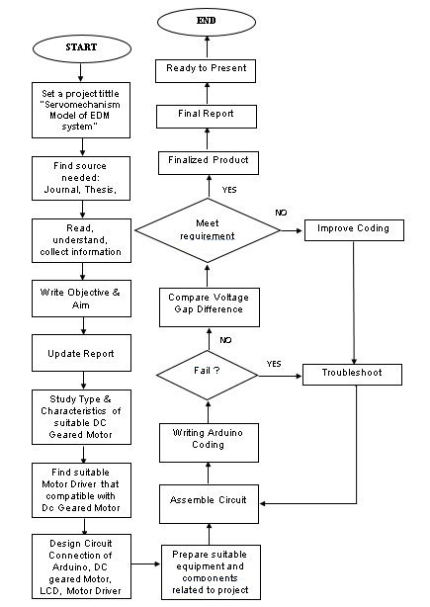

**Figure 3.1:** **The overall workflow of project**

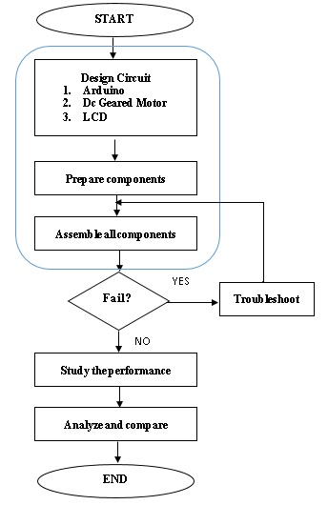**Figure 3.2:** **Hardware Workflow**

Figure 3.2 represent the hardware workflow of the project. The components in blue box related to each other in and become a complete close loop system. The flow of EDM model is as shown in figure 3.3

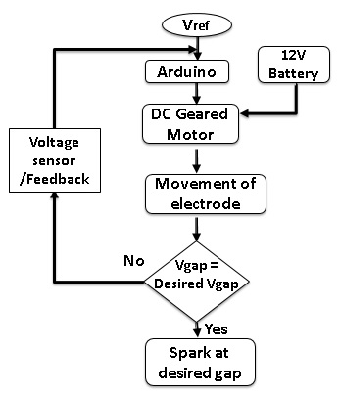

**Figure 3.3: Flow of EDM model**

1. **Energy Harvesting System**

Harvesting energy from human body by using piezoelectric sensor would need a sensor that have higher sensitivity to convert pressure or kinetic energy that is applied on the sensor into electrical energy. A faster speed of continuous pressure on the piezo sensor would produce better electrical output. Therefore, in this experiment, a constant pressure would need to be highlighted as to get desired output.

Scavenging energy by using the thermoelectric sensor would need hot/warm surfaces for it to convert into electrical energy as well. As mentioned earlier, waste heat can be obtained from various sources such as the heat from human body, car engine, kettle, or any metal surfaces that has the potential to absorb heat from the surroundings.

The idea of this project is combining two different sources; pressure and heat, into a common reason which is to convert the waste energy to electrical energy and use the converted energy to charge any small devices. Hardware development is the most crucial part that needs to be considered to carry the harvested energy until it can charge a device.

1. **Hardware Implementation**

There are four major part in this hardware development of energy harvesting system which are the type of sensors used, the connector where it function as to able the switching of sensors, and amplifier circuit. The amplifier circuit are used to amplify the electrical output since the converted energy harvested is insufficient. The type of amplifier circuit involved is buck converter or Joule Thief. Adding an amplifier to boost the voltage output will cause the current to be low. Therefore, transistor is suggested to be added at the last part in the circuit as to amplify the current output so that the charging time would be faster.

1. **Hardware Components**

**3.5.1 Piezoelectric Sensor**

Piezo film (piezo polyvinylidene fluoride, PVDF) can generate electrical energy when it is subjected to mechanical strain. However, the efficiency of conversion between mechanical input energy and electrical output is not high. Piezo film’s material is highly flexible where it can stretch without causing irreversible changes to its properties. Piezo film has the ability to be used for a wide range of frequency. The basic principle is electrostatic and its output power is depending upon the rate of pressure that is applied repeated to it [22].

In energy harvesting applications, the charge developed by the piezo element is more significant than the open circuit voltage. In theoretically, open circuit energy calculation will be used as the “output energy” for the efficiency conversion. Any practical harvesting application will remove energy from the piezo element and transfer it to another circuit or storage element. Bear in mind that this transfer cannot be 100% efficient, therefore the actual harvested energy will be less than what is calculated in theoretically [22].

*LDT4-028K*

The LDT4-028K is one of the piezo sensor that is laminated to a 28µm or 52µm piezo film element. When used in a bending mode, laminated film elements develop much higher voltage output than the non-laminated element. The capacitance is proportional to the area and inversely proportional to the thickness of the element. The weakness of this piezo film is it cannot withstand high temperature (>80ºC) thus soldering of the pins must be done quickly [23].

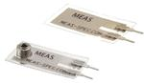

**Figure 3.4:** LDT4-028K Piezo Film Sensor

**3.5.2 Thermoelectric Sensor**

Thermoelectric generators follow the thermoelectricity to produce the required electrical energy. The phenomena of creating electric potential with a temperature difference and vice-versa can be termed as thermoelectricity. The thermal energy is scavenged from any waste heat to convert it into electrical form [23].

In this project, the type of thermoelectric generator used is TEG2-07025HT-SS which is a unique hybrid module. This module will generate DC current as long as differential temperature is applied to its surface. This module has the ability to withstand temperature up to 190ºC hot side. The P and N elements in this module offer the greatest heat transfer capability in a 40x40 mm configuration, resulting highest potential power densities [24].



**Figure 3.5:** TEG2-07025HT-SS Thermoelectric sensor

The specification of this module is as below,

**Table 3.1:** Power Ratings at Various DT’s [11]

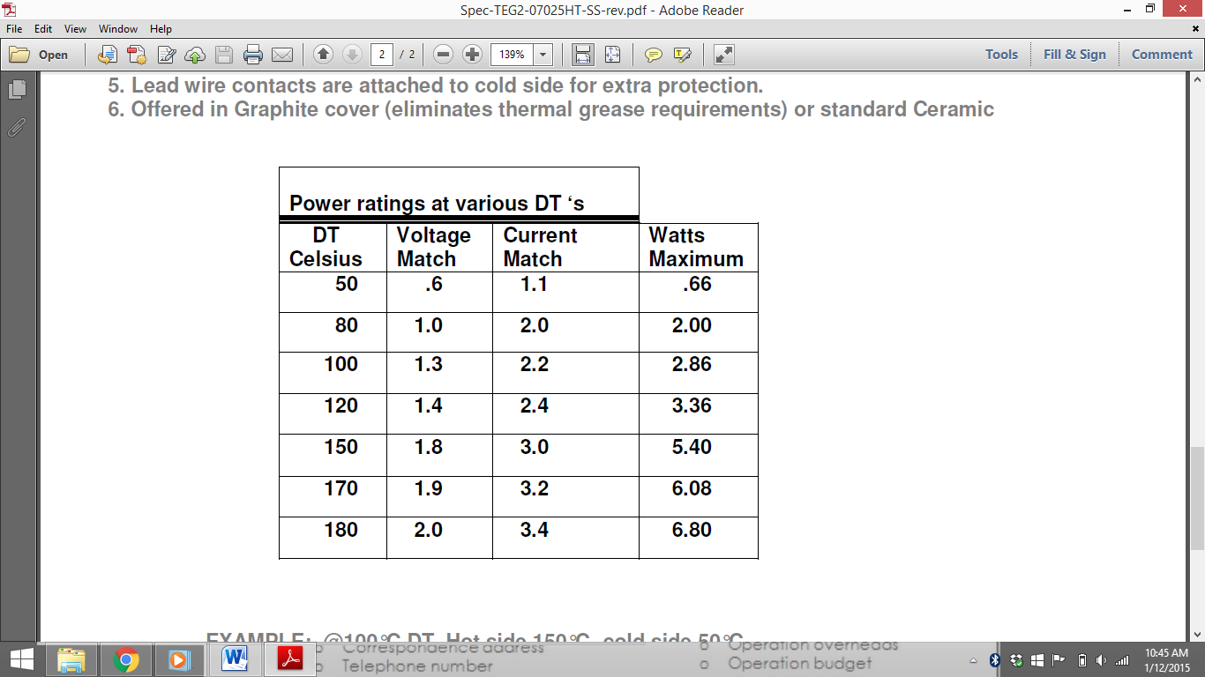

**3.5.3 Connector**

By referring to Figure 3.3, a connector is designed as to enabling the switching of sensors that will be used at a time. The switching of sensor should be simple and friendly to be used by end-user.

**3.5.4 Amplifier**

As mentioned before, the electrical outputs from both sensors are depending on the energy harvested. The piezoelectric sensor will produce more electrical output if repeated pressure is applied to it at faster rate whereas the thermoelectric sensor will convert more electrical energy if the higher differential temperature is applied to it. However, in this case the scope is small. The energy harvested is focused on human or an object which releases waste pressure and heat energy only. From the previous related research, the energy produced from energy scavenging is low. Therefore, an amplifier is essential to boost the voltage or current output for it to be compatible with the required voltage needed by the storing charge device. There are three types of amplifier circuit that will be tested as to obtain the most optimum output which are the buck-boost converter, Joule Thief circuit, and also Villard voltage doubler.

1. *BQ25570 Nano Power Boost Charger and Buck Converter*

A buck-boost converter can be used to step up or to step down the voltage output. Buck-boost converter is suggested because the voltage output from piezo sensor would be small thus it need to be boost to get better voltage output whereas the voltage output from thermoelectric sensor can be lower and higher depending on the differential temperature. Thus, buck boost is suitable to be used in this project.

The type of buck-boost converter that will be used is the bq25570 Nano Power Boost Charger and Buck Converter for energy Harvester Powered Applications. This device is specifically designed to efficiently extract microwatts (µW) to milliwatts (mW) of power generated from a variety of high output impedance DC sources. All of the capabilities of bq25570 are packed into a small foot-print 20-lead 3.5mm x 3.5mm package [25].

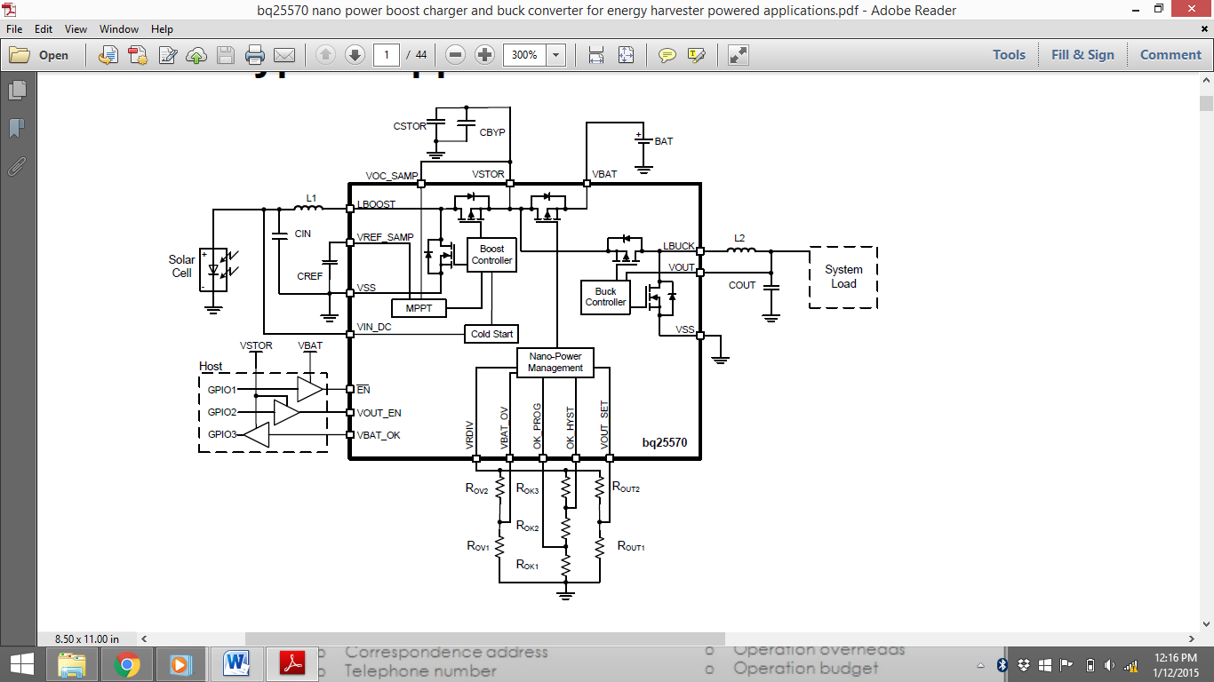

**Figure 3.6:** Typical Application Schematic

1. *Joule Thief*

A “Joule Thief” is a simple voltage booster circuit. It can increase the voltage of a power source by changing the constant low voltage signal into a series of rapid pulses at a higher voltage. The function of capacitor in the circuit is to stabilize the output voltage. A Zener diode is included as to protect the transistor from being damaged by voltage spikes. The diode is used to ensure that there will only be a one way of voltage flow to prevent the device charged from draining back through the transistor. The transformer in the circuit is made by winding wire around a ferrite toroid. The source of electricity can be any type of source. Thus, energy scavenging from piezo film and thermoelectric sensor is applicable to be used but the input voltage will affect how high the output voltage can get. Although this circuit can help to boost the voltage, keep in mind that in when the voltage is boosted, the current will drop significantly. This will then lead to a slower charging time [26].

In short, Joule Thief circuit helps to boost the voltage but lowering the output current thus effecting the charging time of the device. Therefore, one of the solutions that may help to solve this problem is by adding a transistor to the output of Joule Thief circuit because transistor can act as a current amplifier. 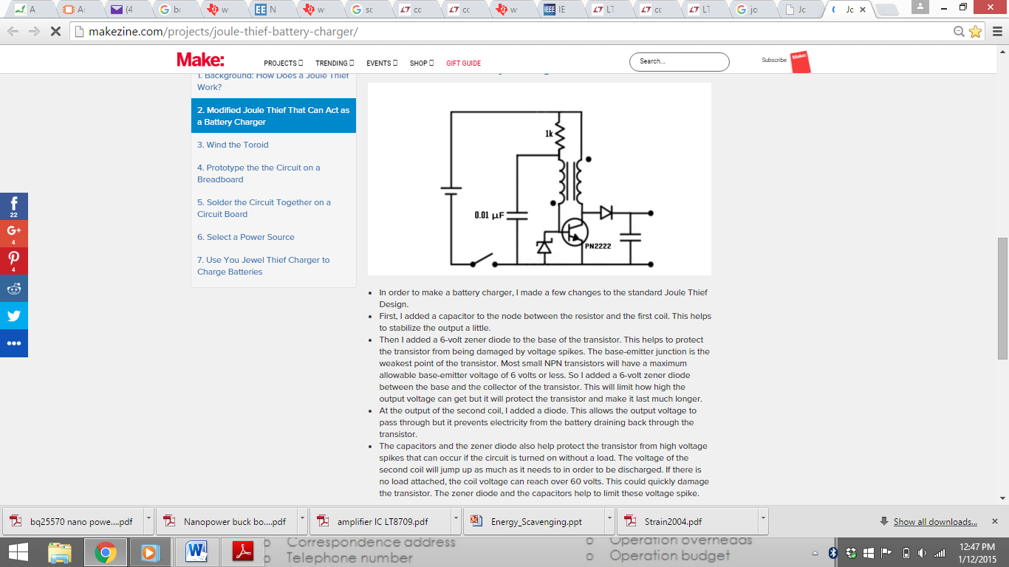 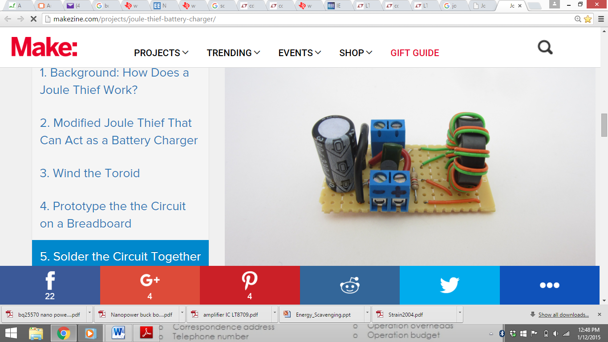

**Figure 3.7:** Modified “Joule Thief” Circuit

1. *Villard voltage doubler*

Figure 3.8 shows a Villard voltage doubler which is a basic multiplier circuit. It is for positive polarity towards ground and negative polarity when diodes are reversed. Diodes and capacitors must be dimensioned for 2x Up. Villard doubler circuit produces 2x Up towards ground at a single output. Besides this advantage, Villard circuit can be connected into cascaded to form multiplier with arbitrary output voltage.

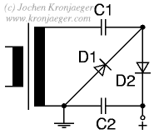

**Figure 3.8** Villard voltage doubler circuit

**3.6 Possibilities of Actions to Test the Circuit**

**3.6.1 Heat Sensor –Thermoelectric Sensor**

The energy harvest circuit by using thermoelectric sensor that convert heat into electrical can be tested in two type of hot metal surface. The first object that will be tested in when the kettle is turned off after water is boiled and the second object that will be tested is the heat absorb from an iron after it is switched off. These two objects are highlighted to be tested because these two objects are very common that are used daily by us. The thermoelectric sensor will be tap to on the surface of this object where it can absorb heat that is released by these electrical appliances. Safety precaution will be taken when conducting this experiment because a very high temperature may cause unintentional incident such as damaging the surface of the device and also may harm the end-user. Therefore, the heat from these two objects will be tested carefully and study the performance on how fast it can charge a device.

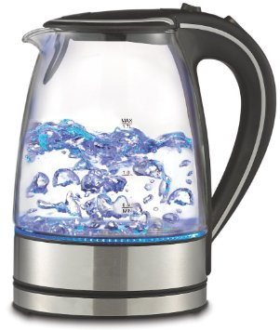  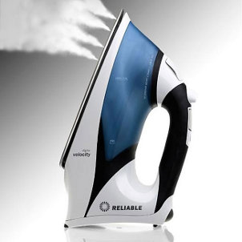

**Figure 3.9:** Electrical appliances that produce heat

**3.6.2 Pressure Sensor –Piezoelectric Sensor**

The energy harvest circuit by using piezoelectric sensor that convert pressure sensor into electrical can be tested by the pressure energy wasted by human. The pressure energy will be focused on the pressure applied on a person’s foot by walking, running or dancing. In order to get better electrical output, the key of using piezoelectric sensor is a constant and fast speed of applied pressure is compulsory. Therefore, these two parameters will be taken when testing is conducted. The picture in Figure 10 shows the pressure or force that is applied by a person when walking. This piezoelectric sensor will be inserted in a person’s shoe as to measure the pressure and convert it into usable energy.

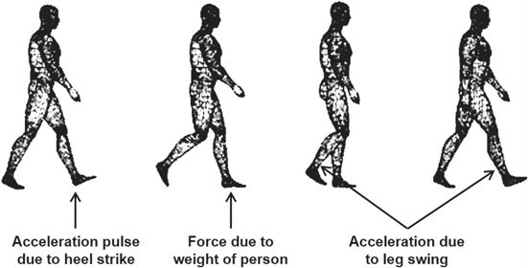

**Figure 3.10:** Illustration on force that is applied by walking

**3.6.3 Parameters**

The important parameters for testing the circuit by using piezoelectric sensor would be the speed of walking or running done by a person, the total energy converted at specific time, and the time taken for it to fully charge a device. On the other hand, the important parameters when using thermoelectric sensor on both electrical appliances would be the transition of heat from hot to cold, the total energy converted at a time, and the time it takes to fully charge a device. The performance by these two sensors would be analysing in detail. A statement of at what condition it would take for a device to be fully charge by both sensors will be discussed after all of the information on parameters needed is obtained.

**CHAPTER 4**

**PRELIMINARY RESULTS AND EXPECTED OUTCOMES**

1. **Introduction**

This chapter will explain the results obtained by previous experiments that have been conducted which are related to the topic of this project. These results are set to be the preliminary result for this project. Discussions on the preliminary results and expected outcomes will also be explained at the end of this chapter.

**4.2 Preliminary Result**

**4.2.1 Heat Sensor – Thermoelectric Sensor**

The previous study has shown that heat energy can be harvested from human body by using TEG sensor. Although the type of TEG sensors that were used by previous study is different, however the result that will be obtained by using the selected thermoelectric sensor for this project should be approximately the same. However, the result would be differing if the type of DC-to-DC controller for this project works better than the previous study. Table 4.1 shows the testing data obtained by using TEP1-1264-1.5 TEG sensor. The data is obtained at Th=200Cº and Tc=70Cº. The heat flux under both temperature Th and Tc is 110Watts [11].

**Table 4.1** Test values of TEG

|  |  |  |  |
| --- | --- | --- | --- |
| Load Resistance (ohm) | Output Voltage (V) | Output Current (A) | Output Power (Watts) |
| Open circuit | 6.28 |  |  |
| 0.9 | 1.44 | 1.6 | 2.30 |
| 1.4 | 2.04 | 1.46 | 3.00 |
| 1.8 | 2.53 | 1.4 | 3.50 |
| 2.3 | 2.88 | 1.25 | 3.60 |
| 2.6 | 3.08 | 1.18 | 3.65 |
| 2.8 | 3.21 | 1.15 | 3.70 |
| 3.0 | 3.28 | 1.09 | 3.60 |
| 3.2 | 3.40 | 1.06 | 3.60 |
| 3.6 | 3.55 | 0.99 | 3.50 |
| 3.8 | 3.61 | 0.95 | 3.43 |
| 4.4 | 3.85 | 0.88 | 3.40 |
| 5.0 | 4.01 | 0.80 | 3.20 |
| 5.6 | 4.19 | 0.75 | 3.14 |
| 6.4 | 4.43 | 0.69 | 3.06 |
| 8.4 | 4.70 | 0.56 | 2.5 |
| 10 | 4.94 | 0.49 | 2.42 |

**4.2.2 Pressure Sensor – Piezoelectric Sensor**

The results obtained by previous studies on the performance of piezoelectric for a single sensor are as shown in Table 4.2 below.

**Table 4.2** The output voltage and current when using single piezoelectric

|  |  |  |  |
| --- | --- | --- | --- |
| Value of Capacitor (µF) | Value of Load (Kµ) | Output Voltage (V) | Output Current (µA) |
| 1 |  | 2.15 | 3.162 |
| 2.2 |  | 2.19 | 3.221 |
| 3.3 | 680 | 2.04 | 3.00 |
| 4.7 |  | 2.04 | 3.00 |
| 10 |  | 1.60 | 2.353 |

Although these output is referring to different type of piezoelectric sensor, but the output that will be obtained by the designed circuit for this project would be approximately the same as in Table 2. However, the output when using piezoelectric sensor would be much differ if the circuit configuration and other are not the same.

* 1. **Expected Outcomes**

A thorough understanding should be obtained by the end of this project. This project is expected to be able to charge small powered devices by harvesting energy from human body and also selected objects as mentioned earlier. Besides that, from the studies that has been made, we can conclude that the energy converted by the thermoelectric sensor would be higher than the piezoelectric sensor due to its characteristic of absorbing the harvested energy and the conversion of energy to another. However, the main expected outcome is to obtained the objectives of this project that is to be able to study the performance of the product designed.

**4.4 Discussion**

Based on the studies and research done in the literature review, the designed circuit should perform the desired output. The sensors that were chosen are to study and test as to obtain the parameters needed. The only comparison that could be made from the two sensors is its performance (output power) in converting the harvested energy to an electrical energy. The period of charging a device is not relevant to be compared by the two sensors due to its unique manufactured material characteristic.

**CHAPTER 5**

**CONCLUSION AND RECOMMENDATION**

With the research and understanding that I have gained, the recommended methodology should be able to get the desired output as to achieve the objectives of this project. The project is consisting of two sensors which are piezoelectric film sensor and thermoelectric generator to convert pressure and waste heat energy into electrical energy respectively. The performances of these two sensors are depending on the energy exerted or experienced by them.

Piezoelectric sensor would need a fast and constant pressure applied on it, whereas thermoelectric generators require larger differential temperature as to produce better output. However, the outputs are still loq. Thus having an amplifier to amplify the output power is essential as to have sufficient power to charge small devices such as mobile phones or power banks.

**REFERENCES**

[1] Kulbir Singh, “Effect of various parameters in metal cutting,” *Journal of Mechanical Engineering,* 2015, v 1, paper 4.

[2] ("FAQ : What are the problems with laser cutting of aluminium and how do i overcome them?")

[3] Stephenson, David A.; Agapiou, John S. (1997), Metal cutting theory and practice, Marcel Dekker, p. 164, ISBN 978-0-8247-9579-5.

[4] Jameson, E. C. (2001). Electrical Discharge Machining, SME, p. 1, ISBN 978-0-87263-521-0.

[5] W.M. Wang, K.P. Rajurkar, “Modelling and adaptive control of EDM systems,” *Journal of Manufacturing Systems,* 1992, v 11, pp 334-335.

[6] S. K. Dewangan, “*Experimental Investigation of Machining Parameters for EDM using U-shaped Electrode,”*2010, pp2-3.

[7] Jameson, E. C. (2001). Electrical Discharge Machining, SME, p. 8, ISBN 978-0-87263-521-0.

[8]

[8] Hsu, C.-T., et al., *Experiments and simulations on low-temperature waste heat harvesting system by thermoelectric power generators.* Applied Energy, 2011. **88**(4): p. 1291-1297.

[9] Elsheikh, M.H., et al., *A review on thermoelectric renewable energy: Principle parameters that affect their performance.* Renewable and Sustainable Energy Reviews, 2014. **30**: p. 337-355.

[10] Lee F.Y., A. Navid, and L. Pilon, “Pyroelectric waste heat energy harvesting using heat conduction,” *Applied thermal engineering,* 2012, 37: p. 30-37.

[11] Mahalakshmi P, Kalaiselvi S, “Energy harvesting from human body using thermoelectric generator,” *International Journal of Advanced Research in Electrical, Electronics and Instrumentation Engineering,* 2014, v 3, pp 9487-9492.

[12] Saez, M. L. M. (2004). Energy harvesting from passive human power.*Journal of wearable computers*, *1*, 40.

[13] T. Starner, "Human-powered wearable computing", IBM Systems Journal, Vol. 35, No. 384, 1996, pp. 618-629.

[14] T. Starner, and J. Paradiso, "Human generated power for mobile electronics", C.(ed), Low-Power Electronics, CRC Press, Chapter 45.

[15] Park G, Farrar C R, Todd M D, Hodgkiss W and Rosing T, “Energy Harvesting for Structural Health Monitoring Sensor Networks,” *Technical Report,* Los Alamos National Laboratories, LA, February 2007.

[16] J. Fraden. *Handbook of Modern Sensors, Third Edition.* Springer Verlag, Berlin, 2004.

[17] Anonymous. Piezo film sensors technical manual. Technical Report 65751, Measurement Specialties (MSI), Inc. (formerly AMP Inc.), Valley Forge, PA, 1995.

[18] Andre Preumont. *Vibration Control of Active Structure, An Introduction*. Berlin Heidelberg New York: University Libre de Bruxelles Active Structure laboratory.

[19] Don Scansen. Thermoelectric Energy Harvesting. www.digikey.com (Accessed on 9/12/2015)

[20] Lee, H., *Optimal design of thermoelectric devices with dimensional analysis.* Applied Energy, 2013. **106**: p. 79-88.

[21] Don Scansen. Thermoelectric Energy Harvesting. www.digikey.com (Accessed on 9/12/2015)

[22] Brown R H, “Energy Generation Using Piezo Film,” *Measurement Specialties (MEAS),* 2012-01-31

[23] Piezo Film Product Guide, *Measurement specialties (MEAS),* August 2008

[24] Specification TEG Module TEG2-07025HT-SS, TEC Datasheet

[25] BQ25570 Nano Power Booster Charger Datasheet. Texas Instruments. March 2015

[26] Joule Thief Circuits. www.instructables.com (Accessed on 27/11/2008)