# Prepared by: Yahya Ayyach EL NAZER

# Supervisor: Dr.Farah ANKOUD

**Presented on 13/2/2022**



Contents

Prepared by: Yahya Ayyach EL NAZER 1

Supervisor: Dr.Farah ANKOUD 1

Motorcycle 2

1. History of motorcycle 2

2. Experimentation and invention 2

3. First commercial products 4

4. Japanese dominance for motorcycle 8

5. Fastest production motorcycles 9

6. Selling motorcycles in the world 11

7. THE WORLD’S BEST SELLING MOTORCYCLE COMPANY IS….. 13

8. The Statistics and Potential Causes of Motorcycle Accidents 15

8.1 The most common causes of motorcycle accidents include: 16

8.1.1 Speeding 16

16

8.2 Riding while under the influence of alcohol 17

8.3 Reckless driving 18

8.2 Motorcycle accident statistics 19

8.4 Motorcycle accident fatalities in previous years 21

**Liste of table**

Table 1 Fastest production motorcycle 11

Table 2 The best company for motor 17

Table 3 NB of accident 25

**Figure 1 harly motorcycle** 1

Fiigure 2 2

Figure 3 Amazing motor 3

Figure 4 Joseph edison 4

Figure 5 motorcycle components 7

Figure 6 Japanese motorcycle 8

Figure 7 Motorcycle sales in the world 11

Figure 8 Motorcycle sales in years 12

Figure 9 Yamaha company logo 13

Figure 10 accident 16

Figure 11 Speed 17

Figure 12 18

Figure 13 19

Figure 14 Amazing accident 20

Figure 15 graphe for accident 21

# Motorcycle

## History of motorcycle

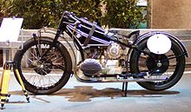At around the same time the history of the motorcycle begins in the second half of the 19th century. Motorcycles are descended from the "safety bicycle," a bicycle with front and rear wheels of the same size and a pedal scrank mechanism to drive the rear wheel. [1] Despite some early landmarks in its development, the motorcycle lacks a rigid pedigree that can be traced back to a single idea or machine. Instead, the idea seems to have occurred to numerous engineers and inventors around Europe.

**Figure 1 harly motorcycle**

## 

## Experimentation and invention

The very first commercial design for a self-propelled bicycle was a three-wheel design called the Butler Petrol Cycle, conceived of and built by Edward Butler in England in 1884. He exhibited his plans for the vehicle at the Stanley Cycle Show in London in 1884, two years earlier than Karl Benz invented his first automobile who is generally recognized as the inventor of the modern automobile. Butler's vehicle was also the first 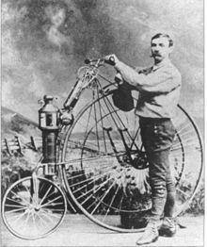design to be shown at the 1885 International Inventions Exhibition

Figure 2 edward javel

Fiigure 2

The vehicle was built by the Merryweather Fire Engine company in Greenwich, in 1888.[6] the Butler Petrol Cycle (first recorded use of the term)[6] It was a three-wheeled vehicle, with the rear wheel directly driven by a 5/8hp (466W) 600 cc (40 in3; 2¼×5-inch {57×127-mm})[6] flat twin four stroke engine (with magneto ignition replaced by coil and battery),[6] equipped with rotary valves and a float-fed carburettor (five years before Maybach),[6] and Ackermann steering,[7] all of which were state of the art at the time. Starting was by compressed air. [6] The engine was liquid-cooled, with a radiator over the rear driving wheel. Speed was controlled by means of a throttle valve lever. No braking system was fitted; the vehicle was stopped by raising and lowering the rear driving wheel using a foot-operated lever; the weight of the machine was then borne by two small castor wheels. The driver was seated between the front wheels.It wasn't, however, a commercial success, as Butler failed to find sufficient financial backing.

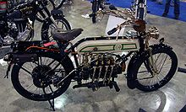Another early internal combustion, petroleum fueled motorcycle was the (wekipedia, 2018) (wekipedia, 2018)Petroleum Reitwagen. It was designed and built by the German inventors Gottlieb Daimler and Wilhelm Maybach in Bad Cannstatt, Germany in 1885. [8] This vehicle was unlike either the safety bicycles or the boneshaker

Figure 3 Amazing motor

Bicycle of the era in that it had zero degrees of steering axis angle and no fork offset, and thus did not use the principles of bicycle and motorcycle dynamics developed nearly 70 years earlier. Instead, it relied on two outrigger wheels to remain upright while turning.[9] The inventors called their invention the Reitwagen ("riding car"). It was designed as an expedient testbed for their new engine, rather than a true prototype vehicle.

## First commercial products

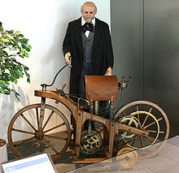In the decade from the late 1880s, dozens of designs and machines emerged, particularly in Germany and in England, and soon spread to America.[12] During this early period of motorcycle history there were many manufacturers, since bicycle makers were adapting their designs for the new internal combustion engine.

Figure 4 Joseph edison

In 1894 Hildebrand & Wolfmüller became the first series production motorcycle, and the first to be called a "motorcycle" (German: Motorrad). [10][11][13][14] However, only a few hundred examples of this motorcycle were ever built. The first instance of the term "motor cycle" also appears in English the same year in materials promoting machines developed by E.J. Pennington, although Pennington's motorcycles never progressed past the prototype stage. (wekipedia, 2018)

Excelsior Motor Company, originally a bicycle-manufacturing company based in Coventry in Warwickshire (England), began production of their first motorcycle model in 1896, available for purchase by the public. The first production motorcycle in the US was the Orient-Aster, built by Charles Metz in 1898 at his factory in Waltham, Massachusetts.

In 1898, Peugeot Motocycles presents at the Paris Motorshow the first motorcycle equipped with a Dion-Bouton motor. Peugeot Motocycles remains the oldest motorcycle manufacturer in the world.

In the early period of motorcycle history, many producers of bicycles adapted their designs to accommodate the new internal-combustion engine. As the engines became more powerful and designs outgrew the bicycle origins, the number of motorcycle producers increased. Many of the nineteenth-century inventors who worked on early motorcycles often moved on to other inventions. Daimler and Roper, for example, both went on to develop automobiles.

At the turn of the 20th century the first major mass-production firms emerged.

In 1901 Englishquadricycle- and bicycle-maker Royal Enfield introduced its first motorcycle, with a 239 cc engine mounted in the front and driving the rear wheel through a belt. In 1898 English bicycle-maker Triumph decided to extend its focus to include motorcycles, and by 1902 the company had produced its first motorcycle—a bicycle fitted with a Belgian-built engine. A year later it was the largest motorcycle-manufacturer, with an annual production of over 500 units. Other British firms included Norton and Birmingham Small Arms Company who began motorbike production in 1902 and 1910, respectively.

In 1901 the Indian Motocycle Manufacturing Company, which had been founded by two former bicycle-racers, designed the so-called "diamond framed" Indian Single, whose engine was built by the Aurora Firm in Illinois per Indian's specifications. The Single was made available in the deep blue. Indian's production was up to over 500 bikes by 1902, and would rise to 32,000, its best ever, in 1913.[18][19] Indian produced over 20,000 bikes per year.[20] The oldest surviving Russian-manufactured motorcycle, the Rossiya, dates from 1902.[21] The American company Harley-Davidson started producing motorcycles in 1903.

During this period, experimentation and innovation were driven by the popular new sport of motorcycle racing, with its powerful incentive to produce tough, fast, reliable machines. These enhancements quickly found their way to the public's machines.

Chief August Vollmer of the Berkeley, California Police Department is credited with organizing the first official police motorcycle-patrol in the United States in 1911.[22] By 1914, motorcycles were no longer just bicycles with engines; they had their own technologies, although many still maintained bicycle elements, like the seats and suspension

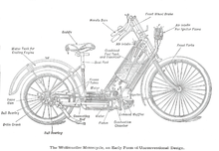

Figure 5 motorcycle components

## 

## Japanese dominance for motorcycle

The excellence of Japanese motorcycles caused similar effects in all Western markets: many Italian bike firms either went bust or only just managed to survive. As a result, BMW's worldwide sales sagged in the 1960s, but came back strongly with the introduction of a completely redesigned "slash-5" series for model year 1970.

From the 1960s through the 1990s, small two-stroke motorcycles were popular worldwide, partly as a result of the pioneering work of the East German Daniel Zimmermann (rotary disc valve) and MZ's Walter Kaaden who developed the two-stroke expansion chamber in the 1950s. These ideas were taken up by Suzuki when Ernst Degner, the MZ engineer and rider, defected to the West on 13 September 1961 after retiring from the 125cc Swedish Grand Prix at Kristianstad. Degner, an excellent engineer, immediately joined Suzuki and his knowledge 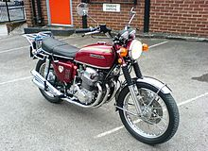became their technology springboard.

Figure 6 Japanese motorcycle

Harley-Davidson in the US at the time suffered from the same problems as the European firms, but its unique product range, American tariff laws and nationalism-driven customer loyalty allowed it to survive. One alleged flaw, however, was retaining the characteristic Harley-Davidson 45° engine vee-angle, which causes excess vibration as well as the loping Harley-Davidson sound.

A factory full fairing was introduced by BMW motorcycle in the R100RS of 1977, the first factory fairing produced in quantity.[38] In 1980, BMW stimulated the "adventure touring" category of motorcycling with its dual-sport model, the R80G/S. In 1988, BMW was the first motorcycle manufacturer to introduce anti-lock-brakes (ABS) on its sporting K100RS-SE and K1 models.

## Fastest production motorcycles

Several models went out of production before being surpassed by a contemporary with a higher top speed. Until a model was introduced that was faster than any previous motorcycle, the fastest bike on the market for a given year was actually slower than an earlier, out of production bike. Models which are actual top speed record holders have their make, model, and speed in bold font, while slower models which were only the fastest in their own time are in italic. For example, in 1956, the Vincent Black Shadow remained the fastest motorcycle to date, with a 125 mph (201 km/h) top speed, but it was no longer in production. The fastest model on the market in 1956 was the BSA Gold Star Clubman, which at 110 mph (180 km/h) was not a record holder, but is listed for the sake of illustrating a more complete timeline.

Table 1 Fastest production motorcycle

|  |  |  |  |  |  |
| --- | --- | --- | --- | --- | --- |
| Make and model | Model years | displacement | power | Top speed | Notes |
| BMW S 1000 RR (second generation | 2019-present | 999 cc (61.0 cu in) | 205 hp (153 kW) | 193 mph (310 km/h) | By some measures, faster than MV Agusta F4 R 312.[1] |
| BMW S 1000 RR (first generation) | 2009-2018 | 999 cc (61.0 cu in) | 199 bhp (148 kW) | 188 mph (303 km/h) | By some measures, faster than MV |
| MV Agusta F4 R 312 | 2007-08 | 998 cc (60.9 cu in) | 183 bhp (136 kW) | 185–193 mph (298–311 km/h) | First European motorcycle exceeding |
| Kawasaki ZX-14 | 2000-2006 | 1,352 cc (82.5 cu in) | 163.3 hp (121.8 kW)† | 186 mph (300 km/h) | Speed limited |
| Kawasaki ZX-12R | 2000–05 | 1,199 cc (73.2 cu in) | 178 bhp (133 kW) | 186 mph (300 km/h) | Speed limited |
| Suzuki Hayabusa (first generation) | 2000–2007 | 1,299 cc (79.3 cu in) | 173 bhp (129 kW | 186 mph (300 km/h) | Speed limited |
| Suzuki Hayabusa (first generation) | 1999 | 1,299 cc (79.3 cu in) | 173 bhp (129 kW) | 188–194 mph (303–312 km/h) | Last model before gentlemen's agreement |

## Selling motorcycles in the world

In the new environment created by the spread of this global virus, the motorcycles industry reported short terms negative impact, mainly registered in the first half of 2020 when lockdown hit production and distribution.

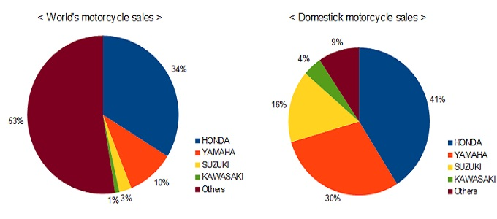

However, benefits have been more than damages with two new trends clearly in place world-wide:

Figure 7 Motorcycle sales in the world

Huge demand for individual mobility, perfectly matched by the two wheeler vehicles

Tangible increased consciousness for environmental among governments, institutions and people

As a result, starting from the second half 2020 the global motorcycles industry has taken a new pathway, with strong sales increase in several countries with shining perspective for the next years.

Global sales in the 2020 have been 56.5 million, down 14% from the previous year, the 5th highest level ever. In volumes, the industry lost over 9 million units, due to the fall of few top countries: India (-5 millions), Indonesia (-2.9 millions), Philippines (-0.7 million), Vietnam (-0.5 millions).

In these countries the motorcycles industry is crucial and the 2021/2022 will report a strong recovery while the rest of the World will keep the already positive trend, resulting in the achievement of a huge year on year increase in the 2021 with the following year projected to establish the new all time record.

The introduction of rules, incentives and subsidies for Electric Two Wheelers will support the market evolution in the rest of this decade. Actually the market is split in two, with China having electric two wheelers (of course, not considering the e-bicycles) already representing more than the half of the industry. In the rest of the World EVs segment is still marginal, with few exemptions, like Taiwan.

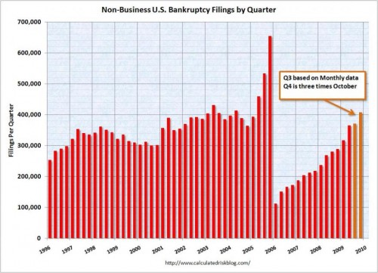Now, we can easily forecast not only that all markets will follow the Chinese pathway, but even that Chinese EVs manufacturers will shake the global competition, having already a huge advantage in terms of knowledge, technology, product portfolio. It is not a case that Yadea in the 2020 took the second place in the World, producing only electric vehicles.

Figure 8 Motorcycle sales in years

## 

## The best company for the manufacture of motorcycles

Motorcycle sales data can be hard to come by, but there is some that is publicly available. While many motorcycle companies are focused on their American sales, the ones that have branched out into international markets are beginning to reign supreme. Polaris, Ducati, Honda, BMW, and Harley Davidson are all popular and hugely successful motorcycle companies. But which one is the World’s Best Selling Motorcycle Company?

Figure 9 Yamaha company logo

Surprisingly, the world’s best-selling motorcycle company is a Honda. Honda’s motorcycle division sold nearly 15.5 million motorcycles worldwide in 2012. The majority of those bikes were sold overseas in Japan and Asia. A shocking 13.2 million motorcycles were sold in Asia alone. In America, Honda also does quite well with 153,000 bikes sold. This represented a 43% increase in sales from previous years.

According to Honda’s reported sales from the fiscal year ending on March 31, 2013, Honda’s motorcycle operations generated net sales of 1.34 trillion yen, which is $13.7 billion U.S. dollars. Models, such as the Gold Wing F6B, the CRF250L, and the CRF110 helped increase Honda’s North American sales. Projects for the fiscal year ending on March 31, 2014 have Honda reaching sales of 17.4 million units.

Honda’s supremacy in the Asian market awards this motorcycle giant the title of World’s Best Selling Motorcycle. But, other competitors aren’t too far behind. Take Harley-Davidson for example. Harley-Davidson’s focus on American markets has shifted and sales are growing in Latin America now. They will likely continue to grow their international brand over the next few years.

Ducati is also growing and now claims 10% market share in its target market of luxury bikes. BMW’s sales have remained steady the last several years, and Polaris is also growing nicely, thanks to their Victory and Indian bikes.

No matter what bike you choose to ride, it is important to ride safely. Before you hit the road, consider becoming a member of BAM, our free roadside and legal assistance program. With over 2 million members and counting, we are the nation’s largest networks of Bikers Helping Bikers®. If you are ever involved in an accident, you can rest assured that you are backed by an experienced motorcycle accident law firm with the knowledge and resources to fight for you. Call Russ Brown Motorcycle Attorneys® at 1-800-4-BIKERS or visit us on the web to learn more about BAM and our law firm. We Ride—We Care—We Win!

Table 2 The best company for motor

|  |  |  |  |  |  |
| --- | --- | --- | --- | --- | --- |
| **Name of company** | **YAMAHA** | **KAWAZAKI** | **HARLY** | **BMW** | **JOK** |
| **NB of production per day** | **2000** | **1905** | **2222** | **2233** | **1234** |
| **Sell daily** | **1000** | **766** | **998** | **555** | **345** |
| **Ranked globally** | **1** | **2** | **4** | **5** | **3** |

# 

# The Statistics and Potential Causes of Motorcycle Accidents

Over the years, several reports and studies have proven that motorcycles are a dangerous form of transportation. But despite the risks, riding a motorcycle remains a popular leisure activity and convenient mode of transport for many people.

While motorcycle riders are more likely to be involved in fatal road mishaps, several measures can ensure safety during the ride. And for these measures to be effective, you need to know what causes motorcycle accidents.

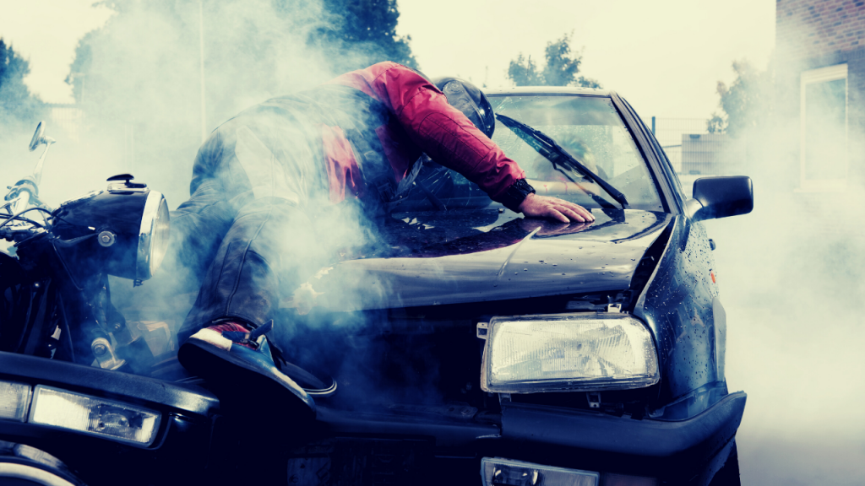

Figure 10 accident

## 

## 8.1 The most common causes of motorcycle accidents include:

• Speeding

• Riding while under the influence of alcohol

• Reckless driving

### Speeding

### 

Figure 11 Speed

Shorter travel time, high-speed performance, flexibility, and low cost are the most common reasons many people choose motorcycles as their primary mode of transport. However, the fatality rate among motorcycle riders remains significantly higher than that of vehicle drivers.

In the 2016 report of the National Highway Traffic Safety Administration (NHTSA), 33% of motorcycle riders involved in fatal accidents were speeding. This is significantly higher than the percentage of car drivers, 19%, light truck drivers at 15%, and significant truck drivers at 7%.

### Riding while under the influence of alcohol

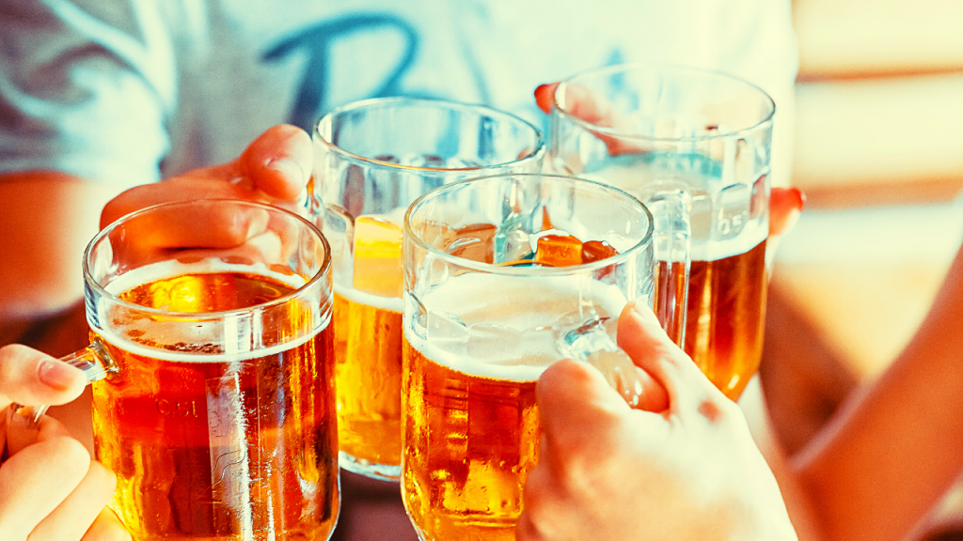

Figure 12

Because of the extreme physical and mental coordination needed to ride a motorcycle, you would think that riders will always have the common sense to not ride after drinking. This is not the case because riding while intoxicated remains a common cause of motorcycle accidents.

Not only does it make you criminally liable, but you are also putting yourself and other motorists in grave danger. In 2016, the NHTSA reported that motorcycle riders involved in fatal accidents had a higher percentage of alcohol-related impairment than any other type of vehicle driver.

The NHTSA also said that out of all the motorcycle riders who died in road-related accidents in the same year, 25% of them were found to have exceeded the blood alcohol content limit of 0.08%.

### Reckless driving

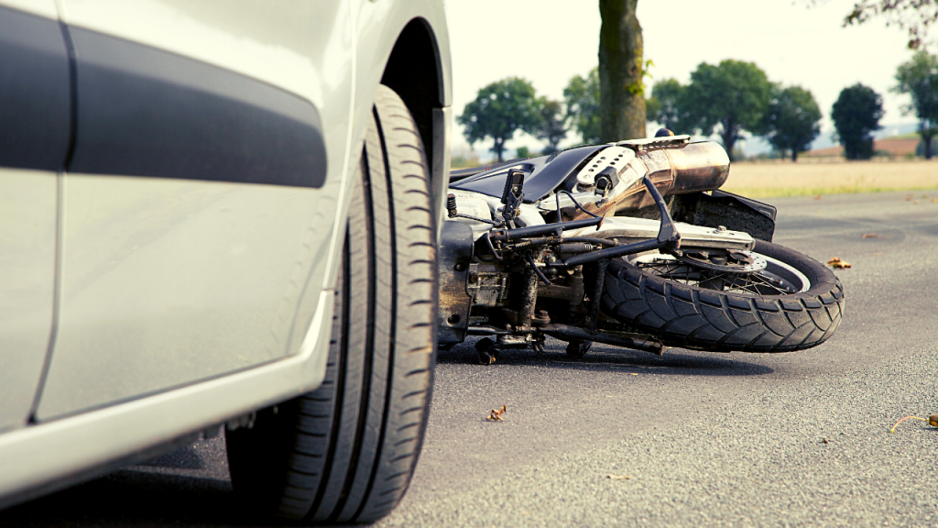

Figure 13

In 2016 and 2017, more than 35% of motorcycle accidents were caused by reckless driving. Such negligence can come in many different forms, such as texting while driving, not observing speed limits, failing to pay attention to the road ahead, and being inexperienced.

Inexperienced drivers can cause more damage than one would initially think. Another report from NHTSA stated that in 2016, 27% of motorcycle riders involved in fatal crashes did not have a valid license.

However, you have no way of knowing this when you are on the road, so the best course of action is always to assume that behind every wheel is an inexperienced driver.

## 8.2 Motorcycle accident statistics

## 

Figure 14 Amazing accident

• Motorcycles are involved in 11% of all road accidents in the United States.

• Frontal collisions account for 74% of motorcycle accidents in the United States.

• Car and motorcycle accidents combined are the leading cause of spinal cord injuries. Half of the new spinal cord injuries every year are a result of these road mishaps.

• About 80% of reported motorcycle accidents lead to death.

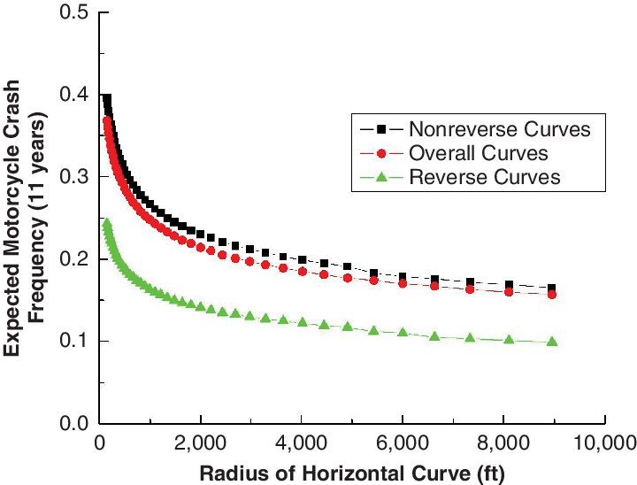• Injuries are sustained in 90% of motorcycle accidents that involved riders who are under the influence of drugs and alcohol. This is significantly higher than the 33% of car accidents that involved high and drunk drivers.

Figure 15 graphe for accident

## 8.3 Motorcycle accident fatalities in previous years

Fatalities are more common in motorcycle accidents than in any other road incident. But even if you do not get killed in a motorcycle accident, the chances of you sustaining fatal injuries that could lead to permanent disability are very high.

Table 3 NB of accident

|  |  |  |  |  |
| --- | --- | --- | --- | --- |
| **year** | **2017** | **2018** | **2019** | **2020** |
| **Nb of accident in the world** | **2000** | **22223** | **3323** | **3333** |
| **Death** | **100** | **111** | **343** | **321** |

• In 2018, motorcycle accidents killed 4,985 motorcycle riders in the United States.

• In 2017, motorcycle riders were 27 times more likely than car drivers and passengers to die in motorcycle-related accidents per mile traveled.

• Mississippi has the most fatal motorcycle accidents, followed by Texas and South Carolina.

• Severe traumatic brain injuries are the leading cause of death in motorcycle accidents.

States, but they account for 14% of all road-related fatalities.

• Riders over the age of 40 make up a considerable percentage of motorcycle accident deaths in the United States.

• In 2017, 91% of riders who died in motorcycle accidents were male.

• The death rate of riders using supersport motorcycles is four times higher than that of regular motorcycle riders

## Summary:

Motorcycles have a long history, and there are many companies that manufacture them, and the nb of motorcycles in the world. we also noted that they are dangerous because the death rate from accidents in bicycles is large.

Les motos on tune logue histoire et il existe de nombreuses entreprisises qui les fabriquent, et il existe des nombreuses etudes sur le nb de velos dans le monde. Nous avans egalement remarque qu’ils sont dangereux car le taux de moralite par accident de velo est eleve.

### References

(The Statistics and Potential Causes of Motorcycle Accidents, 2020) (wekipedia, 2018).

Sorry Dr for the delay we are in Lebanon