**FORMAN CHRISTIAN COLLEGE (A CHARTERED UNIVERSITY)**

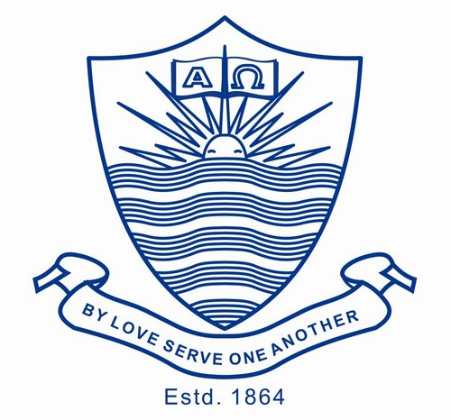

**Technology Management**

**SECTION A**

**Name: Hadi Hassan**

**Roll No: 231469272**

**Technology Management CSCS 450**

**Summer 2022**

**Assignment 1 Description**

**Problem Statement:** In the assignment 1, you are required to explain the field of Technology

Management and how the concepts of IT operations management, IT service management

and IT asset management are related and do write their differences as well. You also need to

determine the role of an IT Manager in the IT operations management and IT service

management. All the material relevant to these concepts is available under the week 2 of your

Moodle course page.

**Submission requirements and deadline**

• You should submit the assignment 1 in the assignment 1 folder within the git

repository “CSCS 450-RollNumber” for this course.

• The link of the git repository should be submitted on Moodle within a word file.

• This is an individual assignment. Therefore, you are not allowed to do work in the

groups.

• The deadline for the **assignment 1** is **Sunday 7th August, 2022**.

• The **total marks** for this assignment are **sixteen** (**16**).

**Grading Criteria**

• Explanation of the concepts “Technology Management”, “IT Operations

Management”, “IT Service Management” and “IT Asset Management**:** 8 marks.

• Relationship of all the defined / explained concepts**:** 4 marks.

• Explanation of the role of “IT Manager” in “IT Operations Management” and “IT

Service Management”**:** 4 marks.

**Technology Management:**

Technology management relates to the development, planning, implementation and the assessment of technological capabilities of an organization. Although it is vital to have good technological skills to be a technology manager, one cannot be a successful technology manager without the ability to budget, manage resources, manage a project effectively and even sometimes be able to sell products. One needs the characteristics of a leader who is results orientated, flexible, fair, strategic to name a few when leading a technology team. Although the task of a Technology manager is quite demanding, they are rewarded handsomely with perks and a competitive salary.

**IT Operations Management:**

The IT operations management is exclusively invested in the running of solutions, management and configuration of Infrastructure and updating the infrastructure when needed. This is done hand in hand with keeping the systems safe and taking measures to mitigate any disasters that might occur. It is essentially related to providing a safe space for the developers and the IT team to work on products and services provided by the company and making it easy and simple for them to work in the most suitable infrastructure.

**IT Service Management:**

Most business organizations in the world now require work to be done using technology, be it the sales, finance, strategy, design department or HR department to name a few. Here is where IT service management comes into play, providing tech support, windows updates, tech repair, software and hardware updates or upgrades. All these services are provided within a framework with the most popular being the ITIL framework and make sure that the technological needs of a business, it’s employees and customers in met for smooth functioning.

**IT Asset Management:**

With every company having to have technological related infrastructure on its premises, that is really expensive to purchase and install, it is absolutely vital that those assets are maintained and conditioned in a way that maximum value can be taken out from them and if needed they can be sold off at the right time to ensure that a major portion of the cost of the upgrades would be covered by the sale of the previous IT assets. Furthermore, it ensures that the licenses and software purchased by the company are not being misused causing the company extra expenditure.

**Relationship of All Concepts:**

Technology management encompasses the top of the IT hierarchy in a business. All the IT employees, managers and teams come underneath it’s supervision. The technology manager delegates, supervises, advices and implements the goals expected from the IT department. The IT Operations Management team, ensures that the IT developers that have been given tasks by the technology manager, have a technical environment that is stocked with the required infrastructure and configuration along with safety measures along technical lines. The IT service management team does the role of tech support and fixes damaged tech products and replaces them. They also provide services outside the IT department and provide the non-technical departments with help regarding technical issues. IT asset management helps in keeping inventory of all the technical products in the company and provide advice to the technology manager of managing the assets and selling and replacing them with minimum financial loss to the company.

**Role of IT Manager in Operations Management and Service Management:**

The IT manager in Operations Management assumes control and oversees all service operations and within the IT department. He not only takes responsibility of the proper working and configuration of the IT infrastructure but also the physical aspects of the business as well, for example ensuring that the room that the servers are put in have proper air conditioning and that there are power backups for when the light goes out. The IT manager in the Service management department makes sure that a proper framework such as ISIL is implemented within the business and the numerous technology related needs of the company across all departments such as product repair, product upgrade, software upgrades are being met according to the framework ensuring proper functioning.