The purpose of this lab is to learn about a new type of data structure, namely binary search trees (BSTs).

**Exercise 1**:

Write two functions (one iterative and one recursive) that verify whether a given binary tree is a BST (Binary Search Tree) or not.

Consider the following simple program. For each node, check if the left node is smaller than the node and if the right node is greater than the node. This approach is incorrect because it will return true for any binary tree. Checking only at the current node is not sufficient.

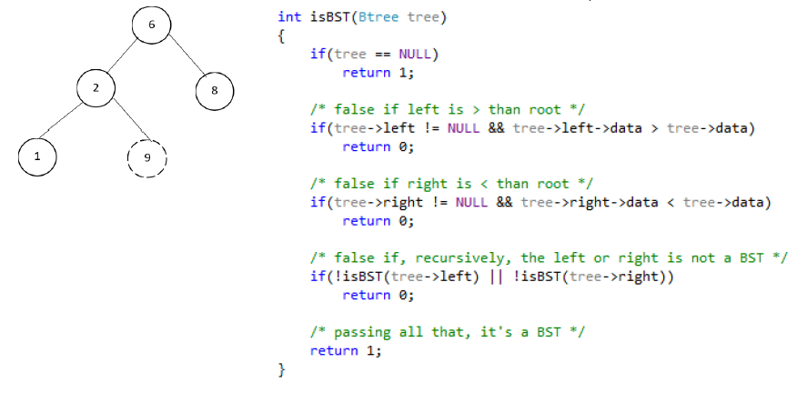

**Exercise 2 :**

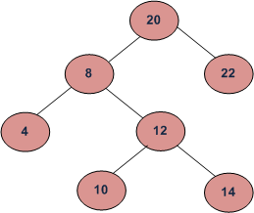Given two values n1 and n2 in a binary search tree, find the Lowest Common Ancestor (LCA). Assume that both values exist in the tree.

LCA of 10 and 14 = 12

LCA of 14 and 8 = 8

LCA of 10 and 22 = 20

**Exercise 3:**

Given a BST and a sum S, find if there exists a pair of nodes having the given sum S.

Exemple :

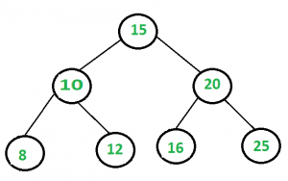

Input : S = 28

Output : Pair found (16, 12)