**LAB # 5**

**Start, Sleep and Stop methods of multithreading**

**Objective:**

**Understanding concurrency by implementing start, sleep and stop thread functions.**

**Lab Task:**

1. **By using start, stop and sleep methods of threading, print alphabets of English from A-Z. (Hint: use math.random method for getting random numbers and then convert them into characters, print 26 characters under rum method loop with fluctuating visualization through sleep method).**

**Syntax:**

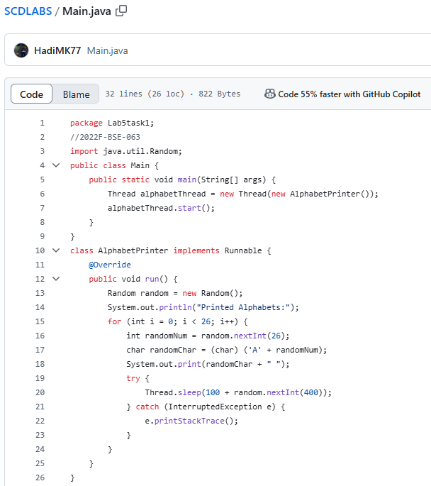

**Output:**

