Lab # 9
Generics in JAVA
Objective:

Lab Task:
- Write a program that takes integer array, double array and character array. Make a generic function that prints these array in reverse order. In JAVA.
Syntax:
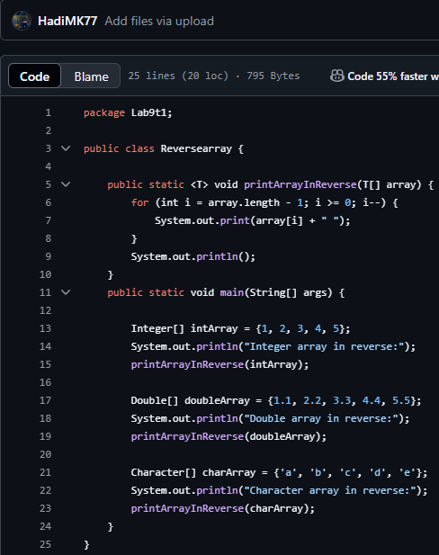

Output:
