* Between routers serial cables.
* Crossover between routers.
* Automatic for switches to routers.

* Call layer to distribution layer connection.

* Access layer to Call layer to distribution layer connection.

**Configuration steps:**

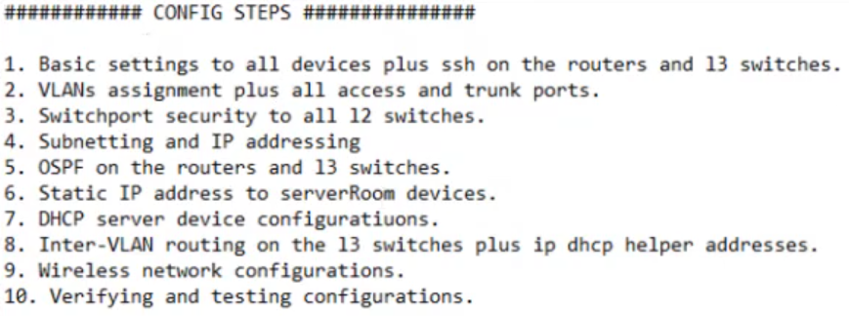

**Layer2 first switch:**

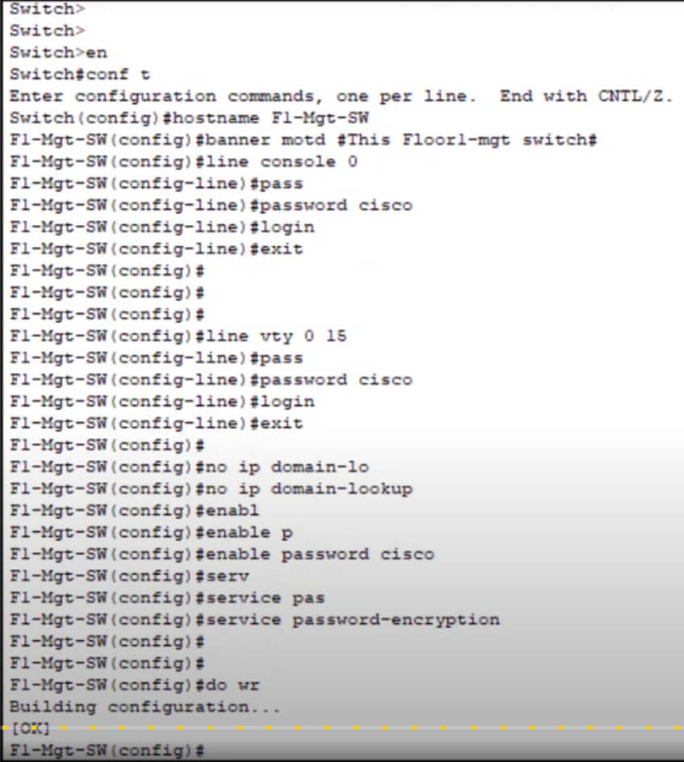

**Layer3 first switch:**

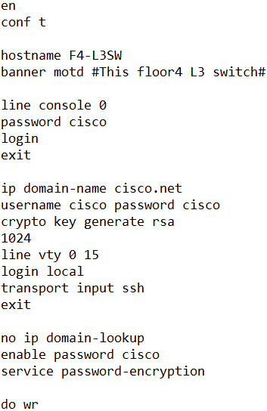

**Core Layer first router:**

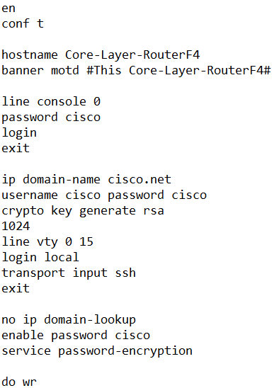

* Trunk ports connected from multi-layer switches to single switch (i.e., 2, fa0/1 & fa0/2).
* Access ports connected from single switch to host devices.

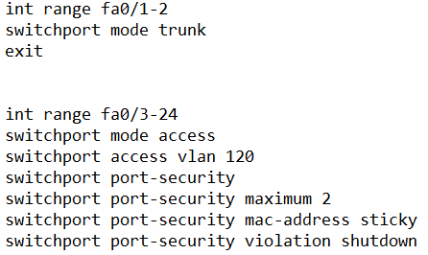

**IP Addressing:**

**1st floor:**

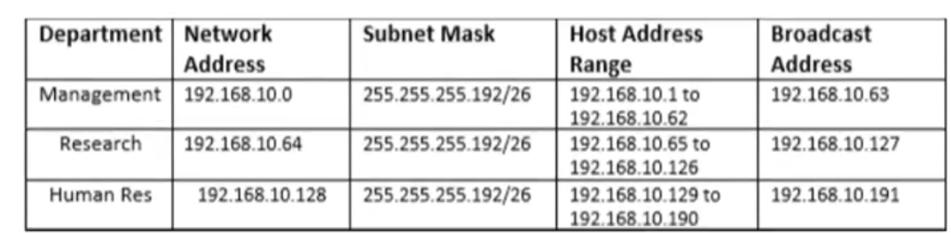

**2nd floor:**

**3rd floor:**

**4th floor:**

**Between the routers and layer 3 switches:**

**Base network address: 10.10.10.0**

