
Database systems lab
Project Milestone # 01




Project Members : Hadia Khan &
Hamna Rehman
Submitted to : Mr. Ali Hassan
Program : BSSE-B (2024-28)
Semester : 4th




May 1, 2026
IM Sciences
1-A, Sector E-5, Phase VII, Hayatabad

Project Name: Capytoons _{(A Comic Reading Platform)}

Project Description:
The global manga, manhwa, manhua, and webtoon industry has expanded into a multi-billion-dollar market, with millions of readers worldwide consuming digital comics daily. Platforms that aggregate content from diverse origins (Japan, Korea, China) have become essential hubs for fan communities. Despite this growth, many popular platforms such as bato.to have experienced prolonged outages or shutdowns, leaving large reader bases without a reliable alternative. A well designed, database-driven reading platform is essential to serve this audience consistently.

Version Control Table:
Milestone | Version | Date | Remarks
ERD Diagram + Schema | 1.0 | 25th April, 2026
ERD Diagram + Schema (Revised) | 1.1 | 1st May, 2026

ERD Diagram:
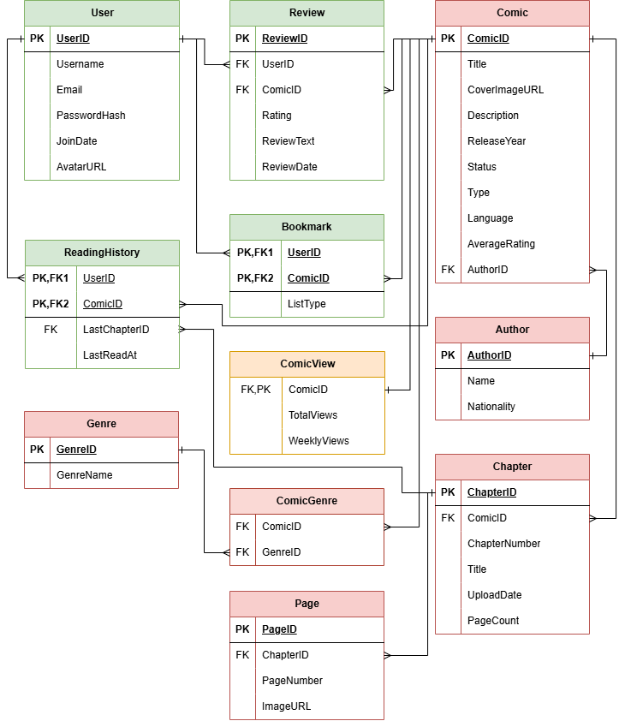
This ERD diagram is made by draw.io that is a well-known tool for drawing Flowcharts, ER Diagrams etc. This Diagram uses Crow-Foot notations to represent the relationships between the tables.
Green represents; User related tables and Pink represents; the Comic related tables. The yellow table ComicView has a one-to-one relation with Comic.
These tables were further populated using a python script and Mangadex API. These tables were filled with around 50 comics that had around 100 chaps.

Table’s Schema:

Table: Author

Schema:
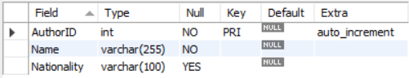

Description:
Author — Stores the name and nationality of comic authors. One author can have many comics, but each comic has one author — a one-to-many relationship with Comic.

Table: Comic

Schema:
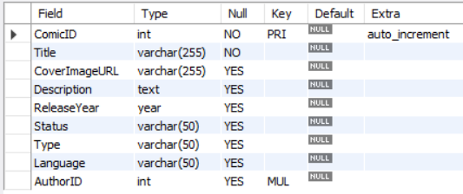

Description:
Comic — The central table of the entire database. Stores all core metadata about a comic including title, cover image, description, release year, status (ongoing/completed/hiatus), type (manga/manhwa/manhua/webtoon), language, and average rating. Links to Author via AuthorID.

Table: Genre

Schema:
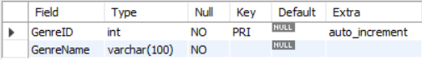

Description:
Genre — A simple lookup table storing genre names like Action, Romance, Fantasy etc. Does not link to Comic directly — the relationship is handled through ComicGenre.

Table: ComicGenre

Schema:
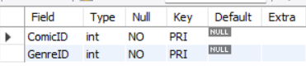

Description:
ComicGenre — A junction/bridge table resolving the many-to-many relationship between Comic and Genre. A comic can have multiple genres, and a genre can belong to many comics. Uses a composite primary key (ComicID, GenreID).

Table: ComicView

Schema:
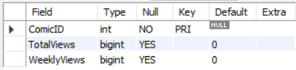

Description:
ComicView — A one-to-one extension of the Comic table. Stores total and weekly view counts used for generating trending and most-viewed feeds. ComicID serves as both the primary key and foreign key, enforcing the one-to-one relationship.

Table: Chapter

Schema:
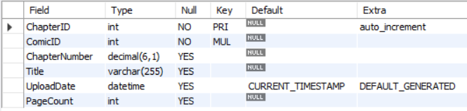

Description:
Chapter — Stores each chapter of a comic. Has a many-to-one relationship with Comic — one comic has many chapters. Stores chapter number, title, upload date, and page count. Cascades on delete so if a comic is removed, all its chapters are removed too.

Table: Page

Schema:
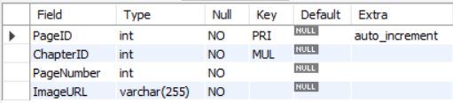

Description:
Page — Stores individual page image URLs for each chapter. Has a many-to-one relationship with Chapter — one chapter has many pages. Each row represents one page with its URL pointing to MangaDex's CDN.

Table: User

Schema:
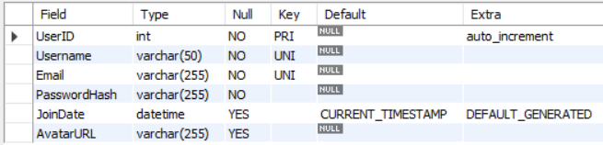

Description:
User — Stores registered user accounts with a unique username, email, and hashed password. Acts as a parent table for Review, Bookmark, and ReadingHistory — all user activity traces back here.

Table: Review

Schema:
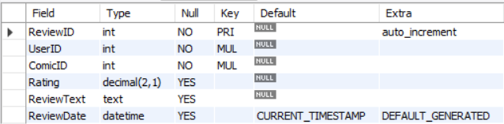

Description:
Review — Stores user-submitted ratings and text reviews. Has a many-to-one relationship with both User and Comic — one user can review many comics, and one comic can have many reviews. The AverageRating in Comic is computed from this table.

Table: Bookmark

Schema:
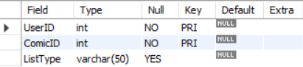

Description:
Bookmark — Allows users to save comics to a personal reading list with a status like Reading, Completed, or Dropped. Resolves a many-to-many relationship between User and Comic using a composite primary key (UserID, ComicID).

Table: ReadingHistory

Schema:
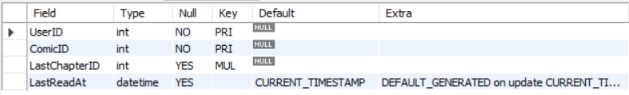

Description:
ReadingHistory — Tracks the last chapter a user read for each comic and when they read it. Also resolves a many-to-many between User and Comic with composite PK (UserID, ComicID). The LastChapterID is a foreign key back to Chapter.

