
Database systems lab
Semester Project




Project Members : Hadia Khan &
Hamna Rehman
Submitted to : Mr. Ali Hassan
Program : BSSE-B (2024-28)
Semester : 4th




May 17, 2026
IM Sciences
1-A, Sector E-5, Phase VII, Hayatabad

Project Name: Capytoons _{(A Comic Reading Platform)}

Project Description:
The global manga, manhwa, manhua, and webtoon industry has expanded into a multi-billion-dollar market, with millions of readers worldwide consuming digital comics daily. Platforms that aggregate content from diverse origins (Japan, Korea, China) have become essential hubs for fan communities. Despite this growth, many popular platforms such as bato.to have experienced prolonged outages or shutdowns, leaving large reader bases without a reliable alternative. A well designed, database-driven reading platform is essential to serve this audience consistently.

Version Control Table:
Milestone | Version | Date | Changes made | Remarks
1. ERD Diagram + Schema | 1.0 | 25th April, 2026 | Simple ERD Diagram with Schema
1. ERD Diagram + Schema (Revised) | 1.1 | 1st May, 2026 | Added Description with the tables
2. Normalization of Existing Schema | 1.2 | 17th May, 2026 | Justification of Normalization + Updated ERD (comment table)

ERD Diagram:
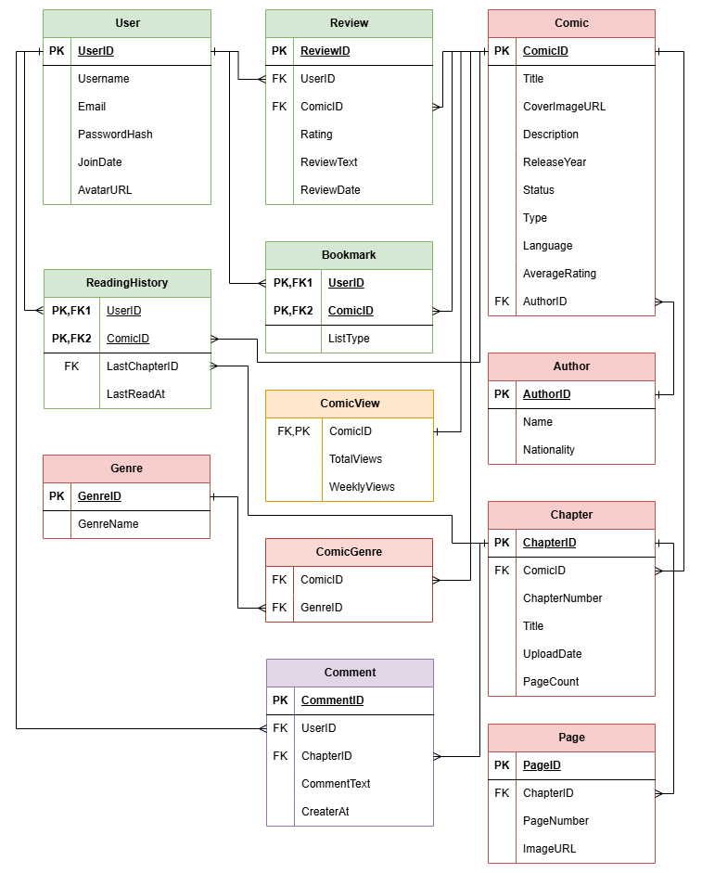
This ERD diagram is made by draw.io that is a well-known tool for drawing Flowcharts, ER Diagrams etc. This Diagram uses Crow-Foot notations to represent the relationships between the tables.
*Comments table was added for users to express their thoughts on each chapter.
Comments are for Chapters whereas Reviews are for Comics.

Table’s Schema:

Table: Author

Schema:
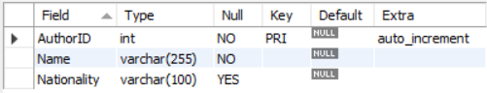

Description:
Author — Stores the name and nationality of comic authors. One author can have many comics, but each comic has one author — a one-to-many relationship with Comic.

Table: Comic

Schema:
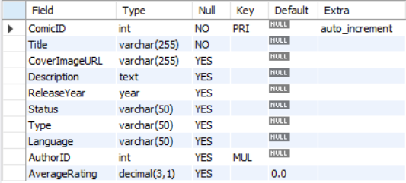

Description:
Comic — The central table of the entire database. Stores all core metadata about a comic including title, cover image, description, release year, status (ongoing/completed/hiatus), type (manga/manhwa/manhua/webtoon), language, and average rating. Links to Author via AuthorID.

Table: Genre

Schema:
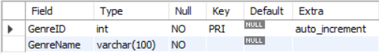

Description:
Genre — A simple lookup table storing genre names like Action, Romance, Fantasy etc. Does not link to Comic directly — the relationship is handled through ComicGenre.

Table: ComicGenre

Schema:
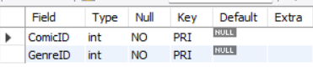

Description:
ComicGenre — A junction/bridge table resolving the many-to-many relationship between Comic and Genre. A comic can have multiple genres, and a genre can belong to many comics. Uses a composite primary key (ComicID, GenreID).

Table: ComicView

Schema:
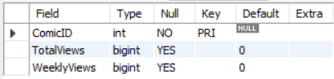

Description:
ComicView — A one-to-one extension of the Comic table. Stores total and weekly view counts used for generating trending and most-viewed feeds. ComicID serves as both the primary key and foreign key, enforcing the one-to-one relationship.

Table: Chapter

Schema:
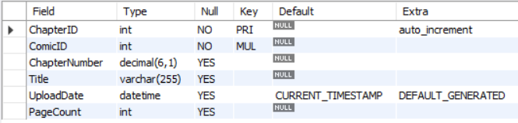

Description:
Chapter — Stores each chapter of a comic. Has a many-to-one relationship with Comic — one comic has many chapters. Stores chapter number, title, upload date, and page count. Cascades on delete so if a comic is removed, all its chapters are removed too.

Table: Page

Schema:
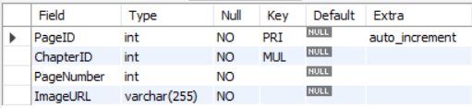

Description:
Page — Stores individual page image URLs for each chapter. Has a many-to-one relationship with Chapter — one chapter has many pages. Each row represents one page with its URL pointing to MangaDex's CDN.

Table: User

Schema:
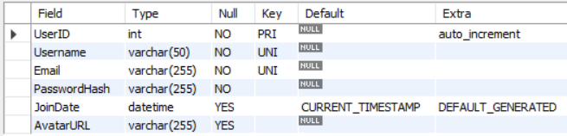

Description:
User — Stores registered user accounts with a unique username, email, and hashed password. Acts as a parent table for Review, Bookmark, and ReadingHistory — all user activity traces back here.

Table: Review

Schema:
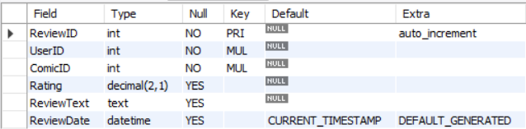

Description:
Review — Stores user-submitted ratings and text reviews. Has a many-to-one relationship with both User and Comic — one user can review many comics, and one comic can have many reviews. The AverageRating in Comic is computed from this table.

Table: Bookmark

Schema:
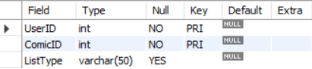

Description:
Bookmark — Allows users to save comics to a personal reading list with a status like Reading, Completed, or Dropped. Resolves a many-to-many relationship between User and Comic using a composite primary key (UserID, ComicID).

Table: ReadingHistory

Schema:
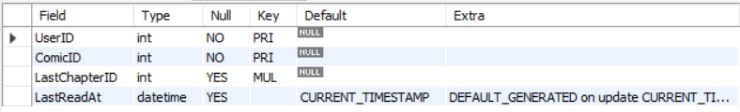

Description:
ReadingHistory — Tracks the last chapter a user read for each comic and when they read it. Also resolves a many-to-many between User and Comic with composite PK (UserID, ComicID). The LastChapterID is a foreign key back to Chapter.

Table: Comment (New)

Schema:
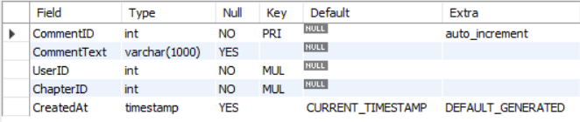

Description:
Comment — Allows users to be able to express their thoughts on each chapter. Unlike Review, Comment has NO UNIQUE (UserID, ComicID) constraint. A user may post multiple comments on the same chapter (discussion thread behavior).

Normalization (1NF to 3NF):
1NF — All values atomic, PK defined.
2NF — 1NF + No partial dependencies (every non-key column depends on the whole PK).
3NF — 2NF + No transitive dependencies (no non-key column depends on another non-key column).

Table: Author

Schema:


Justification:
Already in 3rd Normal Form.
1NF — Atomic, has PK.
2NF — Single-column PK.
3NF — Name is a direct fact about AuthorID. No transitive dependencies.

Table: Comic

Schema:


Justification:
Intentional Denormalization for 3rd Normal Form.
1NF — Atomic values, PK defined.
2NF — Atomic values, PK defined.
3NF — `AverageRating` is technically derivable from the `Review` table (`SELECT AVG(Rating) FROM Review WHERE ComicID = ?`). Storing it here violates strict 3NF.
AverageRating is queried on every comic listing, search result, and home page load. Recalculating it live via aggregation on every request would be expensive at scale. It is maintained by a trigger-style UPDATE in the `reviews.js` route after every new review submission. This is a deliberate performance-first denormalization, a common and accepted practice documented explicitly here.

Table: Genre

Schema:


Justification:
Already in 3rd Normal Form.
A minimal lookup table. GenreName is a direct atomic fact about GenreID.

Table: ComicGenre

Schema:


Justification:
Already in 3rd Normal Form.
Comics have a Many-to-Many relationship with Genres. This junction table correctly resolves that M:N into two 1:N relationships, which is the standard relational approach.

Table: ComicView

Schema:


Justification:
Already in 3rd Normal Form.
TotalViews and WeeklyViews are direct metrics for a comic. Separated from the Comic table to keep the main entity table clean and allow independent indexing of view statistics.

Table: Chapter

Schema:


Justification:
Intentional Denormalization for 3rd Normal Form.
3NF — `PageCount` can be derived from `SELECT COUNT(*) FROM Page WHERE ChapterID = ?`.
PageCount is displayed alongside every chapter listing so readers know how long a chapter is before clicking into it. Counting pages on every chapter list render is unnecessary overhead. PageCount is set once at upload time and rarely changes, making it safe to store directly. Documented as an intentional denormalization for read performance.

Table: Page

Schema:


Justification:
Already in 3rd Normal Form.
All columns are direct facts about PageID. ChapterID is a FK reference, not a transitive dependency.

Table: User

Schema:


Justification:
Already in 3rd Normal Form.
Username and Email are independent facts about the user. PasswordHash only describes UserID. No transitive dependencies.

Table: Review

Schema:


Justification:
Already in 3rd Normal Form.
1NF — Atomic values, PK defined.
2NF — Although the natural key is (UserID, ComicID), a surrogate PK (ReviewID) is used. Rating, ReviewText, and ReviewDate all describe a specific review — they depend on the full natural key.
3NF — No non-key column depends on another non-key column. ReviewDate does not depend on Rating, etc.

Table: Bookmark

Schema:


Justification:
Already in 3rd Normal Form.
ListType is a direct attribute of the (User, Comic) bookmark relationship. No transitive dependencies.

Table: ReadingHistory

Schema:


Justification:
Already in 3rd Normal Form.
LastChapterID and LastReadAt describe the reading progress of a specific user for a specific comic. LastChapterID is a FK reference, not a transitive dependency on chapter data.

Table: Comment

Schema:


Justification:
Already in 3rd Normal Form.
1NF — CommentText is a single atomic text value. CreatedAt is a single timestamp.
2NF — Single-column PK (CommentID). All columns depend on CommentID directly.
3NF — CommentText describes the comment content. CreatedAt describes when it was created. Neither depends on the other. UserID and ComicID are FK references, not transitive paths.

