Errors and Solutions

Week 5
AI Lab - Week 5
Error: Alpha-beta checked all 8 leaves, so it did not save any work compared to minimax.
Error screenshot:
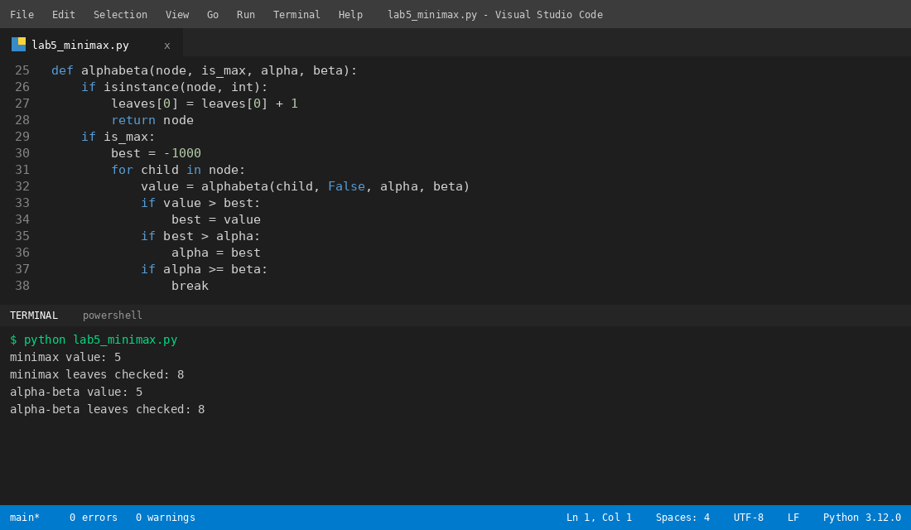
Solution: I reordered the leaf values so the best move comes first, and then alpha-beta checked only 6 leaves. The value stayed 5.
Solution screenshot:


