Errors and Solutions

Week 4
AI Lab - Week 4
Error: A* gave cost 9 because the heuristic value for node C was changed to 10, but the true cost from C is 3.
Error screenshot:
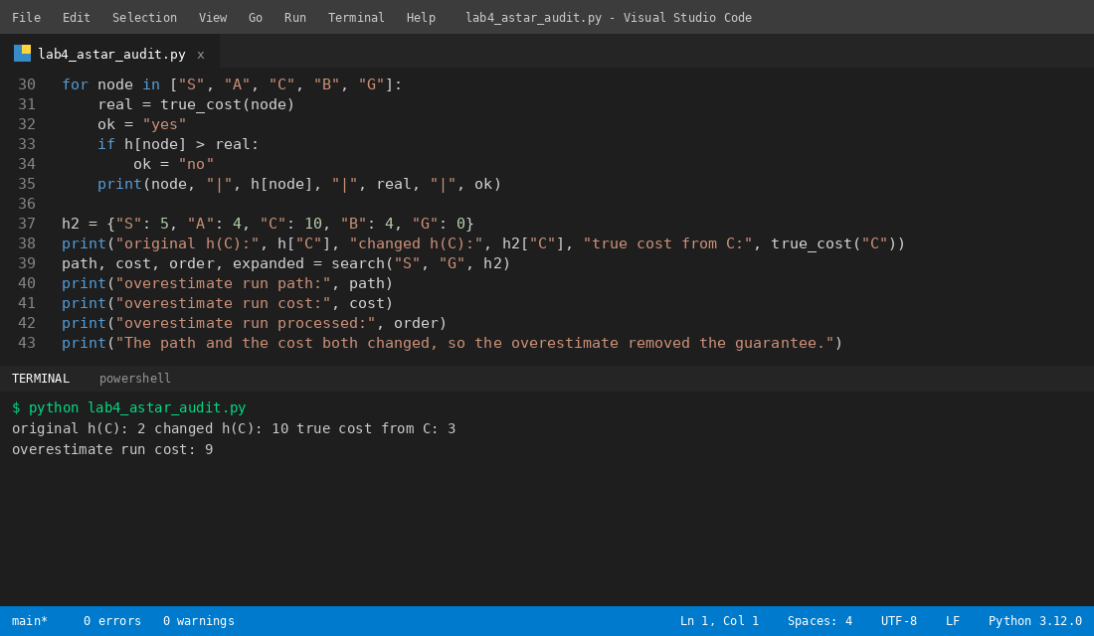
Solution: I kept the heuristic value at or below the true cost, and then A* gave cost 6.
Solution screenshot:


