Errors and Solutions

Week 1
AI Lab - Week 1
Error: The rule method and the score-only method gave different answers for the same student. For Sara (score 85, attendance 60), the rule method said Hold and the score-only method said Approve.
Error screenshot:
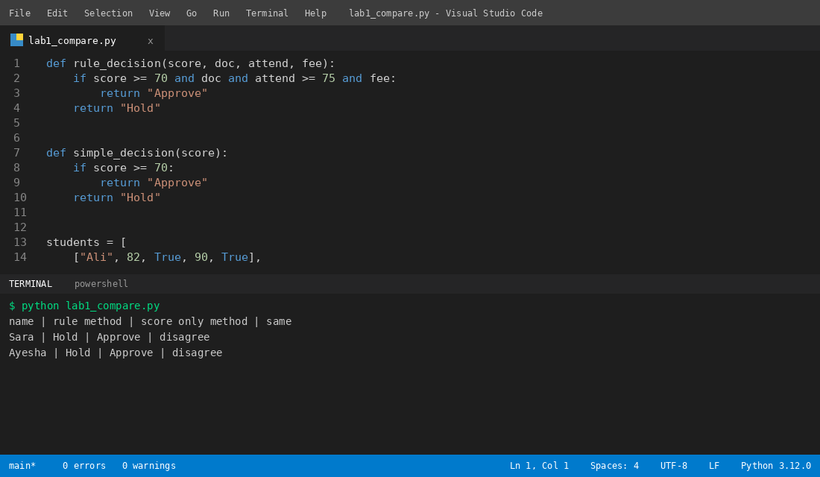
Solution: I kept both answers side by side in the output table and checked the reason for each student.
Solution screenshot:


