Errors and Solutions

Week 3
AI Lab - Week 3
Error: BFS gave a path with cost 12, while the cheapest path costs 3.
Error screenshot:
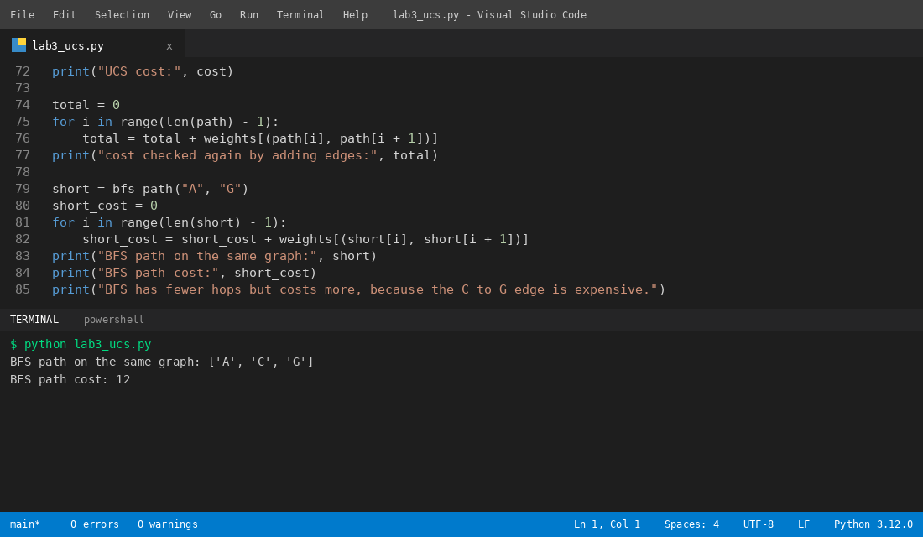
Solution: I used UCS, which checks the edge cost at every step, and it found the path with cost 3.
Solution screenshot:


