Task 04: Complete Business Analytics Project
Retail Sales Analytics | Devixo Solutions | Prepared by Hadia

Executive Summary
This project covers the full analytics cycle for a US retail store (Superstore data, 2015 to 2018): data cleaning, exploratory analysis, KPIs, an interactive dashboard, machine learning and recommendations. The store earned $2.30M revenue and $286K profit (12.5% margin). Revenue grew 20.4% in 2018, but profit grew only 14.2%.
The biggest problem is discounting: orders with more than 20% discount lost about $135K. Furniture sells a lot but earns almost nothing (2.5% margin). Growth came from more orders, while the average order value fell 13% since 2015. The customer base is strong: 258 “Champion” customers give 54% of revenue.
Dashboard: https://claude.ai/artifact/JApJhP5UTvykx5pD9iyQhv

Part 1: Data Preparation
Step | What was done
Import | 10,800 raw rows, 21 columns
Missing values | 806 rows had an ID but no order details, so they were removed. 11 missing postal codes were filled (all Burlington, VT = 05401)
Duplicates | 504 duplicate rows removed (they were copies of the empty rows)
Outliers | IQR check: Sales 11.7%, Profit 18.8%, Quantity 1.7%, Discount 8.6% of rows. These are real big orders, so they were flagged with a column and not deleted
Data types | Dates converted to datetime, Quantity to integer, text columns to category
New features | Year, Month, Quarter, Weekday, Ship Days, Profit Margin %, Loss flag, Discount Band, RFM segment
Result | 9,994 clean order lines, 5,009 orders, 793 customers, 0 missing values

Part 3: KPIs
KPI | Value
Total Revenue | $2,297,201
Total Profit | $286,397
Total Orders | 5,009
Average Order Value | $458.61
Profit Margin | 12.47%
Customer Count | 793
Growth Rate (2018 vs 2017) | +20.4%
Sales CAGR 2015 to 2018 | 14.8% per year

Part 2: Exploratory Analysis and 15 Insights
I made 19 charts (saved in the charts folder). The key charts are below.
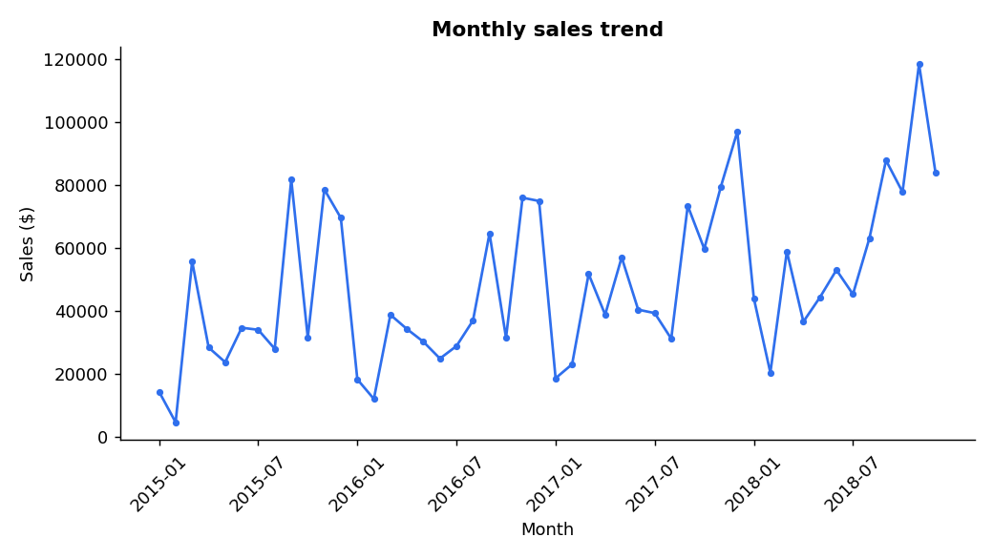
Monthly sales trend
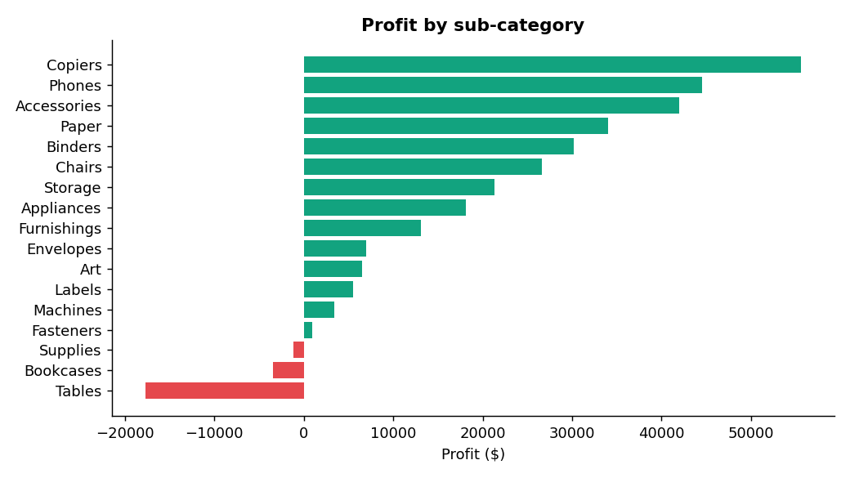
Profit by sub-category
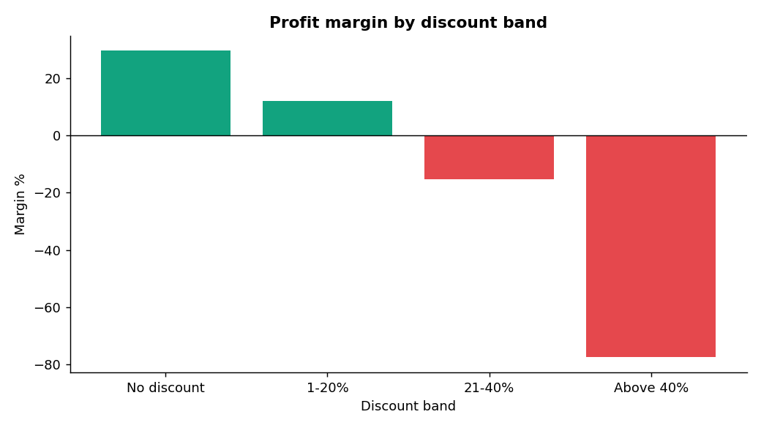
Profit margin by discount band
- Growth is real. Revenue rose from $484K (2015) to $733K (2018). Orders grew 74% (969 to 1,687) and customers grew from 595 to 693.
- Bigger store, smaller baskets. Average order value fell from $500 (2015) to $435 (2018), so growth comes from more orders, not bigger orders.
- Profit is lagging. In 2018 revenue grew 20.4% but profit only 14.2%, and margin dropped from 13.4% to 12.7%.
- Discount is the main profit killer. Margin is 29.5% with no discount, 11.9% at 1 to 20%, -15.3% at 21 to 40%, and -77.4% above 40%. Discount and profit have a negative correlation (-0.22).
- Deep discounts lose about $135K. Biggest losses: Office Supplies above 40% (-$47K), Furniture 21 to 40% (-$29K), Technology above 40% (-$27K).
- Technology and Office Supplies carry the profit. Together they give $268K of the $286K profit, both with a margin above 17%.
- Furniture is a weak category. $742K revenue but only $18K profit (2.5% margin). Chairs, the biggest item, have only 8.1% margin.
- Three sub-categories lose money. Tables -$17.7K, Bookcases -$3.5K, Supplies -$1.2K. Machines sell $189K but earn only 1.8% margin.
- Small items have huge margins. Labels (44%), Paper (43%), Envelopes (42%), Copiers (37%) and Accessories (25%) are the most profitable per dollar sold.
- Central region and some states are weak. Central has a 7.9% margin (West 14.9%). Texas (-$25.7K), Ohio (-$17.0K), Pennsylvania (-$15.6K), Illinois (-$12.6K) and North Carolina (-$7.5K) lose money.
- Customers are loyal. 98.5% of customers ordered more than once, and the average customer placed 6.3 orders.
- A few customers drive the business. RFM clustering found 258 Champions (orders 8.6 each) who give 53.6% of revenue and $163K profit.
- A smaller group is slipping away. 253 “Potential” customers have not ordered for 235 days on average, and 83 “At Risk” customers for 327 days. At Risk customers give only 1.6% of revenue.
- Sales are very seasonal. September, November and December give 43% of the yearly revenue. January and February give only 7%.
- Shipping mode does not change profit. Margins are close (12.1% to 13.9%). Standard Class carries 59% of revenue, and the Consumer segment gives 51% of revenue while Home Office has the best margin (14.0%).

Bonus: Machine Learning
Model | Result
Customer segmentation (RFM + KMeans) | 4 groups: Champions (258 customers, 54% revenue), Loyal (199, 24%), Potential (253, 21%), At Risk (83, 2%)
Future sales (trend + seasonality, Linear Regression) | Jan to Jun 2019 forecast: about $312K, 21% above Jan to Jun 2018 ($257K). Test error 17.1% (better than the “last year x growth” method at 18.8%)
Product demand (same method per category) | Jan to Jun 2019 units: Furniture 1,036 (+27% vs 2018), Office Supplies 3,305 (+20%), Technology 982 (+18%). Test errors 13% to 21%
Customer churn (Random Forest) | Churn (no order in Jul to Dec 2018) was 25% of customers, but the model scored ROC AUC 0.50, which is no better than a guess. Other cutoffs and models gave the same result.
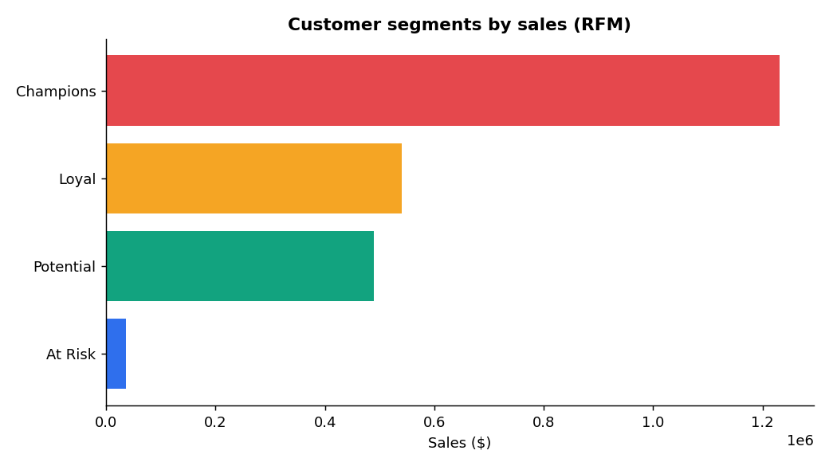
RFM customer segments by sales
The churn result is an honest finding: in this data, past buying behaviour does not predict who will skip the next 6 months. So the RFM segments (Potential and At Risk) are used to choose who to contact, not the churn model. The forecasts are guides, not exact numbers (error about 13% to 21%).
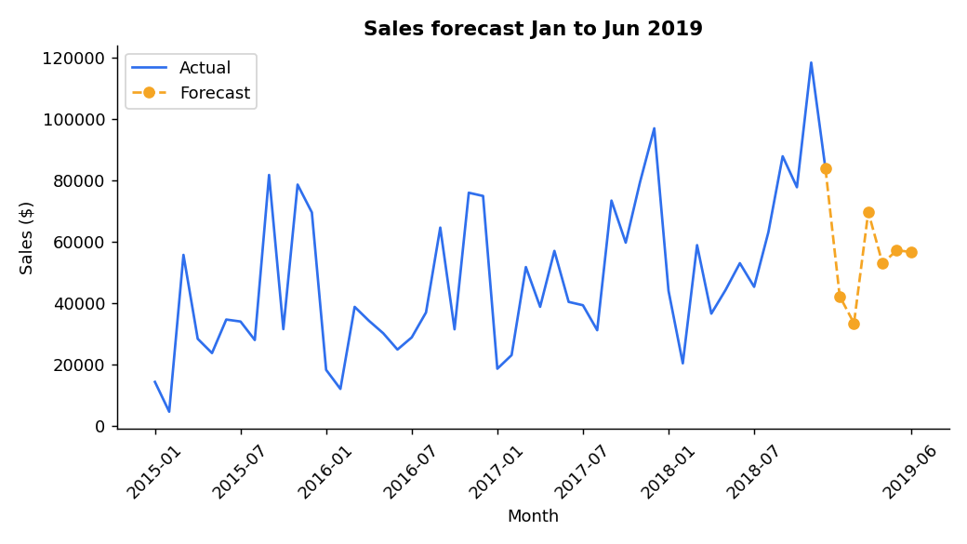
Sales forecast

Part 5: 10 Recommendations
- Cap discounts at 20% unless a manager approves (insights 4 and 5). Orders above 20% discount lost about $135K.
- Stop deep discounts on Office Supplies and Technology. Their above-40% discount orders lost $74K, even though these categories have a 17% margin without it.
- Reprice or drop Tables, Bookcases and Supplies (insight 8). Raise prices, renegotiate supplier cost, or remove the worst items.
- Review Machines pricing (insight 8). $189K sales at 1.8% margin needs a higher price or bundled service.
- Sell more high-margin items (insight 9). Add Paper, Labels, Envelopes and Accessories as add-ons to larger orders. This also helps raise the falling average order value.
- Raise average order value (insight 2) with bundles and a free-shipping minimum, to bring it back toward $500.
- Run a win-back campaign for the 253 Potential and 83 At Risk customers (insight 13), for example a limited offer under 20% discount.
- Start a VIP programme for the 258 Champions (insight 12) with early access and service benefits, not deeper discounts, because they already buy 8.6 times on average.
- Fix the Central region and the five loss-making states (insight 10) with discount rules and a product review. Reaching the South margin in Central would add about $20K profit.
- Plan stock and staff with the forecast (insight 14). Prepare for September to December (43% of revenue), expect about 20% more units in H1 2019, and retrain the model every quarter.

Output Files
task4_complete_analytics.py (all code), superstore_cleaned_task4.csv, task4_kpi_tables.xlsx, customer_segments.csv, churn_predictions.csv, charts/ (19 PNG charts) and the interactive dashboard link above.

