Confidential▼

PON OLT Equipment MIB Specifications

Project Name: CIANET Contract

Unit: ZTE do Brasil

Date: 18/02/2015

Totally 158 Pages (Cover Included)

Confidential▼

Version No. Prepared by
/
Revised by
Revision History

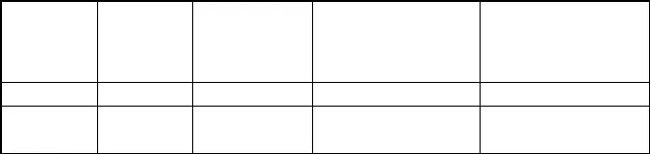
Revision Date Reason for Revision

Main Contents Revised (Main Points)

Zhu Min 2012-11-23
Zhu Min 2013-8-16 Consummate relevant contents

Confidential▼

Overview

This document is applicable to the PON OLT products, such as C200, C220, C300 and C320.
Most information of MIB objects shall be got from the corresponding MIB, and the MIB file is the final and the most accurate source of information of all the MIB objects. This document is only to list key information and the belonging MIB file.
If there are no special specifications, the corresponding MIB has no change among versions, and is suitable for all the OLT versions released.

Confidential▼

Definition of Composite Index

In the OLT equipment, to get index of some MIB tables, you need to combine some fields into 32 bytes, such index is called as composite index in this document.

Corresponding to it, the index directly using numbers like 1, 2, 3 is called as regular index in this document.
The composite index used in the OLT equipment management can be divided into two categories: one is platform composite index, and the other is PON equipment composite index. General functions of different kinds of equipment usually use composite index, while the management of the PON equipment uses PON composite index.

  - Platform Composite Index

The platform index of MIB tables usually consists of a MIB scalar. When accessing an MIB table, you need to select corresponding method to constitute the composite index according to the type of the interface.
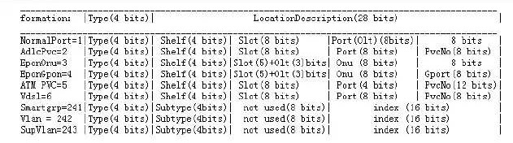
The platform composite index is a 32-bit integer without a symbol, and the composite index—s high 4 bits are used to indicate the type of the index:

    - Slot Conversion of Platform Composite Index

Slot fields of the platform composite index needs to fill in a logic slot value, and the logic slot value is got via the conversion of physical slot value. The conversion modes of different OLT equipment are different, for details, refer to relevant section.

Slot COjVerSiOj Of C220 Shelf

if (slot <= 6)

{
composite index slot = slot - 1;

Confidential▼

}
else if ((slot >= 9) && (slot <= 14))
{

}
else
{

}
composite index slot = slot - 3;

composite index slot = 0;

Slot COjVerSiOj Of C200 Shelf

if (slot <= 3)
{
composite index slot = slot;
}
else if (slot == 6)
{
composite index slot = 5;
}
else if ((slot >= 4) && (slot <= 5))
{
if (The main control card is inserted in the slot)
{

}
else
{

}
}
composite index slot = 0;

composite index slot = 4;

Slot COjVerSiOj Of C300 Shelf

if ((slot >= 2) && (slot <= 9))
{
composite index slot = slot - 2;
}
else if ((slot >= 12) && (slot <= 22))
{

composite index slot = slot - 4;
}

Confidential▼

else
{

}

composite index slot = 0;

Slot COjVerSiOj Of C320 Shelf

if((0 < vSlot) && (ucSlotnum >= vSlot))
{
*vpCardId = vSlot - 1;
}

    - Type 1 Index
Type 1 index indicates port or OLT. From high bit to low bit:
bit31 to bit28 indicates Type, which is 1,
bit27 to bit24 indicates Shelf No., which is 0,
bit23 to bit16 indicates Slot No., to fill in Slot No. after conversion, refer to 1.2 bit15to bit8 indicates Port No. or OLT No., be equal to Port No. or (OLT No. ’ 1) bit7 to bit0 fill in 0

| 4 | 4 | 8 | 8 | 8 |

|Type: 1 | Shelf | Cardid | Port (Olt) | Vc/SrvPortId |

For example: gpon-olt_1/2/3—s index is 0x10000200.

    - Type 3 Index

Type 3 index indicates ONU. The PON cards having 8 ports or less than 8 ports use this index type.
From high bit to low bit:
bit31 to bit28 indicates Type, which is 3, bit27 to bit24 indicates Shelf No., which is 0,
bit23 to bit19 indicates Slot No., to fill in Slot No. after conversion, refer to 1.2

bit18 to bit16 indicates OLT NO., be equal to (OLT NO. ’ 1) bit15 to bit8 indicates ONU NO., be equal to (ONU NO. ’ 1)

Confidential▼

bit7 to bit0 fill in 0

| 4 | 4 | 8 | 8 | 8 |

|Type: 3 | Shelf | Cardid(5b)Olt( 3b) | Onu | |

For example: gpon-onu_1/2/3:2—s index is 0x30020100.

    - Type 4 Index

Type 4 index indicates ONU virtual link. The PON cards having 8 ports or less than 8 ports use this index type.
From high bit to low bit:
bit31 to bit28 indicates Type, which is 3, bit27 to bit24 indicates Shelf No., which is 0,
bit23 to bit19 indicates Slot No., to fill in Slot No. after conversion, refer to1.2
bit18 to bit16 indicates OLT NO., be equal to (OLT NO. ’ 1) bit15 to bit8 indicates ONU NO., be equal to (ONU NO. ’ 1)
bit7 to bit0 indicates ONU virtual link, be equal to 0 for EPON equipment

| 4 | 4 | 8 | 8 | 8 |

|Type: 4 | Shelf | Cardid(5b)Olt(3b) | Onu | Vport/SrvPortId |

Of them, Vport and SrvPortId are differentiated via the highest bit of the belonging field. If it is 1, it indicates srvport.

For example: gpon-onu_1/2/3:2 VPORT1—s index is 0x40020101, gpon-onu_1/2/3:2 service port1—s index is 0x40020181.

    - Type 9 Index

Type 9 index indicates 16-port PON card—s ONU. The PON cards having 8 ports or less than 8 ports use Type 3 index.
From high bit to low bit:
bit31 to bit28 indicates Type, which is 9, bit27 to bit24 indicates Shelf No., which is 0,
bit23 to bit19 indicates Slot No., to fill in Slot No. after conversion, refer to1.2
bit18 to bit16 indicates OLT NO., be equal to (OLT NO. ’ 1) bit15 to bit8 indicates ONU NO., be equal to (ONU NO. ’ 1)

Confidential▼

bit7 to bit0 fill in 0

| 4 | 3 | 9 | 8 | 8 |

|Type: 9 | Shelf(3b) | Cardid(5b)Olt(4b) | Onu | |

    - Type 10 Index

Type 10 index indicates 16-port PON card—s ONU virtual link. The PON cards having 8 ports or less than 8 ports use Type 4 index.
From high bit to low bit:
bit31 to bit28 indicates Type, which is 10, bit27 to bit24 indicates Shelf No., which is 0,
bit23 to bit19 indicates Slot No., to fill in Slot No. after conversion, refer to1.2 bit18 to bit16 indicates OLT NO., be equal to (OLT NO. ’ 1)
bit15 to bit8 indicates ONU NO., be equal to (ONU NO. ’ 1)
bit7 to bit0 indicates ONU virtual link, be equal to 0 for EPON equipment

| 4 | 3 | 9 | 8 | 8 |

|Type: 10 | Shelf(3b) | Cardid(5b)Olt( 4b) | Onu | Vport/SrvPort Id |

  - PON Composite Index

The index of PON MIB tables usually consists of one or multiple MIB scalars. When accessing an MIB table, if the index consists of one MIB scalar, you need to select corresponding method to constitute the composite index according to the type of the interface; if the index consists of multiple MIB scalars, only the first scalar constituting the index needs you to select corresponding method to constitute the composite index according to the type of the interface, while other scalars are all regular indices, which use numbers like 1, 2, 3, etc.
PON composite index is a 32-bit integer without symbols, and the composite index—s high 4 bits are used to indicate the type of the index.
The slot No. in the PON composite index adopts physical slot No., with no need to be converted.

GPON PON port-level objects are all Type 1composite index, ONU -level objects are (PON port Type 1composite index + ONU No.).
EPON PON port-level objects are all Type 1composite index, ONU -level objects are Type 3composite index.

Confidential▼

    - Type 1 Composite Index

Type 1indicates indicates port or OLT. From high bit to low bit:
bit31 to bit28 indicates Type, which is 1, bit27 to bit24 indicates Shelf No., which is 0,
bit23 to bit16 indicates Slot No., fill in Slot No.
bit15 to bit8 indicates Port No. or OLT No., fill in Port No. or OLT No. bit7 to bit0 fill in 0

| 4 | 4 | 8 | 8 | 8 |
| Type: 1 | Shelf | Slot | Port(Olt) | |

For example: gpon-olt_1/2/3's index is 0x10020300.

    - Type 3 Composite Index

Type 3 indicates ONU. From high bit to low bit:
bit31 to bit28 indicates Type, which is 3, bit27 to bit24 indicates Shelf No., which is 0,
bit23 to bit19 indicates Slot No., fill in Slot No. bit18 to bit16 indicates OLT NO., fill in OLT NO. bit15 to bit8 indicates ONU NO., fill in ONU NO. bit7 to bit0 fill in 0

Note: For C300 and C320 NEs, bit18 to bit16 indicates OLT NO., fill in (OLT NO. ‐ 1) while for other NEs, fill in OLT NO.

| 4 | 4 | 8 | 8 | 8 |
| Type: 3 | Shelf |Card(5bit)Olt(3bit)| Onu ID | |

For example: gpon-onu_1/2/3:1's index is 0x30120100.

    - Type 6 Composite Index

Type 6 indicates slot. From high bit to low bit:
bit31 to bit28 indicates Type, which is 6, bit27 to bit24 indicates Shelf No., which is 0,
bit23 to bit16 indicates Slot No., fill in Slot No.

Confidential▼

bit15 to bit8 fill in 0 bit7 to bit0 fill in 0

| 4 | 4 | 8 | 8 | 8 |
| Type: 6 | Shelf | slot | | |

For example: The index of the GPON card in Slot 2 is 0x60020000.


2.2.4 Type 7 Composite Index
Type 7 indicates profile.
From high bit to low bit:
bit31 to bit28 indicates Type, which is 7, bit27 to bit24 indicates Shelf No., which is 0, bit23 to bit16 fill in 0
bit15 to bit0 indicates profile No., fill in profile No.
|
4
|
4 | 8 | 8 |
| Type: 7 | Shelf | 0 | profile No.
8 |
|
For example: Profile index is 0x70000001.
2.2.5 Type 9 Composite Index
Type 9 indicates ONU (The composite index is specially used for the ONUs of the PON cards
having more than 8 ports, while the ONUs of the PON cards having 8 ports or less than 8 ports use Type 3).
From high bit to low bit:

bit31 to bit28 indicates Type, which is 9, bit27 to bit25 indicates Shelf No., which is 0,
bit24 to bit20 indicates Slot No., fill in Slot No. bit19 to bit16 indicates OLT NO., fill in OLT NO.
bit15 to bit8 indicates ONU NO., fill in ONU NO.
bit7 to bit0 fill in 0

Note: For C300 and C320 NEs, bit19 to bit16 indicates OLT NO., fill in (OLT NO. ‐ 1) while for other NEs, fill in OLT NO.

| 4 | 4 | 8 | 8 | 8 |
| Type: 3 | Shelf (3bit)|Slot(5bit)Olt(4bit)| Onu ID | |

Confidential▼

System Control

  - NE Information

Basic NE information includes ObjectID, description information, system operation time, system location and so on.

Index Specification
Global variable, index.0

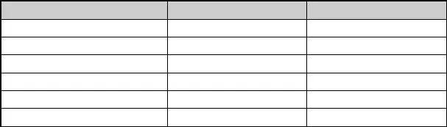OID Specification
sysContact
sysName sysLocation
.1.3.6.1.2.1.1.4
.1.3.6.1.2.1.1.5
.1.3.6.1.2.1.1.6

MIB Variable | OID | Specification
sysDescr | .1.3.6.1.2.1.1.1 | Read Only
sysObjectID | .1.3.6.1.2.1.1.2 | Read Only
sysUpTime | .1.3.6.1.2.1.1.3 | Read Only

  - Shelf Information

Get actual shelf type of the NE and configured shelf type, and set the configured shelf type of the NE

Index Specification
The index is zxAnRackNo (Rack No.) and zxAnShelfNo (Shelf No.), and Rack No. and Shelf No. are numbered from 0.

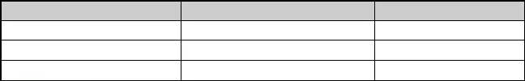
OID Specification

MIB Variable | OID | Specification
zxAnShelfActType | .1.3.6.1.4.1.3902.1015.2.1.1.2.1.3 | Read Only
zxAnShelfCfgType | .1.3.6.1.4.1.3902.1015.2.1.1.2.1.4
zxAnShelfRowStatus | .1.3.6.1.4.1.3902.1015.2.1.1.2.1.15

- Definitions of actual shelf type zxAnShelfActType and configured shelf type zxAnShelfCfgType

Confidential▼

0x00010101 C220 equipment Type-A shelf 0x00010102 C220 equipment Type-B shelf 0x00010103 C200 equipment Type-A shelf 0x00010104 C100 equipment Type-A shelf

  - Card Information

Get the configured card list on the NE

Index Specification
The index is zxAnRackNo (Rack No.), zxAnShelfNo (Shelf No.) and zxAnSlotNo (Slot No.).
Rack No. and Shelf No. are numbered from 0, while Slot No. is numbered from 1.

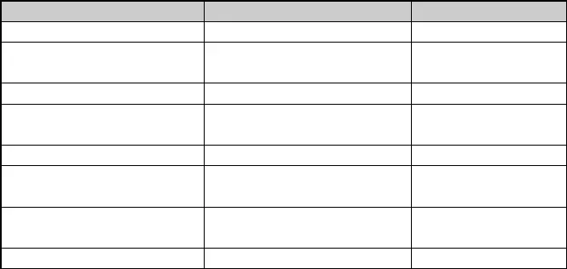
OID Specification

MIB Variable  zxAnCardCfgMainType | OID  .1.3.6.1.4.1.3902.1015.2.1.1.3.1.2 | Specification  Configured card type
zxAnCardActMainType | .1.3.6.1.4.1.3902.1015.2.1.1.3.1.3 | Actual card type (Read
zxAnCardActType | .1.3.6.1.4.1.3902.1015.2.1.1.3.1.4 | Only)  Card name (Read Only)
zxAnCardOperStatus | .1.3.6.1.4.1.3902.1015.2.1.1.3.1.5 | Card status (Read
 |  | Only)
zxAnCardCpuLoad | .1.3.6.1.4.1.3902.1015.2.1.1.3.1.9 | CPU load (Read Only)
zxAnCardMemUsage | .1.3.6.1.4.1.3902.1015.2.1.1.3.1. 1 | Memory usage rate (%)
 |  | (Read Only)
zxAnCardStandbyStatus | .1.3.6.1.4.1.3902.1015.2.1.1.3.1.13 | Card active / standby
 |  | status (Read Only)
zxAnCardRowStatus | .1.3.6.1.4.1.3902.1015.2.1.1.3.1.30

- Definitions of zxAnCardCfgMainType and zxAnCardActMainType

0x00010108 EC4GH
0x00010104 EC4GM
0x00010102 EC4G
0x00011002 EIG
0x00011001 EIGM
0x00012405 EIGMP
0x00011003 EIGMF
0x00011004 EIT1F
0x00011005 EIT2F
0x00012301 EPEB
0x00012302 EPFC
0x00012303 EPFB

Confidential▼

0x00010101 GCSA
0x00010103 GCSC
0x00010105 GCSD
0x00010107 GCSE
0x00011101 CE1B
0x00011102 CE1BB
0x00011103 CL1A
0x00012402 GPTAB
0x00012403 GPTCB
0x00012404 GPFAB
0x00012401 GPTBB
0x00080101 MS8E
0x00080102 MS8EP
0x00081001 EI8E
0x00081002 EI8EP
0x00081101 ETC8B
0x00082301 EPUA
0x00082401 GPUA
0x00082601 V08B
0x00082602 V16B

- Card status 0 On-line
- Off-line
- Fail to provide services 3 hw on-line
- Off-line
- Being configured
- Configuration failed
- The configured card type isn't matched with actual type 8 De-activate
- Fault
- Failure

- Card active / standby status 1 Active status
2 Standby status
15 Unknown status

  - Version Information

To view the information of the version currently running of the NE (active version, boot

Confidential▼

version and firmware version)

Index Specification
The index is zxAnRackNo (Rack No.), zxAnShelfNo (Shelf No.) and zxAnSlotNo (Slot No.). Rack No. and Shelf No. are numbered from 0, while Slot No. is numbered from 1.

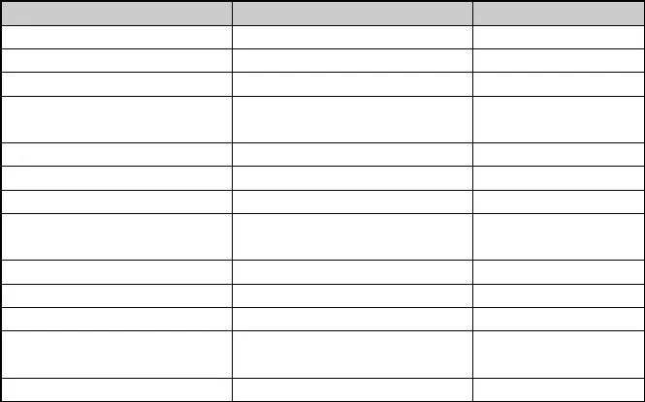
OID Specification

MIB Variable | OID | Specification
zxAnCardHardVersion | .1.3.6.1.4.1.3902.1015.2.1.2.2.1.1 | Card hardware version
zxAnVersionFileType | .1.3.6.1.4.1.3902.1015.2.1.2.2.1.3 | Active version type
zxAnVersionTag | .1.3.6.1.4.1.3902.1015.2.1.2.2.1.4 | Active version No.
.zxAnVersionFileLen | .1.3.6.1.4.1.3902.1015.2.1.2.2.1.5 | Length of the active
 |  | version file
zxAnVersionBuildTime | .1.3.6.1.4.1.3902.1015.2.1.2.2.1.6 | Active version time
zxAnBootromFileType | .1.3.6.1.4.1.3902.1015.2.1.2.2.1.8 | Boot version type
zxAnBootromTag | .1.3.6.1.4.1.3902.1015.2.1.2.2.1.9 | Boot version No.
zxAnBootromFileLen | .1.3.6.1.4.1.3902.1015.2.1.2.2.1.10 | Length of the boot
zxAnBootromBuildTime | .1.3.6.1.4.1.3902.1015.2.1.2.2.1. 1 | version file  Boot version time
zxAnFirmware1FileType | .1.3.6.1.4.1.3902.1015.2.1.2.2.1.13 | Firmware type
zxAnFirmware1Tag | .1.3.6.1.4.1.3902.1015.2.1.2.2.1.14 | Firmware No.
zxAnFirmware1FileLen | .1.3.6.1.4.1.3902.1015.2.1.2.2.1.15 | Length of the firmware
 |  | file
zxAnFirmware1BuildTime | .1.3.6.1.4.1.3902.1015.2.1.2.2.1.16 | Firmware time

  - Fan Information

Get the information of the fan operation.

Index Specification
The index is zxAnEnvFanIndex (fan unit id), which starts from 1. The maximum number is the number of actual fan units. If lower layers fail to read the number of fans correctly, there are 3 19-inch shelves and 4 21-inch shelves.

OID Specification

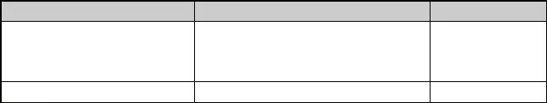
MIB Variable
zxAnEnvFanActualSpeedLevel
OID
.1.3.6.1.4.1.3902.1015.2.1.3.10.10.10.1.3
Specification
Actual
speed
level of the fan
unit
.zxAnEnvFanOperStatus .1.3.6.1.4.1.3902.1015.2.1.3.10.10.10.1.5 Operation status

 |  | of the fan unit
zxAnEnvFanOnlineStatus | .1.3.6.1.4.1.3902.1015.2.1.3.10.10.10.1.6 | Online status of  the fan unit
zxAnEnvFanActualSpeed | .1.3.6.1.4.1.3902.1015.2.1.3.10.10.10.1.7 | Actual speed

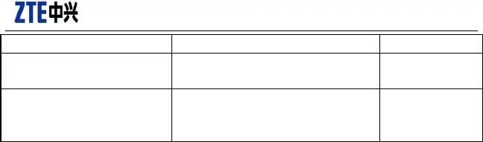zxAnEnvFanActualSpeedLevel:
Confidential▼
(RPM) of the fan
unit
{ lowSpeed ( 1 ) , standardSpeed ( 2 ) , highSpeed ( 3 ) , superSpeed ( 4 ) , other ( 10 ) }

zxAnEnvFanOperStatus:
{ up ( 1 ) , down ( 2 ) , unknown ( 3 ) }

zxAnEnvFanOnlineStatus:
{ online ( 1 ) , offline ( 2 ) , unknown ( 3 ) }

  - Address Information

,
{"zxAnL3IfIpAddressTable" | , |  |  | "1.3.6.1.4.1.3902.1015.4.1.3"} ,
{"zxAnL3IfIpAddressEntry" | , |  |  | "1.3.6.1.4.1.3902.1015.4.1.3.1"} ,
{"zxAnL3IfIp" |  |  |  | "1.3.6.1.4.1.3902.1015.4.1.3.1.1"} ,
{"zxAnL3IfMask" |  |  | , | "1.3.6.1.4.1.3902.1015.4.1.3.1.2"} ,
{"zxAnL3IfIpCatagory" | , |  |  | "1.3.6.1.4.1.3902.1015.4.1.3.1.3"} ,
{"zxAnL3IfIpRowStatus" | , |  |  | "1.3.6.1.4.1.3902.1015.4.1.3.1.4"} ,

Confidential▼

Platform

  - VLAN

Relevant MIB file is: ZTE-AN-VLAN-MIB.mib

    - Create VLAN Interface

{"zxAnL3IfTable" | , "1.3.6.1.4.1.3902.1015.4.1.1"} ,
{"zxAnL3IfEntry" | , "1.3.6.1.4.1.3902.1015.4.1.1.1"} ,
{"zxAnL3IfIndex" | , "1.3.6.1.4.1.3902.1015.4.1.1.1.1"} ,
{"zxAnL3IfName" | , "1.3.6.1.4.1.3902.1015.4.1.1.1.2"} ,
{"zxAnIfReferIndex" | , "1.3.6.1.4.1.3902.1015.4.1.1.1.3"} ,
{"zxAnL3IfArpProxyEnable" | , "1.3.6.1.4.1.3902.1015.4.1.1.1.4"} ,
{"zxAnL3IfRowStatus" | , "1.3.6.1.4.1.3902.1015.4.1.1.1.5"} ,

Name Oid Range Description zzxAnL3IfIndex .1.3.6.1.4.1.3902.1015.4.1.1.1.1
zxAnL3IfName .1.3.6.1.4.1.3902.1015.4.1.1.1.2 STRING ( SIZE ( 1 ..
32 ) )
zxAnIfReferIndex .1.3.6.1.4.1.3902.1015.4.1.1.1.3

able
zxAnL3IfArpProxyEn
.1.3.6.1.4.1.3902.1015.4.1.1.1.4

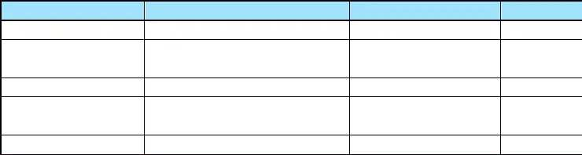zxAnL3IfRowStatus .1.3.6.1.4.1.3902.1015.4.1.1.1.5 rowStatus

    - Configure IP Address of VLAN Interface

{"zxAnL3IfIp" , "1.3.6.1.4.1.3902.1015.4.1.3.1.1"} ,
{"zxAnL3IfMask" , "1.3.6.1.4.1.3902.1015.4.1.3.1.2"} ,
{"zxAnL3IfIpCatagory" , "1.3.6.1.4.1.3902.1015.4.1.3.1.3"} ,
{"zxAnL3IfIpRowStatus" , "1.3.6.1.4.1.3902.1015.4.1.3.1.4"} ,

Name Oid Range Description

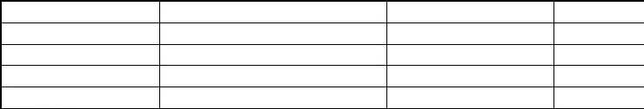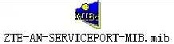

Confidential▼

zzxAnL3IfIndex | .1.3.6.1.4.1.3902.1015.4.1.1.1.1
zxAnL3IfIp | .1.3.6.1.4.1.3902.1015.4.1.3.1.1
zxAnL3IfMask | .1.3.6.1.4.1.3902.1015.4.1.3.1.2
zxAnL3IfIpCatagory | .1.3.6.1.4.1.3902.1015.4.1.3.1.3
zxAnL3IfIpRowStatus | .1.3.6.1.4.1.3902.1015.4.1.3.1.4 | rowStatus

    - Configure Switchport

{"zxAnVlanPortConfVlanCmdTable" , "1.3.6.1.4.1.3902.1015.20.4"} ,
{"zxAnVlanPortConfVlanCmdEntry" , "1.3.6.1.4.1.3902.1015.20.4.1"} ,
{"zxAnVlanPortConfVlanCmd" , "1.3.6.1.4.1.3902.1015.20.4.1.1"} ,
{"zxAnVlanPortConfVlanId" , "1.3.6.1.4.1.3902.1015.20.4.1.2"} ,

    - Configure Serviceport

{"zxAnServicePort" | , |  | "1.3.6.1.4.1.3902.1015.8"} ,
{"zxAnServicePortObjects" |  | , | "1.3.6.1.4.1.3902.1015.8.1"} ,
{"zxAnServicePortConfTable" |  | , | "1.3.6.1.4.1.3902.1015.8.1.1"} ,
{"zxAnServicePortConfEntry" |  | , | "1.3.6.1.4.1.3902.1015.8.1.1.1"} ,
{"zxAnBridgePortIndex" |  | , | "1.3.6.1.4.1.3902.1015.8.1.1.1.1"} ,
{"zxAnUserOutSVid" |  |  | , "1.3.6.1.4.1.3902.1015.8.1.1.1.10"} ,
{"zxAnServicePortRowStatus"  {"zxAnUserTlsVlan" |  | , | "1.3.6.1.4.1.3902.1015.8.1.1.1.100"} ,  , "1.3.6.1.4.1.3902.1015.8.1.1.1.11"} ,
{"zxAnUserSVidCos" |  |  | , "1.3.6.1.4.1.3902.1015.8.1.1.1.12"} ,
{"zxAnVlanTransMode" |  |  | , "1.3.6.1.4.1.3902.1015.8.1.1.1.13"} ,
{"zxAnUserInStartVid" |  | , | "1.3.6.1.4.1.3902.1015.8.1.1.1.14"} ,
{"zxAnUserInEndVid" , "1.3.6.1.4.1.3902.1015.8.1.1.1.15"} ,
{"zxAnUserCVidCos" , "1.3.6.1.4.1.3902.1015.8.1.1.1.16"} ,
{"zxAnUserInSVid" , "1.3.6.1.4.1.3902.1015.8.1.1.1.17"} ,
{"zxAnSrvPortVlanXconnectEnable", "1.3.6.1.4.1.3902.1015.8.1.1.1.18"} ,
{"zxAnServicePortUserDscp" , "1.3.6.1.4.1.3902.1015.8.1.1.1.19"} ,
{"zxAnServicePortID" , "1.3.6.1.4.1.3902.1015.8.1.1.1.2"} ,
{"zxAnServicePortIngressTrafficPrf", "1.3.6.1.4.1.3902.1015.8.1.1.1.20"} ,
{"zxAnServicePortEgressTrafficPrf", "1.3.6.1.4.1.3902.1015.8.1.1.1.21"} ,
{"zxAnServicePortAdminStatus", "1.3.6.1.4.1.3902.1015.8.1.1.1.22"} ,

Confidential▼

{"zxAnServicePortQueueId", "1.3.6.1.4.1.3902.1015.8.1.1.1.23"} ,
{"zxAnServicePortDesc" , "1.3.6.1.4.1.3902.1015.8.1.1.1.3"} ,
{"zxAnServicePortServiceMode" , "1.3.6.1.4.1.3902.1015.8.1.1.1.4"} ,
{"zxAnUserInVid" , "1.3.6.1.4.1.3902.1015.8.1.1.1.5"} ,
{"zxAnUserInPriority" , "1.3.6.1.4.1.3902.1015.8.1.1.1.6"} ,
{"zxAnUserEthType" , "1.3.6.1.4.1.3902.1015.8.1.1.1.7"} ,
{"zxAnUserEthFilter" , "1.3.6.1.4.1.3902.1015.8.1.1.1.8"} ,
{"zxAnUserOutCVid" , "1.3.6.1.4.1.3902.1015.8.1.1.1.9"} ,
{"zxAnUserSceneTable" , "1.3.6.1.4.1.3902.1015.8.1.2"} ,
{"zxAnUserSceneEntry" , "1.3.6.1.4.1.3902.1015.8.1.2.1"} ,
{"zxAnCpeIndex" , "1.3.6.1.4.1.3902.1015.8.1.2.1.1"} ,
{"zxAnSceneMode" , "1.3.6.1.4.1.3902.1015.8.1.2.1.2"} ,
{"zxAnServicePortGlobalObjects" , "1.3.6.1.4.1.3902.1015.8.1.50"} ,
{"zxAnServicePortCompatible" , "1.3.6.1.4.1.3902.1015.8.1.50.1"} ,

  - Multicast

Please refer to ZTE-AN-IGMP-MIB.mib.

    - Global Management


MIB Variable/ OID Type Description

zxAnIgmpAdminStatus 1.3.6.1.4.1.3902.1015.31.1.1.1.1

zxAnIgmpAging 1.3.6.1.4.1.3902.1015.31.1.1.1.2

zxAnIgmpWorkingMode 1.3.6.1.4.1.3902.1015.31.1.1.1.3
INTEGER The administrative status of global
igmp service. Default: enable
Integer32 [30..3600] (Def: 300)
The timeout period in seconds for

aging out Multicast Groups dynamically learned with IGMP.
Note that aging operates on a per interface per VLAN per multicast group basis. The value is 0 means that no igmp aging.
INTEGER [proxy(1), routing(2), snooping(3)]
(Def: 1)
IGMP working mode, igmp entity can work as a igmp proxy, igmp routing or igmp snooping.

zxAnIgmpMcastInAllVlan 1.3.6.1.4.1.3902.1015.31.1.1.1.4
INTEGER [enable(1), disable(2) ] (Def: 1)
enable: multicast forward data in all

Confidential▼

zxAnIgmpDefaultMvlan 1.3.6.1.4.1.3902.1015.31.1.1.1.5
vlans.
disable: multicast play role in their vlans only
Integer32 [0..4095](Def:1)
Default multicast vlan ID.
It is used to auto config (add or delete) multicast group to this default Mvlan. That is if this variable is set then all the operation (add or delete) about a group will not need to operate mvlan manually again to add or delete group to (from) a mvlan.
The agent should add or delete a group to (from) the default mvlan automatically.
0 means no default multicast

zxAnIgmpAutoConfigGrpToDefaultM vlan
1.3.6.1.4.1.3902.1015.31.1.1.1.6

zxAnIgmpFastQureyBasedIpPool 1.3.6.1.4.1.3902.1015.31.1.1.1.7

zxAnIgmpHandleGeneralLeaveMsg 1.3.6.1.4.1.3902.1015.31.1.1.1.8

zxAnIgmpUserSideRoutingIp 1.3.6.1.4.1.3902.1015.31.1.1.1.9

zxAnIgmpV1AdminStatus 1.3.6.1.4.1.3902.1015.31.1.1.1.10
vlan.
INTEGER [enable(1), disable(2) ] (Def: 1)
Enable/disable auto add or delete grp to default mvlan. If it is enable(1),zxAnIgmpDefaultMvlan must be set a non zero value at first.
INTEGER [enable(1), disable(2) ] (Def: 2)
enable(1): enable fast query function based on user's IP log pool. This function helps to speed up the query in case of multi users in same port.
disable(2): disable fast uery function.
INTEGER [enable(1),disable(2)] (Def: 2)
enable(1): enable handling general leave msg.
disable(2): disable handling general leave msg.
IpAddress The routing ip for user side when
the device is looked as a igmp router.
INTEGER [accept(1), ignore(2), drop(3)]
(Def: 1)
The administrative status of IGMP


v1 packet. zxAnIgmpV2AdminStatus INTEGER [accept(1), ignore(2), drop(3)]


Confidential▼

1.3.6.1.4.1.3902.1015.31.1.1.1.11 (Def: 1)
The administrative status of IGMP v2 packet.

zxAnIgmpV3AdminStatus 1.3.6.1.4.1.3902.1015.31.1.1.1.12

zxAnIgmpBandwidthCtrl 1.3.6.1.4.1.3902.1015.31.1.1.1.13

zxAnIgmpRobustnessVariable 1.3.6.1.4.1.3902.1015.31.1.1.1.14
zxAnIgmpQueryInterval 1.3.6.1.4.1.3902.1015.31.1.1.1.15
zxAnIgmpQueryMaxResponseTime 1.3.6.1.4.1.3902.1015.31.1.1.1.16

zxAnIgmpLastMembQueryInterval 1.3.6.1.4.1.3902.1015.31.1.1.1.17
zxAnIgmpLastMembQueryCount
1.3.6.1.4.1.3902.1015.31.1.1.1.18

zxAnIgmpV1QuerierTimeout 1.3.6.1.4.1.3902.1015.31.1.1.1.19

zxAnIgmpUnsolicitedReportInterval1. 3.6.1.4.1.3902.1015.31.1.1.1.20

rfc2662:adslAturConfMinSnrMgn 1.3.6.1.2.1.10.94.1.1.14.1.20
INTEGER [accept(1), ignore(2), drop(3)]
(Def: 1)
The administrative status of IGMP v3 packet.
INTEGER [enable(1), disable(2) ] (Def: 2)
Adminstrative status of bandwidth traffic control for multicast service.
Integer32 [2-5] (Def:2)
IGMP proxy robustness variable.
Integer32 [60-300](Def:125)
IGMP proxy general query interval.
Integer32 [10-250] (Def:100),
IGMP proxy query max response time.
Integer32 [1-255] (Def:10),

IGMP proxy last member query interval.
Integer32 [2-5] (Def:2)
IGMP proxy last member query count.
Integer32 [60-3600] (Def:400)
IGMP proxy version 1 router present timeout.
Integer32 [1-310](Def:310)
IGMP proxy unsolicited report interval.
INTEGER [1-60](Def:10)

IGMP proxy unsolicited report interval.

    - Multicast VLAN Management

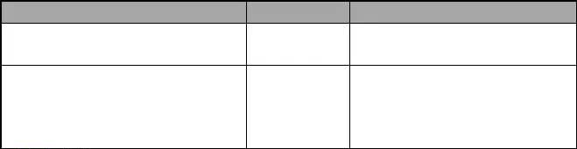
Object name
zxAnIgmpVlanId 1.3.6.1.4.1.3902.1015.31.1.1.22.1.1
Type

Integer32
zxAnMvlanAdminStatus
INTEGER
Description
[1-4094]
Multicast vlan ID
[enable(1), disable(2),drop(3) ] (Def: 1)
1.3.6.1.4.1.3902.1015.31.1.1.22.1.2
The administrative status of IGMP
packet on this MVLAN.

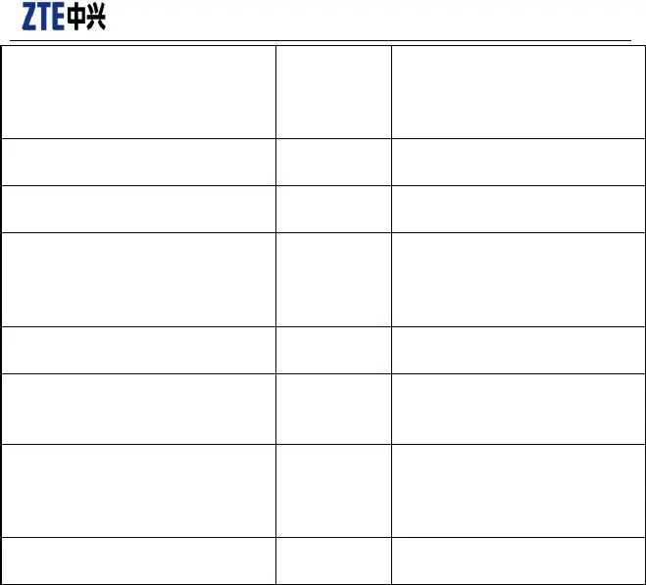
Confidential▼

zxAnMvlanWorkMode 1.3.6.1.4.1.3902.1015.31.1.1.22.1.3

zxAnMvlanNetworkSideHostIp 1.3.6.1.4.1.3902.1015.31.1.1.22.1.4
zxAnMvlanGroupFilterEnable

INTEGER

IpAddress
[igmpv1(1), igmpv2(2), igmpv3(3)] (Def: 2)
The IGMP woke mode of this MVLAN.
The host ip of this MVLAN when working on proxy mode. (Def: 0)

1.3.6.1.4.1.3902.1015.31.1.1.22.1.5 TruthValue

zxAnMvlanMaxGroups
Integer32
1.3.6.1.4.1.3902.1015.31.1.1.22.1.6

zxAnMvlanCurrActGroups

Max groups in mvlan,the value lies on the device's ability. Dsl8000 is 255, dsl9000 is 512,9800
is 1024. (Def:512)

1.3.6.1.4.1.3902.1015.31.1.1.22.1.7

zxAnMvlanPriority
Gauge32 Current active groups in mvlan

[0-7] (Def: 0)

1.3.6.1.4.1.3902.1015.31.1.1.22.1.8

zxAnMvlanHostVersion 1.3.6.1.4.1.3902.1015.31.1.1.22.1.9

zxAnMvlanRowStatus
Integer32

INTEGER
IGMP protocol packet's priority in
proxy/router mode.
[auto(1), igmpv2(2), igmpv3(3)]

(Def: 2)
Igmp version of host on proxy
mode.

1.3.6.1.4.1.3902.1015.31.1.1.21.1.20
RowStatus RowStatus

    - Multicast Group Management

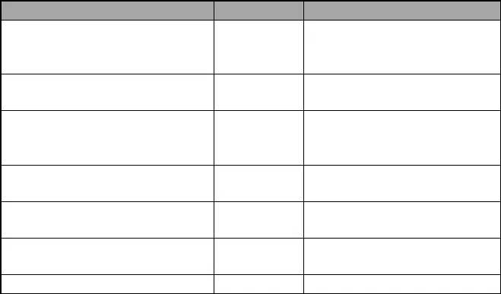
Object name
type
zxAnIgmpSrcIp
description
Multicast source IpAddress in
IpAddress
1.3.6.1.4.1.3902.1015.31.1.1.24.1.1
IGMPv3.If the device can't support
IGMPv3, this object is 0.0.0.0
zxAnIgmpGrpIp
1.3.6.1.4.1.3902.1015.31.1.1.24.1.2
IpAddress
Multicast group IpAddress.
zxAnIgmpGroupBandwidthCost
1.3.6.1.4.1.3902.1015.31.1.1.24.1.3
Estimated Bandwidth cost by this
Integer32 group,it is used as a traffic
and bandwidth control parameter.
zxAnIgmpGroupPrejoinEnable
1.3.6.1.4.1.3902.1015.31.1.1.24.1.4
zxAnIgmpGroupMaxHosts 1.3.6.1.4.1.3902.1015.31.1.1.24.1.5
zxAnIgmpGroupActHosts
TruthValue
(Def: false)
Integer32
Max User in this Multicast Group.
Integer32 Current User in this Multicast Group.
1.3.6.1.4.1.3902.1015.31.1.1.24.1.6
zxAnIgmpGroupRowStatus
RowStatus
RowStatus of this row.

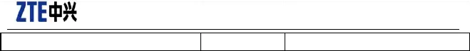
Confidential▼
1.3.6.1.4.1.3902.1015.31.1.1.24.1.15

    - Multicast Vort Management

Add and delete multicast source and receiving ports via the table.

Object name Type Description
The command to operate param list of zxAnMvlanGroupPortListTable.
Each command is related to each meaming of
zxAnMvlanGroupStaticPortList. Command operation

zxAnIgmpParamListCmd 1.3.6.1.4.1.3902.1015.31.1.1.26.1.1

INTEGER
addSrcPortToMvlan(1)
Bind source port with mvlan
delSrcPortFromMvlan(2) unbind source Port with mvlan
addRecPortToMvlan(3)
bind recievingPort with mvlan
delRecPortFromMvlan(4) unbind recievingPort with mvlan addStaticGroup(5) Bind port with Static Multicast
delStaticGroup(6) unbind port with Static Multicast
The value of object ID in param list,eg.

zxAnIgmpParamObject 1.3.6.1.4.1.3902.1015.31.1.1.26.1.2

IDENTIFIER
addSrcPortToMvlan(1) zxAnIgmpParamObject is 'mvid.ifid'
delSrcPortFromMvlan(2) zxAnIgmpParamObject is 'mvid.ifid'
addRecPortToMvlan(3) zxAnIgmpParamObject is 'mvid.ifid'
delRecPortFromMvlan(4) zxAnIgmpParamObject is 'mvid.ifid'
addStaticGroup(5) zxAnIgmpParamObject is 'mvid.srcip.gpip.ifid'
delStaticGroup(6) zxAnIgmpParamObject is 'mvid.srcip.gpip.ifid'

Confidential▼

    - Receiving Port Property Management


Object name Type Description
The logical port No,ie. layer 2 bridge

zxAnIgmpIfIndex
1.3.6.1.4.1.3902.1015.31.1.1.21.1.1

zxAnIgmpPortAdminStatus 1.3.6.1.4.1.3902.1015.31.1.1.21.1.2

zxAnIgmpPortProtoVersion 1.3.6.1.4.1.3902.1015.31.1.1.21.1.3

zxAnIgmpPortFastLeaveEnable 1.3.6.1.4.1.3902.1015.31.1.1.21.1.4

zxAnIgmpPortUsage 1.3.6.1.4.1.3902.1015.31.1.1.21.1.5

zxAnIgmpDataPort 1.3.6.1.4.1.3902.1015.31.1.1.21.1.6

zxAnIgmpPortProxyIp 1.3.6.1.4.1.3902.1015.31.1.1.21.1.7

zxAnIgmpPortPacketLimit 1.3.6.1.4.1.3902.1015.31.1.1.21.1.8
zxAnIgmpPortMaxBandwidth 1.3.6.1.4.1.3902.1015.31.1.1.21.1.9
ZxAnIfindex

INTEGER

INTEGER

TruthValue

INTEGER

ZxAnIfindex

IpAddress

Integer32

Integer32
port. (ie: DSLPVC, PON_VPORT, VDSL)
[enable(1), disable(2),drop(3) ] (Def: 1)
The administrative status of port's igmp service.
[igmpv1(1), igmpv2(2), igmpv3(3)] (Def: 2)
The version of IGMP protocol which is running on this port.
The status of fast-leave property, true:enable fast leave;
false: disable fast leave.(Def: true) [all(1), igmp(2), data(3)] (Def:1)
The usage of the igmp port,igmp signalling only,data only or both signalling and data.
If the logical port indicated by zxAnIgmpIfIndex is used as igmp signaling transporting, ie. zxAnIgmpPortUsage is data(2),zxAnIgmpDataPort must be configured to indicate which port will recieve the igmp data. If the zxAnIgmpPortUsage is All(1), zxAnIgmpDataPort is same as the zxAnIgmpIfIndex. zxAnIgmpPortProxyIp is the ip of igmp proxy when zxAnIgmpWorkingMode is igmp_proxy(1). (Def: 0)
The maxium IGMP packet num can be processed in 1 second on this port, exceeding packets will be discarded. The maximum permitted traffic in this logical port. (Def: 2048)

zxAnIgmpPortMaxConcurrGroups

1.3.6.1.4.1.3902.1015.31.1.1.21.1.10
The max multicast groups supported
Integer32
by this port concurrently. (Def: 1)

zxAnIgmpPortCurrActGroups Gauge32 The active multicast groups on this

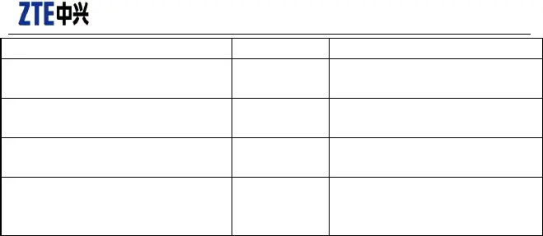
Confidential▼

1.3.6.1.4.1.3902.1015.31.1.1.21.1.11 port currentlly.

zxAnIgmpPortQueryInterval 1.3.6.1.4.1.3902.1015.31.1.1.21.1.12
zxAnIgmpPortLastMembQueryIntvl 1.3.6.1.4.1.3902.1015.31.1.1.21.1.13
zxAnIgmpPortQueryMaxResponseTime 1.3.6.1.4.1.3902.1015.31.1.1.21.1.14
zxAnIgmpPortEtherPriority 1.3.6.1.4.1.3902.1015.31.1.1.21.1.15
Integer32 Def: 125

Integer32 [0-255] (Def: 10)

Integer32 [0-255] (Def: 100)

Integer32 [0-7]
Ether priority assigned to the upstream IGMP packet on the port.

    - Query MVLAN Line Card Port List

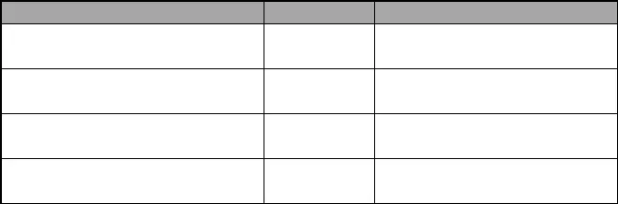
Object name
zxAnMvlanPortListShelf 1.3.6.1.4.1.3902.1015.31.1.1.23.1.1
zxAnMvlanPortListCard 1.3.6.1.4.1.3902.1015.31.1.1.23.1.2
zxAnMvlanPortSrcPortList 1.3.6.1.4.1.3902.1015.31.1.1.23.1.3
zxAnMvlanPortRecvPortList
1.3.6.1.4.1.3902.1015.31.1.1.23.1.4
Type

Integer32

Integer32
Description
The shelf that contains the logical port list.
The card that contains the logical port
list.
ZxAnPortList
Source port in mvlan
ZxAnPortList
Receiving port in mvlan

    - Query MVLAN Dynamic and Static Interfaces

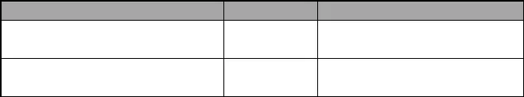
Object name Type Description zxAnIgmpGroupStaticPortList

1.3.6.1.4.1.3902.1015.31.1.1.25.1.1
zxAnIgmpGroupDynamicPortList 1.3.6.1.4.1.3902.1015.31.1.1.25.1.2
ZxAnPortList static port in a mvlan group

dynamic port in a mvlan group
ZxAnPortList

  - Port Location

    - DHCP82 Global Switch
DHCP82 global packet extracting switch: Disable / enable of DHCP82 globally. Disable-the drive doesn—t extract DHCP82 packet; Enable-extract packet.
Index Specification:

Confidential▼

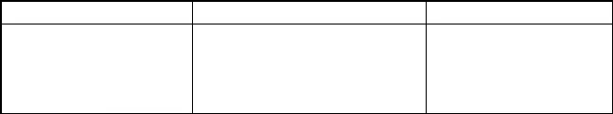
OID Specification:
MIB Variable OID Specification

zxAnPortLocatingDhcp82E nable zxAnPortLocatingDhcp82E nable_enable
1.3.6.1.4.1.3902.1015.32.21.1 INTEGER { enable
( 1 ) , disable ( 2 ) } Default value: 2.

    - DHCP82 Port Switch

DHCP82 Port Switch: DHCP82 disable / enable at the port interface level. Port disable-process the port locating information in DHCP82 message; Port enable-do not process the port locating information in DHCP82 message.
Index Specification:
Platform composite index Type 4
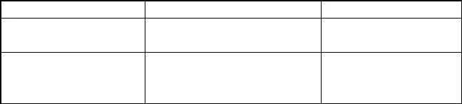
OID Specification:
MIB Variable OID Specification

zxAnPortLocatingDhcpInde x zxAnPortLocatingPortDhcp 82Enable
1.3.6.1.4.1.3902.1015.32.21.20.1.1 platform composite index
Type 4 1.3.6.1.4.1.3902.1015.32.21.20.1.2 INTEGER { enable
( 1 ) , disable ( 2 ) }.
Default value: 2.

    - PPPOE Port Switch

(config-if)#pppoe-plus enable vport 2
.1.3.6.1.4.1.3902.1015.32.40.10.1.2

    - Port Trust Status

Port Trust Status: port-level trust status. True-trust the port locating information in the uplink packet; False-not trust
Index Specification:
Platform composite index Type 4
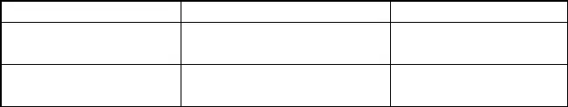
OID Specification:

MIB Variable | OID | Specification
zxAnPortLocatingDhcpIndex | 1.3.6.1.4.1.3902.1015.32.21.20.1.1 | Platform composite index  Type 4
zxAnPortLocatingPortTrust | 1.3.6.1.4.1.3902.1015.32.21.20.1.4 | INTEGER { true ( 1 ) , false  ( 2 ) }. Default value: 2.

Confidential▼

    - Port Trust Measure

Port-level trust measure: when the trust status is true, you can set trust measure as keep or replace; when the trust status is false, you can set trust measure as discard or add. Of them, keep-keep the port locating information in the uplink packet, replace-replace, discard-discard the uplink packet, add-add one port locating information again.
Index Specification:
Platform composite index Type 4
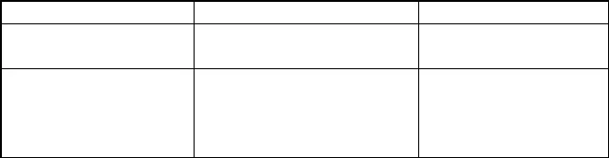OID Specification:

replace ( 2 ) , discard ( 3 ) ,
add ( 4 ) }. Default value: 4.

MIB Variable | OID | Specification
zxAnPortLocatingDhcpIndex | 1.3.6.1.4.1.3902.1015.32.21.20.1.1 | Platform composite index  Type 4
zxAnPortLocatingPortPolicy | 1.3.6.1.4.1.3902.1015.32.21.20.1.5 | INTEGER { keep ( 1 ) ,

    - Port Locating Format

Port Locating Format: configure the format of the port locating information.
Index Specification:
Platform composite index Type 4
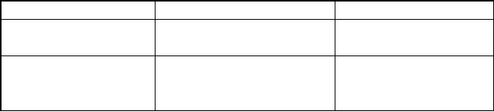
OID Specification:
MIB Variable OID Specification
zxAnPortLocatingIndex 1.3.6.1.4.1.3902.1015.32.20.1.1 Platform composite index
Type 4

zxAnPortLocatingIfaceForm at
1.3.6.1.4.1.3902.1015.32.20.1.2 china_tel, dsl_forum,
china_net, ti,
flexible_syntax, ft, gt, vf.

    - Port Remote ID Switch

RID Switch: RID disable-do not insert RID in the message; enable-insert RID in the message.
Index Specification:
Platform composite index Type 4
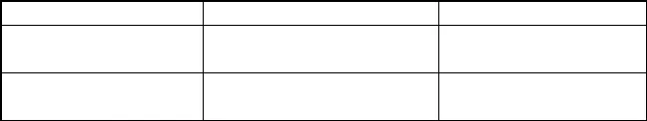OID Specification:
MIB Variable
zxAnPortLocatingIndex
OID
1.3.6.1.4.1.3902.1015.32.20.1.1
Specification
Platform
Type 4
INTEGER
composite
index
zxAnPortLocatingIfaceRem
oteIdEnable
1.3.6.1.4.1.3902.1015.32.20.1.3
{ enable ( 1 ) ,
disable ( 2 ) }

Confidential▼

    - Port Remote ID Content

Port RID Content: Configure specific content of RID, 1-64 characters.
Index Specification:
Platform composite index Type 4
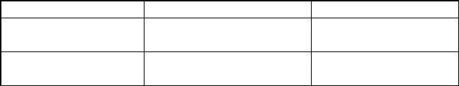OID Specification:
MIB Variable
zxAnPortLocatingIndex
OID
1.3.6.1.4.1.3902.1015.32.20.1.1
Specification
Platform
Type 4
composite
index
zxAnPortLocatingIfaceRem
oteId
1.3.6.1.4.1.3902.1015.32.20.1.4
DisplayString ( SIZE ( 0 ..
64
) )

  - DHCP SNOOPING

ZTE-AN-DHCP-SNOOPING-MIB

Confidential▼

PON Port for Public Use

  - IP Address Pool

{"zxAnXponMgmtIpAddress" , "1.3.6.1.4.1.3902.1015.1010.5.9.1.1"} ,
{"zxAnXponMgmtIpMask" , "1.3.6.1.4.1.3902.1015.1010.5.9.1.2"} ,
{"zxAnXponMgmtPriority" , "1.3.6.1.4.1.3902.1015.1010.5.9.1.3"} ,
{"zxAnXponMgmtCVlan" , "1.3.6.1.4.1.3902.1015.1010.5.9.1.4"} ,
{"zxAnXponMgmtSVlan" , "1.3.6.1.4.1.3902.1015.1010.5.9.1.5"} ,
{"zxAnXponMgmtNetworkIp" , "1.3.6.1.4.1.3902.1015.1010.5.9.1.6"} ,
{"zxAnXponMgmtNetworkMask" , "1.3.6.1.4.1.3902.1015.1010.5.9.1.7"} ,
{"zxAnXponMgmtNetworkGateway" , "1.3.6.1.4.1.3902.1015.1010.5.9.1.8"} ,
{"zxAnXponMgmtIpEnableStatus" , "1.3.6.1.4.1.3902.1015.1010.5.9.1.9"} ,
{"zxAnXponMgmtIpAssignationMode", "1.3.6.1.4.1.3902.1015.1010.5.9.1.10"} ,

Confidential▼

EPON OLT

  - ONU Management

The table is used to create and delete the ONU under a certain OLT interface, to configure the authentication mode, authentication information, etc., and to perform basic management.
OID Specification
onuAdminObjectTable—s OID is .1.3.6.1.4.1.3902.1015.1010.1.7.4.

Index Specification
{ ifIndex }, PON composite index Type 3 or 9.

MIB Specification
For detailed description, refer to ZXEPON-SERVICE-PRIVATE-MIB.mib.
Of them:

onuAuthLoid is LOID information, you can modify the LOID via setting this MIB object. onuLatelyPassDot1xAuthTime is the final authorized pass time, and it can be used as ONU
uptime.

onuAdminObjectTable OBJECT-TYPE
SYNTAX SEQUENCE OF OnuAdminObjectEntry MAX-ACCESS not-accessible
STATUS current DESCRIPTION
""
::= { privateObjects 4 }

onuAdminObjectEntry OBJECT-TYPE
SYNTAX OnuAdminObjectEntry
MAX-ACCESS not-accessible STATUS current DESCRIPTION
""
INDEX { ifIndex }
::= { onuAdminObjectTable 1}

OnuAdminObjectEntry ::= SEQUENCE {
onuDescript DisplayString,

onuSplitterSn INTEGER,
onuOpticalLineSn INTEGER,

Confidential▼

onuUserInfo DisplayString,
onuType DisplayString,
onuAdminState INTEGER,
onuAuthMACAddress MacAddress,
onuRegisterMACAddress MacAddress, onuAuthMACSn OCTET STRING,
onuRegisterSn OCTET STRING,
onuCurrentRegState INTEGER,
onuRegisterTime DisplayString,
onuCurrAdminAuthState INTEGER,
onuLatelyPassAdminAuthTime DisplayString,
onuCurrDot1xAuthState INTEGER,
onuLatelyPassDot1xAuthTime DisplayString,
onuMgmtOnlineStatus INTEGER,
onuActiveStatus INTEGER,
onuMgmtEntryStatus RowStatus, onuMgmtIpCfgMode INTEGER,
onuAuthLoid DisplayString,
onuAuthPassword DisplayString,
onuRegisterLoid DisplayString,
onuRegisterPassword DisplayString
}

  - Unauthenticated ONU

EPON uncfg onu [ZXEPON-SERVICE-PRIVATE-MIB.mib] 6.2 Unauthenticated ONU is the whole table
.iso.org.dod.internet.private.enterprises.zte.zxAn.zxAnPonMib.zxAnEponMib.privateObjects.onuUnPa ssedAdminAuthInfoTable
.1.3.6.1.4.1.3902.1015.1010.1.7.14.1

  - FEC Configuration

zxGponFECMode @ zxGponservice.mib
.1.3.6.1.4.1.3902.1012.3.11.3.1.1

Confidential▼

EPON ONU

  - ONU Remote Operation

OID Specification
zxAnEponOnuActionTable—s OID is .1.3.6.1.4.1.3902.1015.1010.1.1.2.1.

Index Specification
{ zxAnEponOnuIfIndex}, is PON composite index Type 3 or 9.

MIB Specification
For detailed description, refer to ZXANEPON-ONUMGMT-MIB.mi2.
At present, there is only one zxAnEponOnuAction object, and its role is to reset the ONU.

zxAnEponOnuActionTable OBJECT-TYPE
SYNTAX SEQUENCE OF ZxAnEponOnuActionEntry MAX-ACCESS not-accessible
STATUS current DESCRIPTION
"Update ONU parameters during run-time."
::= { zxAnEponOnuExtendedActionMgmt 1 }

zxAnEponOnuActionEntry OBJECT-TYPE SYNTAX ZxAnEponOnuActionEntry MAX-ACCESS not-accessible
STATUS current DESCRIPTION " "
INDEX { zxAnEponOnuIfIndex}
::= { zxAnEponOnuActionTable 1 }

ZxAnEponOnuActionEntry ::= SEQUENCE {
zxAnEponOnuAction INTEGER
}

Confidential▼

  - LAN port

    - Port Status

Index Specification
Type 3—s PON composite index and port No.

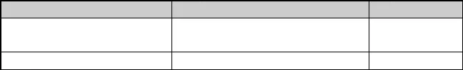
OID Specification

MIB Variable | OID | Specification
zxAnEponOnuPhyAdminState | .1.3.6.1.4.1.3902.1015.1010.1.1.3.1.1.1 | Management
zxAnEponOnuEthPortLinkState | .1.3.6.1.4.1.3902.1015.1010.1.1.1.5.1.2 | status  Online status

- zxAnEponOnuPhyAdminState definition

      - disable
      - enable

- zxAnEponOnuEthPortLinkState definition

- down
- up

    - Auto-Negotiation Status

Index Specification
Type 3—s PON composite index and port No.

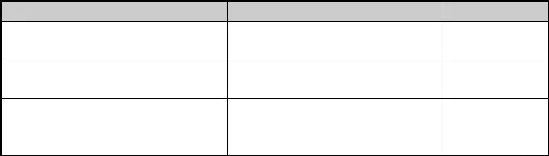
OID Specification

MIB Variable | OID | Specification
zxAnEponOnuAutoNegAdminState | .1.3.6.1.4.1.3902.1015.1010.1.1.3.2.1.1 | Enable  auto-negotiation
zxAnEponOnuAutoNegCapability | .1.3.6.1.4.1.3902.1015.1010.1.1.3.2.1.2 | Auto-negotiation  capacity
zxAnEponOnuAutoNegCapAdvertised | .1.3.6.1.4.1.3902.1015.1010.1.1.3.2.1.3 | Auto-negotiation
advertisement
capacity

Confidential▼

- zxAnEponOnuAutoNegAdminState definition

- disable
- enable

- Meaning that each BIT of zxAnEponOnuAutoNegCapability indicates

zx-GLOBAL ( 0 ) ,
zx-OTHER ( 1 ) ,
zx-UNKNOWN ( 2 ) , zx-10BASE-T ( 3 ) ,
zx-10BASE-TFD ( 4 ) , zx-100BASE-T4 ( 5 ) , zx-100BASE-TX ( 6 ) ,
zx-100BASE-TXFD ( 7 ) , zx-FDX-PAUSE ( 8 ) ,
zx-FDX-APAUSE ( 9 ) , zx-FDX-SPAUSE ( 10 ) , zx-FDX-BPAUSE ( 11 ) , zx-100BASE-T2 ( 12 ) ,
zx-100BASE-T2FD ( 13 ) , zx-1000BASE-X ( 14 ) ,
zx-1000BASE-XFD ( 15 ) , zx-1000BASE-T ( 16 ) ,
zx-1000BASE-TFD ( 17 ) , zx-REM-FAULT1 ( 18 ) , zx-REM-FAULT2 ( 19 ) ,
zx-ISO-ETHERNET ( 20 ) }

- Meaning that each BIT of zxAnEponOnuAutoNegCapAdvertised indicates

zx-GLOBAL ( 0 ) ,
zx-OTHER ( 1 ) ,
zx-UNKNOWN ( 2 ) , zx-10BASE-T ( 3 ) ,
zx-10BASE-TFD ( 4 ) , zx-100BASE-T4 ( 5 ) , zx-100BASE-TX ( 6 ) ,
zx-100BASE-TXFD ( 7 ) , zx-FDX-PAUSE ( 8 ) ,
zx-FDX-APAUSE ( 9 ) ,

zx-FDX-SPAUSE ( 10 ) , zx-FDX-BPAUSE ( 11 ) ,

Confidential▼

zx-100BASE-T2 ( 12 ) ,
zx-100BASE-T2FD ( 13 ) , zx-1000BASE-X ( 14 ) ,
zx-1000BASE-XFD ( 15 ) , zx-1000BASE-T ( 16 ) ,
zx-1000BASE-TFD ( 17 ) , zx-REM-FAULT1 ( 18 ) , zx-REM-FAULT2 ( 19 ) ,
zx-ISO-ETHERNET ( 20 ) }

    - Port VLAN Mode

Index Specification
Type 3's PON composite index and port No.

OID Specification

MIB Variable
zxAnEponOnuVlanMode
OID
.1.3.6.1.4.1.3902.1015.1010.1.1.1.10.1.1.1
Specification

- zxAnEponOnuVlanMode definition
- Transparent transmission mode
- Tag mode
- Translation mode
- Trunk mode
- Hybrid mode

    - Tag VLAN
Index Specification
Type 3's PON composite index and port No.

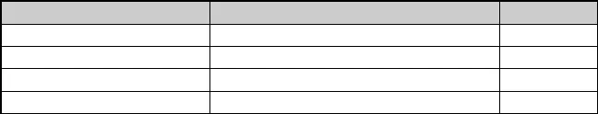
OID Specification

MIB Variable | OID | Specification
zxAnEponOnuVlanTagVid | .1.3.6.1.4.1.3902.1015.1010.1.1.1.10.2.1.1 | VID
zxAnEponOnuVlanTagTpid | .1.3.6.1.4.1.3902.1015.1010.1.1.1.10.2.1.2 | TPID
zxAnEponOnuVlanTagCfi | .1.3.6.1.4.1.3902.1015.1010.1.1.1.10.2.1.3 | CFI
zxAnEponOnuVlanPriority | .1.3.6.1.4.1.3902.1015.1010.1.1.1.10.2.1.4 | Priority

Confidential▼

    - Translation VLAN

Translation VLAN mode's port can configure multiple translation VLAN entries.
Index Specification
Type 3's PON composite index, port NO. and SN (start from 1).

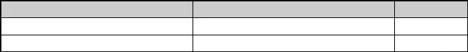
OID Specification

MIB Variable | OID | Specification
zxAnEponOnuVlanTransOriginalTag | .1.3.6.1.4.1.3902.1015.1010.1.1.1.10.3.1.2 | Old VLAN
zxAnEponOnuVlanTransNewTag  7.2.6 Trunk VLAN | .1.3.6.1.4.1.3902.1015.1010.1.1.1.10.3.1.3 | New VLAN

Index Specification
Type 3's PON composite index and port No.

OID Specification

MIB Variable OID Specification zxAnEponOnuVlanTrunkModeVlan .1.3.6.1.4.1.3902.1015.1010.1.1.1.10.4.1.1 VLAN list

    - Hybrid VLAN

Index Specification
Type 3's PON composite index and port No.

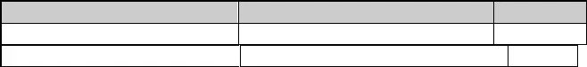
OID Specification

MIB Variable | OID | Specification
zxAnEponOnuVlanTrunkModeVlan | .1.3.6.1.4.1.3902.1015.1010.1.1.1.10.4.1.1 | VLAN list
zxAnEponOnuVlanTagVid | .1.3.6.1.4.1.3902.1015.1010.1.1.1.10.2.1.1 | VID

    - Port Receiving and Sending Byte Numbers

Both sending byte number and receiving byte number are 32-bit integer without a symbol, and are accumulative amount. The port's receiving rate and sending rate can be got through calculating receiving byte number in a period of time ó time.

Confidential▼

Index Specification
Type 3's PON composite index and port No.

OID Specification
MIB Variable | OID | Specification
parameter1 | .1.3.6.1.4.1.3902.1015.1010.1.1.7.1.1.2 | Receiving byte number
parameter6 | .1.3.6.1.4.1.3902.1015.1010.1.1.7.1.1.7 | Sending byte number

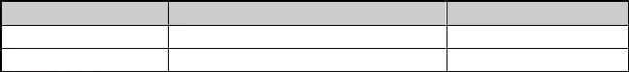
    - Port Traffic Control

Ethernet port traffic control

Index Specification
Type 3's PON composite index and port No.

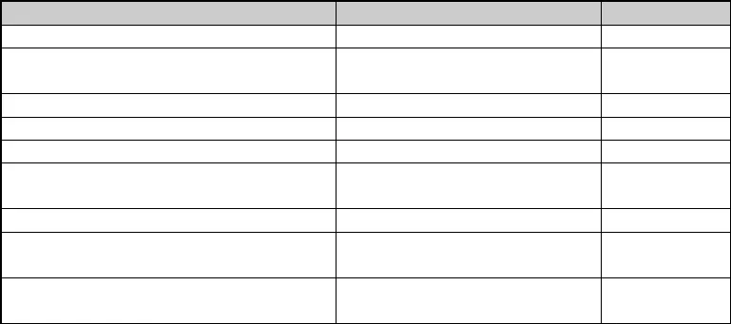OID Specification
ream
Stream

MIB Variable | OID | Specification
zxAnEponOnuPortBackPressure | .1.3.6.1.4.1.3902.1015.1010.1.1.1.6.1.1 | Traffic control
zxAnEponOnuPortPolicing | .1.3.6.1.4.1.3902.1015.1010.1.1.1.7.1.1 | Uplink traffic  policing
zxAnEponOnuPortPolicingCir | .1.3.6.1.4.1.3902.1015.1010.1.1.1.7.1.2 | Uplink CIR
zxAnEponOnuPortPolicingBucketDepth | .1.3.6.1.4.1.3902.1015.1010.1.1.1.7.1.3 | Uplink CBS
zxAnEponOnuPortPolicingExtraBurstSize | .1.3.6.1.4.1.3902.1015.1010.1.1.1.7.1.4 | Uplink EBS
zxAnEponOnuPortPolicingDownStream | .1.3.6.1.4.1.3902.1015.1010.1.1.1.7.1.5 | Downlink traffic
 |  | policing
zxAnEponOnuPortPolicingCirDownStream | .1.3.6.1.4.1.3902.1015.1010.1.1.1.7.1.6 | Downlink CIR
zxAnEponOnuPortPolicingBucketDepthDownSt | .1.3.6.1.4.1.3902.1015.1010.1.1.1.7.1.7 | Downlink CBS
zxAnEponOnuPortPolicingExtraBurstSizeDown | .1.3.6.1.4.1.3902.1015.1010.1.1.1.7.1.8 | Downlink EBS

- zxAnEponOnuPortBackPressure definition
      - deactive
      - active

- zxAnEponOnuPortPolicing definition
- deactive
- active

- zxAnEponOnuPortPolicingDownStream definition

Confidential▼

- deactive
- active

  - Multicast VLAN

multicast vlan port eth_0/2 add vlanlist 40

Name: zxAnEponOnuMulticastVlanTable
Type: OBJECT-TYPE
OID: 1.3.6.1.4.1.3902.1015.1010.1.1.1.12
Full path:
iso(1).org(3).dod(6).internet(1).private(4).enterprises(1).zte(3902).zxAn(1015).z xAnPonMib(1010).zxAnEponMib(1).zxAnEponOnuRemoteMgmt(1).zxAnEponOnuExtendedAttrMg mt(1).zxAnEponOnuMulticastVlanTable(12)
Module: ZXANEPON-ONUMGMT-MIB

Status: current
Max access: not-accessible
Sequences: 1: zxAnEponOnuMulticastVlanAction - INTEGER(2 - integer (32 bit)) 2: zxAnEponOnuMulticastVlanList - OCTET STRING(4 - octets)

  - VOIP

  - ONU E1 port

    - Port Management Status

Index Specification
Type 3's PON composite index and port No.

OID Specification

MIB Variable
zxAnEponOnuE1PortEnable
OID
.1.3.6.1.4.1.3902.1015.1010.1.1.1.9.1.1
Specification

- zxAnEponOnuE1PortEnable definition
- disable
- enable

Confidential▼

  - POTS Port Management

    - Port Management Status

Index Specification
Type 3's PON composite index and port No.

OID Specification

MIB Variable
zxAnEponOnuVoipPortEnable
OID
.1.3.6.1.4.1.3902.1015.1010.1.1.1.8.1.1
Specification

- zxAnEponOnuVoipPortEnable definition
- disable
- enable

  - ONU Fiber Length

View the fiber length between the OLT and ONU

Index Specification
{ ifIndex }, Type 3 or 9 PON composite index.

OID Specification
For details, refer to ZXEPON-SERVICE-MIB.mib dot3MpcpStatTable, the table's OID is .1.3.6.1.4.1.3902.1015.1010.1.2.1.
MIB Variable
dot3MpcpRoundTripTime
OID
.1.3.6.1.4.1.3902.1015.1010.1.2.1.1.10
Specification

- dot3MpcpRoundTripTime
dot3MpcpRoundTripTimeindicates RoundTrip time between the OLT and ONU Fiber length = dot3MpcpRoundTripTim * 1.635 / 1000

  - ONU Version and Model

ONU model, software version, hardware version, etc.

Index Specification

Confidential▼

Type 3's PON composite index

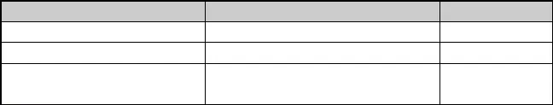
OID Specification

MIB Variable | OID | Specification
zxAnEponOnuModel | .1.3.6.1.4.1.3902.1015.1010.1.1.1.1.1.3 | ONU model
zxAnEponOnuSoftwareVersion | .1.3.6.1.4.1.3902.1015.1010.1.1.1.1.1.6 | Software version
zxAnEponOnuHardwareVersion | .1.3.6.1.4.1.3902.1015.1010.1.1.1.1.1.5 | Hardware  version

Confidential▼

GPON OLT

  - ONU Management

Refer to zxGponOntDevMgmtTable defined in zxGponService.mib. It is used to create and delete the ONU under a certain OLT interface, to configure the authentication mode, authentication information, etc., and to perform basic management.
Of them, zxGponOntRegId corresponds to PW, LOID authentication information, which can be modified via modifying the field.

Name Oid Range Description

zxGponOntDevMgmtTypeNa me zxGponOntDevMgmtProvisio
nSn zxGponOntDevMgmtEntrySta
tus
.1.3.6.1.4.1.3902.10
12.3.28.1.1.1
.1.3.6.1.4.1.3902.10

12.3.28.1.1.5
.1.3.6.1.4.1.3902.10
12.3.28.1.1.9
STRING ( SIZE ( 0 .. 64 ) )

( SIZE ( 8 ) )

SN configured by Olt for the purpose of register

regModeSn(1), regModePw(2),
regModeSnPlusPw(3),



zxGponOntRegMode

.1.3.6.1.4.1.3902.10
12.3.28.1.1.12

regModeRegisterId(4),

regModeRegisterIdPlus8021x( 5),

regModeRegisterIdPlusMutual (6),

regModeTefPw(7), regModeSnPlusTefPw(8), regModeLoid(9), regModeLoidPlusPw(10)
This object indicates the onu registration mode,'regModePwAutoBindSn' mode s is an extension of 'regModePw'. 'regModePwAutoBindSn'
mode indicates serial number will binds password automatically.

Confidential▼

  - ONU Status

Name: zxGponOntPhaseState
OID: .1.3.6.1.4.1.3902.1012.3.28.2.1.4
Description:
INTEGER { logging ( 0 ) , los ( 1 ) , syncMib ( 2 ) , working ( 3 ) , dyinggasp ( 4 ) , authFailed ( 5 ) , offline ( 6 ) }

  - T-CONT Profile

Refer to zxGponBandwidthProfileTable defined in zxGponService.mib.

Name Oid Range Description
.1.3.6.1.4.1.3902.1012

zxGponBWProfileIndex

zxGponBWProfileName zxGponBWProfileFixed
zxGponBWProfileAssur
ed
zxGponBWProfileMaxi
.3.26.1.1.1
.1.3.6.1.4.1.3902.1012
.3.26.1.1.2
.1.3.6.1.4.1.3902.1012
.3.26.1.1.3
.1.3.6.1.4.1.3902.1012
.3.26.1.1.4
.1.3.6.1.4.1.3902.1012

( SIZE ( 0 ..
64 ) )

mum

zxGponBWProfileType

zxGponBWProfileEntry Status
.3.26.1.1.5

 | { type1 | ( 1 ) ,
.1.3.6.1.4.1.3902.1012 | type2 ( 2 ) | , type3
.3.26.1.1.6 | ( 3 ) , type4 | ( 4 ) ,
 | type5 ( 5 ) }
.1.3.6.1.4.1.3902.1012
.3.26.1.1.8

  - Gemport Traffic Profile

Refer to zxGponTrafficProfileTable defined in zxGponService.mib.

Name Oid Range Description

ndex
zxGponTrafficProfileI

zxGponTrafficProfile
.1.3.6.1.4.1.3902.1012.3.26
.2.1.1
.1.3.6.1.4.1.3902.1012.3.26

( SIZE ( 0 ..

Name
.2.1.2
64 ) )

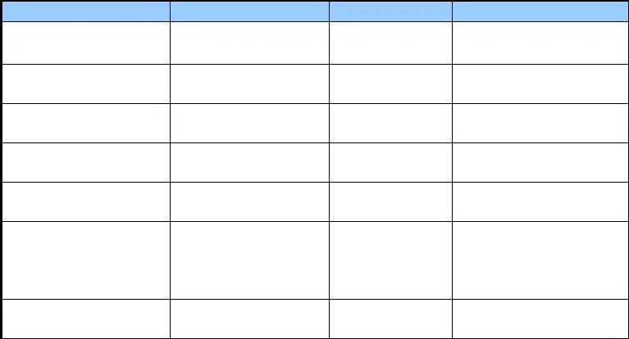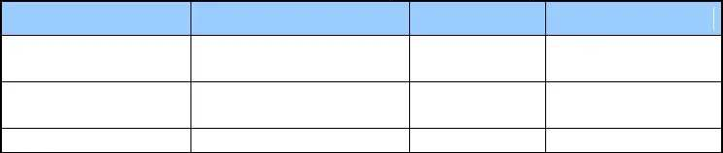zxGponTrafficProfileS .1.3.6.1.4.1.3902.1012.3.26

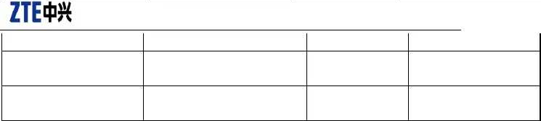
Confidential▼
ir
zxGponTrafficProfileP
ir
zxGponTrafficProfile EntryStatus
.2.1.3
.1.3.6.1.4.1.3902.1012.3.26
.2.1.4
.1.3.6.1.4.1.3902.1012.3.26
.2.1.6

  - T-CONT

Refer to zxOnuTrafficMgmtUnitTable defined in zxGponService.mib.

Name Oid Range Description
An arbitrary(unique) integer

zxOnuTrafficMgmtUnitTcont
Idx

zxOnuTrafficMgmtUnitTcont

UpBWIdxPtr zxOnuTrafficMgmtUnitEntry Status
.1.3.6.1.4.1.3902.1012.3.30
.1.1.1

.1.3.6.1.4.1.3902.1012.3.30

.1.1.3
.1.3.6.1.4.1.3902.1012.3.30
.1.1.8
for identifying an entry
in the table, from 1 to N.
This attribute is the index of template used by T-CONT BW configuration.
This entry can be create modified and delete.

  - GEM-Port

Refer to zxGponGemPortTable defined in zxGponService.mib.

Name Oid Range Description
An arbitrary(unique) integer

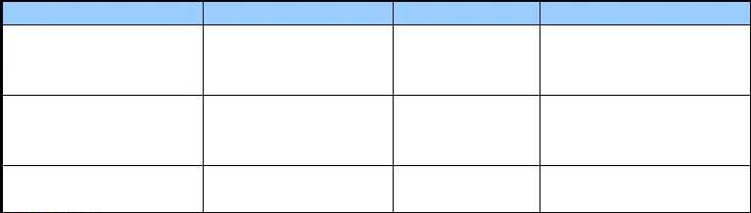
zxGponGemPortIdx

zxGponGemPortName

zxGponGemPortType

zxGponGemPortTcontIdx

zxGponGemPortEntryStatus
.1.3.6.1.4.1.3902.1012.3.30
.2.1.1

.1.3.6.1.4.1.3902.1012.3.30
.2.1.2

.1.3.6.1.4.1.3902.1012.3.30
.2.1.3

.1.3.6.1.4.1.3902.1012.3.30
.2.1.4

.1.3.6.1.4.1.3902.1012.3.30
.2.1.10

( SIZE ( 0 .. 64 ) )

{ unicast ( 1 ) , multicast ( 2 ) }
for identifying an entry
in the table. It is the virtual portid index
This attribute specifies the name of the GEM port.
This attribute specifies the type of the GEM port. Only 'unicast' is supported at present.
It is equal to the 'zxOnuTrafficMgmtUnitTcontI dx' of
'zxOnuTrafficMgmtUnitTable'. This entry can be create modified and delete.

Confidential▼

  - Gemport Traffic Limit

Refer to zxGponGemPortLimitRateTable defined in zxGponService.mib.


Name Oid Range Description
The GEM PORT

zxGponGemPortLimitUpTrafficPtr

zxGponGemPortLimitDownTrafficPtr
.1.3.6.1.4.1.3902.1012.
3.30.3.1.1

.1.3.6.1.4.1.3902.1012.
3.30.3.1.2
upstream traffic descriptor profile.
The GEM PORT
downstream traffic descriptor profile.

  - VLAN (Service Port)

Refer to zxAnServicePortConfTable defined in ZTE-AN-SERVICEPORT-MIB.mib.

Name Oid Range Description 1.3.6.1.4.1.3902.1015.8.

zxAnServicePortServiceMode

zxAnUserInVid zxAnUserOutCVid zxAnUserOutSVid zxAnServicePortRowStatus
1.1.1.4
1.3.6.1.4.1.3902.1015.8.
1.1.1.5
1.3.6.1.4.1.3902.1015.8.
1.1.1.9
1.3.6.1.4.1.3902.1015.8.
1.1.1.10
1.3.6.1.4.1.3902.1015.8.
1.1.1.100
1-15

0-4094

0-4094

0-4094

  - Un-configured ONU

Please refer to zxGponUnCfgSnOntInfoTable defined in zxGponService.mib.

Name Oid Range Description zxGponUnCfgSnIdx .1.3.6.1.4.1.3902.1012.3.13.3.1.1

zxGponUnCfgSnOntSN .1.3.6.1.4.1.3902.1012.3.13.3.1.2
( SIZE
( 8 ) )

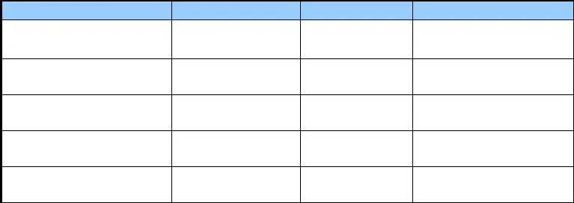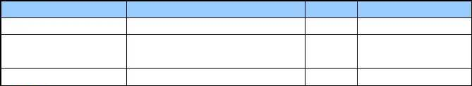zxGponUnCfgSnOntRID .1.3.6.1.4.1.3902.1012.3.13.3.1.3 STRING The register ID of the

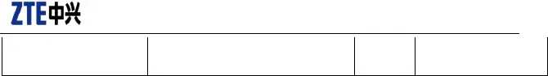
Confidential▼
( SIZE un-configured ONT. ( 4 ) )

This table is read only, and is used to get uncfg ONT SN information.

  - Traffic-profile
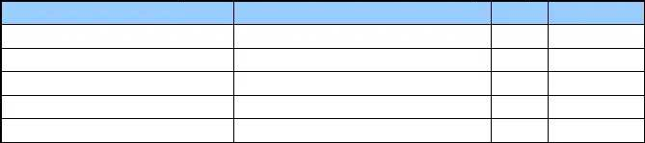
Please refer to zxAnQos3TrafficConfigTable defined in ZTE-AN-QOS3-MIB.mib

Name | Oid | Range | Description
zxAnQos3TrafficConfigTable | .1.3.6.1.4.1.3902.1015.21.4.6.2
zxAnQos3TrafficConfigEntry | .1.3.6.1.4.1.3902.1015.21.4.6.2.1
zxAnQos3TrafficPrf | .1.3.6.1.4.1.3902.1015.21.4.6.2.1.2
zxAnQos3TrafficDirection | .1.3.6.1.4.1.3902.1015.21.4.6.2.1.1
zxAnQos3TrafficConfigRowStatus | .1.3.6.1.4.1.3902.1015.21.4.6.2.1.20

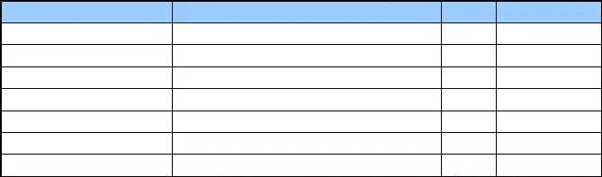
The relationship between profile and ONU interface

Name | Oid | Range | Description
zxAnQos3Rack | .1.3.6.1.4.1.3902.1015.21.4.3.1.1.1
zxAnQos3Shelf | .1.3.6.1.4.1.3902.1015.21.4.3.1.1.2
zxAnQos3Slot | .1.3.6.1.4.1.3902.1015.21.4.3.1.1.3
zxAnQos3Port | .1.3.6.1.4.1.3902.1015.21.4.6.2.1.4
zxAnQos3Onu | .1.3.6.1.4.1.3902.1015.21.4.6.2.1.5
zxAnQos3VCircuitType | .1.3.6.1.4.1.3902.1015.21.4.3.1.1.6
zxAnQos3LogicalId | .1.3.6.1.4.1.3902.1015.21.4.3.1.1.7

Confidential▼

GPON ONU

  - Service

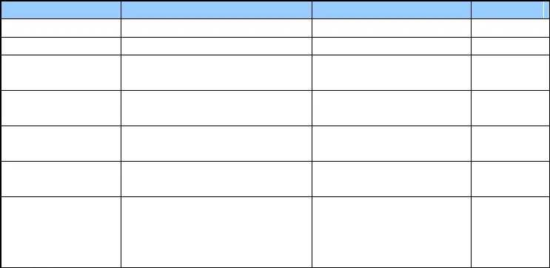
Via creating the mapping from serviceConfigure user flow to gemport, refer to zxGponServiceTable defined in zxGponOntMgmt.mib.

Name | Oid | Range | Description
zxGponServiceIndex | .1.3.6.1.4.1.3902.1012.3.50.11.1.1.1
zxGponServiceName | .1.3.6.1.4.1.3902.1012.3.50.21.1.1.2 | STRING ( SIZE ( 1 .. 32 ) )

zxGponServiceType .1.3.6.1.4.1.3902.1012.3.50.21.1.1.2

zxGponServiceGemPo
.1.3.6.1.4.1.3902.1012.3.50.21.1.1.4
rt
zxGponServiceMapTy
internet(1),iptv(2),voip(3),inter net-iptv(4),hybrid(5)

pe zxGponServiceMapVl
an

zxGponServiceEntryS tatus
.1.3.6.1.4.1.3902.1012.3.50.21.1.1.5 cos(1), vlan (2),cos-vlan (3)

.1.3.6.1.4.1.3902.1012.3.50.21.1.1.7 STRING(SIZE(24))

.1.3.6.1.4.1.3902.1012.3.50.11.1.1.1 2 bytes

This entry can be create modified and delete.

  - LAN Port

    - Port Management

Refer to zxGponPptpEthUNITable defined in zxGponOntMgmt.mib.
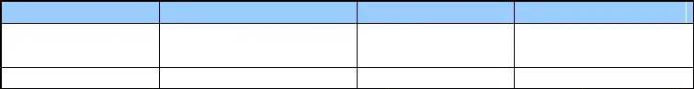
Name
zxGponPptpEthUNIAd minState
Oid
1.3.6.1.4.1.3902.1012.3.50.14.
1.1.5
Range
Description

    - Traffic Management

Confidential▼

  - LAN Port VLAN

Please refer to following tables defined in zxGponOntMgmt.mib. Add and delete ONU UNI port—s VLAN via configuring following tables.

Configuring ONU user port—s vlan filter usually concerns two MIB tables, for the meaning of each MIB variable, refer to definitions in the MIB file:

{"zxGponVlanPortTable" , "1.3.6.1.4.1.3902.1012.3.50.15.100.1"} ,
{"zxGponVlanPortEntry" , "1.3.6.1.4.1.3902.1012.3.50.15.100.1.1"} ,
{"zxGponVlanPortType" , "1.3.6.1.4.1.3902.1012.3.50.15.100.1.1.1"} ,
{"zxGponVlanPortIndex" , "1.3.6.1.4.1.3902.1012.3.50.15.100.1.1.2"} ,
{"zxGponVlanPortMode" , "1.3.6.1.4.1.3902.1012.3.50.15.100.1.1.3"} ,
{"zxGponVlanPortPvid" , "1.3.6.1.4.1.3902.1012.3.50.15.100.1.1.4"} ,

{"zxGponVlanPortConfVlanCmdTable", "1.3.6.1.4.1.3902.1012.3.50.15.100.2"} ,
{"zxGponVlanPortConfVlanCmdEntry", "1.3.6.1.4.1.3902.1012.3.50.15.100.2.1"} ,
{"zxGponVlanPortConfVlanCmd" , "1.3.6.1.4.1.3902.1012.3.50.15.100.2.1.1"} ,
{"zxGponVlanPortConfVlanId" , "1.3.6.1.4.1.3902.1012.3.50.15.100.2.1.2"} ,

In the following, take the configuration of gpon-onu_1/3/1:1 eth_0/1 to specify:

- Transparent transmission mode:

ZXAN(gpon-onu-mng)#show onu running config gpon-onu_1/3/1:1 pon-onu-mng gpon-onu_1/3/1:1
vlan port eth_0/1 mode transparent
／

The corresponding MIB configuration is:

snmpset -v2c -c public ipaddr .1.3.6.1.4.1.3902.1012.3.50.15.100.1.1.3 i 4

- Trunk mode:

ZXAN(gpon-onu-mng)#show onu running config gpon-onu_1/3/1:1 pon-onu-mng gpon-onu_1/3/1:1
vlan port eth_0/1 mode trunk vlan port eth_0/1 vlan 100
／

The corresponding MIB operation:

snmpset -v2c -c public ipaddr .1.3.6.1.4.1.3902.1012.3.50.15.100.1.1.3 i 2

Confidential▼

snmpset -v2c -c public ipaddr .1.3.6.1.4.1.3902.1012.3.50.15.100.2.1.1.268632320.2.1.1 i 1 .1.3.6.1.4.1.3902.1012.3.50.15.100.2.1.2.268632320.2.1.1 i 100

Other vlan processing modes are similar. Try to configure according to MIB definition by yourselves.

    - ZxGponVlanPortTable


Name Oid Range Description ethuni(1),
gemport-unicast(2),

zxGponVlanPortType

zxGponVlanPortIndex

zxGponVlanPortMode
.1.3.6.1.4.1.3902.1012.3.50
.15.100.1.1.1

.1.3.6.1.4.1.3902.1012.3.50
.15.100.1.1.2

.1.3.6.1.4.1.3902.1012.3.50
.15.100.1.1.3

.1.3.6.1.4.1.3902.1012.3.50
gemport-multicast(3), wifiuni(4),
veip(5), wan(6)

4 bytes

iaccess(1),trunk(2), hybrid(3),transparent( 4), na(5)
This attribute indicates the type of port

This attribute indicates the port index.
For eth UNI: The third byte specifies the slot Id associated with this UNI; the forth byte specifies the port Id associated with this UNI.
For flow: The forth byte specifies the flow Id.(4 bytes)
For IPHost: The third and forth bytes provides a unique number for each instance of this managed entity.

the access mode of the port

zxGponVlanPortPvid

zxGponVlanPortDefa ultPriority
.15.100.1.1.4
.1.3.6.1.4.1.3902.1012.3.50
.15.100.1.1.5
1..4094 the pvid of the port

0..7 the default priority of the port

    - ZxGponVlanPortConfVlanCmdTable

Name
zxGponVlanPortConf VlanCmd
Oid
.1.3.6.1.4.1.3902.1012.3.50
.15.100.2.1.1
Range
addTaggedVlan(1),
Description
The command to operate Vlan list of


Confidential▼

zxGponVlanPortConf VlanId

.1.3.6.1.4.1.3902.1012.3.50
.15.100.2.1.2
delTaggedVlan(2), zxGponVlanPortConfTable.Each
command is related to each meaming of
zxGponVlanPortConfVlanObjNa me.
The value of object name in Vlan list,eg.pkgName,chanName.Differ ent command has different
operated Vlan list,so this object
1..4094
has different meanings.please see
the DESCRIPTION of zxGponVlanPortConfVlanListCm d.

Confidential▼

    - ZxGponVlanTranslateTable

Name  zxGponVlanTranslate | Oid  .1.3.6.1.4.1.3902.1012.3.50
VlanId | .15.100.3.1.1
zxGponVlanTranslate | .1.3.6.1.4.1.3902.1012.3.50
Priority | .15.100.3.1.2
zxGponVlanTranslate | .1.3.6.1.4.1.3902.1012.3.50
CVlanId | .15.100.3.1.3
zxGponVlanTranslate | .1.3.6.1.4.1.3902.1012.3.50
CVlanPriority | .15.100.3.1.4
zxGponVlanTranslate | .1.3.6.1.4.1.3902.1012.3.50
SVlanId | .15.100.3.1.5
zxGponVlanTranslate | .1.3.6.1.4.1.3902.1012.3.50
SVlanPriority | .15.100.3.1.6
zxGponVlanTranslate | .1.3.6.1.4.1.3902.1012.3.50
RowStatus | .15.100.3.1.7

  - 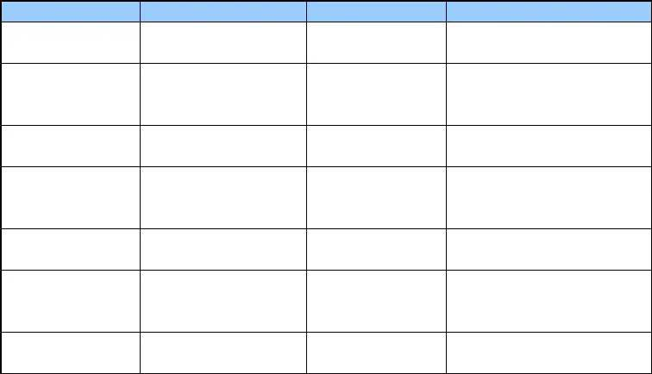Multicast VLAN
Range
Description
1 .. 4094
VlanId for Vlan translate.

Priority for Vlan translate,the
0..8 scope of priority is from 0 to 8
and '8' indicates no configuration.
Inner VLAN for Vlan translate,'0'
0..4094
indicates no translation.
Inner VLAN priority for Vlan
0..8
translate,'8'
translation.
indicates
no
0..4094

0..8
Outer VLAN for Vlan translate,'0'
indicates no SVLAN.
Outer VLAN priority for Vlan translate,'8' indicates copy priority from inner VLAN priority.
This object indicates the status of
this entry

Please refer to zxGponMCastVlanTable defined in zxGponOntMgmt.mib.

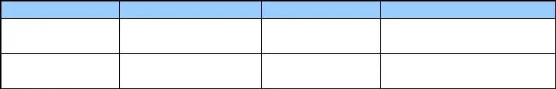
Name Oid Range Description
.1.3.6.1.4.1.3902.1012.3.50.

zxGponMCastVlanId

zxGponMCastVlanEn tryStatus
15.24.1.1
.1.3.6.1.4.1.3902.1012.3.50.
15.24.1.2

  - VOIP

Please refer to zxGponOntMgmt.mib.

Confidential▼

    - IP Host

Please refer to zxGponIPHostConfigDataTable defined in zxGponOntMgmt.mib.

Name Oid Range Description
This attribute provides a unique number for each instance of this managed

zxGponIPHostConfigDataId

zxGponIPHostConfigDataIP Address

zxGponIPHostConfigDataIP Mask
.1.3.6.1.4.1.3902.1012.3.50
.11.1.1.1

.1.3.6.1.4.1.3902.1012.3.50
.16.1.1.5

.1.3.6.1.4.1.3902.1012.3.50
.16.1.1.6
(1~n) read-only

IpAddress 4 bytes

IpAddress 4 bytes
entity.
The ONT creates as many instances as there are independent IP stacks on the ONT.
Address used for all IP services hosted by the ONT, and has a default value of 0x0 [not set].
If this value is set, it will override any values returned in DHCP.
Subnet mask for the IP services hosted by the ONT, and has a default value of 0x0 [not set].
If this value is set, it will override any values returned in DHCP.



zxGponIPHostConfigDataGa teway

.1.3.6.1.4.1.3902.1012.3.50
.16.1.1.7

IpAddress 4 bytes
Default Gateway Address used for all IP services hosted by
the ONT, and has a default value of 0x0 [not set].
If this value is set, it will override any values returned in DHCP.

Confidential▼

    - VoIP Protocol Configuration

Name Oid Range Description 0x00 = None

zxGponVoIPConfigDa taSignalProtocolUsed

.1.3.6.1.4.1.3902.1012.3.
50.17.2.1.2
0x01 = SIP
0x02 = H.248
0x03 = MGCP
0xFF = Selected by Non-OMCI Management Interface
This attribute identifies the type of VoIP signaling protocol used for ONT.
Only one type of protocol is allowed

    - SIP Agent

Name Oid Range Description
This attribute provides a

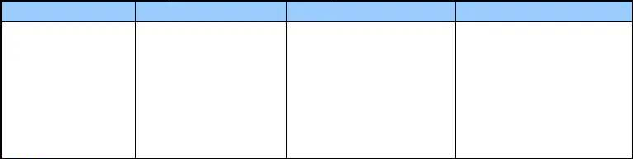zxGponSIPAgentConfigData Id

zxGponSIPAgentConfigData ProxyServer

zxGponSIPAgentConfigData PrimaryDNS

zxGponSIPAgentConfigData UDPTCPPort

zxGponSIPAgentConfigData HostId
.1.3.6.1.4.1.3902.1012.3.50
.17.3.1.1

.1.3.6.1.4.1.3902.1012.3.50
.17.3.1.2

.1.3.6.1.4.1.3902.1012.3.50
.17.3.1.4

.1.3.6.1.4.1.3902.1012.3.50
.17.3.1.6

.1.3.6.1.4.1.3902.1012.3.50
.17.3.1.7

(1~n) (2 bytes)

STRING(SIZE(0..12 8))

4 bytes

2 bytes

2 bytes
unique number for each instance of this managed entity.
This attribute provides a pointer to a LargeString ME that contains the name (IP address or URI) of the SIP Proxy Server for SIP signaling messages.
This attribute defines the Primary SIP DNS IP Address. If this value is zero, the Primary SIP DNS should not be used. Default value of 0.
This attribute indicates the UDP/TCP port num.
This attribute associates the SIP Agent with the TCP/UDP service to be used for communication with the SIP Server.Default value is 0xFFFF.
This attribute associates the SIP Agent with the TCP/UDP service to be used for

Confidential▼

zxGponSIPAgentConfigData EntryStatus

.1.3.6.1.4.1.3902.1012.3.50
.11.1.1.1

2 bytes
communication with the SIP Server.Default value is 0xFFFF.
This entry can be create modified and delete.

    - SIP User

Name Oid Range Description
This attribute provides a

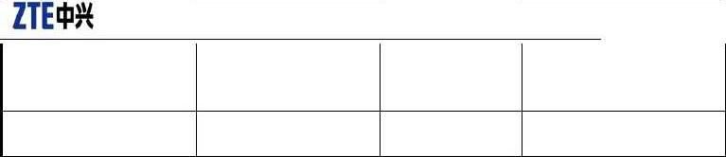
zxGponUNIIndex

zxGponSIPUserDataAgentId

zxGponSIPUserDataUserPart AOR

zxGponSIPUserDataUserNa me

zxGponSIPUserDataPasswor d
.1.3.6.1.4.1.3902.1012.3.50
.11.1.1.3

.1.3.6.1.4.1.3902.1012.3.50
.17.4.1.1

.1.3.6.1.4.1.3902.1012.3.50
.17.4.1.2

.1.3.6.1.4.1.3902.1012.3.50
.17.4.1.4

.1.3.6.1.4.1.3902.1012.3.50
.17.4.1.5

(1~n) (2 bytes)

2 bytes

STRING(SIZE(0..12 8))

STRING(SIZE(0..25
))

STRING(SIZE(0..12 8))
unique number for each instance of this managed entity.
Points to the SIP Agent Config Data ME to be used for signaling.
This attribute provides a pointer to a LargeString ME that contains the user identification part of the Address of Record. This can take the form of an alphanumeric string or the directory number used to reference the user in the network. 0xFFFF indicates that no user part AOR has been defined.
This attribute defines the Customer ID used for outgoing SIP messages display attribute in ASCII string format. Default value shall be null (all zeros).
A pointer to an Authentication Security Method ME that contains a SIP user name and password used
for authentication.

0xFFFF indicates no username/password.

Confidential▼

zxGponSIPUserDataEntrySta tus
.1.3.6.1.4.1.3902.1012.3.50
.17.4.1.17

2 bytes
This entry can be create modified and delete.

    - MGC Config

Name Oid Range Description
This attribute provides a unique

zxGponMGCConfigD
ataId

zxGponMGCConfigD ataPrimaryMGC

zxGponMGCConfigD ataTCPUDPPort

zxGponMGCConfigD ataTerminationIDbase
.1.3.6.1.4.1.3902.1012.3.
50.17.7.1.1

.1.3.6.1.4.1.3902.1012.3.
50.17.7.1.2

.1.3.6.1.4.1.3902.1012.3.
50.17.7.1.12

.1.3.6.1.4.1.3902.1012.3.
50.17.7.1.19

.1.3.6.1.4.1.3902.1015.32
2 bytes

STRING(SIZE(0..128))

2 bytes

STRING (SIZE(0..25))
number for each instance of this managed entity.(1~n)
This attribute points to a network address ME that contains the name (IP address or resolved name) of the primary MGC that controls the signalling messages. The port is optional and defaults to 2944 for text message formats and 2955 for binary message formats.
This attribute specifies the port (1~65535) of TCP/UDP used for communication with the MGC.
The attribute specifies the base string for the H.248 physical termination id(s) for this ONT. This string is intended to uniquely identify an ONT. Vendor specific termination identifiers (i.e. port ids) are optionally added to this string to uniquely identify a termination on a specific ONT.

zxGponMGCConfigD ataEntryStatus
.20.1.2
.1.3.6.1.4.1.3902.1012.3.
50.17.7.1.21
STRING Port location information

This entry can be create modified
2 bytes
and delete.



  - POTS Port

Please refer to zxGponPptpEthUNITable defined in zxGponOntMgmt.mib.

Name Oid Range Description

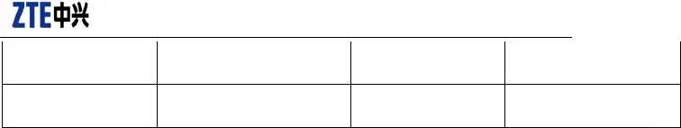
Confidential▼

zxGponPptpPOTSUNIA dminState zxGponPptpPOTSUNIO perState
1.3.6.1.4.1.3902.1012.3.50.17.1.
1.1
1.3.6.1.4.1.3902.1012.3.50.17.1.
1.9

  - Flow Configuration

Please refer to zxGponOntMgmt.mib.

    - ZxGponFlowTable


Name Oid Range Description
This attribute indicates the index of

zxGponFlowIndex .1.3.6.1.4.1.3902.1012.3.50.11.1.1.1 1..255

zxGponFlowEntryStatus .1.3.6.1.4.1.3902.1012.3.50.13.1.1.3
flow in ONT, from 1 to M.(1 bytes)
This entry can be create modified and delete.

    - ZxGponFlowTciModeTable
Name
Oid
Range
mode0(1),
Description
When a frame is received, the frame is processed according to the following Forward Operations. The
mode1(2),

mode2(3),
operations are invoked based on the value of VID, user priority, or the entire TCI or whether or not the
TCI field exists. This attribute indicates the received frame is treated as indicated below.(1 byte)
zxGponFlowTci
ModeForwardOp er
.1.3.6.1.4.1.390
2.1012.3.50.11.
1.1.1
mode3(4),
mode4(5),
tag-filter-action untag-filter-action forward-mode
'transparent' 'transparent' 'mode0'
'discard' 'transparent' 'mode1'

 | 'transparent' | 'discard' | 'mode2'
mode5(6), | 'vid-filter' | 'transparent' | 'mode3'
 | 'vid-filter' | 'discard' | 'mode4'
mode6(7), | 'prio-filter' | 'transparent' | 'mode7'
 | 'prio-filter' | 'discard' | 'mode8'
mode7(8), | 'prio-vid-filter' 'prio-vid-filter' | 'transparent' 'discard' | 'mode 1' 'mode12'

mode8(9), | 'vid-match' | 'transparent' | 'mode15'
 | 'vid-match' | 'discard' | 'mode16'
mode9(10), | 'prio-match' | 'transparent' | 'mode17'
 | 'prio-match' | 'discard' | 'mode18'
mode10(11), | 'prio-vid-match' | 'transparent' | 'mode19'
 | 'prio-vid-match' | 'discard' | 'mode20'
mode11(12), mode12(13), | 'forward' | 'discard' | 'mode21'
mode13(14),
mode14(15),
mode15(16),
mode16(17),

    - 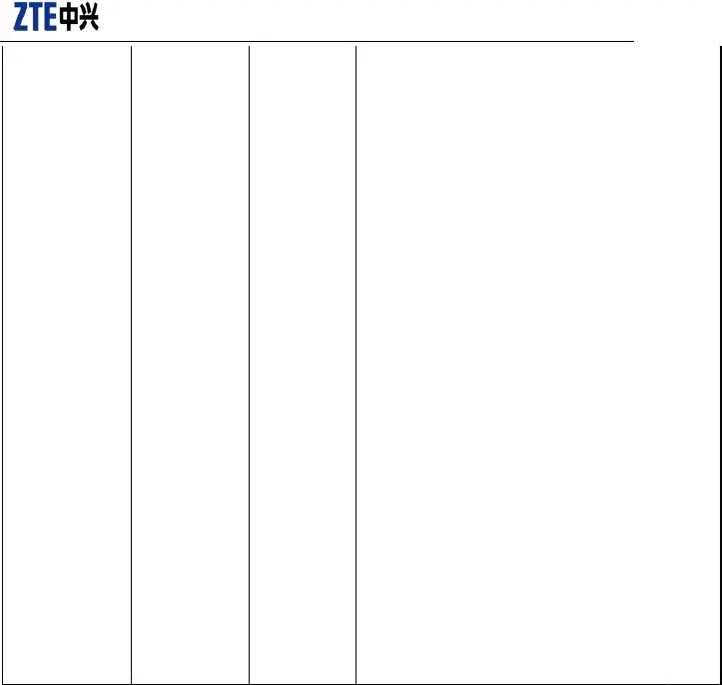ZxGponFlowTciTable
Confidential▼
mode17(18),

mode18(19),
mode19(20),
mode20(21),
mode21(22)


Name Oid Range Description This attribute specifies the
TCI value

zxGponFlowTciIndex .1.3.6.1.4.1.3902.1012.3.50.13.3.1.1 2 bytes

zxGponFlowTciEntryStatus .1.3.6.1.4.1.3902.1012.3.50.13.3.1.2
which is
provisioned at a bridging port.
This entry can be create modified and delete.

Confidential▼

    - GEM Port Flow Configuration

Please refer to zxGponGemFlowTable defined in zxGponOntMgmt.mib.

Name Oid Range Description

zxGponGemFlowId
.1.3.6.1.4.1.3902.1012.3.50.1
3.4.1.1

1..255
This attribute indicates the flow id relate with this GEM flow.
This attribute indicates the priority bit map o this GEM flow.

This bitmap specifies the priorities used by this connection when using 802.1p mapping.Each bit from bit0(LSB) to

zxGponGemFlowPriBit
.1.3.6.1.4.1.3902.1012.3.50.1
1 byte
bit7(MSB) indicates whethe

Map
3.4.1.2
priority0~priority7 is occupied. When the

flow type of zxGponGemFlowId is no 'switch',zxGponGemFlowPriBitMap must be assigned non-zero; Otherwise,zxGponGemFlowPriBitMap i optional which can be assigned as zero.

zxGponGemFlowEntry Status
.1.3.6.1.4.1.3902.1012.3.50.1
3.4.1.3
This entry can be create modified and delete.

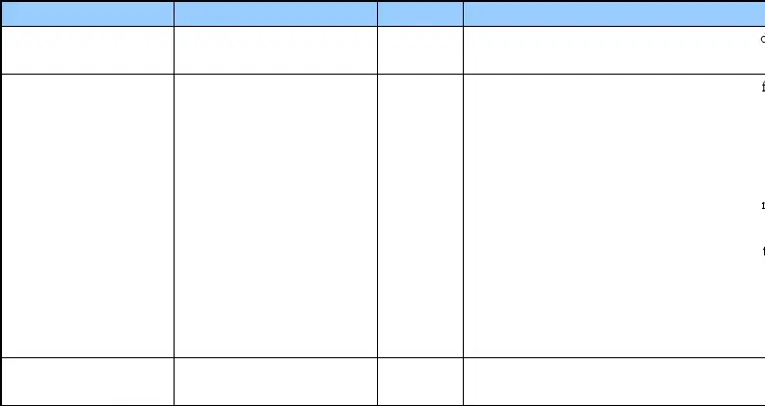

  - Remote Operation

OID Specification
zxGponONTActionTable—s OID is .1.3.6.1.4.1.3902.1012.3.50.11.3.

Index Specification
{ zxGponOltIndex, zxGponONTIndex }, zxGponOltIndex are PON Type 1composite index, others are regular index.

MIB Specification
For detailed description, refer to zxGponOntMgmt.mib. Of them, zxGponONTReboot is to reset the ONU.

zxGponONTActionTable OBJECT-TYPE
SYNTAX SEQUENCE OF ZxGponONTActionEntry MAX-ACCESS not-accessible
STATUS current

Confidential▼

DESCRIPTION
""
::= { zxGponRmONTEquipMgmt 3 }

zxGponONTActionEntry OBJECT-TYPE SYNTAX ZxGponONTActionEntry

MAX-ACCESS not-accessible STATUS current
DESCRIPTION
"It is entry in the zxGponONTActionTable." INDEX { zxGponOltIndex, zxGponONTIndex }
::= { zxGponONTActionTable 1 }

ZxGponONTActionEntry ::= SEQUENCE {
zxGponONTReboot TruthValue,
zxGponONTTest TruthValue,
zxGponONTSyncTime TruthValue,

zxGponONTRestore TruthValue,
zxGponONTTestResult INTEGER,
zxGponONTRestoreFactory TruthValue
}

  - MAC Address Table Query

MIB object name and OID:
{"zxGponBridgePortAddrListTotalNum", "1.3.6.1.4.1.3902.1012.3.50.15.28.1.2"} ,
{"zxGponBridgePortAddrListData" , "1.3.6.1.4.1.3902.1012.3.50.15.28.1.4"} ,

Index Specification:
Level-5 index: INDEX { zxGponOltIndex, zxGponONTIndex, zxGponBridgePortType, zxGponBridgePortIndex, zxGponBridgePortAddrListIndex }
Indicate Type 1—s PON composite index respectively.ONU numbering. Bridge port type. Bridge port numbering. Last time address sequence.

Operation specification:
Only support getnext operation

MIB reference:
zxGponBridgePortAddrListTable defined in zxGponOntMgmt.mib

Confidential▼

  - WIFI Configuration

{"zxAnOnuWifiIfAdminStatus" , "1.3.6.1.4.1.3902.1015.1010.12.2.2.1.1"} ,

{"zxAnOnuWifiIfRadioMeasEnable" , | "1.3.6.1.4.1.3902.1015.1010.12.2.2.1.2"} ,
{"zxAnOnuWifiIfIsolationEnable" , | "1.3.6.1.4.1.3902.1015.1010.12.2.2.1.3"} ,
{"zxAnOnuWifiIfWirelessWorkMode", | "1.3.6.1.4.1.3902.1015.1010.12.2.2.1.4"} ,
{"zxAnOnuWifiIfRegulatoryDomain", | "1.3.6.1.4.1.3902.1015.1010.12.2.2.1.5"} ,
{"zxAnOnuWifiIfArcEnable" , | "1.3.6.1.4.1.3902.1015.1010.12.2.2.1.6"} ,
{"zxAnOnuWifiIfArcInterval" , | "1.3.6.1.4.1.3902.1015.1010.12.2.2.1.7"} ,
{"zxAnOnuWifiIfOperationalStatus", | "1.3.6.1.4.1.3902.1015.1010.12.2.2.1.8"} ,
{"zxAnOnuWifiIfChannelBandwidth", | "1.3.6.1.4.1.3902.1015.1010.12.2.2.1.9"} ,
{"zxAnOnuWifiIfSgiEnable" , | "1.3.6.1.4.1.3902.1015.1010.12.2.2.1.10"} ,
{"zxAnOnuWifiIfChannel" , | "1.3.6.1.4.1.3902.1015.1010.12.2.2.1.11"} ,
{"zxAnOnuWifiIfTxRate" , | "1.3.6.1.4.1.3902.1015.1010.12.2.2.1.12"} ,
{"zxAnOnuWifiIfTxPower" , | "1.3.6.1.4.1.3902.1015.1010.12.2.2.1.13"} ,
{"zxAnOnuWifiIfQosType" , | "1.3.6.1.4.1.3902.1015.1010.12.2.2.1.14"} ,

  - VEIP Configuration

switchport-bind switch_0/1 veip 1

{"zxGponUNIMACBridgePortConfigTable", "1.3.6.1.4.1.3902.1012.3.50.15.3"} ,
{"zxGponUNIMACBridgePortConfigEntry", "1.3.6.1.4.1.3902.1012.3.50.15.3.1"} ,
{"zxGponUNIMACBridgePortConfigBridgeId","1.3.6.1.4.1.3902.1012.3.50.15.3.1.1"} ,
{"zxGponUNIMACBridgePortConfigBridgePort", "1.3.6.1.4.1.3902.1012.3.50.15.3.1.2"} ,
{"zxGponUNIMACBridgePortConfigPortPrio", "1.3.6.1.4.1.3902.1012.3.50.15.3.1.3"} ,
{"zxGponUNIMACBridgePortConfigPortPathCost", "1.3.6.1.4.1.3902.1012.3.50.15.3.1.4"} ,
{"zxGponUNIMACBridgePortConfigPortSpanTreeInd", "1.3.6.1.4.1.3902.1012.3.50.15.3.1.5"} ,
{"zxGponUNIMACBridgePortConfigEncapMethod","1.3.6.1.4.1.3902.1012.3.50.15.3.1.6"} ,
{"zxGponUNIMACBridgePortConfigLANFCSInd", "1.3.6.1.4.1.3902.1012.3.50.15.3.1.7"} ,
{"zxGponUNIMACBridgePortConfigPortMACAddr", "1.3.6.1.4.1.3902.1012.3.50.15.3.1.8"} ,
{"zxGponUNIMACBridgePortConfigEntryStatus", "1.3.6.1.4.1.3902.1012.3.50.15.3.1.9"} ,
{"zxGponUNIMACBridgePortConfigOutboundTDPtr", "1.3.6.1.4.1.3902.1012.3.50.15.3.1.10"} ,
{"zxGponUNIMACBridgePortConfigInboundTDPtr", "1.3.6.1.4.1.3902.1012.3.50.15.3.1.11"} ,
{"zxGponUniMacBridgePortAddrLearnDepth", "1.3.6.1.4.1.3902.1012.3.50.15.3.1.12"} ,
{"zxGponUniMacBPortOutboundTdPrf", "1.3.6.1.4.1.3902.1012.3.50.15.3.1.13"} ,
{"zxGponUniMacBPortInboundTdPrf", "1.3.6.1.4.1.3902.1012.3.50.15.3.1.14"} ,

Confidential▼

Level-3 index: INDEX { zxGponOltIndex, zxGponONTIndex, zxGponUNIIndex } Of them, zxGponUNIIndex code is (2 << 16) | (UNI slot << 8) | UNI port
2 indicates VEIP type.

When creating VEIP bridge port, you need to specify zxGponUNIMACBridgePortConfigBridgeId.

  - UNI Port Performance Statistics

//Ethernet statistics needs to be enabled on the ONU,
you can set via operating {"zxGponOmciEthStatsEntryStatus", "1.3.6.1.4.1.3902.1012.3.50.8.1.1.17"} control performance statistics, when it is set as 4,
it indicates to start; when it is set as 6, it indicates to delete.
Level-3 index: zxGponOltIndex, zxGponONTIndex, zxGponUNIIndex

Ethernet performance statistics Uplink:
{"zxGponOmciEthStatsUpTable" , "1.3.6.1.4.1.3902.1012.3.50.8.16"} ,
{"zxGponOmciEthStatsUpEntry" , "1.3.6.1.4.1.3902.1012.3.50.8.16.1"} ,
{"zxGponOmciEthStatsUpIntervalEndTime", "1.3.6.1.4.1.3902.1012.3.50.8.16.1.1"} ,
{"zxGponOmciEthStatsUpThresDataId", "1.3.6.1.4.1.3902.1012.3.50.8.16.1.2"} ,
{"zxGponOmciEthStatsUpDropEvents", "1.3.6.1.4.1.3902.1012.3.50.8.16.1.3"} ,
{"zxGponOmciEthStatsUpOctets" , "1.3.6.1.4.1.3902.1012.3.50.8.16.1.4"} ,
{"zxGponOmciEthStatsUpPkts" , "1.3.6.1.4.1.3902.1012.3.50.8.16.1.5"} ,

{"zxGponOmciEthStatsUpBroadcastPkts", | "1.3.6.1.4.1.3902.1012.3.50.8.16.1.6"} ,
{"zxGponOmciEthStatsUpMulticastPkts", | "1.3.6.1.4.1.3902.1012.3.50.8.16.1.7"} ,
{"zxGponOmciEthStatsUpCRCErrPkts", | "1.3.6.1.4.1.3902.1012.3.50.8.16.1.8"} ,
{"zxGponOmciEthStatsUpUndersizePkts", | "1.3.6.1.4.1.3902.1012.3.50.8.16.1.9"} ,
{"zxGponOmciEthStatsUpOversizePkts", | "1.3.6.1.4.1.3902.1012.3.50.8.16.1.10"} ,
{"zxGponOmciEthStatsUp64OctetsPkts", | "1.3.6.1.4.1.3902.1012.3.50.8.16.1.11"} ,
{"zxGponOmciEthStatsUp65To127OctetsPkts", "1.3.6.1.4.1.3902.1012.3.50.8.16.1.12"} ,
{"zxGponOmciEthStatsUp128To255OctetsPkts", "1.3.6.1.4.1.3902.1012.3.50.8.16.1.13"} ,
{"zxGponOmciEthStatsUp256To511OctetsPkts", "1.3.6.1.4.1.3902.1012.3.50.8.16.1.14"} ,
{"zxGponOmciEthStatsUp512To1023OctetsPkts", "1.3.6.1.4.1.3902.1012.3.50.8.16.1.15"} ,
{"zxGponOmciEthStatsUp1024To1518OctetsPkts", "1.3.6.1.4.1.3902.1012.3.50.8.16.1.16"} ,
{"zxGponOmciEthStatsUpEntryStatus", "1.3.6.1.4.1.3902.1012.3.50.8.16.1.30"} , //Used to start the performance statistics, when it is set as 4, it indicates to start statistics; when it is set as 6, it indicates to delete statistics.

Downlink:

Confidential▼

{"zxGponOmciEthStatsDownTable" ,"1.3.6.1.4.1.3902.1012.3.50.8.17"} ,
{"zxGponOmciEthStatsDownEntry" , "1.3.6.1.4.1.3902.1012.3.50.8.17.1"} ,
{"zxGponOmciEthStatsDownIntervalEndTime", "1.3.6.1.4.1.3902.1012.3.50.8.17.1.1"} ,
{"zxGponOmciEthStatsDownThresDataId", "1.3.6.1.4.1.3902.1012.3.50.8.17.1.2"} ,
{"zxGponOmciEthStatsDownDropEvents", "1.3.6.1.4.1.3902.1012.3.50.8.17.1.3"} ,
{"zxGponOmciEthStatsDownOctets" , "1.3.6.1.4.1.3902.1012.3.50.8.17.1.4"} ,

{"zxGponOmciEthStatsDownPkts" ,"1.3.6.1.4.1.3902.1012.3.50.8.17.1.5"} ,
{"zxGponOmciEthStatsDownBroadcastPkts", "1.3.6.1.4.1.3902.1012.3.50.8.17.1.6"} ,
{"zxGponOmciEthStatsDownMulticastPkts", "1.3.6.1.4.1.3902.1012.3.50.8.17.1.7"} ,
{"zxGponOmciEthStatsDownCRCErrPkts", "1.3.6.1.4.1.3902.1012.3.50.8.17.1.8"} ,
{"zxGponOmciEthStatsDownUndersizePkts", "1.3.6.1.4.1.3902.1012.3.50.8.17.1.9"} ,
{"zxGponOmciEthStatsDownOversizePkts","1.3.6.1.4.1.3902.1012.3.50.8.17.1.10"} ,
{"zxGponOmciEthStatsDown64OctetsPkts","1.3.6.1.4.1.3902.1012.3.50.8.17.1.11"} ,
{"zxGponOmciEthStatsDown65To127OctetsPkts", "1.3.6.1.4.1.3902.1012.3.50.8.17.1.12"} ,
{"zxGponOmciEthStatsDown128To255OctetsPkts", "1.3.6.1.4.1.3902.1012.3.50.8.17.1.13"} ,
{"zxGponOmciEthStatsDown256To511OctetsPkts",

"1.3.6.1.4.1.3902.1012.3.50.8.17.1.14"} ,
{"zxGponOmciEthStatsDown512To1023OctetsPkts",
"1.3.6.1.4.1.3902.1012.3.50.8.17.1.15"} ,
{"zxGponOmciEthStatsDown1024To1518OctetsPkts", "1.3.6.1.4.1.3902.1012.3.50.8.17.1.16"} ,
{"zxGponOmciEthStatsDownEntryStatus", "1.3.6.1.4.1.3902.1012.3.50.8.17.1.30"} ,
//Used to start the performance statistics, when it is set as 4, it indicates to start statistics; when it is set as 6, it indicates to delete statistics.

Confidential▼

Configuration Process Examples

  - GPON HSI Service

    - Configuration Data

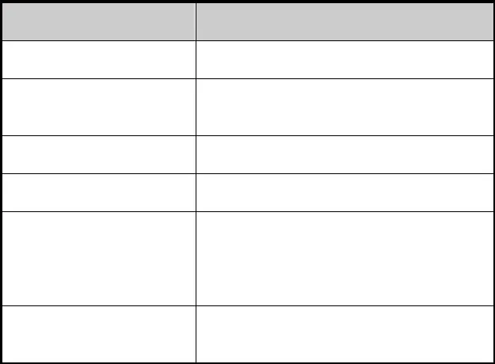
Item Data

T-CONT Bandwidth profile

ONU

T-CONT

GEM-Port

service

vlan port
Index 2
Type1 fixed 20M Slot 3 olt 1 onu 1 type ZTE-F622
register mode : sn CIGG00000001 Index 1
Link profile 20M Index 1
Link T-CONT 1
Index 1
Link GEM-Port 1 ServiceType:internet ServiceMapType:VLAN ServiceMapVlan:200 vlanPortMode:hybrid
untag add pvid vlanProfile0 at ethUni, then vlan 10 translate to vlan 100.

Confidential▼

    - Configuration Steps

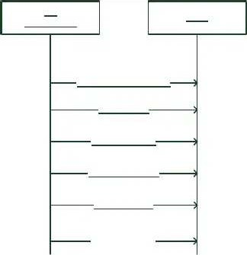
VI
GDL Lrawser
I366
Ireote P-IAJP Vramihe

Ireote AJU
Ireote P-IAJP
Ireote CEG-Vart
Ireote serviie
Ireote vhoj part

In CLI case:

ZXAN(config-gpon)#profile tcont T1-20M type 1 fixed 20000

ZXAN(config-if)#onu 1 type ZTE-F622 sn CIGG00000001

ZXAN(config-if)#tcont 1 p T1-10M

ZXAN(config-if)#gemport 1 name Gem1 unicast tcont 1

ZXAN(gpon-onu-mng)# service vlanProfile00 type internet gemport 1 vlan 100

ZXAN(gpon-onu-mng)# vlan port eth_0/1 mode hybrid

ZXAN(gpon-onu-mng)# vlan port eth_0/1 vlan 10

ZXAN(gpon-onu-mng)# vlan port eth_0/1 translate vlan 10 svlan 100

 |  | Confidential▼
STEP MIB Variable | Parameter
zxGponBWProfileIndex zxGponBWProfileName | 0x70000002  T1-20M (string) | profile name

zxGponBWProfileFixed
20000 rate
20M

Create T-CONT Profile
zxGponBWProfileAssured 0
zxGponBWProfileMaximum 0
1 fixed

Create ONU

Create T-CONT
zxGponBWProfileType

zxGponBWProfileEntryStatus

zxGponOntDevMgmtTypeNam e
zxGponOntDevMgmtProvision Sn
zxGponOntDevMgmtEntryStatu s
zxGponOntRegMode

zxOnuTrafficMgmtUnitTcontId x zxOnuTrafficMgmtUnitTcontUp BWIdxPtr zxOnuTrafficMgmtUnitEntrySta tus
zxGponGemPortIdx
bandwidth 4
Creation

ZTE-F622 (string) ONU type

Hex format number for ONU SN,e.g.CIGG00000001 means
'43:49:47:47:00:00:00:01'
4
creation
1 registration
mode:SN
1 T-CONT
ID

0x70000002 associated Ifid

4
creation
1 GEM-Port
ID

zxGponGemPortName Gem1 (string) PORT Name
1 PORT Type

Create GEM-Port
zxGponGemPortType
unicast

zxGponGemPortTcontIdx 1 associated T-CONT( ID) 4

zxGponGemPortEntryStatus
creation

zxGponServiceIndex 1
zxGponServiceName vlanProfile00 1

Create service
zxGponServiceType
internet

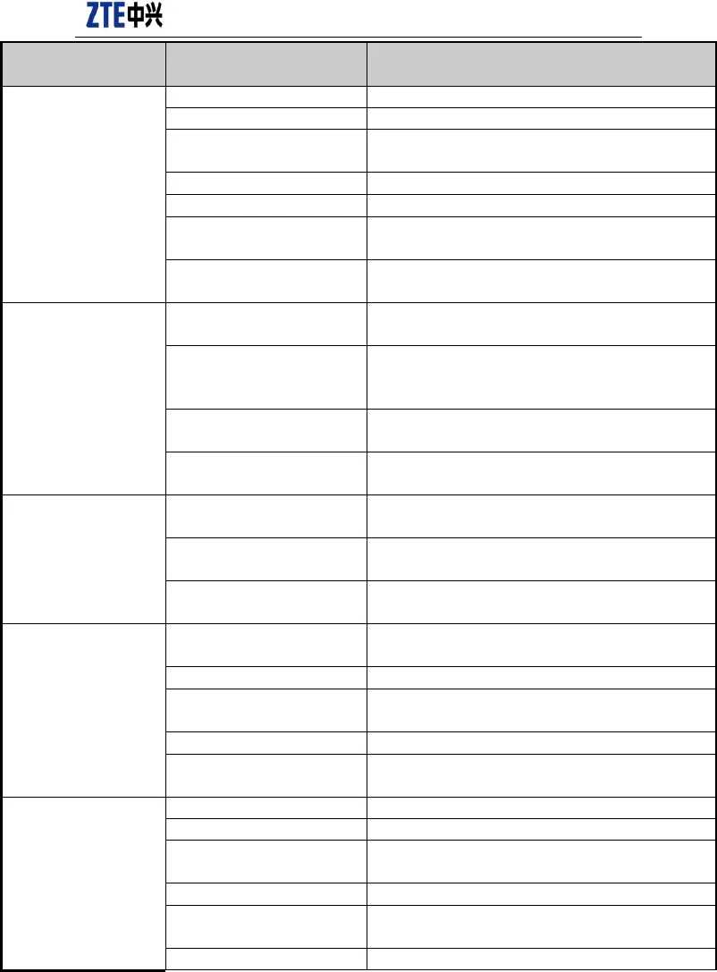
zxGponServiceGemPort gemport 1
2
zxGponServiceMapType
vlan
zxGponServiceMapVlan 100

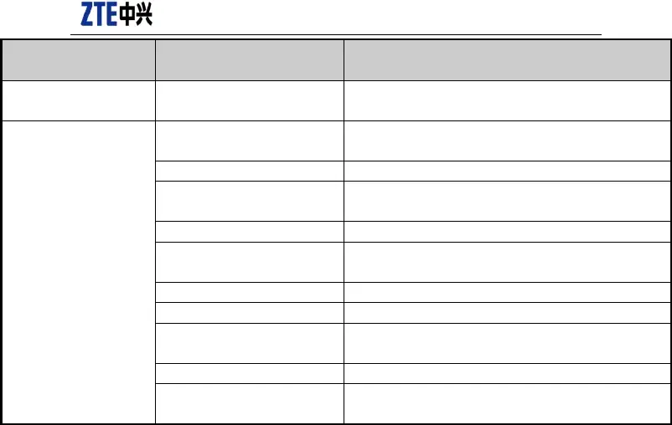
Confidential▼
STEP
MIB Variable
Parameter
zxGponServiceEntryStatus

zxGponVlanPortType
4
creation 1
ethuni
zxGponVlanPortIndex
zxGponVlanPortMode
zxGponVlanPortPvid zxGponVlanPortConfVlanCmd
Create vlan port
zxGponVlanPortConfVlanId
zxGponVlanTranslateVlanId

zxGponVlanTranslatePriority
1
3
hybrid 10
1
addTaggedVlan 10
10
8
configuration 100
8
configuration
no
zxGponVlanTranslateSVlanId
zxGponVlanTranslateSVlanPrio rity
no

PS: The 2nd index is need for ONU/TCONT/GEMPORT creation.

The primary Index: OLT Ifindex

The 2nd Index: ONU ID (e.g. 1, 2, 3, 4, …)

  - GPON VOIP

    - SIP

Configuration Data

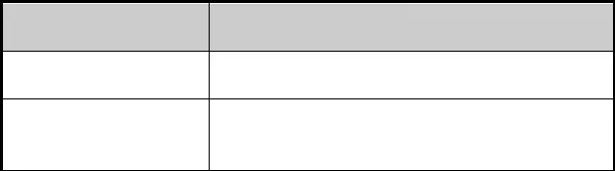
Item
Data
T-CONT Bandwidth profile
Index 2
Type1 fixed 20M
Slot 3 olt 1 onu 1
ONU
type ZTE-F622
register mode : sn CIGG00000001

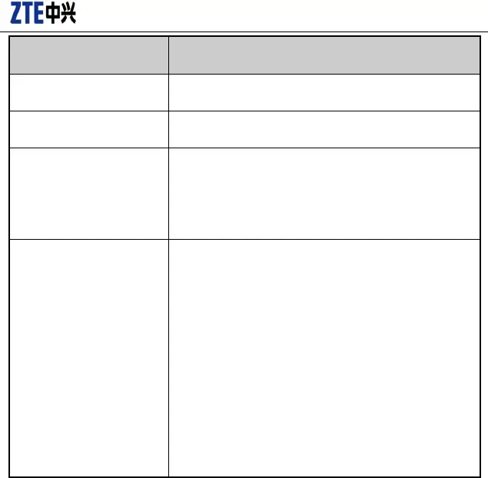
Confidential▼
Item
Data
T-CONT

GEM-Port
Index 1
Link profile 20M Index 1
Link T-CONT 1
service
Index 1
Link GEM-Port 1
ServiceType:voip ServiceMapType:VLAN ServiceMapVlan:200 SignalProtocolUsed:SIP VLAN 200
ONT IP: 10.40.110.101, Mask: 255.255.255.0, Gateway:
10.40.110.254
POTS1:
AOR: 66660050
VoIP (SIP)
Username: 66660050
Password: 123 POTS2:
AOR: 66660051
Username: 66660051
Password: 123

Confidential▼

Configuration Steps

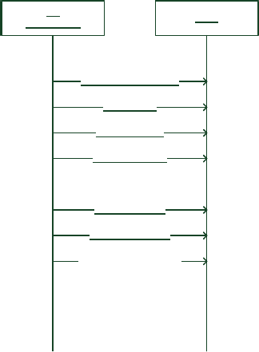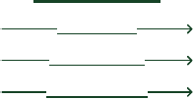
VI
GDL Lrawser
I366
Ireote P-IAJP Vramihe

Ireote AJU Ireote P-IAJP Ireote CEG-Vart Ireote Yerviie Ireote DV Vramihe Ireote ]hoj Vramihe
Iajmicure ]aDV Vrataiah Ireote ]aDV DV
Ireote YDV Vramihe

Ireote YDV Yerviie

In CLI case:

PON configuration is the same as 2.1.2.

ZXAN(gpon-onu-mng)#service voip type voip iphost 1 gemport 1 vlan 200

ZXAN(config-gpon)#onu profile ip ipProfile static gateway 10.40.110.254

ZXAN(config-gpon)# onu profile vlan vlanProfile tag-mode tag cvlan 200

ZXAN(gpon-onu-mng)#voip protocol sip

ZXAN(gpon-onu-mng)#voip-ip mode static ip-profileipProfile ip 10.40.110.101 mask 255.255.255.0 vlan-profile vlanProfile host 1

Confidential▼

ZXAN(config-gpon)#onu profile sip sipProfile proxy 10.40.123.25

ZXAN(gpon-onu-mng)#sip-service pots_0/1 profile sipProfile userid 66660050 username 66660050 password 123

ZXAN(gpon-onu-mng)#sip-service pots_0/2 profile sipProfile userid 66660051 username 66660051 password 123


Steps MIB Variable Parameter

zxGponServiceIndex 1
zxGponServiceName voip
3

Create service
zxGponServiceType

zxGponServiceIfId
voip 2
iphost

zxGponServiceGemPort gemport 1
2

zxGponServiceMapType
vlan

zxGponServiceMapVlan 200
4

zxGponServiceEntryStatus
creation

Create IP Profile

zxGponVoipIpProfileName ipProfile
zxGponVoipIpProfileGateway ’0a:28:6e:fe’ 10.40.110.254
4
zxGponVoipIpProfileRowStatus
creation

zxGponVoipVlanProfileName vlanProfile
1

Create Vlan
zxGponVoipVlanProfileTagMode

tag

Profile
zxGponVoipVlanProfileCVlanId 200
4

zxGponVoipVlanProfileRowStatus
creation

zxGponOnuVoipIpMode
1
static

Create VoIP IP
zxGponOnuVoipIpProfile ipProfile
zxGponOnuVoipVlanProfile vlanProfile
zxGponOnuVoipHostId 1
zxGponOnuVoipIpAddr ’0a:28:6e:65’ 10.40.110.101
24

zxGponOnuVoipIpAddrPfxLen 255.255.255.0

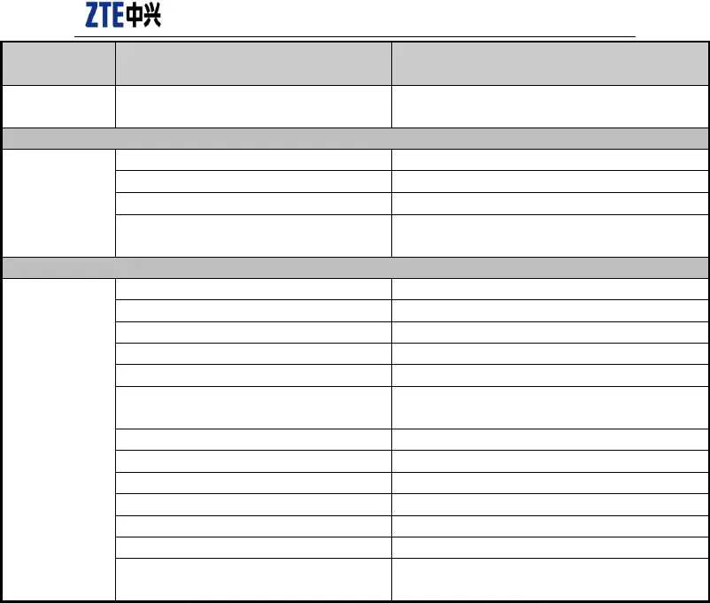
Confidential▼
Steps
MIB Variable
Parameter
Configure
Protocol
VoIP
zxGponVoIPConfigDataSignalProtocolUsed
2
sip
zxGponSipProfileId
0x70000001
Create SIP
Profile
zxGponSipProfileName
zxGponSipProxyServerAddress

zxGponSipRowStatus
sipProfile
’0a:28:7b:19’
4
creation
10.40.123.25
zxGponUNIIndex
zxGponSipUserProfileId zxGponSipUserPartAor zxGponSipUsername zxGponSipUserPassword
zxGponSipUserRowStatus
1
0x70000001
66660050
66660050
123
4
creation
Create Server
SIP
zxGponUNIIndex
zxGponSipUserProfileId zxGponSipUserPartAor zxGponSipUsername zxGponSipUserPassword
zxGponSipUserRowStatus
2
0x70000001
66660051
66660051
123
4
creation

10.2.2 H.248

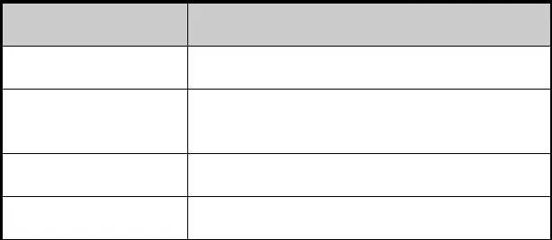
Configuration Data

Item Data

T-CONT Bandwidth profile

ONU

T-CONT
Index 2
Type1 fixed 20M Slot 3 olt 1 onu 1 type ZTE-F622
register mode : sn CIGG00000001 Index 1
Link profile 20M

GEM-Port Index 1
Link T-CONT 1

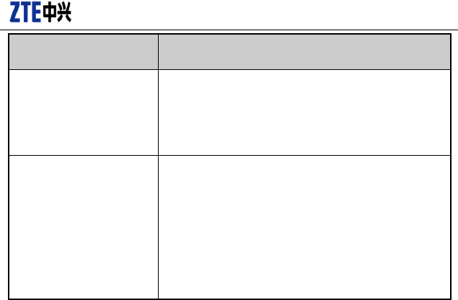
Confidential▼
Item
Data
service
Index 1
Link GEM-Port 1
ServiceType:voip ServiceMapType:VLAN
VoIP (SIP)
ServiceMapVlan:200
Link Service 1
SignalProtocolUsed: H.248 VLAN: 200
ONT IP: 10.40.110.101, Mask: 255.255.255.0, Gateway:
10.40.110.254
Server: 10.63.198.200
user-tid: AG589, postfix-len:5, postfix-start:1
rtp-tid: RTP, postfix-len:3, postfix-start:0
Configuration Steps
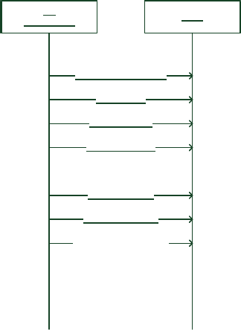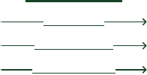
VI
GDL Lrawser
I366
Ireote P-IAJP Vramihe

Ireote AJU Ireote P-IAJP Ireote CEG-Vart Ireote Yerviie Ireote DV Vramihe Ireote ]hoj Vramihe
Iajmicure ]aDV Vrataiah Ireote ]aDV DV
Ireote GCI Vramihe

Ireote GCI Yerviie

In CLI case:

PON configuration is same as 2.1.2.

Confidential▼

ZXAN(gpon-onu-mng)#service voip type voip iphost 1 gemport 1 vlan 200

ZXAN(config-gpon)#onu profile ip ipProfile static gateway 10.40.110.254

ZXAN(config-gpon)# onu profile vlan vlanProfile tag-mode tag cvlan 200

ZXAN(gpon-onu-mng)# voip protocol h248 domain domain1

ZXAN(gpon-onu-mng)#voip-ip mode static ip-profile ipProfile ip 10.40.110.101 mask 255.255.255.0 vlan-profile vlanProfile host 1

ZXAN(config-gpon)#onu profile mgc mgcProfile server1 10.63.198.200

ZXAN(config-gpon)#onu profile mgc mgcProfile user-tid prefix AG589 postfix-len 5 postfix-start 1

ZXAN(config-gpon)#onu profile mgc mgcProfile rtp-tid prefix RTP postfix-len 3 postfix-start 0

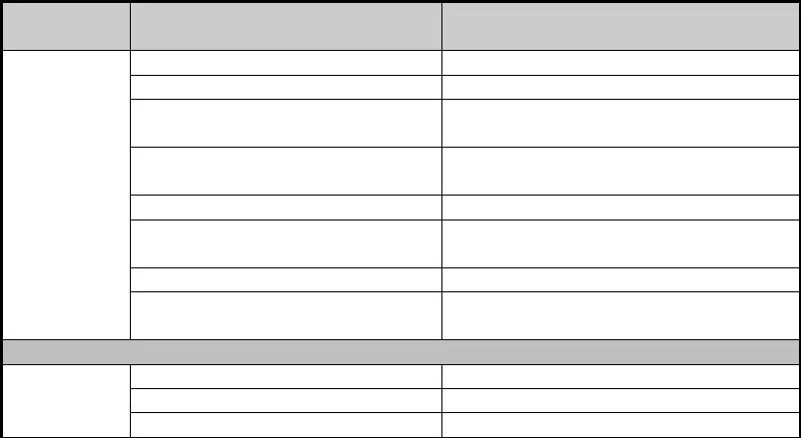ZXAN(gpon-onu-mng)#mgc-service pots_0/1 profile mgcProfile
Steps
MIB Variable
Parameter
zxGponServiceIndex
zxGponServiceName
zxGponServiceType zxGponServiceIfId
Create service
zxGponServiceGemPort

zxGponServiceMapType
zxGponServiceMapVlan zxGponServiceEntryStatus
1
voip 3
voip 2
iphost
gemport 1
2
vlan 200
4
creation
zxGponVoipIpProfileName
Create IP Profile zxGponVoipIpProfileGateway
zxGponVoipIpProfileRowStatus
ipProfile
’0a:28:6e:fe’
4
10.40.110.254


Confidential▼

Steps MIB Variable Parameter
creation

zxGponVoipVlanProfileName vlanProfile
1

Create Vlan
zxGponVoipVlanProfileTagMode

tag

Profile
zxGponVoipVlanProfileCVlanId 200
4

zxGponVoipVlanProfileRowStatus
creation

zxGponOnuVoipIpMode
1
static

Create VoIP IP
zxGponOnuVoipIpProfile ipProfile
zxGponOnuVoipVlanProfile vlanProfile
zxGponOnuVoipHostId 1
zxGponOnuVoipIpAddr ’0a:28:6e:65’ 10.40.110.101
24

zxGponOnuVoipIpAddrPfxLen
255.255.255.0

Configure VoIP Protocol
zxGponVoIPConfigDataSignalProtocolUsed
3 h248

zxGponVoIPOnuDomainName domain1
zxGponMgcProfileId 0x70000001
zxGponMgcProfileName mgcProfile
zxGponMgcPrimaryServer ’0a:28:7b:19’ 10.40.123.25
2

zxGponMgcUserTidAssignPolicy
specified

Create Mgc Profile

zxGponMgcUserTidPrefix AG589
zxGponMgcUserTidPostfixLen 5
zxGponMgcUserTidPostfixStartNum 1
2
zxGponMgcRtpTidAssignPolicy
specified
zxGponMgcRtpTidPrefix RTP
zxGponMgcRtpTidPostfixLen 3
zxGponMgcRtpTidPostfixStartNum 0
4

zxGponSipRowStatus
creation

Create Mgc Server
zxGponUNIIndex 1
zxGponMgcUserProfileId 0x70000001
zxGponMgcUserRowStatus 4

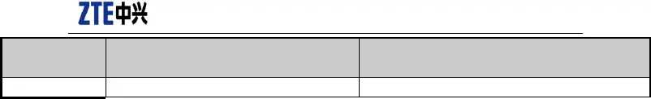
Confidential▼
Steps
MIB Variable
Parameter
creation

  - EPON HIS Service

  - EPON VOIP

Confidential▼

Optical Module and Optical Power

  - V1.2.0 PON Optical Module

OID Specification
zxAnOLTOpticalDiagTable’s OID is .1.3.6.1.4.1.3902.1015.1010.11.1.

Index Specification
{ zxAnOltIndex }, Type 1 PON composite index.

MIB Specification
For detailed description, refer to ZXAN-TRANSCEIVER-MIB.mib. Only optical modules of the PON port use this MIB.
C300V1.2.3 changes to use platform MIB, the following MIB do not support any more. Optical power unit is 0.001dBm.

zxAnOLTOpticalDiagTable OBJECT-TYPE
SYNTAX SEQUENCE OF ZxAnOLTOpticalDiagEntry MAX-ACCESS not-accessible
STATUS deprecated DESCRIPTION
" "
::= { zxAnTransceiver 1 }

zxAnOLTOpticalDiagEntry OBJECT-TYPE SYNTAX ZxAnOLTOpticalDiagEntry MAX-ACCESS not-accessible
STATUS deprecated DESCRIPTION
""
INDEX { zxAnOltIndex }
::= { zxAnOLTOpticalDiagTable 1 }

ZxAnOLTOpticalDiagEntry ::= SEQUENCE { zxAnOltIndex Integer32, zxAnTransceiverTemp Integer32, zxAnTransceiverVoltage Integer32, zxAnTxBiasCurrent Integer32, zxAnTxOpticalPower Integer32,
zxAnRxOpticalPower Integer32, zxAnTransceiverLinkRate Integer32,

Confidential▼

zxAnTransceiverWaveLength Integer32, zxAnTransceiverVendorNa me OCTET STRING, zxAnTransceiverVendorPn OCTET STRING
}

  - Optical Module

All optical modules of the Ethernet port and PON port in V1.2.3 query via this MIB. CES optical modules in V1.2.5 also query via this MIB.

    - Information Query

OID Specification
zxAnOpticalModuleMonTable ’s OID is .1.3.6.1.4.1.3902.1015.3.1.13.

OLT’s transmitting optical power
zxAnOpticalPowerTxCurrValue: .1.3.6.1.4.1.3902.1015.3.1.13.1.4 The index is ifid
gpon-olt_1/3/1 corresponds to: 0x10010000

gei_1/19/1 corresponds to:0x100F0000 gei_1/19/2 corresponds to:0x100F0100
...

0Fcorresponds to logic cardid 01 corresponds to logic port No.

Index Specification
{ ifIndex }, platform Type 1 composite index.

MIB Specification
For detailed description, refer to ZTE-AN-INTERFACE-MIB.mib.

zxAnOpticalModuleMonTable OBJECT-TYPE
SYNTAX SEQUENCE OF ZxAnOpticalModuleMonEntry MAX-ACCESS not-accessible
STATUS current
DESCRIPTION "This table provides objects to monitor optical module in a network element. It also provides
objects for setting high and low threshold levels."
::= { zxAnInterfaceObjects 13 }

Confidential▼

zxAnOpticalModuleMonEntry OBJECT-TYPE SYNTAX ZxAnOpticalModuleMonEntry MAX-ACCESS not-accessible
STATUS current
DESCRIPTION "An entry in zxAnOpticalModuleMonTable." INDEX { ifIndex }
::= { zxAnOpticalModuleMonTable 1 }

ZxAnOpticalModuleMonEntry ::= SEQUENCE { zxAnOpticalPowerRxCurrValue Integer32,
zxAnOpticalPowerRxLowerThresh Integer32,
zxAnOpticalPowerRxUpperThresh Integer32,

zxAnOpticalPowerTxCurrValue Integer32,
zxAnOpticalPowerTxLowerThresh Integer32,
zxAnOpticalPowerTxUpperThresh Integer32,

zxAnOpticalIfRxRate Integer32,
zxAnOpticalIfTxRate Integer32,

zxAnOpticalBiasCurrent Integer32,
zxAnOpticalSupplyVoltage Integer32,
zxAnOpticalWavelength Integer32,
zxAnOpticalTemperature Integer32,
zxAnOpticalVenderPn DisplayString,
zxAnOpticalVenderName DisplayString,

zxAnOpticalBiasCurrLowerThresh Integer32,
zxAnOpticalBiasCurrUpperThresh Integer32,
zxAnOpticalVoltageLowerThresh Integer32,

zxAnOpticalVoltageUpperThresh Integer32, zxAnOpticalTempLowerThresh Integer32,
zxAnOpticalTempUpperThresh Integer32,

zxAnOpticalIfRate Integer32,
zxAnOpticalFiberType INTEGER,
zxAnOpticalVersionLevel DisplayString,
zxAnOpticalVendorSn DisplayString, zxAnOpticalProductionDate DisplayString, zxAnOpticalModuleType DisplayString, zxAnOpticalFiberInterfaceType DisplayString, zxAnOpticalMaterialNumber OCTET STRING,
zxAnOpticalRegisterData OCTET STRING
}

Confidential▼

    - Threshold Value Setting

Index Specification
Profile name, character string
OID Specification
zxAnOptPrfTxPwrUpperThresh
.1.3.6.1.4.1.3902.1015.3.1.23.2.1.5
lower threshold Transmitting

MIB Variable | OID | Specification
zxAnOptPrfRxPwrLowerThresh | .1.3.6.1.4.1.3902.1015.3.1.23.2.1.2 | Receiving optical power  lower threshold
zxAnOptPrfRxPwrUpperThresh | .1.3.6.1.4.1.3902.1015.3.1.23.2.1.3 | Receiving  optical power
 |  | upper threshold
zxAnOptPrfTxPwrLowerThresh | .1.3.6.1.4.1.3902.1015.3.1.23.2.1.4 | Transmitting
 |  | optical power

optical |  |  | power
upper threshold
zxAnOptPrfBiasCurrLowerThresh | .1.3.6.1.4.1.3902.1015.3.1.23.2.1.6 | Current | lower
 |  | threshold
zxAnOptPrfBiasCurrUpperThresh | .1.3.6.1.4.1.3902.1015.3.1.23.2.1.7 | Current | upper
 |  | threshold
zxAnOptPrfVoltageLowerThresh | .1.3.6.1.4.1.3902.1015.3.1.23.2.1.8 | Voltage | lower
 |  | threshold
zxAnOptPrfVoltageUpperThresh | .1.3.6.1.4.1.3902.1015.3.1.23.2.1.9 | Voltage | upper
 |  | threshold
zxAnOptPrfTempLowerThresh | .1.3.6.1.4.1.3902.1015.3.1.23.2.1.10 | Temperature lower threshold
zxAnOptPrfTempUpperThresh | .1.3.6.1.4.1.3902.1015.3.1.23.2.1.11 | Temperature
 |  | upper threshold
zxAnOptPrfOfflineTrapEnable | .1.3.6.1.4.1.3902.1015.3.1.23.2.1.12 | Online alarm
 |  | switch

    - Threshold Value Loading

Index Specification

Type 1 platform composite index
OID Specification

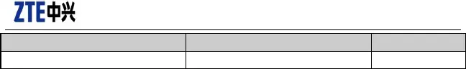
Confidential▼
MIB Variable
zxAnOpticalIfAlmPrf
OID
.1.3.6.1.4.1.3902.1015.3.1.23.3.1.2
Specification
Profile name

  - Receiving Optical Power at OLT Side

1.3.6.1.4.1.3902.1015.1010.11.2.1.2

Level-2 index: Type 1 PON composite index and ONU ID

For example: the index that gpon-onu_1/2/2:3 corresponds to: 268567040.3 Corresponding snmp operation command should be:
snmpwalk -v2c -c public 172.17.56.250 1.3.6.1.4.1.3902.1015.1010.11.2.1.2.268567040.3

*0.002 ’ 30.

  - Optical Power at EPON ONU Side

Index Specification
Type 3 PON composite index

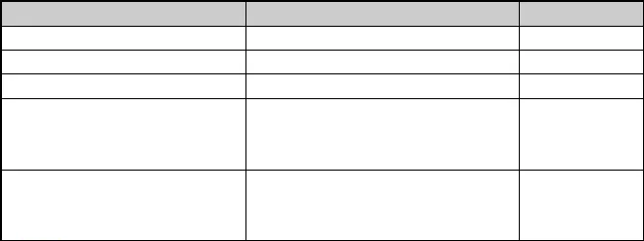
OID Specification

MIB Variable | OID | Specification
zxAnEponOnuTransTemperature | .1.3.6.1.4.1.3902.1015.1010.1.1.1.29.1.1 | Temperature
zxAnEponOnuSupplyVoltage | .1.3.6.1.4.1.3902.1015.1010.1.1.1.29.1.2 | Voltage
zxAnEponOnuTxBiasCurrent | .1.3.6.1.4.1.3902.1015.1010.1.1.1.29.1.3 | Current
zxAnEponOnuTxPower | .1.3.6.1.4.1.3902.1015.1010.1.1.1.29.1.4 | Transmitting
optical power
dBm
zxAnEponOnuRxPower | .1.3.6.1.4.1.3902.1015.1010.1.1.1.29.1.5 | Receiving  optical power dBm

Confidential▼

  - Optical Power at GPON ONU Side

{"zxGponRmANIMgmt" |  |  | , | "1.3.6.1.4.1.3902.1012.3.50.12"} ,
{"zxGponPonTable" | , |  |  | "1.3.6.1.4.1.3902.1012.3.50.12.1"} ,
{"zxGponPonEntry" | , |  |  | "1.3.6.1.4.1.3902.1012.3.50.12.1.1"} ,
{"zxGponPonSRInd" | , |  |  | "1.3.6.1.4.1.3902.1012.3.50.12.1.1.1"} ,
{"zxGponPonTotalTcontNum" | , |  |  | "1.3.6.1.4.1.3902.1012.3.50.12.1.1.2"} ,
{"zxGponPonGemBlockLen" |  | , |  | "1.3.6.1.4.1.3902.1012.3.50.12.1.1.3"} ,
{"zxGponPonPiggybackDBAReporting", |  |  | "1.3.6.1.4.1.3902.1012.3.50.12.1.1.4"} ,
{"zxGponPonWholeOnuDBAReporting", |  |  | "1.3.6.1.4.1.3902.1012.3.50.12.1.1.5"} ,
{"zxGponPonSFThreshold" , |  |  | "1.3.6.1.4.1.3902.1012.3.50.12.1.1.6"} ,
{"zxGponPonSDThreshold" , |  |  | "1.3.6.1.4.1.3902.1012.3.50.12.1.1.7"} ,
{"zxGponPonAlarmReport" , |  |  | "1.3.6.1.4.1.3902.1012.3.50.12.1.1.8"} ,
{"zxGponPonAlarmDisableInterval", |  |  | "1.3.6.1.4.1.3902.1012.3.50.12.1.1.9"} ,
{"zxGponPonRxOpticalLevel" , |  |  | "1.3.6.1.4.1.3902.1012.3.50.12.1.1.10"} ,
{"zxGponPonLowerRxOpticalThreshold", |  |  | "1.3.6.1.4.1.3902.1012.3.50.12.1.1.11"} ,
{"zxGponPonUpperRxOpticalThreshold", |  |  | "1.3.6.1.4.1.3902.1012.3.50.12.1.1.12"} ,

{"zxGponPonOntResponseTime" , "1.3.6.1.4.1.3902.1012.3.50.12.1.1.13"} ,
{"zxGponPonTxOpticalLevel" , "1.3.6.1.4.1.3902.1012.3.50.12.1.1.14"} ,
{"zxGponPonLowerTxOpticalThreshold", "1.3.6.1.4.1.3902.1012.3.50.12.1.1.15"} ,
{"zxGponPonUpperTxOpticalThreshold", "1.3.6.1.4.1.3902.1012.3.50.12.1.1.16"} ,
{"zxGponPonPowerFeedVoltage" , "1.3.6.1.4.1.3902.1012.3.50.12.1.1.17"} ,
{"zxGponPonLaserBiasCurrent" , "1.3.6.1.4.1.3902.1012.3.50.12.1.1.18"} ,
{"zxGponPonTemperature" , "1.3.6.1.4.1.3902.1012.3.50.12.1.1.19"} ,
{"zxGponPonLowerVoltageThreshold", "1.3.6.1.4.1.3902.1012.3.50.12.1.1.20"} ,
{"zxGponPonUpperVoltageThreshold", "1.3.6.1.4.1.3902.1012.3.50.12.1.1.21"} ,
{"zxGponPonLowerCurrentThreshold", "1.3.6.1.4.1.3902.1012.3.50.12.1.1.22"} ,
{"zxGponPonUpperCurrentThreshold", "1.3.6.1.4.1.3902.1012.3.50.12.1.1.23"} ,
{"zxGponPonLowerTemperatureThreshold", "1.3.6.1.4.1.3902.1012.3.50.12.1.1.24"} ,

{"zxGponPonUpperTemperatureThreshold","1.3.6.1.4.1.3902.1012.3.50.12.1.1.25"} ,

Confidential▼

Performance Statistics

  - Ethernet Port Real-time Statistics

Both V1.2.0 and V1.2.3 support it.

    - ifTable Real-time Statistics

OID Specification
ifTable’s OID is .1.3.6.1.2.1.2.2.

Index Specification
{ ifIndex } , Type 1 platform composite index.

MIB Specification
Refer to rfc2863.mib.

ifTable OBJECT-TYPE
SYNTAX SEQUENCE OF IfEntry
MAX-ACCESS not-accessible STATUS current DESCRIPTION
"A list of interface entries. The number of entries is given by the value of ifNumber."
::= { interfaces 2 }

ifEntry OBJECT-TYPE SYNTAX IfEntry
MAX-ACCESS not-accessible STATUS current DESCRIPTION
"An entry containing management information applicable to a particular interface."
INDEX { ifIndex }
::= { ifTable 1 }

IfEntry ::=
SEQUENCE {

ifIndex InterfaceIndex,
ifDescr DisplayString,
ifType IANAifType,

Confidential▼

ifMtu Integer32,
ifSpeed Gauge32,
ifPhysAddress PhysAddress,
ifAdminStatus INTEGER,
ifOperStatus INTEGER,
ifLastChange TimeTicks,

ifInOctets Counter32,
ifInUcastPkts Counter32,
ifInNUcastPkts Counter32, -- deprecated
ifInDiscards Counter32,
ifInErrors Counter32,
ifInUnknownProtos Counter32,
ifOutOctets Counter32,
ifOutUcastPkts Counter32,
ifOutNUcastPkts Counter32, -- deprecated
ifOutDiscards Counter32,
ifOutErrors Counter32,
ifOutQLen Gauge32, -- deprecated

ifSpecific OBJECT IDENTIFIER -- deprecated
}

    - ifXTable Real-time Statistics

OID Specification
ifXTable’s OID is .1.3.6.1.2.1.31.1.1.

Index Specification

{ ifIndex } , Type 1 platform composite index.

MIB Specification
Refer to rfc2863.mib.

ifXTable OBJECT-TYPE
SYNTAX SEQUENCE OF IfXEntry
MAX-ACCESS not-accessible STATUS current DESCRIPTION
"A list of interface entries. The number of entries is

given by the value of ifNumber. This table contains additional objects for the interface table."
::= { ifMIBObjects 1 }

Confidential▼

ifXEntry OBJECT-TYPE SYNTAX IfXEntry MAX-ACCESS not-accessible STATUS current DESCRIPTION

"An entry containing additional management information applicable to a particular interface."
AUGMENTS { ifEntry }
::= { ifXTable 1 }

IfXEntry ::=
SEQUENCE {
ifName DisplayString,
ifInMulticastPkts Counter32,
ifInBroadcastPkts Counter32, ifOutMulticastPkts Counter32, ifOutBroadcastPkts Counter32,
ifHCInOctets Counter64,
ifHCInUcastPkts Counter64,
ifHCInMulticastPkts Counter64, ifHCInBroadcastPkts Counter64, ifHCOutOctets Counter64,
ifHCOutUcastPkts Counter64, ifHCOutMulticastPkts Counter64, ifHCOutBroadcastPkts Counter64, ifLinkUpDownTrapEnable INTEGER, ifHighSpeed Gauge32,
ifPromiscuousMode TruthValue, ifConnectorPresent TruthValue,
ifAlias DisplayString, ifCounterDiscontinuityTime TimeStamp
}

    - zxAnEtherIfStatTable Real-time Statistics

ZxAnEtherIfStatEntry ::= SEQUENCE { zxAnEtherIfStatFCSErrors Counter32,
zxAnEtherIfStat15minFCSErrors Counter32,

zxAnEtherIf15minFcsErrsThresh Integer32,
zxAnEtherIfStat1dayFCSErrors Counter32,
zxAnEtherIf1dayFcsErrsThresh Integer32,

Confidential▼

zxAnEtherIfOutDiscardPktRatio Integer32,
zxAnEtherIfInDiscardPktRatio Integer32,
zxAnEtherIfInErrPktRatio Integer32,
zxAnEtherIfOutPkts Counter64, zxAnEtherIfInOctetsCorrect Counter64,
zxAnEtherIfOutOctetsCorrect Counter64,
zxAnEtherIfInOctetsError Counter64,
zxAnEtherIfOutOctetsError Counter64,
zxAnEthIfStat1SecFcsErrs Counter64,
zxAnEthIfStat1SecFcsErrsThresh Integer32,
zxAnEtherIfStatOutDiscardPkt Counter64,
zxAnEtherIfStatInDiscardPkt Counter64,
zxAnEtherIfStatReset INTEGER
}

  - OLT Ethernet Real-time Statistics

Both V1.2.0 and V1.2.3 versions support it.

    - Real-time Performance

OID Specification
zxAnXponOltIfStatTable’s OID is .1.3.6.1.4.1.3902.1015.1010.5.4.

Index Specification
{ zxAnXponOltIfIndex }, Type 1 PON composite index.

MIB Specification
Refer to zxAnXpon.mib.

zxAnXponOltIfStatTable OBJECT-TYPE
SYNTAX SEQUENCE OF ZxAnXponOltIfStatEntry MAX-ACCESS not-accessible
STATUS current DESCRIPTION
"xPON interface statistics table"
::= { zxAnXpon 4 }

zxAnXponOltIfStatEntry OBJECT-TYPE
SYNTAX ZxAnXponOltIfStatEntry MAX-ACCESS not-accessible
STATUS current

Confidential▼

DESCRIPTION ""
INDEX { zxAnXponOltIfIndex }
::= { zxAnXponOltIfStatTable 1}

ZxAnXponOltIfStatEntry ::=
SEQUENCE {
zxAnXponOltIfIndex INTEGER,
zxAnXponOltIfRxOctes Counter64,
zxAnXponOltIfRxPkts Counter64,
zxAnXponOltIfRxUniPkts Counter64,
zxAnXponOltIfRxNonUniPkts Counter64,
zxAnXponOltIfRxMultPkts Counter64,
zxAnXponOltIfRxBroadPkts Counter64,
zxAnXponOltIfRxPktsDiscard Counter64,
zxAnXponOltIfRxPktsErr Counter64, zxAnXponOltIfRxPDR DisplayString,
zxAnXponOltIfRxPER DisplayString,
zxAnXponOltIfTxOctes Counter64,
zxAnXponOltIfTxPkts Counter64,
zxAnXponOltIfTxUniPkts Counter64,
zxAnXponOltIfTxNonUniPkts Counter64,
zxAnXponOltIfTxMultPkts Counter64,
zxAnXponOltIfTxBroadPkts Counter64,
zxAnXponOltIfTxPktsDiscard Counter64,
zxAnXponOltIfTxPktsErr Counter64, zxAnXponOltIfTxPDR DisplayString,
zxAnXponOltIfTxPER DisplayString, zxAnXponOltIfRxCRCAlignErrors Counter64, zxAnXponOltIfRxUndersizePkts Counter64,
zxAnXponOltIfRxOversizePkts Counter64, zxAnXponOltIfRx64OctetPkts Counter64,
zxAnXponOltIfTx64OctetPkts Counter64, zxAnXponOltIfRx65To127OctetPkts Counter64, zxAnXponOltIfTx65To127OctetPkts Counter64, zxAnXponOltIfRx128To255OctetPkts Counter64, zxAnXponOltIfTx128To255OctetPkts Counter64, zxAnXponOltIfRx256To511OctetPkts Counter64, zxAnXponOltIfTx256To511OctetPkts Counter64, zxAnXponOltIfRx512To1023OctPkts Counter64, zxAnXponOltIfTx512To1023OctPkts Counter64, zxAnXponOltIfRx1024To1518OctPkts Counter64,
zxAnXponOltIfTx1024To1518OctPkts Counter64, zxAnXponOltIfStatus INTEGER

Confidential▼

}

  - ONU Ethernet Real-time Statistics

Both V1.2.0 and V1.2.3 versions support it.

    - Real-time Performance

OID Specification
zxAnXponOnuIfStatTable’s OID is .1.3.6.1.4.1.3902.1015.1010.5.5.

Index Specification
{ zxAnXponOnuIfIndex }, Type 3 or 9 PON composite index.

MIB Specification
Refer to zxAnXpon.mib.

zxAnXponOnuIfStatTable OBJECT-TYPE
SYNTAX SEQUENCE OF ZxAnXponOnuIfStatEntry MAX-ACCESS not-accessible
STATUS current DESCRIPTION
"xPON interface statistics table"
::= { zxAnXpon 5 }

zxAnXponOnuIfStatEntry OBJECT-TYPE
SYNTAX ZxAnXponOnuIfStatEntry MAX-ACCESS not-accessible
STATUS current DESCRIPTION
""
INDEX { zxAnXponOnuIfIndex }
::= { zxAnXponOnuIfStatTable 1}

ZxAnXponOnuIfStatEntry ::=
SEQUENCE {
zxAnXponOnuIfIndex INTEGER, zxAnXponOnuIfRxOctes Counter64,
zxAnXponOnuIfRxPkts Counter64,
zxAnXponOnuIfRxUniPkts Counter64,
zxAnXponOnuIfRxNonUniPkts Counter64,
zxAnXponOnuIfRxMultPkts Counter64,
zxAnXponOnuIfRxBroadPkts Counter64,

Confidential▼

zxAnXponOnuIfRxPktsDiscard Counter64,
zxAnXponOnuIfRxPktsErr Counter64, zxAnXponOnuIfRxPDR DisplayString,
zxAnXponOnuIfRxPER DisplayString,
zxAnXponOnuIfTxOctes Counter64,
zxAnXponOnuIfTxPkts Counter64,
zxAnXponOnuIfTxUniPkts Counter64,
zxAnXponOnuIfTxNonUniPkts Counter64,
zxAnXponOnuIfTxMultPkts Counter64,
zxAnXponOnuIfTxBroadPkts Counter64,
zxAnXponOnuIfTxPktsDiscard Counter64,
zxAnXponOnuIfTxPktsErr Counter64, zxAnXponOnuIfTxPDR DisplayString,
zxAnXponOnuIfTxPER DisplayString, zxAnXponOnuIfStatus INTEGER
}

  - GPON OLT PON-Layer Real-time Statistics

Both V1.2.0 and V1.2.3 versions support it.

    - Real-time Performance

OID Specification
.zxGponOltPmStatisRealtimeInfoTable’s OID is .1.3.6.1.4.1.3902.1012.3.12.13.

Index Specification
{ zxGponMgmtPonOltId }, Type 1 PON composite index.

MIB Specification
Refer to zxGponService.mib.

zxGponOltPmStatisRealtimeInfoTable OBJECT-TYPE
SYNTAX SEQUENCE OF ZxGponOltPmStatisRealtimeInfoEntry MAX-ACCESS not-accessible
STATUS current DESCRIPTION
"" REFERENCE
""
::= { zxGponStandardOlt 13 }

Confidential▼

zxGponOltPmStatisRealtimeInfoEntry OBJECT-TYPE SYNTAX ZxGponOltPmStatisRealtimeInfoEntry MAX-ACCESS not-accessible
STATUS current DESCRIPTION
""
INDEX { zxGponMgmtPonOltId }
::= { zxGponOltPmStatisRealtimeInfoTable 1 }

ZxGponOltPmStatisRealtimeInfoEntry ::= SEQUENCE {
zxGponOltPmStatisInfoCorrectNonIdleGemFramesUpstream

Unsigned32, Unsigned32,

Unsigned32,

zxGponOltPmStatisInfoCorrectIdleGemFramesUpstream

zxGponOltPmStatisInfoErroredGemFramesUpstream Unsigned32, zxGponOltPmStatisInfoGemPayloadBytesUpstream

Unsigned32, Unsigned32,

Unsigned32,

Unsigned32, Unsigned32, Unsigned32, Unsigned32, Unsigned32,
Unsigned32,
zxGponOltPmStatisInfoCorrectEthernetFramesUpstream zxGponOltPmStatisInfoErroredEthernetFramesUpstream
zxGponOltPmStatisInfoTotalOmciFramesUpstream Unsigned32, zxGponOltPmStatisInfoERR Unsigned32,
zxGponOltPmStatisInfoREI Unsigned32, zxGponOltPmStatisInfoValidEthernetPacketDownstream

zxGponOltPmStatisInfoCpuPacketDownstream Unsigned32, zxGponOltPmStatisInfoPloamDownstream Unsigned32, zxGponOltPmStatisInfoPloamUpstream Unsigned32,
zxGponOltPmStatisInfoInvalidPacketUpstream Unsigned32, zxGponOltPmFecCorrectedBytes

zxGponOltPmFecCorrectedWords zxGponOltPmFecUncorrectedWords zxGponOltPmFecTotalRxWords zxGponOltPmBipErrBits zxGponOltPmCrcErrPkts
zxGponOltPmStatisReset INTEGER

Confidential▼

}

  - GPON ONU PON-Layer Real-time Statistics

Both V1.2.0 and V1.2.3 versions support it.

    - Real-time Performance

OID Specification
zxGponOntPmStatisRealtimeInfoTable ’s OID is .1.3.6.1.4.1.3902.1012.3.28.6.1.

Index Specification
{ zxGponMgmtPonOltId, zxGponMgmtPonOnuId }, of them. zxGponMgmtPonOltId is Type 1 PON composite index, while others are regular index.

MIB Specification
Refer to zxGponService.mib.

zxGponOntPmStatisRealtimeInfoTable OBJECT-TYPE
SYNTAX SEQUENCE OF ZxGponOntPmStatisRealtimeInfoEntry MAX-ACCESS not-accessible
STATUS current DESCRIPTION
"unused attribute" REFERENCE
"G.984.3"
::= { zxGponPrivateOnu 6 }

zxGponOntPmStatisRealtimeInfoEntry OBJECT-TYPE SYNTAX ZxGponOntPmStatisRealtimeInfoEntry MAX-ACCESS not-accessible
STATUS current DESCRIPTION
""
INDEX { zxGponMgmtPonOltId, zxGponMgmtPonOnuId }
::= { zxGponOntPmStatisRealtimeInfoTable 1 }

ZxGponOntPmStatisRealtimeInfoEntry ::= SEQUENCE {
zxGponOntPmStatisInfoCorrectNonIdleGemFramesUpstream Unsigned32, zxGponOntPmStatisInfoCorrectIdleGemFramesUpstream Unsigned32, zxGponOntPmStatisInfoErroredGemFramesUpstream

Confidential▼

Unsigned32, Unsigned32,

Unsigned32, Unsigned32,

Unsigned32,

zxGponOntPmStatisInfoGemPayloadBytesUpstream

zxGponOntPmStatisInfoCorrectEthernetFramesUpstream Unsigned32, zxGponOntPmStatisInfoErroredEthernetFramesUpstream Unsigned32, zxGponOntPmStatisInfoTotalOmciFramesUpstream Unsigned32,
zxGponOntPmStatisInfoERRi zxGponOntPmStatisInfoREIi
zxGponOntPmStatisInfoUnreceivedBurstsUpstream Unsigned32, zxGponOntPmStatisInfoBipErrorUpstream Unsigned32,
zxGponOntPmStatisInfoCorrectedBitsUpstream Unsigned32, zxGponOntPmStatisInfoNotCorrectedWordsUpstream Unsigned32, zxGponOntPmStatisInfoLostBurst Unsigned32, zxGponOntTxCorrectNonIdleGemFrms

zxGponOntTxCorrectIdleGemFrms

Unsigned32, Unsigned32,
Unsigned32, Unsigned32, Unsigned32, Unsigned32,
Unsigned32, Unsigned32,
Unsigned32, Unsigned32,
INTEGER
}

zxGponOntTxOmciFrms zxGponOntTxPloamFrms zxGponOntRxPloamFrms zxGponOntLofiAlarms zxGponOntPmFecCorrectedBytes zxGponOntPmFecCorrectedWords zxGponOntPmFecUncorrectedWords zxGponOntPmFecTotalRxWords zxGponOntPmCrcErrPkts zxGponOntPmReset

Confidential▼

  - Ethernet Port Performance (V1.2.3)

    - Real-time Performance

OID Specification
zxAnEthIfCurrStatsPolhe’s OID is .1.3.6.1.4.1.3902.1015.3.11.2.2.

Index Specification
{ ifIndex } , Type 1 platform composite index.

MIB Specification
Refer to ZTE-AN-INTERFACE-STATS-MIB.mib.

zxAnEthIfCurrStatsTable OBJECT-TYPE
SYNTAX SEQUENCE OF ZxAnEthIfCurr StatsEntry MAX-ACCESS not-accessible

STATUS current DESCRIPTION
"Current performance data table of the ethernet interfaces."
::= { zxAnIfPerfObjects 2 }

zxAnEthIfCurrStatsEntry OBJECT-TYPE SYNTAX ZxAnEthIfCurrStatsEntry MAX-ACCESS not-accessible
STATUS current DESCRIPTION
"Current performance data entry of the ethernet interfaces."

INDEX { ifIndex}
::= { zxAnEthIfCurrStatsTable 1 }

ZxAnEthIfCurrStatsEntry ::= SEQUENCE { zxAnEthIfInOctets Counter64,
zxAnEthIfInPkts Counter64,
zxAnEthIfInUcastPkts Counter64,
zxAnEthIfInMcastPkts Counter64,
zxAnEthIfInBcastPkts Counter64, zxAnEthIfInOversizedPkts Counter64, zxAnEthIfInUndersizedPkts Counter64, zxAnEthIfOutOctets Counter64,
zxAnEthIfOutPkts Counter64,
zxAnEthIfOutUcastPkts Counter64,
zxAnEthIfOutMcastPkts Counter64,

Confidential▼

zxAnEthIfOutBcastPkts Counter64,
zxAnEthIfOutPausePkts Counter64,
zxAnEthIfOutDiscardPkts Counter64,
zxAnEthIfOutCollisions Counter64, zxAnEthIfSingleCollisions Counter64, zxAnEthIfMultipleCollisions Counter64,
zxAnEthIfFcsErrors Counter64, zxAnEthIfAlignmentErrors Counter64,
zxAnEthIfReset INTEGER
}

    - 15-MiniteReal-time Performance

OID Specification
zxAnEthIfCurr15MinPerfTable ’s OID is .1.3.6.1.4.1.3902.1015.3.12.2.2.

Index Specification
{ ifIndex } , Type 1 platform composite index.

MIB Specification
Refer to ZTE-AN-INTERFACE-ETH-PERF-MIB.mib.

zxAnEthIfCurr15MinPerfTable OBJECT-TYPE
SYNTAX SEQUENCE OF ZxAnEthIfCurr15MinPerfEntry MAX-ACCESS not-accessible
STATUS current DESCRIPTION
"The 15 minutes interval performance data table of the ethernet

interfaces."
::= { zxAnEthIfPerfObjects 2 }

zxAnEthIfCurr15MinPerfEntry OBJECT-TYPE SYNTAX ZxAnEthIfCurr15MinPerfEntry MAX-ACCESS not-accessible
STATUS current DESCRIPTION
"The 15 minutes interval performance data entry of the ethernet interfaces."
INDEX { ifIndex}
::= { zxAnEthIfCurr15MinPerfTable 1 }

ZxAnEthIfCurr15MinPerfEntry ::= SEQUENCE { zxAnEthIfC15MTimeElapsed Gauge32,
Page 90

Confidential▼

zxAnEthIfC15MInOctets Counter64,
zxAnEthIfC15MInPkts Counter64,
zxAnEthIfC15MInUcastPkts Counter64,
zxAnEthIfC15MInMcastPkts Counter64,
zxAnEthIfC15MInBcastPkts Counter64, zxAnEthIfC15MInOversizedPkts Counter64,
zxAnEthIfC15MInUndersizedPkts Counter64, zxAnEthIfC15MOutOctets Counter64,
zxAnEthIfC15MOutPkts Counter64,
zxAnEthIfC15MOutUcastPkts Counter64,
zxAnEthIfC15MOutMcastPkts Counter64,
zxAnEthIfC15MOutBcastPkts Counter64,
zxAnEthIfC15MOutPausePkts Counter64, zxAnEthIfC15MOutDiscardPkts Counter64, zxAnEthIfC15MOutCollisions Counter64, zxAnEthIfC15MSingleCollisions Counter64, zxAnEthIfC15MMultipleCollisions Counter64, zxAnEthIfC15MFcsErrors Counter64,
zxAnEthIfC15MAlignmentErrors Counter64, zxAnEthIfC15MReset INTEGER
}

    - 24-Hour Real-time Performance

OID Specification
zxAnEthIfCurr1DayPerfPolhe’s OID is .1.3.6.1.4.1.3902.1015.3.12.2.3.

Index Specification
{ ifIndex } , Type 1 platform composite index.

MIB Specification
Refer to ZTE-AN-INTERFACE-ETH-PERF-MIB.mib.

zxAnEthIfCurr1DayPerfTable OBJECT-TYPE
SYNTAX SEQUENCE OF ZxAnEthIfCurr1DayPerfEntry MAX-ACCESS not-accessible
STATUS current DESCRIPTION
"The 1 day interval performance data table of the ethernet interfaces."
::= { zxAnEthIfPerfObjects 3 }

zxAnEthIfCurr1DayPerfEntry OBJECT-TYPE SYNTAX ZxAnEthIfCurr1DayPerfEntry

Confidential▼

MAX-ACCESS not-accessible STATUS current DESCRIPTION
"The 1 day interval performance data entry of the ethernet interfaces."
INDEX { ifIndex}
::= { zxAnEthIfCurr1DayPerfTable 1 }

ZxAnEthIfCurr1DayPerfEntry ::= SEQUENCE { zxAnEthIfC1DTimeElapsed Gauge32,
zxAnEthIfC1DInOctets Counter64,
zxAnEthIfC1DInPkts Counter64,
zxAnEthIfC1DInUcastPkts Counter64,
zxAnEthIfC1DInMcastPkts Counter64,
zxAnEthIfC1DInBcastPkts Counter64, zxAnEthIfC1DInOversizedPkts Counter64, zxAnEthIfC1DInUndersizedPkts Counter64, zxAnEthIfC1DOutOctets Counter64,
zxAnEthIfC1DOutPkts Counter64,
zxAnEthIfC1DOutUcastPkts Counter64,
zxAnEthIfC1DOutMcastPkts Counter64,
zxAnEthIfC1DOutBcastPkts Counter64,
zxAnEthIfC1DOutPausePkts Counter64,
zxAnEthIfC1DOutDiscardPkts Counter64,
zxAnEthIfC1DOutCollisions Counter64, zxAnEthIfC1DSingleCollisions Counter64, zxAnEthIfC1DMultipleCollisions Counter64, zxAnEthIfC1DFcsErrors Counter64, zxAnEthIfC1DAlignmentErrors Counter64, zxAnEthIfC1DReset INTEGER
}

    - 15-Minite Historical Performance

OID Specification
zxAnEthIfHis15MinPerfPolhe’s OID is .1.3.6.1.4.1.3902.1015.3.12.2.4.

Index Specification
{ ifIndex } , Type 1 platform composite index.

MIB Specification

Refer to ZTE-AN-INTERFACE-ETH-PERF-MIB.mib.

zxAnEthIfHis15MinPerfTable OBJECT-TYPE

Confidential▼

SYNTAX SEQUENCE OF ZxAnEthIfHis15MinPerfEntry MAX-ACCESS not-accessible
STATUS current DESCRIPTION
"The 15 minutes interval history performance data table of the ethernet interfaces."
::= { zxAnEthIfPerfObjects 4 }

zxAnEthIfHis15MinPerfEntry OBJECT-TYPE SYNTAX ZxAnEthIfHis15MinPerfEntry MAX-ACCESS not-accessible
STATUS current DESCRIPTION
"The 15 minutes interval performance data entry of the ethernet interfaces."
INDEX { ifIndex, zxAnEthIfH15MIntervalNo }
::= { zxAnEthIfHis15MinPerfTable 1 }

ZxAnEthIfHis15MinPerfEntry ::= SEQUENCE { zxAnEthIfH15MIntervalNo Integer32,
zxAnEthIfH15MIntervalValidData TruthValue, zxAnEthIfH15MDateTime DateAndTime,
zxAnEthIfH15MInOctets Counter64,
zxAnEthIfH15MInPkts Counter64,
zxAnEthIfH15MInUcastPkts Counter64,
zxAnEthIfH15MInMcastPkts Counter64,
zxAnEthIfH15MInBcastPkts Counter64, zxAnEthIfH15MInOversizedPkts Counter64, zxAnEthIfH15MInUndersizedPkts Counter64, zxAnEthIfH15MOutOctets Counter64,
zxAnEthIfH15MOutPkts Counter64,
zxAnEthIfH15MOutUcastPkts Counter64,
zxAnEthIfH15MOutMcastPkts Counter64,
zxAnEthIfH15MOutBcastPkts Counter64,
zxAnEthIfH15MOutPausePkts Counter64, zxAnEthIfH15MOutDiscardPkts Counter64, zxAnEthIfH15MOutCollisions Counter64, zxAnEthIfH15MSingleCollisions Counter64, zxAnEthIfH15MMultipleCollisions Counter64, zxAnEthIfH15MFcsErrors Counter64, zxAnEthIfH15MAlignmentErrors Counter64
}

Confidential▼

    - 24-Hour Historical Performance

OID Specification
zxAnEthIfHis1DayPerfTable’s OID is .1.3.6.1.4.1.3902.1015.3.12.2.5.

Index Specification
{ ifIndex } , Type 1 platform composite index.

MIB Specification
Refer to ZTE-AN-INTERFACE-ETH-PERF-MIB.mib.

zxAnEthIfHis1DayPerfTable OBJECT-TYPE
SYNTAX SEQUENCE OF ZxAnEthIfHis1DayPerfEntry MAX-ACCESS not-accessible
STATUS current DESCRIPTION
"The 1 day interval history performance data table of the ethernet

interfaces."
::= { zxAnEthIfPerfObjects 5 }

zxAnEthIfHis1DayPerfEntry OBJECT-TYPE SYNTAX ZxAnEthIfHis1DayPerfEntry MAX-ACCESS not-accessible
STATUS current DESCRIPTION
"The 1 day interval performance data entry of the ethernet interfaces."
INDEX { ifIndex, zxAnEthIfH1DIntervalNo }
::= { zxAnEthIfHis1DayPerfTable 1 }

ZxAnEthIfHis1DayPerfEntry ::= SEQUENCE { zxAnEthIfH1DIntervalNo Integer32, zxAnEthIfH1DIntervalValidData TruthValue, zxAnEthIfH1DDateTime DateAndTime,
zxAnEthIfH1DInOctets Counter64,
zxAnEthIfH1DInPkts Counter64,
zxAnEthIfH1DInUcastPkts Counter64,
zxAnEthIfH1DInMcastPkts Counter64,
zxAnEthIfH1DInBcastPkts Counter64, zxAnEthIfH1DInOversizedPkts Counter64, zxAnEthIfH1DInUndersizedPkts Counter64,
zxAnEthIfH1DOutOctets Counter64,
zxAnEthIfH1DOutPkts Counter64,
zxAnEthIfH1DOutUcastPkts Counter64,

Confidential▼

zxAnEthIfH1DOutMcastPkts Counter64,
zxAnEthIfH1DOutBcastPkts Counter64,
zxAnEthIfH1DOutPausePkts Counter64,
zxAnEthIfH1DOutDiscardPkts Counter64,
zxAnEthIfH1DOutCollisions Counter64, zxAnEthIfH1DSingleCollisions Counter64,
zxAnEthIfH1DMultipleCollisions Counter64, zxAnEthIfH1DFcsErrors Counter64,
zxAnEthIfH1DAlignmentErrors Counter64
}

    - Performance Threshold Alarm Profile

OID Specification
zxAnEthIfAlmProfileTable’s OID is .1.3.6.1.4.1.3902.1015.3.12.2.8. zxAnEthIfAlmProfileConfPolhe’s OID is .1.3.6.1.4.1.3902.1015.3.12.2.6.

Index Specification
{ zxAnEthIfAlmProfileName, zxAnEthIfPerfVariable }

MIB Specification
Refer to ZTE-AN-INTERFACE-ETH-PERF-MIB.mib.
Type 1 platform composite index.

zxAnEthIfAlmProfileTable OBJECT-TYPE
SYNTAX SEQUENCE OF ZxAnEthIfAlmProfileEntry MAX-ACCESS not-accessible
STATUS current DESCRIPTION

"The performance alarm threshold profile table of the ethernet interfaces.It can be used to delete all of the performance alarm
threshold profiles which has the same name configured in
‒zxOjEtbImOhgVramiheIajmPolhe’."
::= { zxAnEthIfPerfObjects 8 }

zxAnEthIfAlmProfileEntry OBJECT-TYPE SYNTAX ZxAnEthIfAlmProfileEntry MAX-ACCESS not-accessible
STATUS current DESCRIPTION
"The performance alarm threshold profile entry of the ethernet

interfaces."
INDEX { zxAnEthIfAlmProfileName}
::= { zxAnEthIfAlmProfileTable 1 }

Confidential▼

ZxAnEthIfAlmProfileEntry ::= SEQUENCE { zxAnEthIfAlmProfileRowStatus RowStatus
}

zxAnEthIfAlmProfileConfTable OBJECT-TYPE
SYNTAX SEQUENCE OF ZxAnEthIfAlmProfileConfEntry MAX-ACCESS not-accessible
STATUS current DESCRIPTION
"The performance alarm threshold profile table of the ethernet interfaces."
::= { zxAnEthIfPerfObjects 6 }

zxAnEthIfAlmProfileConfEntry OBJECT-TYPE SYNTAX ZxAnEthIfAlmProfileConfEntry MAX-ACCESS not-accessible
STATUS current DESCRIPTION
"The performance alarm threshold profile entry of the ethernet interfaces.These variables in the profile configuration is optional, if not configured, it means the correspongding alarm is not reported, but the alarm and clear alarm threshold configuration is needed to bind."
INDEX { zxAnEthIfAlmProfileName, zxAnEthIfPerfVariable }
::= { zxAnEthIfAlmProfileConfTable 1 }

ZxAnEthIfAlmProfileConfEntry ::= SEQUENCE { zxAnEthIfAlmProfileName DisplayString,
zxAnEthIfPerfVariable OBJECT IDENTIFIER, zxAnEthIfRiseAlmThresh HCPerfCurrentCount, zxAnEthIfClrRiseAlmThresh HCPerfCurrentCount,
zxAnEthIfRiseWarnThresh HCPerfCurrentCount, zxAnEthIfClrRiseWarnThresh HCPerfCurrentCount, zxAnEthIfFallWarnThresh HCPerfCurrentCount, zxAnEthIfClrFallWarnThresh HCPerfCurrentCount, zxAnEthIfFallAlmThresh HCPerfCurrentCount, zxAnEthIfClrFallAlmThresh HCPerfCurrentCount, zxAnEthIfThreshUsed BITS, zxAnEthIfAlmProfileConfRowStatus RowStatus
}

Confidential▼

    - Performance Alarm Profile Loading

OID Specification
zxAnEthIfAlmProfileApplyTable’s OID is .1.3.6.1.4.1.3902.1015.3.12.2.7.

Index Specification
{ ifIndex } , Type 1 platform composite index.

MIB Specification
Refer to ZTE-AN-INTERFACE-ETH-PERF-MIB.mib.

zxAnEthIfAlmProfileApplyTable OBJECT-TYPE
SYNTAX SEQUENCE OF ZxAnEthIfAlmProfileApplyEntry MAX-ACCESS not-accessible
STATUS current DESCRIPTION
"The performance alarm threshold profile configuration table of
the ethernet interfaces."
::= { zxAnEthIfPerfObjects 7 }

zxAnEthIfAlmProfileApplyEntry OBJECT-TYPE SYNTAX ZxAnEthIfAlmProfileApplyEntry MAX-ACCESS not-accessible
STATUS current DESCRIPTION
"The performance alarm threshold profile configuration entry of the ethernet interfaces."
INDEX { ifIndex }
::= { zxAnEthIfAlmProfileApplyTable 1 }

ZxAnEthIfAlmProfileApplyEntry ::= SEQUENCE { zxAnEthIfAlmPrf DisplayString, zxAnEthIfAlmPrfApplyRowStatus RowStatus
}

  - VPORT Performance (V1.2.3)

    - Starting and Ending

OID Specification
zxGponVportCurrPerfTable’s OID is .1.3.6.1.4.1.3902.1012.3.34.2.

Confidential▼

Index Specification
{ zxGponMgmtPonOltId, zxGponMgmtPonOnuId, zxGponMgmtPonOnuBpIndex }, of them, zxGponMgmtPonOltId is PON Type 1 composite index, while others are regular index.

MIB Specification
Refer to zxGponVportCurrPerfTable defined in zxGponService.mib.
By default, the system won’t perform VPORT performance statistics. If needed, you can start or end a certain VPORT performance statistics via operating zxGponVportCurrRowStatus.

zxGponVportCurrPerfTable OBJECT-TYPE
SYNTAX SEQUENCE OF ZxGponVportCurrPerfEntry MAX-ACCESS not-accessible
STATUS current DESCRIPTION
"Enable/disable the interface GPON vport Statisic."
::= { zxAnGponVportPerfMgmt 2 }

zxGponVportCurrPerfEntry OBJECT-TYPE SYNTAX ZxGponVportCurrPerfEntry MAX-ACCESS not-accessible
STATUS current DESCRIPTION
"It is entry in the table zxGponVportCurrPerfTable." INDEX { zxGponMgmtPonOltId, zxGponMgmtPonOnuId,
zxGponMgmtPonOnuBpIndex }
::= { zxGponVportCurrPerfTable 1 }

ZxGponVportCurrPerfEntry ::= SEQUENCE {
zxGponVportCurrRowStatus RowStatus
}

    - Real-time Performance

OID Specification
zxAnBrgIfCurrStats Table’s OID is .1.3.6.1.4.1.3902.1015.3.11.2.3.

Index Specification

{ ifIndex } , Type 4 or 10 platform composite index.

MIB Specification

Confidential▼

Refer to ZTE-AN-INTERFACE-STATS-MIB.mib.

zxAnBrgIfCurrStatsTable OBJECT-TYPE
SYNTAX SEQUENCE OF ZxAnBrgIfCurrStatsEntry MAX-ACCESS not-accessible
STATUS current
DESCRIPTION
"Current performance data table of bridge interfaces."
::= { zxAnIfPerfObjects 3 }

zxAnBrgIfCurrStatsEntry OBJECT-TYPE SYNTAX ZxAnBrgIfCurrStatsEntry MAX-ACCESS not-accessible
STATUS current DESCRIPTION
"Current performance data entry of bridge interfaces." INDEX { ifIndex}
::= { zxAnBrgIfCurrStatsTable 1 }

ZxAnBrgIfCurrStatsEntry ::= SEQUENCE { zxAnBrgIfInOctets Counter64,
zxAnBrgIfInUcastPkts Counter64,
zxAnBrgIfInMcastPkts Counter64,
zxAnBrgIfInBcastPkts Counter64,
zxAnBrgIfOutOctets Counter64,
zxAnBrgIfOutUcastPkts Counter64,
zxAnBrgIfOutMcastPkts Counter64,
zxAnBrgIfOutBcastPkts Counter64,
zxAnBrgIfReset INTEGER
}

    - 15-Minute Real-time Performance

OID Specification
zxAnBrgIfCurr15MinPerf Table’s OID is .1.3.6.1.4.1.3902.1015.3.13.2.2.

Index Specification
{ ifIndex } , Type 4 or 10 platform composite index.

Confidential▼

zxAnBrgIfCurr15MinPerfTable OBJECT-TYPE
SYNTAX SEQUENCE OF ZxAnBrgIfCurr15MinPerfEntry MAX-ACCESS not-accessible
STATUS current DESCRIPTION
"The 15 minutes interval performance data table of the bridge
interfaces."
::= { zxAnBrgIfPerfObjects 2 }

zxAnBrgIfCurr15MinPerfEntry OBJECT-TYPE SYNTAX ZxAnBrgIfCurr15MinPerfEntry MAX-ACCESS not-accessible
STATUS current DESCRIPTION
"The 15 minutes interval performance data entry of the bridge interfaces."
INDEX { ifIndex}
::= { zxAnBrgIfCurr15MinPerfTable 1 }

ZxAnBrgIfCurr15MinPerfEntry ::= SEQUENCE { zxAnBrgIfC15MTimeElapsed Gauge32,
zxAnBrgIfC15MInOctets Counter64,
zxAnBrgIfC15MInUcastPkts Counter64,
zxAnBrgIfC15MInMcastPkts Counter64,
zxAnBrgIfC15MInBcastPkts Counter64,
zxAnBrgIfC15MOutOctets Counter64,
zxAnBrgIfC15MOutUcastPkts Counter64,
zxAnBrgIfC15MOutMcastPkts Counter64,
zxAnBrgIfC15MOutBcastPkts Counter64,
zxAnBrgIfC15MReset INTEGER
}

    - 24-Hour Real-time Performance

OID Specification
zxAnBrgIfCurr1DayPerf Table’s OID is .1.3.6.1.4.1.3902.1015.3.13.2.2.

Index Specification
{ ifIndex } , Type 4 or 10 platform composite index.

Confidential▼

zxAnBrgIfCurr1DayPerfTable OBJECT-TYPE
SYNTAX SEQUENCE OF ZxAnBrgIfCurr1DayPerfEntry MAX-ACCESS not-accessible
STATUS current DESCRIPTION
"The 1 day interval performance data table of the bridge
interfaces."
::= { zxAnBrgIfPerfObjects 3 }

zxAnBrgIfCurr1DayPerfEntry OBJECT-TYPE SYNTAX ZxAnBrgIfCurr1DayPerfEntry MAX-ACCESS not-accessible
STATUS current DESCRIPTION
"The 1 day interval performance data entry of the bridge interfaces."
INDEX { ifIndex}
::= { zxAnBrgIfCurr1DayPerfTable 1 }

ZxAnBrgIfCurr1DayPerfEntry ::= SEQUENCE { zxAnBrgIfC1DTimeElapsed Gauge32,
zxAnBrgIfC1DInOctets Counter64,
zxAnBrgIfC1DInUcastPkts Counter64,
zxAnBrgIfC1DInMcastPkts Counter64,
zxAnBrgIfC1DInBcastPkts Counter64,
zxAnBrgIfC1DOutOctets Counter64,
zxAnBrgIfC1DOutUcastPkts Counter64,
zxAnBrgIfC1DOutMcastPkts Counter64,
zxAnBrgIfC1DOutBcastPkts Counter64,
zxAnBrgIfC1DReset INTEGER
}

    - 15-Minute Historical Performance

OID Specification
zxAnBrgIfHis15MinPerfPolhe—s OID is .1.3.6.1.4.1.3902.1015.3.13.2.4.

Index Specification
{ ifIndex } , Type 4 or 10 platform composite index.

MIB Specification

Refer to ZTE-AN-INTERFACE-BRG-PERF-MIB.mib.

zxAnBrgIfHis15MinPerfTable OBJECT-TYPE

Confidential▼

SYNTAX SEQUENCE OF ZxAnBrgIfHis15MinPerfEntry MAX-ACCESS not-accessible
STATUS current DESCRIPTION
"The 15 minutes interval history performance data table of the bridge interfaces."
::= { zxAnBrgIfPerfObjects 4 }

zxAnBrgIfHis15MinPerfEntry OBJECT-TYPE SYNTAX ZxAnBrgIfHis15MinPerfEntry MAX-ACCESS not-accessible
STATUS current DESCRIPTION
"The 15 minutes interval performance data entry of the bridge interfaces."
INDEX { ifIndex,zxAnBrgIfH15MIntervalNo }
::= { zxAnBrgIfHis15MinPerfTable 1 }

ZxAnBrgIfHis15MinPerfEntry ::= SEQUENCE { zxAnBrgIfH15MIntervalNo Integer32, zxAnBrgIfH15MIntervalValidData TruthValue,
zxAnBrgIfH15MDateTime DateAndTime,
zxAnBrgIfH15MInOctets Counter64,
zxAnBrgIfH15MInUcastPkts Counter64,
zxAnBrgIfH15MInMcastPkts Counter64,
zxAnBrgIfH15MInBcastPkts Counter64,
zxAnBrgIfH15MOutOctets Counter64,
zxAnBrgIfH15MOutUcastPkts Counter64,
zxAnBrgIfH15MOutMcastPkts Counter64,
zxAnBrgIfH15MOutBcastPkts Counter64
}

    - 24-Hour Historical Performance

OID Specification
zxAnBrgIfHis1DayPerf Polhe—s OID is .1.3.6.1.4.1.3902.1015.3.13.2.5.

Index Specification
{ ifIndex } , Type 4 or 10 platform composite index.

MIB Specification
Refer to ZTE-AN-INTERFACE-BRG-PERF-MIB.mib.

Confidential▼

zxAnBrgIfHis1DayPerfTable OBJECT-TYPE
SYNTAX SEQUENCE OF ZxAnBrgIfHis1DayPerfEntry MAX-ACCESS not-accessible
STATUS current DESCRIPTION
"The 1 day interval history performance data table of the bridge
interfaces."
::= { zxAnBrgIfPerfObjects 5 }

zxAnBrgIfHis1DayPerfEntry OBJECT-TYPE SYNTAX ZxAnBrgIfHis1DayPerfEntry MAX-ACCESS not-accessible
STATUS current DESCRIPTION
"The 1 day interval performance data entry of the bridge interfaces."
INDEX { ifIndex,zxAnBrgIfH1DIntervalNo }
::= { zxAnBrgIfHis1DayPerfTable 1 }

ZxAnBrgIfHis1DayPerfEntry ::= SEQUENCE { zxAnBrgIfH1DIntervalNo Integer32, zxAnBrgIfH1DIntervalValidData TruthValue, zxAnBrgIfH1DDateTime DateAndTime,
zxAnBrgIfH1DInOctets Counter64,
zxAnBrgIfH1DInUcastPkts Counter64,
zxAnBrgIfH1DInMcastPkts Counter64,
zxAnBrgIfH1DInBcastPkts Counter64,
zxAnBrgIfH1DOutOctets Counter64,
zxAnBrgIfH1DOutUcastPkts Counter64,
zxAnBrgIfH1DOutMcastPkts Counter64,
zxAnBrgIfH1DOutBcastPkts Counter64
}

    - Performance Threshold Alarm Profile

OID Specification
zxAnBrgIfAlmProfileTable's OID is .1.3.6.1.4.1.3902.1015.3.13.2.8. zxAnBrgIfAlmProfileConfTable's OID is .1.3.6.1.4.1.3902.1015.3.13.2.6.

Index Specification
{ ifIndex } , Type 4 or 10 platform composite index.

MIB Specification
Refer to ZTE-AN-INTERFACE-BRG-PERF-MIB.mib.

Confidential▼

zxAnBrgIfAlmProfileTable OBJECT-TYPE
SYNTAX SEQUENCE OF ZxAnBrgIfAlmProfileEntry MAX-ACCESS not-accessible
STATUS current DESCRIPTION
"The performance alarm threshold profile table of the bridge interfaces. It can be used to delete all of the performance alarm
threshold profiles which has the same name configured in
‒zxOjLrcImOlgVramileIajmTable'."
::= { zxAnBrgIfPerfObjects 8 }

zxAnBrgIfAlmProfileEntry OBJECT-TYPE SYNTAX ZxAnBrgIfAlmProfileEntry MAX-ACCESS not-accessible
STATUS current DESCRIPTION
"The performance alarm threshold profile entry of the bridge interfaces."
INDEX { zxAnBrgIfAlmProfileName}
::= { zxAnBrgIfAlmProfileTable 1 }

ZxAnBrgIfAlmProfileEntry ::= SEQUENCE { zxAnBrgIfAlmProfileRowStatus RowStatus
}
zxAnBrgIfAlmProfileConfTable OBJECT-TYPE
SYNTAX SEQUENCE OF ZxAnBrgIfAlmProfileConfEntry MAX-ACCESS not-accessible
STATUS current DESCRIPTION
"The performance alarm threshold profile table of the bridge interfaces."
::= { zxAnBrgIfPerfObjects 6 }

zxAnBrgIfAlmProfileConfEntry OBJECT-TYPE SYNTAX ZxAnBrgIfAlmProfileConfEntry MAX-ACCESS not-accessible
STATUS current DESCRIPTION
"The performance alarm threshold profile table of the bridge interfaces.These variables in the profile configuration is optional, if not configured, it means the correspongding alarm is not reported, but the alarm and clear alarm threshold configuration is needed to bind. "

Confidential▼

INDEX { zxAnBrgIfAlmProfileName, zxAnBrgIfPerfVariable }
::= { zxAnBrgIfAlmProfileConfTable 1 }

ZxAnBrgIfAlmProfileConfEntry ::= SEQUENCE { zxAnBrgIfAlmProfileName DisplayString, zxAnBrgIfPerfVariable OBJECT IDENTIFIER,
zxAnBrgIfRiseAlmThresh HCPerfCurrentCount, zxAnBrgIfClrRiseAlmThresh HCPerfCurrentCount,
zxAnBrgIfRiseWarnThresh HCPerfCurrentCount, zxAnBrgIfClrRiseWarnThresh HCPerfCurrentCount, zxAnBrgIfFallWarnThresh HCPerfCurrentCount, zxAnBrgIfClrFallWarnThresh HCPerfCurrentCount, zxAnBrgIfFallAlmThresh HCPerfCurrentCount, zxAnBrgIfClrFallAlmThresh HCPerfCurrentCount, zxAnBrgIfThreshUsed BITS, zxAnBrgIfAlmProfileConfRowStatus RowStatus
}

    - Performance Alarm Profile Loading

OID Specification
zxAnBrgIfAlmProfileApplyTable's OID is .1.3.6.1.4.1.3902.1015.3.13.2.7.

Index Specification
{ ifIndex } , Type 4 or 10 platform composite index.

MIB Specification
Refer to ZTE-AN-INTERFACE-BRG-PERF-MIB.mib.

zxAnBrgIfAlmProfileApplyTable OBJECT-TYPE
SYNTAX SEQUENCE OF ZxAnBrgIfAlmProfileApplyEntry
MAX-ACCESS not-accessible STATUS current DESCRIPTION
"The performance alarm threshold profile configuration table of the bridge interfaces."
::= { zxAnBrgIfPerfObjects 7 }

zxAnBrgIfAlmProfileApplyEntry OBJECT-TYPE SYNTAX ZxAnBrgIfAlmProfileApplyEntry MAX-ACCESS not-accessible
STATUS current DESCRIPTION
"The performance alarm threshold profile configuration entry of

Confidential▼

the bridge interfaces." INDEX { ifIndex }
::= { zxAnBrgIfAlmProfileApplyTable 1 }

ZxAnBrgIfAlmProfileApplyEntry ::= SEQUENCE { zxAnBrgIfAlmPrf DisplayString,
zxAnBrgIfAlmPrfApplyRowStatus RowStatus
}

  - OLT Ethernet Performance (V1.2.3)

The performance is started by default.

    - Real-time Performance

OID Specification
zxAnPonOltIfCurrPerfTable's OID is .1.3.6.1.4.1.3902.1015.1010.5.55.1.

Index Specification
{ zxAnXponOltIfIndex } , Type 1 PON composite index.

MIB Specification
Refer to zxAnXpon.mib.

zxAnPonOltIfCurrPerfTable OBJECT-TYPE
SYNTAX SEQUENCE OF ZxAnPonOltIfCurrPerfEntry MAX-ACCESS not-accessible
STATUS current DESCRIPTION
"The current interface performance data table of XPON OLT."
::= { zxAnPonOltPerfMgmt 1 }

zxAnPonOltIfCurrPerfEntry OBJECT-TYPE SYNTAX ZxAnPonOltIfCurrPerfEntry MAX-ACCESS not-accessible
STATUS current DESCRIPTION
"An entry in the OLT current interface performance data table." INDEX { zxAnXponOltIfIndex }
::= { zxAnPonOltIfCurrPerfTable 1 }

ZxAnPonOltIfCurrPerfEntry ::=

Confidential▼

SEQUENCE {
zxAnPonOltIfDropEvents Counter64,
zxAnPonOltIfRxOctets Counter64,
zxAnPonOltIfTxOctets Counter64,
zxAnPonOltIfRxPkts Counter64,
zxAnPonOltIfTxPkts Counter64,
zxAnPonOltIfRxBroadPkts Counter64,
zxAnPonOltIfTxBroadPkts Counter64,
zxAnPonOltIfRxMultiPkts Counter64,
zxAnPonOltIfTxMultiPkts Counter64,
zxAnPonOltIfRxCRCErrors Counter64,
zxAnPonOltIfTxCRCErrors Counter64,
zxAnPonOltIfRxUnderPkts Counter64,
zxAnPonOltIfTxUnderPkts Counter64,
zxAnPonOltIfRxOverPkts Counter64,
zxAnPonOltIfTxOverPkts Counter64,
zxAnPonOltIfRxFragments Counter64,
zxAnPonOltIfTxFragments Counter64,
zxAnPonOltIfRxJabbers Counter64,
zxAnPonOltIfTxJabbers Counter64,
zxAnPonOltIfCollisions Counter64, zxAnPonOltIfRx64Octs Counter64,
zxAnPonOltIfRx65To127Octs Counter64,
zxAnPonOltIfRx128To255Octs Counter64,
zxAnPonOltIfRx256To511Octs Counter64,
zxAnPonOltIfRx512To1023Octs Counter64,
zxAnPonOltIfRx1024To1518Octs Counter64,
zxAnPonOltIfTx64Octs Counter64,
zxAnPonOltIfTx65To127Octs Counter64,
zxAnPonOltIfTx128To255Octs Counter64,
zxAnPonOltIfTx256To511Octs Counter64,
zxAnPonOltIfTx512To1023Octs Counter64,
zxAnPonOltIfTx1024To1518Octs Counter64, zxAnPonOltIfCurrPerfReset INTEGER
}

    - 15-Minute Real-time Performance

OID Specification
zxAnPonOltIfCurr15MinPerfTable 's OID is .1.3.6.1.4.1.3902.1015.1010.5.55.2.

Index Specification

Confidential▼

{ zxAnXponOltIfIndex } , Type 1 PON composite index.

MIB Specification
Refer to zxAnXpon.mib.

zxAnPonOltIfCurr15MinPerfTable OBJECT-TYPE
SYNTAX SEQUENCE OF ZxAnPonOltIfCurr15MinPerfEntry MAX-ACCESS not-accessible
STATUS current DESCRIPTION
"The current 15 minutes performance data table of XPON OLT."
::= { zxAnPonOltPerfMgmt 2 }

zxAnPonOltIfCurr15MinPerfEntry OBJECT-TYPE SYNTAX ZxAnPonOltIfCurr15MinPerfEntry MAX-ACCESS not-accessible
STATUS current DESCRIPTION
"An entry in the OLT current 15 minutes performance data table." INDEX { zxAnXponOltIfIndex }
::= { zxAnPonOltIfCurr15MinPerfTable 1 }

ZxAnPonOltIfCurr15MinPerfEntry ::= SEQUENCE {
zxAnPonOltIfC15MTimeElapsed Gauge32,
zxAnPonOltIfC15MDropEvents Counter64,
zxAnPonOltIfC15MRxOctets Counter64,
zxAnPonOltIfC15MTxOctets Counter64,
zxAnPonOltIfC15MRxPkts Counter64,
zxAnPonOltIfC15MTxPkts Counter64,
zxAnPonOltIfC15MRxBroadPkts Counter64,
zxAnPonOltIfC15MTxBroadPkts Counter64,
zxAnPonOltIfC15MRxMultiPkts Counter64,
zxAnPonOltIfC15MTxMultiPkts Counter64,
zxAnPonOltIfC15MRxCRCErrors Counter64,
zxAnPonOltIfC15MTxCRCErrors Counter64,
zxAnPonOltIfC15MRxUnderPkts Counter64,
zxAnPonOltIfC15MTxUnderPkts Counter64,
zxAnPonOltIfC15MRxOverPkts Counter64,
zxAnPonOltIfC15MTxOverPkts Counter64,
zxAnPonOltIfC15MRxFragments Counter64,
zxAnPonOltIfC15MTxFragments Counter64,
zxAnPonOltIfC15MRxJabbers Counter64,
zxAnPonOltIfC15MTxJabbers Counter64,

Confidential▼

zxAnPonOltIfC15MCollisions Counter64, zxAnPonOltIfC15MRx64Octs Counter64,
zxAnPonOltIfC15MRx65To127Octs Counter64,
zxAnPonOltIfC15MRx128To255Octs Counter64,
zxAnPonOltIfC15MRx256To511Octs Counter64,
zxAnPonOltIfC15MRx512To1023Octs Counter64,
zxAnPonOltIfC15MRx1024To1518Octs Counter64,
zxAnPonOltIfC15MTx64Octs Counter64,
zxAnPonOltIfC15MTx65To127Octs Counter64,
zxAnPonOltIfC15MTx128To255Octs Counter64,
zxAnPonOltIfC15MTx256To511Octs Counter64,
zxAnPonOltIfC15MTx512To1023Octs Counter64,
zxAnPonOltIfC15MTx1024To1518Octs Counter64,
zxAnPonOltIfC15MPerfReset INTEGER
}

    - 24-Minute Real-time Performance
OID Specification
zxAnPonOltIfCurr1DayPerfTable 's OID is .1.3.6.1.4.1.3902.1015.1010.5.55.3.

Index Specification
{ zxAnXponOltIfIndex } , Type 1 PON composite index.

MIB Specification
Refer to zxAnXpon.mib.

zxAnPonOltIfCurr1DayPerfTable OBJECT-TYPE

SYNTAX SEQUENCE OF ZxAnPonOltIfCurr1DayPerfEntry MAX-ACCESS not-accessible
STATUS current DESCRIPTION
"The current 1 day performance data table of XPON OLT."
::= { zxAnPonOltPerfMgmt 3 }

zxAnPonOltIfCurr1DayPerfEntry OBJECT-TYPE SYNTAX ZxAnPonOltIfCurr1DayPerfEntry MAX-ACCESS not-accessible
STATUS current DESCRIPTION
"An entry in the OLT current 1 day performance data table." INDEX { zxAnXponOltIfIndex }
::= { zxAnPonOltIfCurr1DayPerfTable 1 }

Confidential▼

ZxAnPonOltIfCurr1DayPerfEntry ::= SEQUENCE {
zxAnPonOltIfC1DTimeElapsed Gauge32,
zxAnPonOltIfC1DDropEvents Counter64,
zxAnPonOltIfC1DRxOctets Counter64,
zxAnPonOltIfC1DTxOctets Counter64,
zxAnPonOltIfC1DRxPkts Counter64,
zxAnPonOltIfC1DTxPkts Counter64,
zxAnPonOltIfC1DRxBroadPkts Counter64,
zxAnPonOltIfC1DTxBroadPkts Counter64,
zxAnPonOltIfC1DRxMultiPkts Counter64,
zxAnPonOltIfC1DTxMultiPkts Counter64,
zxAnPonOltIfC1DRxCRCErrors Counter64,
zxAnPonOltIfC1DTxCRCErrors Counter64,
zxAnPonOltIfC1DRxUnderPkts Counter64,
zxAnPonOltIfC1DTxUnderPkts Counter64,
zxAnPonOltIfC1DRxOverPkts Counter64,
zxAnPonOltIfC1DTxOverPkts Counter64,
zxAnPonOltIfC1DRxFragments Counter64,
zxAnPonOltIfC1DTxFragments Counter64,
zxAnPonOltIfC1DRxJabbers Counter64,
zxAnPonOltIfC1DTxJabbers Counter64,
zxAnPonOltIfC1DCollisions Counter64, zxAnPonOltIfC1DRx64Octs Counter64,
zxAnPonOltIfC1DRx65To127Octs Counter64,
zxAnPonOltIfC1DRx128To255Octs Counter64,
zxAnPonOltIfC1DRx256To511Octs Counter64,
zxAnPonOltIfC1DRx512To1023Octs Counter64,
zxAnPonOltIfC1DRx1024To1518Octs Counter64,
zxAnPonOltIfC1DTx64Octs Counter64,
zxAnPonOltIfC1DTx65To127Octs Counter64,
zxAnPonOltIfC1DTx128To255Octs Counter64,
zxAnPonOltIfC1DTx256To511Octs Counter64,
zxAnPonOltIfC1DTx512To1023Octs Counter64,
zxAnPonOltIfC1DTx1024To1518Octs Counter64,
zxAnPonOltIfC1DPerfReset INTEGER
}

    - 15-Minute Historical Performance

OID Specification
zxAnPonOltIfHis15MinPerfTable 's OID is .1.3.6.1.4.1.3902.1015.1010.5.55.4.

Confidential▼

Index Specification
{ zxAnXponOltIfIndex } , Type 1 PON composite index.

MIB Specification
Refer to zxAnXpon.mib.

zxAnPonOltIfHis15MinPerfTable OBJECT-TYPE
SYNTAX SEQUENCE OF ZxAnPonOltIfHis15MinPerfEntry MAX-ACCESS not-accessible
STATUS current DESCRIPTION
"The 15 minutes interval performance data table of XPON OLT."
::= { zxAnPonOltPerfMgmt 4 }

zxAnPonOltIfHis15MinPerfEntry OBJECT-TYPE SYNTAX ZxAnPonOltIfHis15MinPerfEntry MAX-ACCESS not-accessible
STATUS current DESCRIPTION
"An entry in the OLT 15 minutes interval performance data table." INDEX { zxAnXponOltIfIndex,zxAnPonOltIfH15MIntervalNumber }
::= { zxAnPonOltIfHis15MinPerfTable 1 }

ZxAnPonOltIfHis15MinPerfEntry ::= SEQUENCE {
zxAnPonOltIfH15MIntervalNumber Integer32,
zxAnPonOltIfH15MDateAndTime DateAndTime,
zxAnPonOltIfH15MDropEvents Counter64,
zxAnPonOltIfH15MRxOctets Counter64,
zxAnPonOltIfH15MTxOctets Counter64,
zxAnPonOltIfH15MRxPkts Counter64,
zxAnPonOltIfH15MTxPkts Counter64,
zxAnPonOltIfH15MRxBroadPkts Counter64,
zxAnPonOltIfH15MTxBroadPkts Counter64,
zxAnPonOltIfH15MRxMultiPkts Counter64,
zxAnPonOltIfH15MTxMultiPkts Counter64,
zxAnPonOltIfH15MRxCRCErrors Counter64,
zxAnPonOltIfH15MTxCRCErrors Counter64,
zxAnPonOltIfH15MRxUnderPkts Counter64,
zxAnPonOltIfH15MTxUnderPkts Counter64,
zxAnPonOltIfH15MRxOverPkts Counter64,
zxAnPonOltIfH15MTxOverPkts Counter64,
zxAnPonOltIfH15MRxFragments Counter64,

Confidential▼

zxAnPonOltIfH15MTxFragments Counter64,
zxAnPonOltIfH15MRxJabbers Counter64,
zxAnPonOltIfH15MTxJabbers Counter64,
zxAnPonOltIfH15MCollisions Counter64, zxAnPonOltIfH15MRx64Octs Counter64,
zxAnPonOltIfH15MRx65To127Octs Counter64,
zxAnPonOltIfH15MRx128To255Octs Counter64,
zxAnPonOltIfH15MRx256To511Octs Counter64,
zxAnPonOltIfH15MRx512To1023Octs Counter64,
zxAnPonOltIfH15MRx1024To1518Octs Counter64,
zxAnPonOltIfH15MTx64Octs Counter64,
zxAnPonOltIfH15MTx65To127Octs Counter64,
zxAnPonOltIfH15MTx128To255Octs Counter64,
zxAnPonOltIfH15MTx256To511Octs Counter64,
zxAnPonOltIfH15MTx512To1023Octs Counter64,
zxAnPonOltIfH15MTx1024To1518Octs Counter64, zxAnPonOltIfH15MValidData TruthValue
}

    - 24-Hour Historical Performance

OID Specification
zxAnPonOltIfHis1DayPerfTable 's OID is .1.3.6.1.4.1.3902.1015.1010.5.55.5.

Index Specification
{ zxAnXponOltIfIndex } , Type 1 PON composite index.

MIB Specification
Refer to zxAnXpon.mib.

zxAnPonOltIfHis1DayPerfTable OBJECT-TYPE
SYNTAX SEQUENCE OF ZxAnPonOltIfHis1DayPerfEntry MAX-ACCESS not-accessible
STATUS current DESCRIPTION
"The 1 day interval performance data table of XPON OLT."
::= { zxAnPonOltPerfMgmt 5 }

zxAnPonOltIfHis1DayPerfEntry OBJECT-TYPE SYNTAX ZxAnPonOltIfHis1DayPerfEntry
MAX-ACCESS not-accessible STATUS current
DESCRIPTION

Confidential▼

"The 1 day interval performance data entry of interfaces."
INDEX { zxAnXponOltIfIndex,zxAnPonOltIfH1DIntervalNumber }
::= { zxAnPonOltIfHis1DayPerfTable 1 }

ZxAnPonOltIfHis1DayPerfEntry ::= SEQUENCE {
zxAnPonOltIfH1DIntervalNumber Integer32, zxAnPonOltIfH1DDateAndTime DateAndTime,
zxAnPonOltIfH1DDropEvents Counter64,
zxAnPonOltIfH1DRxOctets Counter64,
zxAnPonOltIfH1DTxOctets Counter64,
zxAnPonOltIfH1DRxPkts Counter64,
zxAnPonOltIfH1DTxPkts Counter64,
zxAnPonOltIfH1DRxBroadPkts Counter64,
zxAnPonOltIfH1DTxBroadPkts Counter64,
zxAnPonOltIfH1DRxMultiPkts Counter64,
zxAnPonOltIfH1DTxMultiPkts Counter64,
zxAnPonOltIfH1DRxCRCErrors Counter64,
zxAnPonOltIfH1DTxCRCErrors Counter64,
zxAnPonOltIfH1DRxUnderPkts Counter64,
zxAnPonOltIfH1DTxUnderPkts Counter64,
zxAnPonOltIfH1DRxOverPkts Counter64,
zxAnPonOltIfH1DTxOverPkts Counter64,
zxAnPonOltIfH1DRxFragments Counter64,
zxAnPonOltIfH1DTxFragments Counter64,
zxAnPonOltIfH1DRxJabbers Counter64,
zxAnPonOltIfH1DTxJabbers Counter64,
zxAnPonOltIfH1DCollisions Counter64, zxAnPonOltIfH1DRx64Octs Counter64,
zxAnPonOltIfH1DRx65To127Octs Counter64,
zxAnPonOltIfH1DRx128To255Octs Counter64,
zxAnPonOltIfH1DRx256To511Octs Counter64,
zxAnPonOltIfH1DRx512To1023Octs Counter64,
zxAnPonOltIfH1DRx1024To1518Octs Counter64,
zxAnPonOltIfH1DTx64Octs Counter64,
zxAnPonOltIfH1DTx65To127Octs Counter64,
zxAnPonOltIfH1DTx128To255Octs Counter64,
zxAnPonOltIfH1DTx256To511Octs Counter64,
zxAnPonOltIfH1DTx512To1023Octs Counter64,
zxAnPonOltIfH1DTx1024To1518Octs Counter64, zxAnPonOltIfH1DValidData TruthValue
}

Confidential▼

  - ONU Ethernet Performance (V1.2.3)

The performance is started by default.

    - Real-time Performance

OID Specification
zxAnPonOnuIfCurrPerfTable's OID is .1.3.6.1.4.1.3902.1015.1010.5.56.1.

Index Specification
{ zxAnXponOnuIfIndex },Type 3 or 9 PON composite index.

MIB Specification
Refer to zxAnXpon.mib.

zxAnPonOnuIfCurrPerfTable OBJECT-TYPE

SYNTAX SEQUENCE OF ZxAnPonOnuIfCurrPerfEntry MAX-ACCESS not-accessible
STATUS current DESCRIPTION
"The current interface performance data table of XPON ONU."
::= { zxAnPonOnuPerfMgmt 1 }

zxAnPonOnuIfCurrPerfEntry OBJECT-TYPE SYNTAX ZxAnPonOnuIfCurrPerfEntry MAX-ACCESS not-accessible
STATUS current DESCRIPTION

"An entry in the ONU current interface performance data table." INDEX { zxAnXponOnuIfIndex }
::= { zxAnPonOnuIfCurrPerfTable 1 }

ZxAnPonOnuIfCurrPerfEntry ::= SEQUENCE {
zxAnPonOnuIfDropEvents Counter64,
zxAnPonOnuIfRxOctets Counter64,
zxAnPonOnuIfTxOctets Counter64,
zxAnPonOnuIfRxPkts Counter64,
zxAnPonOnuIfTxPkts Counter64,
zxAnPonOnuIfRxBroadPkts Counter64,

zxAnPonOnuIfTxBroadPkts Counter64,
zxAnPonOnuIfRxMultiPkts Counter64,
zxAnPonOnuIfTxMultiPkts Counter64,

Confidential▼

zxAnPonOnuIfRxCRCErrors Counter64,
zxAnPonOnuIfTxCRCErrors Counter64,
zxAnPonOnuIfRxUnderPkts Counter64,
zxAnPonOnuIfTxUnderPkts Counter64,
zxAnPonOnuIfRxOverPkts Counter64,
zxAnPonOnuIfTxOverPkts Counter64,
zxAnPonOnuIfRxFragments Counter64,
zxAnPonOnuIfTxFragments Counter64,
zxAnPonOnuIfRxJabbers Counter64,
zxAnPonOnuIfTxJabbers Counter64,
zxAnPonOnuIfCollisions Counter64, zxAnPonOnuIfRx64Octs Counter64,
zxAnPonOnuIfRx65To127Octs Counter64,
zxAnPonOnuIfRx128To255Octs Counter64,
zxAnPonOnuIfRx256To511Octs Counter64,
zxAnPonOnuIfRx512To1023Octs Counter64,
zxAnPonOnuIfRx1024To1518Octs Counter64,
zxAnPonOnuIfTx64Octs Counter64,
zxAnPonOnuIfTx65To127Octs Counter64,
zxAnPonOnuIfTx128To255Octs Counter64,
zxAnPonOnuIfTx256To511Octs Counter64,
zxAnPonOnuIfTx512To1023Octs Counter64,
zxAnPonOnuIfTx1024To1518Octs Counter64,
zxAnPonOnuIfCurrPerfReset INTEGER
}

    - 15-Minute Real-time Performance

OID Specification
zxAnPonOnuIfCurr15MinPerfTable 's OID is .1.3.6.1.4.1.3902.1015.1010.5.56.2.

Index Specification
{ zxAnXponOnuIfIndex },Type 3 or 9 PON composite index.

MIB Specification
Refer to zxAnXpon.mib.

zxAnPonOnuIfCurr15MinPerfTable OBJECT-TYPE
SYNTAX SEQUENCE OF ZxAnPonOnuIfCurr15MinPerfEntry MAX-ACCESS not-accessible
STATUS current
DESCRIPTION
"The current 15 minutes performance data table of XPON ONU."
::= { zxAnPonOnuPerfMgmt 2 }

Confidential▼

zxAnPonOnuIfCurr15MinPerfEntry OBJECT-TYPE SYNTAX ZxAnPonOnuIfCurr15MinPerfEntry MAX-ACCESS not-accessible
STATUS current DESCRIPTION
"An entry in the ONU current 15 minutes performance data table." INDEX { zxAnXponOnuIfIndex }
::= { zxAnPonOnuIfCurr15MinPerfTable 1 }

ZxAnPonOnuIfCurr15MinPerfEntry ::= SEQUENCE {
zxAnPonOnuIfC15MTimeElapsed Gauge32,
zxAnPonOnuIfC15MDropEvents Counter64,
zxAnPonOnuIfC15MRxOctets Counter64,
zxAnPonOnuIfC15MTxOctets Counter64,
zxAnPonOnuIfC15MRxPkts Counter64,
zxAnPonOnuIfC15MTxPkts Counter64,
zxAnPonOnuIfC15MRxBroadPkts Counter64,
zxAnPonOnuIfC15MTxBroadPkts Counter64,
zxAnPonOnuIfC15MRxMultiPkts Counter64,
zxAnPonOnuIfC15MTxMultiPkts Counter64,
zxAnPonOnuIfC15MRxCRCErrors Counter64,
zxAnPonOnuIfC15MTxCRCErrors Counter64,
zxAnPonOnuIfC15MRxUnderPkts Counter64,
zxAnPonOnuIfC15MTxUnderPkts Counter64,
zxAnPonOnuIfC15MRxOverPkts Counter64,
zxAnPonOnuIfC15MTxOverPkts Counter64,
zxAnPonOnuIfC15MRxFragments Counter64,
zxAnPonOnuIfC15MTxFragments Counter64,
zxAnPonOnuIfC15MRxJabbers Counter64,
zxAnPonOnuIfC15MTxJabbers Counter64,
zxAnPonOnuIfC15MCollisions Counter64, zxAnPonOnuIfC15MRx64Octs Counter64,
zxAnPonOnuIfC15MRx65To127Octs Counter64,
zxAnPonOnuIfC15MRx128To255Octs Counter64,
zxAnPonOnuIfC15MRx256To511Octs Counter64,
zxAnPonOnuIfC15MRx512To1023Octs Counter64,
zxAnPonOnuIfC15MRx1024To1518Octs Counter64,
zxAnPonOnuIfC15MTx64Octs Counter64,
zxAnPonOnuIfC15MTx65To127Octs Counter64,
zxAnPonOnuIfC15MTx128To255Octs Counter64,
zxAnPonOnuIfC15MTx256To511Octs Counter64,
zxAnPonOnuIfC15MTx512To1023Octs Counter64,

Confidential▼

zxAnPonOnuIfC15MTx1024To1518Octs Counter64, zxAnPonOnuIfC15MPerfReset INTEGER
}

    - 24-Minute Real-time Performance
OID Specification
.zxAnPonOnuIfCurr1DayPerfTable 's OID is .1.3.6.1.4.1.3902.1015.1010.5.56.3.

Index Specification
{ zxAnXponOnuIfIndex },Type 3 or 9 PON composite index.

MIB Specification
Refer to zxAnXpon.mib.

zxAnPonOnuIfCurr1DayPerfTable OBJECT-TYPE

SYNTAX SEQUENCE OF ZxAnPonOnuIfCurr1DayPerfEntry MAX-ACCESS not-accessible
STATUS current DESCRIPTION
"The current 1 day performance data table of XPON ONU."
::= { zxAnPonOnuPerfMgmt 3 }

zxAnPonOnuIfCurr1DayPerfEntry OBJECT-TYPE SYNTAX ZxAnPonOnuIfCurr1DayPerfEntry MAX-ACCESS not-accessible
STATUS current DESCRIPTION
"An entry in the ONU current 1 day performance data table." INDEX { zxAnXponOnuIfIndex }
::= { zxAnPonOnuIfCurr1DayPerfTable 1 }

ZxAnPonOnuIfCurr1DayPerfEntry ::= SEQUENCE {
zxAnPonOnuIfC1DTimeElapsed Gauge32,
zxAnPonOnuIfC1DDropEvents Counter64,
zxAnPonOnuIfC1DRxOctets Counter64,
zxAnPonOnuIfC1DTxOctets Counter64,
zxAnPonOnuIfC1DRxPkts Counter64,
zxAnPonOnuIfC1DTxPkts Counter64,
zxAnPonOnuIfC1DRxBroadPkts Counter64,
zxAnPonOnuIfC1DTxBroadPkts Counter64,
zxAnPonOnuIfC1DRxMultiPkts Counter64,

Confidential▼

zxAnPonOnuIfC1DTxMultiPkts Counter64,
zxAnPonOnuIfC1DRxCRCErrors Counter64,
zxAnPonOnuIfC1DTxCRCErrors Counter64,
zxAnPonOnuIfC1DRxUnderPkts Counter64,
zxAnPonOnuIfC1DTxUnderPkts Counter64,
zxAnPonOnuIfC1DRxOverPkts Counter64,
zxAnPonOnuIfC1DTxOverPkts Counter64,
zxAnPonOnuIfC1DRxFragments Counter64,
zxAnPonOnuIfC1DTxFragments Counter64,
zxAnPonOnuIfC1DRxJabbers Counter64,
zxAnPonOnuIfC1DTxJabbers Counter64,
zxAnPonOnuIfC1DCollisions Counter64, zxAnPonOnuIfC1DRx64Octs Counter64,
zxAnPonOnuIfC1DRx65To127Octs Counter64,
zxAnPonOnuIfC1DRx128To255Octs Counter64,
zxAnPonOnuIfC1DRx256To511Octs Counter64,
zxAnPonOnuIfC1DRx512To1023Octs Counter64,
zxAnPonOnuIfC1DRx1024To1518Octs Counter64,
zxAnPonOnuIfC1DTx64Octs Counter64,
zxAnPonOnuIfC1DTx65To127Octs Counter64,
zxAnPonOnuIfC1DTx128To255Octs Counter64,
zxAnPonOnuIfC1DTx256To511Octs Counter64,
zxAnPonOnuIfC1DTx512To1023Octs Counter64,
zxAnPonOnuIfC1DTx1024To1518Octs Counter64,
zxAnPonOnuIfC1DPerfReset INTEGER
}

    - 15-Minute Historical Performance

OID Specification
zxAnPonOnuIfHis15MinPerfTable 's OID is .1.3.6.1.4.1.3902.1015.1010.5.56.4.

Index Specification
{ zxAnXponOnuIfIndex },Type 3 or 9 PON composite index.

MIB Specification
Refer to zxAnXpon.mib.

zxAnPonOnuIfHis15MinPerfTable OBJECT-TYPE
SYNTAX SEQUENCE OF ZxAnPonOnuIfHis15MinPerfEntry MAX-ACCESS not-accessible
STATUS current DESCRIPTION
"The 15 minutes interval performance data table of XPON ONU."

Confidential▼

::= { zxAnPonOnuPerfMgmt 4 }

zxAnPonOnuIfHis15MinPerfEntry OBJECT-TYPE SYNTAX ZxAnPonOnuIfHis15MinPerfEntry MAX-ACCESS not-accessible
STATUS current DESCRIPTION
"An entry in the ONU 15 minutes interval performance data table."
INDEX { zxAnXponOnuIfIndex, zxAnPonOnuIfH15MIntervalNumber}
::= { zxAnPonOnuIfHis15MinPerfTable 1 }

ZxAnPonOnuIfHis15MinPerfEntry ::= SEQUENCE {
zxAnPonOnuIfH15MIntervalNumber Integer32, zxAnPonOnuIfH15MDateAndTime DateAndTime,
zxAnPonOnuIfH15MDropEvents Counter64,
zxAnPonOnuIfH15MRxOctets Counter64,
zxAnPonOnuIfH15MTxOctets Counter64,
zxAnPonOnuIfH15MRxPkts Counter64,
zxAnPonOnuIfH15MTxPkts Counter64,
zxAnPonOnuIfH15MRxBroadPkts Counter64,
zxAnPonOnuIfH15MTxBroadPkts Counter64,
zxAnPonOnuIfH15MRxMultiPkts Counter64,
zxAnPonOnuIfH15MTxMultiPkts Counter64,
zxAnPonOnuIfH15MRxCRCErrors Counter64,
zxAnPonOnuIfH15MTxCRCErrors Counter64,
zxAnPonOnuIfH15MRxUnderPkts Counter64,
zxAnPonOnuIfH15MTxUnderPkts Counter64,
zxAnPonOnuIfH15MRxOverPkts Counter64,
zxAnPonOnuIfH15MTxOverPkts Counter64,
zxAnPonOnuIfH15MRxFragments Counter64,
zxAnPonOnuIfH15MTxFragments Counter64,
zxAnPonOnuIfH15MRxJabbers Counter64,
zxAnPonOnuIfH15MTxJabbers Counter64,
zxAnPonOnuIfH15MCollisions Counter64, zxAnPonOnuIfH15MRx64Octs Counter64,
zxAnPonOnuIfH15MRx65To127Octs Counter64,
zxAnPonOnuIfH15MRx128To255Octs Counter64,
zxAnPonOnuIfH15MRx256To511Octs Counter64,
zxAnPonOnuIfH15MRx512To1023Octs Counter64,
zxAnPonOnuIfH15MRx1024To1518Octs Counter64,
zxAnPonOnuIfH15MTx64Octs Counter64,
zxAnPonOnuIfH15MTx65To127Octs Counter64,
zxAnPonOnuIfH15MTx128To255Octs Counter64,

Confidential▼

zxAnPonOnuIfH15MTx256To511Octs Counter64,
zxAnPonOnuIfH15MTx512To1023Octs Counter64,
zxAnPonOnuIfH15MTx1024To1518Octs Counter64, zxAnPonOnuIfH15MValidData TruthValue}

    - 24-Hour Historical Performance
OID Specification
zxAnPonOnuIfHis1DayPerfTable's OID is .1.3.6.1.4.1.3902.1015.1010.5.56.5.

Index Specification
{ zxAnXponOnuIfIndex },Type 3 or 9 PON composite index.

MIB Specification
Refer to zxAnXpon.mib.

zxAnPonOnuIfHis1DayPerfTable OBJECT-TYPE

SYNTAX SEQUENCE OF ZxAnPonOnuIfHis1DayPerfEntry MAX-ACCESS not-accessible
STATUS current DESCRIPTION
"The 1 day interval performance data table of XPON ONU."
::= { zxAnPonOnuPerfMgmt 5 }

zxAnPonOnuIfHis1DayPerfEntry OBJECT-TYPE SYNTAX ZxAnPonOnuIfHis1DayPerfEntry MAX-ACCESS not-accessible
STATUS current DESCRIPTION
"The 1 day interval performance data entry of interfaces."
INDEX { zxAnXponOnuIfIndex,zxAnPonOnuIfH1DIntervalNumber }
::= { zxAnPonOnuIfHis1DayPerfTable 1 }

ZxAnPonOnuIfHis1DayPerfEntry ::= SEQUENCE {
zxAnPonOnuIfH1DIntervalNumber Integer32, zxAnPonOnuIfH1DDateAndTime DateAndTime,
zxAnPonOnuIfH1DDropEvents Counter64,
zxAnPonOnuIfH1DRxOctets Counter64,
zxAnPonOnuIfH1DTxOctets Counter64,
zxAnPonOnuIfH1DRxPkts Counter64,
zxAnPonOnuIfH1DTxPkts Counter64,
zxAnPonOnuIfH1DRxBroadPkts Counter64,
zxAnPonOnuIfH1DTxBroadPkts Counter64,

Confidential▼

zxAnPonOnuIfH1DRxMultiPkts Counter64,
zxAnPonOnuIfH1DTxMultiPkts Counter64,
zxAnPonOnuIfH1DRxCRCErrors Counter64,
zxAnPonOnuIfH1DTxCRCErrors Counter64,
zxAnPonOnuIfH1DRxUnderPkts Counter64,
zxAnPonOnuIfH1DTxUnderPkts Counter64,
zxAnPonOnuIfH1DRxOverPkts Counter64,
zxAnPonOnuIfH1DTxOverPkts Counter64,
zxAnPonOnuIfH1DRxFragments Counter64,
zxAnPonOnuIfH1DTxFragments Counter64,
zxAnPonOnuIfH1DRxJabbers Counter64,
zxAnPonOnuIfH1DTxJabbers Counter64,
zxAnPonOnuIfH1DCollisions Counter64, zxAnPonOnuIfH1DRx64Octs Counter64,
zxAnPonOnuIfH1DRx65To127Octs Counter64,
zxAnPonOnuIfH1DRx128To255Octs Counter64,
zxAnPonOnuIfH1DRx256To511Octs Counter64,
zxAnPonOnuIfH1DRx512To1023Octs Counter64,
zxAnPonOnuIfH1DRx1024To1518Octs Counter64,
zxAnPonOnuIfH1DTx64Octs Counter64,
zxAnPonOnuIfH1DTx65To127Octs Counter64,
zxAnPonOnuIfH1DTx128To255Octs Counter64,
zxAnPonOnuIfH1DTx256To511Octs Counter64,
zxAnPonOnuIfH1DTx512To1023Octs Counter64,
zxAnPonOnuIfH1DTx1024To1518Octs Counter64, zxAnPonOnuIfH1DValidData TruthValue
}

  - GPON OLT PON-Layer Performance (V1.2.3)

    - Real-time Performance

OID Specification
zxGponOltCurrPerfTable’s OID is .1.3.6.1.4.1.3902.1012.3.31.1.

Index Specification
zxGponMgmtPonOltId , Type 1 PON composite index.

MIB Specification
Refer to zxGponService.mib.

zxGponOltCurrPerfTable OBJECT-TYPE
SYNTAX SEQUENCE OF ZxGponOltCurrPerfEntry

Confidential▼

MAX-ACCESS not-accessible STATUS current DESCRIPTION
"The current performance data table of GPON OLT."
::= { zxAnGponOltPerfMgmt 1 }

zxGponOltCurrPerfEntry OBJECT-TYPE SYNTAX ZxGponOltCurrPerfEntry MAX-ACCESS not-accessible
STATUS current DESCRIPTION
"An entry in the OLT current performance data table." INDEX { zxGponMgmtPonOltId }
::= { zxGponOltCurrPerfTable 1 }

ZxGponOltCurrPerfEntry ::= SEQUENCE {
zxGponOltCorrNonIdleGemFrmUp Counter64, zxGponOltCorrIdleGemFrmUp Counter64, zxGponOltErroredGemFrmUp Counter64, zxGponOltGemPayloadBytesUp Counter64, zxGponOltCorrEtherFrmUp Counter64, zxGponOltErroredEtherFrmUp Counter64, zxGponOltPerfErr Counter64,
zxGponOltPerfRei Counter64, zxGponOltValidEtherPktDown Counter64, zxGponOltPloamDown Counter64,
zxGponOltErroredPloamUp Counter64,
zxGponOltPloamUp Counter64, zxGponOltFecCorrBytes Counter64, zxGponOltFecCorrWords Counter64, zxGponOltFecUnCorrWords Counter64, zxGponOltFecTotalRxWords Counter64, zxGponOltBipCorrBits Counter64, zxGponOltCrcErrPkts Counter64,
zxGponOltCurrReset INTEGER
}

    - 15-Minute Real-time Performance

OID Specification
zxGponOltCurrPerf15MinTable ’s OID is .1.3.6.1.4.1.3902.1012.3.31.2.

Confidential▼

Index Specification
zxGponMgmtPonOltId , Type 1 PON composite index.

MIB Specification
Refer to zxGponService.mib.

zxGponOltCurrPerf15MinTable OBJECT-TYPE
SYNTAX SEQUENCE OF ZxGponOltCurrPerf15MinEntry MAX-ACCESS not-accessible
STATUS current DESCRIPTION
"The current 15 minutes performance data table of GPON OLT."
::= { zxAnGponOltPerfMgmt 2 }

zxGponOltCurrPerf15MinEntry OBJECT-TYPE SYNTAX ZxGponOltCurrPerf15MinEntry MAX-ACCESS not-accessible
STATUS current DESCRIPTION
"An entry in the OLT current 15 minutes performance data table." INDEX { zxGponMgmtPonOltId }
::= { zxGponOltCurrPerf15MinTable 1 }

ZxGponOltCurrPerf15MinEntry ::= SEQUENCE {
zxGponOltC15MTimeElapsed Gauge32, zxGponOltC15MCorrNonIdleGemFrmUp Counter64, zxGponOltC15MCorrIdleGemFrmUp Counter64, zxGponOltC15MErroredGemFrmUp Counter64, zxGponOltC15MGemPayloadBytesUp Counter64, zxGponOltC15MCorrEtherFrmUp Counter64, zxGponOltC15MErroredEtherFrmUp Counter64, zxGponOltC15MErr Counter64,
zxGponOltC15MRei Counter64, zxGponOltC15MValidEtherPktDown Counter64, zxGponOltC15MPloamDown Counter64, zxGponOltC15MErroredPloamUp Counter64, zxGponOltC15MPloamUp Counter64, zxGponOltC15MFecCorrBytes Counter64, zxGponOltC15MFecCorrWords Counter64, zxGponOltC15MFecUnCorrWords Counter64, zxGponOltC15MFecTotalRxWords Counter64, zxGponOltC15MBipCorrBits Counter64, zxGponOltC15MCrcErrPkts Counter64,

Confidential▼

zxGponOltC15MReset INTEGER
}

    - 24-Hour Real-time Performance

OID Specification
zxGponOltCurrPerf1DayTable ’s OID is .1.3.6.1.4.1.3902.1012.3.31.3.

Index Specification
zxGponMgmtPonOltId , Type 1 PON composite index.

MIB Specification
Refer to zxGponService.mib.

zxGponOltCurrPerf1DayTable OBJECT-TYPE
SYNTAX SEQUENCE OF ZxGponOltCurrPerf1DayEntry

MAX-ACCESS not-accessible STATUS current
DESCRIPTION
"The current 1 day performance data table of GPON OLT."
::= { zxAnGponOltPerfMgmt 3 }

zxGponOltCurrPerf1DayEntry OBJECT-TYPE SYNTAX ZxGponOltCurrPerf1DayEntry MAX-ACCESS not-accessible
STATUS current DESCRIPTION
"An entry in the OLT current 1 day performance data table."
INDEX { zxGponMgmtPonOltId }
::= { zxGponOltCurrPerf1DayTable 1 }

ZxGponOltCurrPerf1DayEntry ::= SEQUENCE {
zxGponOltC1DTimeElapsed Gauge32, zxGponOltC1DCorrNonIdleGemFrmUp Counter64, zxGponOltC1DCorrIdleGemFrmUp Counter64, zxGponOltC1DErroredGemFrmUp Counter64, zxGponOltC1DGemPayloadBytesUp Counter64, zxGponOltC1DCorrEtherFrmUp Counter64, zxGponOltC1DErroredEtherFrmUp Counter64,
zxGponOltC1DErr Counter64,
zxGponOltC1DRei Counter64,
zxGponOltC1DValidEtherPktDown Counter64,

Confidential▼

zxGponOltC1DPloamDown Counter64, zxGponOltC1DErroredPloamUp Counter64, zxGponOltC1DPloamUp Counter64, zxGponOltC1DFecCorrBytes Counter64, zxGponOltC1DFecCorrWords Counter64, zxGponOltC1DFecUnCorrWords Counter64, zxGponOltC1DFecTotalRxWords Counter64, zxGponOltC1DBipCorrBits Counter64, zxGponOltC1DCrcErrPkts Counter64,
zxGponOltC1DReset INTEGER
}

    - 15-Minute Historical Performance

OID Specification
zxGponOltPerf15MinIntervalTable ’s OID is .1.3.6.1.4.1.3902.1012.3.31.4.

Index Specification
zxGponMgmtPonOltId , Type 1 PON composite index.

MIB Specification
Refer to zxGponService.mib.

zxGponOltPerf15MinIntervalTable OBJECT-TYPE
SYNTAX SEQUENCE OF ZxGponOltPerf15MinIntervalEntry MAX-ACCESS not-accessible
STATUS current DESCRIPTION
"The 15 minutes interval performance data table of GPON OLT."
::= { zxAnGponOltPerfMgmt 4 }

zxGponOltPerf15MinIntervalEntry OBJECT-TYPE SYNTAX ZxGponOltPerf15MinIntervalEntry MAX-ACCESS not-accessible
STATUS current DESCRIPTION
"An entry in the OLT 15 minutes interval performance data table." INDEX { zxGponMgmtPonOltId, zxGponOltH15MIntervalNumber }
::= { zxGponOltPerf15MinIntervalTable 1 }

ZxGponOltPerf15MinIntervalEntry ::= SEQUENCE {
zxGponOltH15MIntervalNumber Integer32,

Confidential▼

zxGponOltH15MDateAndTime DateAndTime, zxGponOltH15MCorrNonIdleGemFrmUp Counter64, zxGponOltH15MCorrIdleGemFrmUp Counter64, zxGponOltH15MErroredGemFrmUp Counter64, zxGponOltH15MGemPayloadBytesUp Counter64, zxGponOltH15MCorrEtherFrmUp Counter64, zxGponOltH15MErroredEtherFrmUp Counter64, zxGponOltH15MErr Counter64,
zxGponOltH15MRei Counter64, zxGponOltH15MValidEtherPktDown Counter64, zxGponOltH15MPloamDown Counter64, zxGponOltH15MErroredPloamUp Counter64, zxGponOltH15MPloamUp Counter64, zxGponOltH15MFecCorrBytes Counter64, zxGponOltH15MFecCorrWords Counter64, zxGponOltH15MFecUnCorrWords Counter64, zxGponOltH15MFecTotalRxWords Counter64, zxGponOltH15MBipCorrBits Counter64, zxGponOltH15MCrcErrPkts Counter64,
zxGponOltH15MValidData TruthValue
}

    - 24-Hour Historical Performance

OID Specification
zxGponOltPerf1DayIntervalTable ’s OID is .1.3.6.1.4.1.3902.1012.3.31.5.

Index Specification
zxGponMgmtPonOltId , Type 1 PON composite index.

MIB Specification
Refer to zxGponService.mib.

zxGponOltPerf1DayIntervalTable OBJECT-TYPE
SYNTAX SEQUENCE OF ZxGponOltPerf1DayIntervalEntry MAX-ACCESS not-accessible
STATUS current DESCRIPTION
"The 1 day interval performance data table of interfaces."
::= { zxAnGponOltPerfMgmt 5 }

zxGponOltPerf1DayIntervalEntry OBJECT-TYPE
SYNTAX ZxGponOltPerf1DayIntervalEntry

Confidential▼

MAX-ACCESS not-accessible STATUS current DESCRIPTION
"The 1 day interval performance data entry of interfaces."
INDEX { zxGponMgmtPonOltId, zxGponOltH1DIntervalNumber }
::= { zxGponOltPerf1DayIntervalTable 1 }

ZxGponOltPerf1DayIntervalEntry ::= SEQUENCE {
zxGponOltH1DIntervalNumber Integer32, zxGponOltH1DDateAndTime DateAndTime, zxGponOltH1DCorrNonIdleGemFrmUp Counter64, zxGponOltH1DCorrIdleGemFrmUp Counter64, zxGponOltH1DErroredGemFrmUp Counter64, zxGponOltH1DGemPayloadBytesUp Counter64, zxGponOltH1DCorrEtherFrmUp Counter64, zxGponOltH1DErroredEtherFrmUp Counter64, zxGponOltH1DErr Counter64,
zxGponOltH1DRei Counter64, zxGponOltH1DValidEtherPktDown Counter64, zxGponOltH1DPloamDown Counter64,
zxGponOltH1DErroredPloamUp Counter64,
zxGponOltH1DPloamUp Counter64, zxGponOltH1DFecCorrBytes Counter64, zxGponOltH1DFecCorrWords Counter64, zxGponOltH1DFecUnCorrWords Counter64, zxGponOltH1DFecTotalRxWords Counter64, zxGponOltH1DBipCorrBits Counter64, zxGponOltH1DCrcErrPkts Counter64,
zxGponOltH1DValidData TruthValue
}

  - GPON ONU PON-Layer Performance (V1.2.3)

    - Real-time Performance

OID Specification
zxGponOntCurrPerfTable’s OID is .1.3.6.1.4.1.3902.1012.3.32.1.

Index Specification
{ zxGponMgmtPonOltId, zxGponMgmtPonOnuId }, of them, zxGponMgmtPonOltId is PON
Type 1 composite index, while others are regular index.

Confidential▼

MIB Specification
Refer to zxGponService.mib.

zxGponOntCurrPerfTable OBJECT-TYPE
SYNTAX SEQUENCE OF ZxGponOntCurrPerfEntry MAX-ACCESS not-accessible
STATUS current DESCRIPTION
"The GPON ONU current performance data table"
::= { zxAnGponOntPerfMgmt 1 }

zxGponOntCurrPerfEntry OBJECT-TYPE SYNTAX ZxGponOntCurrPerfEntry MAX-ACCESS not-accessible
STATUS current DESCRIPTION
"The entry in the ONU current performance data table." INDEX { zxGponMgmtPonOltId, zxGponMgmtPonOnuId }
::= { zxGponOntCurrPerfTable 1 }

ZxGponOntCurrPerfEntry ::= SEQUENCE {
zxGponOntCorrNonIdleGemFrmUp Counter64,
zxGponOntGemPayloadBytesUp Counter64,
zxGponOntCorrEtherFrmUp Counter64,
zxGponOntErroredEtherFrmUp Counter64,
zxGponOntTotlOmciFrmUp Counter64, zxGponOntErri Counter64,
zxGponOntReii Counter64,
zxGponOntUnrxBurstsUp Counter64,
zxGponOntBipErrorUp Counter64,
zxGponOntCorrBitsUp Counter64,
zxGponOntNotCorrWordsUp Counter64,
zxGponOntCorrNonIdleGemFrmDn Counter64,
zxGponOntTxOmciFrames Counter64,
zxGponOntTxPloamFrames Counter64,
zxGponOntRxPloamFrames Counter64,
zxGponOntLofiAlms Counter64,
zxGponOntFecCorrBytes Counter64,
zxGponOntFecCorrWords Counter64,
zxGponOntFecUnCorrWords Counter64, zxGponOntFecTotalRxWords Counter64,
zxGponOntCrcErrPkts Counter64,

Confidential▼

zxGponOntCurrReset INTEGER
}

    - 15-Minute Real-time Performance

OID Specification
zxGponOntCurrPerf15MinTable ’s OID is .1.3.6.1.4.1.3902.1012.3.32.1.

Index Specification
{ zxGponMgmtPonOltId, zxGponMgmtPonOnuId }, of them, zxGponMgmtPonOltId is PON Type 1 composite index, while others are regular index.

MIB Specification
Refer to zxGponService.mib.

zxGponOntCurrPerf15MinTable OBJECT-TYPE
SYNTAX SEQUENCE OF ZxGponOntCurrPerf15MinEntry
MAX-ACCESS not-accessible STATUS current
DESCRIPTION
"The current 15 minutes performance data table of GPON ONU."
::= { zxAnGponOntPerfMgmt 2 }

zxGponOntCurrPerf15MinEntry OBJECT-TYPE SYNTAX ZxGponOntCurrPerf15MinEntry MAX-ACCESS not-accessible
STATUS current DESCRIPTION
"An entry in the ONU current 15 minutes performance data table."
INDEX { zxGponMgmtPonOltId, zxGponMgmtPonOnuId }
::= { zxGponOntCurrPerf15MinTable 1 }

ZxGponOntCurrPerf15MinEntry ::= SEQUENCE {
zxGponOntC15MTimeElapsed Gauge32, zxGponOntC15MCorrNonIdleGemFrmUp Counter64, zxGponOntC15MGemPayloadBytesUp Counter64,
zxGponOntC15MCorrEtherFrmUp Counter64,
zxGponOntC15MErroredEtherFrmUp Counter64,
zxGponOntC15MTotlOmciFrmUp Counter64,
zxGponOntC15MErri Counter64,
zxGponOntC15MReii Counter64

Confidential▼

zxGponOntC15MUnrxBurstsUp Counter64,
zxGponOntC15MBipErrorUp Counter64,
zxGponOntC15MCorrBitsUp Counter64,
zxGponOntC15MNotCorrWordsUp Counter64, zxGponOntC15MCorrNonIdleGemFrmDn Counter64, zxGponOntC15MTxOmciFrms Counter64,
zxGponOntC15MTxPloamFrms Counter64,
zxGponOntC15MRxPloamFrms Counter64,
zxGponOntC15MLofiAlarms Counter64, zxGponOntC15MFecCorrBytes Counter64,
zxGponOntC15MFecCorrWords Counter64, zxGponOntC15MFecUnCorrWords Counter64,
zxGponOntC15MFecTotalRxWords Counter64,
zxGponOntC15MCrcErrPkts Counter64,
zxGponOntC15MReset INTEGER
}

    - 24-Hour Real-time Performance
OID Specification
zxGponOntCurrPerf1DayTable ’s OID is .1.3.6.1.4.1.3902.1012.3.32.3.

Index Specification
{ zxGponMgmtPonOltId, zxGponMgmtPonOnuId }, of them, zxGponMgmtPonOltId is PON Type 1 composite index, while others are regular index.

MIB Specification
Refer to zxGponService.mib.

zxGponOntCurrPerf1DayTable OBJECT-TYPE
SYNTAX SEQUENCE OF ZxGponOntCurrPerf1DayEntry MAX-ACCESS not-accessible
STATUS current DESCRIPTION
"The current 1 day performance data table of GPON ONU."
::= { zxAnGponOntPerfMgmt 3 }

zxGponOntCurrPerf1DayEntry OBJECT-TYPE SYNTAX ZxGponOntCurrPerf1DayEntry MAX-ACCESS not-accessible
STATUS current DESCRIPTION
"An entry in the ONU current 1 day

Confidential▼

performance data table."
INDEX { zxGponMgmtPonOltId, zxGponMgmtPonOnuId }
::= { zxGponOntCurrPerf1DayTable 1 }

ZxGponOntCurrPerf1DayEntry ::= SEQUENCE {
zxGponOntC1DTimeElapsed Gauge32, zxGponOntC1DCorrNonIdleGemFrmUp Counter64, zxGponOntC1DGemPayloadBytesUp Counter64,
zxGponOntC1DCorrEtherFrmUp Counter64,
zxGponOntC1DErroredEtherFrmUp Counter64,
zxGponOntC1DTotlOmciFrmUp Counter64,
zxGponOntC1DErri Counter64,
zxGponOntC1DReii Counter64,
zxGponOntC1DUnrxBurstsUp Counter64,
zxGponOntC1DBipErrorUp Counter64,
zxGponOntC1DCorrBitsUp Counter64,
zxGponOntC1DNotCorrWordsUp Counter64, zxGponOntC1DCorrNonIdleGemFrmDn Counter64, zxGponOntC1DTxOmciFrms Counter64,
zxGponOntC1DTxPloamFrms Counter64,
zxGponOntC1DRxPloamFrms Counter64,
zxGponOntC1DLofiAlarms Counter64, zxGponOntC1DFecCorrBytes Counter64,
zxGponOntC1DFecCorrWords Counter64, zxGponOntC1DFecUnCorrWords Counter64,
zxGponOntC1DFecTotalRxWords Counter64,
zxGponOntC1DCrcErrPkts Counter64,
zxGponOntC1DReset INTEGER
}

    - 15-Minute Historical Performance

OID Specification
zxGponOntPerf15MinIntervalTable ’s OID is .1.3.6.1.4.1.3902.1012.3.32.4.

Index Specification
{ zxGponMgmtPonOltId, zxGponMgmtPonOnuId }, of them, zxGponMgmtPonOltId is PON Type 1 composite index, while others are regular index.

MIB Specification
Refer to zxGponService.mib.
zxGponOntPerf15MinIntervalTable OBJECT-TYPE

Confidential▼

SYNTAX SEQUENCE OF ZxGponOntPerf15MinIntervalEntry MAX-ACCESS not-accessible
STATUS current DESCRIPTION
"The 15 minutes interval performance data table of GPON ONT."
::= { zxAnGponOntPerfMgmt 4 }

zxGponOntPerf15MinIntervalEntry OBJECT-TYPE SYNTAX ZxGponOntPerf15MinIntervalEntry MAX-ACCESS not-accessible
STATUS current DESCRIPTION
"The entry in the ONU 15 minutes interval performance data table."
INDEX { zxGponMgmtPonOltId, zxGponMgmtPonOnuId, zxGponOntH15MIntervalNumber }
::= { zxGponOntPerf15MinIntervalTable 1 }

ZxGponOntPerf15MinIntervalEntry ::= SEQUENCE {
zxGponOntH15MIntervalNumber Integer32,
zxGponOntH15MDateAndTime DateAndTime, zxGponOntH15MCorrNonIdleGemFrmUp Counter64, zxGponOntH15MGemPayloadBytesUp Counter64,
zxGponOntH15MCorrEtherFrmUp Counter64,
zxGponOntH15MErroredEtherFrmUp Counter64,
zxGponOntH15MTotlOmciFrmUp Counter64,
zxGponOntH15MErri Counter64,
zxGponOntH15MReii Counter64,
zxGponOntH15MUnrxBurstsUp Counter64,
zxGponOntH15MBipErrorUp Counter64,
zxGponOntH15MCorrBitsUp Counter64,
zxGponOntH15MNotCorrWordsUp Counter64, zxGponOntH15MCorrNonIdleGemFrmDn Counter64, zxGponOntH15MTxOmciFrms Counter64,
zxGponOntH15MTxPloamFrms Counter64,
zxGponOntH15MRxPloamFrms Counter64,
zxGponOntH15MLofiAlarms Counter64, zxGponOntH15MFecCorrBytes Counter64,
zxGponOntH15MFecCorrWords Counter64, zxGponOntH15MFecUnCorrWords Counter64,
zxGponOntH15MFecTotalRxWords Counter64,
zxGponOntH15MCrcErrPkts Counter64,
zxGponOntH15MValidData TruthValue

Confidential▼

}

    - 24-Hour Historical Performance

OID Specification
zxGponOntPerf1DayIntervalTable ’s OID is .1.3.6.1.4.1.3902.1012.3.32.5.

Index Specification
{ zxGponMgmtPonOltId, zxGponMgmtPonOnuId }, of them, zxGponMgmtPonOltId is PON Type 1 composite index, while others are regular index.

MIB Specification
Refer to zxGponService.mib.

zxGponOntPerf1DayIntervalTable OBJECT-TYPE
SYNTAX SEQUENCE OF ZxGponOntPerf1DayIntervalEntry MAX-ACCESS not-accessible
STATUS current DESCRIPTION
"The 1 day interval performance data table of GPON ONT."
::= { zxAnGponOntPerfMgmt 5 }

zxGponOntPerf1DayIntervalEntry OBJECT-TYPE SYNTAX ZxGponOntPerf1DayIntervalEntry MAX-ACCESS not-accessible
STATUS current DESCRIPTION
"The entry in the ONU 1 day interval performance data table."
INDEX { zxGponMgmtPonOltId, zxGponMgmtPonOnuId, zxGponOntH1DIntervalNumber }
::= { zxGponOntPerf1DayIntervalTable 1 }

ZxGponOntPerf1DayIntervalEntry ::= SEQUENCE {
zxGponOntH1DIntervalNumber Integer32,
zxGponOntH1DDateAndTime DateAndTime, zxGponOntH1DCorrNonIdleGemFrmUp Counter64, zxGponOntH1DGemPayloadBytesUp Counter64,
zxGponOntH1DCorrEtherFrmUp Counter64,
zxGponOntH1DErroredEtherFrmUp Counter64,
zxGponOntH1DTotlOmciFrmUp Counter64,
zxGponOntH1DErri Counter64,

zxGponOntH1DReii Counter64,

All Rights reserved, No Spreading abroad without Permission of ZTE Page 133

Confidential▼

zxGponOntH1DUnrxBurstsUp Counter64,
zxGponOntH1DBipErrorUp Counter64,
zxGponOntH1DCorrBitsUp Counter64,
zxGponOntH1DNotCorrWordsUp Counter64, zxGponOntH1DCorrNonIdleGemFrmDn Counter64, zxGponOntH1DTxOmciFrms Counter64,
zxGponOntH1DTxPloamFrms Counter64,
zxGponOntH1DRxPloamFrms Counter64,
zxGponOntH1DLofiAlarms Counter64, zxGponOntH1DFecCorrBytes Counter64,
zxGponOntH1DFecCorrWords Counter64, zxGponOntH1DFecUnCorrWords Counter64,
zxGponOntH1DFecTotalRxWords Counter64,
zxGponOntH1DCrcErrPkts Counter64,
zxGponOntH1DValidData TruthValue
}

  - GPON GEMPORT Real-time Statistics (V1.2.3)

    - Real-time Performance

OID Specification
zxAnGponGemportPerfMgmt’s OID is .1.3.6.1.4.1.3902.1012.3.33.2.

Index Specification
{ zxGponMgmtPonOltId, zxGponMgmtPonOnuId, zxGponGemPortIdx }, of them, zxGponMgmtPonOltId is PON Type 1 composite index, while others are regular index.

MIB Specification
Refer to zxGponService.mib.
By default, the system won’t perform Gemport performance statistics. If needed, you need to create the performance point first via operating zxGponGemPortCurrRowStatus.

zxGponGemPortCurrPerfTable OBJECT-TYPE
SYNTAX SEQUENCE OF ZxGponGemPortCurrPerfEntry MAX-ACCESS not-accessible
STATUS current DESCRIPTION
"The GPON GEM port current performance data table"
::= { zxAnGponGemportPerfMgmt 2 }
zxGponGemPortCurrPerfEntry OBJECT-TYPE

Confidential▼

SYNTAX ZxGponGemPortCurrPerfEntry MAX-ACCESS not-accessible
STATUS current DESCRIPTION
"The entry in the GEM port current performance data table."
INDEX { zxGponMgmtPonOltId, zxGponMgmtPonOnuId, zxGponGemPortIdx }
::= { zxGponGemPortCurrPerfTable 1 }

ZxGponGemPortCurrPerfEntry ::= SEQUENCE {
zxGponGemPortRxOctets Counter64,
zxGponGemPortRxUcastPkts Counter64,
zxGponGemPortRxBroadcastPkts Counter64,
zxGponGemPortRxMulticastPkts Counter64,
zxGponGemPortRxDiscards Counter64,
zxGponGemPortTxOctets Counter64,
zxGponGemPortTxUcastPkts Counter64,
zxGponGemPortTxBroadcastPkts Counter64,
zxGponGemPortTxMulticastPkts Counter64,
zxGponGemPortTxDiscards Counter64,
zxGponGemPortCurrReset INTEGER,
zxGponGemPortCurrRowStatus RowStatus
}

Confidential▼

System Control Alarms & Notifications

ZTE-AN-EQUIP-MIB.mib

  - Notification of System Cold Starting

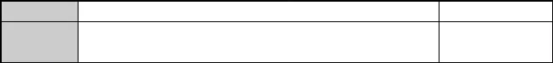
TripOID
Variable Carried
.1.3.6.1.6.3.1.1.5.1
Null
Notification

  - Notification of Active / Standby Changeover
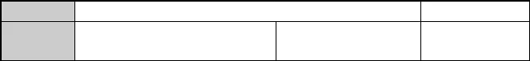
TripOID
.1.3.6.1.4.1.3902.1015.2.2.1.2
Notification
Variable
Carried
.1.3.6.1.4.1.3902.1015.2.1.1.3.1.5
zxAnCardOperStatus
The card is in
running status

  - Notification of Failing to Synchronize Active / Standby Data
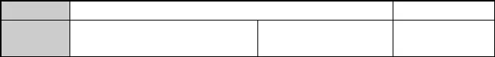
TripOID
Variable Carried
.1.3.6.1.4.1.3902.1015.2.2.1.3
.1.3.6.1.4.1.3902.1015.2.1.1.3.1.5
zxAnCardOperStatus
Notification
The card is in running status

  - Alarms that the Card Works Abnormally

    - 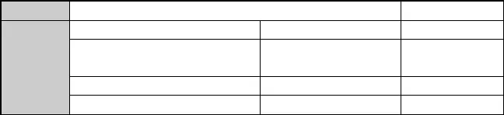Alarms
TripOID
.1.3.6.1.4.1.3902.1015.2.2.2.2
Major Alarm
Variable
Carried

.1.3.6.1.2.1.2.2.1.1 | ifIndex | ifIndex
.1.3.6.1.4.1.3902.1015.2.1.1.3.1.2 | zxAnCardCfgMainType | Configured card  type
.1.3.6.1.4.1.3902.1015.2.1.1.3.1.3 | zxAnCardActMainType | Actual card type
.1.3.6.1.4.1.3902.1015.2.1.1.3.1.4 | zxAnCardActType | Card name

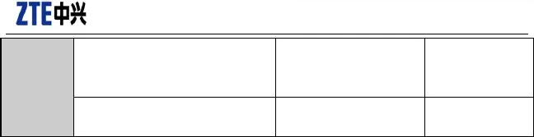
Confidential▼
.1.3.6.1.4.1.3902.1015.2.1.1.3.1.6
zxAnCardAdminStatus Administration
status
card
of
the
.1.3.6.1.4.1.3902.1015.2.1.1.3.1.5
zxAnCardOperStatus
Running status
of the card
Note: Of them, for the structure coding rules inside ifIndex, refer to ZTE EPON Equipment Composite Index Definitions.
The running status values of the card (.1.3.6.1.4.1.3902.1015.2.1.1.3.1.5):
1: The card is working normally 2: The card can not be used
3: The card’s software isn’t running 4: The card is off-line
5: The card is being configured
6: Configuration of the card failed 7: Card types aren’t matched
8: The card isn’t activated
9: The card is working abnormally 10: The card can not be used

    - Alarm Recovery


TripOID
.1.3.6.1.4.1.3902.1015.2.2.2.1
.1.3.6.1.2.1.2.2.1.1
.1.3.6.1.4.1.3902.1015.2.1.1.3.1.2
ifIndex
zxAnCardCfgMainType
Variable
Carried
.1.3.6.1.4.1.3902.1015.2.1.1.3.1.3
.1.3.6.1.4.1.3902.1015.2.1.1.3.1.4
.1.3.6.1.4.1.3902.1015.2.1.1.3.1.6
Alarm Recovery
ifIndex Configured card type
zxAnCardActMainType Actual card type zxAnCardActType Card name
zxAnCardAdminStatus Administration
status
card
of
the
.1.3.6.1.4.1.3902.1015.2.1.1.3.1.5
zxAnCardOperStatus
Running status
of the card

  - Alarm of Failing to Detect / Scan Cards

    - 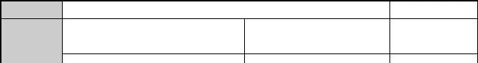Alarm
TripOID .1.3.6.1.4.1.3902.1015.2.2.2.3
Minor Alarm
Variable
Carried
.1.3.6.1.4.1.3902.1015.2.1.1.3.1.3
zxAnCardActMainType
Actual
type
card

All Rights reserved, No Spreading abroad without Permission of ZTE Page 137
.1.3.6.1.4.1.3902.1015.2.1.1.3.1.4
zxAnCardActType
Card name

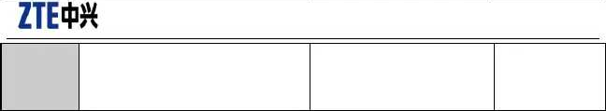
Confidential▼
.1.3.6.1.4.1.3902.1015.2.1.1.3.1.13 zxAnCardStandbyStatus
Active
/
standby status
of the card

    - Alarm Recovery


TripOID .1.3.6.1.4.1.3902.1015.2.2.2.4
Alarm
Recovery
.1.3.6.1.4.1.3902.1015.2.1.1.3.1.3
zxAnCardActMainType
Actual
type
card
Variable
Carried
.1.3.6.1.4.1.3902.1015.2.1.1.3.1.4 zxAnCardActType Card name
.1.3.6.1.4.1.3902.1015.2.1.1.3.1.13 zxAnCardStandbyStatus Active /
standby status of the card

  - Alarm of Wrong Communication of Card Services

    - Alarm

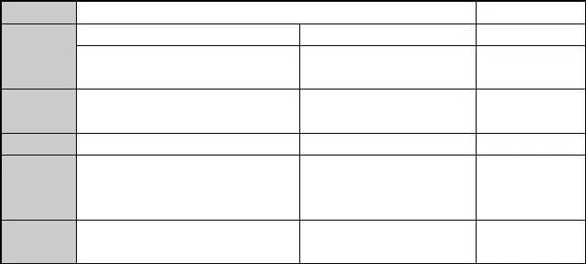
TripOID
Variable Carried
.1.3.6.1.4.1.3902.1015.2.2.2.12
.1.3.6.1.2.1.2.2.1.1
.1.3.6.1.4.1.3902.1015.2.1.1.3.1.2
ifIndex
zxAnCardCfgMainType
Minor Alarm
ifIndex
Configured card type
.1.3.6.1.4.1.3902.1015.2.1.1.3.1.3
zxAnCardActMainType
Actual
type
card
.1.3.6.1.4.1.3902.1015.2.1.1.3.1.4
.1.3.6.1.4.1.3902.1015.2.1.1.3.1.6
zxAnCardActType
zxAnCardAdminStatus
Card name
Administration
.1.3.6.1.4.1.3902.1015.2.1.1.3.1.5
zxAnCardOperStatus
status of the
card
Running status of the card

    - Alarm Recovery
TripOID .1.3.6.1.4.1.3902.1015.2.2.2.13
Variable
Carried
.1.3.6.1.2.1.2.2.1.1
.1.3.6.1.4.1.3902.1015.2.1.1.3.1.2
ifIndex
zxAnCardCfgMainType
Alarm
Recovery
ifIndex Configured
.1.3.6.1.4.1.3902.1015.2.1.1.3.1.3
zxAnCardActMainType
card type
Actual card

type

All Rights reserved, No Spreading abroad without Permission of ZTE Page 138

 |  | Confidential▼
.1.3.6.1.4.1.3902.1015.2.1.1.3.1.4 | zxAnCardActType | Card name
.1.3.6.1.4.1.3902.1015.2.1.1.3.1.6 | zxAnCardAdminStatus | Administration status of the  card
.1.3.6.1.4.1.3902.1015.2.1.1.3.1.5 | zxAnCardOperStatus | Running status  of the card

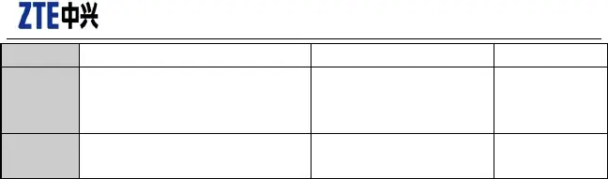
  - Alarm of Memory Overloading

    - Alarm


TripOID .1.3.6.1.4.1.3902.1015.2.2.2.3
.1.3.6.1.4.1.3902.1015.2.1.1.3.1.11 zxAnCardMemUsage
Variable
Carried
.1.3.6.1.4.1.3902.1015.2.1.1.3.1.12
Minor
Alarm Memory usage rate
zxAnCardMemUsageThreshold Memory
usage
threshold

    - Alarm Recovery
TripOID .1.3.6.1.4.1.3902.1015.2.2.2.8
Alarm
Variable
Carried

 |  | Recovery
.1.3.6.1.4.1.3902.1015.2.1.1.3.1.11 | zxAnCardMemUsage | Memory  usage rate
.1.3.6.1.4.1.3902.1015.2.1.1.3.1.12 | zxAnCardMemUsageThreshold | Memory usage
 |  | threshold

  - Alarm of CPU Overloading

    - Alarm
TripOID .1.3.6.1.4.1.3902.1015.2.2.2.6
.1.3.6.1.4.1.3902.1015.2.1.1.3.1.9
zxAnCardCpuLoad
Variable
Carried
Minor
Alarm Current CPU
utilization
rate

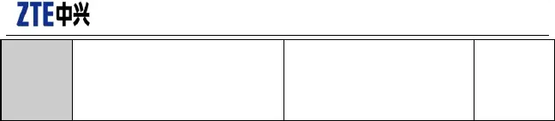
Confidential▼
.1.3.6.1.4.1.3902.1015.2.1.1.3.1.109 zxAnCardCpuLoadThreshold CPU
utilization rate threshold


    - Alarm Recovery

TripOID | .1.3.6.1.4.1.3902.1015.2.2.2.7  .1.3.6.1.4.1.3902.1015.2.1.1.3.1.9 | zxAnCardCpuLoad | Alarm  Recovery  Current
CPU
utilization
Variable |  |  | rate
Carried | .1.3.6.1.4.1.3902.1015.2.1.1.3.1.109 | zxAnCardCpuLoadThreshold | CPU
utilization
rate threshold

  - Alarm that the Card Fails to Update Version

    - Alarm

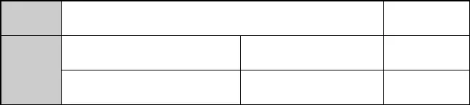
TripOID .1.3.6.1.4.1.3902.1015.2.2.2.10
.1.3.6.1.4.1.3902.1015.2.1.2.5.1.2
zxAnVerUpdateStatus
Common
Alarm
Version update
Variable Carried
.1.3.6.1.4.1.3902.1015.2.1.2.5.1.3
zxAnVerUpdateReason
status
Version update
reason

    - Alarm Recovery

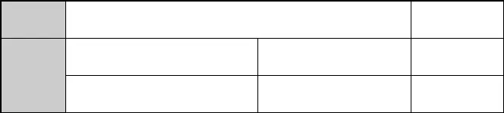
TripOID
.1.3.6.1.4.1.3902.1015.2.2.2.11
.1.3.6.1.4.1.3902.1015.2.1.2.5.1.2
zxAnVerUpdateStatus
Variable
Carried .1.3.6.1.4.1.3902.1015.2.1.2.5.1.3 zxAnVerUpdateReason
Alarm
Recovery Version update status
Version update
reason

Confidential▼

  - Alarm of Abnormal Power Supply

    - Alarm

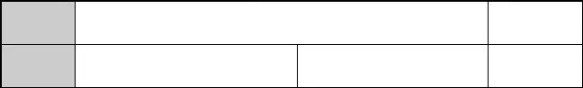
TripOID .1.3.6.1.4.1.3902.1015.2.2.3.12
Variable .1.3.6.1.4.1.3902.1015.2.1.3.9.2.1.2
Carried
Common
Alarm zxAnPowerSupplyOperState Operation
state

    - Alarm Recovery

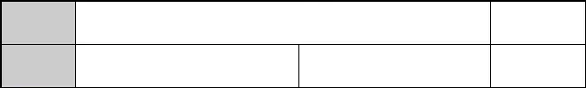
TripOID .1.3.6.1.4.1.3902.1015.2.2.3.13
Variable .1.3.6.1.4.1.3902.1015.2.1.3.9.2.1.2
Carried
Alarm
Recovery zxAnPowerSupplyOperState Operation
state

  - High Temperature Alarm

    - Alarm

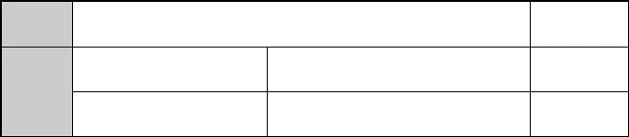
TripOID .1.3.6.1.4.1.3902.1015.2.2.3.1
.1.3.6.1.4.1.3902.1015.2.1.3.2 zxAnEnvTemperature
Variable
Carried .1.3.6.1.4.1.3902.1015.2.1.3.3 zxAnEnvTemperatureAlarmThreshold
Common
Alarm Actual Temperature Threshold
Temperature

    - Alarm Recovery


TripOID .1.3.6.1.4.1.3902.1015.2.2.3.2
.1.3.6.1.4.1.3902.1015.2.1.3.2 zxAnEnvTemperature
Variable
Carried .1.3.6.1.4.1.3902.1015.2.1.3.3 zxAnEnvTemperatureAlarmThreshold
Alarm
Recovery Actual Temperature Threshold
Temperature

Confidential▼

  - Alarm that the Fan is Off-line

    - Alarm

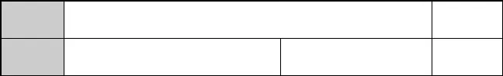
TripOID .1.3.6.1.4.1.3902.1015.2.2.3.5
Variable
Carried
.1.3.6.1.4.1.3902.1015.2.1.3.10.10.10.1.6
Common
Alarm
zxAnEnvFanOnlineStatus Fan status

    - Alarm Recovery

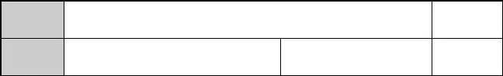
TripOID .1.3.6.1.4.1.3902.1015.2.2.3.6
Variable
Carried
.1.3.6.1.4.1.3902.1015.2.1.3.10.10.10.1.6
Alarm
Recovery
zxAnEnvFanOnlineStatus Fan status

  - Alarm that the Fan Operates Abnormally

    - Alarm


TripOID .1.3.6.1.4.1.3902.1015.2.2.2.8
.1.3.6.1.4.1.3902.1015.2.1.3.10.10.10.1.5 zxAnEnvFanOperStatus
Variable
Carried
Common
Alarm Fan operation status
up(1),
down(2), unknown(3)

    - Alarm Recovery
TripOID .1.3.6.1.4.1.3902.1015.2.2.2.9
.1.3.6.1.4.1.3902.1015.2.1.3.10.10.10.1.5 zxAnEnvFanOperStatus
Variable
Carried
Alarm
Recovery Fan operation status
up(1),
down(2), unknown(3)

Confidential▼

  - Alarm of Abnormal Dust Cover

    - Alarm

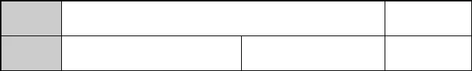
TripOID .1.3.6.1.4.1.3902.1015.2.2.3.10
Common
Alarm
Variable
Carried
Null

    - Alarm Recovery

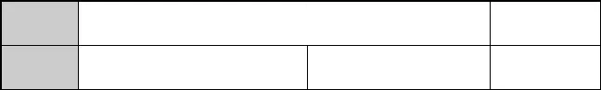
TripOID
.1.3.6.1.4.1.3902.1015.2.2.3.11
Alarm
Recovery
Variable
Carried
Null

  - Notification of Damaged Sensor
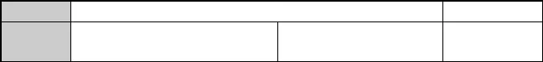
TripOID
Variable Carried
.1.3.6.1.4.1.3902.1015.2.2.3.7
Null
Notification

  - Alarm of Link Down of Environment Monitoring Interface

    - Alarm

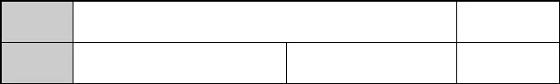
TripOID .1.3.6.1.4.1.3902.1015.2.2.3.3
Common
Alarm
Variable
Carried
Null

    - Alarm Recovery

All Rights reserved, No Spreading abroad without Permission of ZTE Page 143
TripOID .1.3.6.1.4.1.3902.1015.2.2.3.4
Alarm

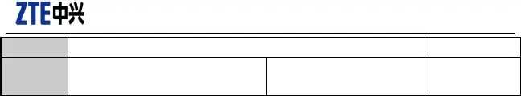
Confidential▼

Recovery
Variable
Carried
Null

Confidential▼

Platform Alarms & Notifications

  - LinkDown Alarm of Uplink Port

    - Alarm

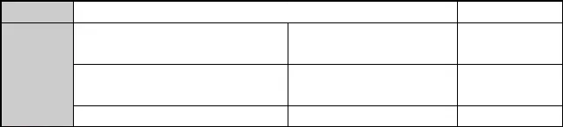
TripOID .1.3.6.1.4.1.3902.1015.3.2.2
.1.3.6.1.2.1.2.2.1.7
ifAdminStatus
Variable
Carried
.1.3.6.1.2.1.2.2.1.8
ifOperStatus
.1.3.6.1.2.1.2.2.1.3
ifType
Major Alarm
Administration status Operation status
Interface type

    - Alarm Recovery

TripOID .1.3.6.1.4.1.3902.1015.3.2.1
.1.3.6.1.2.1.2.2.1.7
ifAdminStatus
Variable
Carried
.1.3.6.1.2.1.2.2.1.8
ifOperStatus
.1.3.6.1.2.1.2.2.1.3
ifType
Alarm
Recovery Administration status Operation status
Interface type

  - Dos Attack Alarm

    - Alarm


TripOID .1.3.6.1.4.1.3902.1015.11.2.1
Variable
Carried
.1.3.6.1.2.1.2.2.1.1
.1.3.6.1.4.1.3902.1015. 1.1.1.1.6
ifIndex
zxAnServiceAntiDosSourceMac
.1.3.6.1.4.1.3902.1015. 1.1.1.1.7
zxAnServiceAntiDosPortVlan
Common
Alarm IfIndex Source MAC
address
Port VLAN

Confidential▼

    - Alarm Recovery


TripOID .1.3.6.1.4.1.3902.1015.2.2.2.4
.1.3.6.1.2.1.2.2.1.1
.1.3.6.1.4.1.3902.1015. 1.1.1.1.6
ifIndex
zxAnServiceAntiDosSourceMac
Variable
Carried
.1.3.6.1.4.1.3902.1015.11.1.1.1.7
zxAnServiceAntiDosPortVlan
Alarm
Recovery IfIndex Source MAC
address
Port VLAN

  - 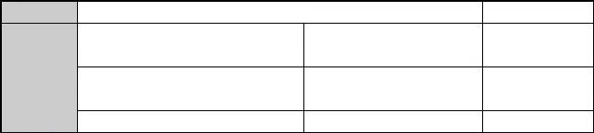LinkUp Notification of User Port
Variable
Carried
.1.3.6.1.2.1.2.2.1.8
ifOperStatus
.1.3.6.1.2.1.2.2.1.3
ifType
status
Operation state
Interface type

TripOID | .1.3.6.1.4.1.3902.1015.2.2.2.9 |  | Notification
 | .1.3.6.1.2.1.2.2.1.7 | ifAdminStatus | Administration

  - LinkDown Notification of User Port

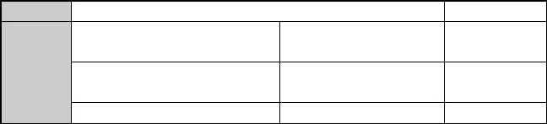
TripOID .1.3.6.1.4.1.3902.1015.2.2.2.4
.1.3.6.1.2.1.2.2.1.7
ifAdminStatus
Variable
Carried
.1.3.6.1.2.1.2.2.1.8
ifOperStatus
Notification
Administration status
Operation
.1.3.6.1.2.1.2.2.1.3
ifType
state
Interface type

  - Notification of Logging on Serial Port or Administration Port
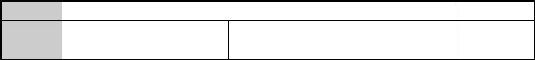
TripOID
Variable Carried
.1.3.6.1.4.1.3902.1015.1.2.6.1
.1.3.6.1.4.1.3902.1015.1.1.3.4
Notification
zxAnSysLatestLogonCrftTerminalType Logon type

Confidential▼

  - Notification of Logging out Serial Port or Administration Port
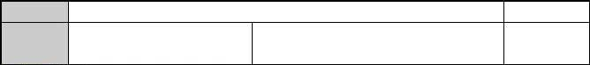
TripOID
Variable Carried
.1.3.6.1.4.1.3902.1015.1.2.6.2
.1.3.6.1.4.1.3902.1015.1.1.3.4
Notification
zxAnSysLatestLogonCrftTerminalType Logon type

Confidential▼

EPON Alarms & Notifications

ZXEPON-TRAP-MIB.mib

  - Notification of PON Port Resetting
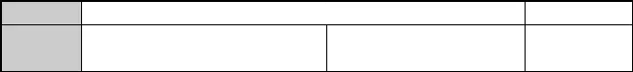
TripOID
Variable Carried
.1.3.6.1.4.1.3902.1015.1010.1.10.3.2
.1.3.6.1.2.1.2.2.1.1
ifIndex
Notification
ifIndex

  - Notification that Unknown ONUs are Online
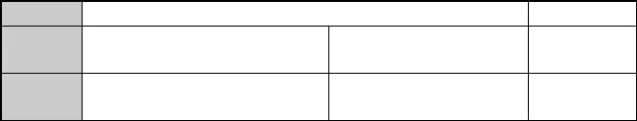
TripOID
Variable Carried
.1.3.6.1.4.1.3902.1015.1010.1.10.3.9
.1.3.6.1.2.1.2.2.1.1
ifIndex
Notification
ifIndex
.1.3.6.1.4.1.3902.1015.1010.1.10.3.1 zxAnEponTrapEventString Additional
information

  - Notification of Refusing Registration of Unknown ONUs

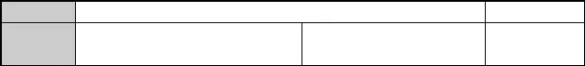
TripOID
Variable Carried
.1.3.6.1.4.1.3902.1015.1010.1.10.3.8
.1.3.6.1.2.1.2.2.1.1
ifIndex
Notification
ifIndex

  - Notification of Failing to Find Extended OAM
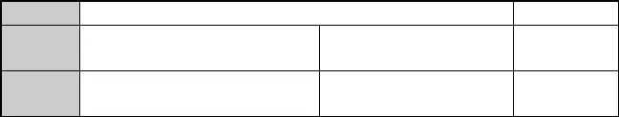
TripOID
Variable Carried
.1.3.6.1.4.1.3902.1015.1010.1.10.3.5
.1.3.6.1.2.1.2.2.1.1
ifIndex
Notification
ifIndex
.1.3.6.1.4.1.3902.1015.1010.1.10.3.1 zxAnEponTrapEventString Additional
information

Confidential▼

  - Notification that Unknown ONUs are Offline

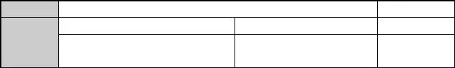
TripOID .1.3.6.1.4.1.3902.1015.1010.1.10.3.7
.1.3.6.1.2.1.2.2.1.1 ifIndex
Variable
.1.3.6.1.4.1.3902.1015.1010.1.10.3.1 zxAnEponTrapEventString
Carried
Notification
ifIndex
Additional information

  - Notification of Power-down of ONUs
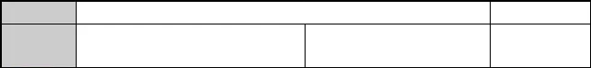
TripOID
Variable Carried
.1.3.6.1.4.1.3902.1015.1010.1.10.3.12
.1.3.6.1.2.1.2.2.1.1
ifIndex
Notification
ifIndex

  - ONU Offline Alarm

    - 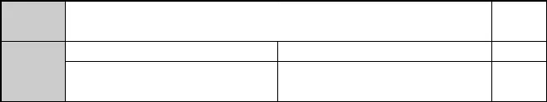Alarm
TripOID
Variable
Carried

.1.3.6.1.4.1.3902.1015.1010.1.10.1.15  .1.3.6.1.2.1.2.2.1.1 | ifIndex | Major  Alarm ifIndex
.1.3.6.1.4.1.3902.1015.1010.1.10.2.8 | zxAnEponTrapOnuOffLineReason | Offline  reason

    - Alarm Recovery

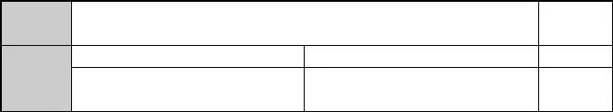
TripOID .1.3.6.1.4.1.3902.1015.1010.1.10.1.16
.1.3.6.1.2.1.2.2.1.1
Variable
.1.3.6.1.4.1.3902.1015.1010.1.10.2.8
Carried
Alarm
Recovery
ifIndex ifIndex
zxAnEponTrapOnuOffLineReason Offline
reason

Confidential▼

  - Alarm of Losing PON Port Signals

    - 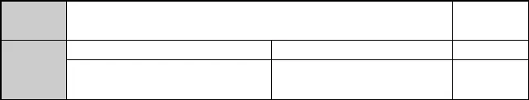Alarm
TripOID
Variable
Carried

.1.3.6.1.4.1.3902.1015.1010.1.10.1.13 |  | Major
 |  | Alarm
.1.3.6.1.2.1.2.2.1.1 | ifIndex | ifIndex
.1.3.6.1.4.1.3902.1015.1010.1.10.2.7 | zxAnEponTrapPonLosReason | Alarm  reason

Values of LOS reasons (.1.3.6.1.4.1.3902.1015.1010.1.10.2.7):
1- The fiber is disconnected. 2 - Unknown reasons.
- - The ONU is powered down.
- - The ONU has never been online.

    - Alarm Recovery

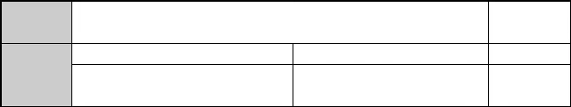
TripOID .1.3.6.1.4.1.3902.1015.1010.1.10.1.14
.1.3.6.1.2.1.2.2.1.1
Variable
.1.3.6.1.4.1.3902.1015.1010.1.10.2.7
Carried
Alarm
Recovery
ifIndex ifIndex
zxAnEponTrapPonLosReason Alarm
reason

  - Alarm of PON Port Bit Error Rate

    - Alarm

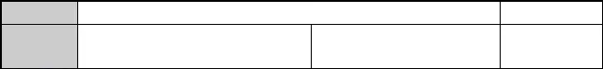
TripOID
Variable Carried
.1.3.6.1.4.1.3902.1015.1010.1.10.1. 1
.1.3.6.1.2.1.2.2.1.1
ifIndex
Major Alarm
ifIndex

    - 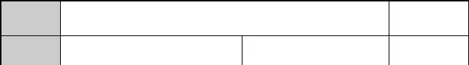Alarm Recovery
TripOID .1.3.6.1.4.1.3902.1015.1010.1.10.1.12
Variable
Carried
.1.3.6.1.2.1.2.2.1.1
ifIndex
Alarm
Recovery
ifIndex

Confidential▼

  - Alarm of Exceeding Threshold of ONU Optical Power

    - Alarm
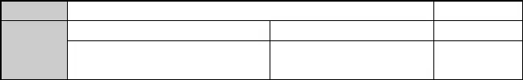
TripOID .1.3.6.1.4.1.3902.1015.1010.1.10.1.1 Major Alarm
.1.3.6.1.2.1.2.2.1.1 ifIndex ifIndex
Variable
.1.3.6.1.4.1.3902.1015.1010.1.10.3.1 zxAnEponTrapEventString Threshold
Carried
information

    - Alarm Recovery

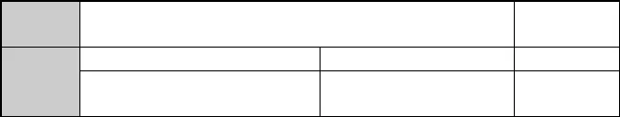
TripOID .1.3.6.1.4.1.3902.1015.1010.1.10.1.2
Alarm
Recovery
Variable
Carried
.1.3.6.1.2.1.2.2.1.1
.1.3.6.1.4.1.3902.1015.1010.1.10.3.1
ifIndex ifIndex
zxAnEponTrapEventString Threshold
information

  - Alarm of Interval Event of ONU—s Error Symbols

    - Alarm

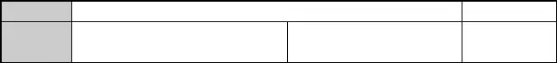
TripOID
Variable Carried
.1.3.6.1.4.1.3902.1015.1010.1.10.1.17
.1.3.6.1.2.1.2.2.1.1
ifIndex
Major Alarm
ifIndex

    - Alarm Recovery

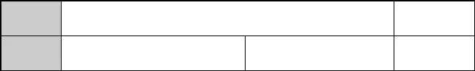
TripOID .1.3.6.1.4.1.3902.1015.1010.1.10.1.18
Variable
Carried
.1.3.6.1.2.1.2.2.1.1
ifIndex
Alarm
Recovery ifIndex

Confidential▼

    - ONU Error Frame Event

    - Alarm

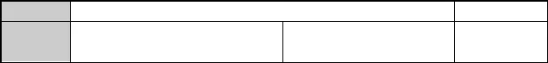
TripOID
Variable
Carried
.1.3.6.1.4.1.3902.1015.1010.1.10.1.19
.1.3.6.1.2.1.2.2.1.1
ifIndex
Major Alarm
ifIndex

    - Alarm Recovery

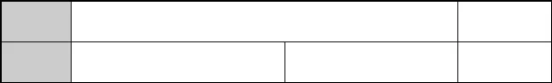
TripOID .1.3.6.1.4.1.3902.1015.1010.1.10.1.20
Variable
Carried
.1.3.6.1.2.1.2.2.1.1
ifIndex
Alarm
Recovery
ifIndex

  - Alarm of Interval Event of ONU—s Error Frames

    - Alarm

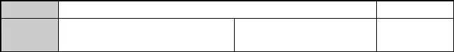
TripOID
Variable Carried
.1.3.6.1.4.1.3902.1015.1010.1.10.1.21
.1.3.6.1.2.1.2.2.1.1
ifIndex
Major Alarm
ifIndex

    - Alarm Recovery

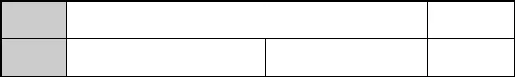
TripOID .1.3.6.1.4.1.3902.1015.1010.1.10.1.22
Variable
Carried
.1.3.6.1.2.1.2.2.1.1
ifIndex
Alarm
Recovery
ifIndex

  - Alarm of Total Number of Seconds Event of ONU—s Error Frames

    - Alarm

TripOID .1.3.6.1.4.1.3902.1015.1010.1.10.1.23
Major Alarm

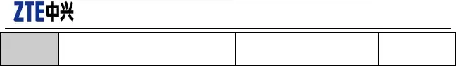
Confidential▼
Variable
Carried
.1.3.6.1.2.1.2.2.1.1
ifIndex
ifIndex

    - Alarm Recovery

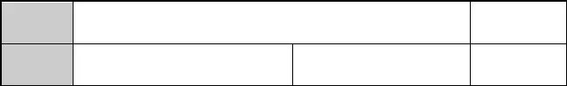
TripOID .1.3.6.1.4.1.3902.1015.1010.1.10.1.24
Variable
Carried
.1.3.6.1.2.1.2.2.1.1
ifIndex
Alarm
Recovery
ifIndex

  - Alarm of ONU Uplink—s Link Bit Error

    - Alarm

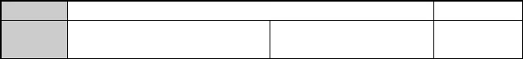
TripOID .1.3.6.1.4.1.3902.1015.1010.1.10.1.25
Major Alarm
Variable
Carried
.1.3.6.1.2.1.2.2.1.1
ifIndex
ifIndex

    - Alarm Recovery

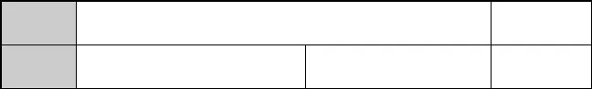
TripOID .1.3.6.1.4.1.3902.1015.1010.1.10.1.26
Variable
Carried
.1.3.6.1.2.1.2.2.1.1
ifIndex
Alarm
Recovery
ifIndex

  - Alarm of ONU Uplink—s Link Frame Error

    - Alarm

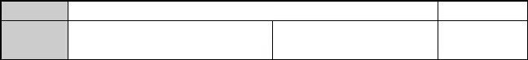
TripOID
Variable Carried
.1.3.6.1.4.1.3902.1015.1010.1.10.1.27
.1.3.6.1.2.1.2.2.1.1
ifIndex
Major Alarm
ifIndex

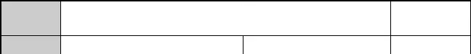
    - Alarm Recovery

TripOID | .1.3.6.1.4.1.3902.1015.1010.1.10.1.28 |  | Alarm
Variable | .1.3.6.1.2.1.2.2.1.1 | ifIndex | Recovery ifIndex

Carried

All Rights reserved, No Spreading abroad without Permission of ZTE Page 153

Confidential▼

  - Notification of Failing to Configure Local ONUs

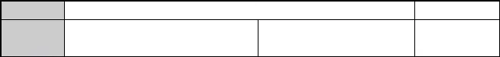
TripOID
Variable Carried
.1.3.6.1.4.1.3902.1015.1010.1.10.3.6
.1.3.6.1.2.1.2.2.1.1
ifIndex
Notification
ifIndex

  - Notification of Extended OAM Event
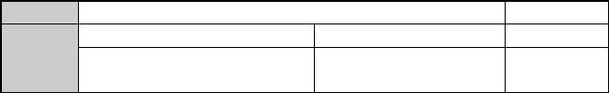
TripOID .1.3.6.1.4.1.3902.1015.1010.1.10.3. 1 Notification
.1.3.6.1.2.1.2.2.1.1 ifIndex ifIndex
Variable
.1.3.6.1.4.1.3902.1015.1010.1.10.3.1 zxAnEponTrapEventString OAM
Carried
information

All Rights reserved, No Spreading abroad without Permission of ZTE Page 154

Confidential▼

16 GPON Alarms & Notifications

{"zxGponOltSDi" , "1.3.6.1.4.1.3902.1012.3.45.109"} ,

{"zxGponOltSDiRestore" , "1.3.6.1.4.1.3902.1012.3.45.110"} ,
{"zxGponOltTxPowerAbnormalInform", "1.3.6.1.4.1.3902.1012.3.45.181"} ,

{"zxGponOnuOMCITrap" , "1.3.6.1.4.1.3902.1012.3.50.7.1"} ,

